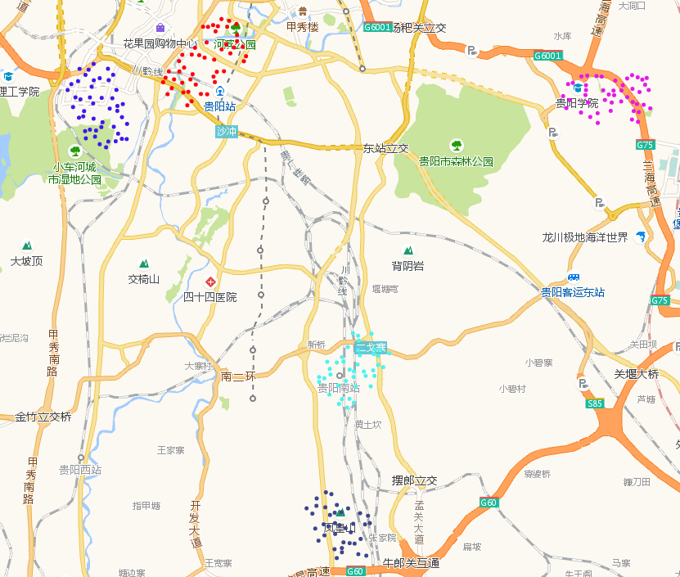
Figure.1. Hot Spots in Nanming District at 8pm, Feb.26th

Table 1. Hot Spots Statistics
Clusters ID | Detail Address | Color
1 | West Street of Huaguoyuan,Nanming District | blue
2 | Jiefang Road, Nanming District | red
3 | Lanhai Expressway, Nanming District | pink
4 | South Second Ring, Nanming District | wathet blue
5 | Niulangguan overpass, Nanming District | navy blue

In Figure1, the clusters of Nanming District at 8pm, Feb.26th has been shown, and the describe of each cluster has been shown in Table1.
The area represented by cluster1 is the Huaguoyuan which is a famous place in Guiyang, and it is not only a residential area but also an office area, the trading area, bank, hospital, cinema are included. The customers, workers and residents is the indispensable people in this area.
The area represented by cluster2 is a comprehensive area near the Guiyang railway station in which the trading areas, hotels, schools, academies, institutes, apartments are included, so this area is a gathering place of tourists, researchers and residents.
The area represented by cluster3 is a school district, in this area, we can see the Guiyang University, Guizhou Police College, Guizhou Socialist Institutes, Guizhou Medical University and other schools. Obviously, there are many students and teachers stay in this area.
The area represented by cluster4 around Guiyang south railway station, it is well-known that the train passengers flow in and flow out this place at every moment.
The area represented by cluster5 is a main artery near the Niulangguan overpass and Guiyang south railway station, there are a lot of cars and trains passing by, and carrying many passengers.

