Who Wrote It? Identifying LLMs from Their Responses
CMPSC 448: Midterm Project 1 Author: Eric Farrall (individual project)

1. Problem Definition and Dataset Curation

1.1 Problem
Large language models leave stylistic fingerprints in their text. We frame the problem as a supervised 6-way text classification task: given a piece of text (and optionally the prompt that produced it), predict which LLM family generated the response. We address:
- RQ1: Can we identify which LLM generated a response, using the response text alone?
- RQ2: Does the user’s prompt help identify the LLM? We compare prompt-only, response-only, and prompt+response classifiers.
- RQ3 (extra credit): Do fingerprints generalize across tasks/domains?
- RQ4 (extra credit): What structural/linguistic characteristics distinguish the models?

1.2 Data source and how it was collected
We use lmarena-ai/arena-human-preference-140k (Hugging Face, license CC-BY-4.0): 140k real “battles” from the LMArena (Chatbot Arena) platform in which a human user submitted one prompt and two anonymous LLMs each answered it, after which the user voted for the better answer. Unlike synthetic benchmark datasets, these are natural, spontaneously written user prompts and unrestricted model responses, collected and released publicly by the LMArena team. We chose it because (a) each row links one prompt to two different models, which is ideal for RQ2 and controls for prompt content, and (b) it spans many modern models and model families.

1.3 Dataset construction
Raw rows are battles of the form (model_a, model_b, conversation_a, conversation_b, category_tag, conv_metadata). We transform each battle into individual samples (model, prompt, response):
- Download all 7 parquet shards (1.6 GB) directly from the HF Hub.
- Flatten: each battle yields 2 samples (side a and side b).
- Keep English, first-turn, text-only conversations with a non-empty user message and assistant reply (images and multi-turn contexts are outside our text-only scope).
- Filter prompts < 5 characters and responses < 100 characters.
- Deduplicate exact (model, prompt, response) triples.
From the 142,279 extracted English first-turn samples, we then select one representative model per family and cap each class for balance:
Family | Model (API name) | Train | Val | Test
OpenAI | gpt-4.1-2025-04-14 | 1050 | 225 | 225
Anthropic | claude-sonnet-4-20250514 | 1050 | 225 | 225
Google | gemini-2.5-pro | 1050 | 225 | 225
Alibaba | qwen3-235b-a22b-no-thinking | 1050 | 225 | 225
DeepSeek | deepseek-v3-0324 | 1050 | 225 | 225
Meta | llama-4-maverick-03-26-experimental | 1050 | 225 | 225
Total: 9000 samples (1500 per class), perfectly balanced.
Leakage control (important for RQ2). Arena users frequently re-submit the same prompt, and one battle produces two samples with identical prompts. A naive random split would put the same prompt in train and test. We therefore group samples by the MD5 hash of the normalized prompt and assign whole groups to train/val/test (70/15/15) using a deterministic hash bucket. We verified the three splits share zero prompt hashes. This means test prompts are always unseen, which is the honest evaluation setup for RQ2.

1.4 Dataset characteristics relevant to the task
Response length alone varies enormously across models (median words: Claude 216, DeepSeek 320, GPT 324, Qwen 424, Llama 660, Gemini 810), and formatting differs (Claude uses almost no Markdown headers/lists, while Gemini/Llama/DeepSeek use many). These signals are analyzed systematically in RQ4.

2. Models and Training Details

2.1 Text preprocessing
- Tokenizer: lowercase regex tokenizer splitting words [a-z0-9']+ and individual punctuation/markdown characters (#, *, -, …). Keeping punctuation is deliberate: formatting markers are part of the fingerprint.
- Vocabulary: top 30,000 tokens with frequency ≥ 2, built on the training split; special tokens <pad>=0, <unk>=1, <sep>=2.
- Sequence truncation: prompt-only 128 tokens; response-only 300 tokens; prompt+response: prompt truncated to 80 tokens, then <sep>, then response, whole sequence truncated to 320 tokens.
- Batching: padded to the longest sequence in each batch; lengths passed to the RNN for pack_padded_sequence.

2.2 CNN (TextCNN)
- Embedding (dim 64, padding index 0)
- Three parallel 1-D convolutions with kernel sizes 3, 4, 5; 128 filters each; ReLU
- Global max pooling over time, concatenation (384 features)
- Dropout 0.3 → fully connected layer → 6 logits
- ~2.02M parameters

2.3 RNN (BiLSTM)
- Embedding (dim 64)
- Bidirectional LSTM, hidden size 128 per direction, on packed sequences
- Final forward + backward hidden states concatenated (256)
- Dropout 0.3 → fully connected layer → 6 logits
- ~2.1M parameters

2.4 Training protocol (identical for every configuration)
Setting | Value
Optimizer | Adam, lr = 1e-3
Batch size | 64
Loss | Cross-entropy
Grad clipping | 1.0
Max epochs | 15
Early stopping | patience 3 on validation macro-F1
Seed | 448 (Python, NumPy, PyTorch)
Hardware | CPU only (no GPU), PyTorch 2.14.1, 20 threads
The same protocol is run for all 6 combinations of {input, output, combined} × {CNN, LSTM}; only the token sequence changes. Model selection uses validation macro-F1; the test set is touched once at the end. Predictions, per-class reports, and confusion matrices are saved as JSON for reproducibility.

2.5 Classical baseline (additional classifier)
To place the neural results in context we also trained a non-neural baseline: TF-IDF features (word 1-2 grams, min document frequency 2, up to 50k features, sublinear term frequency) with a logistic-regression classifier (C = 4), using the same three input settings and the same splits. This is the classic strong baseline for text classification and costs seconds to train.

3. Results

3.1 RQ1 + RQ2
All configurations were trained under the identical protocol of Section 2.4. Test-set results (1350 samples with unseen prompts, chance = 1/6 ≈ 0.167):
Input | Model | Test accuracy | Macro-F1 | Best epoch
Prompt only | CNN | 0.165 | 0.152 | 4
Prompt only | BiLSTM | 0.177 | 0.176 | 11
Prompt only | TF-IDF + LR | 0.182 | 0.181 | n/a
Response only | CNN | 0.833 | 0.833 | 15
Response only | BiLSTM | 0.700 | 0.700 | 8
Response only | TF-IDF + LR | 0.802 | 0.801 | n/a
Prompt + response | CNN | 0.827 | 0.827 | 10
Prompt + response | BiLSTM | 0.611 | 0.610 | 14
Prompt + response | TF-IDF + LR | 0.775 | 0.774 | n/a
(“Best epoch” is not applicable for the TF-IDF + LR baseline: it is fitted in one shot by scikit-learn, with no epoch-based training.)
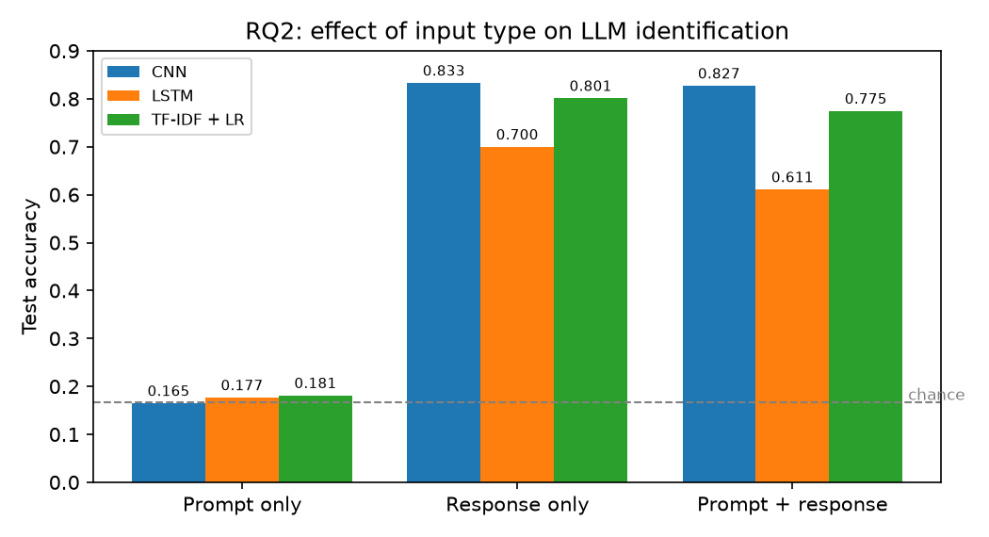
RQ2: effect of input type
RQ1 (response-only identification). Both required architectures learn real fingerprints: the CNN reaches 83.3% accuracy and the BiLSTM 70.0%, compared to the 16.7% chance baseline. The CNN wins by 13 points. This intuitively makes sense, as much of the difference between LLMs may lie in their output style. This style is likely easily detectable with the CNN’s filters, while the BiLSTM needs to compress the entire document into one hidden state. A classical TF-IDF + logistic-regression baseline reaches 80.2% without any neural machinery, a reminder that surface-level style statistics already carry most of the signal.
RQ2 (does the prompt help?).
- Input only. All three model families sit at chance (16.5% / 17.7% / 18.2%; the spread is within ~1.5 standard errors of 16.7%). The prompt genuinely carries no information about which of the two combatants produced the reply. This is expected as in this dataset the same prompt is answered by two different models. To better answer this question, it may be good to locate a dataset where users select their own models. Since different groups of people use different models, this may express itself in the prompts written.
- Output only vs input + output. Adding the prompt to the response never helps and sometimes hurts: the CNN stays flat (0.833 → 0.827, within noise), the TF-IDF baseline drops slightly (0.802 → 0.775), and the BiLSTM drops sharply (0.700 → 0.611). This is a second, independent confirmation of the input-only result. The BiLSTM’s sensitivity is explainable: an 80-token irrelevant prefix changes the recurrent state trajectory before any response tokens are read, while CNN max-pooling is nearly insensitive to where the style markers appear.
- Why might input-only work “surprisingly well”? It does not here. Inputs may hold information if users are allowed to self select the LLMs they use.
A methodological note: because identical prompts appear with two different labels (side a / side b), we never let the same prompt cross the train/test boundary; otherwise the input-only classifier could memorize prompts rather than learn anything generalizable.

3.2 What the errors look like
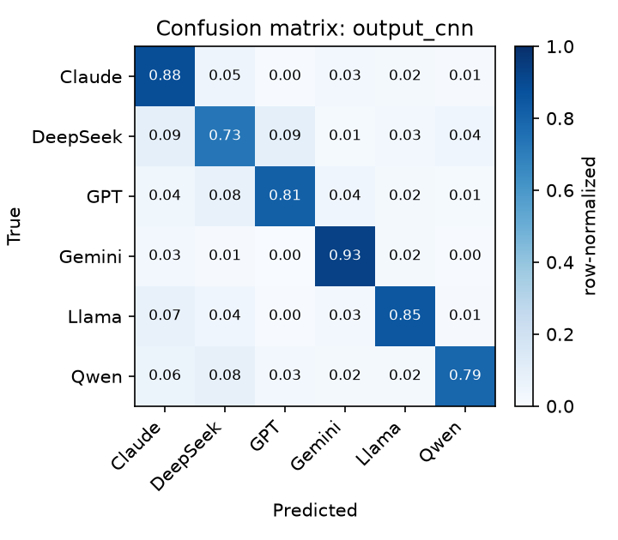
Confusion matrix of the response-only CNN
Per-class test accuracy for the response-only models:
Model | CNN | BiLSTM
Gemini | 0.933 | 0.862
Claude | 0.884 | 0.747
Llama | 0.849 | 0.773
GPT | 0.813 | 0.698
Qwen | 0.791 | 0.529
DeepSeek | 0.729 | 0.591
Gemini is the easiest model for both architectures, and both models find DeepSeek hardest. For the CNN, DeepSeek’s errors split between GPT (21) and Claude (20). The DeepSeek/GPT/Qwen middle group writes similarly formatted answers (Section 4.2), and DeepSeek’s replies also drift toward Claude-like terseness on some prompts. Errors are also uncertain: the mean predicted probability on misclassified samples is only 0.66, so the classifier rarely makes confident mistakes. The BiLSTM degrades unevenly: Qwen collapses to 0.53, which is consistent with its weaker overall performance and its tendency to overfit (training loss 0.14 vs validation loss 0.93 by epoch 11).
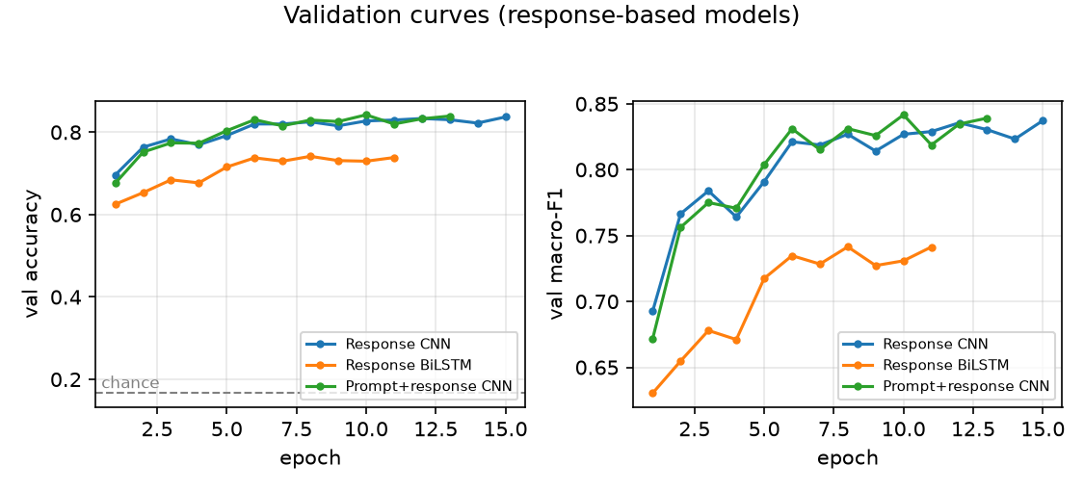
Validation curves
One honest caveat: several configurations were still improving when they hit the epoch cap (the response CNN at epoch 15, the combined-input BiLSTM at epoch 14), so their numbers are lower bounds, while the response-only BiLSTM peaked around epoch 8 and then overfit. The CNN/LSTM gap should therefore be read as “at least 13 points” rather than a converged comparison.

4. In-depth Analyses (Extra Credit)

4.1 RQ3: Cross-task generalization
We defined four disjoint task domains using the dataset’s own annotation flags: code (is_code), math, creative writing, and general (none of the above), and trained Response-only CNNs on one domain distribution and tested on another, always keeping the global prompt-group split so no prompt is ever shared between train and test.
Results (CNN, response-only, trained on the “train” domain and tested on the “test” domain; ~270-360 test samples per experiment, i.e. roughly 45-60 per class, so small per-class differences should not be over-interpreted):
Experiment | Test accuracy | Macro-F1
Code (in-domain) | 0.733 | 0.736
Math (in-domain) | 0.786 | 0.776
Creative writing (in-domain) | 0.692 | 0.688
General (in-domain) | 0.811 | 0.810
Train non-creative → test creative | 0.670 | 0.663
Train code → test math | 0.679 | 0.655
Train general → test code | 0.689 | 0.670
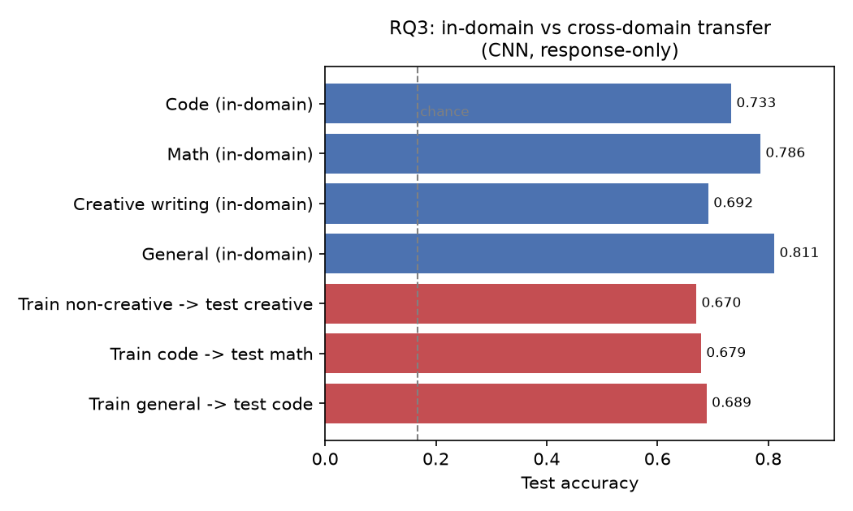
RQ3: in-domain vs cross-domain
i) Does performance decrease on unseen tasks? Yes, but modestly: the largest gap is code→math (−10.7 points versus in-domain math), while general→code loses only 4.4 and non-creative→creative loses 2.2 points. All transfer results remain far above chance (16.7%), so the classifier learns a substantial domain-independent fingerprint rather than task memorization.
ii) Are some models more consistently identifiable across domains? Yes. Per-class accuracy across the three transfer tests:
Model | non-creative → creative | code → math | general → code
Gemini | 0.73 | 0.88 | 0.90
Llama | 0.70 | 0.65 | 0.88
Qwen | 0.59 | 0.79 | 0.93
Claude | 1.00 | 0.80 | 0.48
GPT | 0.57 | 0.34 | 0.63
DeepSeek | 0.47 | 0.53 | 0.30
Gemini is the most consistently identifiable model in every domain (0.73-0.90): its extreme response length and formatting style survive the task change. Claude is fascinating in both directions: 100% identifiable on creative writing (its short, unformatted style is unique among story generators) but only 48% on code, where telling Claude apart from other terse code answers becomes hard. DeepSeek is consistently the hardest (0.30-0.53). Its style is the most “generic”.
iii) A general fingerprint or task-specific patterns? Both. If style were purely task-specific, cross-task accuracy would collapse to chance; if purely general, transfer would match in-domain accuracy. The observed 4-11 point drops indicate that the models mix a stable stylistic signature (length/formatting habits) with task-dependent regularities (e.g. how each model formats code blocks or math derivations).

4.2 RQ4: What distinguishes the models?
First, descriptive statistics (median values per model over the training split):
Model | Words | Tokens | Headers | UL items | Bold marks | TTR (200w)
Claude | 216 | 313 | 0 | 0 | 3 | 0.66
DeepSeek | 320 | 626 | 5 | 10 | 16 | 0.62
GPT | 324 | 589 | 5 | 9 | 14 | 0.60
Qwen | 424 | 785 | 6 | 11 | 14 | 0.66
Llama | 660 | 1235 | 0 | 13 | 31 | 0.63
Gemini | 810 | 1289 | 5 | 12 | 23 | 0.62
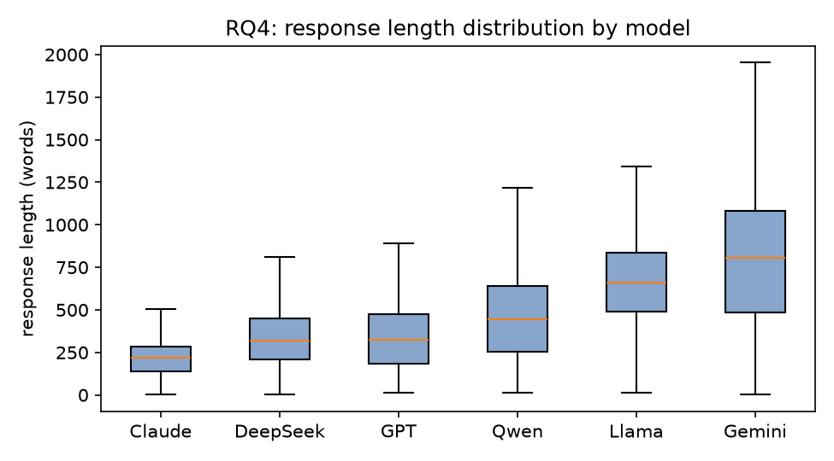
Response length by model
The models separate into three styles: Claude is terse and almost unformatted (median 216 words, zero headers, zero list items), the DeepSeek/GPT/Qwen middle group writes moderately long, heavily formatted answers, and Gemini/Llama respond 2-4x longer than Claude with the heaviest formatting (10-13 bullet items, 23-31 bold runs). Lexical diversity (type-token ratio) is nearly identical across models (0.60-0.66), so the fingerprint is much more structural than lexical.
Second, how far do non-neural signals get? Note that this is a different baseline from the TF-IDF + LR model of Section 3.1: here the classifier never sees the words themselves, only twelve hand-crafted summary numbers per response (length, formatting counts, and the lexical rates above). Logistic-regression classifiers on the same grouped splits:
Features | Test accuracy | Macro-F1
Length only (log word count) | 0.285 | 0.236
Structural (length, tokens, headers, lists, bold) | 0.555 | 0.541
Structural + lexical (TTR, word length, punctuation rates) | 0.580 | 0.570
Response-only CNN (reference) | 0.833 | 0.833
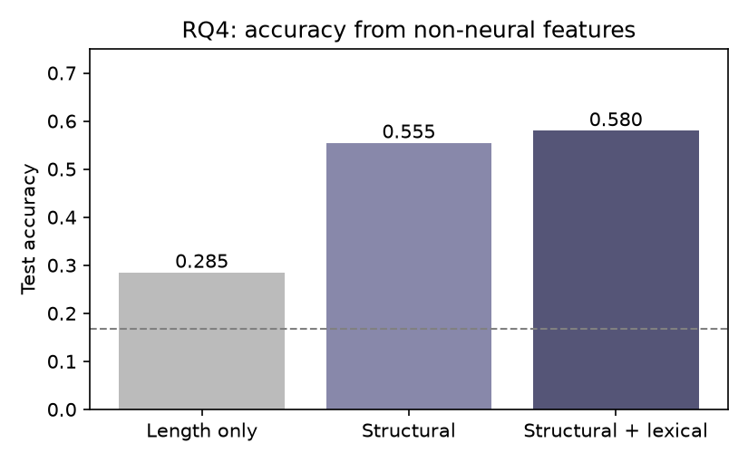
Non-neural feature baselines
Response length alone already reaches 28.5% (70% above chance), and simple formatting counts reach 58%, about 70% of the neural model’s accuracy. Lexical features add only ~2.5 points. This supports the “structural fingerprint” picture: the CNN’s advantage over the metadata baselines must come from where and how the formatting is used (e.g. ## headings vs bold-led sentences, sentence rhythm), not merely from how much formatting is present.
Third, the TF-IDF + logistic-regression baseline (Section 2.5) gives a directly interpretable view of which phrases identify each model: because the model is linear, its largest per-class feature weights are readable. The highest-weighted 1-2 gram features per class (learned on the training split, all lowercase):
Class | Highest-weight 1-2 grams
Claude | that, rather than, typically, rather, through
DeepSeek | would you, you like, would, key, but
GPT | summary, certainly, summary table, absolutely, you want
Gemini | of course, course, this is, here is, is the
Llama | now, ll, happy, here the, question
Qwen | know if, you like, like, sure, me know
The baseline essentially rediscovers each model’s conversation-level verbal tics: GPT’s “Certainly!”/“Absolutely!” and “in summary” wrappers, Gemini’s “Of course!”, Qwen’s “Sure, let me…”, Llama’s “Now go…” and “Happy to help”. Several of the strongest cues are phrasal rather than single words (in summary, would you, let me, you like), which matches the CNN’s design: n-gram filters detect exactly this kind of multi-word habit. The idf weighting also explains why the baseline is strong despite being linear. Distinctive words dominate common ones (idf: the 1.08, excellent 3.45, certainly 4.17), so the classifier automatically focuses on style rather than topic. Note, however, that TF-IDF sees only word tokens (punctuation and Markdown marks are dropped by its default tokenizer), so it cannot use the formatting signals quantified above; this is part of why the CNN still wins by ~3 points.
Fourth, an ablation isolates length: the response-only CNN was retrained with all responses truncated to the first 128 tokens (the median response is ~780 tokens and 94% of responses exceed 128 tokens, so the length signal is destroyed for nearly every sample). Accuracy falls from 0.833 to 0.792 (−4.1 points), which is real but far from fatal. The model keeps 95% of its accuracy, meaning the fingerprint lives mostly in what the text looks like in the first ~800 words (vocabulary, formatting choices, sentence rhythm), with length as an additional but secondary cue.
Caveats: the formatting styles are partly an artifact of each vendor’s default chat template and system prompt, not necessarily “intrinsic” linguistic fingerprints. A fairer follow-up would re-measure with formatting stripped and lengths equalized.

5. Lessons and Experience
- Data leakage is easy to miss. The most valuable habit from this project was checking whether the same prompt appeared in train and test. Arena users resubmit the same questions constantly, and one battle produces two samples with identical prompts; a random split would have inflated every RQ2 number. Grouping by prompt hash and verifying the disjointness changed the setup from “probably fine” to “provably clean”.
- Negative results are results. “The prompt does not identify the model” (16.5-18.2% vs 16.7% chance across three model families) is only credible because the same pipeline achieves 83% from the response; reporting input-only without that control would have meant nothing.
- Architecture matters less than representation. The CNN beat the BiLSTM by 13 points on identical tokens, mostly, we suspect, because max-pooling over n-gram detectors does not have to summarize a whole document into one vector. The non-neural baselines (58% from six metadata columns) further showed that a large share of the signal is simple structure, not deep semantics.
- Respect the compute budget. With no GPU, a single BiLSTM epoch on 300-token sequences costs ~15 minutes. Choosing sequence lengths, model size, and the number of configurations before launching runs is part of the experiment design, not an afterthought; we checkpointed each run so a long sweep could resume after interruption.
- Measurement discipline. Fixing the seed, keeping one protocol across all six configurations, selecting models on validation macro-F1, and touching the test set only once were small habits that made the comparisons trustworthy.
- Tooling. Development was assisted by an AI coding agent (opencode); all code, data decisions, and results were reviewed, run, and verified by the author.

6. Reproducibility
Repository layout:
src/build_dataset.py download + flatten LMArena shards
src/make_splits.py class selection, balance, leakage-free splits
src/textdata.py tokenizer, vocabulary, Dataset/collate
src/models.py TextCNN and BiLSTM definitions
src/train.py training/evaluation for one configuration
src/run_all.sh runs the 6 RQ1/RQ2 configurations
src/tfidf_baseline.py TF-IDF + logistic-regression baseline
src/rq3_transfer.py RQ3 domain-transfer subsets
src/rq4_analysis.py RQ4 feature analysis + non-neural classifiers
src/make_figures.py report figures
results/ metrics, predictions, models (JSON/parquet)
Run src/build_dataset.py → src/make_splits.py → src/run_all.sh to reproduce the main results; src/rq3_transfer.py, src/rq4_analysis.py, src/make_figures.py reproduce the extra-credit analyses. Raw data is not redistributed in the repo; it is downloaded from the public HF dataset.

