Home Page Design

Banner image with search bar

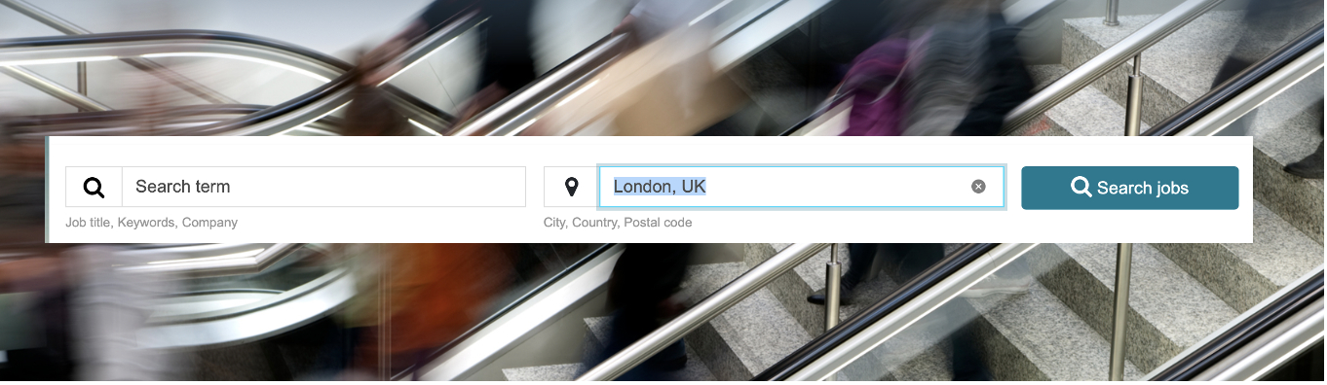

Tabs

Home

Jobs

News

Events

Insights

Media

Education > mixture of embedded (Podcasts / Video /

ETF Providers (list of companies, name, address, website, tel,) - when you open it, it will contain a full company about us page, showing what the company does, almost like our directory page. It will also have a filter system based on Country, Asset class and Category <https://www.etf.com/etfanalytics/etf-finder>.

Search bar

Can the text ‘Job title, Keywords, company’ show inside the box until the user starts typing.

<https://www.efinancialcareers.co.uk/search/?countryCode=GB&radius=40&radiusUnit=km&page=1&pageSize=20&currencyCode=GBP&language=en>

The landing page should have a mixture of mainly news, have a featured job sections and other tab information.

There should be a box to search the site

There should be a Candidate Login and Recruiter login (like the black directory job section)

Job search tab

Filter requirements

Date posted:

Location (country, city)

Job Type

Company

Employment Type

Experience level

Salary range

We want a nice news section layout, maybe this?

<https://demo.tagdiv.com/newspaper_london_news_pro/>