**Skilaverkefni 1**

BigHit Video Inc. wants to create an information system for online sales of movies in both DVD and videotape format. People will be allowed to register as customers of the online site and to update their stored information. Information must be maintained about customers’ shipping addresses, e-mail ad-dresses and credit cards. In a single sale, customers will be allowed to purchase any quantity of videos. The items in a single sale will be shipped to a single address and will have a single credit card charge a customer will be provided with a virtual shopping cart to store items to be purchased. As each item is selected, it is added to the shopping cart. When the customer finishes shopping, he will be directed to a checkout area where he can purchase all of the items in the shopping cart. At this time, payment and shipping information is entered. Once the sale is complete, the shopping cart will be deleted and the customer will be sent a receipt by e-mail.

1. Data analysis
2. Identify Entities, Attributes and constraints

|  |  |  |
| --- | --- | --- |
| **ENTITY** | **ATTRIBUTE** | **CONSTRAINTS** |
| 1.customer | accountID  lastName  firstName  shippingAddresses  emailAddress  creditCards | Key  Not null  Multivalued composite with components name,  Street, city, state and zipcode  Multivalued composite with components type, accountNumber, expiration |
| 2. videos | videoID  price  format | Primary |
| 3. credit card | creditcardNumber  expirationDate | Primary |
| 4. shipping address | street  city  state  zipCode |  |
| 5. shopping cart | cartID | Primary |
| 6. checkout area | saleID  saleDate  saleTotal | Primary |

2. Identify the Relationships

|  |  |  |  |  |
| --- | --- | --- | --- | --- |
| **Relationship Type** | **Entity Class** | **Entity Class** | **Cardinality Ratio** | **Attributes** |
| Purchases | Customer | Video | 1…M | accountID |
| Owns | Customer | Credit Card | 1…M | accountID |
| Directed | Customer | Checkout Area | 1…M | accountID |
| Provided | Customer | Shopping Cart | 1…1 | accountID |
| Entered in | Credit Card | Checkout Area | 1…1 | creditcardNumber |
| Entered in | Shipping Address | Checkout Area | 1…1 | shippingID |
| Are in | Video | Shopping Cart | M…1 | videoID |
| Purchased in | Video | Checkout Area | M…1 | videoID |

1. Data Modeling
2. Based on the information that you collected in the data dictionary, draw an ER (Entity Relationship) diagram that depicts all entities, strong entities, weak entities, relationships and cardinalities.
3. Draw an ERD Mapping of all entities in a logical schema and link the foreign keys that references the primary keys.
4. Use database normal forms to eliminate database redundancy and data anomalies.
5. Database creation
6. Create database called BigHit_db in MYSQL.
7. Write SQl queries to insert some data in each table
8. Write SQl SELECT statement to generate records from each table.

Note: The project need to be submitted in word or pdf format, including ER diagram images and the SQL queries.

Kennari: abdel

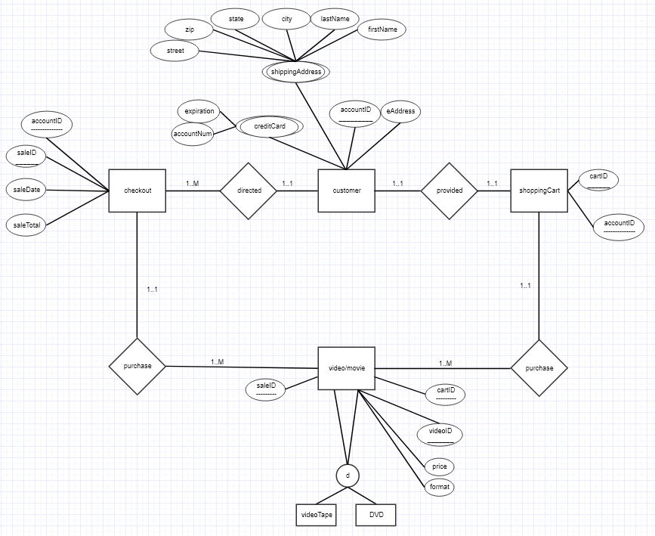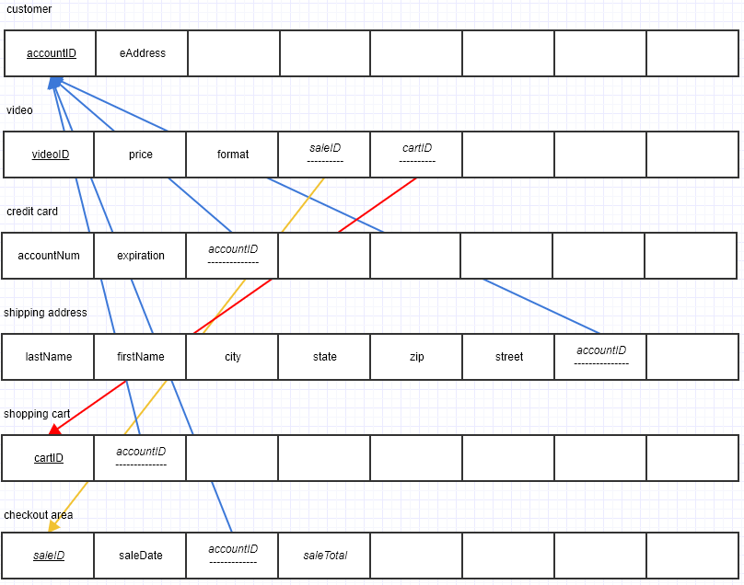

CREATE DATABASE 1101003610_bighitDB

Use 1101003610_bighitDB

CREATE TABLE customers(

accountID INT PRIMARY KEY AUTO_INCREMENT,

eAddress VARCHAR(50));

CREATE TABLE shoppingCarts(

cartID INT PRIMARY KEY AUTO_INCREMENT,

accountID INT NOT NULL,

FOREIGN KEY (accountID) REFERENCES customers(accountID));

CREATE TABLE checkoutArea(

saleID INT PRIMARY KEY AUTO_INCREMENT,

saleDate DATE,

accountID INT,

saleTotal INT,

FOREIGN KEY (accountID) REFERENCES customers(accountID));

CREATE TABLE videos(

videoID INT PRIMARY KEY AUTO_INCREMENT,

price VARCHAR(25),

format VARCHAR(10),

saleID INT NOT NULL,

cartID INT NOT NULL,

FOREIGN KEY (cartID) REFERENCES shoppingCarts(cartID),

FOREIGN KEY (saleID) REFERENCES checkoutArea(saleID));

CREATE TABLE creditCards(

accountNum CHAR(16),

expirationDate DATE,

accountID INT NOT NULL,

FOREIGN KEY (accountID) REFERENCES customers(accountID));

CREATE TABLE shippingAddress(

lastName VARCHAR(30),

firstName VARCHAR(30),

city VARCHAR(35),

state VARCHAR(30),

zip VARCHAR(10),

street VARCHAR(50),

accountID INT NOT NULL,

FOREIGN KEY (accountID) REFERENCES customers(accountID));

INSERT INTO customers(eAddress)

VALUES

("foodlover69@gmail.com"),

("notarealemail@fake.is"),

("fundaysahead@cooldude.govt.co");

INSERT INTO checkoutArea(saleDate, accountID, saleTotal)

VALUES

("2010.11.25", 1, 2399),

("2009.06.13", 2, 1399),

("2013.06.12", 3, 4900);

INSERT INTO videos(price, format, saleID, cartID)

VALUES

("2599 Kr.", "DVD", "1", "1"),

("1599 Kr.", "CD", "2", "2"),

("4700 Kr.", "CD", "3", "3");

INSERT INTO creditCards(expirationDate, accountID)

VALUES

("2031.11.23", 1),

("2041.12.11", 2),

("2013.12.12", 3);

INSERT INTO shippingAddress(lastName, firstName, city, state, zip, street, accountID)

VALUES

("John", "Newman", "Kef Lavík", "None", "230", "Funstreet 1", 1),

("Gary", "Pluto", "New York", "IDK", "1139", "Magicland 123", 2),

("Davenport", "Kennedy", "Luguaria", "IDK AGAIN", "42069", "Rustreet", 3);

SELECT firstName AS 'First Name', lastName AS 'Last Name', saleID AS "Sale ID" FROM shippingAddress, checkoutArea;

SELECT * FROM customers, shoppingCarts, checkoutArea, videos, creditCards, shippingAddress;