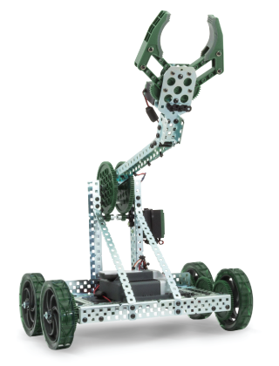

**Velmenn 2**

*Livinus felix bassey*



**1.Inngangur**

with all these and by the use of the C++ Professional Programming Language. i intend to build a machine as a

1. Robot that picks up different coloured balls and sort them into seperate boxes (QR codes?)

2. Robot that creates pictures and shapes with differently coloured balls or perhaps cubes

its is also going to be a

3. robots that have live streaming videos

4. Robot that follows lines

verkefni2

5. robot follows traffic light like a car.

6. robot Stops when sign is red and can turns in direction of arrow, etc.

8. robots Follows lines that are the roads. Can turn on controller.

9. robots crash prevention (ultrasonic range finder). Can recognize shapes and colors. Course leads to object that it picks up and delivers onto a platform.

10. Robot that stacks cubes in a specific order by color or creates 3d models with them.

11. option

verkefni2

12. 2 wheel robot that balances itself

13. Robot that can go over hills. Could use a variety of different methods to do this. Can also go down (lines, color of hill, gyroscope).

14. Robot that can be controlled through the internet using a keyboard. Livestreams video.

15. Crane robot that can spin its body/arm.

**2. Vélbúnaður**

\section{Vélbúnaður}

Ég notaði efni frá Vexrobotic \cite{vexrobotics}

i intend to use materials kits from the V5 CLASSROOM SUPER KITS which has Contents that Includes all required parts such as:

the V5 System Bundle: with the V5 System Bundle.

This bundle includes everything ineed to get started with V5,

and is engineered to provide the most advanced way of building the machine.

though does not include any motors or structural parts.

\section{Inngangur}

Ég notaði efni frá Vexrobotic \cite{vexrobotics}

l

i intend to use materials kits from the V5 CLASSROOM SUPER KITS which has Contains that Includes all required parts such as

V5 System Bundle: this V5 System Bundle,

This bundle includes everything i need to get started with V5,

and is engineered to provide the most advanced way of building the machine.

though it does not include any motors or structural parts.

it contains the V5 Smart Motors: The V5 Smart Motor is more than twice as powerful as the 2-Wire motor 393,

and puts an integrated encoder and a motor controller into one compact package.

Customize speed and torque with interchangeable gear cartridges.it Uses the built-in encoder to track a robot's rotational position and velocity

it Ships with the standard gear cartridge of 18:1 (200 RPM).

Cartridges for 36:1 (100 RPM) & 6:1 (600 RPM) are also available. Compatible with both VEX EDR shaft sizes. and

The motor runs at a slightly lower voltage than the batteries minimum voltage, and the motor's power is accurately controlled to +/-1%.

This means the motor will perform the same for every match and every autonomous run regardless of battery charge or motor temperature.

it also contains the Vision Sensor: this features Give the driver the chance to see things from the robot's perspective.

The Vision Sensor is capable of detecting up to 7 colors at once, including multi-colored objects.

Connect a phone or tablet to the V5 Robot Brain through built-in WiFi to stream a live feed of your robot's view to your device. and

Other features include: Tracks up to seven individual colors at once, Analyze objects for advanced tracking and path planning, Built-in Wi-Fi radio,

and Compatible with VEX IQ

Electronics

V5 Electronics:

(1) V5 Robot Brain

(1) V5 Controller

(1) V5 Robot Radio

(1) V5 Robot Battery Li-Ion 1100mAh

(1) V5 Robot Battery Cable

(1) V5 Robot Battery Charger

(4) V5 Smart Motors

(2) Bumper Switch v2

V5 Smart Cables:

(3) 300mm Smart Cables

(1) 600mm Smart Cable

(1) 900mm Smart Cable

Charging Cable:

(1) USB A to Micro Cable

Motion

Wheels:

(2) 4" Omni Wheels

(2) 4" Wheels

Shafts:

(2) 2" Shafts

(2) 3" Shafts

(1) 3.5" Shaft

(3) 4" Shafts

High Strength Gears & Inserts:

(1) 12T Metal Pinion

(1) 12T Metal Pinion Insert

(1) 84T High Strength Spur Gear

(10) High Strength Gear Shaft Inserts

Other Motion Components

(1) V5 Claw Assembly

Structure

Nuts & Connectors:

(30) #8-32 Hex Nut

(15) 1-Post Hex Nut Retainer w/ Flat Bearing

(5) 1-Post Hex Nut Retainer

(7) 4-Post Hex Nut Retainer

Shaft Hardware:

(5) Flat Bearing

(23) Rubber Shaft Collar

(6) 0x2 Connector Pin

(8) 1/8" Nylon Spacer

(4) 3/8" Nylon Spacer

(3) 1/2" Nylon Spacer

(2) 7/8" Nylon Spacer

Screws:

(30) #8-32 x 3/8" Star Drive Screw

(2) #8-32 x 1.000" Star Drive Screw

(4) #8-32 x 1/2" Locking Star Drive Screw

(4) #8-32 x 1.500" Locking Star Drive Screw

Steel Structure:

(3) 2x2x2x20 Steel U-Channels

(2) 1x2x1x15 Steel C-Channels

(2) 1x2x1x25 Steel C-Channels

(2) 2x2x14x20 Steel Angles

Tools & Accessories

(2) V5 Battery Clips

(2) #32 Rubber Bands

(2) T15 Star Drive Key

(50) 4" Zip Ties

(1) V5 Clawbot Instruction Manual

**3. Tímaáætlun**

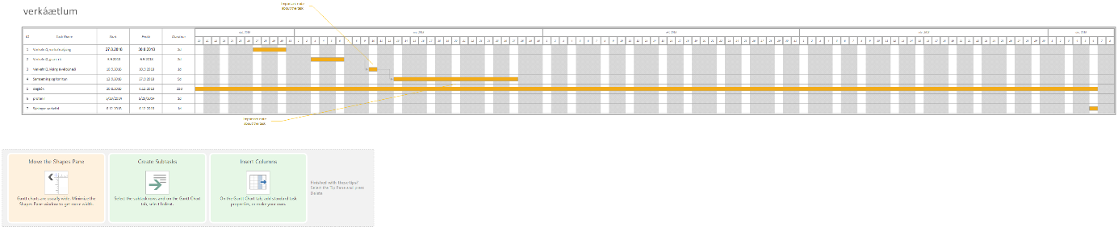

**4. Flæðirit og sauðakóði**



Hér skal gera æðirit og sauðakóða nýtið ykkur https://draw.io. Þegar þið hað lokið að gera æðiritið farið í export-image og vistið grað í skyrsla/img meðnafni "owhart". í Þessu skjali skuluð þið gera sauðakóða Ef þið lesið ykkur til um hvernig rita eigi sauðakóða þá setjið þið in tilvitnun svona : [5] Sauðakóða dæmi: loop forewer{ drive(until done) ArmUp(30) armDon(30) clawOpen() drive(until done



