W12-Lab10: SQL Basics

Members: Tyler, Christine, Angelina, Humza, Nathan, Efaz

1. Find all movie titles released after the year 2000.
   1. Input
      1. SELECT title, release_date
      2. FROM movies
      3. WHERE release_date > '2000-01-01';
   2. 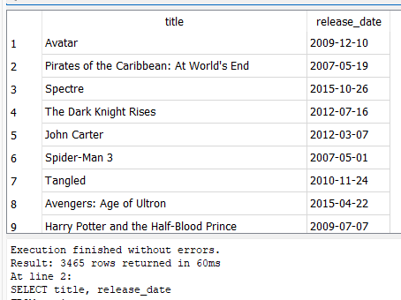
2. Show all movies with a budget between 1,000,000 and 10,000,000.
   1. Input
      1. SELECT *
      2. FROM movies
      3. WHERE budget BETWEEN 1000000 AND 10000000;
   2. 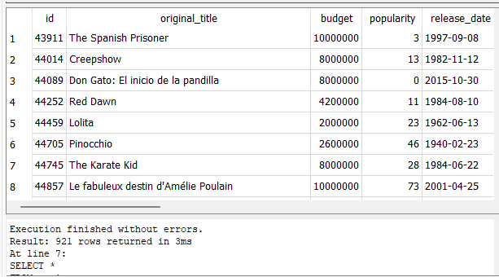
3. Display movie titles that contain the word 'Star', along with their release dates and vote average.
   1. Input
      1. SELECT title, release_date, vote_average
      2. FROM movies
      3. WHERE title LIKE '%Star%';
   2. A screenshot of a computer

      Description automatically generated
4. 4. Retrieve the titles of movies with a vote average greater than 7, ordered by vote count in descending order, and limit the results to the top 5.
   1. Input
      1. SELECT title, vote_count
      2. FROM movies
      3. WHERE vote_average > 7
      4. ORDER BY vote_count DESC
      5. LIMIT 5;
   2. A screenshot of a computer

      Description automatically generated
5. Display the movie titles and their release dates for movies released on or after '2000-01-01' with a budget of 0, ordered by release date.
   1. Input
      1. SELECT title, release_date
      2. FROM movies
      3. WHERE release_date >= '2000-01-01' AND budget = 0
      4. ORDER BY release_date;
   2. A screenshot of a computer

      Description automatically generated
6. Retrieve the top 5 most popular movies with the title ending in 'Wars', released before '1980-01-01'.
   1. Input
      1. SELECT title, popularity
      2. FROM movies
      3. WHERE title LIKE '%Wars' AND release_date < '1980-01-01'
      4. ORDER BY popularity DESC
      5. LIMIT 5;
   2. A screenshot of a computer

      Description automatically generated
7. Retrieve the titles of movies released in the 90s (1990-1999) that had no revenue recorded.
   1. Input
      1. SELECT title, release_date
      2. FROM movies
      3. WHERE release_date BETWEEN '1990-01-01' AND '1999-12-31' AND revenue = 0;
   2. A screenshot of a computer

      Description automatically generated
8. Retrieve the titles of movies that have 'Star' in the title, were released before the year 2000, and have more than 100 votes.
   1. Input
      1. SELECT title, release_date
      2. FROM movies
      3. WHERE title LIKE '%Star%' AND release_date < '2000-01-01' AND vote_count > 100;
   2. A screenshot of a computer

      Description automatically generated
9. Find the movie titles with exactly 7.5 vote average, with vote counts greater than 50 but fewer than 100, or with revenue over 1 million but under 2 million
   1. Input
      1. SELECT title, vote_average, vote_count, revenue
      2. FROM movies
      3. WHERE (vote_average = 7.5 AND vote_count > 50 AND vote_count < 100)
      4. OR (revenue > 1000000 AND revenue < 2000000);
   2. A screenshot of a computer

      Description automatically generated
10. List all directors with 'James' in their name who do not direct in the 'Directing' department or have a 'gender' value of anything other than '2'.
    1. Input
       1. SELECT *
       2. FROM directors
       3. WHERE name LIKE '%James%' AND (department != 'Directing' OR gender != 2);
    2. A screenshot of a computer

       Description automatically generated
11. List the movie titles that have 'Love' in the title, with a release date after 2010, having vote counts between 100 and 300, or with a popularity score above 20 but below 50.
    1. Input
       1. SELECT title, release_date, vote_count, popularity
       2. FROM movies
       3. WHERE (title LIKE '%Love%' AND release_date > '2010-01-01' AND vote_count BETWEEN 100 AND 300)
       4. OR (title LIKE '%Love%' AND popularity > 20 AND popularity < 50);
    2. A screenshot of a computer

       Description automatically generated
12. Display the movie titles with either an average vote of exactly 6.5 or an average vote of exactly 8.5, with more than 100 votes, and having a revenue of over 50 million or less than 10 million
    1. Input
       1. SELECT title, vote_average, vote_count, revenue
       2. FROM movies
       3. WHERE (vote_average = 6.5 OR vote_average = 8.5) AND vote_count > 100
       4. AND (revenue > 50000000 OR revenue < 10000000);
    2. A screenshot of a computer

       Description automatically generated