Project Title: Project Tortoise
Full Name: Efaz Hossain, Sahithi Mutyala
Domain and Data Science Advisor: Boros Laboratories
Report Submission Date: December 6th, 2024

Table of Contents
- Introduction
- Project Background
- Methodology
  - Data Understanding
  - Data Preprocessing
  - Modeling
  - Fine-Tuning
- Challenges and Solutions
  - Challenges Encountered
  - Approaches and Solutions
  - Impact
- Key Results and Insights
- Conclusion
- Plans for Capstone 2

Abstract
Tortoise is an advanced assistive solution for individuals with memory loss, utilizing assistive wearable technology with a mobile application to facilitate facial recognition, object location memory, and wandering prevention. By enabling users to recognize familiar faces, locate commonly used objects, and prevent wandering via real-time GPS monitoring, Tortoise significantly enhances the independence and safety of individuals with memory loss. Combining cutting-edge AI technology with user-friendly interfaces, Tortoise not only empowers users by restoring confidence in their daily interactions, but also offers caregivers and family peace of mind through timely alerts and location tracking.
- Introduction
Memory loss conditions, such as Alzheimer’s disease and dementia, are increasingly prevalent, impacting millions worldwide. According to the World Health Organization, around 50 million people currently live with dementia, and nearly 10 million new cases are reported annually. These conditions can severely impair an individual’s ability to recognize faces, remember the locations of everyday objects, and navigate their surroundings safely, leading to a significant reduction in independence and quality of life. Research indicates that assistive technologies can play a vital role in supporting individuals with memory loss, potentially delaying the need for full-time care and significantly enhancing their ability to manage daily tasks.
Tortoise is an advanced assistive system designed for individuals with memory loss, combining smart devices to support facial recognition, object location memory, and wandering prevention. By helping users identify familiar faces, find frequently used objects, and prevent wandering through real-time GPS monitoring, Tortoise greatly enhances the independence and safety of those with memory challenges. Integrating cutting-edge AI technology with intuitive interfaces, Tortoise not only empowers users by restoring confidence in their daily activities but also provides caregivers and family members with peace of mind through timely alerts and location tracking.
- Project Background
The growing prevalence of memory loss disorders has intensified the need for innovative assistive technology. According to the World Health Organization, over 50 million individuals live with dementia, with nearly 10 million new cases diagnosed annually. These conditions often result in social withdrawal, reduced autonomy and the need for intensive caregiving.
While existing solutions such as GPS trackers, digital reminders and standalone facial recognition applications provide partial relief, they fail to address the interconnected nature of the challenges faced by individuals with memory loss. Project Tortoise was conceived to fill this gap by offering a comprehensive system that integrates facial and object recognition with geofencing capabilities into a single, accessible platform.
The system harnesses pre-trained models like VGG16 and YOLOv11 for their proven ability to perform accurate and efficient image classification and object detection tasks. By incorporating these technologies into a wearable and mobile platform, Project Tortoise and the members at Boros Laboratories aim to enhance safety, promote independence and streamline caregiving through real-time alerts and data insights.
- Methodology
  - Data Understanding
    - Comprised of two primary categories:
      - Facial Dataset: A small dataset of 500 images covering diverse ethnicities, age groups and expressions
      - Object Dataset: A larger dataset of 6,000 spanning 100 object categories
    - Key Observations from exploratory data analysis (EDA):
      - Class Imbalance: Some classes, particularly in the facial dataset, were significantly underrepresented
      - Variability: Images from both datasets exhibited diverse resolutions, lighting conditions and orientations
      - Quality Issues: Around 5% of facial datasets required manual relabeling due to missing or incorrect labels
  - Data Preprocessing
    - Steps to combat challenges identified during EDA:
      - Resizing: All images were standardized to 224x224 pixels for compatibility with VGG16 and EfficientNet
      - Normalization: Scaled pixel values to the range [0,1] for uniform input distribution
      - Data Augmentation
        - Techniques included rotations, flips, brightness/saturation adjustments and cropping
        - Augmentation increased dataset diversity and mitigated class imbalance which grew to 15,000 images total and equal amounts of images when splitting for model training.
  - Modeling
    - Base Model: VGG16
      - VGG16 was selected for its well-documented performance in image classification tasks.
        - 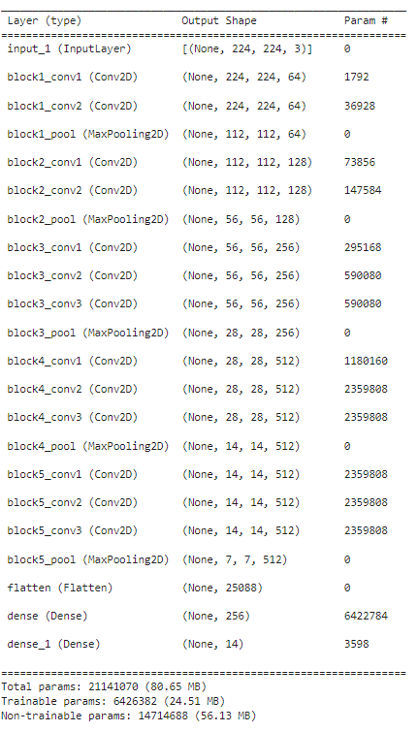
      - Pretrained weights from ImageNet provided a strong foundation, achieving an initial benchmark accuracy of 64.06%
    - Augmented Model
      - Used images from augmented dataset to improve accuracy to 68.75%
    - Fine-Tuned Model:
      - By unfreezing the top layers of VGG16 and fine-tuning via hyperparameter adjustments, the model achieved a validation accuracy of 83.57% and a test accuracy of 84.07%
  - Fine-Tuning
    - Hyperparameter Tuning
      - Optimized learning rate, dropout and batch size using Keras-Tuner
        - A total of 10 trials were ran with all of the datasets ran twice through 20 epochs on varying hyperparameters, determining the best parameters for optimal performance.
          - 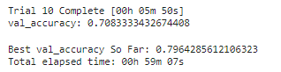
    - Transfer Learning
      - Attempted transfer learning with EfficientNet but due to small dataset, not much of a performance increase
      - Potentially considering scrubbing this attempt
- Challenges and Solutions
  - Challenges Encountered
    - Class Imbalance
    - Overfitting
    - Computational Constraints during initial training
    - Deployment Issues
  - Approaches and Solutions
    - Class imbalance was dealt with by augmenting classes with synthetic images, increasing diversity
    - Overfitting was dealt with by introducing dropout layers, weight regularization and attempts for early stopping
    - Computational constraints were dealt with by utilizing a HPC (High-powered computing) machine and running training models onto it.
    - Deployment has optimized models by pruning redundant layers and testing inference times with a Flask API
  - Impact
    - Data augmentation and fine-tuning significantly enhanced model generalization, as evidenced by the improved validation accuracy and reduced loss
    - Deployment strategies ensured that the models could operate efficiently on wearable devices, paving the way for real-world testing in Capstone 2, and potentially in real-world markets.
- Key Results and Insights
The results of Project Tortoise demonstrate significant improvements across different stages of model development and deployment. The base model, VGG16, achieved a validation accuracy of 64.06% during initial training. This provided a strong foundation but highlighted the need for enhanced generalization and performance optimization. After incorporating data augmentation techniques and fine-tuning the VGG16 model, the validation accuracy improved to 83.57%, with a test accuracy of 84.07%. These refinements also led to a significant reduction in validation loss from 0.527 to 0.3879 and test loss from 0.549 to 0.2768.
Hyperparameter tuning further enhanced performance by optimizing learning rates, dropout rates, and batch sizes. The use of EfficientNet in transfer learning experiments showed promise, achieving improved computational efficiency and comparable accuracy. Deployment testing confirmed the system's real-world applicability. A Flask API was successfully implemented to facilitate model inference, and preliminary tests on unseen data showcased robust accuracy and minimal latency.
Metric | Base Model | Augmented Model | Fine-Tuned Model
Validation Accuracy | 64.04% | 68.75% | 83.57$
Test Accuracy | 64.50% | 68.25% | 84.07%
Validation Loss | 0.527 | 0.421 | 0.388
Test Loss | 0.549 | 0.433 | 0.277
Figure 1: Metrics table of our three models
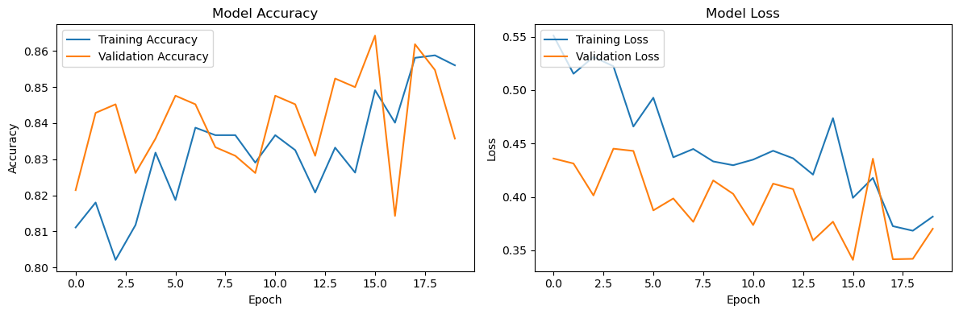
Figure 2: Model Accuracy and Model Loss of Base Model
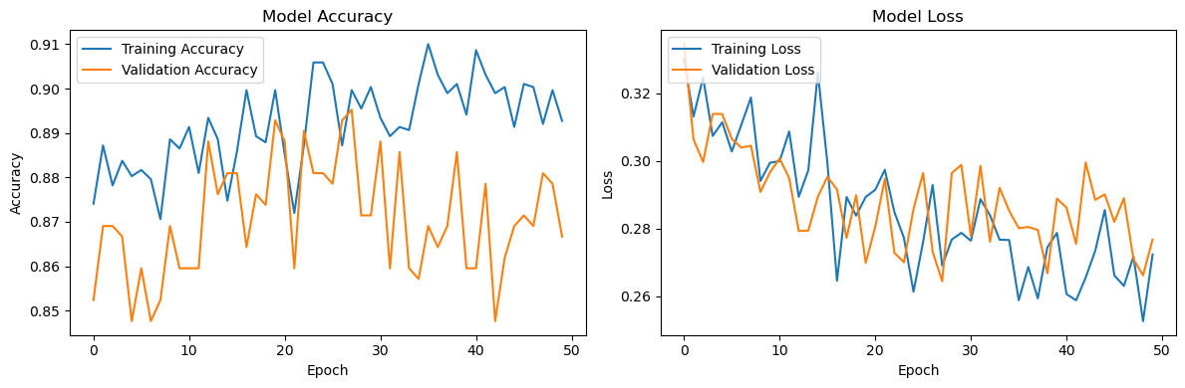
Figure 3: Model Accuracy and Model Loss of Augmented Model
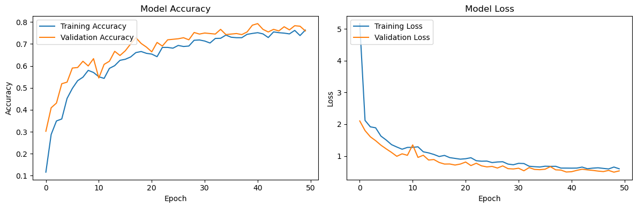
Overall, these results highlight the project's progress in creating scalable, efficient, and reliable assistive technology. The combination of robust preprocessing, fine-tuning, and deployment mechanisms underscores the system's readiness for broader real-world testing and further enhancements in Capstone 2.
- Conclusion
Project Tortoise has demonstrated the potential of assistive technologies in addressing the challenges faced by individuals with memory loss. Through the integration of facial recognition, object location memory, and wandering prevention, the project successfully combined machine learning models with wearable and mobile platforms to provide real-time assistance. Key achievements include:
- Model Optimization: Fine-tuning of VGG16 and experimentation with EfficientNet and YOLOv8 led to significant improvements in accuracy and loss metrics, achieving a test accuracy of 84.07%.
- Data Augmentation: Addressed class imbalance and enhanced dataset diversity, resulting in improved generalization across unseen data.
- Deployment Readiness: Developed a scalable deployment pipeline using a Flask API, enabling efficient inference for wearable devices.
These efforts not only improved the technical performance of the system but also underscored its practical applicability in enhancing user independence and caregiver support. The work completed in this phase lays a solid foundation for further advancements and real-world deployment in Capstone 2.
- Plans for Capstone 2
The next phase of Project Tortoise will focus on enhancing the system's real-world applicability and optimizing its performance. A primary goal is to integrate the assistive system into smart glasses and mobile applications to enable real-time functionality. This capability is crucial for providing immediate feedback to users and caregivers, ensuring practical usability in daily scenarios. Additionally, expanding the dataset will be a priority, incorporating new facial and object classes captured in diverse environments to improve model robustness and generalizability.
To further optimize the system, experimentation with advanced architectures, such as YOLOv9, will be undertaken. These models promise faster inference times and higher accuracy, making them well-suited for deployment on resource-constrained devices. User feedback will play a critical role in this phase, with planned usability studies to gather insights from target users. These insights will help refine the system and ensure it meets real-world needs and expectations.
Another important aspect is the development of multi-device support, enabling seamless synchronization across smart glasses, mobile devices, and cloud platforms. This feature will enhance the system’s versatility and adaptability for various use cases. By prioritizing these advancements, the next phase of Project Tortoise aims to bridge the gap between research and deployment, bringing the system closer to becoming a transformative assistive technology.

