Screenshot Coding

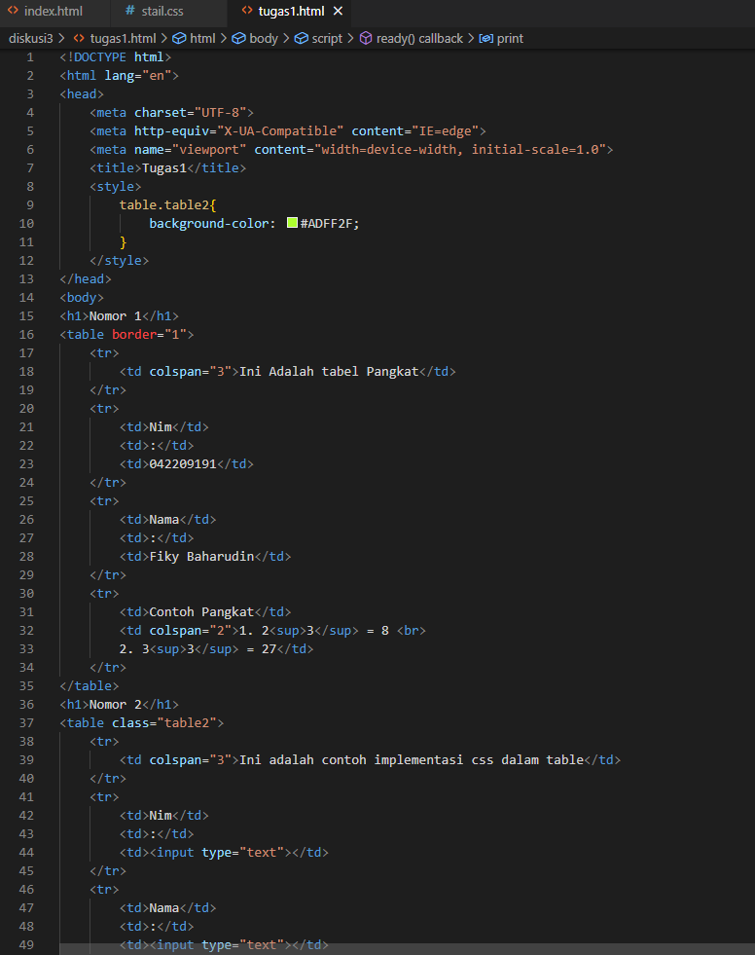

Screenshot Hasil

