Running head: Appoo et al.Coconut crab population dynamics on Aldabra

**Population demographics and dynamics of the coconut crab, *Birgus latro,* on Aldabra Atoll, Seychelles**

Jennifer Appoo1[1], E. Fernando Cagua2*, Janske van de Crommenacker1

*1Seychelles Islands Foundation, Victoria, Mahé, Seychelles;*

*2Center for Integrative Ecology, School of Biological Sciences, University of Canterbury, Christchurch 8041, New Zealand;*

ABSTRACT

Island species are highly vulnerable to disturbances linked to human interference, such as habitat loss. Increased knowledge about the remaining healthy populations is important for their conservation. One such species is the coconut crab, *Birgus latro,* with population declines documented across its range it is currently listed as data deficient on the IUCN Red List. Aldabra Atoll (Seychelles) hosts a significant and unexploited *B. latro* population. We investigated the spatial and temporal dynamics of *B. latro* on Aldabra over a period of nine years. We found a *B. latro* mean density of 35.4 ± 1.69 individuals per hectare which has largely remained stable over the study period. Nevertheless, the population exhibited high spatial and temporal variability in density, size and sex ratio. The observed *B. latro* population on Aldabra is heavily skewed towards males (sex ratio 3:1 male to female) and is sexually dimorphic with males attaining larger sizes than females. Our results show that for a species with such a cryptic nature and dynamic behaviour, long terms studies are necessary to provide accurate information and develop conservation measures. Overall, our results indicate that Aldabra represents an important refuge for *B. latro* and holds the potential to repopulate other protected areas in the Western Indian Ocean.

KEY WORDS: density, spatial variability, seasonal dynamics, moulting, reproductive season.

INTRODUCTION

Present extinction rates of species globally are exceptionally high, estimated to be around 100 extinctions per million species per year (Pimm et al. 2014). This is 1,000 times higher than the natural background extinction rate (de Vos et al. 2014). Around 10,673 species are classified as data deficient on the IUCN Red List, meaning that their threat status cannot be assessed due to uncertainties in species taxonomy, distribution, population status or unknown threats (Veron et al. 2016). These uncertainties impact the likelihood of active conservation measures being adopted. Unless directly targeted for monitoring, species classified as data deficient are likely to go extinct without notice (Bland et al. 2014). Taking into account information on data deficient species may therefore help fill data gaps in biodiversity indicators, as well as conserve poorly known biodiversity (Bland et al. 2014). Likewise, the conservation attention paid to invertebrates lags far behind that of vertebrates (Collen et al. 2012). It is crucial to understand the conservation status and trends of invertebrates, since it is these often cryptic and overlooked species that are essential for the functioning of ecosystems (Baillie et al. 2010).

The largest land arthropod, the coconut crab (*Birgus latro*)*,* is classified as data deficient (Eldredge 1996) due to limited information on the status of the different populations (Drew et al. 2010). Although *B. latro* has a broad geographical range in the tropical Indo-Pacific region, the size and distribution of the populations have been significantly reduced in areas where the species were sympatric with humans (Schiller 1992). This decline is mostly attributed to loss of habitat and unmanaged harvesting for human consumption (Drew et al. 2010). Despite being present in large quantities all across the Indo-Pacific (Drewet al. 2010), in the Indian Ocean, the distribution is now largely confined to three populations centred on Aldabra Atoll, Chagos Archipelago and Christmas Island (Lavery et al. 1996). *B. latro* is locally extinct in Mauritius (Eldredge 1996), is believed to be no longer present on Mayotte and the Comoros Islands, and has only been occasionally recorded with low incidence on some of the outer Seychelles islands (Poupin et al. 2013). Despite *B. latro*’s relative rareness and documented threats, information on the species life-history, behaviour and ecological requirements is insufficient (Drew et al. 2010), making it difficult to assess its status and design potential conservation measures.

*B. latro* is a major ecological player on island ecosystems (Paulay & Starmer 2011, Laidre 2017). As scavengers they remove rotting material and so reduce the number of carrion breeding flies, help to decompose leaf litter, contribute greatly to seed dispersal, provide a food source for birds in the juvenile stage and in turn influence the populations of crab species upon which the birds prey (Alexander 1976). Furthermore, *B. latro* contribute to soil aeration and erosion through their burrowing activity (Alexander 1976) and also serve as hosts to several commensal or parasitic species (McDermott et al. 2010).

We investigated the demographics and dynamics of *B. latro* on Aldabra Atoll (Seychelles) where the species has benefited from complete protection since Aldabra's designation as a special reserve in 1981 and UNESCO World Heritage Site in 1982. *B. latro* is widely distributed throughout the atoll, inhabiting rock crevices, deep pot-holes, vegetation and sandy areas (Grubb 1971). On Aldabra, *B. latro* is a scavenger of major importance on the remains of dead tortoises and preys on marine turtle eggs and hatchlings (Haig 1984). Although being one of the last remaining viable populations in the Indian Ocean, the status and ecological characteristics of Aldabra’s *B. latro* population have not recently been reported.

Here we present the results of a nine-year study where counts and biometrics data were collected on *B. latro* individuals at regular intervals between 2007 and 2016. Due to its isolation and protection, we hypothesise that Aldabra hosts a significant *B. latro* population with the potential to be a source population for translocations to other protected areas within its known historic range. Our aim is to define baseline information of the population structure and its spatial and temporal variability providing ecological parameters that contribute towards appropriate monitoring and conservation strategies on Aldabra and elsewhere. We hope to give *B. latro* the conservation leverage it deserves.

MATERIALS AND METHODS

*Study site*

Aldabra Atoll (9°25′0″ S, 46°24′59″ E, land area 155km2) lies in the Western Indian Ocean and forms part of the Seychelles archipelago. It is located approximately 1100km south west of Mahé, the main island of the Seychelles, and 420km from Madagascar (Fig. 1). Aldabra is the second largest raised coral atoll, ca. 34km long and 14km wide, and is composed of a characteristic and irregular coral limestone formation termed as ‘champignon’. The terrestrial environment is dominated by dense scrub of varying height, either continuous or in a mosaic with open rocky ground (Hnatiuk & Merton 1979). Aldabra’s climate is determined by two distinct seasons: the wet season of the northwest monsoon from November to April (Stoddart & Mole 1977), while between May to October there is lower rainfall resulting from the southeast monsoon winds.

*Sampling*

The distribution of *Birgus latro* is thought to be structured by distance from the coastline (Schiller 1992). Therefore we conducted *B. latro* population surveys on two transects established on existing walking trails at varying distances from the shore (Fig. 1). The predominantly coastal transect was 1.4km long, composed of 27 lineal sections of 50m and separated from the shore by distances ranging between 1 and 26m. The predominantly inland transect was 1.8km long, composed of 39 lineal sections of 50m with distances from the shore ranging between 38 and 177m. We surveyed both transects simultaneously after sunset, roughly every two weeks between January 2007 and May 2016.

All *B. latro* individuals encountered within five meters on either side of the mid transect line were recorded. For each individual encounter, we recorded the following parameters:

1. Distance to the mid transect line, estimated to the nearest meter.
2. Sex: The sex of *B.latro* was identified; female *B.latro* possesses three large, feathery pleopods on the ventral surface of the abdomen which are used to support their egg-masses (Fletcher 1993). Male *B.latro* do not have the pleopods. When a female was identified, we noted whether it was carrying eggs or not.
3. Thoracic length: a highly significant relationship between weight and thoracic length was previously found for the *B. latro* population on Aldabra (P. Pistorius unpubl. data), corresponding to findings in other studies (Amesbury 1980, Anagnostou & Shubart 2014, Helagi et al. 2015). Therefore, for each individual we measured thoracic length, the linear distance between anterior and posterior borders of the thoracic groove, with vernier calipers (Helfman 1973).
4. Moult: several studies (Amesbury 1980, Fletcher et al. 1990, Held 1963 cited by Drew et al. 2010) noted a distinct expansion of the abdomen on *B. latro* prior to moulting. Pleonal expansion has also been linked to the reproductive condition of females, as it can be indicative of gonad development (Fletcher et al. 1991, Sato & Yoseda 2009). Therefore we recorded the degree of pleonal expansion using a four-level categorical scale: category 1: all tergal plates were touching each other or there was only a small gap between the most posterior tergal plate (first plate) and the second plate; category 2: the pleon was slightly swollen and the fleshy abdomen was visible between the first and second plates, and somewhat visible between the second and third plate; category 3: the pleon was swollen and the fleshy abdomen was clearly present between the first, second and third plates, and somewhat visible between the third and the fourth plate; and category 4: a strongly swollen pleon with the fleshy abdomen visible between all tergal plates.

*Habitat classification*

We considered the habitat along the transects to be representative of the dominant landscape on Aldabra. However, to control for potential habitat effects, we determined habitat composition using high resolution satellite imagery (Walton 2015) and classified it into eight different habitat types. In each transect section we calculated the percentage of area occupied by the different habitat types that could affect *B. latro* detectability and/or abundance. In decreasing order of area occupied these habitats were: open mixed scrub, exposed surface, standard mixed scrub, grasses, mangrove, sand, dense *Pemphis acidula* bush, and champignon.

*Data analysis*

*Density and abundance*

We estimated the density of *B. latro* during each survey using the hierarchical distance sampling model of Royle et al. (2004) implemented in the R package unmarked (Fiske & Chandler 2011). We used the numbers of individuals within five distance categories 0−1, 1−2, 2−3, 3−4, 4−5m from the mid-transect line to estimate the overall density and evaluated the association between habitat composition with both the detectability and abundance of *B. latro*.

To maximise differentiation between transect sites and reduce the dimensionality of the data, we transformed habitat composition percentages using a principal component analysis. Finally, we included the two components, explaining the largest proportion of the variance as covariates in the distance sampling model. Due to the large number of surveys, we used a fixed effects meta-analysis approach to ascertain the importance of the covariates. A covariate was determined to affect *B.latro* detectability if its effect was significant and consistent over a majority of surveys, and to affect abundance if its effect was either consistent over surveys or variable but according to the seasons. We used the Akaike Information Criterion (AIC) to determine whether the detection process was better approximated by a half-normal, a negative exponential, a hazard-rate, or a uniform distribution function.

Next, we used a generalised additive model (GAM) to determine whether *B. latro* densities varied significantly (i) over the years, (ii) over the yearly cycle, and (iii) over the lunar cycle. We fitted the models using the R package mgcv (Wood 2006a), and assessed the model parsimony by comparing their AIC values. We back calculated the phase of the moon during the survey using the R package oce (Kelley & Richards 2015) and defined it as a continuous variable from zero to one with both extremes corresponding to new moon, 1/4 for first quarter, 1/2 for full moon, and 3/4 for last quarter (Meeus 1982). To analyze abundance patterns at a finer spatial and temporal scale, we used a set of GAMs to quantify the relative effect of the aforementioned variables on the counts of both male and female individuals. This was possible because initial analysis indicated that *B.latro* detectability did not change over time and was not influenced by habitat composition (see Results) and consequently direct counts provide an accurate index of *B.latro* abundance. As it is plausible that environmental factors interact with habitat requirements, we also included the tensor product interaction between day of the year and distance from shore in the model (Wood 2006b).

*Sex ratio and sizes*

We calculated observed sex ratios from the individual counts. Because of the relevance for reproduction, we also calculated the sex ratio that would be observed if only sexually mature individuals were included. We assumed full sexual maturity based on size, where individuals with a thoracic length longer than 28mm were considered adults (Fletcher et al. 1990, Sato & Yoseda 2008, Drew et al. 2010). All studied island populations of *B. latro* reveal males being consistently larger than females (Drew et al.2010). We also therefore used thoracic length to determine whether the Aldabra population also exhibits size sexual dimorphism. We evaluated the difference by visually inspecting the size distribution for both sexes and Mann–Whitney tests on the length measurements. We used a set of GAMs to infer the effects that time of the year, distance from shore, and phase of the moon may have on the sex ratio and sizes of individuals encountered. Competing models were compared using their AIC.

*Moulting and reproduction*

To determine whether there is evidence of synchronous seasonal moulting, and to provide insight into the onset of reproductive season, we constructed two additional GAMs, one for each sex. In these models the response variable was the index of pleonal expansion (treated as a numeric variable) and the predictor was the time of the year. To determine the reproductive season of *B. latro* on Aldabra, we constructed a GAM with a binomial error distribution with the response variable being whether a female was seen carrying eggs during a survey transect or not, with time of the year and phase of the moon as response variables.

RESULTS

*Density and abundance*

Overall, we performed 281 surveys over the study period which led to a total of 8145 individual encounters. The two principal components of the habitat composition explained 81% of the variance found among transect sections (Fig. S1 in Supplement 1). The first component was strongly correlated with an increase on the area covered by open mixed scrub, but mainly with a decrease on percentage of exposed surface. The second component was largely correlated with an increase of grass and with a decrease of standard mixed scrub. These habitat differences, however, did not significantly affect the detectability or the abundances of *Birgus latro* (Fig. S2 and Fig. S3 in Supplement 2). Overall, based on AIC values, the most parsimonious models were those fitting a negative exponential function to the detection process.

*B. latro* density in the study area varied between 3.2 and 189.4 individuals per hectare, with an overall average density of 35.4 ± 1.69 ind. ha-1 (mean ± SE). The overall density shows small variations over the years, but no long term trend is observable (Fig. 2A). Similarly, there was no significant variation on density with moon cycle (p = 0.916). Contrastingly, there were important seasonal changes on abundance, being above average between February and June, with a clear peak in April, and below average for the rest of the year (Fig. 2B).

The number of *B. latro* males and females encountered was strongly affected by the time of the year and the distance from shore. In general, male counts in each transect section were largest during the first half of the year. Within that period, between March and April, males concentrated away from shore (Fig. 3A). During the same period, when inshore counts were high for males, female counts were higher closer to shore. In contrast, during the second half of the year when male counts were the lowest, female counts were at the highest both in coastal and inshore sections, particularly between October and November (Fig. 3A).

Although moon phase did not affect the overall *B. latro* densities, it had distinct and complementary effects on males and females (Fig. 4A). While female counts were the largest during periods of full moon, males were encountered in higher densities during new moon when the illuminated fraction of the moon was at its minimum.

*Sex ratio and sizes*

The overall *B. latro* male:female ratio of observed individuals was approximately 3:1 (76% male), which increases to approximately 4:1 (82% male) if only sexually mature individuals are included. As inferred by the count models, this ratio however, shows significant temporal and spatial variation, ranging between 57% of individuals encountered being male during November in areas close to shore and 86% during March in areas far from shore.

In addition to female *B.latro* being recognized by three additional large, feathery pleopods on the ventral surface of their abdomen, a marked size sexual dimorphism was observed (Fig. 5). Male thoracic length, ranged from 9 to 78mm (mean 40.9 mm, median 48.8 mm), while female ranged from 6 to 76mm (mean 30.6 mm, median 48.9 mm). Although the distributions of the two groups did not differ significantly (Mann–Whitney, n1 = 6182, n2= 1994, p = 0.725 two-tailed), large males were significantly larger than female counterparts (Mann–Whitney of upper decile, n1 = 666, n2 = 197, p < 0.001). The mean size of both male and female individuals encountered showed two distinct peaks during the year, one between October and December, and another more pronounced between March and May (Fig. 3B).

The mean sizes were also found to be affected by the distance to shore. In general, females encountered close to shore were generally larger than those encountered inland. On the other hand, males found away from the coast were substantially larger than those encountered close to shore. This difference on male size between coastal and inshore habitats, however, becomes inconspicuous in December and January and from June to August (Fig. 3B). Furthermore, the size of males encountered close to new moon was significantly larger than that of males encountered close to full moon. In contrast, the size of encountered females showed no variation over the moon cycle (Fig. 4B).

*Moulting and reproduction*

Males over 30mm were found to exhibit a yearly cycle regarding the size of their pleon, with a clear peak in April and May (Fig.6). In contrast, females encountered in November have the largest pleon with an additional less conspicuous peak of pleon expansion between May and July (Fig. 6). Throughout the monitoring period, few *B. latro* females (14 out of 2071 individuals in 12 out of 438 transect surveys) were ovigerous. Nevertheless, these observations consistently pointed out to a reproductive season between December and March with an increased probability to encounter females carrying eggs just before new moon (Fig. 7).

DISCUSSION

The density of *Birgus latro* has been stable in the survey location on Aldabra over the nine years of the study period. The stable population trend suggests that the *B. latro* population on Aldabra might be close to carrying capacity. However, we acknowledge that our study focused on only one island and other islands of Aldabra should be sampled to confirm this. We found substantial spatial and temporal heterogeneity on observed densities which suggests highly dynamic behaviours, likely in response to climate and resource competition. Despite being a dry coral atoll with relatively low primary productivity, Aldabra might potentially have one of the most significant *B. latro* populations worldwide, likely as a consequence of decades of protection. The only other two studied unexploited populations of *B. latro* have densities estimated at 147 ind. ha-1 (Enewetok, Marshall Islands, 5.85 km2; Helfman 1973) and 190 ind. ha-1 (Taiaro, French Polynesia, 12 km2; Chauvet & Kadiri-Jan 1999). However, these islands are relatively small when compared to Aldabra Atoll (35 ind. ha-1; 155km2). Christmas Island, a comparatively larger island (135 km2) where the *B. latro* population experiences limited exploitation, has densities estimated to be between 4−47 ind. ha-1; however Drew & Hansson (2014) reported significant decline. It is important to mention that the survey methodologies used for these above-mentioned assessments differ, and tended to be focused on areas known to be preferred by *B. latro*.

As observed in all other studied populations, *B. latro* on Aldabra is sexually dimorphic, with males attaining larger sizes than females. Interestingly, the mean thoracic length of *B. latro* recorded on Aldabra is considerably smaller than all other studied populations (see Drew et al. 2010). Resource limitation might be the reason behind this difference. *B. latro* compete intensively with hermit crabs of the genus *Coenobita*, which are abundant on Aldabra (Grubb 1971). In areas with high abundance of *Coenobita*, the amount of scavengeable material available to *B. latro* may be limited, as well as the availability of gastropod shells for the glaucothoe stage (Amesbury 1980). The interspecific competition might be compounded by the drought frequency on Aldabra, which is reported to have increased from two to six months per year between 1970 and 2013 (Haverkamp et al.2017). *B. latro* is suggested to exhibit a decrease in the frequency of their foraging activity during the dry season compared to the wet season (Fletcher 1993), thereby resulting in a slower growing population on Aldabra.

At the spatial scale of this study, sex ratio appears to be biased towards males, most likely as a result of the cryptic nature of the species and the sampling design. Transect studies typically report male bias ratios compared to grid sampling and are sensitive to variations in habitat use between sexes (Drew et al. 2012). Female *B.latro* have been shown to have affinity to denser vegetation and are therefore less likely to be encountered on transects along existing paths (Drew et al.2012). Furthermore, James (2008) suggested a more sedentary behaviour of female *B. latro* outside of the breeding season, suggesting that the males are wider ranging, increasing their chances of being encountered in surveys along pathways.

The high spatial and temporal variability of *B. latro* density, size and sex is most likely linked with a complex life cycle associated with reproductive migrations, moulting requirements, availability of resources and behavioural variations associated with environmental conditions at a site (Drew & Hansson 2014). From February to May, the overall number of crabs observed was higher than average. This is largely due to an increase in the number of active males present in the study area. During this time, large dominant males favoured areas further from shore, presumably richer in resources, while females and smaller males were mostly encountered in near-shore habitats. Drew & Hansson (2014) noted that large males often actively exclude females and potentially smaller males from desirable feeding locations. Afterwards, roughly from June to December, the overall number of *B.latro* was lower than average, again largely due to a decrease on the number of males, particularly of large ones, which are potentially undergoing moulting during the drier months of the year (Fletcher et al.1991). *B. latro* undergoes moulting in shallow burrows to minimize their vulnerability to predation and desiccation during the moulting process (Drew et al. 2010). Contrastingly, female counts increased on the second half of the year both in the coastal and inshore areas, likely opportunistically exploiting the available resources left by dominant males (Drew & Hansson 2014). Female densities peaked between September to December close to shore which coincided with a period in which males of sexually active sizes are commonly encountered. This suggests a breeding migration of female *B. latro* involving females moving to the coast to release larvae into the ocean (Schiller et al. 1991). The few studies detailing mating behaviour in *B. latro* indicate that copulation is brief and not preceded by elaborate courtship (Brown & Fielder 1991).

Based on encounters with ovigerous females, the reproductive season on Aldabra occurs with most likelihood between December and March, during the rainy season. This also corresponds with the period of highest peak of female pleonal expansion in November to December, which is believed to be related to gonad development (Fletcher et al. 1991, Sato & Yoseda 2009). This period coincides with the reproductive seasons observed in other *B. latro* populations in the southern hemisphere (Drew et al.2010). Moreover, signs of synchrony with the moon cycle were found as ovigerous females were mostly encountered during surveys performed close to new moon. This synchrony is likely related to the timing of spawning or egg extrusion (Sato & Yoseda 2009). The timing between mating and egg extrusion is unknown. As female individuals don't possess a seminal receptacle, it is believed that egg extrusion occurs shortly after mating (Sato & Yoseda 2009, Drew et al. 2010). The period of egg maturation from egg extrusion to hatching is estimated to be about 25 to 45 days with the majority of eggs maturing 27 to 29 days after extrusion (Schiller et al. 1991, Sato & Yoseda 2009). This means that if female *B. latro* extrude their eggs around the new moon phase, the females will be able to hatch its larvae around the next new moon phase (Sato & Yoseda 2009).

Although some additional research regarding life history and ecological requirements are required, altogether our results show that Aldabra appears to be a potentially viable source of individuals for eventual translocations. We hope similar long term studies under natural conditions are prioritised for other *B. latro* populations especially in locations where the species is exploited. Although the highly cryptic nature of the species (Drew & Hansson 2014) and the seasonal variability might complicate monitoring, more studies are essential to revise the IUCN Red List threat status of *B. latro* and leverage conservation efforts for this remarkable species.

CONCLUSION

This study used one of the longest continuously recorded data sets on *Birgus latro* populations and provides additional insight into the ecology of this species. *B. latro* on Aldabra is highly dynamic due mainly to their life history traits and resource availability. With a significant, stable and unexploited *B. latro* population, Aldabra Atoll represents a refuge for this species recorded to be on decline elsewhere throughout its range and potentially a crucial reservoir for repopulating other suitable islands in the Western Indian Ocean (Poupin et al. 2013). Aldabra as a research base is in a privileged position to unravel long held questions on *B. latro*. Its strict protection from human disturbance provides the opportunity to investigate the potential for this species to persist in the face of global climatic changes and provide important lessons for other managed and unmanaged populations elsewhere.

ACKNOWLEDGEMENTS

LITERATURE CITED

Alexander HGL (1976) An ecological study of the terrestrial decapod Crustacea of Aldabra. PhD thesis, University of London, London.

Amesbury SS (1980) Biological Studies on the Coconut Crab (*Birgus latro*) in the Mariana Islands. Agriculture Experiment Station, College of Agriculture and Life Sciences, University of Guam, Technical report no. 17.

Anagnostou C, Schubart C (2014) Morphometric characterisation of a population of adult coconut crabs *Birgus latro* (Decapoda: Anomura: Coenobitidae) from Christmas Island in the Indian Ocean. Raffles Bull Zool30: 136–149.

Baillie JEM, Griffiths J, Turvey ST, Loh J, Collen B (2010) Invertebrata: Are vertebrates representative of animal biodiversity as a whole? In: Samways M, Böhm M (eds) Evolution Lost: Status and Trends of the World’s Vertebrates. Zoological Society of London, United Kingdom, pp. 55–61.

Bland LM, Collen B, Orme CDL, Bielby J (2014) Predicting the conservation status of data-deficient species. Conserv Biol 00: 1–10.

Brown IW, Fielder DR (1991) Project overview and literature survey. In: Brown IW, Fielder DR (eds) The Coconut Crab: Aspects of biology and ecology of *Birgus latro* in the Republic of Vanuatu. Australian Centre for International Agricultural Research, Canberra, pp. 1–11.

Chauvet C, Kadiri-Jan T (1999) Assessment of an unexploited population of coconut crabs, *Birgus latro* (Linne, 1767) on Taiaro atoll (Tuamotu Archipelago, French Polynesia). Coral Reefs 18: 297–299.

Collen B, Böhm M, Kemp R, Baillie JEM (2012) Spineless: status and trends of the world’s invertebrates. Zoological Society of London, United Kingdom.

de Vos JM, Joppa LN, Gittleman JL, Stephens PR, Pimm SL (2014) Estimating the normal background rate of species extinction. Conserv Biol 00: 1–10.

Drew MM, Hansson BS (2014) The population structure of *Birgus latro* (Crustacea: Decapoda: Anomura: Coenobitidae) on Christmas Island with incidental notes on behaviour. Raffles Bull Zool30: 150–161.

Drew MM, Hartnoll RG, Hansson BS (2012) An improved mark-recapture method using passive integrated transponder (PIT) tags in *Birgus latro* (Linnaeus, 1767) (Decapoda, Anomura). Crustaceana 85: 89–102.

Drew MM, Harzsch S, Stensmyr, M, Erland S, Hansson BS (2010) A review of the biology and ecology of the Robber Crab, *Birgus latro* (Linnaeus, 1767) (Anomura: Coenobitidae). Zool Anz 249: 45–67.

Eldredge LG (1996) *Birgus latro*. The IUCN Red List of Threatened Species 1996:e.T2811A9484078.

Fiske I, Chandler R (2011) ‘unmarked’: an R package for Fitting Hierarchichal Models of Wildlife Occurrence and Abundance. J Stat Softw 43: 1–23.

Fletcher WJ (1993) Coconut crabs. In: Wright A, Hill L (eds)Nearshore marine resources of the south Pacific. Institute of Pacific Studies. University of the South Pacific. FFA and ICOD, pp. 643–681.

Fletcher WJ, Brown IW, Fielder DR (1990) Growth of the coconut crab *Birgus latro* in Vanuatu. J Exp Mar Biol Ecol 141: 63–78.

Fletcher WJ, Brown IW, Fielder DR, Obed A (1991) Moulting and growth characteristics. In: Brown IW, Fielder DR (eds)The Coconut Crab: Aspects of biology and ecology of *Birgus latro* in the Republic of Vanuatu. Australian Centre for International Agricultural Research, Canberra, pp. 35–60.

Grubb P (1971) Ecology of terrestrial decapod crustaceans on Aldabra. Philos Trans R Soc London, B 260: 411–416.

Haig J (1984) Land and freshwater crabs of the Seychelles and neighbouring islands. In: Stoddart DR (ed) Biogeography and ecology of the Seychelles Islands. Dr W. Junk Publishers, The Hague, Boston, Lancaster.

Haverkamp PJ, Shekeine J, de Jong R, Schaepman M, Turnbull LA, Baxter R, Hansen D, Bunbury N, Fleischer-Dogley F, Schaepman-Strub G (2017) Giant tortoise habitats under increasing drought conditions on Aldabra Atoll- Ecological indicators to monitor rainfall anomalies and related vegetation activity. Ecol Indic 80: 354–362.

Helagi N, Tafatu J, Bertram I, Moore B, Linawak M, Pakoa K (2015) Status of the coconut crab *Birgus latro* in Niue. Niue Department of Agriculture, Forestry and Fisheries. Pacific Community. Vanuatu Fisheries Department.

Helfman GS (1973) Ecology and behavior of the coconut crab, *Birgus latro* (L.). MSc Thesis, University of Hawaii. Honolulu.

Hnatiuk R, Merton L (1979) A Perspective of the Vegetation of Aldabra. Philos Trans R Soc Lond B Biol Sci 286: 79–84.

James DJ (2008) Christmas Island Biodiversity Monitoring Program: December 2003 to April 2007. Report to the Department of Finance and Deregulation from the Director of National Parks.

Kadiri-Jan T (1995) Biology and population dynamics of the coconut crab (*Birgus latro*) in Loyalty Island, New Caledonia. Universite Francaise du Pacifique, New Caledonia.

Kelley D, Richards D (2015) oce: Analysis of Oceanographic Data. The comprehensive R network https://cran.r-project.org/ (accessed 1st July 2016)

Laidre ME (2017) Ruler of the atoll: the world's largest land invertebrate. Front Ecol Environ 15(9): 527–528.

Lavery S, Moritz C, Fielder DR (1996) Indo-Pacific population structure and evolutionary history of the coconut crab *Birgus latro*. Mol Ecol 5: 557–570.

McDermott JJ, Williams JD, Boyko CB (2010) The unwanted guests of hermits: A global review of the diversity and natural history of hermit crab parasites. J Exp Mar Biol Ecol 394: 2–44.

Meeus J (1982) Astronomical formulae for calculators. 2 edn. Richmond: Willmann-Bell.

Paulay G, Starmer J (2011) Evolution, Insular Restriction, and Extinction of Oceanic Land Crabs, Exemplified by the Loss of an Endemic Geograpsus in the Hawaiian Islands. PLoS ONE 6(5): e19916.

Pimm SL, Jenkins CN, Abell R, Brooks TM, Gittleman JL, Joppa LN, Raven PH, Roberts CM, Sexton JO (2014) The biodiversity of species and their rates of extinction, distribution, and protection. Science 344: doi: 10.1126/science.1246752

Poupin J, Zubia M, Gravier-Bonnet N, Chabanet P (2013) Crustacea decapoda of Glorieuses Islands with notes on the distribution of the coconut crab (*Birgus latro*) in the Western Indian Ocean. Mar Biodivers Rec: <https://doi.org/10.1017/S175526721300105X>

Royle AJ, Dawson DK, Bates S (2004) Modelling abundance effects in distance sampling. Ecology 85: 1591–1597.

Sato T, Yoseda K (2008) Reproductive season and female maturity size of coconut crab *Birgus latro* on Hatoma Island, southern Japan. Fish Sci 74: 1277–1282.

Sato T, Yoseda K (2009) Prediction of timing of mating and egg extrusion in the coconut crab *Birgus latro* judged from female pleonal expansion. Fish Sci 75: 641–48.

Schiller CB (1992) Assessment of the status of the coconut crab *Birgus latro* on Niue Island with recommendations regarding an appropriate resource management strategy. Consultancy report FAO Rome, Italy, pp.69.

Schiller C, Fielder DR, Brown IW, Obed A (1991) Reproduction, early life history and recruitment. In: Brown IW, Fielder DR (eds)The Coconut Crab: Aspects of biology and ecology of *Birgus latro* in the Republic of Vanuatu. Australian Centre for International Agricultural Research, Canberra, pp.13–33.

Stoddart DR, Mole LU (1977) Climate of Aldabra Atoll. Atoll Res Bull 202: 1–21.

Veron S, Penone C, Clergeau P, Costa, GC, Oliviera BF, Sao-Pedro VA, Pavoine S (2016) Integrating data-deficient species in analyses of evolutionary history loss. Ecol Evol 6: 8502–8514.

Walton R (2015) Habitat use and preference of the Aldabra giant tortoise (*Aldabrachelys gigantea*) on Aldabra Atoll, Seychelles. MSc thesis. The University of Edinburgh. Edinbrugh.

Wood SN (2006a) Generalized additive models: an introduction with R. CRC press.

Wood SN (2006b) Low-Rank Scale-Invariant Tensor Product Smooths for Generalized Additive Mixed Models. Biometrics 62: 1025–36.

FIGURES

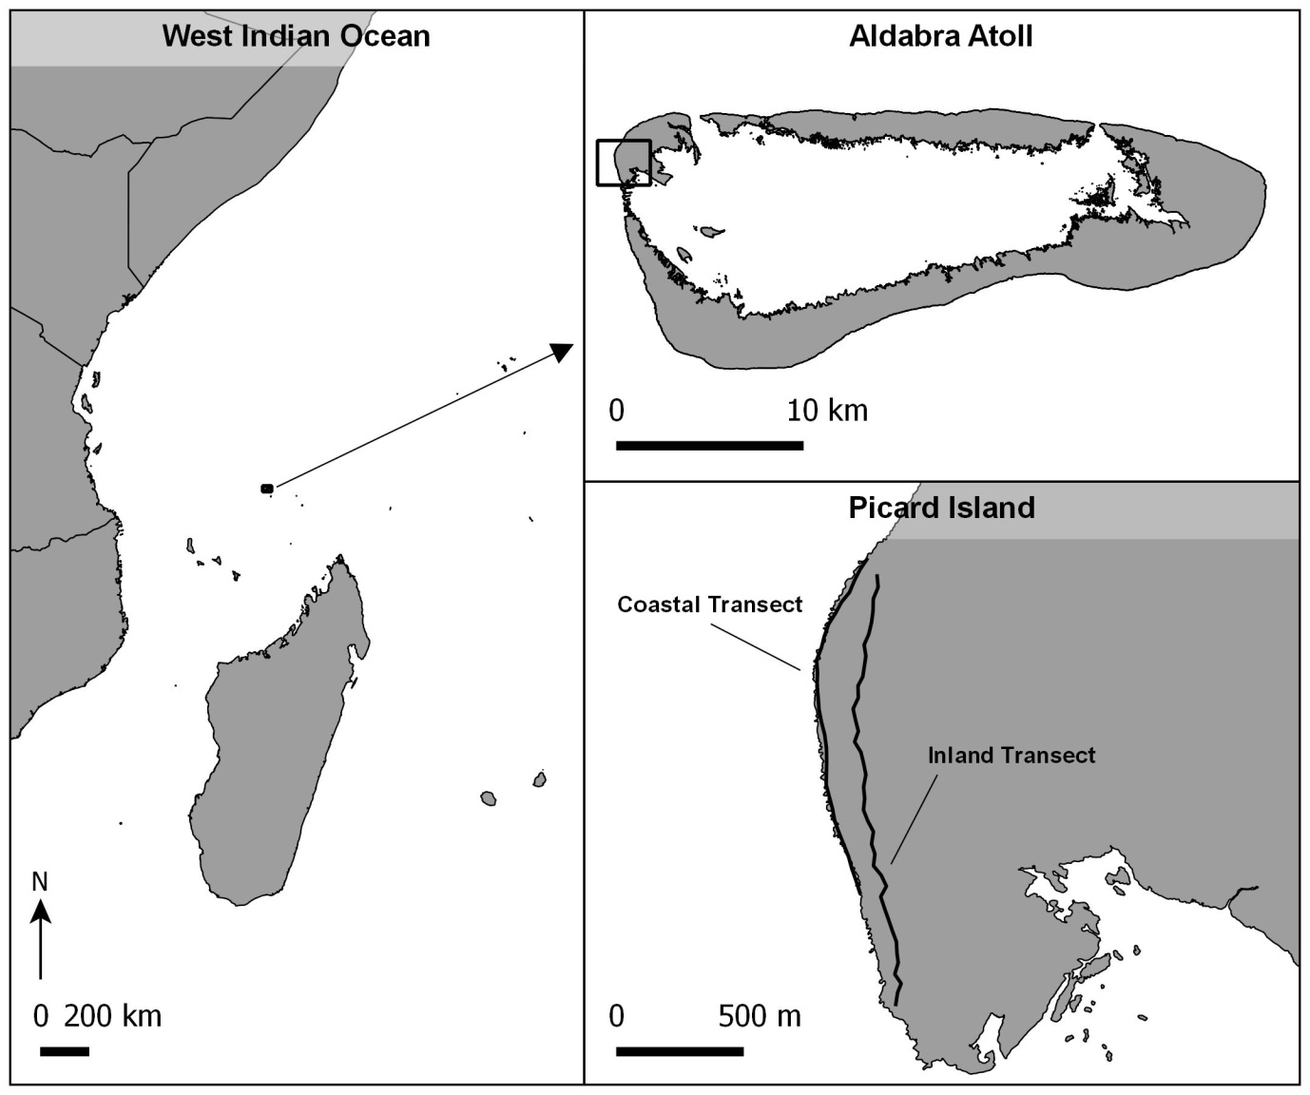**Figure 1.** Aldabra Atoll and monitoring transects for *Birgus latro*.

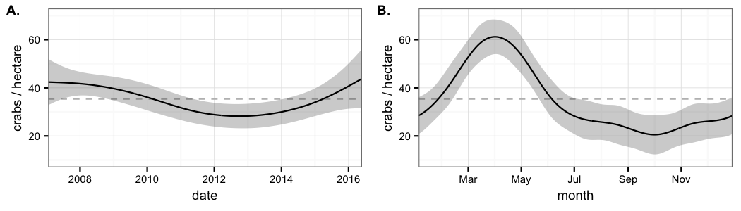**Figure 2.** *Birgus latro* density (**A**) over the years and (**B**) over the yearly cycle. The solid lines show the values predicted by the Generalised Additive Model, while grey ribbons depict the standard error. The dashed lines indicate the mean *B.latro* density.

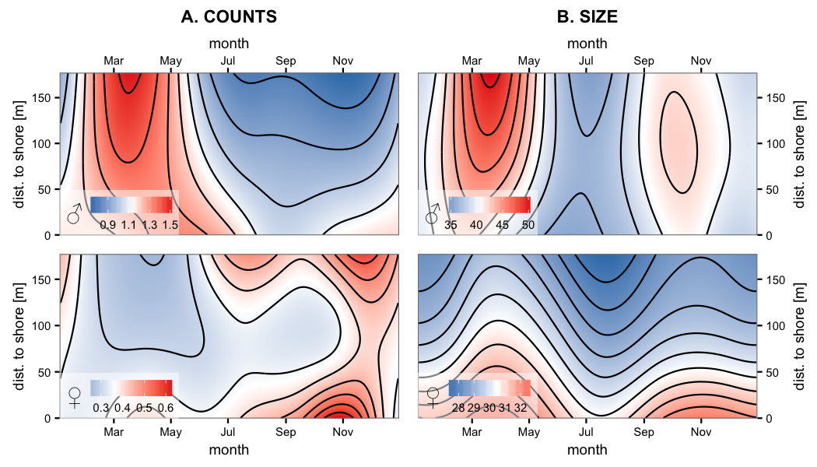**Figure 3.** Contour plots of the effect of time of the year and distance from shore on (**A**) the counts and (**B**) the size. Top panels represent male *Birgus latro* and bottom panels represent female *B.latro*. In all panels, shades of red and blue indicate values larger and smaller than the average respectively.

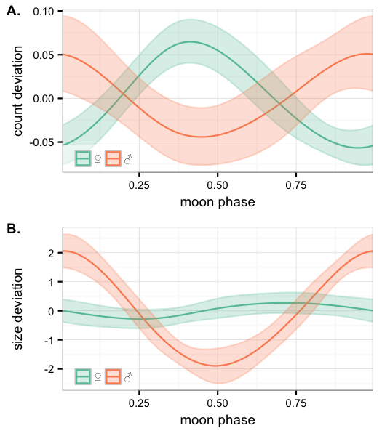**Figure 4.** Association between the phase of the moon and (**A**) the count and (**B**) the size of encountered *Birgus latro.* Females are represented in green and males in orange. The top and bottom y-axes show the effect on the mean counts (0.36 females and 1.13 males) and the mean sizes (30.5mm thoracic length for females and 40.6mm for males) per transect section respectively. The solid lines show the values predicted by the Generalised Additive Model, while ribbons represent the standard error. The phase of the moon is defined as 0 and 1 for new moon, 0.25 for first quarter, 0.5 for full moon, and 0.75 for last quarter (Meeus 1982).

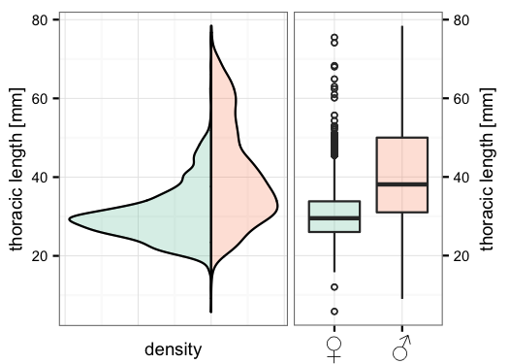**Figure 5**: Size distribution of *Birgus latro* on Aldabra for female and male individuals. Females are represented in green and males in orange.

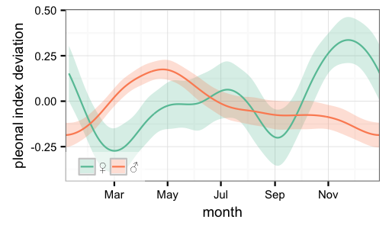**Figure 6**: Association between time of the year and the mean pleon size for *Birgus latro* females and males. Females are represented in green and males in orange. Pleon size was estimated using an index between 1 and 4. An index of 1 indicates that all tergal plates are touching each other of there is only a small gap between the most posterior tergal plate and the next. An index of 4 indicates a strongly swollen abdomen and all tergal plates are divided by thick gaps.

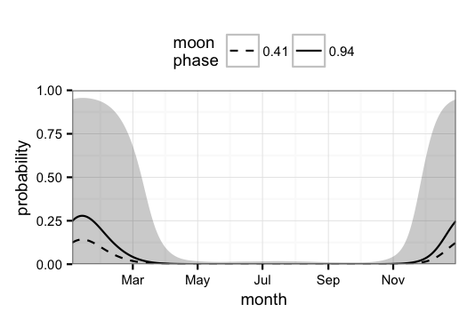**Figure 7:** Probability of encountering an ovigerous female during a survey. The solid line and dashed line correspond to the maximum and minimum encounter probability during the moon cycle respectively. A moon phase of 0.41 corresponds to about three days before full moon and 0.94 to around two days before new moon (Meeus 1982). Grey ribbon indicates confidence interval of the mean probability across the year.

1. These authors contributed equally to the work.Corresponding authors: jcappoo@hotmail.com; efcaguab@gmail.com