The pollination trade-off
E. Fernando Cagua¹, Hugo J. Marrero², Jason M. Tylianakis¹, Daniel B. Stouffer¹

¹ Centre for Integrative Ecology, School of Biological Sciences, University of Canterbury, Private Bag 4800, Christchurch 8041, New Zealand
² Centro de Recursos Naturales Renovables de las Zonas Semiáridas, CONICET, Camino de la Carrindanga Km. 7, 8000 Bahía Blanca, Argentina
Author for correspondence: E. Fernando Cagua (efc29@uclive.ac.nz) - Centre for Integrative Ecology, School of Biological Sciences, University of Canterbury, Private Bag 4800, Christchurch 8140, New Zealand
Manuscript length: 35,172 characters, approx. 5,160 words (excludes front-matter, abstract, awknoledgements, references, and figure/table legends); 26 min. reading time.
Abstract length: 19 words.

Abstract
TBC. But probably it will be something along the lines of the last paragraph of the discussion which goes:
Keywords: X, Y, Z

Introduction
Animal pollination systems play a disproportionally important role in food production and maintenance of global biodiversity (Bascompte & Jordano 2007; Klein et al. 2007; Ollerton et al. 2011). Alongside the direct mutualisms between plants and their pollinators, biodiversity can be supported as a result of inter-species “facilitation”—the positive feedback loops that exist between plant species that share pollinators or pollinators that share plants (Moeller 2004; Ghazoul 2006; Molina-Montenegro et al. 2008). This inter-species facilitation is able to promote species coexistence by offsetting the effects of direct resource competition (Stachowicz 2001). Indeed, studies at the core of our current theoretical knowledge of mutualisms predict that the maximum number of coexisting species is achieved when the number of shared mutualistic partners is maximised in a community (Bastolla et al. 2009).
However, in natural communities, plants rarely share all available pollinators. One explanation is that plants are effectively competing for mutualistic partners because there is a trade-off between the benefits gained from maximising the number of mutualistic partners and the costs of sharing them with other plant species (Waser 1978). It has been clear for a long time (both experimentally and theoretically; Robertson 1895; Lewis 1961; Levin & Anderson 1970) that when competition for pollination is strong enough, it can be detrimental to plants’ fitness. In fact, it can be sufficient to drive ecological differentiation (Caruso 2000; for example by driving the evolution of both traits and reproductive strategies; Mitchell et al. 2009). It is less clear, however, how exactly ecological differentiation, in turn, affect the trade-off between facilitation and competition that is involved in the pollination service.
There are two main mechanisms through which competition for pollinators can affect plant fertilization (Morales & Traveset 2008). The first is intraspecific pollen transfer. This happens, for example, when plants with distinctively attractive flowers might reduce the number of visits—and hence the amount of conspecific pollen deposited by animals—to those less attractive neighbouring plants (Yang et al. 2011). The second is intraspecific pollen transfer and occurs when plants share pollination partners. In that case, even receiving a visit might not necessarily translate into fertilization (Campbell & Motten 1985) because a focal plant might receive heterospecific pollen or pollen from the focal plant might be lost to different species. Generally speaking, the higher the amount of conspecific pollen (both in absolute terms and relative to heterospecific pollen) the better the pollination service received by the focal plant. These two mechanisms of competition, by definition, occur at the community scale. However, with few exceptions (Rathcke 1988; Lopezaraiza–Mikel et al. 2007; Hegland et al. 2009; Aizen & Rovere 2010; Tur et al. 2016), most of what we know about the deposition of conspecific and heterospecific pollen—and its relationship to competition vs. facilitation in pollination systems—is based on studies of two plant species.
At the community scale, the factors that determine the patterns of conspecific and heterospecific pollen deposition are tightly intertwined, operate simultaneously, and may lead to emergent phenomena not observed at smaller scales (Flanagan et al. 2011). For instance, recent empirical evidence suggests that plants with flowering traits that are “original” relative to others in the community generally have fewer interaction partners (Coux et al. 2016). This evidence is aligned with the notion that a species that interacts with few species does so strongly with each of them whereas a species that interacts with a large number of species does so comparatively weakly (TODO: ref needed). If evolutionary specialisation occurs by changing traits to focus on fewer but better partners (Caruso 2000), we should expect a reduction of competition for pollinators in species with “original” traits and an increase in species with a large number of interaction partners (Gibson et al. 2012). Alternatively, it might also be the case that density (for example in terms of flower or pollen counts) is the dominant force driving pollen transfer (Seifan et al. 2014). Abundant plant species might experience a dilution of available pollinators (Feinsinger 1987) but might also receive more effective visits by capitalising on a larger share of both visits and pollinator “real state”. In this case, a potential reduction in the absolute amount of conspecific pollen received could be compensated by an increase in the amount relative to heterospecific pollen. Altogether, it is clear that some ecological factors can influence pollen deposition and that these factors, in the specific context of pollination, could be used to roughly define a species realised niche in their community. However, the intertwined nature of these factors makes it hard to determine whether they favour or hinder the pollination service at the community level. Moreover, their relative importance has not yet been empirically evaluated in natural plant communities.
Here, we investigate competition for pollination at the community scale using empirical data from eleven plant-pollinator communities in the Argentinian Pampas. First, we estimate the extent to which the net outcome of plants sharing pollinators is facilitation or competition. If facilitation is the primary outcome, we could expect two things. On the one hand, we could expect an overall positive relationship between the amount of conspecific pollen deposited in stigmas and the amount of heterospecific pollen (Tur et al. 2016). The higher the deposition of conspecific pollen relative to heterospecific, the larger the slope of that relationship. On the other, we could also expect a larger amount of conspecific pollen deposited in stigmas when flowers are open to animal pollinators than is deposited due to self-pollination. Second, we investigate the relative contribution that four ecological factors have on the pollination service. Specifically, we hypothesize that competition (measured as absolute and relative conspecific pollen deposition) should increase for plants that share many pollination partners. However, we also hypothesize that other factors like the plant’s functional originality, its relative abundance, and the visit effectiveness should have the potential to compensate for this increase in competition. Third, we examine how community context influences the way plants use these factors to minimise competition. Although some plant species might be widespread across multiple locations, competition for pollinators occurs at the community level and hence we predict the competition for pollination niche to be influenced by the local context. If plant strategy is not flexible across communities (TODO: ref needed), we could expect niches to be more similar within species than across species in the study. On the contrary, if a species’ strategy is flexible, we should expect plants to be able to occupy different niches in each community such that competition could be minimised regardless of the context.

Methods
We collected data from eleven co-flowering plant communities and their pollinators in three locations in the Argentinian Pampas. These locations are distributed across a precipitation gradient with a humid temperate climate in the eastern Flooding Pampas and becoming drier as one moves inland and westward towards the Pampean Grasslands. This precipitation gradient generated a natural gradient of network architecture which allowed us to examine the generality of our findings. In each location, we sampled two restored and two agricultural fragments, except in the Flooding Pampas, where we were only able to sample one restored fragment due to the lack of available sites.

Competition vs. facilitation
Our first objective was to identify whether the outcome of plants sharing pollinators at the community level is facilitation or competition. The first line of evidence can be found via the relationship between heterospecific and conspecific pollen deposited in plant stigmas (Tur et al. 2016). This is because heterospecific pollen can be seen as an unavoidable cost that plants must pay for receiving conspecific pollen from shared pollinators. A negative relationship (when shared pollinators increase heterospecific pollen loads and decrease conspecific loads) may indicate that competition for pollination is strong. This negative relationship could arise, for example, when another, more dominant species, monopolizes a limited number of pollinators (Lopezaraiza–Mikel et al. 2007; Mitchell et al. 2009), when heterospecific pollen deposited in the stigma interferes with deposition of conspecific pollen (Runquist 2012), or when conspecific pollen is lost to heterospecific stigmas (Mitchell et al. 2009; Muchhala & Thomson 2012). In contrast, a positive relationship is what would be observed when facilitation is the dominant outcome. For example, when the abundance of shared pollinators is positively influenced by floral resources, these positive effects ripple through the mutualistic network in a chain of positive feedback loops (Liao et al. 2011).
The second line of evidence can be obtained by examining the difference between the amount of conspecific pollen deposited in flower stigmas with and without animal-mediated pollination. Self-pollination can be favourable to plant reproduction when competition for pollination is strong because it provides insurance against poor pollination service (Kalisz & Vogler 2003). If competition for pollination is sufficiently strong, then the amount of conspecific pollen deposited in flower stigmas when animal pollination is prevented could be higher than when floral visits are allowed. In contrast, the opposite pattern may indicate that plants benefit from having pollen delivered directly to the stigma by animals. We did not specifically test the effect of pollen viability or the extent to which self-pollen vs. pollen from a conspecific may differ in their value for fertilization which can be important factors (TODO: ref needed). However, it is reasonable to expect that the difference between outcross and self-pollen may be generally relevant and particularly so for species that are not self-fertile or those in which self-fertilization is rarely effective due to a temporary separation in the maturation of the sexes (dichogamy) (TODO: ref needed).

Data collection
In each of the studied communities, we quantified pollen deposition in a subset of plant species between December 2010 and February 2011. This subset comprised between three and nine common insect-pollinated (entomophilous) plant species that were flowering during the sampling period (see Figure @ref(fig:fig-trade-off-predictions)a). We chose plant species such that they cover a wide range on a specialization-generalization gradient as well as a wide range of abundances. Briefly, in each of the selected plants, we removed all flowers leaving only buds that were expected to go into florescence on the next day. Approximately a quarter of these buds were bagged to prevent animal pollination. Two days after inflorescence, we counted the pollen grains in the remaining flowers’ pistils, classified them between conspecific and heterospecific pollen, and calculated the number of pollen grains per stigma in each flower. More details about the study sites, data collection, and laboratory protocols can be found in Marrero et al. (2016).

Data analysis
To evaluate the relationship between heterospecific and conspecific pollen, we used a generalised linear mixed model (GLMM) with a Poisson error distribution (Tur et al. 2016). In this model, the number conspecific pollen grains per stigma was the response variable and the number of heterospecific grains the predictor (the number of stigmas sampled from the flower was added as an offset term). The slope and intercept of this relationship were allowed to differ between plant species within each community, which were modelled as a random effect. Models were fitted using the function glmer from the R package lme4 1.1-19 (Bates et al. 2015). To compare the conspecific pollen deposited with and without animal-mediated pollination, we followed the same approach as above. In this case, however, the predictor was the treatment (whether the flower was bagged or unbagged) instead of the number of heterospecific grains.

Ecological constraints the pollination service
Our second objective was to investigate the relative contribution of different factors that describe the plant competition for pollination niche to the pollination service. Specifically, we investigated the effect of (i) a plant’s number of shared pollinator species, (ii) a plants abundance relative to the rest of the community, (iii) the mean visit effectiveness—a metric that combines the share of pollen that a plant species is able to place on each of their floral visitors and the number of visits it receives from them (see Data Analysis section below for more details), and (iv) the plants functional originality (add ref).

Data collection
To obtain the number of shared pollinators for each species, we collected data to construct qualitative and quantitative pollination networks. Qualitative networks were constructed based on two-hour observations of floral visits in each fragment. Quantitative networks were constructed using two 50 m randomly located transects in each fragment. We counted and collected all floral visitors found in a 2 m wide strip while walking at a pace of 10 m per minute (Memmott 1999; Marrero et al. 2014). We visited the transects each month between November 2010 and March 2011. To obtain plant abundance, we counted all units of floral attraction found during an independent sampling of the transects used to construct the quantitative visitation networks. To estimate visit effectiveness we need to construct pollen transfer networks in addition to the visitation networks. To construct the transfer networks, we examined the pollen loads present on the floral visitors collected (Marrero et al. 2017). When the pollen count on an individual animal was estimated to be less than 2,000 grains, we identified every grain to the species level when possible and to pollen complexes when it was not. When the pollen count was above 2,000 grains, we classified approx. 50% of pollen and total pollen counts were extrapolated (Bosch et al. 2009). Finally, we also recorded morphological traits that relate to plant type (herb, shrub, climber), life cycle (annual, perennial), flower colouration, phenology, and whether the species is native in the study region. We used those traits because they were the only ones available… (TODO: Add a better justification for the traits used) More details about the study sites, data collection, and laboratory protocols can be found in Marrero et al. (2014 and 2017).

Data analysis
We investigated the impact of the ecological factors on pollination services. Generally speaking, the more conspecific pollen deposited in stigmas, both absolutely and relative to heterospecific pollen, the better the pollination service. Specifically, we used two sets of linear mixed models (LMM) in which the response variables are the number of conspecific and heterospecific pollen grains deposited per stigma in flowers open to animal-mediated pollination. In general, using LMMs in which pollen loads were log-transformed (Figure @ref(S-fig:fig-deposition-gain-log-transformed-or-not)) offered a better fit than a GLMM with Poisson (or quasipoisson) error structure. Models were fitted using the R package nlme 3.1-131 (Pinheiro et al. 2018).
Because the amount of deposited pollen can vary widely across species, and potentially also across communities, we evaluated two possible structures for the random effects: one that includes a random intercept for plant species, and one that treats measures from species across different communities as independent. We selected the best random structure by comparing the median Akaike Information Criterion for small samples (AICc).
As predictors in the models, we included the four ecological variables described above. Specifically, we calculated the number of shared pollinators for each plant species by pooling data from the qualitative and quantitative pollination networks. To calculate the plants’ relative abundance in their community, we simply aggregated floral counts for each species. We then calculated the mean visit effectiveness. We define the effectiveness of a visit by pollinator species i to plant species j as
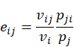
where v_{ij} is the observed number of visits by i to j, p_{ji} is the number of pollen grains from j attached to i, v_{i} is the total number of visits performed by i, and p_{j} is the total number of grains carried by j. Because the number of shared pollinators, floral abundance, visitation, and pollen production roughly followed a power-law distribution, we log-transformed these three predictors before including them in the model.
Finally, functional originality is defined as the distance of a species from the community trait average–the centroid of functional space of the community (Laliberté & Legendre 2010; Coux et al. 2016). To include phenology we treated plant abundance in each of the survey months (November to March) as a “trait” in our analysis. Then we assigned the abundances a weight of 1/5 compared to other functional traits, this accounted for the non-independence of floral counts across months and effectively weights phenology equally to other traits. We scaled all traits prior to calculating the centroid of the functional space and calculated the species-specific functional coordinates using the R package FD 1.0-12 (Laliberté et al. 2014). Finally, to facilitate comparison across the four continuous explanatory variables in our models, we rescaled them all to have a zero mean and unitary variance.
To estimate the coefficients and to perform model selection and quantify the associated uncertainty, we used a combination of multi-model inference and bootstrap resampling with one hundred replicates. First, we performed model selection using the AICc and determined the likelihood of each candidate model (a particular combination of predicting variables) by calculating the median AICc (relative to the most likely model) for each bootstrap sample. As we wanted model coefficients from more likely candidate models to carry more weight in our results, we sampled the coefficients for our variables proportional to the likelihood of its candidate model. We “shrank” the estimated coefficient of potentially unimportant variables by setting their estimate to 0 when the variable was not included in the model. Finally, we used these distributions of the model coefficients to estimate their mean impact on the pollination service (in terms of absolute and relative conspecific pollen deposition). Again, here we used bootstrap resampling to estimate the uncertainty around these means.

Flexibility of plant strategies
Our last objective was to tease apart the plant strategies that might reduce competition and, importantly, how the community context influences these strategies. If community context plays a relatively small role or the species strategy is inflexible we would expect plants of the same species to fill similar competition for pollination niches across different communities. Alternatively, if the community plays a large role and plants strategies are flexible, we should be able to observe differences in the niche a plant species occupies across communities. First, we used a principal component analysis (PCA) of the four ecological variables. We scaled variables across the whole study to ensure that the PCA space does not change according to the species present in each community. We define a species’ niche in a community as its coordinates in PCA space. For each species that was present in two or more communities, we then calculated (i) the median distance between the strategies that the species uses in different communities and (ii) the area of the convex hull defined by these points in the first two principal components (only for species present in three or more communities). We then compared the magnitude of these two metrics to those obtained with 99 Monte Carlo randomizations in which we replaced the strategy of the focal plant species by that of another randomly selected species in the dataset.

Results

Competition vs. facilitation
We first examined the degree of facilitation/competition in natural communities. Specifically, we examined the slope of the relationship between the heterospecific and conspecific pollen deposited on stigmas of each species in a community. We found that overall neither facilitation nor competition dominates (Table @ref(S-tab:table-facilitation-models-general)). Indeed, we found that the proportion of species that experienced a significantly positive or neggative relationship between heterospecific and conspecific pollen than neggative was very similar (35% and 37%, respectively; Figure @ref(fig:fig-trade-off-predictions)a; Table @ref(S-tab:table-facilitation-models-random)). Most of the variation between plants in a facilitation-competition gradient was driven by differences between species; however, we also observed some important differences within species. For instance, six of the species sampled across multiple communities (Carduus acanthoides, Cirsium vulgare, Cypella herbertii, Diplotaxis tenuifolia, Hirschfeldia incana, and Verbena intermedia) showed evidence that the same species, can experience facilitation (positive relationships) in some communities and competition (negative relationships) in others. Interestingly, although there was a wide variation in the slope of the relationship between heterospecific and conspecific pollen almost all plants had more conspecific than heterospecific pollen deposited on their stigmas (Figure @ref(fig:fig-trade-off-predictions)b).
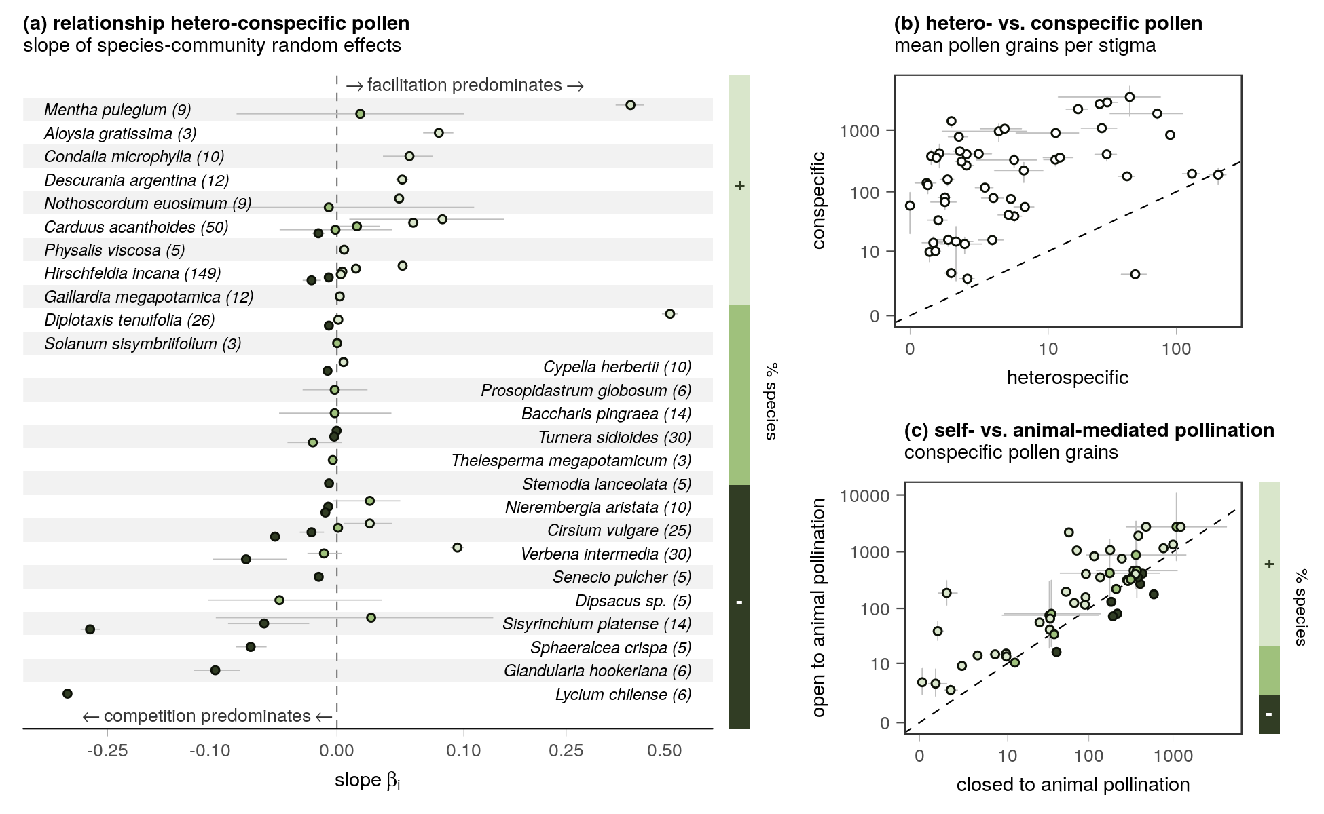
Competition vs. facilitation at the community level. (a) Some species experience more competition for pollination than others. Points indicate the estimated slopes for the relationship between the amount of heterospecific and conspecific pollen deposited per stigma across species in their communities. Significantly negative slopes (darkest shade) indicate that plants experience competition for animal-mediated pollination, while significantly positive slopes (lightest shade) indicate that facilitation is the predominant outcome. The number of plants analysed for each species is shown within brackets next to the species name. (b) Despite the variety of slopes, overall plants had more conspecific than heterospecific pollen deposited in their stigmas. (c) Generally, plants also had more pollen deposited in their stigmas when they were open to animal-mediated pollination than when they were closed. In all plots, error bars correspond to the standard error (SE).
Second, we compared the amount of conspecific pollen deposited on flowers that were open to animal-mediated pollinators with that of those that were closed. Here, we again found large differences between plants but with a clear tendency to find more pollen in open flowers (Table @ref(S-tab:table-open-bagged-models-general)). Specifically, 66% of plants had significantly more pollen when open and 15% had significantly less pollen when open (the difference was non-signifcant for the remainding 19%; Figure @ref(fig:fig-trade-off-predictions)c; Table @ref(S-tab:table-open-bagged-models-random)). Variation within species was slightly smaller and only four species (C. acanthoides, C. vulgare, H. incana, and Sisyrinchium platense) had both significantly positive and negative differences.

Ecological constraints in the pollination service
We then examined the potential roles played by four ecological variables (number of shared pollinators, abundance, mean visit effectiveness, and functional originality) play in pollen deposition. We found that our models of pollen deposition had high explanatory power (the coefficient of determination R² ranged between 0.76 and 0.93) although a large portion of the explanatory power came from the random effects (Table @ref(S-tab:table-R2)). As determined by AICc, the random structure best supported by the data was the one that fit an intercept for each species in each community (as opposed to a common intercept for each species irrespective of the community they belong to). This structure was best for both the models of conspecific and heterospecific pollen (Table @ref(S-tab:table-aic-random-models)).
Of the four variables, we considered, we found that a plant’s mean visit effectiveness and abundance were the most important ecological variables predicting pollen deposition in plant stigmas (Figure @ref(fig:fig-average-qual-quant)a). Surprisingly, the number of shared pollinators was comparatively unimportant, particularly for models of heterospecific pollen deposition, as it was only ever included in models with relatively large AICc values (Table @ref(S-tab:table-aic-fixed-models)).
We found that the relationship between each of the ecological factors and pollen deposition was similar for both conspecific and heterospecific pollen. That is, strategies that were associated with an increase in conspecific pollen were also associated with an increase in heterospecific pollen deposition. Specifically, the plants’ mean visit effectiveness had a positive effect on pollen deposition (Figure @ref(fig:fig-average-qual-quant)b). However, the effect size was slightly larger for heterospecific than for conspecific pollen. This indicates that, although there is a positive association between visit effectiveness and the absolute amount of conspecific pollen, there is a negative relationship with the relative amount of conspecific relative to heterospecific pollen (Figure @ref(fig:fig-average-qual-quant)c). In contrast, a plants’ relative abundance had a negative effect on the absolute amount of conspecific pollen, but the mean difference between the coefficients in the models indicates a positive association with the relative amount of conspecific pollen (Figure @ref(fig:fig-average-qual-quant)c). The third most important variable, functional originality, had a positive, although comparatively smaller, association with both the absolute and relative amount of conspecific pollen deposited. Finally, the number of shared pollinators had a negative and neutral association with conspecific and heterospecific pollen, but these impacts were small when compared to the other variables.
Overall, collinearity did not influence our findings qualitatively. Although relative abundance, the number of shared pollinators, and the visit effectiveness were all positively correlated (Figure @ref(S-fig:fig-correlation)), the effect each had on conspecific pollen was similar among models that included all or just some of these three explanatory variables (Figure @ref(S-fig:fig-model-results)). One exception was visit-effectiveness, which exhibits a positive association with the relative amount of conspecific pollen under some variable combinations (all with relatively low AICc support).
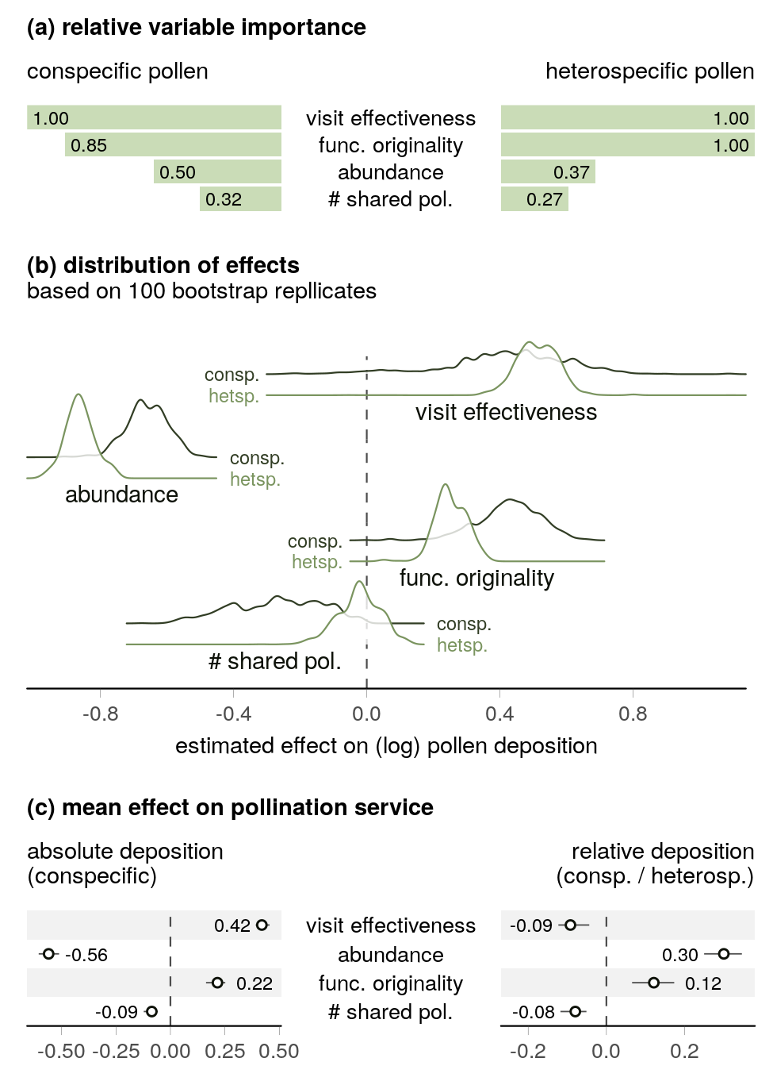
Effect of strategies to minimise competition in the pollination service. (a) The plant’s visit effectiveness and relative abundance are the most important variables determining the deposition of conspecific and heterospecific pollen. Meanwhile, the number of shared pollinators was relatively unimportant. The graph shows the relative variable importance calculated as the sum of the Akaike weights of the candidate models that included the variable. (b) The association between ecological variables and heterospecific pollen tended to align with their association with conspecific pollen. Visit effectiveness and functional originality had a positive association with pollen deposition, while abundance and the number of shared pollinators had a negative association. The plot shows the distribution of the effects (across 99 bootstrap replicates) of the four ecological variables for conspecific and heterospecific pollen. (c) The end result of these associations is that only the plants’ functional originality has a positive impact on both the absolute and relative amount of conspecific pollen deposition (relative to heterospecific pollen). The plot shows the model averaged mean effect ( SE).

Flexibility of plant strategies
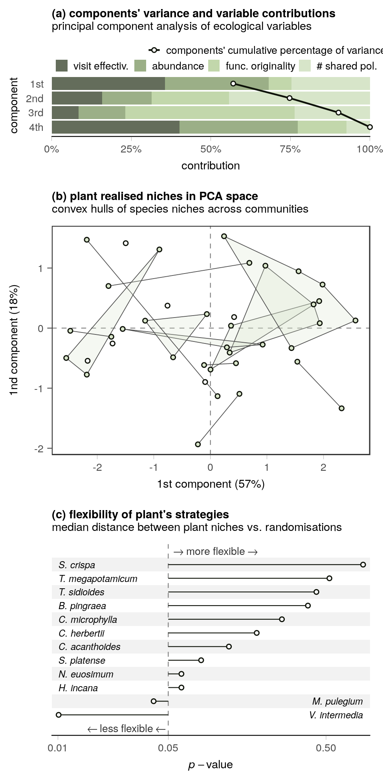
The flexibility of plant strategies. (a) The two first components explain a large proportion of the total variance. (b) When plants that were sampled in more than one community are plotted with these two components, we observe that points, which represent the strategy (the particular combination of ecological variables) of a species in a community do not seem to be grouped by plant species. (c) This was confirmed using Monte Carlo randomizations of the median distance between strategies of a plant species. Only one of the examined species had strategies that were more tightly connected than what would be expected at random.
We used a PCA of the analysed species to investigate whether plants’ niche of competition for pollination is similar across communities or whether they are flexible, and therefore a reflection of the community context. The first two PCA components explained 75% of the total variance (Figure @ref(fig:fig-pca)a). The first component was dominated by changes in visit effectiveness and relative abundance while the second component was dominated by the number of shared pollinators and the plant’s functional originality. When we locate the species that were sampled in more than one community in the first two PCA components (Figure @ref(fig:fig-pca)b), we observe that the niches of any given species do not tend to be close to each other. Indeed, when we measured the median distance between the plants coordinates, we found that it was only significantly smaller than that of randomisations for only two of the twelve analysed species (Figure @ref(fig:fig-pca)c).

Discussion
All else being equal, our results suggest that community context plays a central role in determining net cost or benefit of sharing pollinators. First, we found that the costs of pollinator sharing are pervasive. In particular, we found that a significant proportion of species experiences overall neutral or competitive effects from animal-mediated pollination. Second, we found that multiple ecological factors can modulate the intensity of this competition; however, conspecific and heterospecific pollen deposition are tightly coupled and therefore these factors are likely to involve a trade-off between the quantity and quality of pollination. Third, we found that the way these factors influence competition is strongly shaped by the community context, this is, if collectively these factors are used to define a niche of competition for pollination, the same plant species can occupy dramatically different niches depending on the community it belongs to.
Both of the tests we used to identify the effect of animal-mediated pollination suggested the same outcome: that net facilitation is only experienced by a fraction of species in a community. A recent study also suggested a wide range of outcomes in a multi-species context (Tur et al. 2016). However, the factors explaining why some species experience more competition than others were not understood. Here we show that the prevalence of neutral and competitive effects of animal-mediated pollination can be at least partially explained by the trade-offs that minimising competition can involve.
These trade-offs were most evident in precisely the factors that most strongly modulate pollen deposition. Specifically, we found that the factors related to the relative dominance of the species (in terms of pollen and visits, or abundance) also tended to be the most important predictors of pollen deposition. At the same time, receiving high visitation increases the absolute levels of conspecific pollen deposition but increases heterospecific deposition to a greater extent—even when the visitors are likely to carry a high proportion of conspecific pollen. Similarly, being abundant reduces the amount of heterospecific pollen deposited but at the expense of a noticeable reduction in the amount of conspecific pollen. Multiple studies recognise the importance of visitation and abundance to competition for pollination (Feldman et al. 2004; Morales & Traveset 2008; Muñoz & Cavieres 2008). Our results strongly corroborate the importance of these two factors but also suggest that (because visitation, pollen production and abundance are correlated; Sargent & Otto 2006), plants must reach a fine balance between increasing conspecific pollen and reduce heterospecific pollen deposition to minimise competition for pollination.
Further evidence of the intricacies of balancing costs and benefits can be found when we examine the other two factors analysed in our models. We show that being a specialist and sharing no pollinators might be preferable in the short term (as it is generally detrimental to pollen deposition). However, over long periods of time, there could be a risk associated with a specialist plant having no pollinators. Hence, is likely that to ensure long term survival, plants also need to balance this risk with the costs of sharing pollinators. One possible solution is to share pollinators and have original traits—as we show that trait originality is generally beneficial to pollen deposition and it’s commonly thought that species that are further from others in trait space suffer reduced competition. Yet again, there are two possible caveats to this strategy that highlight the interrelatedness of the ecological factors. First, in a mutualism context, it is also possible that trait originality could come at the cost of being less ‘apparent’ to pollinators. Second, the usually negative, relationship between originality and generalism has been shown depend on the plant’s abundance (Coux et al. 2016), with generalist species being able to also have original traits only when they are abundant enough to provide a valuable reward to make it worth to pollinators.
How precisely plants balance the costs and benefits in the short and the long term likely depends on the species sensitivity to different risks but also, as we show here, on the community it belongs to. For instance, a plant species that experience a large reduction in seed set due to heterospecific pollen deposition might be better off by sharing few pollinators, while sharing pollinators makes more sense for those mainly affected by low levels of conspecific pollen deposition (Campbell & Motten 1985). Nevertheless, the observed diversity of the facilitation/competition outcomes across communities and the relevance of random effects in our models suggests that the community context has a very important effect on the way plant species respond to competition for pollination beyond species identity. Perhaps overgeneralising, some plant families (Asteraceae for example) are often generalists in their communities, others (Orchidaceae) are known to be more commonly specialised. While it is possible, from an evolutionary perspective, that selection for a particular strategy might say something about the community in which a species has typically inhabited during its evolutionary history, we show that most plant species are still flexible enough to adopt markedly different niches in different communities. From a more applied perspective, flowering plants are sometimes introduced to attract pollinators on other nearby plants. Our results highlight the difficulties involved in predicting whether the introduced plant species will facilitate or compete with neighbours. This is so because the outcome might depend not only on the particular niche each species occupies in a particular community but also on other factors that we were unable to measure (Cariveau & Norton 2009; Flanagan et al. 2011; e.g. pollinator behaviour and densities or spatial context; Ye et al. 2014). However, our results also suggest that introduced species are more likely to be beneficial if they have different traits to local plants.
Overall, our results suggest that pollination communities might not necessarily be the paradigmatic mutualistic communities we often believe. Instead, we confirm that plant competition is pervasive in pollination communities and that potential strategies to minimise competition are likely to involve strong trade-offs in the pollination service either in the short or the long term. As expected, not sharing pollinators and being functionally unique reduces competition for pollination by increasing conspecific pollen deposition (both in absolute numbers and relative to heterospecific pollen). However, this increase is surprisingly small when compared to the effect of relative abundance and visitation. Interestingly, these two factors also involve the largest trade-offs between increasing deposition of conspecific pollen and reducing that of heterospecific pollen. Despite large intra-species differences among species our results provide solid evidence of the role that competition for pollination plays in natural communities. Species coexistence is not solely determined by direct and indirect mutualistic relationships, but also strongly shaped by the multiple intertwined ecological factors that shape competition for pollination at the community level. Achieving a better understanding of how (plant?) biodiversity is supported by pollination communities will require seeing them as both mutualistic and competitive communities.

Acknowledgements
We thank Cátedra de Botánica General, Facultad de Agronomía, Universidad de Buenos Aires. The Agrasar and Bordeu families, and the University of Buenos Aires, for logistical support and permission to conduct this study at estancias Anquilóo, Las Chilcas and San Claudio, respectively. Field work was supported by grants PICT 08–12504 and 0851. EFC acknowledges the support from the University of Canterbury Doctoral Scholarship, the University of Canterbury Meadow Mushrooms Postgraduate Scholarship, and a New Zealand International Doctoral Research Scholarship.DBS and JMT acknowledge the support of a Rutherford Discovery Fellowship. DBS also awknoledges the Marsden Fund Council from New Zealand Government funding.

References
Aizen, M.A. & Rovere, A.E. (2010). Reproductive interactions mediated by flowering overlap in a temperate hummingbird-plant assemblage. Oikos, 119, 696–706.
Bascompte, J. & Jordano, P. (2007). Plant-Animal Mutualistic Networks: The Architecture of Biodiversity. Annual Review of Ecology, Evolution, and Systematics, 38, 567–593.
Bastolla, U., Fortuna, M.A., Pascual-García, A., Ferrera, A., Luque, B. & Bascompte, J. (2009). The architecture of mutualistic networks minimizes competition and increases biodiversity. Nature, 458, 1018–1020.
Bates, D., Mächler, M., Bolker, B. & Walker, S. (2015). Fitting Linear Mixed-Effects Models Using lme4. Journal of Statistical Software, 67, 1–48.
Bosch, J., Martín González, A.M., Rodrigo, A. & Navarro, D. (2009). Plant-pollinator networks: Adding the pollinator’s perspective. Ecology Letters, 12, 409–419.
Campbell, D.R. & Motten, A.F. (1985). The Mechanism of Competition for Pollination between Two Forest Herbs. Ecology, 66, 554–563.
Cariveau, D.P. & Norton, A.P. (2009). Spatially contingent interactions between an exotic and native plant mediated through flower visitors. Oikos, 118, 107–114.
Caruso, C.M. (2000). Competition for Pollination Influences Selection on Floral Traits of Ipomopsis aggregata. Evolution, 54, 1546–1557.
Coux, C., Rader, R., Bartomeus, I. & Tylianakis, J.M. (2016). Linking species functional roles to their network roles. Ecology Letters, 19, 762–770.
Feinsinger, P. (1987). Effects of plant species on each others pollination: Is community structure influenced?, 2, 4.
Feldman, T.S., Morris, W.F. & Wilson, W.G. (2004). When can two plant species facilitate each other’s pollination? Oikos, 105, 197–207.
Flanagan, R.J., Mitchell, R.J. & Karron, J.D. (2011). Effects of multiple competitors for pollination on bumblebee foraging patterns and Mimulus ringens reproductive success. Oikos, 120, 200–207.
Ghazoul, J. (2006). Floral diversity and the facilitation of pollination. Journal of Ecology, 94, 295–304.
Gibson, M.R., Richardson, D.M. & Pauw, A. (2012). Can floral traits predict an invasive plant’s impact on native plant-pollinator communities? Journal of Ecology, 100, 1216–1223.
Hegland, S.J., Grytnes, J.-A. & Totland, Ø. (2009). The relative importance of positive and negative interactions for pollinator attraction in a plant community. Ecological Research, 24, 929–936.
Kalisz, S. & Vogler, D.W. (2003). Benefits of autonomus selfing under unpredictable pollinator environments. Ecology, 84, 2928–2942.
Klein, A.-M., Vaissiere, B.E., Cane, J.H., Steffan-Dewenter, I., Cunningham, S.A. & Kremen, C. et al. (2007). Importance of pollinators in changing landscapes for world crops. Proceedings of the Royal Society B: Biological Sciences, 274, 303–313.
Laliberté, E. & Legendre, P. (2010). A distance-based framework for measuring functional diversity from multiple traits. Ecology, 91, 299–305.
Laliberté, E., Legendre, P. & Shipley, B. (2014). FD: Measuring functional diversity from multiple traits, and other tools for functional ecology.
Levin, D.A. & Anderson, W.W. (1970). Competition for pollinators between simultaneously flowering species. The American Naturalist, 104, 455–467.
Lewis, H. (1961). Experimental Sympatric Populations of Clarkia. The American Naturalist, 95, 155–168.
Liao, K., Gituru, R.W., Guo, Y.-H. & Wang, Q.-F. (2011). The presence of co-flowering species facilitates reproductive success of Pedicularis monbeigiana (Orobanchaceae) through variation in bumble-bee foraging behaviour. Annals of Botany, 108, 877–884.
Lopezaraiza–Mikel, M.E., Hayes, R.B., Whalley, M.R. & Memmott, J. (2007). The impact of an alien plant on a native plant–Pollinator network: An experimental approach. Ecology Letters, 10, 539–550.
Marrero, H., Medan, D., Zarlavsky, G. & Torretta, J. (2016). Agricultural land management negatively affects pollination service in Pampean agro-ecosystems. Agriculture, Ecosystems & Environment, 218, 28–32.
Marrero, H., Torretta, J. & Medan, D. (2014). Effect of land use intensification on specialization in plant–Floral visitor interaction networks in the Pampas of Argentina. Agriculture, Ecosystems & Environment, 188, 63–71.
Marrero, H.J., Torretta, J.P., Vázquez, D.P., Hodara, K. & Medan, D. (2017). Exotic plants promote pollination niche overlap in an agroecosystem. Agriculture, Ecosystems & Environment, 239, 304–309.
Memmott, J. (1999). The structure of a plant-pollinator food web. Ecology Letters, 2, 276–280.
Mitchell, R.J., Flanagan, R.J., Brown, B.J., Waser, N.M. & Karron, J.D. (2009). New frontiers in competition for pollination. Annals of Botany, 103, 1403–1413.
Moeller, D.A. (2004). FACILITATIVE INTERACTIONS AMONG PLANTS VIA SHARED POLLINATORS. Ecology, 85, 3289–3301.
Molina-Montenegro, M.A., Badano, E.I. & Cavieres, L.A. (2008). Positive interactions among plant species for pollinator service: Assessing the “magnet species” concept with invasive species. Oikos, 117, 1833–1839.
Morales, C.L. & Traveset, A. (2008). Interspecific Pollen Transfer: Magnitude, Prevalence and Consequences for Plant Fitness. Critical Reviews in Plant Sciences, 27, 221–238.
Muchhala, N. & Thomson, J.D. (2012). Interspecific competition in pollination systems: Costs to male fitness via pollen misplacement: Pollen misplacement. Functional Ecology, 26, 476–482.
Muñoz, A.A. & Cavieres, L.A. (2008). The presence of a showy invasive plant disrupts pollinator service and reproductive output in native alpine species only at high densities: Invasive impacts on native species pollination. Journal of Ecology, 96, 459–467.
Ollerton, J., Winfree, R. & Tarrant, S. (2011). How many flowering plants are pollinated by animals? Oikos, 120, 321–326.
Pinheiro, J., Bates, D., DebRoy, S., Sarkar, D. & R Core Team. (2018). Nlme: Linear and Nonlinear Mixed Effects Models.
Rathcke, B. (1988). Interactions for Pollination among Coflowering Shrubs. Ecology, 69, 446–457.
Robertson, C. (1895). The Philosophy of Flower Seasons, and the Phaenological Relations of the Entomophilous Flora and the Anthophilous Insect Fauna. The American Naturalist, 29, 97–117.
Runquist, R.D.B. (2012). Pollinator-mediated competition between two congeners, Limnanthes douglasii subsp. rosea and L. alba (Limnanthaceae). American Journal of Botany, 99, 1125–1132.
Sargent, R.D. & Otto, S.P. (2006). The Role of Local Species Abundance in the Evolution of Pollinator Attraction in Flowering Plants. The American Naturalist, 167, 67–80.
Seifan, M., Hoch, E.-M., Hanoteaux, S. & Tielbörger, K. (2014). The outcome of shared pollination services is affected by the density and spatial pattern of an attractive neighbour. Journal of Ecology, 102, 953–962.
Stachowicz, J.J. (2001). Mutualism, Facilitation, and the Structure of Ecological Communities. BioScience, 51, 235.
Tur, C., Sáez, A., Traveset, A. & Aizen, M.A. (2016). Evaluating the effects of pollinator-mediated interactions using pollen transfer networks: Evidence of widespread facilitation in south Andean plant communities. Ecology Letters, 19, 576–586.
Waser, N.M. (1978). Interspecific pollen transfer and competition between co-occurring plant species. Oecologia, 36, 223–236.
Yang, S., Ferrari, M.J. & Shea, K. (2011). Pollinator Behavior Mediates Negative Interactions between Two Congeneric Invasive Plant Species. The American Naturalist, 177, 110–118.
Ye, Z.-M., Dai, W.-K., Jin, X.-F., Gituru, R.W., Wang, Q.-F. & Yang, C.-F. (2014). Competition and facilitation among plants for pollination: Can pollinator abundance shift the plant–Plant interactions? Plant Ecology, 215, 3–13.

