ATHENA

Z80 CPU Bring-up
Progress, Evidence and Learning Record
From first clock interface to observable instruction execution

Current milestone: controlled NOP execution and bus observation
Prepared from the bench work completed to 18 September 2026

Status
Working CPU bring-up experiment; not yet a complete computer

1. Purpose and scope
This document records the Athena Z80 CPU bring-up work from the point at which the system clock became usable through to the first directly observed, decoded instruction-fetch address sequence. The objective was not simply to make a Z80 run. The objective was to understand and verify how the processor responds to power, clock, reset, defined control inputs and a known instruction value, and then to observe that behaviour using an oscilloscope and a DSLogic Plus logic analyser.
The present experiment deliberately forces the Z80 data bus to 00h, which is the one-byte NOP instruction. This creates a simple, predictable model: after reset, each opcode fetch should read NOP and the Program Counter should advance by one. That model gives a strong basis for learning how to correlate physical signals with CPU architecture.

2. Executive summary of progress
- The 1986 NMOS Z80A-class CPU has been powered and clocked successfully.
- The Athena clock output was adapted electrically to satisfy the Z80 clock-input requirement without replacing the clock architecture.
- RESET̄, WAIT̄, BUSRQ̄, INT̄ and NMĪ were placed in defined states and verified.
- A local ground fault introduced during CPU reseating was isolated by measurement and corrected.
- M1̄ activity was observed, with an approximately 4:1 relationship between the ~288.5 kHz system clock and ~72.05 kHz M1̄ activity.
- All eight data lines were pulled LOW through 1 kΩ resistors, presenting 00h (NOP) on every instruction fetch.
- A0 and A1 were observed on the oscilloscope and showed the expected counting behaviour.
- A DSLogic Plus was connected to A0-A7, M1̄, MREQ̄, RD̄ and CLK.
- DSView's Parallel decoder was configured to sample A7-A0 on the falling edge of RD̄.
- Long clean runs of sequential decoded addresses were observed, including 156, 157, 158, 159, 160 and onward in decimal.
- The logic analyser has therefore become a practical CPU-debugging instrument rather than merely a source of square-wave traces.
- The Athena clock also provides a second observability mode: selecting MANUAL and pressing STEP advances the Z80 by one T-state per pulse, allowing individual machine-cycle states to be examined deliberately.

3. CPU and current breadboard configuration
The processor under test is a vintage NMOS Z80A-class device dating from 1986. The current breadboard arrangement is intentionally minimal. No ROM, RAM or I/O device is yet connected. The CPU is being exercised with a known clock, defined asynchronous inputs, a reset control and a temporary forced-NOP data bus.

3.1 Current Z80 pin arrangements used in bring-up
Z80 pin | Signal | Current arrangement
6 | CLK | From Athena SN7400 pin 11; 330 Ω pull-up to +5 V on the clock node
7 | D4 | 1 kΩ pull-down to GND
8 | D3 | 1 kΩ pull-down to GND
9 | D5 | 1 kΩ pull-down to GND
10 | D6 | 1 kΩ pull-down to GND
11 | VCC | +5 V
12 | D2 | 1 kΩ pull-down to GND
13 | D7 | 1 kΩ pull-down to GND
14 | D0 | 1 kΩ pull-down to GND
15 | D1 | 1 kΩ pull-down to GND
16 | INT̄ | 10 kΩ pull-up to +5 V
17 | NMĪ | 10 kΩ pull-up to +5 V
18 | HALT̄ | Output; available for observation
19 | MREQ̄ | Output; logic analyser D9
21 | RD̄ | Output; logic analyser D10; decoder sampling event
24 | WAIT̄ | 10 kΩ pull-up to +5 V
25 | BUSRQ̄ | 10 kΩ pull-up to +5 V
26 | RESET̄ | 10 kΩ pull-up to +5 V; momentary grounding switch
27 | M1̄ | Output; logic analyser D8
29 | GND | Common ground
30-37 | A0-A7 | Outputs; logic analyser D0-D7

3.2 Temporary forced-NOP data bus
The eight Z80 data pins are each connected to ground through a 1 kΩ resistor. This presents:
D7 D6 D5 D4 D3 D2 D1 D0 = 00000000₂ = 00h = NOP
NOP is a one-byte instruction. In the present experiment there is no ordinary operand or data read associated with it. If every opcode fetch returns 00h, the processor should repeatedly execute NOP and increment the Program Counter by one.

4. Clock interface and electrical adaptation
The Athena clock module is based on an NE556 dual timer, SN7400 NAND logic and an SN74LS157 multiplexer. The final CPU clock is produced at SN7400 pin 11 and is connected to Z80 pin 6.

4.1 Initial clock-level problem
Observed: The raw SN7400 clock HIGH level at the Z80 input was approximately 3.8 V.
Documented requirement used during bring-up: The older NMOS Z80 clock input requires a higher guaranteed clock-HIGH level than an ordinary TTL HIGH.
Change made: A 330 Ω pull-up was added from +5 V to the Z80 clock node while leaving the SN7400 output directly connected.
Observed after change: The clock HIGH level at Z80 pin 6 rose to approximately 5.0-5.1 V while the LOW level remained close to ground.
Deduction: The clock-generation architecture itself did not need replacement; the electrical boundary between the TTL gate and the NMOS clock input needed adaptation.

4.2 Clock frequency for CPU bring-up
The original clock range was deliberately slow for breadboard learning and visual observation. For Z80 bring-up the NE556 timing capacitor was reduced. A 470 pF timing capacitor produced a measured clock of approximately 286-289 kHz. This is still slow enough to observe comfortably while fast enough for the present NMOS processor experiment.
Measurement | Observed | Interpretation
Initial CPU clock HIGH | ~3.8 V | Insufficient margin for the NMOS Z80 clock input
After 330 Ω pull-up | ~5.0-5.1 V HIGH | Suitable clock amplitude observed at pin 6
Clock frequency | ~288.5 kHz | Current bring-up operating region

5. Reset and asynchronous control inputs
Before attempting meaningful execution, the asynchronous control inputs were placed into defined inactive states. This prevents the CPU from being held, interrupted or bus-requested by floating inputs.
Signal | Pin | Arrangement | Purpose
RESET̄ | 26 | 10 kΩ to +5 V; pushbutton to GND | LOW asserts reset
WAIT̄ | 24 | 10 kΩ to +5 V | Held inactive HIGH
BUSRQ̄ | 25 | 10 kΩ to +5 V | Held inactive HIGH
INT̄ | 16 | 10 kΩ to +5 V | Held inactive HIGH
NMĪ | 17 | 10 kΩ to +5 V | Held inactive HIGH

5.1 Reset bounce
Oscilloscope captures showed that the mechanical RESET switch does not make a single clean transition. It bounces, producing several rapid LOW/HIGH transitions during operation. This was useful practical evidence that a mechanical switch is not equivalent to an ideal logic transition.

6. Fault isolation after CPU reseating
After the processor was reseated and rewired, the supply measured only about 3.1 V when measured directly between Z80 VCC and GND. Rather than restarting all previous checks, measurements were taken to distinguish the power rail from the local CPU connections.
Measurement | Observed | Meaning
Main +5 V rail to breadboard ground | ~4.67 V | Supply rail present
Z80 pin 11 VCC to breadboard ground | ~4.6 V | VCC connection present
Z80 pin 29 GND to breadboard ground | ~3.2 V | CPU ground connection incorrect

Deduction: The fault was local to the Z80 ground connection, not the bench supply or the clock.
Corrective action: The physical pin-29 ground connection was corrected before further CPU activity was interpreted.

7. First convincing CPU execution evidence
Following correction of the ground connection, M1̄ activity became visible after reset. One capture showed a system clock of approximately 288.5 kHz and M1̄ activity of approximately 72.05 kHz.
288.5 kHz ÷ 72.05 kHz ≈ 4.00
That near-exact 4:1 relationship is consistent with the normal four-T-state structure of a Z80 M1 opcode-fetch cycle. At that stage, however, the data bus was still floating, so the observation was treated as strong evidence of machine-cycle activity rather than proof that the processor was executing a known instruction stream.

8. Forced-NOP experiment and Program Counter visibility
To replace the undefined floating data bus with a known instruction, all eight data lines were pulled LOW through 1 kΩ resistors. This guarantees that a memory read sees 00h unless some other device drives the bus. With no memory device attached, the intended instruction stream is therefore an endless sequence of NOPs.

8.1 Prediction
- RESET places the processor into its defined reset state and execution begins from the reset address.
- The CPU performs an opcode fetch.
- The data bus presents 00h, so the instruction is NOP.
- NOP consumes one byte.
- The Program Counter increments by one.
- The next fetch occurs at the next sequential address.
- The cycle repeats.

8.2 Oscilloscope observation of A0 and A1
A0 produced a continuous square-wave-like pattern after reset. A1 also showed regular activity consistent with a binary count. These observations demonstrated that the low address bits were changing as expected when the Program Counter advanced.
The oscilloscope remained valuable for waveform integrity and timing, but it became increasingly awkward for interpreting several simultaneous address bits. That limitation motivated the transition to the logic analyser.

9. DSLogic Plus connection and acquisition setup
The DSLogic Plus was introduced so that several Z80 signals could be captured simultaneously and interpreted as a bus rather than as isolated square waves.
DSLogic | Z80 signal | Z80 pin | Observed role
D0 | A0 | 30 | Address bit 0
D1 | A1 | 31 | Address bit 1
D2 | A2 | 32 | Address bit 2
D3 | A3 | 33 | Address bit 3
D4 | A4 | 34 | Address bit 4
D5 | A5 | 35 | Address bit 5
D6 | A6 | 36 | Address bit 6
D7 | A7 | 37 | Address bit 7
D8 | M1̄ | 27 | Opcode-fetch machine-cycle indicator
D9 | MREQ̄ | 19 | Memory request
D10 | RD̄ | 21 | Read strobe; current decoder sampling event
D11 | CLK | 6 | CPU clock

9.1 Sample rate
The first useful capture was initially made at 1 MHz. With a ~288 kHz CPU clock this provides only about 3.5 analyser samples per clock period, which is inadequate for trustworthy timing analysis. The sample rate was increased to 20 MHz, giving roughly 69 samples per CPU clock period and much cleaner timing information.

9.2 Capture length and saved acquisition
A 100 ms acquisition window was used for a longer analysis capture. The native DSView capture was saved so that the raw acquisition could be retained independently of screenshots or decoder display settings.

10. Learning to decode the address bus in DSView
The key learning step was to stop treating A0-A7 as eight independent traces and instead configure DSView's Parallel decoder to interpret them as one eight-bit quantity.

10.1 Parallel decoder configuration
Decoder field | Setting | Meaning
Decoder D0-D7 | DSLogic D0-D7 | Z80 A0-A7
Decoder CLK | DSLogic D10 | Z80 RD̄
Sampling edge | Falling | Sample address when RD̄ asserts
Data wordsize | 0 | Report each sampled bus value
Endianness | Little | Current decoder setting
Display | Decimal or hexadecimal | Presentation only; raw bits are unchanged

10.2 Why the sampling signal mattered
Several decoder configurations were tried deliberately. Sampling on every CPU clock edge produced repeated and mixed address values because the Z80 address bus is used throughout the machine cycle, including refresh activity. Sampling on the falling edge of M1̄ was also unsatisfactory because the bus was being sampled at the boundary at which the M1 cycle begins.
The useful configuration was to sample A0-A7 on the falling edge of RD̄. During the current forced-NOP experiment there are no ordinary operand or data reads, so RD̄ assertion corresponds to the opcode read. By that point the fetch address is established on the address bus.

10.3 Meaning of the decoder annotations
The green DSView 'lozenges' are decoder annotations. Each annotation contains the numerical value obtained by combining the eight simultaneous states of A7-A0 at the chosen sampling event. For example, a decimal annotation of 156 represents:
156₁₀ = 9Ch = 10011100₂
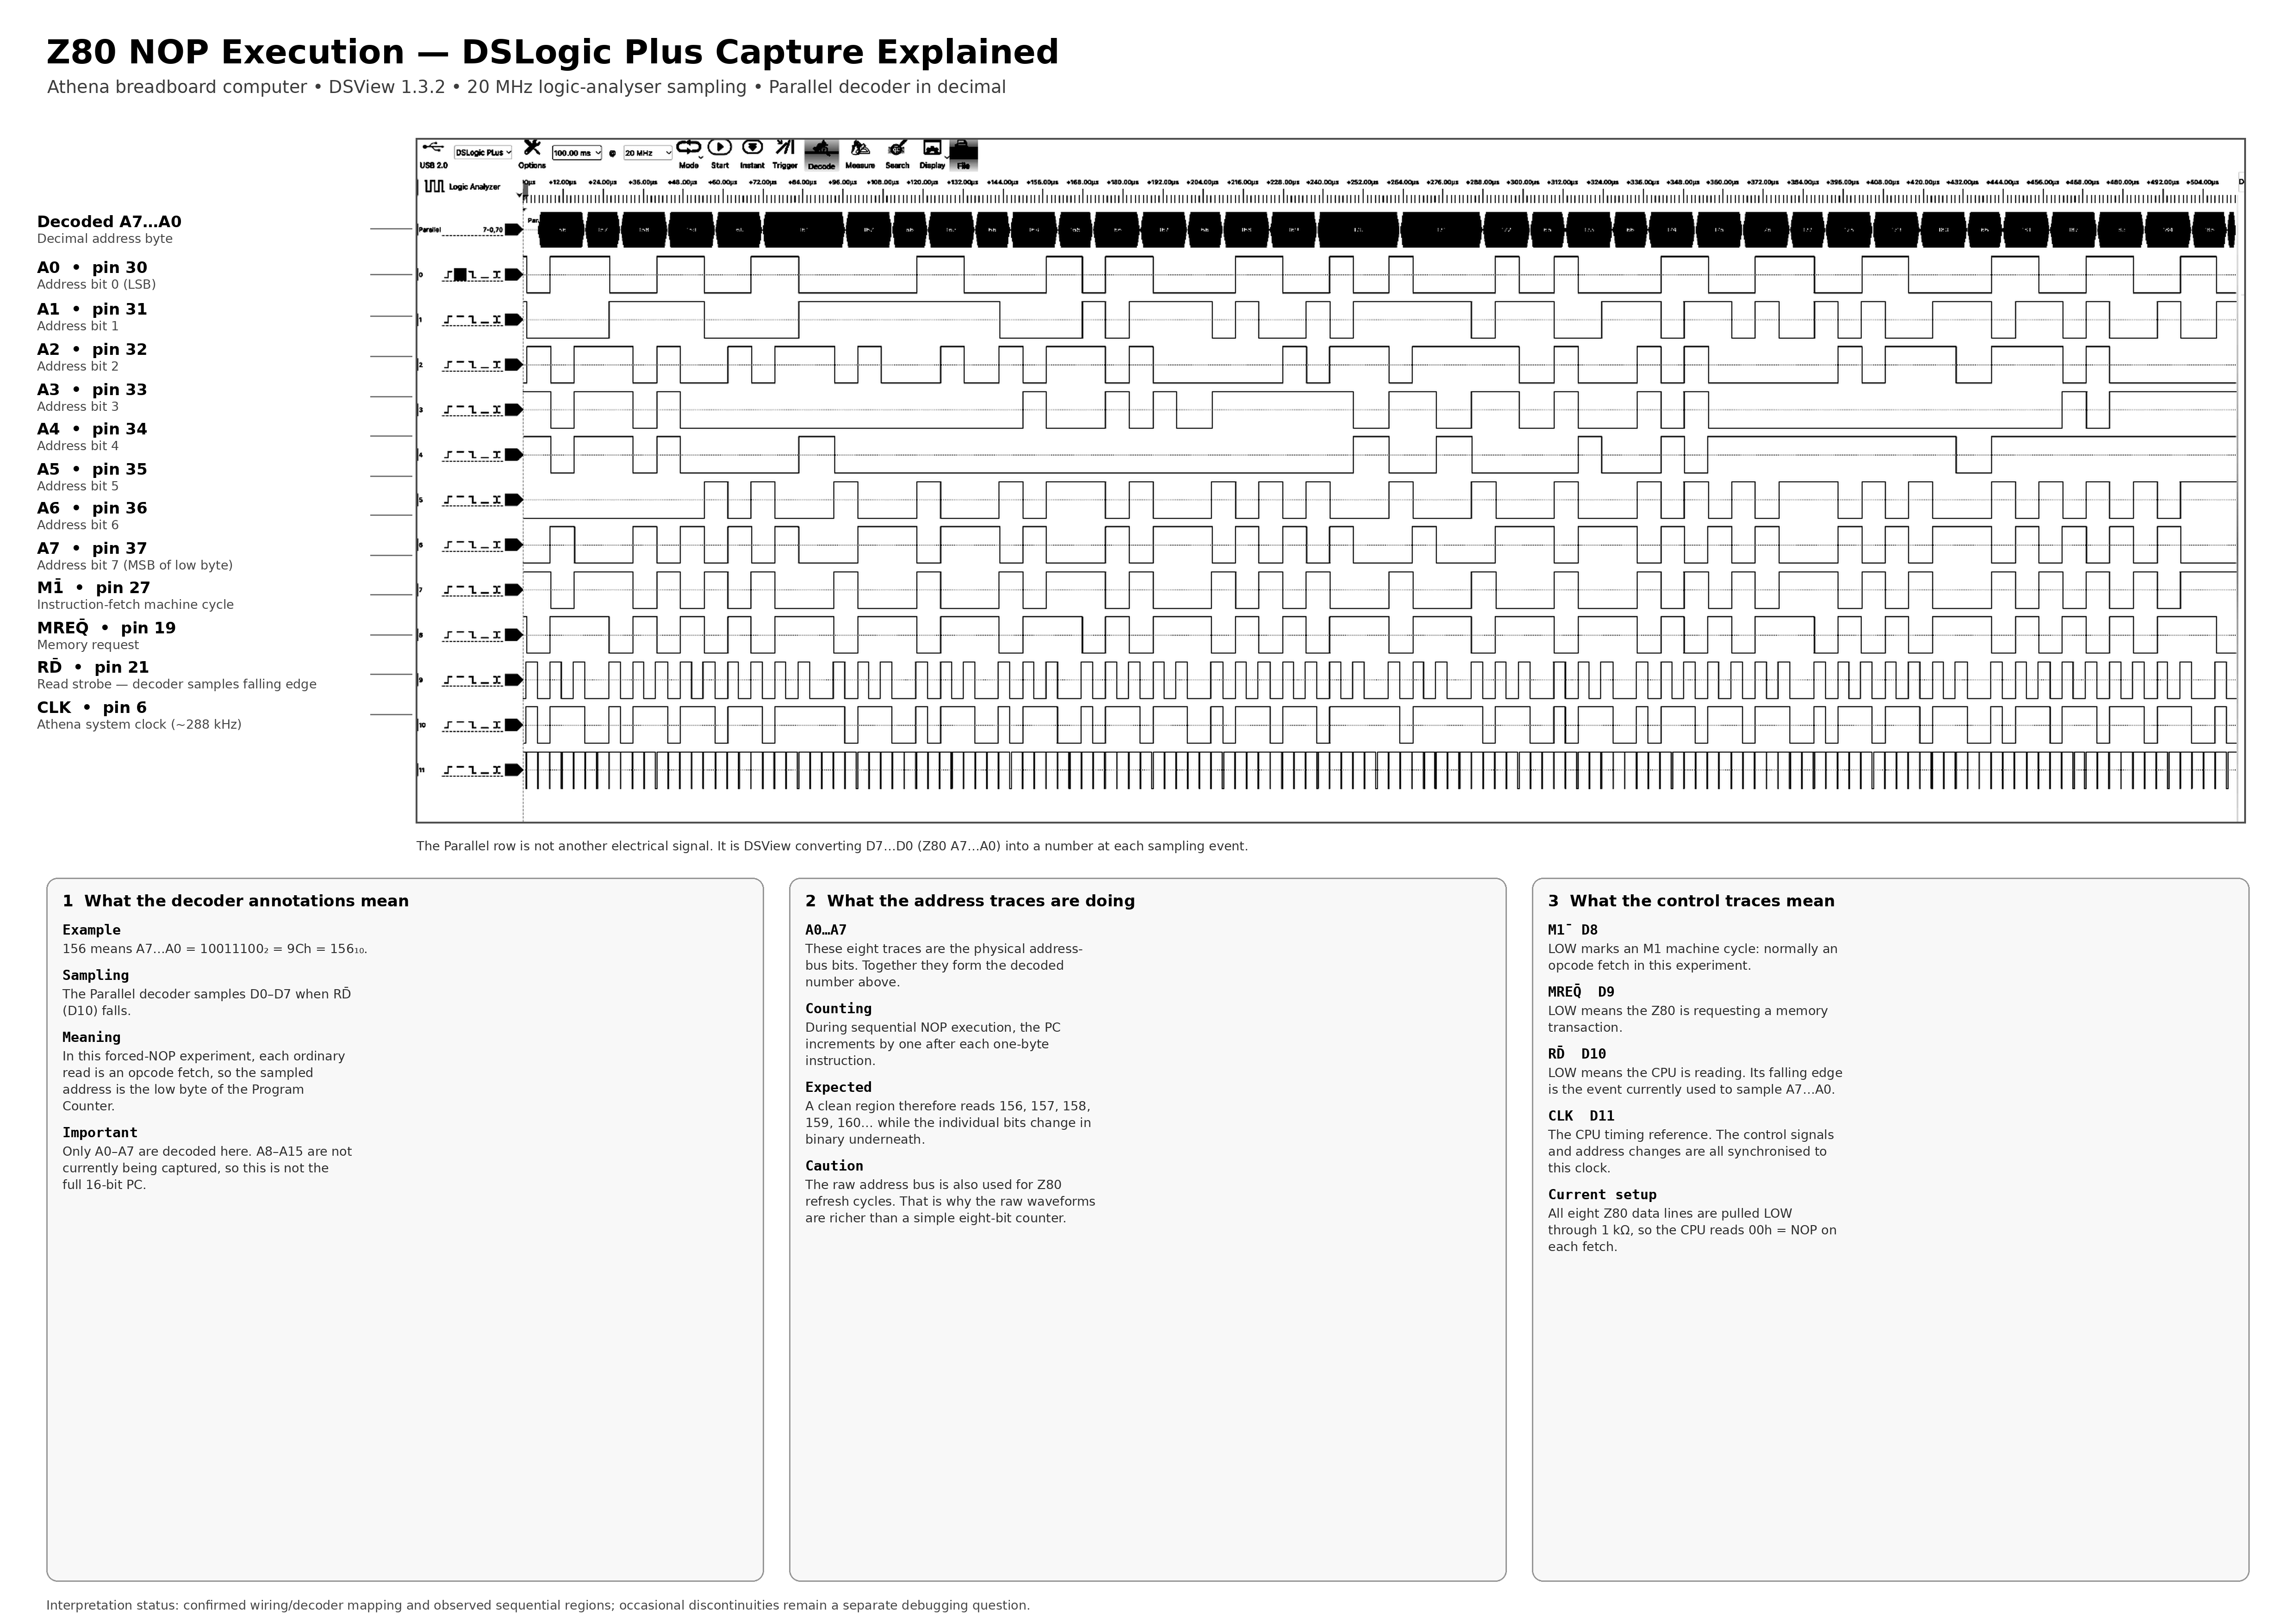
Figure 1. Annotated DSLogic Plus capture showing A0-A7, control signals and Parallel decoder interpretation.

11. Decoded sequential execution
Once the decoder was configured appropriately, long clean sequential runs appeared in the Parallel decoder. One visible region showed:
156 → 157 → 158 → 159 → 160 → 161 → 162 → 163 → …
This is exactly the expected low-byte Program Counter behaviour for repeated one-byte NOP instructions. The raw A0-A7 traces underneath the annotations are the physical binary representation of those numbers; the Parallel decoder simply performs the conversion automatically.
Observed fact: The low eight address bits produce extended runs of consecutive decoded values when sampled on RD̄ falling.
Deduction: During those runs the processor is repeatedly fetching one-byte instructions from consecutive addresses.
Supported model: With D0-D7 pulled LOW, those fetches are consistent with repeated 00h NOP execution.
Limitation: Only A0-A7 are currently decoded. The full 16-bit Program Counter is not yet being captured.
Open issue: Occasional discontinuities have also been observed. Their cause has not yet been established and remains a useful debugging exercise.

11.1 Manual single-T-state stepping
The clock module's MANUAL mode provides a controlled way to stop treating the processor as a continuously running device. In MANUAL mode, each press of the STEP pushbutton generates one monostable CPU_CLK pulse. For the Z80, that advances the processor by one T-state, not by one whole instruction.
This allows a machine cycle to be traversed one clock at a time while watching the address, data and control buses. The particularly useful signals are A0-A15, D0-D7, M1̄, MREQ̄, RD̄, WR̄, RFSH̄, IORQ̄ and CLK.
Established clock behaviour: The clock module has already been verified to deliver one final CPU_CLK pulse for one STEP press in MANUAL mode.
Deduction for Z80 operation: Because the Z80 state machine advances on clock transitions, each manual pulse advances one T-state. This enables direct comparison of observed external signals with the Z80 timing diagrams.
Important distinction: This is cycle-by-cycle stepping, not instruction-by-instruction stepping. A Z80 instruction normally contains several T-states and may contain several machine cycles.

12. Technical learning from the bring-up

12.1 Logical compatibility is not electrical compatibility
The SN7400 produced a valid TTL HIGH, but that did not automatically make it a guaranteed valid NMOS Z80 clock HIGH. The clock interface therefore had to be evaluated as an electrical interface, not merely as a Boolean connection.

12.2 A square wave is not sufficient evidence of a valid CPU clock
Clock amplitude, frequency, timing and the receiving device's input specification all matter. The bring-up required both suitable voltage levels and a useful operating frequency.

12.3 Defined inputs matter
WAIT̄, BUSRQ̄, INT̄ and NMĪ were deliberately held inactive rather than left floating. The forced-NOP experiment similarly replaced a floating data bus with a known byte. This converted unpredictable behaviour into a testable model.

12.4 Internal CPU state becomes observable through buses
The Program Counter is an internal 16-bit register, but its value appears externally on the address bus during instruction fetches. By qualifying the address bus with the correct control event, the logic analyser allows part of that internal state to be observed directly.

12.5 Timing context gives meaning to logic levels
A raw address value is not meaningful by itself. The same physical bus can carry a program address or a refresh address at different points in the Z80 cycle. M1̄, MREQ̄, RD̄ and CLK provide the context needed to decide what the address value means.

12.6 A manual clock turns timing diagrams into bench experiments
A timing diagram no longer has to be treated only as a drawing in a databook. The STEP clock makes each T-state experimentally accessible: predict the state of the buses and control outputs, press STEP once, measure, and compare the result with the documented timing model.

13. Debugging approach developed during the work
- Begin with a prediction, not merely a probe point.
- Use one controlled change at a time.
- Separate power, ground, clock, reset and bus-state problems before blaming the processor.
- Treat each measurement as evidence for or against a model.
- Do not replace a known subsystem before proving that it is the cause of the failure.
- Distinguish raw electrical activity from architecturally meaningful transactions.
- Use an unexpected result as a reason to improve the measurement method rather than forcing the evidence to fit the expectation.
- Preserve anomalies until they are explained; do not discard them as noise without evidence.

13.1 Why the non-sequential captures were useful
The early decoded captures did not immediately produce a perfect sequence. That forced the analyser configuration itself to be examined: sample rate, decoder mapping, sampling event and the distinction between opcode-fetch and refresh activity. A first-time perfect result would have verified the model, but it would have taught much less about how to use a logic analyser as a CPU-debugging instrument.

14. Current established state
Area | Status | Evidence / note
Power | Established | CPU supply and ground have been verified; one local ground fault was found and corrected.
Clock | Established | ~288 kHz clock reaches Z80 pin 6 with pull-up-assisted HIGH level.
Reset | Established | RESET̄ control works; mechanical bounce has been observed.
Control inputs | Established | WAIT̄, BUSRQ̄, INT̄ and NMĪ held inactive HIGH.
Known instruction | Established | D0-D7 pulled LOW through 1 kΩ resistors, presenting 00h.
Machine cycles | Established | M1̄ activity observed.
Address activity | Established | A0/A1 observed on scope; A0-A7 captured on logic analyser.
Parallel decode | Established | A0-A7 decoded on RD̄ falling edge.
Sequential fetches | Established | Long consecutive address sequences observed.
Occasional discontinuities | Open | Observed but not yet explained.
Full 16-bit PC | Future | A8-A15 not yet included in the current decoded bus.
Manual T-state stepping | Available | MANUAL/STEP provides one CPU_CLK pulse per press, permitting one-T-state-at-a-time Z80 observation.

15. Next work
1. Use the MANUAL/STEP clock to walk through a forced-NOP M1 cycle one T-state at a time and correlate A0-A15, D0-D7, M1̄, MREQ̄, RD̄, RFSH̄ and CLK with the Z80 timing diagram.
2. Investigate the occasional discontinuities in the otherwise sequential decoded address stream.
3. Capture and inspect the data bus directly to verify 00h at the actual opcode-read event.
4. Use M1̄, MREQ̄, RD̄, RFSH̄ and CLK together to distinguish opcode fetch, memory read and refresh phases explicitly.
5. Extend observation to A8-A15 when the additional wiring provides enough educational value.
6. Define acceptance criteria for the forced-NOP CPU bring-up milestone.
7. Only after the current behaviour is sufficiently understood, replace the forced data bus with real ROM and begin executing deliberate firmware.

Appendix A. DSLogic Plus physical mapping
DSLogic | Z80 signal | Z80 pin
D0 | A0 | 30
D1 | A1 | 31
D2 | A2 | 32
D3 | A3 | 33
D4 | A4 | 34
D5 | A5 | 35
D6 | A6 | 36
D7 | A7 | 37
D8 | M1̄ | 27
D9 | MREQ̄ | 19
D10 | RD̄ | 21
D11 | CLK | 6

Appendix B. Forced-NOP data-pin mapping
Z80 pin | Data bit | Temporary connection
7 | D4 | 1 kΩ to GND
8 | D3 | 1 kΩ to GND
9 | D5 | 1 kΩ to GND
10 | D6 | 1 kΩ to GND
12 | D2 | 1 kΩ to GND
13 | D7 | 1 kΩ to GND
14 | D0 | 1 kΩ to GND
15 | D1 | 1 kΩ to GND

Appendix C. Evidence classification used in this document
Classification | Meaning
Observed fact | A directly measured or visibly captured result from the bench.
Documented fact | A behaviour or requirement taken from component documentation or an established project record.
Deduction | A conclusion that follows from observations plus the working model.
Hypothesis | A plausible explanation that still requires a discriminating test.

