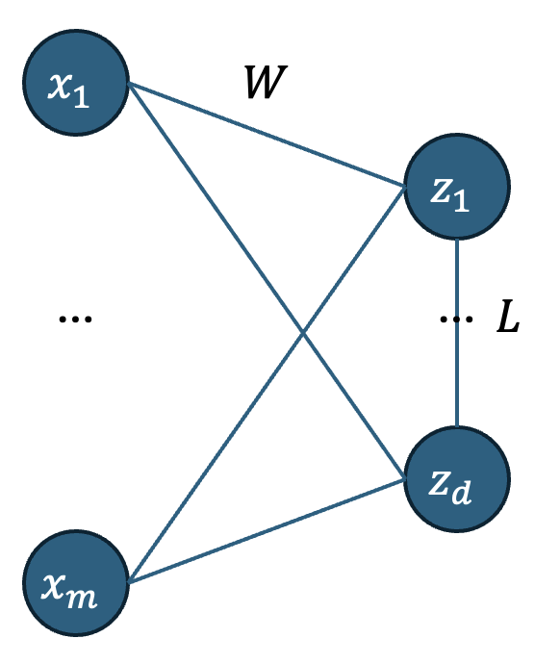
Current Model
To solve the blind signal problem, the current model I am exploring is a two layered neural network.
Input layer $x∈R^{m}$, output layer $z∈R^{d}$, weight matrix $W∈R^{d×m}$.
We have $v=Wx$. This is the initial value of the second layer activations, $z$. Afterwards, we take gradient steps to minimise an energy function, modifying $z$.
Figure 1 Two-layer neural network with lateral connections
The energy function for the $i$th node in the second layer is given by
$$E_{i}=\frac{1}{2} [{A\left(z_{i}-v_{i}\right)}^{2}+\frac{B}{d-1}\sum_{j≠i}{{\left\langle x_{i}^{2}x_{j}^{2}\right\rangle }^{2}}+C{\left(1-var\left(x_{i}\right)\right)}^{2}]$$
where $A, B, C$ are hyperparameters that weight the importance of each term. The first term is the usual squared error, the second term aims to minimise the covariances and the final term aims to make the variance of each dimension close to 1.
To keep track of the variances and covariances we use an exponential moving average. These estimates are stored as weights in matrices $V$ and $L$.
$$V_{i}←αz_{i}^{2}+ \left(1-α\right)V_{i} for i∈\{1,…,d\}$$
$$L_{ij}←αz_{i}z_{j}+ {\left(1-α\right)L}_{ij} for i≠j$$

Then,
$$\frac{∂E_{i}}{∂z_{i}}=A\left(z_{i}-v_{i}\right)+\frac{B}{d-1}\sum_{j≠i}{L_{ij}(α)(z_{j})}+C(1-V_{i})(-2αz_{i})]$$
assuming $\left\langle x_{i}^{2}x_{j}^{2}\right\rangle ≈L_{ij}$, $\frac{∂L_{ij}}{∂z_{i}}=αz_{j}$, $var(z_{i})≈V_{i}$, $\frac{∂V_{i}}{∂z_{i}}=2αz_{i}$.
We take multiple gradient steps updating $z$. Optionally, we can also introduce activation function in the second layer that we apply after relaxation. Then, we take a single gradient step updating W.
$$\frac{∂E_{i}}{∂W_{ij}}=A\left(z_{i}-v_{i}\right)(-x_{j})$$
This is performed for every input datapoint and the process is repeated.

