DungeonKUrawler
Design D1 Updated Sections - Visual Diagram Version
This document updates the previous D1 pages for the current codebase. It replaces the old controller/UI names in the original PDF with the classes that are now implemented, and adds the ranged-combat and armor behavior that was added later.

Communication Diagrams

1. Start Game
Current flow: the main menu no longer starts a dungeon directly in every case. START GAME enters the tower flow. If no save exists, a new tower run is created; if saves exist, the player chooses a save first.
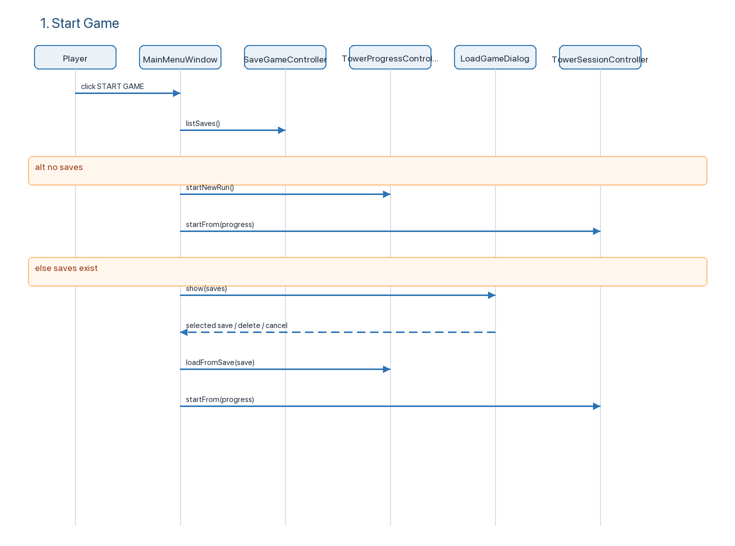
Key classes: MainMenuWindow, SaveGameController, TowerProgressController, LoadGameDialog, TowerSessionController.

2. Build Map
Current flow: DesignWindow is the build-mode UI. It delegates map mutation to BuildModeController, which delegates validation/placement to StandardBuildPlacementStrategy.
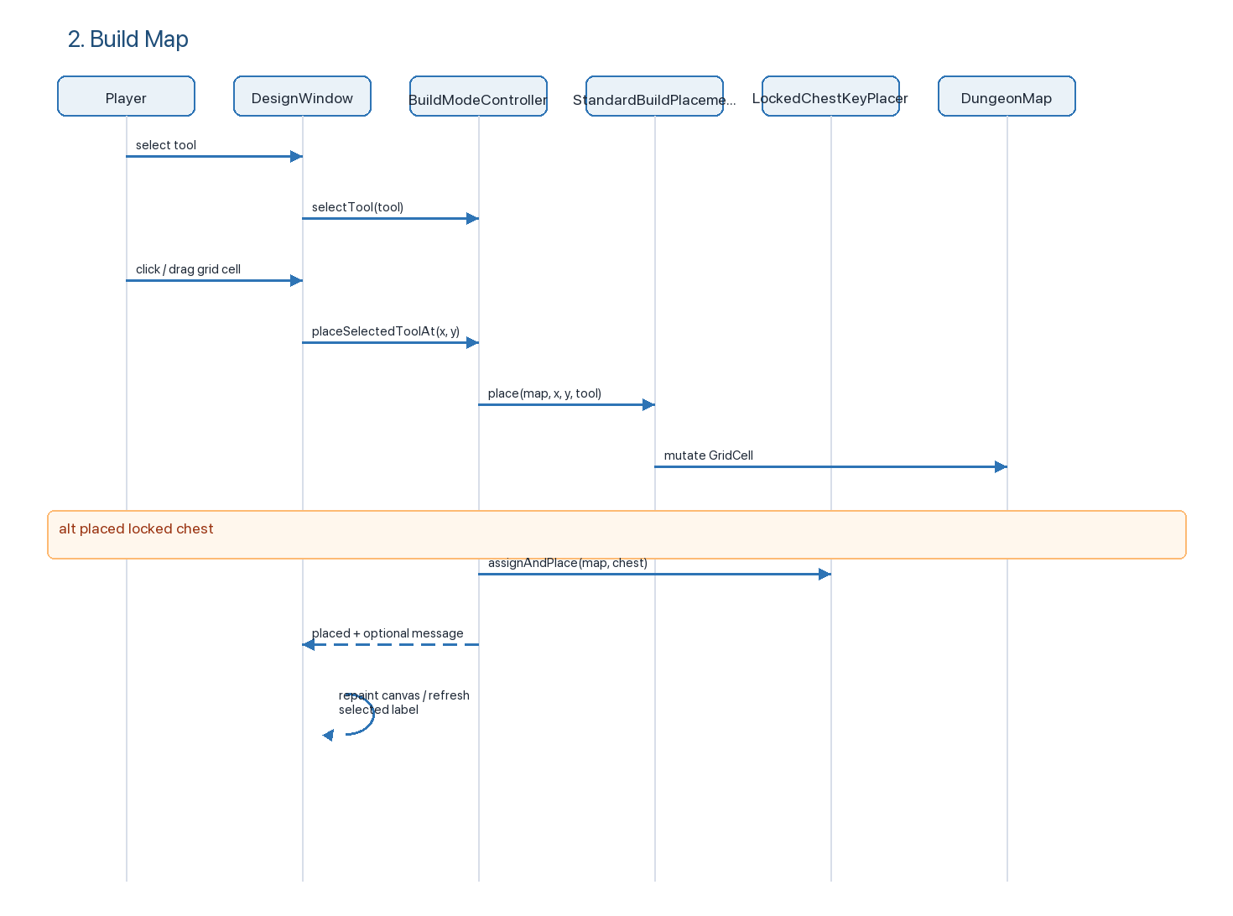
Key classes: DesignWindow, BuildModeController, BuildToolCatalog, BuildTool, StandardBuildPlacementStrategy, LockedChestKeyPlacer, DungeonMap, GridCell.

3. Load Map
There are two load-map paths now: load a designed map directly from the main menu, or load/save inside build mode.
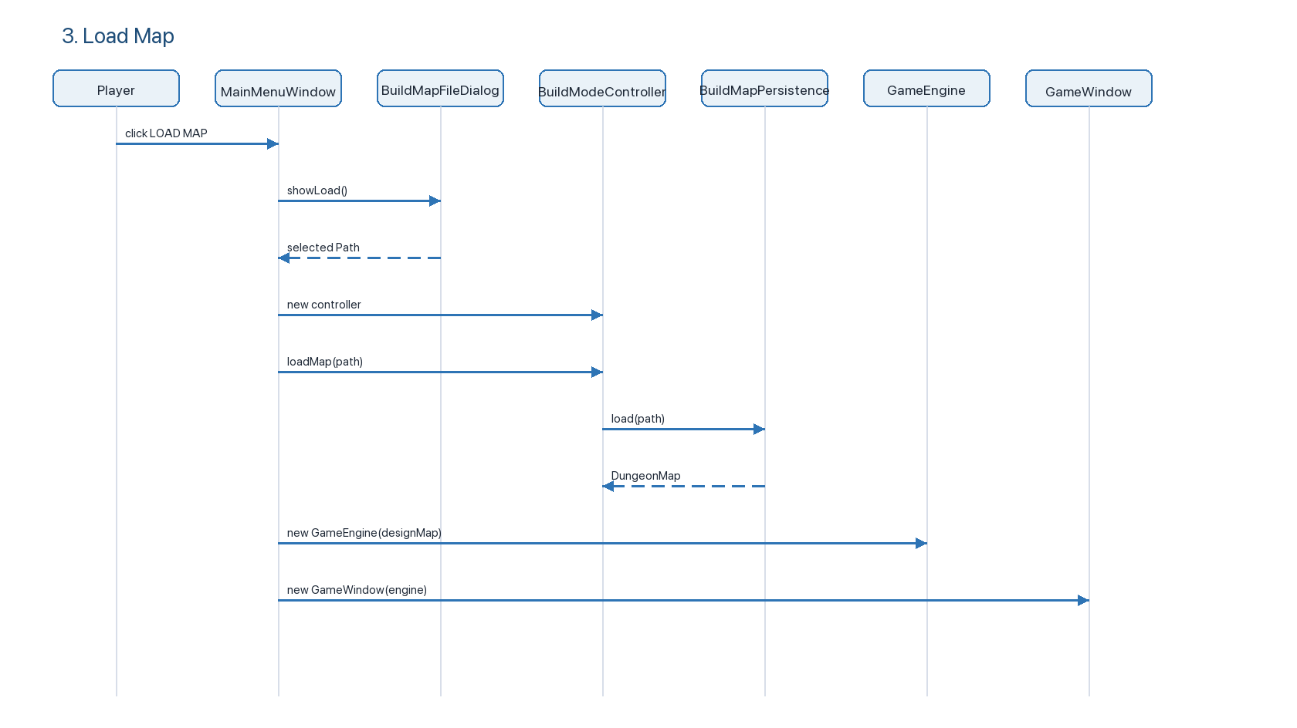
Build-mode save/load uses the same persistence service:
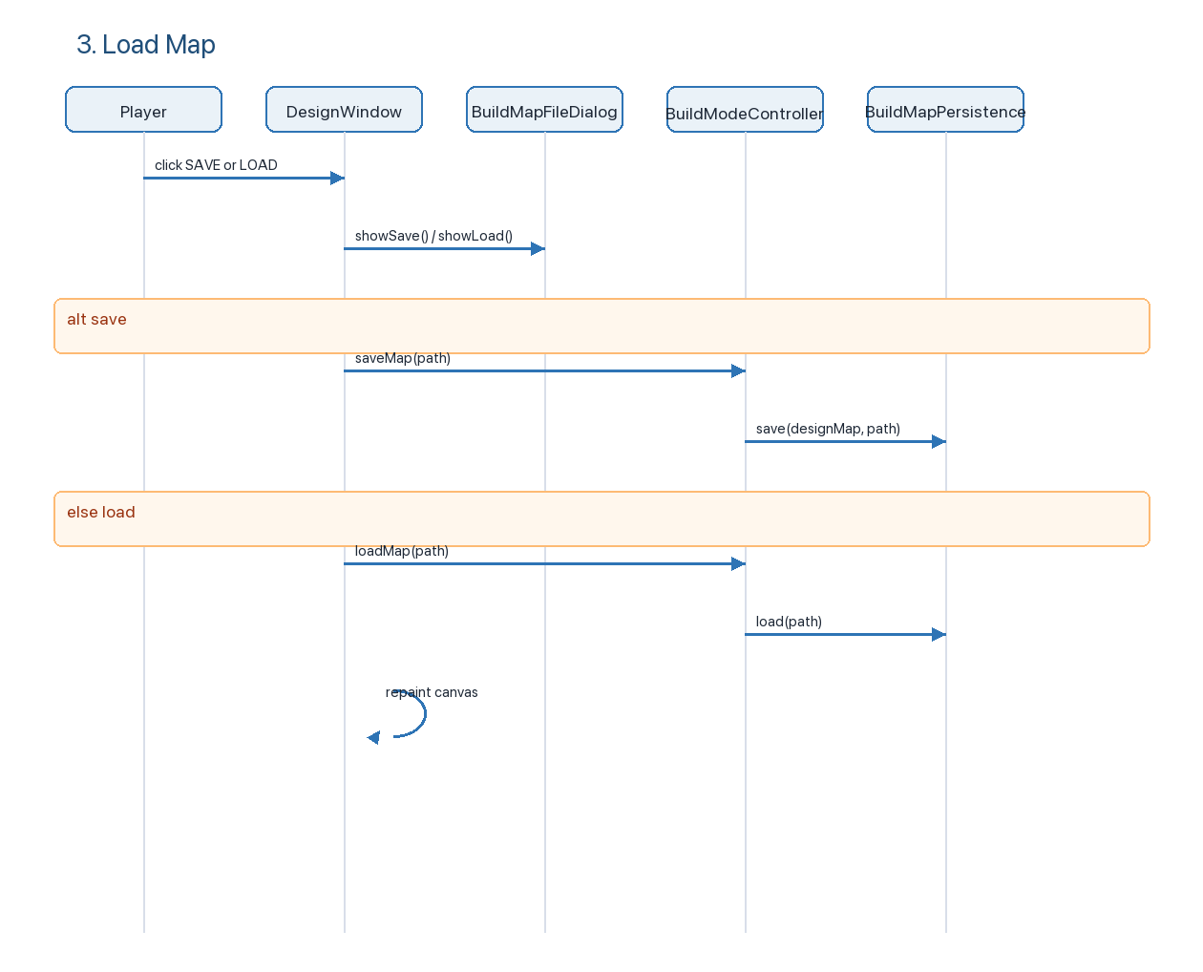
Key classes: BuildMapFileDialog, BuildModeController, BuildMapPersistence, MainMenuWindow, DesignWindow.

4. Add Random Items
Current flow: the old RandomItemGenerator is now BuildRandomItemPlacer. The controller limits this action to three uses per map with MAX_RANDOM_ITEM_ADDS = 3.
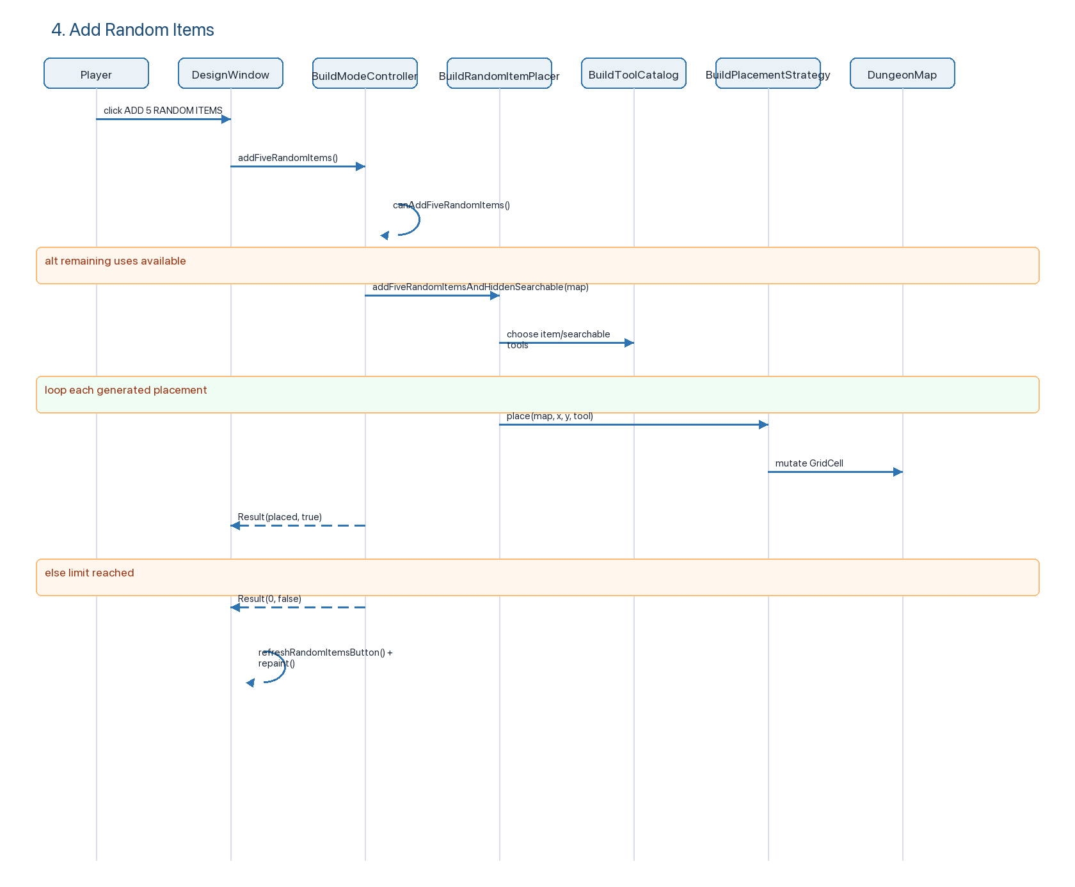
Key classes: BuildModeController, BuildRandomItemPlacer, BuildToolCatalog, BuildPlacementStrategy, DungeonMap.

5. Run Map in Play Mode
Current flow: DesignWindow validates/uses its design map by constructing a GameEngine, then opens GameWindow. GameWindow creates the player-facing controllers and GamePanel.
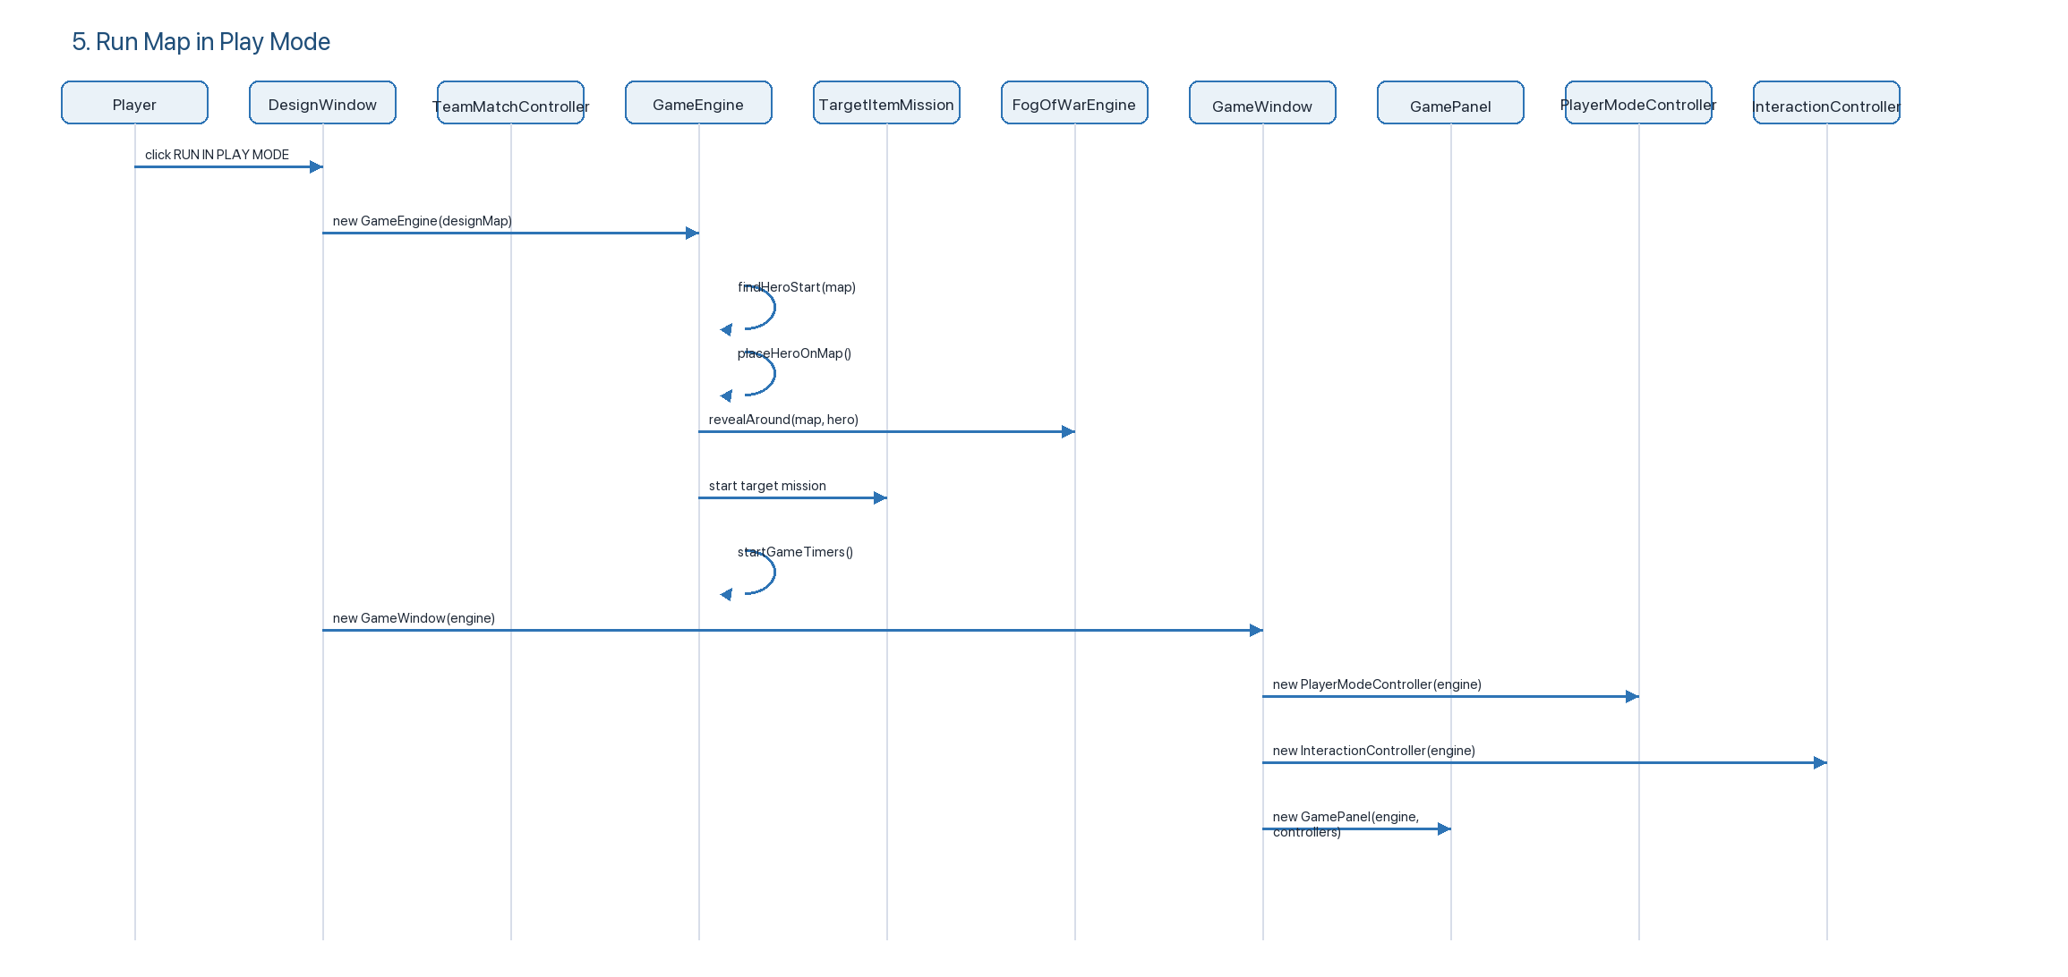
Team Match is a separate run option:
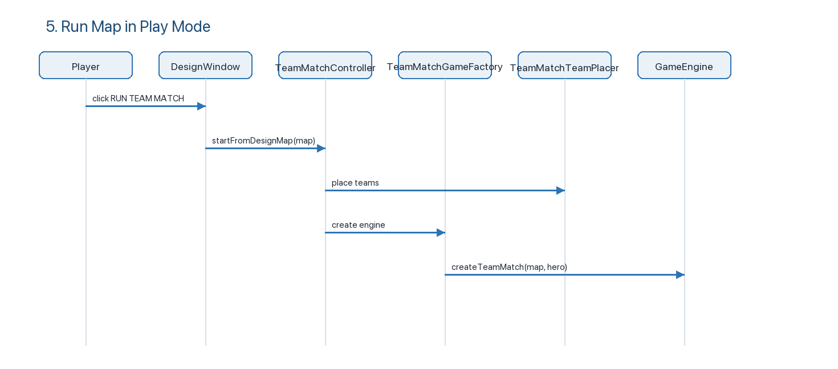
Key classes: DesignWindow, GameEngine, GameWindow, GamePanel, PlayerModeController, InteractionController, TeamMatchController.

6. Move Hero
Current flow: movement is keyboard-driven from GamePanel, but movement rules live in PlayerModeController and GameEngine.
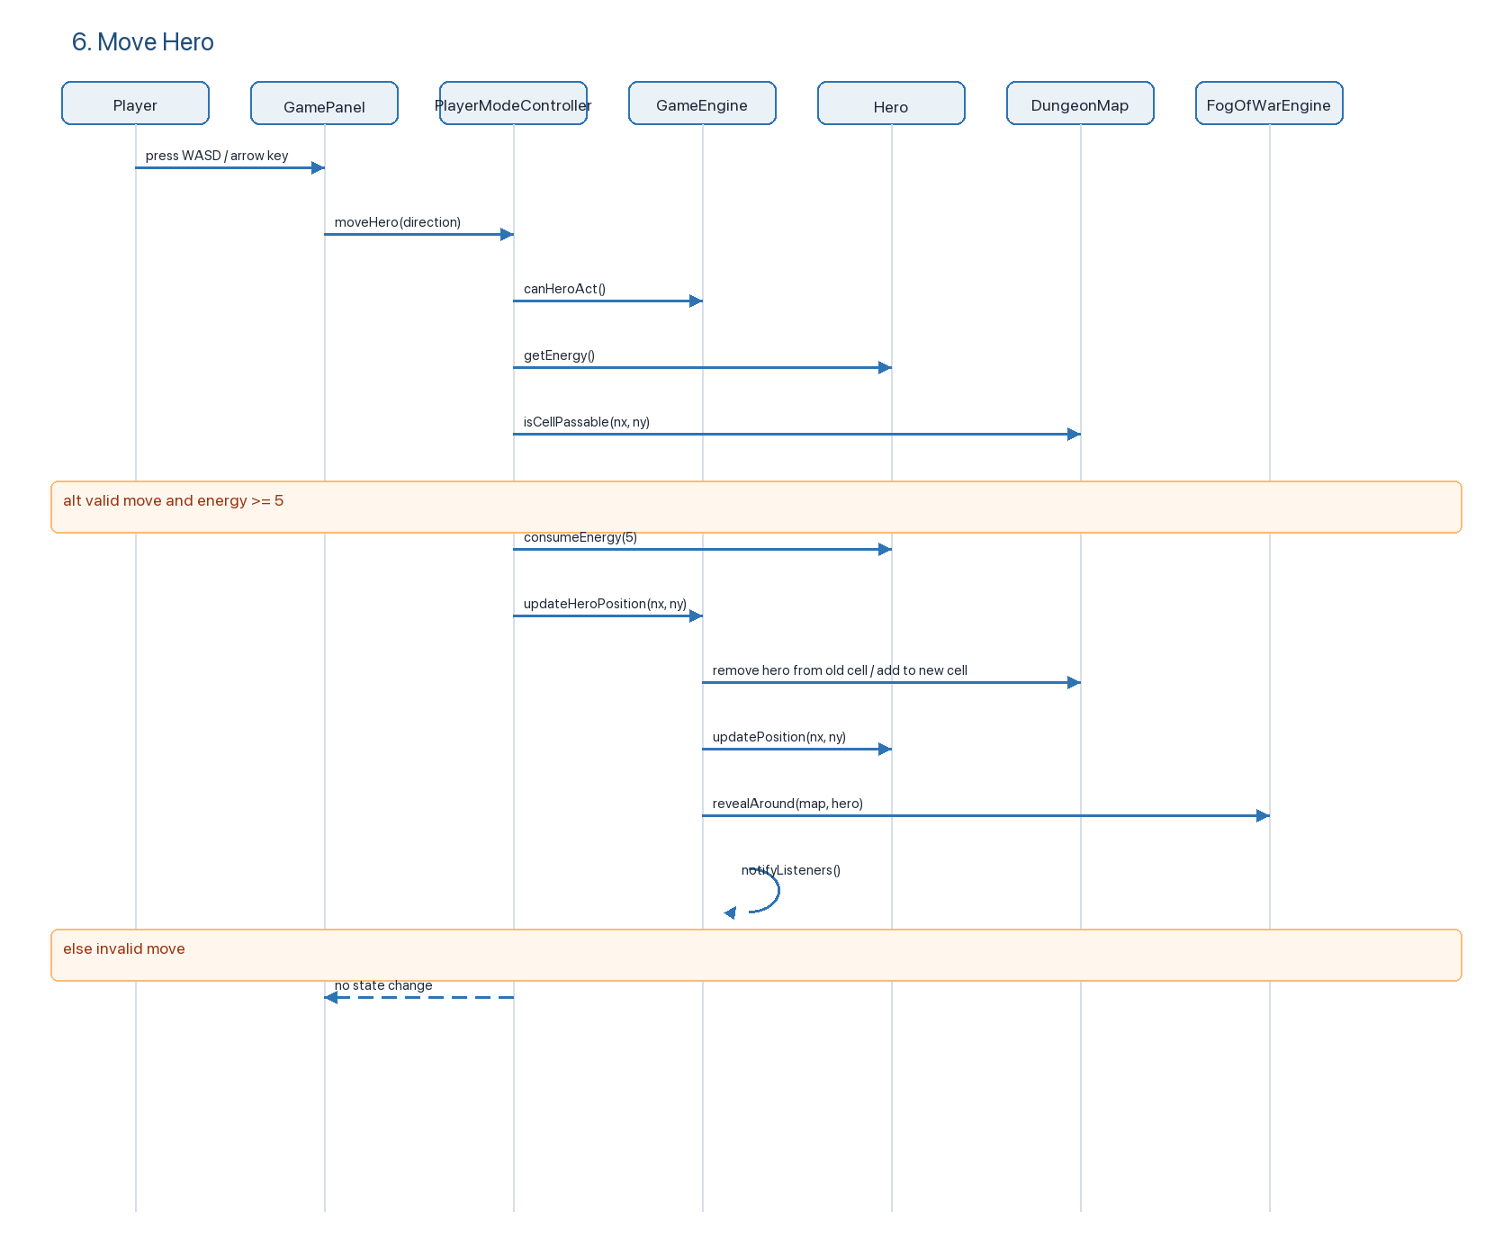
Key classes: GamePanel, PlayerModeController, GameEngine, Hero, DungeonMap, FogOfWarEngine.

7. Interact with Object
Current flow: mouse click selects a visible grid cell. GamePanel first attempts combat on the clicked cell, then asks InteractionController for item interactions.
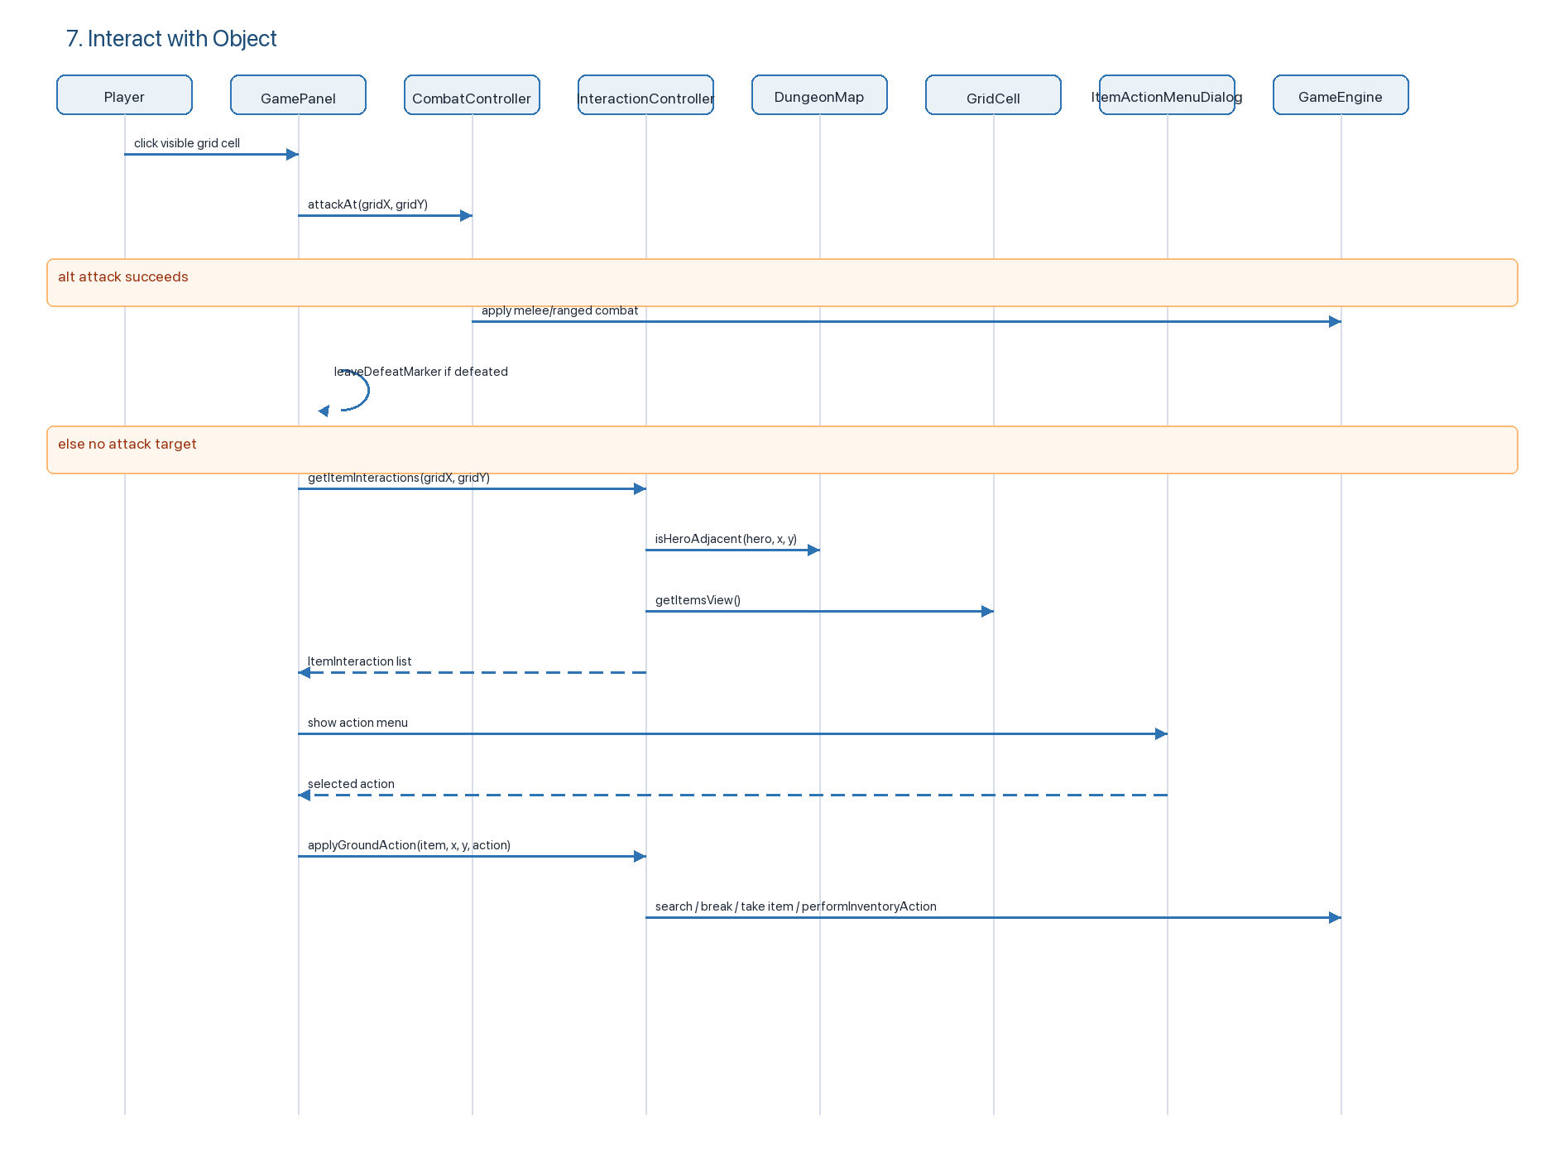
Key classes: GamePanel, CombatController, InteractionController, ItemActionMenuDialog, GameEngine, DungeonMap.

8. Collect Item
Current flow: item pickup is shared by keyboard (T), click interaction, container loot, and search results. Coins and valuables bypass the 8-slot per-level bag.
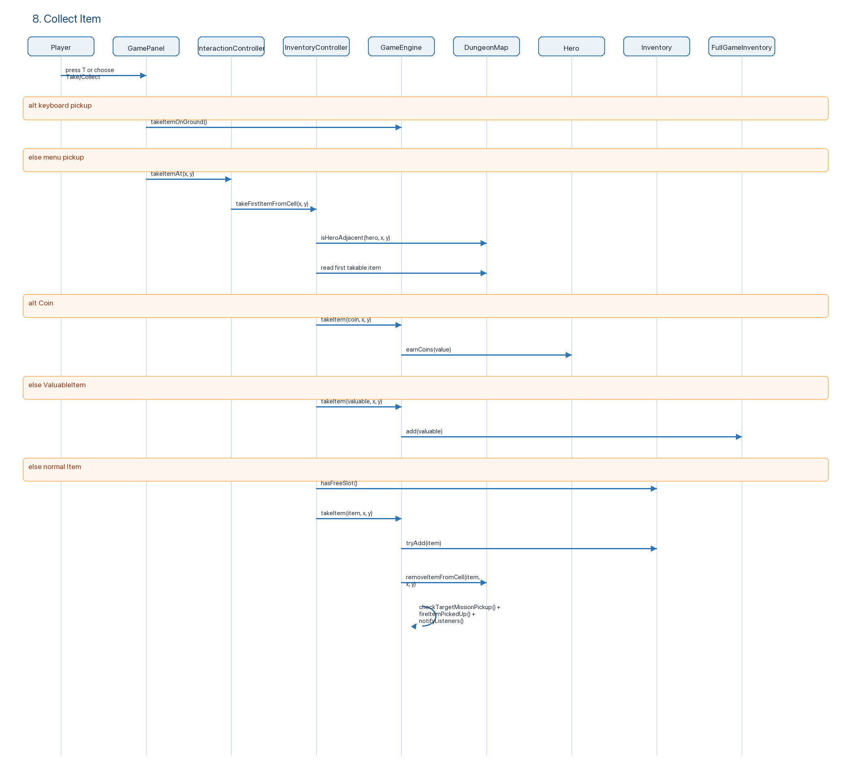
Key classes: GamePanel, InteractionController, InventoryController, GameEngine, Hero, Inventory, FullGameInventory.

9. Manage Inventory
Current flow: inventory UI lists carried items and their actions. The effect of each action is delegated through ItemActionEffects, which is a command/strategy registry.
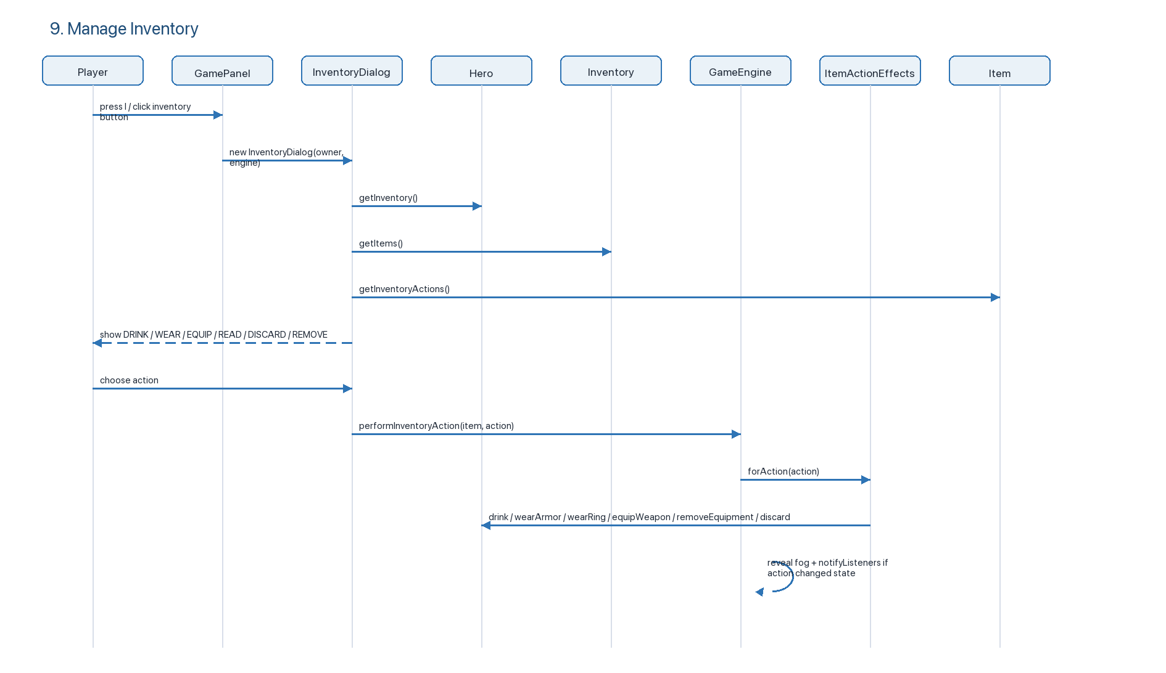
Armor-specific path:
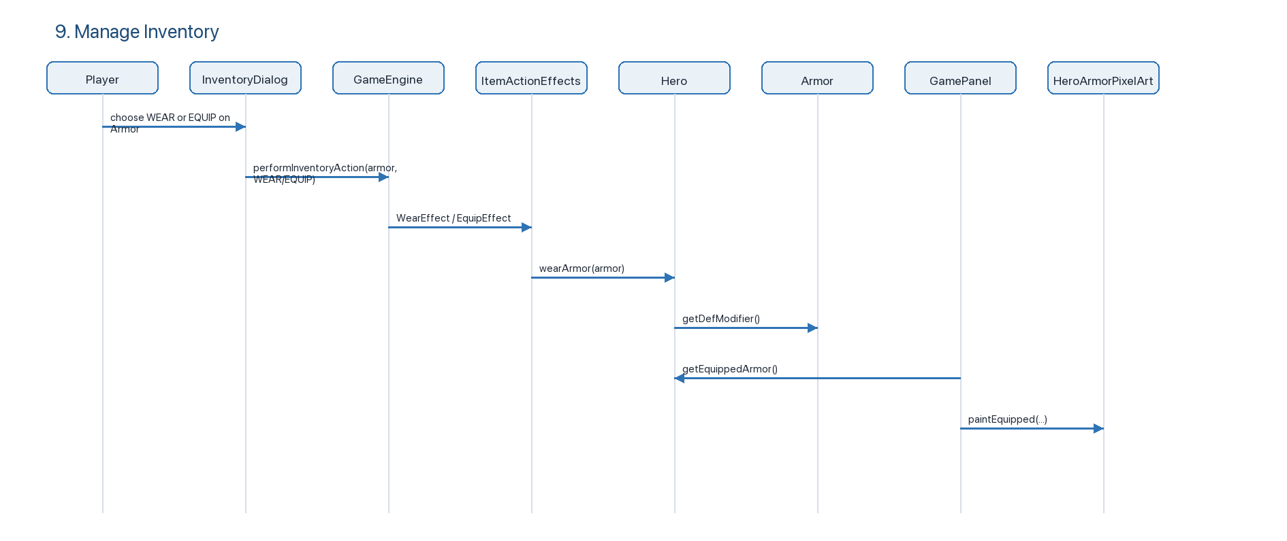
Key classes: InventoryDialog, GameEngine, ItemActionEffects, Hero, Armor, Weapon, Ring, Inventory.

10. Fight Enemy
Current flow: combat supports melee, enemy projectiles, and hero-owned ranged projectiles.

10A. Melee Attack
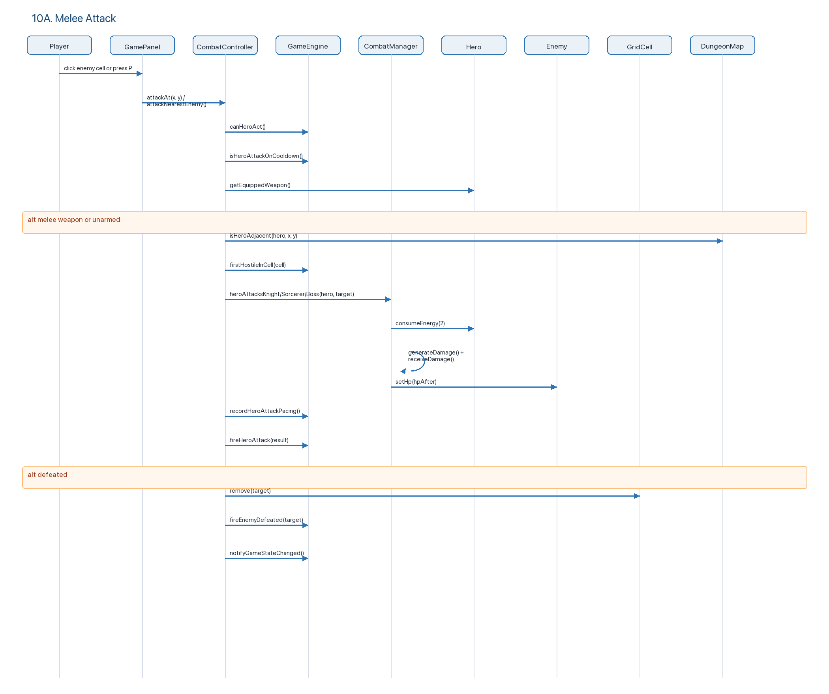

10B. Ranged Attack
Current ranged weapons:
| Weapon | Category | ATK | Range setting | Cost | Projectile |
| --- | --- | ---: | --- | --- | --- |
| Wooden Bow | bows | 6 | WeaponType.maxRange = 4; current test build ignores range in canHeroRangedTarget and keeps line-of-sight only | 3 Energy | Arrow |
| Magic Wand | staves | 8 | WeaponType.maxRange = 4; current test build ignores range in canHeroRangedTarget and keeps line-of-sight only | 5 Mana | Ice bolt |
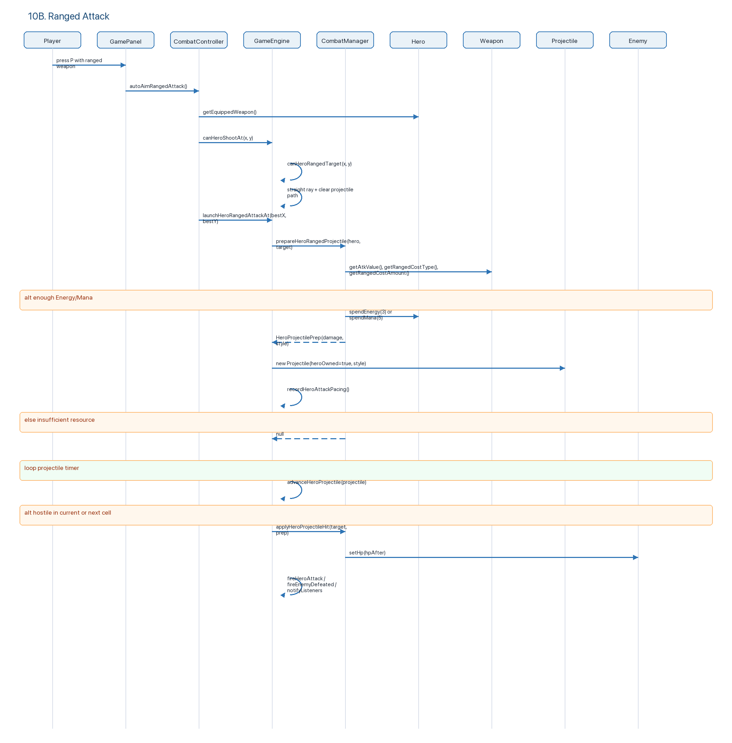
Enemy projectile path:
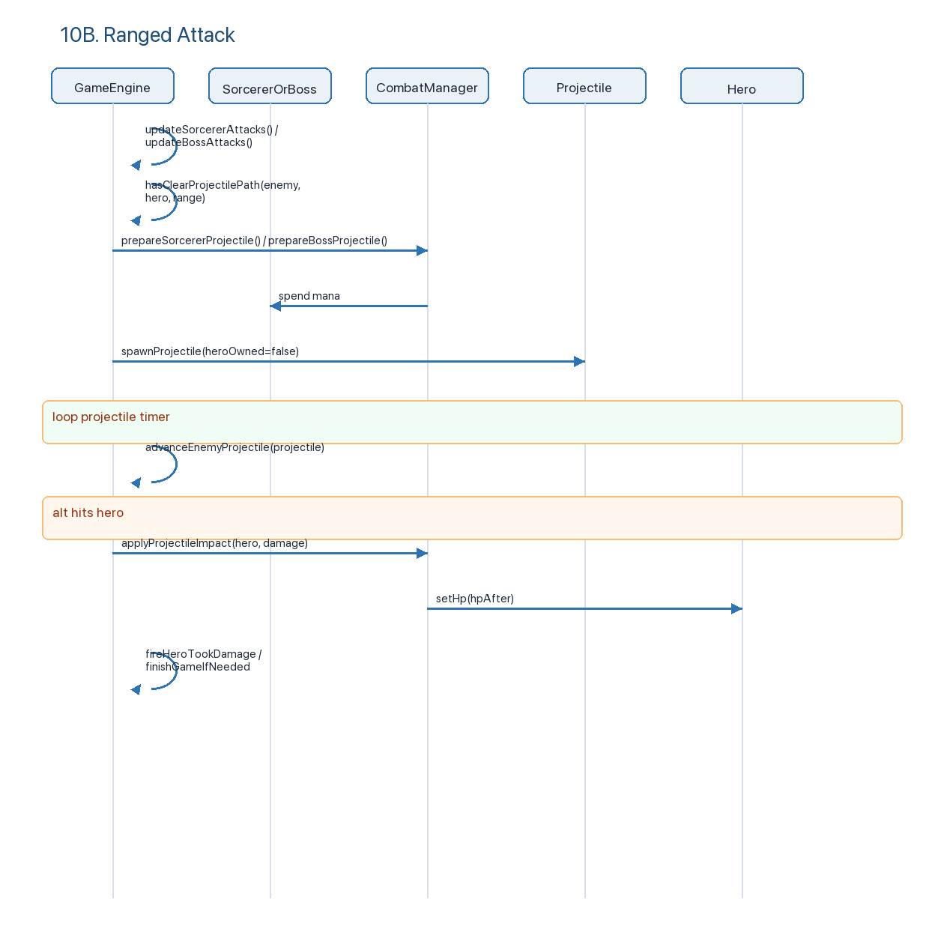
Key classes: CombatController, CombatManager, GameEngine, Projectile, Weapon, WeaponType, HeroProjectileStyle, RangedCostType, Hero, Knight, Sorcerer, BossEnemy.

UML Class Diagram - Updated Class List and Relationships
The original PDF class diagram used older placeholders such as GameController, MapEditorController, BuildMapUI, PlayModeUI, Map, and generic Enemy. The current implementation has more specific classes and separates UI, controllers, services, model objects, rendering, and persistence.
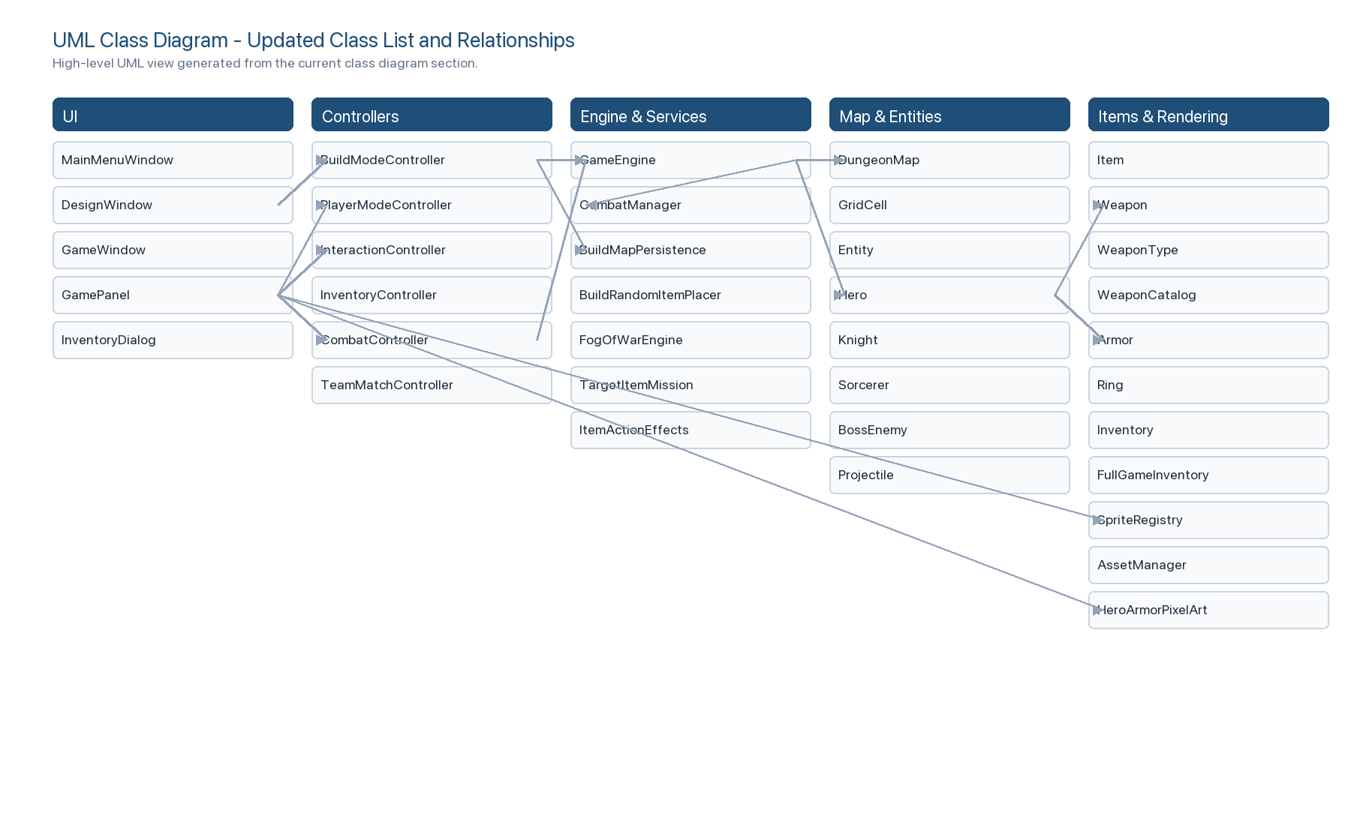

Design Alternatives Discussion

Current Design
The current design is controller/service oriented and closer to GRASP than the earlier D1 draft. UI classes forward user intent; controllers coordinate use cases; model classes own state; service/factory/catalog classes isolate creation, persistence, combat math, rendering assets, and rules.
Current responsibilities:
- MainMenuWindow: top-level navigation; starts tower flow, load-game flow, load-map flow, or build mode.
- DesignWindow: build-mode view; delegates all map edits to BuildModeController.
- BuildModeController: build-mode GRASP Controller; owns selected tool, design map, save/load, random item count, and placement requests.
- StandardBuildPlacementStrategy: placement rules for floors, walls, tools, items, containers, weapons, armor, and searchables.
- BuildMapPersistence: serializes/deserializes designed maps.
- GameWindow and GamePanel: gameplay shell and observer/rendering surface. They forward key/mouse input to controllers and repaint after GameEngine notifications.
- GameEngine: central game-state owner and observer subject. It owns map, hero, timers, mission state, fog, projectiles, enemy spawning/AI ticks, pickup/search/open logic, and listener notifications.
- PlayerModeController: movement use case; checks energy and passability before asking GameEngine to move the hero.
- InteractionController: ground item interaction, search, break, and take/use-on-ground flow.
- InventoryController: pickup validation and item transfer from map to inventory/full inventory.
- CombatController: player-initiated melee/ranged combat and auto-aim.
- CombatManager: stateless combat formulas, resource spending for ranged attacks, projectile prep, and damage application.
- ItemActionEffects: command/strategy registry for inventory actions (DRINK, WEAR, EQUIP, READ, REMOVE, DISCARD, SEARCH, BREAK, OPEN, etc.).
- WeaponCatalog / WeaponType: Flyweight catalog for weapon stats and sprites. B23 ranged weapons are registered here.
- Armor: equipment item that contributes to Hero.getDef() and supplies /weapons/armor.png as its item sprite.
- HeroArmorPixelArt: fitted equipped-armor overlay for the hero sprite; item icon and equipped overlay are intentionally separate.

Pros
- Clearer separation between UI and rules than the old D1 diagram.
- Build mode uses a Strategy (BuildPlacementStrategy) instead of placing everything directly in the UI.
- Inventory action behavior is extensible through ItemActionEffects instead of a large UI switch.
- Combat math is centralized in CombatManager.
- Ranged weapons are data-driven through WeaponType and WeaponCatalog.
- Rendering assets are separated through SpriteRegistry, AssetManager, and sprite-resource overrides.
- Armor is integrated as normal equipment: inventory action, DEF calculation, item sprite, and equipped visual.
- GameEngine implements observer-style listener notification so views repaint after state changes.

Cons / Remaining Risks
- GameEngine is still large. It owns core state, timers, projectiles, enemy AI updates, mission state, pickups, search, locks, fog, and notifications.
- GamePanel still has many rendering and input responsibilities in one class.
- Hero ranged range is currently in test mode: WeaponType.maxRange is 4, but GameEngine.canHeroRangedTarget and CombatController.autoAimRangedAttack currently use Integer.MAX_VALUE while preserving straight-line and wall/projectile-block checks.
- Some class names changed significantly from the earlier D1 diagrams, so old documentation using GameController, MapEditorController, BuildMapUI, PlayModeUI, and generic Enemy no longer matches the code.

Alternative 1: Split GameEngine into Smaller Services
Move projectile ticking, enemy AI timers, mission/floor completion, and pickup/search/open logic into separate services/controllers.
Pros:
- GameEngine would become a thinner state facade.
- Easier unit testing for projectile movement and enemy AI.
- Lower risk when modifying one subsystem.
Cons:
- More dependency wiring.
- More classes for teammates to understand.
- Current project size may not justify full decomposition yet.
Recommended use: split next if new combat/AI/floor mechanics continue to grow.

Alternative 2: Keep GameEngine as Facade, Extract Rendering Helpers
Keep GameEngine as the state owner, but move more GamePanel drawing into small renderers, similar to AmbienceRenderer.
Pros:
- Reduces GamePanel size.
- Makes ranged projectile, HUD, hero equipment, and item drawing easier to maintain.
- Preserves current controller/model architecture.
Cons:
- Rendering helpers need stable inputs and careful ordering.
- Does not reduce GameEngine complexity.
Recommended use: good near-term refactor because the current UI has grown with ranged weapons, armor, fog, pets, HUD, projectiles, and animation.

Alternative 3: Make Ranged Weapon Rules Fully Data-Driven
Restore strict weapon.getMaxRange() checks and move all B23 weapon values into a data file or dedicated catalog configuration.
Pros:
- Easier balancing: bow/wand cost, damage, range, projectile style can be changed without touching combat flow.
- Documentation and code will match weapon stats exactly.
- Avoids temporary test-mode range behavior becoming accidental final behavior.
Cons:
- Needs migration or validation for old saved maps.
- More data validation required.
Recommended use: before final submission, restore dynamic max-range behavior if the requirement says weapons must be range-limited.

Alternative 4: Treat Armor Visuals as Two Separate Assets
Current implementation uses /weapons/armor.png for item/build/inventory display and code-drawn fitted overlay for the equipped hero.
Pros:
- Item icon can remain high quality.
- Equipped armor does not replace or distort the hero sprite.
- Weapons still draw on top of armor because GamePanel draws armor first, then equipped weapon.
Cons:
- Item icon and equipped overlay are not identical.
- More manual pixel tuning may be needed if hero sprite changes.
Recommended use: keep this split. A full armor PNG is good as an item icon, but too large to draw directly on the 16x32 hero sprite.

Pattern / GRASP Notes
- Controller: BuildModeController, PlayerModeController, InteractionController, InventoryController, CombatController, TeamMatchController.
- Information Expert: Hero owns equipment and derived DEF; Inventory owns capacity; DungeonMap owns cells; GridCell owns local items/entities.
- Low Coupling: UI delegates to controllers; action effects are isolated in ItemActionEffects; rendering assets are isolated from model through sprite-resource paths and registries.
- High Cohesion: CombatManager handles combat formulas; BuildMapPersistence handles map persistence; BuildRandomItemPlacer handles random build-mode placement.
- Strategy: BuildPlacementStrategy, EnemySpawnPolicy, VisibilityStrategy, ItemActionEffects.Effect.
- Observer: GameEngine notifies GameStateListener; audio/game events are emitted through GameEventListener and mission listeners.
- Flyweight: WeaponType stores shared weapon intrinsic state; Weapon instances reference it.
- Singleton/Flyweight cache: AssetManager caches loaded sprites.

Implementation Facts Added Since Original D1
- Ranged weapons:
- Wooden Bow: ATK 6, Energy cost 3, projectile style ARROW.
- Magic Wand: ATK 8, Mana cost 5, projectile style ICE_BOLT.
- Both are registered in WeaponCatalog.registerB23RangedWeapons().
- Ranged pacing:
- Hero attacks use Hero.lastAttackTimeMs.
- GameConstants.GLOBAL_ACTION_TICK_MS controls the cooldown.
- CombatController ignores inputs during cooldown.
- Projectiles:
- Hero-owned projectiles and enemy-owned projectiles share Projectile.
- GameEngine.updateProjectiles() advances them on a timer.
- Hero projectiles check the current cell before moving, then the next cell, so moving enemies are less likely to be skipped.
- Armor:
- Armor.getInventoryActions() returns WEAR, EQUIP, and DISCARD.
- ItemActionEffects.WearEffect and EquipEffect both support armor.
- Hero.getDef() adds base DEF + armor bonus + ring bonus.
- Armor.spriteResource() returns /weapons/armor.png.
- Equipped armor is drawn with HeroArmorPixelArt.paintEquipped(...) so it fits the hero sprite and does not cover the weapon overlay.
- Rendering:
- No external runtime image downloads are used.
- Existing local sprites live under src/main/resources.
- Bow/wand custom pixel art is drawn in GamePanel, DesignWindow, and InventoryDialog.
- Armor item icon uses the local PNG, while equipped armor uses fitted pixel overlay.

