Software Requirements Specification
for
Car Rental Application
Version 2.0 approved
Prepared by Efkan Efe Kabakcı, İbrahim Taha Pınar, Mehmet Tahir Doğu, Yusuf Emre Yüzügüllü
Fırat University – Software Engineering Department
29.04.2025
Table of Contents
Table of Contents ii
Revision History ii
1. Introduction 1
1.1 Purpose 1
1.2 Document Conventions 1
1.3 Intended Audience and Reading Suggestions 1
1.4 Product Scope 1
1.5 References 1
2. Overall Description 2
2.1 Product Perspective 2
2.2 Product Functions 2
2.3 User Classes and Characteristics 2
2.4 Operating Environment 2
2.5 Design and Implementation Constraints 2
2.6 User Documentation 2
2.7 Assumptions and Dependencies 3
3. External Interface Requirements 3
3.1 User Interfaces 3
3.2 Hardware Interfaces 3
3.3 Software Interfaces 3
3.4 Communications Interfaces 3
4. System Features 4
4.1 System Feature 1 4
4.2 System Feature 2 (and so on) 4
5. Other Nonfunctional Requirements 4
5.1 Performance Requirements 4
5.2 Safety Requirements 5
5.3 Security Requirements 5
5.4 Software Quality Attributes 5
5.5 Business Rules 5
6. Other Requirements 5
Appendix A: Glossary 5
Appendix B: Analysis Models 5
Appendix C: To Be Determined List 6

Revision History
Name | Date | Reason For Changes | Version
Efkan Efe Kabakcı | 29.04.25 | Initial Draft | 1.0
İbrahim Taha Pınar | 29.04.25 | Overall Description part is written | 1.0
Mehmet Tahir Doğu | 30.04.25 | External Interface part is written | 1.0
Efkan Efe Kabakcı | 01.04.25 | System Feature part is written. UI file prototype is attached to the “3.1 User Interfaces” part. User documentation file is attached to the “2.6 User Documentation” | 1.0
Yusuf Emre Yüzügüllü | 01.05.25 | Other Nonfunctional Requirements and Other Requirements part is written. | 1.0
Efkan Efe Kabakcı | 08.05.25 | Use Case scenarios are created and Overall Description part is extended. | 2.0
Efkan Efe Kabakcı | 24.05.25 |  | 3.0

Introduction
  - Purpose
This document defines the software requirements specification of Car Rental Application. The purpose of this SRS is to create a common understanding between software developers, test engineers, project managers and the stakeholders for the normal user side of the application. The system is designed as a standalone desktop application.

Document Convention
Throughout this document, the following conventions have been used:
- Font: - Times New Roman
- Font Size: 18 for Main Headings
- Font Size: 14 for Sub Headings
- Font Size: 12 for the rest of the document
- “Must” and “Shall” indicate mandatory system behaviors.
- “Should” indicates a recommended behavior, not strictly enforced.
- File names are underlined.
- Links are underlined and colored blue

Intended Audience and Reading Suggestions
This SRS document is made for software developers, test engineers, project managers and the end user.
- Software Developers: To know what the system will do and how it will do it.
- Test Engineers: To create test scenarios based on the system requirements.
- Project Managers: To understand the scope and job organization of the project.
- End User: to check whether the desired functions are in the application.
All readers should read the 1st section (Introduction) and 2nd section (Overall Description).
Developers should focus on 3rd section (External Interface Requirements).
Test Engineers should focus on 4th section (System Features)

Product Scope
Car Rental Application is a desktop application that allows remote management of car rental related operations. The main purpose of the app is to save time by saving people the hassle of going to a car rental company and automating of procedures related to vehicle rental.

References
IEEE. IEEE Std 830-1998 IEEE Recommended Practice for Software Requirements Specifications.
Python 3.12 https://docs.python.org/3.12/
PyQt6 https://doc.qt.io/qtforpython-6/

Overall Description

Product Perspective
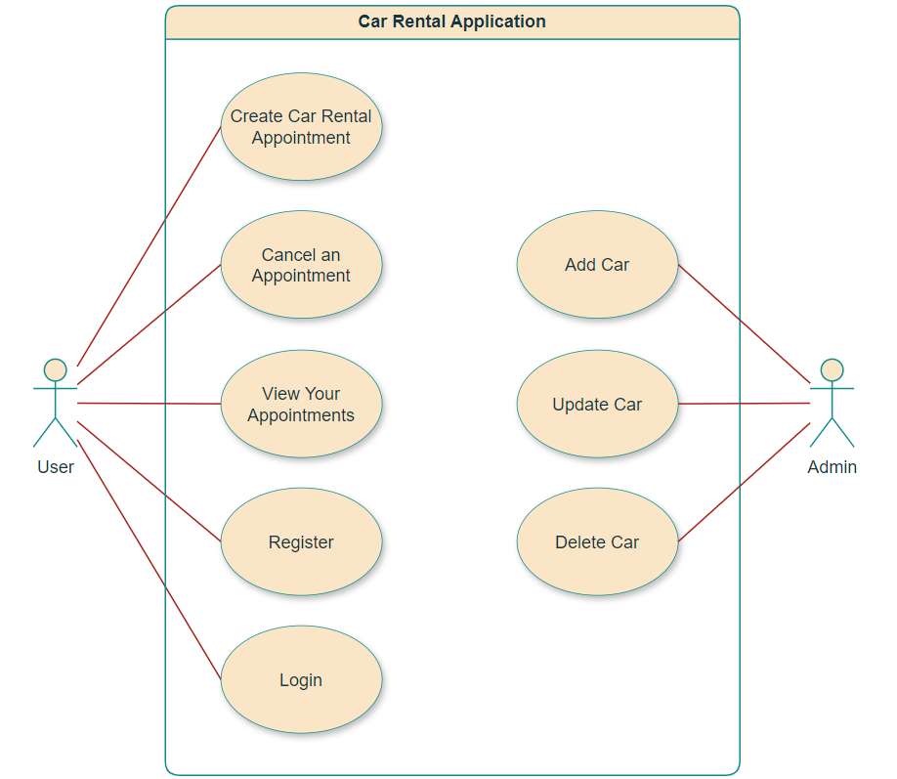
The Car Rental Application has one active actor and one cooperating system. Using the application, the user can examine the cars, make appointments and manage the cars they rent without going to the sales office.

Product Functions
This section outlines the user use-cases separately. The user actor has 6 use cases.

User Use-Cases
Create Car Rental Appointment Use Case
Pre-Conditions
- The user must be logged in to the system.
Main Scenario
- The user clicks the “Select a Car” button.
- The system navigates the user to the “Cars” screen.
- The user selects a car from the list.
- The system navigates the user to the “Booking” screen.
- The user enters the start and end day for the appointment.
- The system checks the validity of the dates.
- The user clicks the “Create Appointment” button.
- The system displays a confirmation dialog to the user.
- The user confirms the appointment.
- The system saves the appointment in the database.
Exceptions
- 6a. The dates are invalid.
  - 6a.1. The “Create Appointment” button is disabled.
  - 6a.2. The text field enters error state.

View Your Appointments Use Case
Pre-Conditions
- The user must be logged in to the system.
Main Scenario
- The user clicks the “View Your Appointments” button.
- The system navigates the user to the “Appointments” screen.
- The system fetches rental appointments that match the user's ID.
- The system displays the list of appointments created in the past or currently active.
Cancel an Appointment
Pre-Conditions
- The user must be logged in to the system.
- The user must have at least one active appointment.
Main Scenario
- [Include: View Your Appointments]
- The user selects the appointment they want to cancel from the list.
- The user clicks on the “Confirm” button.
- The system asks the user a confirmation question.
- The user confirms the cancellation.
- The system updates the appointment status as “0”.

Register Use Case
Pre-Conditions
- The user must be of legal age.
Main Scenario
- The user clicks on the “Don’t have an account? Register” button.
- The user fills in all the information completely.
- Each information is validated by the system.
- The user clicks on the “Register” button.
- The system registers the new user in the database.
- The system shows a success dialog.
- The system redirects the user to the home page.
Exceptions
- 3a. Any information may be in an incorrect format or incomplete.
  - 3a.1. The “Register” button is disabled.
  - 3a.2. The text field enters error state.

Login Use Case
Pre-Conditions
- The user must have a registered account.
Main Scenario
- User enters email and password.
- System forwards credentials to Auth System.
- Auth System verifies the credentials.
- If valid, user is authenticated.
- System redirects to main dashboard.
Exceptions
- 3a. Incorrect credentials.
  - 3a.1. The system shows an error message.

Admin Use Cases
Add Car Use
Pre-Conditions
- The admin must be logged in to the system.
Main Scenario
- The admin clicks the “Add New Car“ button.
- The system shows the “AdminCarDialog“ window.
- The admin enters the information about the car to be added.
- Inputs are validated by the system.
- The admin clicks the “Confirm” button.
- The system adds a new car to the database.
Exceptions
- 4a. Any information may be in an incorrect format or incomplete.
  - 3a.1. The “Confirm” button is disabled.
Update Car Use
Pre-Conditions
- The admin must be logged in to the system.
Main Scenario
- The admin clicks a row from the table.
- The system shows the “AdminCarDialog“ window.
- The admin enters new information about the car.
- Inputs are validated by the system.
- The admin clicks the “Confirm” button.
- The system updates the car.
Exceptions
- 4a. Any information may be in an incorrect format or incomplete.
  - 3a.1. The “Confirm” button is disabled.
Delete Car Use
Pre-Conditions
- The admin must be logged in to the system.
Main Scenario
- The admin clicks on the trash can icon in the row containing the car they want to delete.
- The system shows a confirmation dialog.
- If the admin confirms, the system deletes the car from the database.

User Classes and Characteristics
- Normal User
  - It uses basic user interface.
  - It rents a car.
- Admin
  - It uses admin panel.
  - It can change an attribute of a car.

Operating Environment
Car Rental App is built for Windows 10 or higher operating system. If you want to run the software on another OS, you can rebuild the software from the source code. For the software to run properly, the system requires at least 2 GB of RAM, a 1 GHz dual-core processor and 400 MB of free disc space.

Design and Implementation Constraints
No design or implementation constraints are specified.

User Documentation
User Documentation for Car Rental Application

Assumptions and Dependencies
It is also assumed that users compiling from the source code have installed the dependencies in the requirements.txt file on their machine.

External Interface Requirements

User Interfaces
- Login Screen: Allows users to enter their email and password. Contains a "Don’t have an account? Register" link.
- Registration Screen: Enables users to create a new account. Fields include full name, email, password, id, and birthdate.
- Home Screen: Presents the user "Choose Your Car" and "View Your Appointments" buttons.
- Cars Screen: Displays available cars with filtering options (brand, model, price, fuel type, gear type).
- Booking Screen: Allows the user to and enter reservation dates approve its selection car. A summary widget shows total cost.
- Appointments Screen: Displays car rental appointments. Appointment cancellation are also made from this window.
- Admin Home Screen: This is the screen where admin manages the cars.
User Interfaces

Hardware Interfaces
Basic computer setup with a keyboard and mouse are required.

Software Interfaces
The application reads and writes data by establishing a direct connection with the SQLite3 database. There is no external API or third-party software integration.

Communications Interfaces
This application is designed to work completely offline. It does not need an internet connection or network communication.

System Features

Login
4.1.1 Description and Priority
The user shall be able to login with its email and password.
Priority: High
4.1.2 Stimulus/Response Sequences
1. User Action: User enters its information and clicks the login button.
System Response: The application navigates to the home page.
4.1.3 Functional Requirements
REQ-1: When the user clicks “Login” button, the system must verify the
information by comparing it with the data in the database.
REQ-2: If the information entered by the user does not match an account from the
database, an error message must be displayed.
REQ-3: If the information entered by the user match an account from the
database, system must navigate the user to the home screen.

Registration
4.2.1 Description and Priority
The user shall be able to register by entering the requested information.
Priority: High
4.2.2 Stimulus/Response Sequences
1. User Action: User clicks the “Don’t have an account? Register” button.
System Response: The application navigates to the register page.
3. User Action: User clicks the “Register” button.
System Response: The application saves the user information to the database and show a success dialog.
4.2.3 Functional Requirements
REQ-1: The system must redirect the user to the registration page when the user
clicks on the “Don't have an account? Register” link, it should redirect to
the register page.
REQ-2: The form for registration must ask the user to enter the following
Information: email, name, password, password again, birthdate, id number.
REQ-3: The system must check the validity of the email, birthdate and password
format.
REQ-4: If validation is unsuccessful, the system must warn the user and disable
the “Register” button.
REQ-6: The system must control the user age.
REQ-7: If the user is underage, the system must disable the register button and
warn the user.
REQ-7: After clicking the register button, the system must save the user to the
database.
REQ-8: After clicking the register button, the system must navigate the user to the
home page.

Car Selection and Booking
4.3.1 Description and Priority
The user shall be able to view a list of available cars, access details of selected car, and initiate a booking.
Priority: High
4.3.2 Stimulus/Response Sequences
1. User Action: User clicks a car in the page.
System Response: The application navigates to the car detail page.
2. User Action: User clicks the “Create an Appointment” button.
System Response: The system confirms the booking.

4.3.3 Functional Requirements
REQ-1: When the user clicks “Choose Your Vehicle” button, the system must fetch the data from the database.
REQ-2: When the user clicks a car, the system must navigate the user to the Booking page.
REQ-3: When the user enters the dates in an incorrect format, the system must
warn the user and disable the “Create an Appointment” button.
REQ-4: After clicking the “Create an Appointment” button, the system must show a pop-up that contains a success message.
REQ-5: After clicking the “Create an Appointment” button, the system must save the appointment information to the system.

Viewing and Cancelling Appointments
4.4.1 Description and Priority
The user shall be able to view and return its car appointments.
Priority: High
4.4.2 Stimulus/Response Sequences
1. User Action: User clicks “View Your Appointments” button.
System Response: The application navigates the user to the “Rented Cars” page.
2. User Action: User clicks “Cancel” button.
System Response: The application shows a confirmation dialog. If the response is “Confirm”, the system updates the database.
4.4.3 Functional Requirements
REQ-1: When the user clicks “View your rented cars” button, the system must
fetch the data from local database file.
REQ-2: When the user clicks “View your rented cars” button, the system must
navigate the user to the rented cars page.
REQ-3: When the user clicks “Cancel” button, the system must show a
confirmation pop-up.
REQ-4: When the user clicks “Confirm” button in confirmation pop-up, the system
must update the database and remove the car from user’s rented cars list.

Other Nonfunctional Requirements

Performance Requirements
This is a small-scale project developed for academic purposes. Therefore, no specific performance requirements have been defined.

Safety Requirements
- While renting, the same car cannot be rented simultaneously by another user.
- If the user enters a faulty information, system must warn the user and not allow them to continue what they are doing.
- The database file must not be manipulated from the outside.

Security Requirements
- Authentication must be done during user login process (password + e-mail).

Software Quality Attributes
- The code must be modular, new features must be easily added.
- Codebase must contain at least 30% documentation comments.
- To improve developability, the code should be divided into meaningful packages.
- UI must be user-friendly.

Business Rules
- An underage user cannot register to the system.
- Just a registered users can rent a car.
- Cars can be returned by the user before the chosen return date. There is no refund for this situation.

Other Requirements
- The system must use a relational database to store user and vehicle data.
Appendix A: Glossary
SRS: Software Requirements Specification
API: Application Programming Interface
UI: User Interface
Admin: System administrator with full control over the platform
Normal User: End-user who can rent cars but cannot manage system data

Appendix B: Analysis Models
