Copilot-Assisted Packet Sniffer: Seeing the Network (Ethically)
Efe Ahworegba · Course name · September 30, 2026
Repo: https://github.com/<your-username>/copilot-packet-sniffer

1. Setup
I did this lab on my own laptop instead of a VM: a 15-inch MacBook Air (M3, 2024) running macOS Sonoma 14.5. I used Python 3.12.14 in a virtual environment with Scapy 2.7.0 and pytest 9.1.1, and VS Code with GitHub Copilot Chat in Agent mode. I didn't have an instructor lab network, so all of my live capture was on the loopback interface (lo0). That means the only traffic I could see was traffic I made myself, using a small local web server (lab/victim_server.py on 127.0.0.1:8080) and a script that sends fake logins and DNS queries (lab/generate_traffic.py). All the passwords, tokens and cookies in that script are fake.
The sniffer calls Scapy's sniff() with iface="lo0", a BPF filter (tcp port 80 or tcp port 8080 or udp port 53), a count (25 by default), and a prn callback that decodes each packet, runs it through redaction, and only then prints it. The first time I ran the test suite, all 40 tests passed (Figure A1).

2. What I captured

Mode 2: reading a pcap file
I started with pcap mode because it doesn't need sudo. lab/sample.pcap has 10 made-up packets. With the default filter, 8 of them came through: a DNS query and response for victim.lab.local, one TCP SYN, and five HTTP requests. The HTTPS packet on port 443 and an NTP packet on port 123 were dropped by the filter, which is what I wanted. When I changed the filter to udp port 53, only the two DNS packets were left.
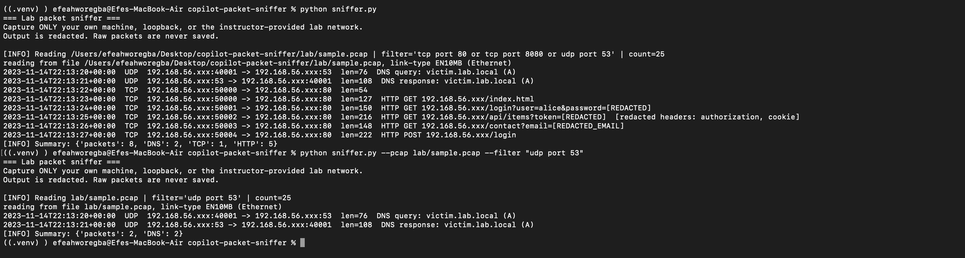
Figure 1. pcap mode with the default filter (top) and with a DNS-only BPF filter (bottom).

Mode 1: live capture on loopback
Next I ran it live on lo0 with sudo while the victim server was running. My first try used --count 40, and it stopped after only 3 of the 5 HTTP requests (summary: 40 packets, 3 DNS, 34 TCP, 3 HTTP; Figure A2). That confused me at first, but most of the lines were TCP packets with no data in them: the three-way handshake (len=68), ACKs, and the connection closing (len=56). Each HTTP request took about 11 packets in total. I ran it again with --count 120 and got all three DNS queries and all five HTTP requests (Figures 2 and 3).
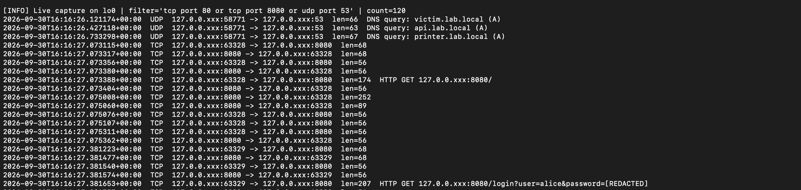
Figure 2. Live capture on lo0: three DNS queries, then TCP handshakes and the first two HTTP requests.
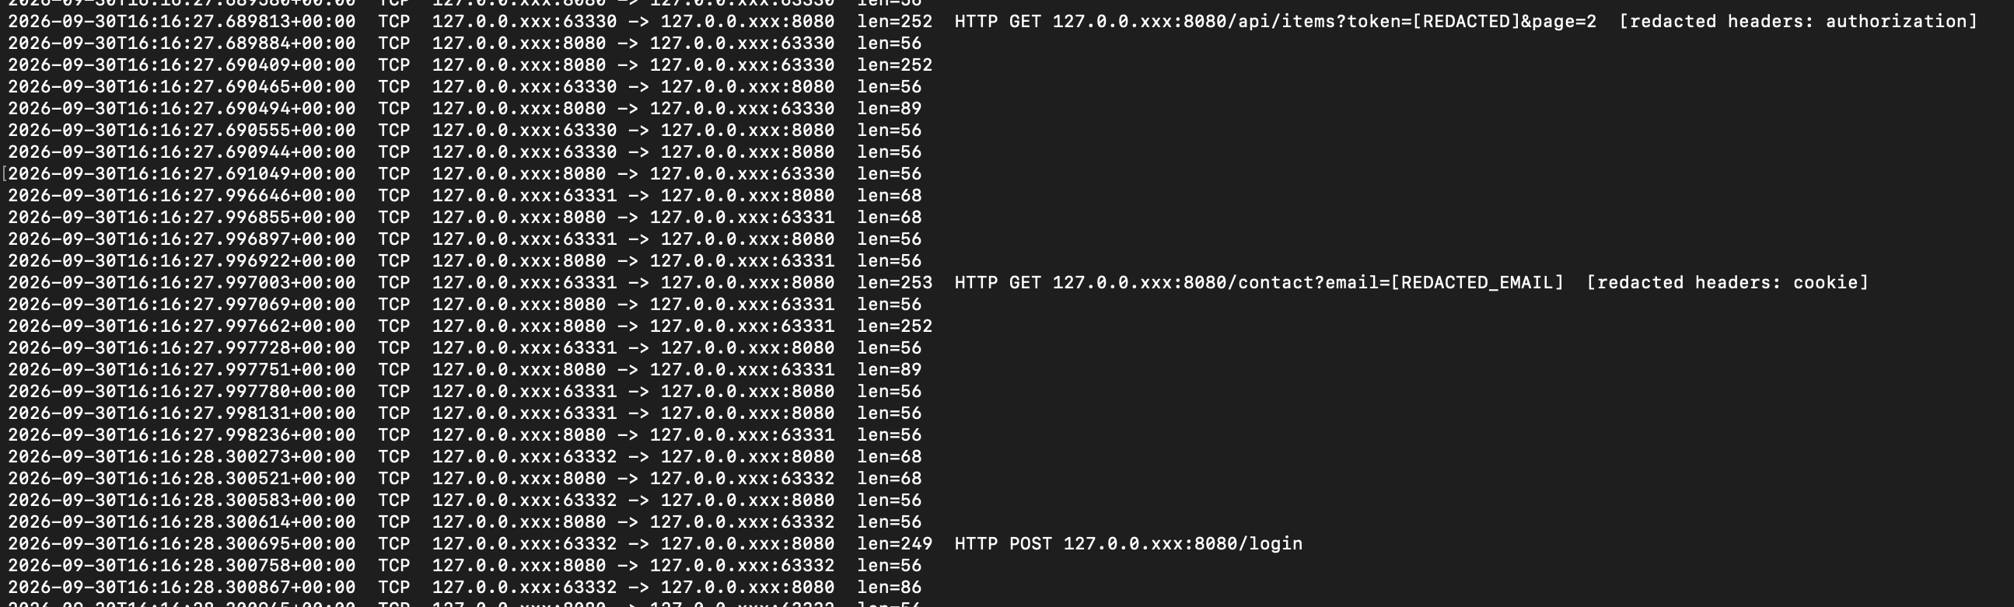
Figure 3. The rest of the live capture: token, Authorization header, email and Cookie header all redacted.
Here are the most important lines from that run (timestamps removed so they fit):
UDP 127.0.0.xxx:58771 -> 127.0.0.xxx:53 len=66 DNS query: victim.lab.local (A)
TCP 127.0.0.xxx:63329 -> 127.0.0.xxx:8080 len=207 HTTP GET 127.0.0.xxx:8080/login?user=alice&password=[REDACTED]
TCP 127.0.0.xxx:63330 -> 127.0.0.xxx:8080 len=252 HTTP GET 127.0.0.xxx:8080/api/items?token=[REDACTED]&page=2
[redacted headers: authorization]
TCP 127.0.0.xxx:63331 -> 127.0.0.xxx:8080 len=253 HTTP GET 127.0.0.xxx:8080/contact?email=[REDACTED_EMAIL]
[redacted headers: cookie]
TCP 127.0.0.xxx:63332 -> 127.0.0.xxx:8080 len=249 HTTP POST 127.0.0.xxx:8080/login
TCP 127.0.0.xxx:63332 -> 127.0.0.xxx:8080 len=86

Going through one line layer by layer: on lo0 there is no Ethernet header (macOS uses a small 4-byte loopback header instead), then IPv4 with the addresses masked, then UDP or TCP with the ports, then the application layer. DNS runs over UDP port 53 and the domain name is right there in plain text. HTTP on port 8080 is also plain text, so the method, host and full path, including anything in the query string, can be read by anyone who can see the packet.
Two things I noticed that I didn't expect:
- The POST body was split into its own packet. The login POST shows up as HTTP POST /login with no body. Right after it there's another packet from the client with len=86. Every empty packet on lo0 was 56 bytes, so that packet carried 30 bytes of data, which is exactly the length of user=bob&password=correcthorse. Python's HTTP client sent the headers and the body as two separate TCP segments. My parser only recognizes the first one as HTTP, so the second one is printed as plain TCP with just a length. If I had tried to protect passwords by searching each payload for "password=" and hiding it, a secret split across packets could have slipped through. Never printing payloads at all is the safer design.
- The server's cookie never showed up. The server's responses (the len=252 packets going from port 8080 back to the client) contain a Set-Cookie: sessionid=... header. My tool only parses requests, not responses, so that session cookie never appears in the output.

3. What I redacted and why
Everything goes through redaction before it is printed or written to the JSON log, and the tool never saves raw packets (--out refuses a .pcap filename). The decoder also only pulls out certain fields (method, host, path, sensitive header names, body length) instead of dumping the whole packet, so the regex redaction is a second layer, not the only one.
What | What the tool does | Why
IP addresses | Last octet becomes xxx (IPv6: host half hidden) | Identifies a specific device or person; the subnet is enough to learn from
MAC addresses | Keep vendor prefix only | Hardware IDs are permanent and can be used to track a device
Authorization, Bearer/Basic tokens, JWTs | [REDACTED]; only the header name is shown | These are working credentials. Anyone who copies one can log in as that user
Cookie / Set-Cookie / session IDs | [REDACTED]; only the header name is shown | A stolen session cookie lets someone take over a session without the password
password=, token=, api_key=, secret= and similar | Value becomes [REDACTED] | Secrets often end up in URLs and form posts
Email addresses (also %40-encoded) | [REDACTED_EMAIL] | Personal information
US phone numbers (added with Copilot) | [REDACTED] | Personal information
HTTP bodies | Never printed, only the length | Bodies carry form posts, JSON logins and personal content

The one thing I left readable on purpose is DNS names. They're the main thing you're supposed to learn from in this lab, and in my case they were all fake .lab.local names. On a real network, DNS names would be sensitive too, because they show every site someone visits.

4. Ethical controls I tested
The handout says leaving out iface sniffs every interface. My tool refuses that on purpose: you have to name the interface, and it has to be lo0/lo or something an instructor added to allowlist.txt. I tested both main guardrails:
- Running sudo .venv/bin/python sniffer.py --iface en0 (my Wi-Fi) was refused, even with sudo: [ERROR] Interface 'en0' is not allowlisted. Allowed: ['lo', 'lo0'] (Figure 4).
- Running python sniffer.py --iface lo0 without sudo printed [WARNING] No capture privileges ... Falling back to pcap mode and read the sample pcap instead of trying to get around the permission check (Figure 5).
These are also covered by unit tests (test_allowlist_blocks_unlisted_interface, test_unlisted_interface_exits_with_error, test_falls_back_to_pcap_without_privileges), and the packet count is capped at 500.
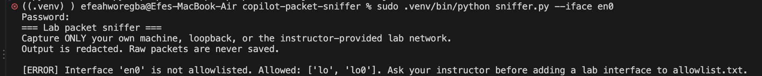
Figure 4. The sniffer refuses to capture on en0 (Wi-Fi), even with sudo.
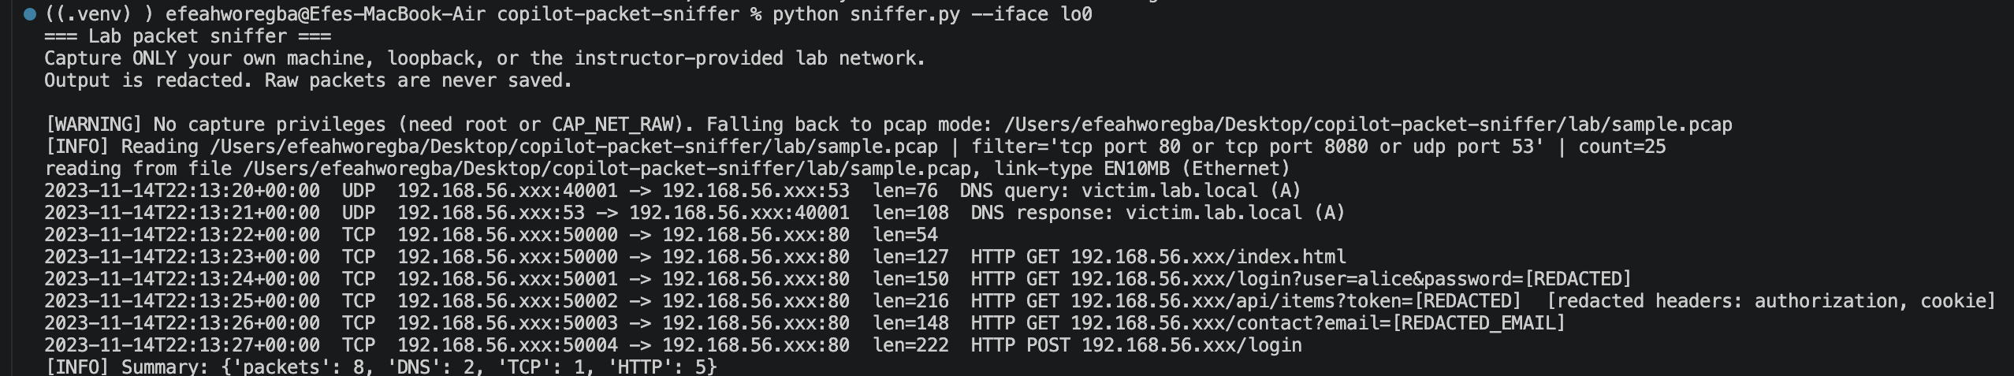
Figure 5. Without sudo, the sniffer falls back to pcap mode.

5. Copilot: what I kept, changed and rejected
I used Copilot Chat in Agent mode, which means it can edit files and run terminal commands by itself (it asks before running commands). I gave it three prompts, and I also used its inline autocomplete once.

Prompt 1: "Write a Python function using Scapy that sniffs packets and prints them." (Modified)
I expected a generic sniffer that listens on every interface and prints whole packets, because that's literally what the prompt asks for. Instead, Copilot searched my project first, said it had "confirmed the project's intended output is redacted," and added a sniff_and_print() helper to sniffer.py (+29 lines) that reuses my allowlist, privilege and count checks, plus a test for it (Figure 6). So the guardrails already in the repo pushed it toward the safe version.
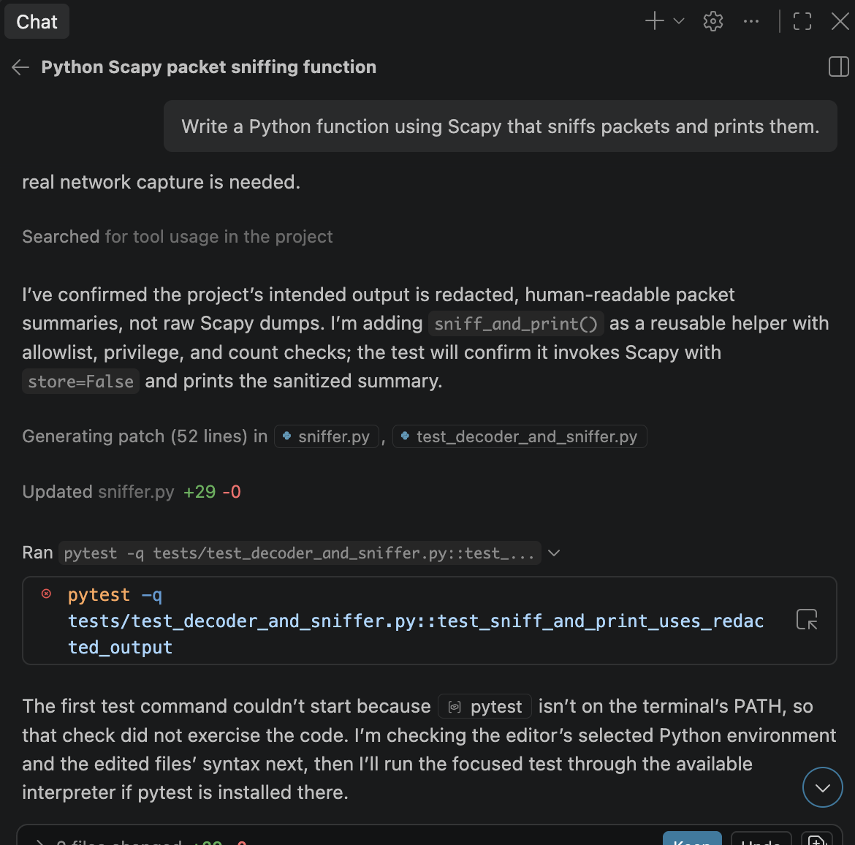
Figure 6. Copilot read the project and built a helper that uses the existing guardrails.
It wasn't perfect. Its first attempt to run the test didn't work because pytest wasn't on its terminal's PATH (it wasn't using my .venv). When I ran the whole suite myself, its new test failed: 43 passed, 1 failed (Figure 7). The error said the output was empty, but pytest's "Captured stdout" section clearly showed the redacted line. The problem was that RecordWriter used sys.stdout as a default argument. Python evaluates that once, when the file is imported, so it kept writing to the old stdout instead of the one the test was capturing. So Copilot's test actually found a real bug in the existing code. I kept Copilot's function and changed RecordWriter to look up sys.stdout when it's created instead of at import time. After that, all 45 tests passed, including Copilot's test_sniff_and_print_uses_redacted_output (Figure A5).
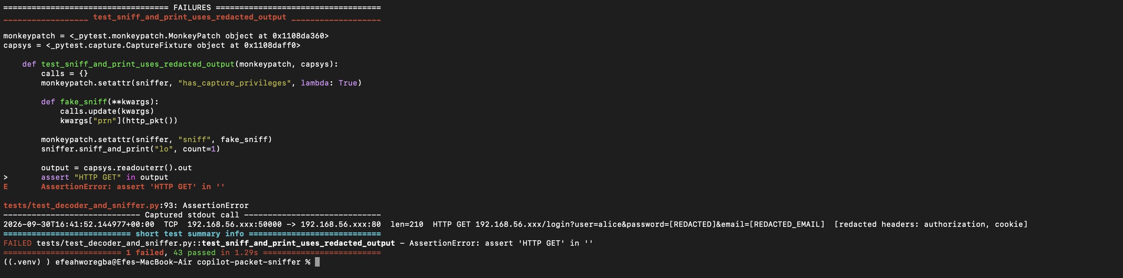
Figure 7. Copilot's test failed even though the redacted output was printed.

Prompt 2: "Add a regex to redact US phone numbers like 410-555-1234 in redact_text." (Accepted)
Copilot reviewed four files, noticed redact_text had no phone-number rule, added one compiled pattern for common US formats, and wrote a parametrized test with several formats including +1 410.555.1234 (Figure 8). It asked permission before running python3 -m pytest; I ran the tests myself in my venv instead. The phone tests passed. I also wanted to make sure the new pattern didn't eat normal output like timestamps or port numbers, and in the captured output from that test run, the timestamp 2026-09-30T16:41:52.144977 and the ports were still intact.
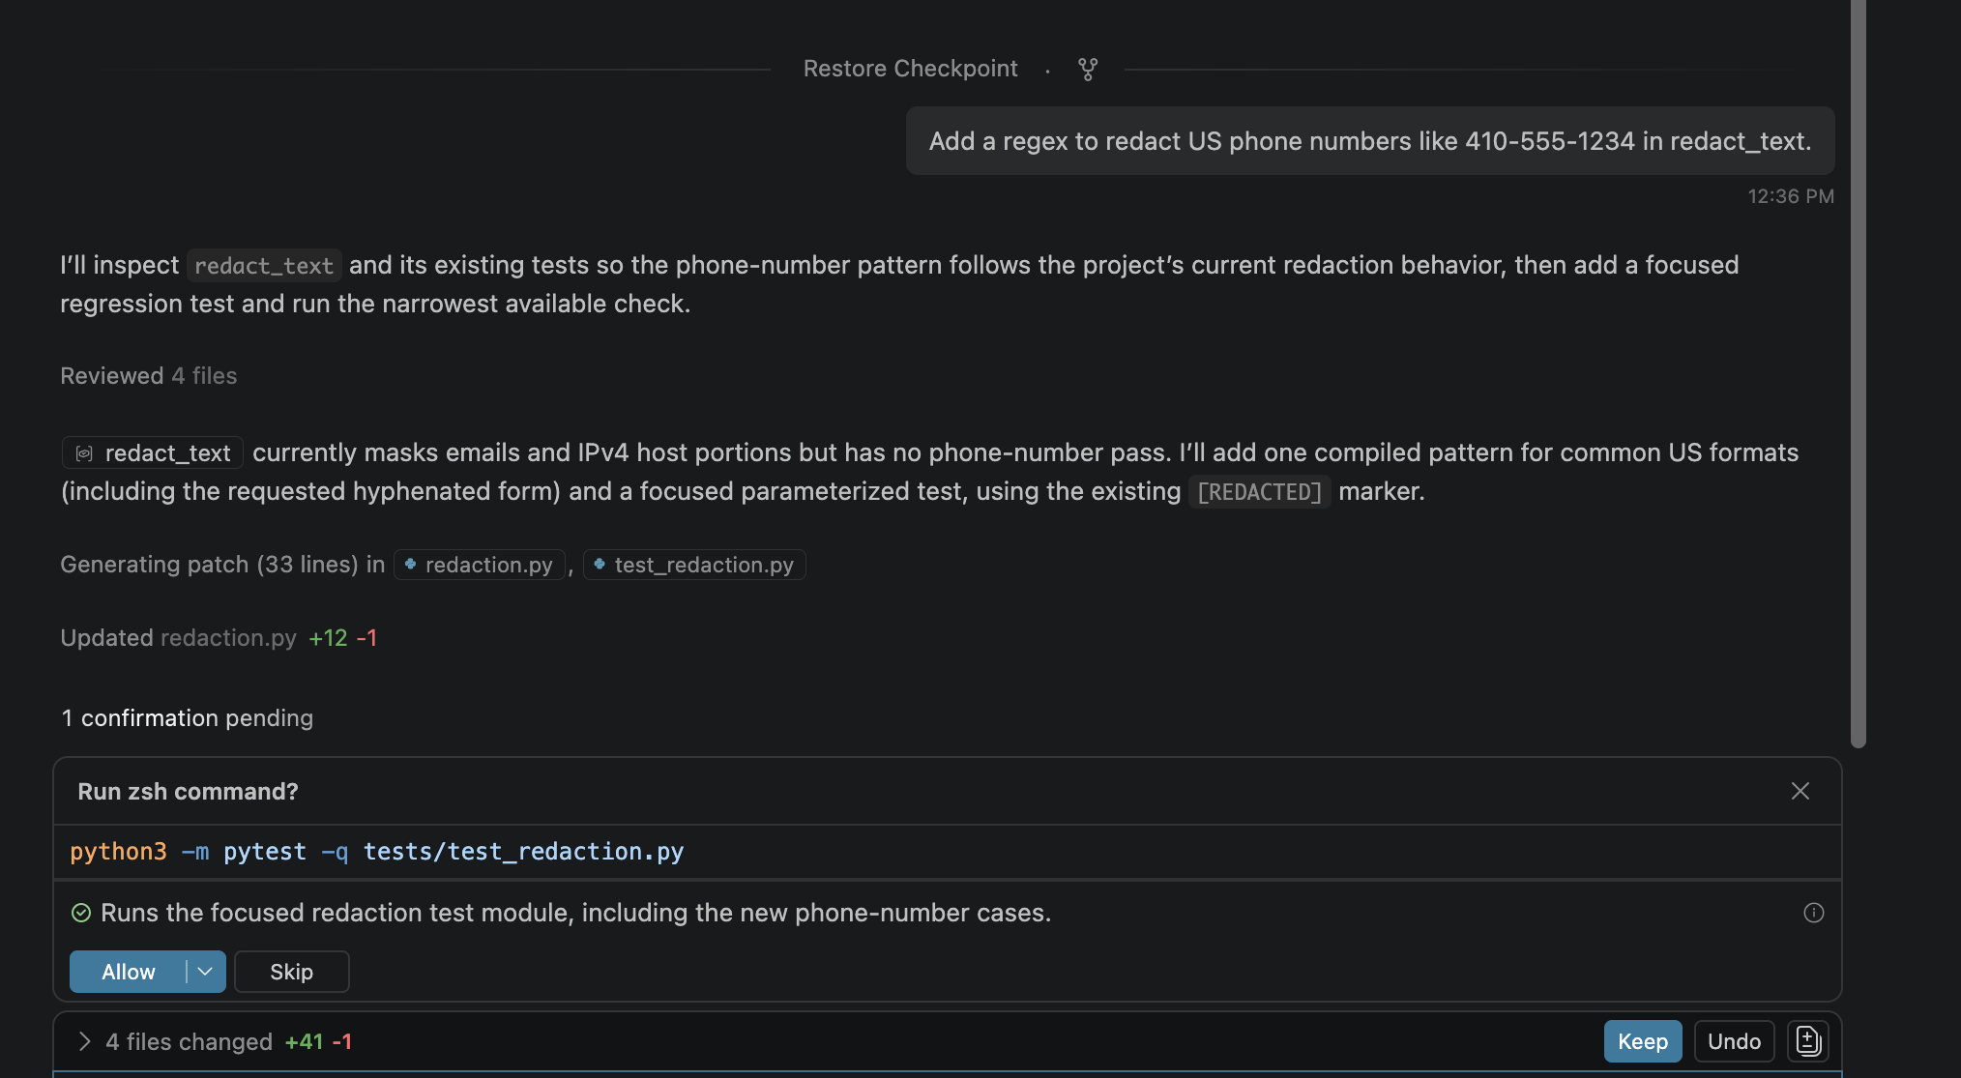
Figure 8. Copilot adds the phone-number rule and a parametrized test.
Inline suggestion (Rejected): later I started typing def test_phone_numbers_redacted(): myself and Copilot's autocomplete filled in a one-line test (Figure A3). I deleted it because it only repeated one case that Copilot's parametrized test already covered, and it was jammed right under the previous test with no blank line between them.

Prompt 3: "Add an epilog with usage examples to the argparse.ArgumentParser." (Accepted, after checking)
Copilot added examples for pcap mode, filtered capture, live loopback and JSON output, plus a --help test. It said it "verified the rendered help with temporary import stubs" because pytest and Scapy were "unavailable in the terminal environment" (Figure 9). That wasn't really true: both are installed in my .venv, and Copilot's terminal just wasn't using it. When I ran python sniffer.py --help for real, it crashed (Figure A4). The crash wasn't Copilot's fault. It happened while importing Scapy, which reads the Mac's routing table and hit its 4096-item limit (MaximumItemsCount). Importing Scapy had worked fine earlier the same day, so it seems to depend on the network I'm connected to. I fixed it by raising conf.max_list_count before importing Scapy, and then --help showed Copilot's examples correctly (Figure A6). One thing I noticed in its examples: the live-capture line uses --iface lo, which is the Linux name for loopback. On my Mac it's lo0, so that example wouldn't work as written for me.
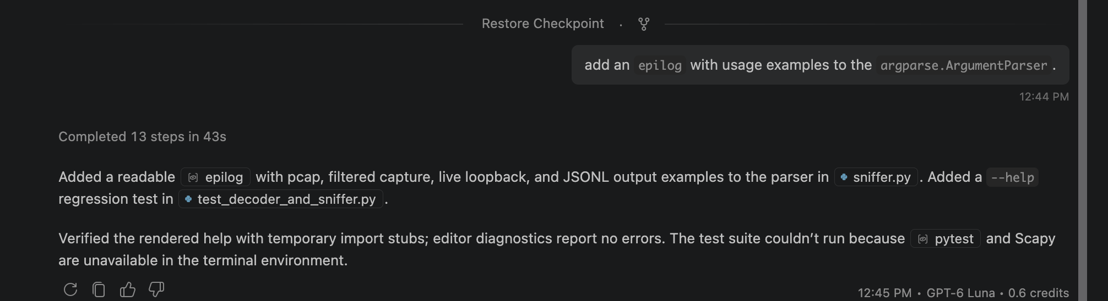
Figure 9. Copilot says it "verified" the help text using fake imports.

What I learned about using Copilot
Copilot was best at boilerplate, like the help text and the test scaffolding, which matches the AI Use Policy. The most interesting part was prompt 1: a prompt that could have produced an unsafe sniffer produced a safe one, but only because the repo already had an allowlist and redaction for it to copy. If I had started from an empty folder, I think I would have gotten a much riskier tool. The main problems were with checking its own work: two of its test runs never actually ran, one of its tests failed when I ran it, and its "verification" of the help text used fake imports. I had to run everything myself before I trusted any of it.

6. Risk memo: why sniffers are powerful and how defenders catch misuse
Why they're powerful. A sniffer sees everything that crosses an interface. In this lab, one short run showed me passwords in URLs, API tokens, session cookies and every domain that was looked up, all before I added redaction. Even encrypted traffic still leaks who is talking to whom, when, and how much. On a shared network, or combined with ARP spoofing, one compromised machine can watch many others. The same tool that helps an admin debug a network can be used to steal credentials or spy on people, which is why I only captured my own loopback traffic.
How defenders detect misuse.
- Promiscuous mode: interface flags (like PROMISC) show when a machine is listening to traffic not meant for it, and some tools send test frames to see which host responds.
- Host monitoring: endpoint tools can alert when a user runs tcpdump, Wireshark or Scapy, opens raw sockets, or uses root or BPF devices unexpectedly. Large unexplained .pcap files are also a red flag.
- Network controls: switch port security and 802.1X stop unknown devices from joining. Dynamic ARP Inspection, DHCP snooping and arpwatch catch the ARP spoofing attackers use to route traffic through their sniffer.
- Intrusion detection: tools like Zeek and Suricata flag things like duplicate IP-to-MAC mappings and ARP floods.
How to make sniffing less useful. The biggest fix is encryption: HTTPS everywhere (with HSTS), TLS for internal services, and encrypted DNS. Also: don't put secrets in URLs, use short-lived tokens, segment networks, and use WPA3 on Wi-Fi. My sniffer skipped the port 443 packet and just labeled it as encrypted, and that's what a real attacker would run into too.

7. Takeaway
Before this lab I knew HTTP wasn't encrypted, but seeing a password show up in a URL after one command made it real. Writing the redaction also showed me how easy it is to miss something, like a POST body arriving in a separate packet. With Copilot, my main takeaway is that it's helpful for boilerplate but I can't trust that something works just because it says it checked.
AI use: The starter code, tests and lab scripts were generated with help from Claude, and I extended them with GitHub Copilot as described in section 5. This report was drafted with Claude's help from my own screenshots and results, and I reviewed and edited it.

Appendix: additional screenshots
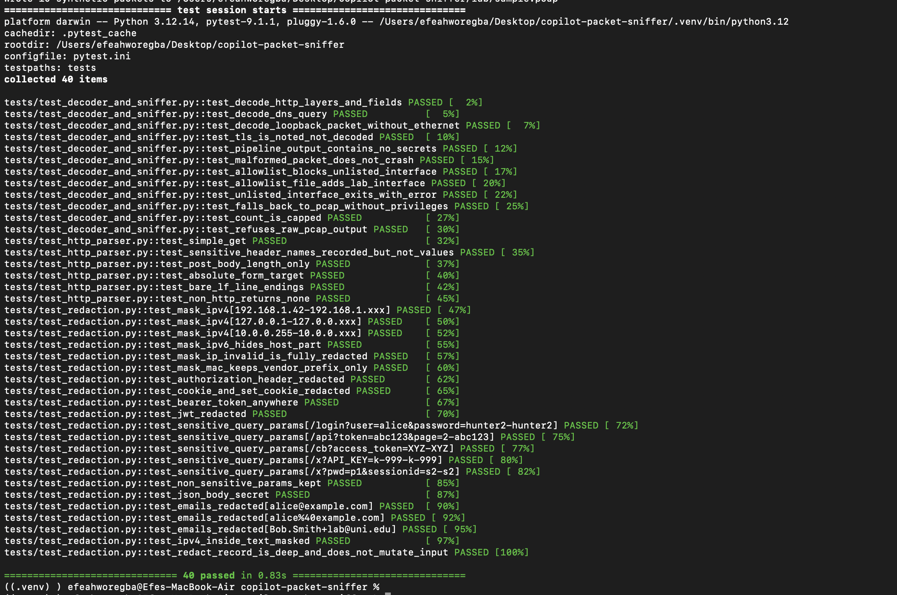
Figure A1. First test run: 40 tests passed.
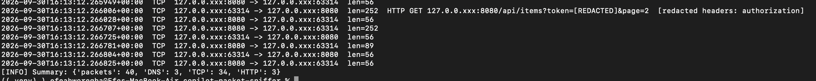
Figure A2. First live run with --count 40 ran out after 3 HTTP requests (34 of 40 packets were TCP).
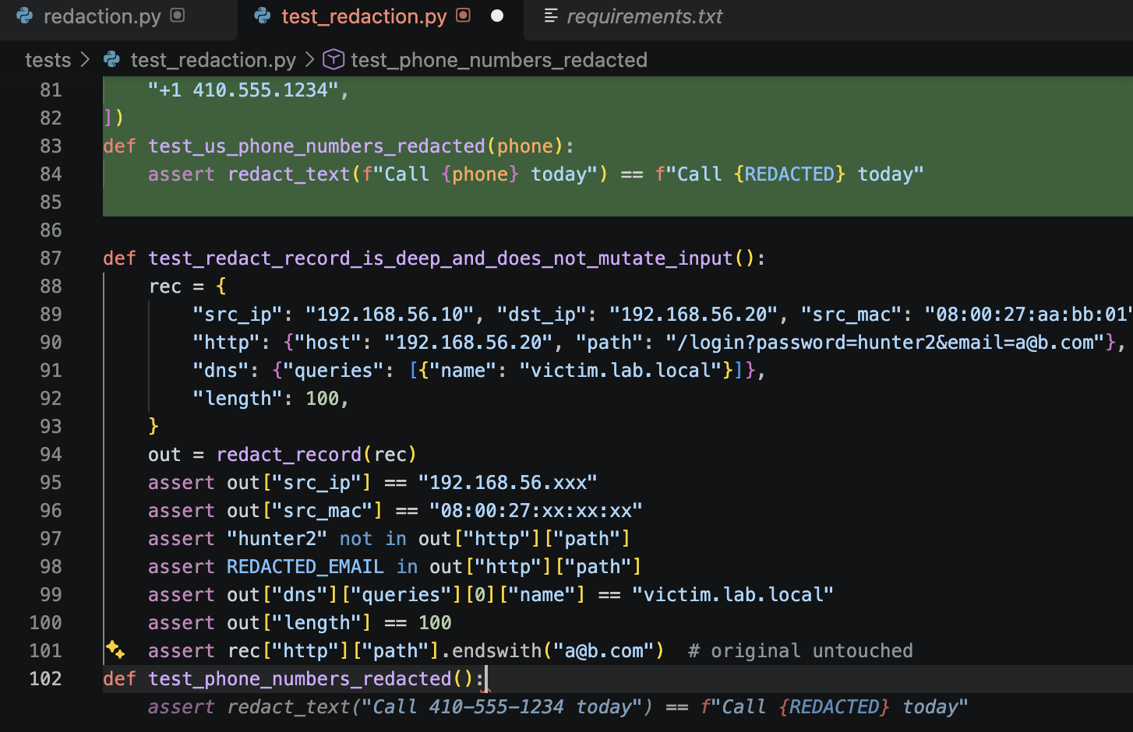
Figure A3. Copilot's inline autocomplete (grey text on the last line) duplicated an existing test, so I rejected it.
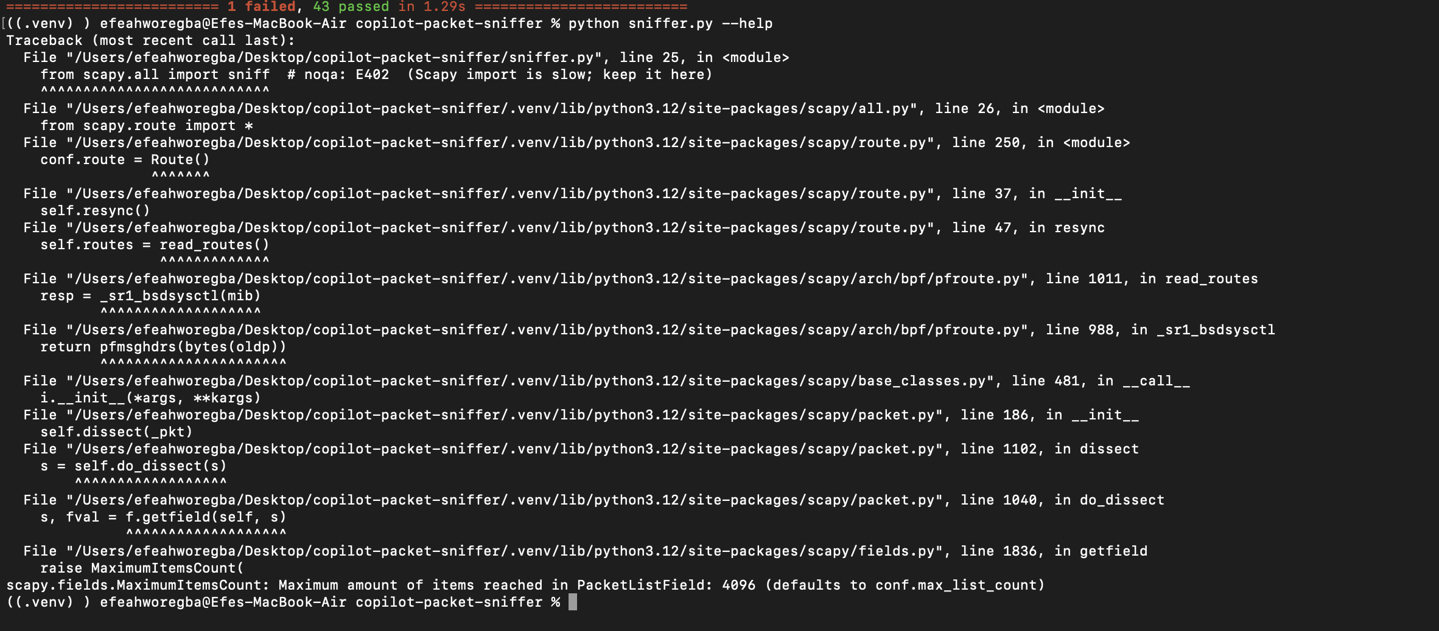
Figure A4. --help crashed while importing Scapy (routing-table limit on macOS), not in Copilot's code.
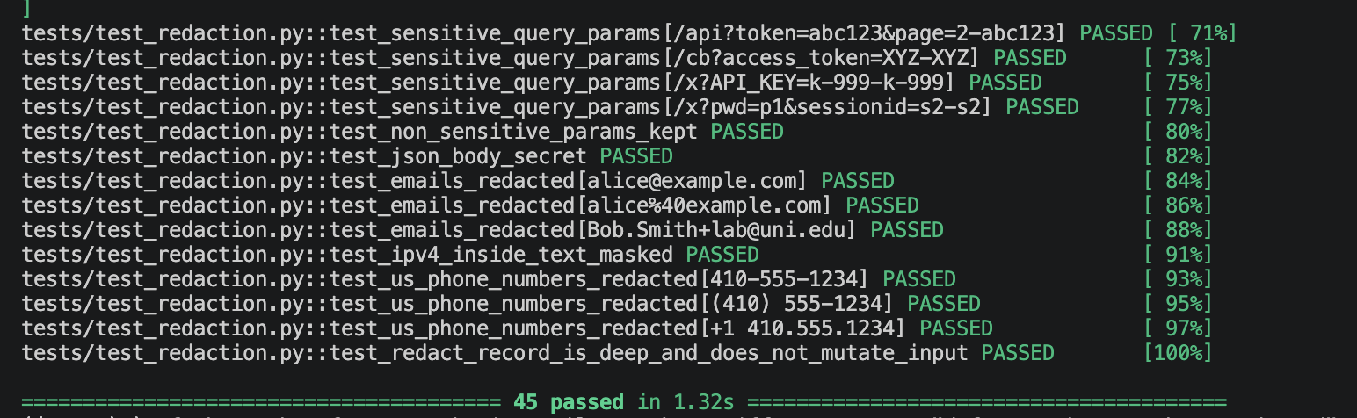
Figure A5. All 45 tests pass after fixing RecordWriter, including Copilot's new tests.
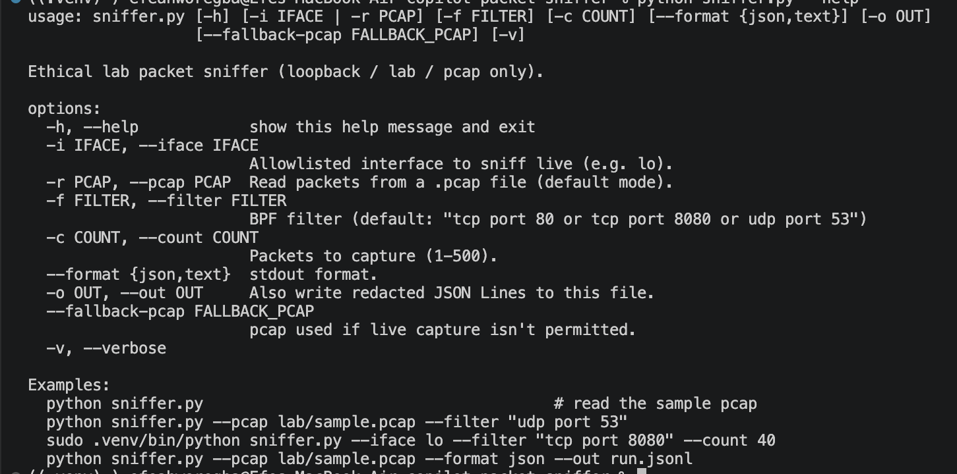
Figure A6. Help text with Copilot's usage examples.

