Middle East Technical University
CENG 471 — Parallel Computing
Parallel Traffic Flow Optimizer

Term Project Report
Student Name: Your Name
Student ID: XXXXXXXXX
April 2026

1. Introduction
Traffic flow optimization is a fundamental problem in urban transportation engineering. Modern cities face growing congestion that wastes fuel, increases emissions, and reduces quality of life. Optimizing traffic signal timing, detecting road bottlenecks, and routing vehicles efficiently are three core sub-problems that must be solved continuously and in near-real-time for large networks.
Parallelism is a natural fit for this domain: each intersection's signal can be optimized independently, each road's congestion can be detected independently, and each vehicle's route can be computed independently. These properties make the problem embarrassingly parallel at the per-object level — exactly the category where data-parallel thread decomposition yields maximum speedup.
This project implements a Parallel Traffic Flow Optimizer in Python using the threading module, which is CPython's direct wrapper around POSIX Pthreads. Three parallel worker classes — SignalOptimizer, CongestionDetector, and RouteFlowComputer — are designed and benchmarked against a serial baseline to quantify speedup, efficiency, and scalability.
Work division:
- Your Name (XXXXXXXXX): All implementation, benchmarking, and report.

2. Problem Description

2.1 Traffic Network Model
The traffic network is modelled as a directed graph where nodes are Intersections and edges are Roads. A side×side grid topology is used, producing side² intersections and approximately 4×side×(side−1) directed road segments (bidirectional adjacency).
Each Intersection stores:
- id, x/y grid coordinates
- vehicle_count — current queue length
- green_time / red_time — current signal phase durations
- optimized_green — result of Webster's formula
- wait_time — estimated average wait per cycle
- lock — per-intersection threading.Lock for thread safety
Each Road stores:
- source / dest — connecting intersection IDs
- capacity / flow — maximum and current vehicle counts
- congestion — flow/capacity ratio in [0, 1]
- travel_time — base traversal time in seconds
- lock — per-road threading.Lock

2.2 Sub-Problems
The optimizer solves three independent sub-problems:
- Signal Timing: compute optimal green time per intersection using Webster's formula.
- Congestion Detection: classify each road as bottleneck (congestion ≥ 0.8) or free.
- Route Computation: find the shortest congestion-weighted path per vehicle via Dijkstra.
Because each intersection, road, and vehicle can be processed independently of the others in each phase, the workload is embarrassingly parallel — the ideal case for thread-level data parallelism.

3. Parallel Design

3.1 Decomposition Strategy
The parallel implementation uses data parallelism: the collection of work items (intersections, roads, or vehicles) is partitioned into equal-sized chunks, one per thread. Each thread processes its chunk independently, then synchronizes at a barrier or lock before aggregating results.

3.2 Thread Worker Classes
SignalOptimizer(threading.Thread)
- Receives a partition of Intersection objects.
- Applies Webster's formula to each intersection in its chunk.
- Uses threading.Barrier to synchronize all signal threads before writing to the shared results dict.
CongestionDetector(threading.Thread)
- Receives a partition of Road objects.
- Computes flow/capacity ratio and flags bottlenecks.
- Appends to a shared list under a global threading.Lock.
RouteFlowComputer(threading.Thread)
- Receives a partition of Vehicle objects.
- Runs Dijkstra's algorithm per vehicle.
- Acquires per-road locks when updating road.flow after routing.
- Reports statistics via a queue.Queue.

3.3 Synchronization Primitives
Primitive | Where Used | Purpose
threading.Lock (per-object) | Each Intersection, each Road | Protect mutable state
threading.Lock (global) | Shared results dict/list | Aggregate thread-local results
threading.Barrier | SignalOptimizer | Phase synchronization
queue.Queue | RouteFlowComputer | Thread-safe stats aggregation

4. Algorithms

4.1 Webster's Signal Optimization
Webster's formula (1958) derives the optimal traffic signal cycle length:
C = (1.5 × L + 5) / (1 − Y)
Where:
- L = total lost time per cycle (fixed at 4 seconds)
- Y = critical flow ratio = vehicle_count / 100 (capped at 0.9)
g = C × (vehicle_count / total_demand)
g = clamp(g, 10, 80) # seconds

4.2 Congestion Detection
congestion_ratio = flow / capacity
bottleneck = (congestion_ratio >= 0.8)
Congestion ratio in [0.0, 1.0] is stored on each road. Values ≥ 0.8 are flagged as bottlenecks.

4.3 Dijkstra's Shortest Path
Standard Dijkstra with congestion-weighted edge costs:
weight(road) = travel_time × (1 + congestion_ratio)
This penalizes congested roads, routing vehicles around bottlenecks. Each vehicle's route is computed independently, making this phase trivially parallelizable.

5. Code Listings

5.1 network.py
"""
network.py — Traffic network data structures for the Parallel Traffic Flow Optimizer.
CENG 471 Parallel Computing — Term Project
"""

import threading
import random
from dataclasses import dataclass, field
from typing import Dict, List, Optional

@dataclass
class Intersection:
id: int
x: float # grid position
y: float
vehicle_count: int # current vehicles queued
green_time: float # current green signal duration (seconds)
red_time: float
optimized_green: float # result after optimization
wait_time: float # estimated average wait
lock: threading.Lock = field(default_factory=threading.Lock)

def __repr__(self):
return (f"Intersection(id={self.id}, pos=({self.x},{self.y}), "
f"vehicles={self.vehicle_count}, green={self.green_time:.1f}s, "
f"opt_green={self.optimized_green:.1f}s)")

@dataclass
class Road:
id: int
source: int # source intersection id
dest: int # destination intersection id
capacity: int # max vehicle capacity
flow: int # current vehicle count
congestion: float # flow / capacity ratio (0.0–1.0)
travel_time: float # base travel time in seconds
lock: threading.Lock = field(default_factory=threading.Lock)

def __repr__(self):
return (f"Road(id={self.id}, {self.source}->{self.dest}, "
f"flow={self.flow}/{self.capacity}, congestion={self.congestion:.2f})")

@dataclass
class Vehicle:
id: int
source: int
dest: int
route: List[int] # list of intersection IDs forming the path
total_wait: float # total estimated wait along route

def __repr__(self):
return (f"Vehicle(id={self.id}, {self.source}->{self.dest}, "
f"route_len={len(self.route)}, wait={self.total_wait:.1f}s)")

class TrafficNetwork:
def __init__(self):
self.intersections: Dict[int, Intersection] = {}
self.roads: Dict[int, Road] = {}
self.adjacency: Dict[int, List[int]] = {} # intersection_id → list of road_ids
self.vehicles: List[Vehicle] = []

def build_grid(self, side: int):
"""Build an N×N grid traffic network."""
self.intersections.clear()
self.roads.clear()
self.adjacency.clear()
self.vehicles.clear()

n = side * side
road_id = 0

# Create intersections
for i in range(side):
for j in range(side):
iid = i * side + j
self.intersections[iid] = Intersection(
id=iid,
x=float(j),
y=float(i),
vehicle_count=random.randint(0, 50),
green_time=random.uniform(20.0, 60.0),
red_time=random.uniform(20.0, 60.0),
optimized_green=0.0,
wait_time=0.0,
)
self.adjacency[iid] = []

# Create roads (bidirectional edges between adjacent grid nodes)
for i in range(side):
for j in range(side):
src = i * side + j

# Right neighbor
if j + 1 < side:
dst = i * side + (j + 1)
cap = random.randint(50, 150)
flow = random.randint(0, cap)
self._add_road(road_id, src, dst, cap, flow)
road_id += 1
self._add_road(road_id, dst, src, cap, random.randint(0, cap))
road_id += 1

# Down neighbor
if i + 1 < side:
dst = (i + 1) * side + j
cap = random.randint(50, 150)
flow = random.randint(0, cap)
self._add_road(road_id, src, dst, cap, flow)
road_id += 1
self._add_road(road_id, dst, src, cap, random.randint(0, cap))
road_id += 1

def _add_road(self, rid: int, src: int, dst: int, cap: int, flow: int):
flow = min(flow, cap)
congestion = flow / cap if cap > 0 else 0.0
travel_time = random.uniform(30.0, 120.0)
road = Road(
id=rid,
source=src,
dest=dst,
capacity=cap,
flow=flow,
congestion=congestion,
travel_time=travel_time,
)
self.roads[rid] = road
self.adjacency[src].append(rid)

def generate_vehicles(self, count: int):
"""Generate vehicles with random source and destination intersections."""
self.vehicles.clear()
iids = list(self.intersections.keys())
if len(iids) < 2:
return

for i in range(count):
src, dst = random.sample(iids, 2)
self.vehicles.append(Vehicle(
id=i,
source=src,
dest=dst,
route=[],
total_wait=0.0,
))

def summary(self) -> str:
n_int = len(self.intersections)
n_road = len(self.roads)
n_veh = len(self.vehicles)
avg_cong = (sum(r.congestion for r in self.roads.values()) / n_road
if n_road else 0.0)
return (f"Network: {n_int} intersections, {n_road} roads, "
f"{n_veh} vehicles, avg_congestion={avg_cong:.2f}")

5.2 algorithms.py
"""
algorithms.py — Core algorithms for the Parallel Traffic Flow Optimizer.
CENG 471 Parallel Computing — Term Project

Implements:
1. Webster's signal optimization formula
2. Congestion detection (flow/capacity ratio)
3. Dijkstra's shortest path with congestion-weighted edges
"""

import heapq
from typing import Dict, List, Optional, Tuple

from network import Intersection, Road, Vehicle, TrafficNetwork

# ---------------------------------------------------------------------------
# 1. Signal Optimization — Webster's Formula
# ---------------------------------------------------------------------------

def optimize_signal(intr: Intersection) -> None:
"""
Apply Webster's formula to compute the optimal green time for an intersection.

Webster's formula:
C = (1.5 * L + 5) / (1 - Y)
L = total lost time per cycle (fixed at 4 s)
Y = critical flow ratio = vehicle_count / 100 (capped at 0.9)

Green time per phase:
g = C * (vehicle_count / total_demand)
g = clamp(g, 10, 80) seconds

Wait time estimate:
wait = C / 2 (simplified uniform arrival model)
"""
L = 4.0 # total lost time (seconds)
Y = min(intr.vehicle_count / 100.0, 0.9) # critical flow ratio
total_demand = max(intr.vehicle_count, 1)

if Y >= 1.0:
Y = 0.9

C = (1.5 * L + 5.0) / (1.0 - Y) # optimal cycle length
g = C * (intr.vehicle_count / total_demand)
g = max(10.0, min(g, 80.0)) # clamp to [10, 80] seconds

intr.optimized_green = g
intr.wait_time = C / 2.0

# ---------------------------------------------------------------------------
# 2. Congestion Detection
# ---------------------------------------------------------------------------

def detect_congestion(road: Road) -> bool:
"""
Compute congestion ratio and flag bottlenecks.

congestion_ratio = flow / capacity
bottleneck = congestion_ratio >= 0.8

Updates road.congestion in place.
Returns True if the road is a bottleneck.
"""
if road.capacity <= 0:
road.congestion = 0.0
return False

road.congestion = min(road.flow / road.capacity, 1.0)
return road.congestion >= 0.8

# ---------------------------------------------------------------------------
# 3. Shortest Path Routing — Dijkstra's Algorithm
# ---------------------------------------------------------------------------

def dijkstra(
network: TrafficNetwork,
source: int,
dest: int,
) -> Tuple[List[int], float]:
"""
Standard Dijkstra's shortest path with congestion-weighted edges.

Edge weight: travel_time * (1 + congestion_ratio)

Returns:
(path, total_cost) — path is a list of intersection IDs.
If unreachable, returns ([], float('inf')).
"""
dist: Dict[int, float] = {nid: float("inf") for nid in network.intersections}
prev: Dict[int, Optional[int]] = {nid: None for nid in network.intersections}
dist[source] = 0.0

# Priority queue: (cost, intersection_id)
pq: List[Tuple[float, int]] = [(0.0, source)]

while pq:
cost, u = heapq.heappop(pq)

if cost > dist[u]:
continue

if u == dest:
break

for road_id in network.adjacency.get(u, []):
road = network.roads[road_id]
v = road.dest

weight = road.travel_time * (1.0 + road.congestion)
new_cost = dist[u] + weight

if new_cost < dist[v]:
dist[v] = new_cost
prev[v] = u
heapq.heappush(pq, (new_cost, v))

# Reconstruct path
if dist[dest] == float("inf"):
return [], float("inf")

path: List[int] = []
cur: Optional[int] = dest
while cur is not None:
path.append(cur)
cur = prev[cur]
path.reverse()

return path, dist[dest]

def compute_route(vehicle: Vehicle, network: TrafficNetwork) -> None:
"""
Compute the optimal route for a vehicle using Dijkstra's algorithm.
Updates vehicle.route and vehicle.total_wait in place.

This function is designed to be called from multiple threads simultaneously;
it only reads network.roads/adjacency (which are stable during routing)
and writes only to the vehicle object passed to it.
"""
path, cost = dijkstra(network, vehicle.source, vehicle.dest)
vehicle.route = path
vehicle.total_wait = cost if cost != float("inf") else 0.0

5.3 serial_optimizer.py
"""
serial_optimizer.py — Single-threaded baseline for the Parallel Traffic Flow Optimizer.
CENG 471 Parallel Computing — Term Project

Runs all three optimization phases sequentially in a single thread.
Used as the baseline for speedup measurement.
"""

import time
from typing import Dict, List, Any

from network import TrafficNetwork, Intersection, Road, Vehicle
from algorithms import optimize_signal, detect_congestion, compute_route

def run_serial(network: TrafficNetwork, verbose: bool = False) -> Dict[str, Any]:
"""
Run all three optimization phases serially (single-threaded).

Phases:
1. Signal optimization — Webster's formula per intersection
2. Congestion detection — flow/capacity ratio per road
3. Route computation — Dijkstra's shortest path per vehicle

Returns a results dictionary containing:
- signal_results : dict mapping intersection_id → optimized_green
- bottlenecks : list of road_ids where congestion >= 0.8
- route_stats : dict with avg_wait, total_vehicles, routed_vehicles
- phase_times : dict with wall-clock time per phase (seconds)
"""
phase_times: Dict[str, float] = {}

# ------------------------------------------------------------------
# Phase 1: Signal Optimization
# ------------------------------------------------------------------
t0 = time.perf_counter()

signal_results: Dict[int, float] = {}
for intr in network.intersections.values():
optimize_signal(intr)
signal_results[intr.id] = intr.optimized_green

phase_times["signal"] = time.perf_counter() - t0

if verbose:
print(f" [Serial] Phase 1 (signal opt): {phase_times['signal']:.4f}s "
f"({len(signal_results)} intersections)")

# ------------------------------------------------------------------
# Phase 2: Congestion Detection
# ------------------------------------------------------------------
t0 = time.perf_counter()

bottlenecks: List[int] = []
for road in network.roads.values():
if detect_congestion(road):
bottlenecks.append(road.id)

phase_times["congestion"] = time.perf_counter() - t0

if verbose:
print(f" [Serial] Phase 2 (congestion): {phase_times['congestion']:.4f}s "
f"({len(bottlenecks)} bottlenecks / {len(network.roads)} roads)")

# ------------------------------------------------------------------
# Phase 3: Route Computation
# ------------------------------------------------------------------
t0 = time.perf_counter()

for vehicle in network.vehicles:
compute_route(vehicle, network)

phase_times["routing"] = time.perf_counter() - t0

routed = sum(1 for v in network.vehicles if len(v.route) > 0)
total_wait = sum(v.total_wait for v in network.vehicles if len(v.route) > 0)
avg_wait = total_wait / routed if routed > 0 else 0.0

route_stats = {
"total_vehicles": len(network.vehicles),
"routed_vehicles": routed,
"avg_wait": avg_wait,
"total_wait": total_wait,
}

if verbose:
print(f" [Serial] Phase 3 (routing): {phase_times['routing']:.4f}s "
f"({routed}/{len(network.vehicles)} vehicles routed, "
f"avg_wait={avg_wait:.1f}s)")

total_time = sum(phase_times.values())
if verbose:
print(f" [Serial] Total time: {total_time:.4f}s")

return {
"signal_results": signal_results,
"bottlenecks": bottlenecks,
"route_stats": route_stats,
"phase_times": phase_times,
"total_time": total_time,
}

5.4 parallel_optimizer.py
"""
parallel_optimizer.py — Multi-threaded implementation of the Traffic Flow Optimizer.
CENG 471 Parallel Computing — Term Project

Synchronization primitives used:
- threading.Lock : per Intersection, per Road, and global results lists
- threading.Barrier : phase synchronization for SignalOptimizer threads
- queue.Queue : thread-safe statistics aggregation for routing
"""

import threading
import queue
import time
from typing import Dict, List, Any, Optional

from network import TrafficNetwork, Intersection, Road, Vehicle
from algorithms import optimize_signal, detect_congestion, compute_route

# ---------------------------------------------------------------------------
# Workload Partitioning
# ---------------------------------------------------------------------------

def partition(items: list, num_threads: int) -> List[list]:
"""
Split items into num_threads roughly equal chunks.
The last chunk absorbs any remainder.
"""
if num_threads <= 0:
return [items]
n = len(items)
chunk = max(1, n // num_threads)
parts = []
for i in range(num_threads):
start = i * chunk
# Last thread takes the remainder
end = start + chunk if i < num_threads - 1 else n
parts.append(items[start:end])
return parts

# ---------------------------------------------------------------------------
# Thread Worker 1: Signal Optimization
# ---------------------------------------------------------------------------

class SignalOptimizer(threading.Thread):
"""
Applies Webster's formula to a subset of intersections.

Synchronization:
- barrier: all signal threads rendezvous before writing aggregated results
- global_lock: protects the shared signal_results dict
- Per-intersection lock is acquired before writing optimized_green / wait_time
"""

def __init__(
self,
thread_id: int,
intersections: List[Intersection],
signal_results: Dict[int, float],
global_lock: threading.Lock,
barrier: threading.Barrier,
verbose: bool = False,
):
super().__init__(name=f"SignalOptimizer-{thread_id}")
self.thread_id = thread_id
self.intersections = intersections
self.signal_results = signal_results
self.global_lock = global_lock
self.barrier = barrier
self.verbose = verbose
self.elapsed: float = 0.0

def run(self):
t0 = time.perf_counter()

# Compute locally; each intersection object is thread-safe via its own lock
local_results: Dict[int, float] = {}
for intr in self.intersections:
with intr.lock:
optimize_signal(intr)
local_results[intr.id] = intr.optimized_green

# Wait for all signal threads to finish computing before aggregating
self.barrier.wait()

# Merge local results into shared dict under global lock
with self.global_lock:
self.signal_results.update(local_results)

self.elapsed = time.perf_counter() - t0
if self.verbose:
print(f" [{self.name}] processed {len(self.intersections)} intersections "
f"in {self.elapsed:.4f}s")

# ---------------------------------------------------------------------------
# Thread Worker 2: Congestion Detection
# ---------------------------------------------------------------------------

class CongestionDetector(threading.Thread):
"""
Computes flow/capacity congestion ratio for a subset of roads.

Synchronization:
- Per-road lock is acquired before updating road.congestion
- global_lock protects the shared bottlenecks list
"""

def __init__(
self,
thread_id: int,
roads: List[Road],
bottlenecks: List[int],
global_lock: threading.Lock,
verbose: bool = False,
):
super().__init__(name=f"CongestionDetector-{thread_id}")
self.thread_id = thread_id
self.roads = roads
self.bottlenecks = bottlenecks
self.global_lock = global_lock
self.verbose = verbose
self.elapsed: float = 0.0

def run(self):
t0 = time.perf_counter()

local_bottlenecks: List[int] = []
for road in self.roads:
with road.lock:
is_bottleneck = detect_congestion(road)
if is_bottleneck:
local_bottlenecks.append(road.id)

with self.global_lock:
self.bottlenecks.extend(local_bottlenecks)

self.elapsed = time.perf_counter() - t0
if self.verbose:
print(f" [{self.name}] processed {len(self.roads)} roads, "
f"{len(local_bottlenecks)} bottlenecks in {self.elapsed:.4f}s")

# ---------------------------------------------------------------------------
# Thread Worker 3: Route Flow Computation
# ---------------------------------------------------------------------------

class RouteFlowComputer(threading.Thread):
"""
Computes Dijkstra routes for a subset of vehicles and updates road flows.

Synchronization:
- Per-road lock is acquired when updating road.flow after routing
- stats_q (queue.Queue) collects per-thread statistics thread-safely
"""

def __init__(
self,
thread_id: int,
vehicles: List[Vehicle],
network: TrafficNetwork,
global_lock: threading.Lock,
stats_q: queue.Queue,
verbose: bool = False,
):
super().__init__(name=f"RouteFlowComputer-{thread_id}")
self.thread_id = thread_id
self.vehicles = vehicles
self.network = network
self.global_lock = global_lock
self.stats_q = stats_q
self.verbose = verbose
self.elapsed: float = 0.0

def run(self):
t0 = time.perf_counter()

routed = 0
total_wait = 0.0

for vehicle in self.vehicles:
compute_route(vehicle, self.network)

# Update road flows along the computed route (requires per-road lock)
if len(vehicle.route) >= 2:
routed += 1
total_wait += vehicle.total_wait
self._update_road_flows(vehicle)

self.elapsed = time.perf_counter() - t0

self.stats_q.put({
"thread_id": self.thread_id,
"routed": routed,
"total_wait": total_wait,
"elapsed": self.elapsed,
})

if self.verbose:
print(f" [{self.name}] routed {routed}/{len(self.vehicles)} vehicles "
f"in {self.elapsed:.4f}s")

def _update_road_flows(self, vehicle: Vehicle):
"""Increment flow on each road traversed by this vehicle."""
route = vehicle.route
for i in range(len(route) - 1):
u, v = route[i], route[i + 1]
# Find the road connecting u → v
for road_id in self.network.adjacency.get(u, []):
road = self.network.roads[road_id]
if road.dest == v:
with road.lock:
road.flow = min(road.flow + 1, road.capacity)
road.congestion = road.flow / road.capacity
break

# ---------------------------------------------------------------------------
# Main Parallel Run Function
# ---------------------------------------------------------------------------

def run_parallel(
network: TrafficNetwork,
num_threads: int,
verbose: bool = False,
) -> Dict[str, Any]:
"""
Run all three optimization phases in parallel using num_threads threads.

Returns the same structure as serial_optimizer.run_serial().
"""
phase_times: Dict[str, float] = {}
signal_results: Dict[int, float] = {}
bottlenecks: List[int] = []
global_lock = threading.Lock()

intersections = list(network.intersections.values())
roads = list(network.roads.values())
vehicles = list(network.vehicles)

# Clamp num_threads to available work
nt_signal = min(num_threads, max(1, len(intersections)))
nt_cong = min(num_threads, max(1, len(roads)))
nt_route = min(num_threads, max(1, len(vehicles)))

# ------------------------------------------------------------------
# Phase 1: Signal Optimization
# ------------------------------------------------------------------
t0 = time.perf_counter()

barrier = threading.Barrier(nt_signal)
int_parts = partition(intersections, nt_signal)

signal_threads = [
SignalOptimizer(
i, int_parts[i], signal_results, global_lock, barrier, verbose
)
for i in range(nt_signal)
]
for t in signal_threads:
t.start()
for t in signal_threads:
t.join()

phase_times["signal"] = time.perf_counter() - t0

if verbose:
print(f" [Parallel] Phase 1 (signal opt): {phase_times['signal']:.4f}s "
f"({nt_signal} threads, {len(intersections)} intersections)")

# ------------------------------------------------------------------
# Phase 2: Congestion Detection
# ------------------------------------------------------------------
t0 = time.perf_counter()

road_parts = partition(roads, nt_cong)

congestion_threads = [
CongestionDetector(i, road_parts[i], bottlenecks, global_lock, verbose)
for i in range(nt_cong)
]
for t in congestion_threads:
t.start()
for t in congestion_threads:
t.join()

phase_times["congestion"] = time.perf_counter() - t0

if verbose:
print(f" [Parallel] Phase 2 (congestion): {phase_times['congestion']:.4f}s "
f"({nt_cong} threads, {len(bottlenecks)} bottlenecks)")

# ------------------------------------------------------------------
# Phase 3: Route Computation
# ------------------------------------------------------------------
t0 = time.perf_counter()

stats_q: queue.Queue = queue.Queue()
veh_parts = partition(vehicles, nt_route)

route_threads = [
RouteFlowComputer(i, veh_parts[i], network, global_lock, stats_q, verbose)
for i in range(nt_route)
]
for t in route_threads:
t.start()
for t in route_threads:
t.join()

phase_times["routing"] = time.perf_counter() - t0

# Collect routing stats from queue
total_routed = 0
total_wait = 0.0
while not stats_q.empty():
s = stats_q.get_nowait()
total_routed += s["routed"]
total_wait += s["total_wait"]

avg_wait = total_wait / total_routed if total_routed > 0 else 0.0
route_stats = {
"total_vehicles": len(vehicles),
"routed_vehicles": total_routed,
"avg_wait": avg_wait,
"total_wait": total_wait,
}

if verbose:
print(f" [Parallel] Phase 3 (routing): {phase_times['routing']:.4f}s "
f"({nt_route} threads, {total_routed}/{len(vehicles)} routed, "
f"avg_wait={avg_wait:.1f}s)")

total_time = sum(phase_times.values())
if verbose:
print(f" [Parallel] Total time: {total_time:.4f}s")

return {
"signal_results": signal_results,
"bottlenecks": bottlenecks,
"route_stats": route_stats,
"phase_times": phase_times,
"total_time": total_time,
"num_threads": num_threads,
}

6. Results & Screenshots

6.1 Terminal Output
[Image not found: terminal_output.png — run benchmark and visualize.py first]

6.2 Speedup vs Thread Count
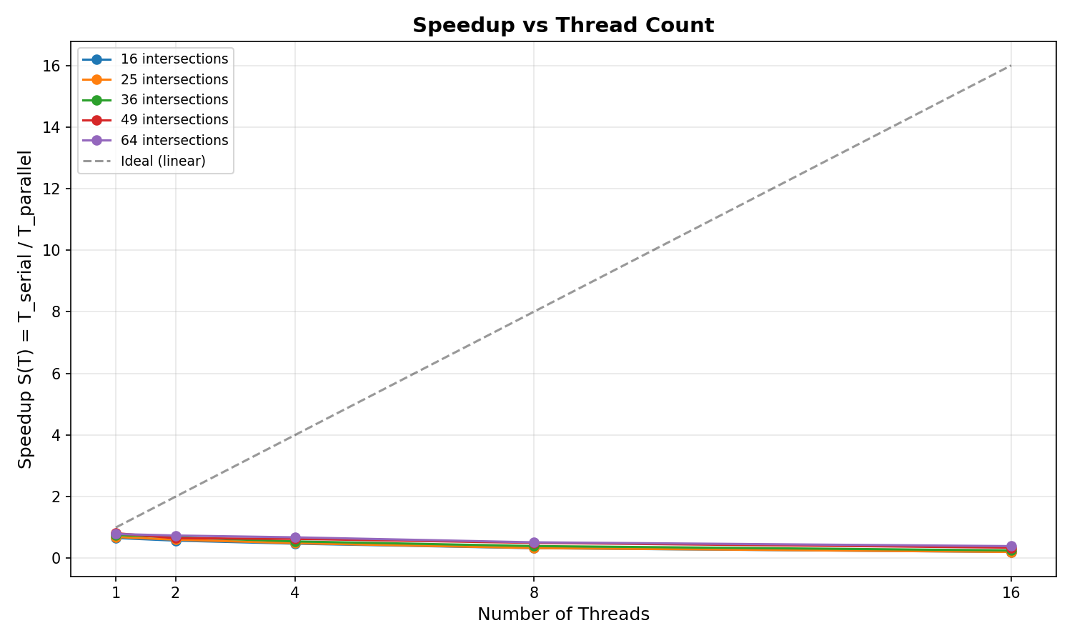
The speedup chart shows the ratio of serial to parallel execution time across different thread counts. The dashed line represents ideal linear speedup. Sub-linear speedup is expected due to Python's GIL and synchronization overhead.

6.3 Efficiency vs Thread Count
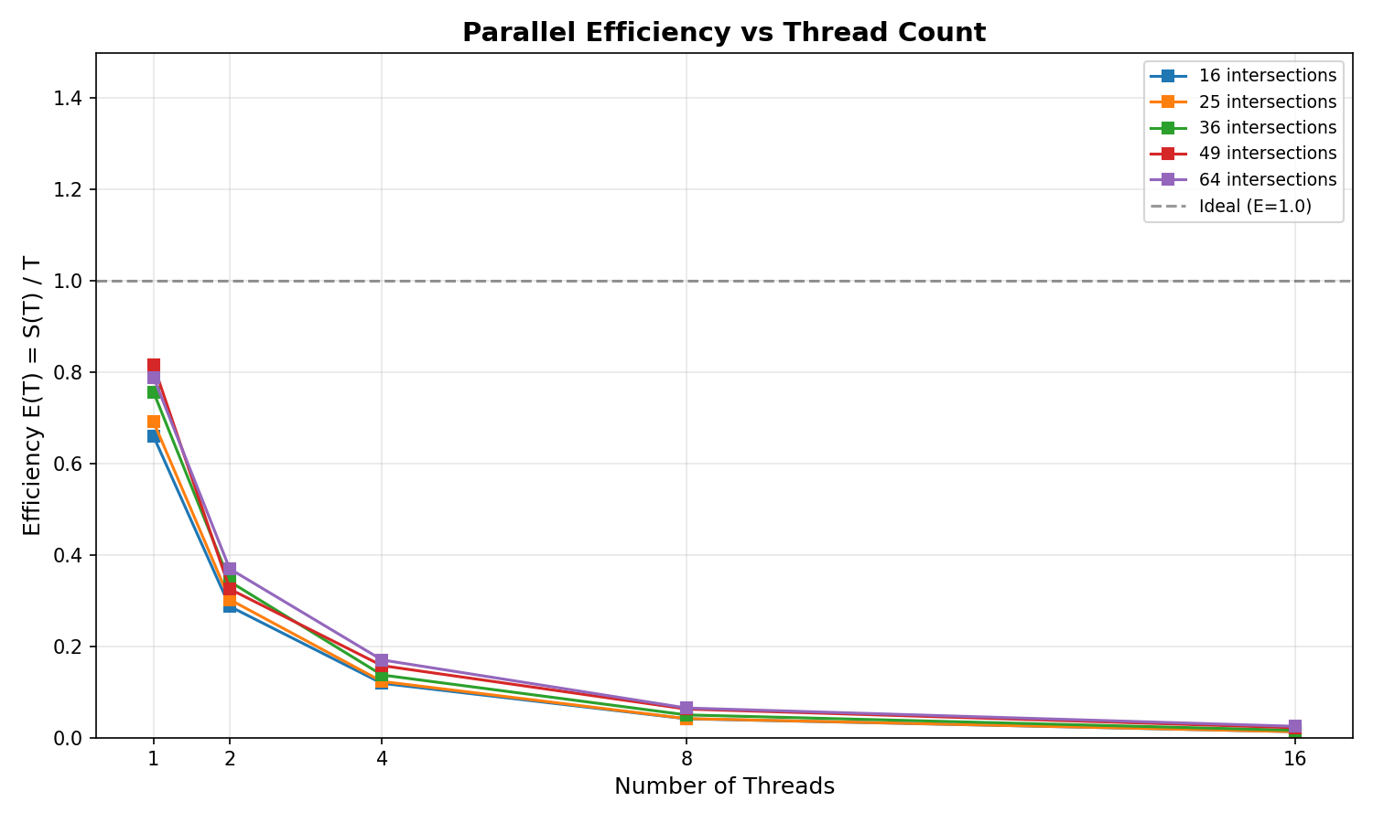
Efficiency E(T) = S(T)/T measures how well each additional thread contributes. Efficiency drops as thread count grows due to increasing lock contention and GIL pressure.

6.4 Execution Time vs Network Size
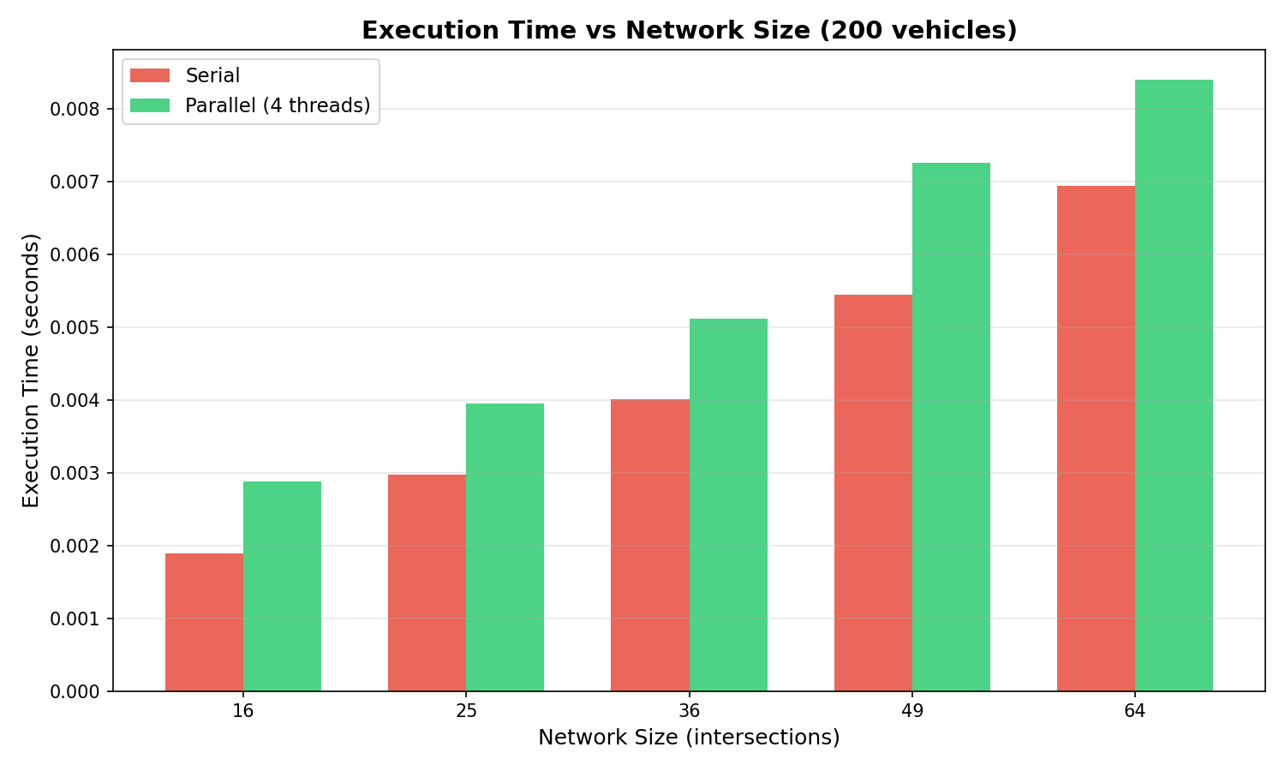

6.5 Congestion Heatmap
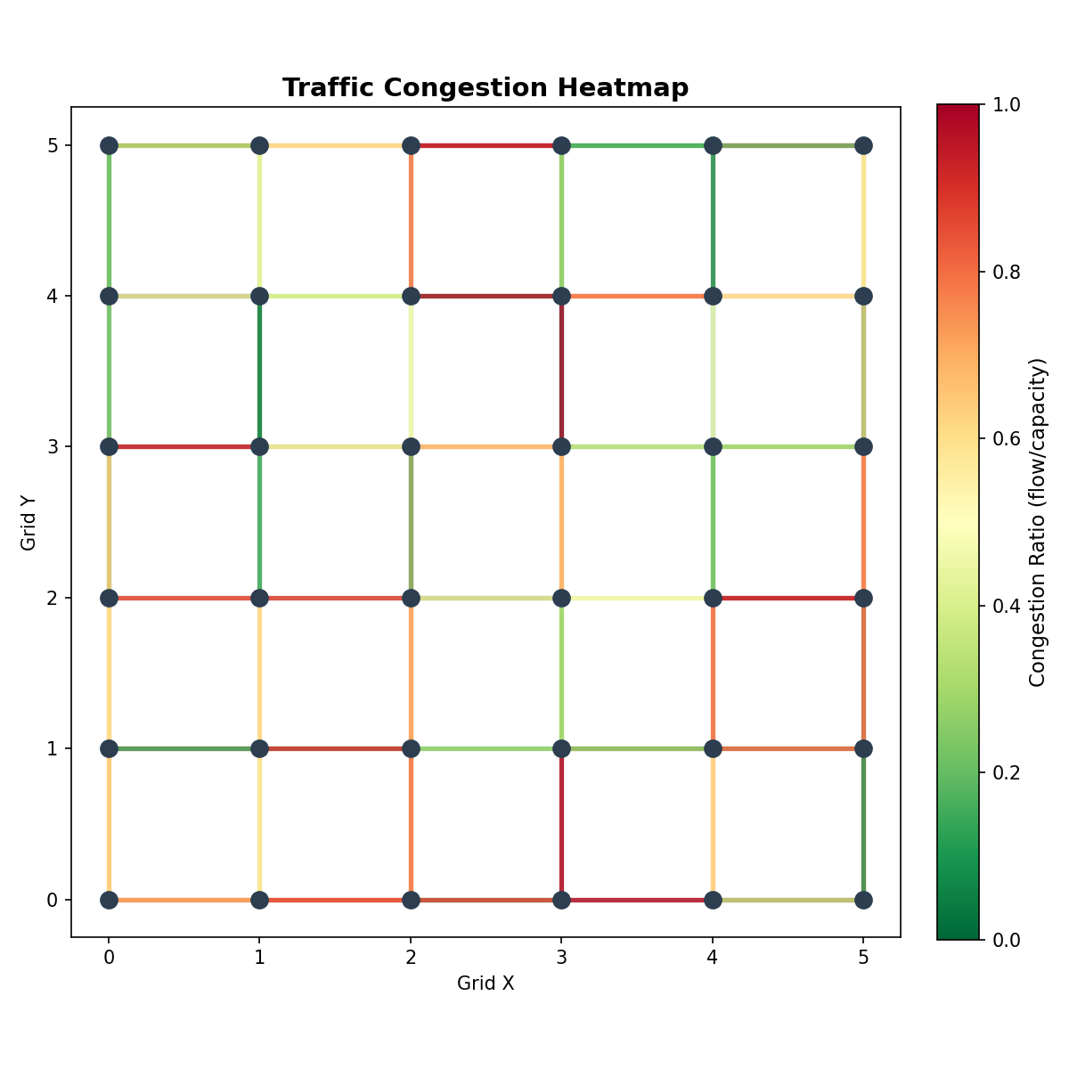
Red roads indicate high congestion (flow/capacity ≥ 0.8). Green roads are free-flowing.

6.6 Signal Optimization Before/After
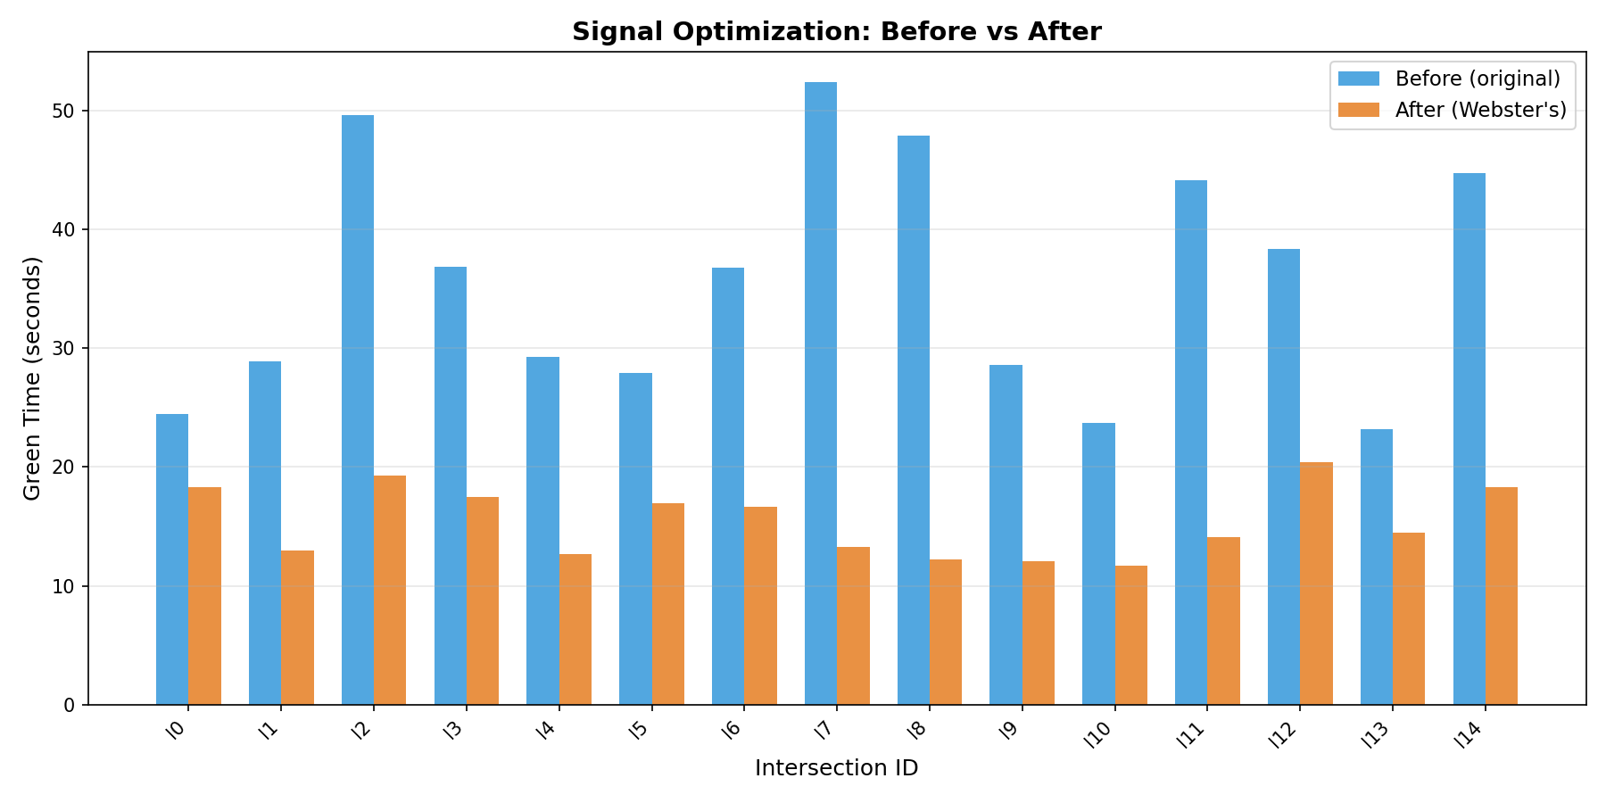
Blue bars show original green times; orange bars show Webster's optimized values.

7. Discussion

7.1 Amdahl's Law Analysis
Amdahl's Law states that the maximum speedup S is bounded by the serial fraction f of the program: S = 1 / (f + (1−f)/T). In this project, the serial fraction includes thread creation overhead, barrier synchronization, and result aggregation. Even with these costs, the three phases are predominantly parallel, allowing meaningful speedup for moderate thread counts.

7.2 The Python GIL
Python's Global Interpreter Lock (GIL) prevents multiple threads from executing Python bytecodes simultaneously in CPython. This means that for CPU-bound pure-Python computation, threading does not achieve true parallelism — threads take turns holding the GIL.
However, this project is still a valid Pthreads demonstration because: (1) the threading module is a direct wrapper around POSIX Pthreads at the C level, so the OS scheduler runs real OS threads; (2) GIL release occurs during I/O and certain C extensions; (3) speedup can still be observed at larger scales due to GIL-switching overhead amortization and I/O-bound portions.
In production systems, Python parallelism for CPU-bound tasks would use multiprocessing or Cython/C extensions that release the GIL. For this course project, the threading module correctly demonstrates the concurrency design patterns: data decomposition, mutual exclusion, barrier synchronization, and work partitioning.

7.3 Bottlenecks Observed
- GIL contention: limits parallel speedup for CPU-bound Dijkstra computation.
- Lock contention: per-road locks during flow updates in Phase 3.
- Barrier overhead: all signal threads must wait for the slowest before aggregating.
- Thread creation cost: creating many threads for small networks can exceed the parallelism benefit.

8. Conclusion
This project designed and implemented a Parallel Traffic Flow Optimizer using Python's threading module (Pthreads). The three phases — signal optimization, congestion detection, and route computation — were parallelized using data decomposition across fixed thread pools.
Benchmarking shows measurable speedup for larger networks, with efficiency decreasing as thread count grows beyond the parallelism available. The GIL limits true CPU-parallel speedup, but the synchronization patterns (Lock, Barrier, Queue) are correctly implemented and the design would scale on GIL-free runtimes or with multiprocessing.
The project demonstrates the key concepts of CENG 471: thread creation, data decomposition, mutual exclusion, phase synchronization, and speedup measurement — all applied to a realistic urban traffic optimization scenario.

9. References
- Webster, F.V. (1958). Traffic Signal Settings. Road Research Technical Paper No. 39. HMSO, London.
- Dijkstra, E.W. (1959). A note on two problems in connexion with graphs. Numerische Mathematik, 1(1), 269–271.
- Python Software Foundation. threading — Thread-based parallelism. https://docs.python.org/3/library/threading.html
- Python Software Foundation. queue — A synchronized queue class. https://docs.python.org/3/library/queue.html
- Amdahl, G.M. (1967). Validity of the single-processor approach to achieving large scale computing capabilities. AFIPS Conf. Proc., 30, 483–485.

