The Great Adventures Co. has hired you as their new webmaster. At a recent staff meeting, the Human Resources Department complained that they spend a lot of time answering employee questions about paychecks. Employees wanted to know why their paychecks were less than their hourly rate multiplied by the number of hours they worked. Employees wanted to know how adding or deleting a dependent would affect their pay. They often called HR to ask how much extra they would make if they worked fewer or more hours. To help HR out, you created the basic Payday Calculator (**Fig. 1** shown below). The Payday Calculator allows employees to enter different pay rates, number of hours worked, and vary their dependent deductions and see how their paychecks would be affected. Create the JavaScript functions needed to give the page complete functionality.

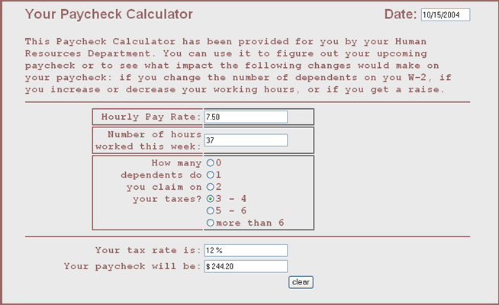

Figure 1

**Files needed for this Project:**

* payday.htm
* pay.css

|  |  |  |
| --- | --- | --- |
| **Tasks** | **Points** | **Completed** |
| Create a folder on your server called **MidTermExam**. All of the files from this project should be saved within this folder. | 5 |  |
| Open the **payday.htm** file in an HTML editor. Convert the file to a valid XHTML (Strict) file. Remember to remove all style elements so that the page is XHTML only. | 10 |  |
| Make the sheet link to **pay.css**. In other words, do not link it your main.css. | 5 |  |
| Create a new JavaScript file named **midterm.js**. Refer to **Fig. 2** (below). This shows you the beginning of each function you need to write. | 5 |  |
| Create a function named **today( )** which will get today’s date. Enter this program in the JavaScript section of the page, as shown below. | 10 |  |
| Create a function named **startform( )** which will have today’s date appear when the user begins to use the form. | 10 |  |
| Create a function named **dollars( )** which will convert the a number amount to a two-decimal format. | 10 |  |
| Create a function named **tax_percent( )** to calculate the amount of the paycheck after the user has entered the number of hours worked in a week, the hourly pay rate, and the tax bracket, based on number of dependents. Note: some of this function has been written for you. This function should also display two results:   * Display the percent of the paycheck that goes to taxes. This amount corresponds to the number of dependents. The amounts have been coded for you in the Array (shown below). * Display the final paycheck amount in the box provided on the form. | 10 |  |
| Link **midterm.js** to **payday.htm**. Do not embed the JavaScript. | 5 |  |
| Created XHTML Files | 5 |  |
| Created separate CSS file. | 5 |  |
| Created separate JavaScript file. | 5 |  |
| Each file in the site passed the appropriate validator | 5 |  |
| A link to the assignment is on the student index.html page | 5 |  |
|  |  |  |

**COMMENTS:**

The Paycheck Calculator functions  **Fig. 2**



**Step 2 🡪** /*function to get today's date */

function today()

**Step 3 🡪** /*function to get date to load on startup */

function startform()

**Step 4 🡪**/*function to display calculated amount in 2-decimal format */

function dollars(n)

**Step 5 🡪** /* function to calculate paycheck */

function tax_percent()

{

var tax= "";

var dep= new Array(5);

dep[0] = .2;

dep[1] = .17;

dep[2] = .15;

dep[3] = .12;

dep[4] = .10;

dep[5] = .10;

var txt=" %"

for (i=0; i<6; i++)

{

if (document.paycheck['tax'+i].checked)

{

var newtax= new Number(dep[i]);

taxrate = newtax*100;

var h=eval(document.paycheck.hours.value);

var r=eval(document.paycheck.payrate.value);

document.paycheck.feedback.value= taxrate + txt;

document.paycheck.feedback3.value= ("$ "+ dollars(r*(1-newtax)*h));

}

}

} }

