CSE3017 PROJECT – CPU

- The Design

The design for the CPU we have come with includes the modules:
- a 16-bit ALU which has 16 operations,
- a Register File consisting of 16 registers (Just like the Block RAM we did on lab 5),
- a 16-bit Comparator,
- a 12-bit Program Counter,
- Status/Comparison registers,
- Multiplexers,
- Demultiplexers

ALU operations:
- ADD, (addition)
- SUB, (subtraction)
- NEG, (negation)
- INC, (increment)
- DEC, (decrement)
- MOV, (move to register)
- AND, (logical and)
- OR, (logical or)
- XOR, (logical xor)
- NOT, (logical not)
- ASR, (arithmetic shift right)
- ASL, (arithmetic shift left)
- LSR, (logical shift right)
- LSL, (logical shift left)
- CSR, (circular shift right)
- CSL, (circular shift left)

Result of ALU is connected to Register File as feedback from the operation done.

This creates the possibility for doing operations on read registers and written back to them.

The Register File works simple:

If we look at all the assembly instructions there is at most 3 registers. Lets say these registers are called “Rz, Rx, Ry” in order and lets say for example instruction is “ADD”. So we have received a instruction:

ADD Rz, Rx, Ry

This will be interpreted on Register File after CPU decodes the instruction. Register file gets z, x and y as inputs so the module can decide which register to read: Rx and Ry. Also which register to read the result into: Rz.

Also we already know that operations write only some registers and some operations, outside of ALU operations, do not even write registers for example:

STR (store to RAM/BUS), NOP (No Operation)

So we should also give register file an input so it can decide whether to write or not. This is done by the input: regWR (register write)

We also need clock since we deal with registers. And we need reset signal so we can clean registers if CPU is reseted via outside input or the operation: RES.

We also have an enable input as CPU can be disabled if enable input is not given to CPU.

Finally z, x, y inputs will be assigned to needed decoded registere indexes. For example ADD:

ADD Rz, Rx, Ry

But for STR:

STR Rx, Ry

or

STR Rx, (Immediate Value)

All operations have specific syntaxes and the design will be done according to their own syntax by using multiplexers at inputs of Register File deciding the registers to read/write.

We can decide the Rx and Ry read registers by 16x16 multiplexers (16 bit data 16 bit select bits) and we can decide which register to read into by 1x16 (1 bit data 16 bit select bits). The choosen read register is enabled so that clock’s are effective and data is written into others remain same.

Finally we have to decide which data to read into selected read register. There is 3 different inputs according to instruction.

For example for immediate operations:

MOV R1, 10

We have to somehow pull the “10” immediate value from the decoded instruction and put to Rz input of Register File.

For example for normal operations:

MOV R1, R2

We already discussed this type of operations result can be pulled from the ALU output and read into register file.

For example for load operation:

LD R1, 0x20

The value at address 0x20 should be loaded from the RAM/BUS.

This all can be done by two 16x16 multiplexers by selecting the input according to if the instruction is immediate or not and if the instruction is a load instruction or not.
Next we have to design a 16-bit Comparator so we can actually execute comparison (CMP) and conditional jump/branching instructions.

In our design we included a CMP instruction and 16 different conditional jumps.
These jumps are:

- JG, (jump greater)
- JGE, (jump greater than or equal)
- JE, (jump equal)
- JNE, (jump not equal)
- JLE, (jump less than or equal)
- JL, (jump less than)
- JC, (jump if carry, carry ALU flag)
- JZ, (jump if zero, zero ALU flag)
- JN, (jump if negative, negative ALU flag)
- JO, (jump if overflow, overflow ALU flag)
- JP, (jump if odd parity, odd parity ALU flag)
- JNC, (jump if not carry)
- JNZ, (jump if not zero)
- JNN, (jump if not negative, positive)
- JNO, (jump if not overflow)
- JNP (jump if not odd parity, even parity)

So we need 2 register to store these conditions so when a jump instruction comes we decide upon whether to jump or not by reading these registers.

First register is called CPSR (Current Program Status Register):

This register holds status flags from the ALU if the alu is enabled otherwise should remain the same so the conditions won’t be overwritten in other non-ALU instructions such as CMP.

Second register is called Status register:

This register holds comparison results and only enabled when the CMP instruction is being executed.

Finally we can decide upon whether to jump or not according to corresponding condition by decoding the condition from the instruction bits. This can be done using a 16x1 multiplexer with the CPSR and Status register outputs.

We can give these conditions as a signal to program counter to signify a incoming jump and a jump address so the program counter can load the address to jump. Program counter is a simple 12 bit counter unless a jump is received then the new address is loaded. Program counter output is connected to ROM so we fetch needed instruction one by one sequentially each clock.

Finally we have to have a RAM load/store unit. At early designs we implemented a single port RAM type structure because we were designing a SDRAM controller which we have a SDRAM on board. We designed a SDRAM module but it did not work at all and we didn’t even got any output as result (0’s always). We tried analysing the signals using the Quartus program with SignalTap logic analyser but we weren’t able to understand it either so we changed the idea to design a Block RAM. Only thing changed is now we have much less memory but it is still enough.

So we have 2 different designs for the CPU first we are gonna show the codes for the early designs with SDRAM in mind. Next we will be showing last designs we did.

Now this out of the way we should add a table for the instruction set structure:

Command Table
ALU Instruction | B1, B0 | B3, B2 | B5, B4 | B9…B6 | B13...B10 | B17...B14 | B21...B18 | B25...B22 |  | B29…B26 | B30
ADD Rz, Rx, Ry | 00 | 00 | 00 | z | x | y | XXXX | XXXX |  | XXXX | 1
SUB Rz, Rx, Ry | 00 | 01 | 00 | z | x | y | XXXX | XXXX |  | XXXX | 1
NEG Rz, Rx, | 00 | 10 | 00 | z | x | XXXX | XXXX | XXXX |  | XXXX | 1
INC Rz, Rx | 00 | 11 | 00 | z | x | XXXX | XXXX | XXXX |  | XXXX | 1
DEC Rz, Rx | 00 | 00 | 01 | z | x | XXXX | XXXX | XXXX |  | XXXX | 1
AND Rz, Rx, Ry | 00 | 10 | 01 | z | x | y | XXXX | XXXX |  | XXXX | 1
OR Rz, Rx, Ry | 00 | 11 | 01 | z | x | y | XXXX | XXXX |  | XXXX | 1
XOR Rz, Rx, Ry | 00 | 00 | 10 | z | x | y | XXXX | XXXX |  | XXXX | 1
NOT Rz, Rx | 00 | 01 | 10 | z | x | XXXX | XXXX | XXXX |  | XXXX | 1
ASR Rz, Rx, Ry | 00 | 10 | 10 | z | x | y | XXXX | XXXX |  | XXXX | 1
ASL Rz, Rx, Ry | 00 | 11 | 10 | z | x | y | XXXX | XXXX |  | XXXX | 1
LSR Rz, Rx, Ry | 00 | 00 | 11 | z | x | y | XXXX | XXXX |  | XXXX | 1
LSL Rz, Rx, Ry | 00 | 01 | 11 | z | x | y | XXXX | XXXX |  | XXXX | 1
CSR Rz, Rx, Ry | 00 | 10 | 11 | z | x | y | XXXX | XXXX |  | XXXX | 1
CSL Rz, Rx, Ry | 00 | 11 | 11 | z | x | y | XXXX | XXXX |  | XXXX | 1
MOV Instruction | B1, B0 | B3, B2 | B5, B4 | B9…B6 | B13...B10 | B17...B14 | B21...B18 | B25...B22 |  | B29…B26 | B30
MOV Rz, Rx | 00 | 01 | 01 | z | x | XXXX | XXXX | XXXX |  | XXXX | 1
MOV Rz, #Imm | 00 | 01 | 01 | z | 16-Bit Immediate Value |  |  |  |  | XXXX | 1
LD/STR Ins. | B1, B0 | B3, B2 | B5, B4 | B9…B6 | B13...B10 | B17...B14 | B21...B18 | B25...B22 |  | B29…B26 | B30
LD Rz, Ry | 01 | XX | XX | z | XXXX | y | XXXX | XXXX |  | XXXX | 1
STR Rx, Ry | 10 | XX | XX | XXXX | x | y | XXXX | XXXX |  | XXXX | 0
Immediates
LD/STR Ins. | B1, B0 | B3, B2 | B5, B4 | B9…B6 | B13...B10 | B17...B14 | B21...B18 | B25...B22 |  | B29…B26 | B30
LD Rz, #Imm | 01 | XX | XX | z | 12-Bit Address |  |  | XXXX |  | XXXX | 1
STR Rx, #Imm | 10 | XX | XX | x | 12-Bit Address |  |  | XXXX |  | XXXX | 0
Other Ins. | B1, B0 | B3, B2 | B5, B4 | B9…B6 | B13...B10 | B17...B14 | B21...B18 | B25...B22 |  | B29…B26 | B30
NOP | 11 | 11 | XX | XXXX | XXXX | XXXX | XXXX | XXXX |  | XXXX | 0
CMP Rx, Ry | 11 | 01 | XX | XXXX | x | y | XXXX | XXXX |  | XXXX | 0
RES | 11 | 00 | XX | XXXX | XXXX | XXXX | XXXX | XXXX |  | XXXX | 0
JUMP Instruction | B1, B0 | B3, B2 | B5, B4 | B9…B6 | B13...B10 | B17...B14 | B21...B18 | B25...B22 |  | B29…B26 | B30
JG Ry | 11 | 10 | XX | XXXX | XXXX | y | XXXX | XXXX |  | 0000 | 0
JGE Ry | 11 | 10 | XX | XXXX | XXXX | y | XXXX | XXXX |  | 0001 | 0
JE Ry | 11 | 10 | XX | XXXX | XXXX | y | XXXX | XXXX |  | 0010 | 0
JNE Ry | 11 | 10 | XX | XXXX | XXXX | y | XXXX | XXXX |  | 0011 | 0
JLE Ry | 11 | 10 | XX | XXXX | XXXX | y | XXXX | XXXX |  | 0100 | 0
JL Ry | 11 | 10 | XX | XXXX | XXXX | y | XXXX | XXXX |  | 0101 | 0
JC Ry | 11 | 10 | XX | XXXX | XXXX | y | XXXX | XXXX |  | 0110 | 0
JZ Ry | 11 | 10 | XX | XXXX | XXXX | y | XXXX | XXXX |  | 0111 | 0
JN Ry | 11 | 10 | XX | XXXX | XXXX | y | XXXX | XXXX |  | 1000 | 0
JO Ry | 11 | 10 | XX | XXXX | XXXX | y | XXXX | XXXX |  | 1001 | 0
JP Ry | 11 | 10 | XX | XXXX | XXXX | y | XXXX | XXXX |  | 1010 | 0
JNC Ry | 11 | 10 | XX | XXXX | XXXX | y | XXXX | XXXX |  | 1011 | 0
JNZ Ry | 11 | 10 | XX | XXXX | XXXX | y | XXXX | XXXX |  | 1100 | 0
JNN Ry | 11 | 10 | XX | XXXX | XXXX | y | XXXX | XXXX |  | 1101 | 0
JNO Ry | 11 | 10 | XX | XXXX | XXXX | y | XXXX | XXXX |  | 1110 | 0
JNP Ry | 11 | 10 | XX | XXXX | XXXX | y | XXXX | XXXX |  | 1111 | 0
Immediates
JUMP Instruction | B1, B0 | B3, B2 | B5, B4 | B9…B6 | B13...B10 | B17...B14 | B21...B18 | B25...B22 |  | B29…B26 | B30
JG #Imm | 11 | 10 | XX | XXXX | 12-Bit Address |  |  | XXXX |  | 0000 | 0
JGE #Imm | 11 | 10 | XX | XXXX | 12-Bit Address |  |  | XXXX |  | 0001 | 0
JE #Imm | 11 | 10 | XX | XXXX | 12-Bit Address |  |  | XXXX |  | 0010 | 0
JNE #Imm | 11 | 10 | XX | XXXX | 12-Bit Address |  |  | XXXX |  | 0011 | 0
JLE #Imm | 11 | 10 | XX | XXXX | 12-Bit Address |  |  | XXXX |  | 0100 | 0
JL #Imm | 11 | 10 | XX | XXXX | 12-Bit Address |  |  | XXXX |  | 0101 | 0
JC #Imm | 11 | 10 | XX | XXXX | 12-Bit Address |  |  | XXXX |  | 0110 | 0
JZ #Imm | 11 | 10 | XX | XXXX | 12-Bit Address |  |  | XXXX |  | 0111 | 0
JN #Imm | 11 | 10 | XX | XXXX | 12-Bit Address |  |  | XXXX |  | 1000 | 0
JO #Imm | 11 | 10 | XX | XXXX | 12-Bit Address |  |  | XXXX |  | 1001 | 0
JP #Imm | 11 | 10 | XX | XXXX | 12-Bit Address |  |  | XXXX |  | 1010 | 0
JNC #Imm | 11 | 10 | XX | XXXX | 12-Bit Address |  |  | XXXX |  | 1011 | 0
JNZ #Imm | 11 | 10 | XX | XXXX | 12-Bit Address |  |  | XXXX |  | 1100 | 0
JNN #Imm | 11 | 10 | XX | XXXX | 12-Bit Address |  |  | XXXX |  | 1101 | 0
JNO #Imm | 11 | 10 | XX | XXXX | 12-Bit Address |  |  | XXXX |  | 1110 | 0
JNP #Imm | 11 | 10 | XX | XXXX | 12-Bit Address |  |  | XXXX |  | 1111 | 0

In our implementation we decided to change don’t care values with zeros.

And we designed a assembler so we can directly turn these assembly codes for instruction into machine code for our CPU. The java code for our assembler:

package Assembler;

import java.util.ArrayList;
import java.util.Arrays;
import java.util.Scanner;

import java.io.File;
import java.io.FileWriter;

public class Assembler {

private static ArrayList<String> instructions = new ArrayList<String>(Arrays.asList(new String[]{
// ALU Operations
"ADD", "SUB", "NEG", "INC",
"DEC", "AND", "OR", "XOR" ,
"NOT", "ASR", "ASL", "LSR",
"LSL", "CSR", "CSL",
// MOV Operation
"MOV",
// RAM Operations
"LD", "STR",

// Other Instructions
"NOP", "CMP", "RES",

// JUMP Instructions (Comparator)
"JG", "JGE", "JE", "JNE",
"JLE", "JL",
// Jump Instructions (CPSR)
"JC", "JZ", "JN", "JO",
"JP", "JNC", "JNZ", "JNN",
"JNO", "JNP"
}));

private static ArrayList<String> codes = new ArrayList<String>(Arrays.asList(new String[]{
// ALU Operations
"000000", "000100", "001000", "001100",
"010000", "011000", "011100", "100000" ,
"100100", "101000", "101100", "110000",
"110100", "111000", "111100",
// MOV Operation
"010100",
// RAM Operations
"000001", "000010",

// Other Instructions
"001111", "000111", "000011",

// JUMP Instructions (Comparator)
"001011", "001011", "001011", "001011",
"001011", "001011",
// Jump Instructions (CPSR)
"001011", "001011", "001011", "001011",
"001011", "001011", "001011", "001011",
"001011", "001011"
}));

public static void main(String[] args) {
StringBuilder executable = new StringBuilder();
try {
File inputFile = new File(args[0]);
if (inputFile.exists()) {
Scanner sc = new Scanner(inputFile);
int lineNumber = 1;
while(sc.hasNextLine()) {
String line = sc.nextLine();
line = line.toUpperCase();
if(line.trim().length() != 0){
if(line.trim().charAt(0) != ';') {
String parsed = parseLine(line, lineNumber);

executable.append(toHex(parsed).toUpperCase() + "\n");
lineNumber++;
}
}
}
sc.close();
} else {
System.out.println("Input file does not exist...");
System.exit(-1);
}
File outputFile = new File(args[1]);
if(!outputFile.exists()) {
System.out.println("Output file does not exist...");
System.out.println("Creating output file: " + args[1]);
outputFile.createNewFile();
}
FileWriter fw = new FileWriter(outputFile, false);
/* Not needed
String fileFormat =
"DEPTH = 4096; -- The size of memory in words\n" +
"WIDTH = 32; -- The size of data in bits\n" +
"ADDRESS_RADIX = HEX; -- The radix for address values\n" +
"DATA_RADIX = HEX; -- The radix for data values\n" +
"CONTENT -- start of (address : data pairs)\n" +
"BEGIN\n" +
"-- memory address : data\n" +
"%s" +
"END;\n";

String lines[] = executable.toString().split("\n");
StringBuilder content = new StringBuilder();

for(int i = 0; i < lines.length; i++) {
content.append("" + toHex(toBinary(i, 12)) + " : " + lines[i] + ";\n");
}

fw.write(String.format(fileFormat, content));
*/

fw.write(executable.toString());

fw.close();
} catch (Exception e) {
e.printStackTrace();
}
}

private static String toHex(String bin) {
String hex = "";

for(int i = bin.length() - 1; i > 0; i-=4) {
int hexdigit = 0;
for(int j = i; j > i-4 && j >= 0; j--) {
hexdigit += (bin.charAt(j) == '1' ? 1: 0) * Math.pow(2, i-j);
}
hex = Integer.toString(hexdigit, 16) + hex;
}

return hex;
}
private static String toBinary(int number, int length) {
String bin = Integer.toBinaryString((0x1 << (length)) | number).substring(1);
return bin;
}
private static String parseLine(String line, int lineNumber) {
String binaryLine = "";

String words[] = line.replaceAll(",", "").split(" ");

String instruction = words[0];

boolean immediate = false;

for(int i = 1; i < words.length; i++) {
if(words[i].charAt(0) != 'R') {
if(words[i].length() >= 4) {
if(!words[i].substring(0, 3).equals("ACC")) {
immediate = true;
break;
}
} else {
immediate = true;
break;
}
}
}

binaryLine += immediate ? "1": "0"; // Decide for the Immediate bit

int indexOfInstruction = instructions.indexOf(instruction);

if(indexOfInstruction == -1) {
System.err.println("Instruction: \"" + instruction + "\" at line " + lineNumber + " is not supported.");
System.exit(-1);
}

binaryLine += indexOfInstruction < 17 ? "1" : "0"; // Decide for the RegWr bit

binaryLine += indexOfInstruction > 20 ? toBinary(indexOfInstruction - 21, 4) : "0000";

String operands[] = new String[words.length - 1];

for(int i = 1; i < words.length; i++) {
operands[i-1] = words[i];
}

binaryLine += parseOperands(indexOfInstruction, operands, immediate); // Put the bits related to instruction operands.

binaryLine += codes.get(indexOfInstruction);

return binaryLine;
}

private static String parseOperands(int insIndex, String[] operands, boolean immediate) {
String binary = "";
String instruction = instructions.get(insIndex);

for(int i = 0; i < operands.length; i++) {
if(operands[i].startsWith("R")) {
operands[i] = operands[i].replaceAll("R", "");
} else if (operands[i].startsWith("ACC")) {
operands[i] = Integer.toString(Integer.parseInt(operands[i].replaceAll("ACC", "")) + 12);
} else if(operands[i].startsWith("0X")) {
operands[i] = Integer.toString(Integer.parseInt(operands[i].replaceAll("0X", ""), 16));
} else if(operands[i].startsWith("0B")) {
operands[i] = Integer.toString(Integer.parseInt(operands[i].replaceAll("0B", ""), 2));
}
}

if(immediate) {
if(instruction.equals("LD") || instruction.equals("STR")) {
binary += "0000";

int address = Integer.parseInt(operands[1]);

binary += toBinary(address, 12);

int registerIndex = Integer.parseInt(operands[0]);

binary += toBinary(registerIndex, 4);

} else if(instruction.equals("MOV")){
int value = Integer.parseInt(operands[1]);

binary += toBinary(value, 16);

int registerIndex = Integer.parseInt(operands[0]);

binary += toBinary(registerIndex, 4);
} else {
binary += "0000";
int value = Integer.parseInt(operands[0]);

binary += toBinary(value, 12);

binary += "0000";
}
} else {
binary += "00000000";
if(instruction.equals("INC") || instruction.equals("DEC") || instruction.equals("NEG") || instruction.equals("NOT") || instruction.equals("MOV")) {
binary += "0000";

int xRegisterIndex = Integer.parseInt(operands[1]);

binary += toBinary(xRegisterIndex, 4);

int zRegisterIndex = Integer.parseInt(operands[0]);

binary += toBinary(zRegisterIndex, 4);
} else if(instruction.equals("LD")) {
int yRegisterIndex = Integer.parseInt(operands[1]);

binary += toBinary(yRegisterIndex, 4);
binary += "0000";

int zRegisterIndex = Integer.parseInt(operands[0]);

binary += toBinary(zRegisterIndex, 4);
} else if(instruction.equals("STR") || instruction.equals("CMP")) {
int yRegisterIndex = Integer.parseInt(operands[1]);

binary += toBinary(yRegisterIndex, 4);

int xRegisterIndex = Integer.parseInt(operands[0]);

binary += toBinary(xRegisterIndex, 4);

binary += "0000";
} else if(instruction.equals("NOP") || instruction.equals("RES")) {
binary += "000000000000";
} else if(insIndex < 15) {
int yRegisterIndex = Integer.parseInt(operands[2]);

binary += toBinary(yRegisterIndex, 4);
int xRegisterIndex = Integer.parseInt(operands[1]);

binary += toBinary(xRegisterIndex, 4);

int zRegisterIndex = Integer.parseInt(operands[0]);

binary += toBinary(zRegisterIndex, 4);
} else {
int yRegisterIndex = Integer.parseInt(operands[0]);

binary += toBinary(yRegisterIndex, 4);

binary += "00000000";
}
}

return binary;
}
}

Logic circuits for our first designs:

First the ALU:
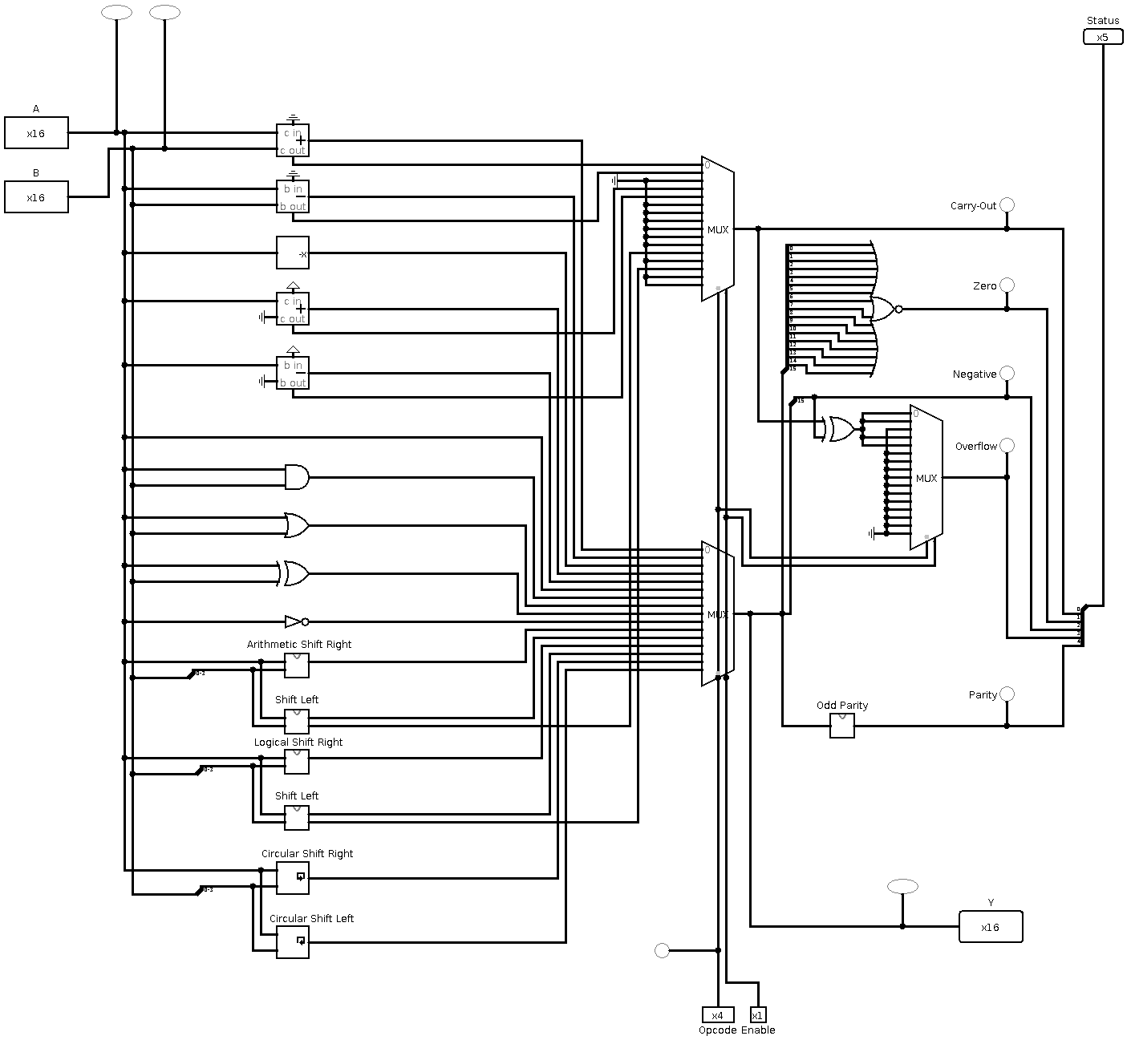

Next Register File:

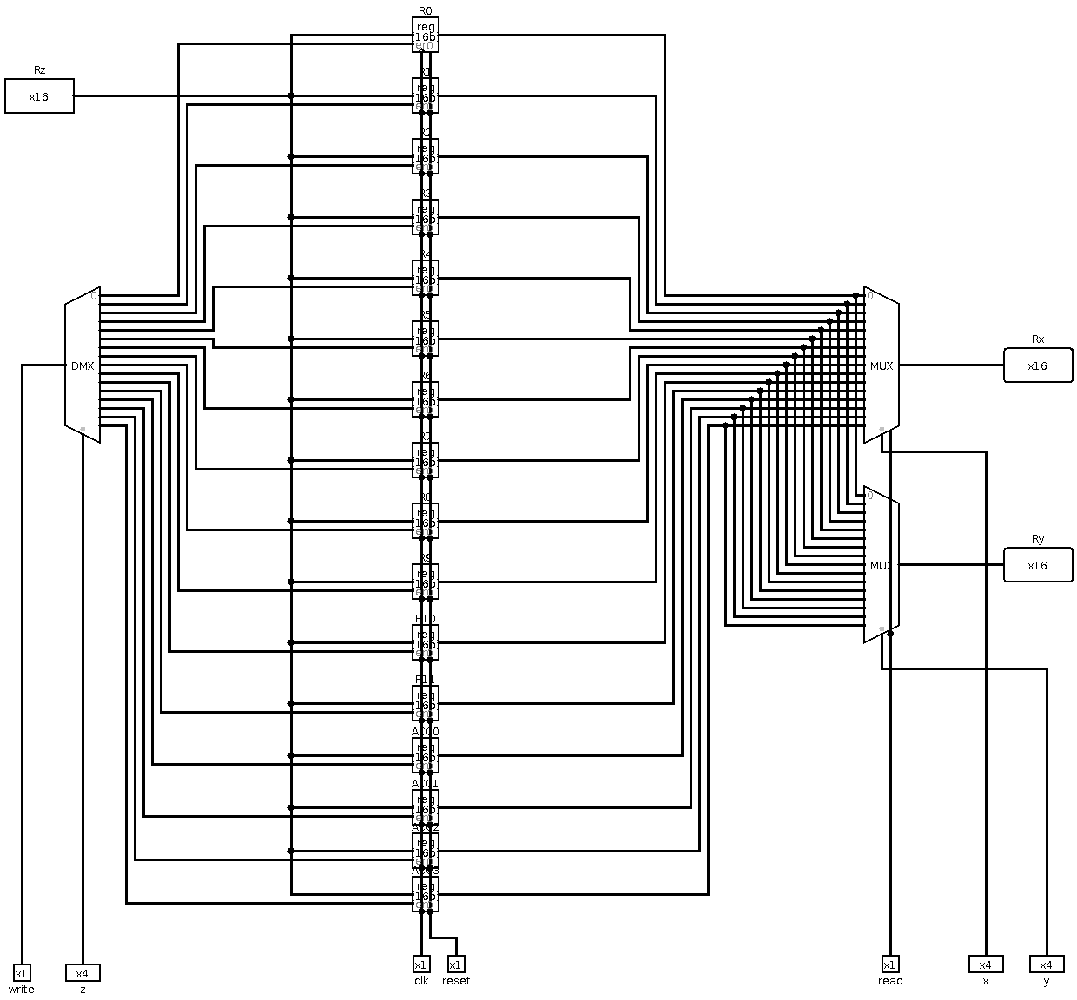

And to create a 16-bit Comparator:

First 2-bit comparator:
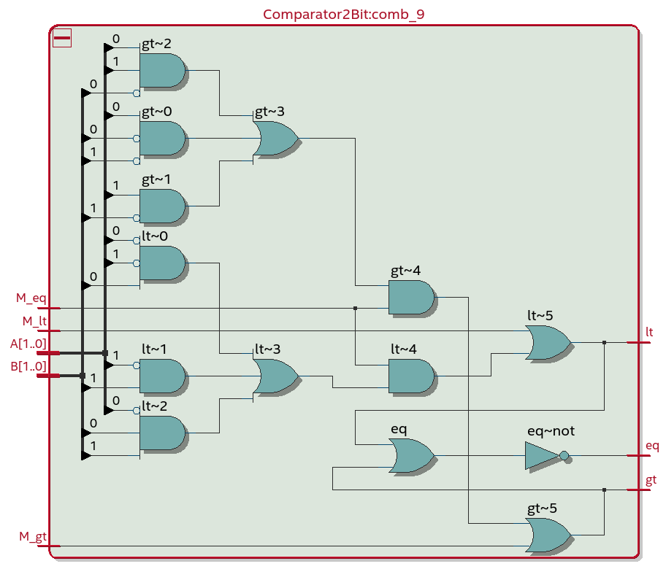

16-Bit comparator:

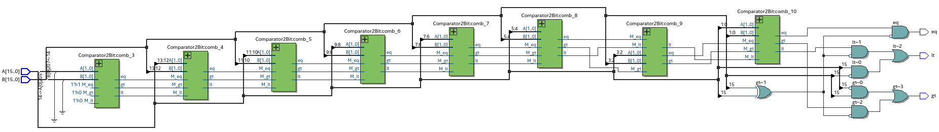

Finally the main design:

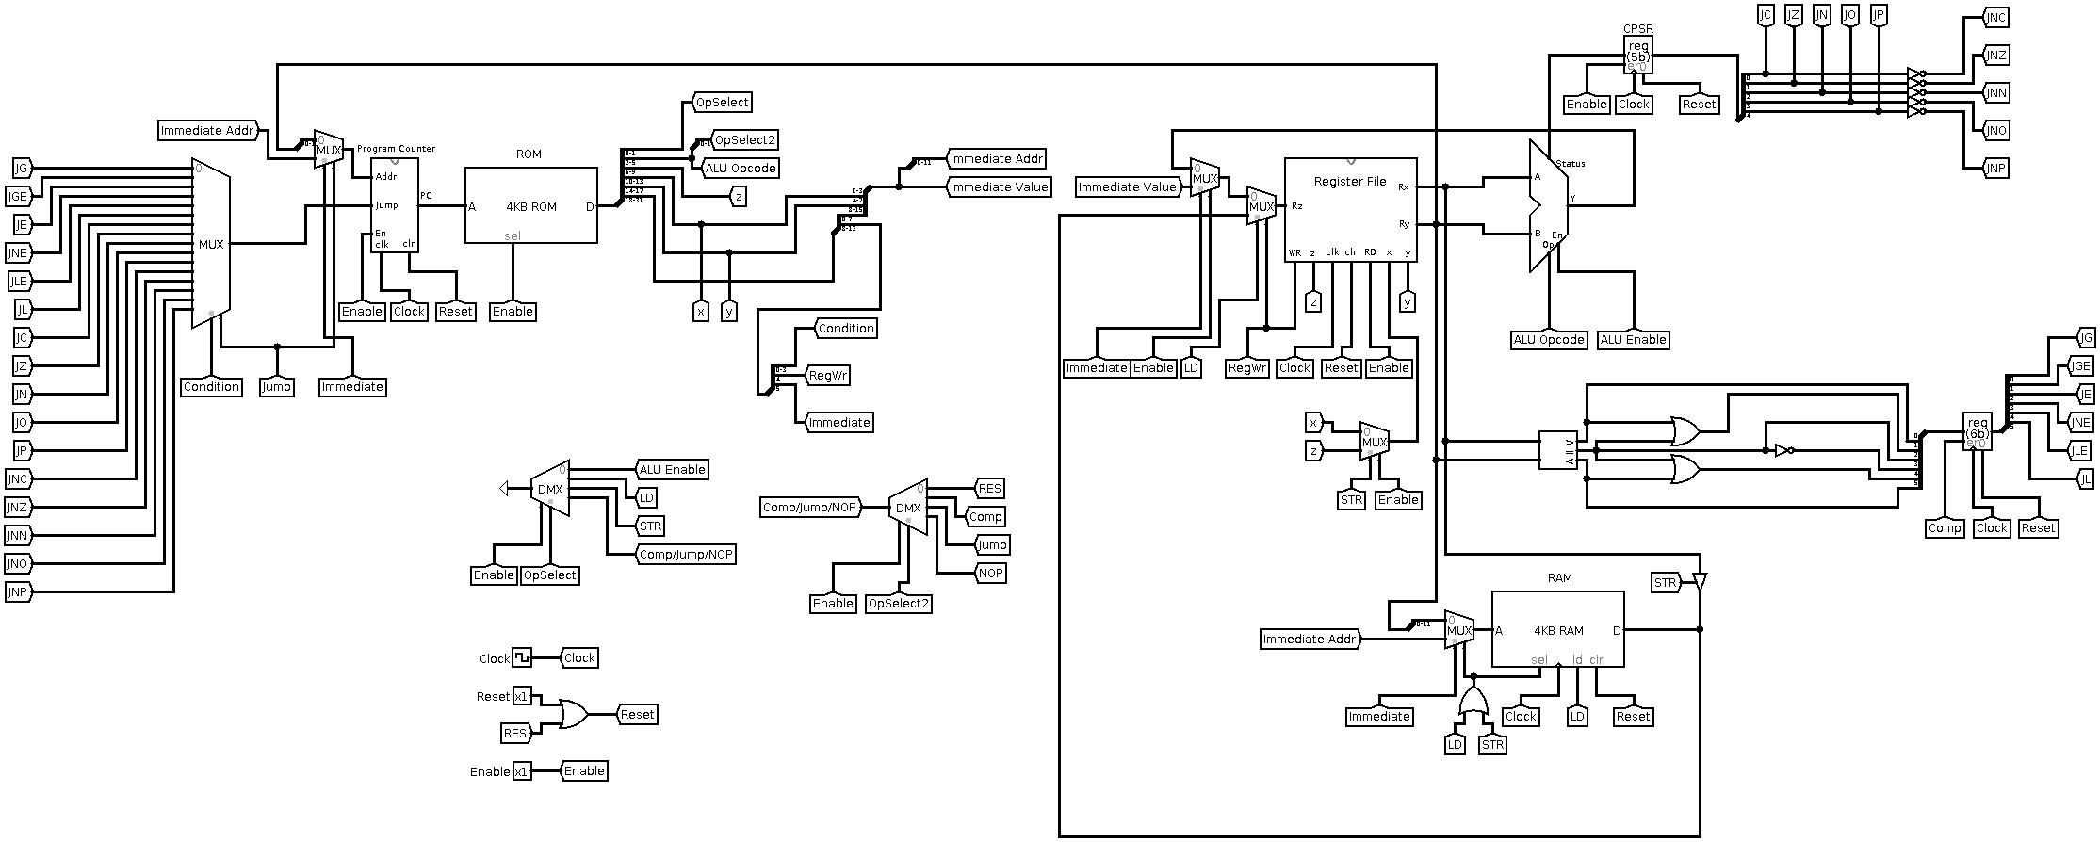

- Codes

Main design first then submodules:

First design for our CPU:

module CPU(
input clk,
input res,
input enable,
// Instruction fetch pins (ROM)
output [11:0] instructionAddr,
input [31:0] instruction,
output selInstruction,
// Data load/str pins (RAM)
output [11:0] dataAddr,
input [15:0] dataIn,
output [15:0] dataOut,
output selData,
output ldData,
output clrData
);

// DECODE THE RECEIVED INSTRUCTION:
wire [1:0] opSelect1;
wire [1:0] opSelect2;
wire [3:0] ALUOpcode;
wire [3:0] z;
wire [3:0] x;
wire [3:0] y;
wire [11:0] immediateAddr;
wire [15:0] immediateValue;
wire [3:0] condition;
wire regWr;
wire immediate;
assign opSelect1 = instruction[1:0];
assign opSelect2 = instruction[3:2];
assign ALUOpcode = instruction[5:2];
assign z = instruction[9:6];
assign x = instruction[13:10];
assign y = instruction[17:14];
assign immediateAddr = instruction[21:10];
assign immediateValue = instruction[25:10];
assign condition = instruction[29:26];
assign regWr = instruction[30];
assign immediate = instruction[31];
// Create CPU operation group selectors:
wire ALUEnable;
wire LD;
wire STR;
wire nextGroup;
DEMUX1x4(
1'b1,
opSelect1,
enable,
{nextGroup, STR, LD, ALUEnable}
);
wire RES;
wire COMP;
wire JUMP;
wire NOP;
DEMUX1x4(
nextGroup,
opSelect2,
enable,
{NOP, JUMP, COMP, RES}
);
// Create inner CPU reset signal:
wire reset;
assign reset = res | RES;
// ALU result will be connected to this wire:
wire [15:0] ALUResult;
// Setting up Register File
wire [15:0] Rz0;
MUX2x16(ALUResult, immediateValue, immediate, enable, Rz0);
wire [15:0] Rz; // Read register value
MUX2x16(Rz0, dataIn, LD, regWr, Rz);
wire [3:0] xSelected;
MUX2x4(x, z, STR, enable, xSelected);
wire [15:0] Rx; // A input for ALU/Comparator
wire [15:0] Ry; // B input for ALU/Comparator
RegisterFile(
regWr,
enable,
~clk,
reset,
z,
xSelected,
y,
Rz,
Rx,
Ry
);
// Setting up ALU
wire [4:0] CPSRnow;
ALU16Bit(
Rx,
Ry,
ALUOpcode,
ALUEnable,
ALUResult,
CPSRnow
);
// Setting up Comparator:
wire gt;
wire eq;
wire lt;
Comparator16Bit(
Rx,
Ry,
gt,
eq,
lt
);
// Setting up CPSR:
wire [4:0] CPSR;
Register5Bit(
CPSRnow,
~clk,
enable,
reset,
CPSR
);
// Setting up Comparison registers:
wire [5:0] regCOMP;
Register6Bit(
{lt, lt | eq, ~eq, eq, eq | gt, gt},
~clk,
COMP,
reset,
regCOMP
);
// Setting up data (RAM) connections:
assign selData = LD | STR;
MUX2x12(Ry[11:0], immediateAddr, immediate, selData, dataAddr);
assign ldData = LD;
assign clrData = reset;
assign dataOut = Rx;
// Selecting jump conditions:
wire jumpPC;
MUX16x1(
{
~CPSR[4], // JNP
~CPSR[3], // JNO
~CPSR[2], // JNN
~CPSR[1], // JNZ
~CPSR[0], // JNC
CPSR[4], // JP
CPSR[3], // JO
CPSR[2], // JN
CPSR[1], // JZ
CPSR[0], // JC
regCOMP[5], // JL
regCOMP[4], // JLE
regCOMP[3], // JNE
regCOMP[2], // JE
regCOMP[1], // JGE
regCOMP[0] // JG
},
condition,
JUMP,
jumpPC
);
// Setting up Program Counter:
wire [11:0] addrPC;
MUX2x12(Ry[11:0], immediateAddr, immediate, JUMP, addrPC);
ProgramCounter(
addrPC,
jumpPC,
enable,
clk,
reset,
instructionAddr
);
// Setting up instruction (ROM) connections:
assign selInstruction = enable;

endmodule

Second design (Program Counter changed etc.):

module CPUv2(
input clk,
input resIn,
input enable,
// Instruction fetch pins (ROM)
output reg [11:0] instructionAddr,
input [31:0] instructionNow,
output selInstruction,
// Data load/str pins (RAM)
output [11:0] dataAddr,
input [15:0] dataIn,
output [15:0] dataOut,
output selData,
output ldData,
output clrData
);

// Fetched Instruction:
reg [31:0] instruction;

// DECODE THE RECEIVED INSTRUCTION:
wire [1:0] opSelect1;
wire [1:0] opSelect2;
wire [3:0] ALUOpcode;
wire [3:0] z;
wire [3:0] x;
wire [3:0] y;
wire [11:0] immediateAddr;
wire [15:0] immediateValue;
wire [3:0] condition;
wire regWr;
wire immediate;
assign opSelect1 = instruction[1:0];
assign opSelect2 = instruction[3:2];
assign ALUOpcode = instruction[5:2];
assign z = instruction[9:6];
assign x = instruction[13:10];
assign y = instruction[17:14];
assign immediateAddr = instruction[21:10];
assign immediateValue = instruction[25:10];
assign condition = instruction[29:26];
assign regWr = instruction[30];
assign immediate = instruction[31];
// Create CPU operation group selectors:
wire ALUEnable;
wire LD;
wire STR;
wire nextGroup;
DEMUX1x4(
1'b1,
opSelect1,
enable,
{nextGroup, STR, LD, ALUEnable}
);
wire RES;
wire COMP;
wire JUMP;
wire NOP;
DEMUX1x4(
nextGroup,
opSelect2,
enable,
{NOP, JUMP, COMP, RES}
);
// Create inner CPU reset signal:
wire reset;
assign reset = resIn | RES;
// ALU result will be connected to this wire:
wire [15:0] ALUResult;
// Setting up Register File
wire [15:0] Rz0;
MUX2x16(ALUResult, immediateValue, immediate, enable, Rz0);
wire [15:0] Rz; // Read register value
MUX2x16(Rz0, dataIn, LD, regWr, Rz);
wire [3:0] xSelected;
MUX2x4(x, z, STR, enable, xSelected);
wire [15:0] Rx; // A input for ALU/Comparator
wire [15:0] Ry; // B input for ALU/Comparator
RegisterFile(
regWr,
enable,
~clk,
reset,
z,
xSelected,
y,
Rz,
Rx,
Ry
);
// Setting up ALU
wire [4:0] CPSRnow;
ALU16Bit(
Rx,
Ry,
ALUOpcode,
ALUEnable,
ALUResult,
CPSRnow
);
// Setting up Comparator:
wire gt;
wire eq;
wire lt;
Comparator16Bit(
Rx,
Ry,
gt,
eq,
lt
);
// Setting up data (RAM) connections:
assign selData = LD | STR;
MUX2x12(Ry[11:0], immediateAddr, immediate, selData, dataAddr);
assign ldData = LD;
assign clrData = reset;
assign dataOut = Rx;
// Status/Comparison Registers:
reg [4:0] CPSR;
reg [5:0] regCOMP;
// Selecting jump conditions:
wire jumpPC;
MUX16x1(
{
~CPSR[4], // JNP
~CPSR[3], // JNO
~CPSR[2], // JNN
~CPSR[1], // JNZ
~CPSR[0], // JNC
CPSR[4], // JP
CPSR[3], // JO
CPSR[2], // JN
CPSR[1], // JZ
CPSR[0], // JC
regCOMP[5], // JL
regCOMP[4], // JLE
regCOMP[3], // JNE
regCOMP[2], // JE
regCOMP[1], // JGE
regCOMP[0] // JG
},
condition,
JUMP,
jumpPC
);
// Setting up Program Counter:
wire [11:0] addrPC;
MUX2x12(Ry[11:0], immediateAddr, immediate, JUMP, addrPC);
/*
ProgramCounter(
addrPC,
jumpPC,
enable,
clk,
reset,
instructionAddr
);
*/
// Setting up instruction (ROM) connections:
assign selInstruction = enable;
// Current Program Status Register
initial begin
CPSR <= 5'b000000;
end
always @(posedge ALUEnable or posedge reset)
begin
if(reset)
begin
CPSR <= 5'b00000;
end
else
begin
CPSR <= enable ? CPSRnow : 5'b00000;
end
end
// Comparison Registers
initial begin
regCOMP <= 6'b00000;
end
always @(posedge COMP or posedge reset)
begin
if(reset)
begin
regCOMP <= 6'b000000;
end
else
begin
regCOMP <= enable ? {lt, lt | eq, ~eq, eq, eq | gt, gt} : 6'b000000;
end
end
// Program Counter (Instruction Fetching Mechanism)
reg resetFlag;
reg jumpFlag;
initial begin
instruction <= 32'h00000000;
instructionAddr <= 12'h000;
resetFlag <= 1'b0;
jumpFlag <= 1'b0;
end
always @(posedge clk or posedge reset or posedge jumpPC)
begin
instruction <= instructionNow; // Fetch current instruction

if(reset)
begin
instructionAddr <= 12'h000;
resetFlag <= 1'b1;
end
else if(jumpPC)
begin
instructionAddr <= enable ? addrPC : instructionAddr;
jumpFlag <= 1'b1;
end
else
begin
if(resetFlag)
begin
resetFlag <= 1'b0; // Wait one cycle to load first instruction
end
else if(jumpFlag)
begin
jumpFlag <= 1'b0; // Wait one cycle to load next instruction
end
else
begin
if(instructionAddr == 12'hFFF)
begin
instructionAddr <= 12'h000;
end
else
begin
instructionAddr <= enable ? instructionAddr + 12'h001 : instructionAddr;
end
end
end
end

endmodule

Now submodules:

ALU:

module ALU16Bit(
input [15:0] A,
input [15:0] B,
input [3:0] opcode,
input enable,
output [15:0] Y,
output [4:0] status
);

wire [15:0] opResult [15:0];
wire [15:0] opCarry;
// ADD - A, B, Cin, Result, Cout
Adder16Bit(A, B, 1'b0, opResult[0], opCarry[0]);
// SUB - A, B, Bin, Result, Bout
Subtractor16Bit(A, B, 1'b0, opResult[1], opCarry[1]);
// NEG - A, Result
Negator16Bit(A, opResult[2]);
assign opCarry[2] = 1'b0;
// INC - A, 1, Cin, Result, Cout
Adder16Bit(A, 1'b1, 1'b0, opResult[3], opCarry[3]);
// DEC - A, 1, Bin, Result, Bout
Subtractor16Bit(A, 1'b1, 1'b0, opResult[4], opCarry[4]);
// MOV (Pass-through) - A, Result
assign opResult[5] = A;
assign opCarry[5] = 1'b0;
// AND - A, B, Result
assign opResult[6] = A & B;
assign opCarry[6] = 1'b0;
// OR - A, B, Result
assign opResult[7] = A | B;
assign opCarry[7] = 1'b0;
// XOR - A, B, Result
assign opResult[8] = A ^ B;
assign opCarry[8] = 1'b0;
// NOT - A, Result
assign opResult[9] = ~A;
assign opCarry[9] = 1'b0;
// ASR - A, B, Result
ArithmeticShiftRight16Bit(A, B[3:0], opResult[10]);
assign opCarry[10] = 1'b0;
// ASL - A, B, Result, Cout
ShiftLeft16Bit(A, B[3:0], opResult[11], opCarry[11]);
// LSR - A, B, Result
LogicalShiftRight16Bit(A, B[3:0], opResult[12]);
assign opCarry[12] = 1'b0;
// LSL - A, B, Result, Cout
ShiftLeft16Bit(A, B[3:0], opResult[13], opCarry[13]);
// CSR - A, B, Result
CircularShiftRight16Bit(A, B[3:0], opResult[14]);
assign opCarry[14] = 1'b0;

// CSL - A, B, Result
CircularShiftLeft16Bit(A, B[3:0], opResult[15]);
assign opCarry[15] = 1'b0;
// Decide the operation
wire [15:0] result;
MUX16x16(opResult[0], opResult[1], opResult[2], opResult[3], opResult[4], opResult[5], opResult[6], opResult[7], opResult[8], opResult[9], opResult[10], opResult[11], opResult[12], opResult[13], opResult[14], opResult[15], opcode, 1'b1, result);
// Decide the flags
wire [4:0] flags;
MUX16x1(opCarry, opcode, 1'b1, flags[0]); // Carry-Out
assign flags[1] = ~(result[0] | result[1] | result[2] | result[3] | result[4] | result[5] | result[6] | result[7] | result[8] | result[9] | result[10] | result[11] | result[12] | result[13] | result[14] | result[15]); // Zero
assign flags[2] = result[15]; // Negative
wire OV;
assign OV = flags[0] ^ flags[2];
MUX16x1({11'b000000000, OV, OV, 1'b0, OV, OV}, opcode, 1'b1, flags[3]); // Overflow
OddParity16Bit(result, flags[4]); // Parity
// Add tri-state buffer at end
assign Y = enable ? result : 16'b0000000000000000;
assign status = enable ? flags : 5'b00000;
endmodule

Operations related to ALU:

Adder: (ADD)

module Adder16Bit(
input [15:0] A,
input [15:0] B,
input Cin,
output [15:0] Result,
output Cout
);
wire [14:0] w;
FullAdder(A[0], B[0], Cin, Result[0], w[0]);
FullAdder(A[1], B[1], w[0], Result[1], w[1]);
FullAdder(A[2], B[2], w[1], Result[2], w[2]);
FullAdder(A[3], B[3], w[2], Result[3], w[3]);
FullAdder(A[4], B[4], w[3], Result[4], w[4]);
FullAdder(A[5], B[5], w[4], Result[5], w[5]);
FullAdder(A[6], B[6], w[5], Result[6], w[6]);
FullAdder(A[7], B[7], w[6], Result[7], w[7]);
FullAdder(A[8], B[8], w[7], Result[8], w[8]);
FullAdder(A[9], B[9], w[8], Result[9], w[9]);
FullAdder(A[10], B[10], w[9], Result[10], w[10]);
FullAdder(A[11], B[11], w[10], Result[11], w[11]);
FullAdder(A[12], B[12], w[11], Result[12], w[12]);
FullAdder(A[13], B[13], w[12], Result[13], w[13]);
FullAdder(A[14], B[14], w[13], Result[14], w[14]);
FullAdder(A[15], B[15], w[14], Result[15], Cout);

endmodule

Subtractor: (SUB)

module Subtractor16Bit(
input [15:0] A,
input [15:0] B,
input Bin, // Borrow in
output [15:0] Result,
output Bout // Borrow out
);

wire Cout;
Adder16Bit(A, ~B, ~Bin, Result, Cout);
assign Bout = ~Cout;

endmodule

Negator: (NEG)

module Negator16Bit(
input [15:0] X,
output [15:0] Y
);

wire w;
Adder16Bit(~X, 16'h0001, 1'b0, Y, w);

endmodule

Arithmetic Shift Right: (ASR)

module ArithmeticShiftRight16Bit(
input [15:0] A,
input [3:0] B,
output [15:0] C
);

wire [15:0] w [15:0];
assign w[0] = A;
assign w[1] = {A[15], A[15:1]};
assign w[2] = {A[15], 1'b0, A[15:2]};
assign w[3] = {A[15], 2'b00, A[15:3]};
assign w[4] = {A[15], 3'b000, A[15:4]};
assign w[5] = {A[15], 4'b0000, A[15:5]};
assign w[6] = {A[15], 5'b00000, A[15:6]};
assign w[7] = {A[15], 6'b000000, A[15:7]};
assign w[8] = {A[15], 7'b00000000, A[15:8]};
assign w[9] = {A[15], 8'b000000000, A[15:9]};
assign w[10] = {A[15], 9'b000000000, A[15:10]};
assign w[11] = {A[15], 10'b0000000000, A[15:11]};
assign w[12] = {A[15], 11'b00000000000, A[15:12]};
assign w[13] = {A[15], 12'b000000000000, A[15:13]};
assign w[14] = {A[15], 13'b0000000000000, A[15:14]};
assign w[15] = {A[15], 14'b00000000000000, A[15]};

MUX16x16(w[0], w[1], w[2], w[3], w[4], w[5], w[6], w[7], w[8], w[9], w[10], w[11], w[12], w[13], w[14], w[15], B, 1'b1, C);

endmodule

Shift Left: (LSL and ASL)

module ShiftLeft16Bit(
input [15:0] A,
input [3:0] B,
output [15:0] C,
output Cout
);

wire [15:0] w [15:0];
assign w[0] = A;
assign w[1] = {A[14:0], 1'b0};
assign w[2] = {A[13:0], 2'b00};
assign w[3] = {A[12:0], 3'b000};
assign w[4] = {A[11:0], 4'b0000};
assign w[5] = {A[10:0], 5'b00000};
assign w[6] = {A[9:0], 6'b000000};
assign w[7] = {A[8:0], 7'b0000000};
assign w[8] = {A[7:0], 8'b00000000};
assign w[9] = {A[6:0], 9'b000000000};
assign w[10] = {A[5:0], 10'b0000000000};
assign w[11] = {A[4:0], 11'b00000000000};
assign w[12] = {A[3:0], 12'b000000000000};
assign w[13] = {A[2:0], 13'b0000000000000};
assign w[14] = {A[1:0], 14'b00000000000000};
assign w[15] = {A[0], 15'b000000000000000};
wire [15:0] carry;
assign carry[0] = 1'b0;
assign carry[1] = A[15];
assign carry[2] = A[15] | A[14];
assign carry[3] = A[15] | A[14] | A[13];
assign carry[4] = A[15] | A[14] | A[13] | A[12];
assign carry[5] = A[15] | A[14] | A[13] | A[12] | A[11];
assign carry[6] = A[15] | A[14] | A[13] | A[12] | A[11] | A[10];
assign carry[7] = A[15] | A[14] | A[13] | A[12] | A[11] | A[10] | A[9];
assign carry[8] = A[15] | A[14] | A[13] | A[12] | A[11] | A[10] | A[9] | A[8];
assign carry[9] = A[15] | A[14] | A[13] | A[12] | A[11] | A[10] | A[9] | A[8] | A[7];
assign carry[10] = A[15] | A[14] | A[13] | A[12] | A[11] | A[10] | A[9] | A[8] | A[7] | A[6];
assign carry[11] = A[15] | A[14] | A[13] | A[12] | A[11] | A[10] | A[9] | A[8] | A[7] | A[6] | A[5];
assign carry[12] = A[15] | A[14] | A[13] | A[12] | A[11] | A[10] | A[9] | A[8] | A[7] | A[6] | A[5] | A[4];
assign carry[13] = A[15] | A[14] | A[13] | A[12] | A[11] | A[10] | A[9] | A[8] | A[7] | A[6] | A[5] | A[4] | A[3];
assign carry[14] = A[15] | A[14] | A[13] | A[12] | A[11] | A[10] | A[9] | A[8] | A[7] | A[6] | A[5] | A[4] | A[3] | A[2];
assign carry[15] = A[15] | A[14] | A[13] | A[12] | A[11] | A[10] | A[9] | A[8] | A[7] | A[6] | A[5] | A[4] | A[3] | A[2] | A[1];

MUX16x16(w[0], w[1], w[2], w[3], w[4], w[5], w[6], w[7], w[8], w[9], w[10], w[11], w[12], w[13], w[14], w[15], B, 1'b1, C);
MUX16x1(carry, B, 1'b1, Cout);

endmodule

Logical Shift Right: (LSR)

module LogicalShiftRight16Bit(
input [15:0] A,
input [3:0] B,
output [15:0] C
);

wire [15:0] w [15:0];
assign w[0] = A;
assign w[1] = {1'b0, A[15:1]};
assign w[2] = {2'b00, A[15:2]};
assign w[3] = {3'b000, A[15:3]};
assign w[4] = {4'b0000, A[15:4]};
assign w[5] = {5'b00000, A[15:5]};
assign w[6] = {6'b000000, A[15:6]};
assign w[7] = {7'b0000000, A[15:7]};
assign w[8] = {8'b00000000, A[15:8]};
assign w[9] = {9'b000000000, A[15:9]};
assign w[10] = {10'b000000000, A[15:10]};
assign w[11] = {11'b0000000000, A[15:11]};
assign w[12] = {12'b00000000000, A[15:12]};
assign w[13] = {13'b000000000000, A[15:13]};
assign w[14] = {14'b0000000000000, A[15:14]};
assign w[15] = {15'b00000000000000, A[15]};

MUX16x16(w[0], w[1], w[2], w[3], w[4], w[5], w[6], w[7], w[8], w[9], w[10], w[11], w[12], w[13], w[14], w[15], B, 1'b1, C);

endmodule

Circular Shift Right: (CSR)

module CircularShiftRight16Bit(
input [15:0] A,
input [3:0] B,
output [15:0] C
);

wire [15:0] w [15:0];
assign w[0] = A;
assign w[1] = {A[0], A[15:1]};
assign w[2] = {A[1:0], A[15:2]};
assign w[3] = {A[2:0], A[15:3]};
assign w[4] = {A[3:0], A[15:4]};
assign w[5] = {A[4:0], A[15:5]};
assign w[6] = {A[5:0], A[15:6]};
assign w[7] = {A[6:0], A[15:7]};
assign w[8] = {A[7:0], A[15:8]};
assign w[9] = {A[8:0], A[15:9]};
assign w[10] = {A[9:0], A[15:10]};
assign w[11] = {A[10:0], A[15:11]};
assign w[12] = {A[11:0], A[15:12]};
assign w[13] = {A[12:0], A[15:13]};
assign w[14] = {A[13:0], A[15:14]};
assign w[15] = {A[14:0], A[15]};

MUX16x16(w[0], w[1], w[2], w[3], w[4], w[5], w[6], w[7], w[8], w[9], w[10], w[11], w[12], w[13], w[14], w[15], B, 1'b1, C);

endmodule

Circular Shift Left: (CSL)

module CircularShiftLeft16Bit(
input [15:0] A,
input [3:0] B,
output [15:0] C
);

wire [15:0] w [15:0];
assign w[0] = A;
assign w[1] = {A[14:0], A[15]};
assign w[2] = {A[13:0], A[15:14]};
assign w[3] = {A[12:0], A[15:13]};
assign w[4] = {A[11:0], A[15:12]};
assign w[5] = {A[10:0], A[15:11]};
assign w[6] = {A[9:0], A[15:10]};
assign w[7] = {A[8:0], A[15:9]};
assign w[8] = {A[7:0], A[15:8]};
assign w[9] = {A[6:0], A[15:7]};
assign w[10] = {A[5:0], A[15:6]};
assign w[11] = {A[4:0], A[15:5]};
assign w[12] = {A[3:0], A[15:4]};
assign w[13] = {A[2:0], A[15:3]};
assign w[14] = {A[1:0], A[15:2]};
assign w[15] = {A[0], A[15:1]};

MUX16x16(w[0], w[1], w[2], w[3], w[4], w[5], w[6], w[7], w[8], w[9], w[10], w[11], w[12], w[13], w[14], w[15], B, 1'b1, C);

endmodule

Multiplexers:

2-bit select, 1-bit data:

module MUX2x1(
input [1:0] data,
input sel,
input enable,
output out
);
wire selected;
assign selected = data[0] & ~sel | data[1] & sel;
assign out = enable ? selected : 1'b0;

endmodule

2-bit select, 4-bit data:

module MUX2x4(
input [3:0] data0,
input [3:0] data1,
input sel,
input enable,
output [3:0] out
);
MUX2x1({data1[0], data0[0]}, sel, enable, out[0]);
MUX2x1({data1[1], data0[1]}, sel, enable, out[1]);
MUX2x1({data1[2], data0[2]}, sel, enable, out[2]);
MUX2x1({data1[3], data0[3]}, sel, enable, out[3]);
endmodule

2-bit select, 12-bit data:

module MUX2x12(
input [11:0] data0,
input [11:0] data1,
input sel,
input enable,
output [11:0] out
);
MUX2x1({data1[0], data0[0]}, sel, enable, out[0]);
MUX2x1({data1[1], data0[1]}, sel, enable, out[1]);
MUX2x1({data1[2], data0[2]}, sel, enable, out[2]);
MUX2x1({data1[3], data0[3]}, sel, enable, out[3]);
MUX2x1({data1[4], data0[4]}, sel, enable, out[4]);
MUX2x1({data1[5], data0[5]}, sel, enable, out[5]);
MUX2x1({data1[6], data0[6]}, sel, enable, out[6]);
MUX2x1({data1[7], data0[7]}, sel, enable, out[7]);
MUX2x1({data1[8], data0[8]}, sel, enable, out[8]);
MUX2x1({data1[9], data0[9]}, sel, enable, out[9]);
MUX2x1({data1[10], data0[10]}, sel, enable, out[10]);
MUX2x1({data1[11], data0[11]}, sel, enable, out[11]);
endmodule

2-bit select, 16-bit data:

module MUX2x16(
input [15:0] data0,
input [15:0] data1,
input sel,
input enable,
output [15:0] out
);
MUX2x1({data1[0], data0[0]}, sel, enable, out[0]);
MUX2x1({data1[1], data0[1]}, sel, enable, out[1]);
MUX2x1({data1[2], data0[2]}, sel, enable, out[2]);
MUX2x1({data1[3], data0[3]}, sel, enable, out[3]);
MUX2x1({data1[4], data0[4]}, sel, enable, out[4]);
MUX2x1({data1[5], data0[5]}, sel, enable, out[5]);
MUX2x1({data1[6], data0[6]}, sel, enable, out[6]);
MUX2x1({data1[7], data0[7]}, sel, enable, out[7]);
MUX2x1({data1[8], data0[8]}, sel, enable, out[8]);
MUX2x1({data1[9], data0[9]}, sel, enable, out[9]);
MUX2x1({data1[10], data0[10]}, sel, enable, out[10]);
MUX2x1({data1[11], data0[11]}, sel, enable, out[11]);
MUX2x1({data1[12], data0[12]}, sel, enable, out[12]);
MUX2x1({data1[13], data0[13]}, sel, enable, out[13]);
MUX2x1({data1[14], data0[14]}, sel, enable, out[14]);
MUX2x1({data1[15], data0[15]}, sel, enable, out[15]);
endmodule

4-bit select, 1-bit data:

module MUX4x1(
input [3:0] data,
input [1:0] sel,
input enable,
output out
);
wire [1:0] w;
MUX2x1({data[2], data[0]}, sel[1], 1'b1, w[0]);
MUX2x1({data[3], data[1]}, sel[1], 1'b1, w[1]);
MUX2x1(w, sel[0], enable, out);

endmodule

8-bit select, 1-bit data:

module MUX8x1(
input [7:0] data,
input [2:0] sel,
input enable,
output out
);
wire [1:0] w;
MUX4x1({data[6], data[4], data[2], data[0]}, sel[2:1], 1'b1, w[0]);
MUX4x1({data[7], data[5], data[3], data[1]}, sel[2:1], 1'b1, w[1]);
MUX2x1(w, sel[0], enable, out);

endmodule

16-bit select, 1-bit data:

module MUX16x1(
input [15:0] data,
input [3:0] sel,
input enable,
output out
);
wire [1:0] w;
MUX8x1({data[14], data[12], data[10], data[8], data[6], data[4], data[2], data[0]}, sel[3:1], 1'b1, w[0]);
MUX8x1({data[15], data[13], data[11], data[9], data[7], data[5], data[3], data[1]}, sel[3:1], 1'b1, w[1]);
MUX2x1(w, sel[0], enable, out);

endmodule

16-bit select, 16-bit data:

module MUX16x16(
input [15:0] data0,
input [15:0] data1,
input [15:0] data2,
input [15:0] data3,
input [15:0] data4,
input [15:0] data5,
input [15:0] data6,
input [15:0] data7,
input [15:0] data8,
input [15:0] data9,
input [15:0] data10,
input [15:0] data11,
input [15:0] data12,
input [15:0] data13,
input [15:0] data14,
input [15:0] data15,
input [3:0] sel,
input enable,
output [15:0] out
);
wire [15:0] data_transpose [15:0];
assign data_transpose[0] = {data15[0], data14[0], data13[0], data12[0], data11[0], data10[0], data9[0], data8[0], data7[0], data6[0], data5[0], data4[0], data3[0], data2[0], data1[0], data0[0]};
assign data_transpose[1] = {data15[1], data14[1], data13[1], data12[1], data11[1], data10[1], data9[1], data8[1], data7[1], data6[1], data5[1], data4[1], data3[1], data2[1], data1[1], data0[1]};
assign data_transpose[2] = {data15[2], data14[2], data13[2], data12[2], data11[2], data10[2], data9[2], data8[2], data7[2], data6[2], data5[2], data4[2], data3[2], data2[2], data1[2], data0[2]};
assign data_transpose[3] = {data15[3], data14[3], data13[3], data12[3], data11[3], data10[3], data9[3], data8[3], data7[3], data6[3], data5[3], data4[3], data3[3], data2[3], data1[3], data0[3]};
assign data_transpose[4] = {data15[4], data14[4], data13[4], data12[4], data11[4], data10[4], data9[4], data8[4], data7[4], data6[4], data5[4], data4[4], data3[4], data2[4], data1[4], data0[4]};
assign data_transpose[5] = {data15[5], data14[5], data13[5], data12[5], data11[5], data10[5], data9[5], data8[5], data7[5], data6[5], data5[5], data4[5], data3[5], data2[5], data1[5], data0[5]};
assign data_transpose[6] = {data15[6], data14[6], data13[6], data12[6], data11[6], data10[6], data9[6], data8[6], data7[6], data6[6], data5[6], data4[6], data3[6], data2[6], data1[6], data0[6]};
assign data_transpose[7] = {data15[7], data14[7], data13[7], data12[7], data11[7], data10[7], data9[7], data8[7], data7[7], data6[7], data5[7], data4[7], data3[7], data2[7], data1[7], data0[7]};
assign data_transpose[8] = {data15[8], data14[8], data13[8], data12[8], data11[8], data10[8], data9[8], data8[8], data7[8], data6[8], data5[8], data4[8], data3[8], data2[8], data1[8], data0[8]};
assign data_transpose[9] = {data15[9], data14[9], data13[9], data12[9], data11[9], data10[9], data9[9], data8[9], data7[9], data6[9], data5[9], data4[9], data3[9], data2[9], data1[9], data0[9]};
assign data_transpose[10] = {data15[10], data14[10], data13[10], data12[10], data11[10], data10[10], data9[10], data8[10], data7[10], data6[10], data5[10], data4[10], data3[10], data2[10], data1[10], data0[10]};
assign data_transpose[11] = {data15[11], data14[11], data13[11], data12[11], data11[11], data10[11], data9[11], data8[11], data7[11], data6[11], data5[11], data4[11], data3[11], data2[11], data1[11], data0[11]};
assign data_transpose[12] = {data15[12], data14[12], data13[12], data12[12], data11[12], data10[12], data9[12], data8[12], data7[12], data6[12], data5[12], data4[12], data3[12], data2[12], data1[12], data0[12]};
assign data_transpose[13] = {data15[13], data14[13], data13[13], data12[13], data11[13], data10[13], data9[13], data8[13], data7[13], data6[13], data5[13], data4[13], data3[13], data2[13], data1[13], data0[13]};
assign data_transpose[14] = {data15[14], data14[14], data13[14], data12[14], data11[14], data10[14], data9[14], data8[14], data7[14], data6[14], data5[14], data4[14], data3[14], data2[14], data1[14], data0[14]};
assign data_transpose[15] = {data15[15], data14[15], data13[15], data12[15], data11[15], data10[15], data9[15], data8[15], data7[15], data6[15], data5[15], data4[15], data3[15], data2[15], data1[15], data0[15]};
MUX16x1(data_transpose[0], sel, enable, out[0]);
MUX16x1(data_transpose[1], sel, enable, out[1]);
MUX16x1(data_transpose[2], sel, enable, out[2]);
MUX16x1(data_transpose[3], sel, enable, out[3]);
MUX16x1(data_transpose[4], sel, enable, out[4]);
MUX16x1(data_transpose[5], sel, enable, out[5]);
MUX16x1(data_transpose[6], sel, enable, out[6]);
MUX16x1(data_transpose[7], sel, enable, out[7]);
MUX16x1(data_transpose[8], sel, enable, out[8]);
MUX16x1(data_transpose[9], sel, enable, out[9]);
MUX16x1(data_transpose[10], sel, enable, out[10]);
MUX16x1(data_transpose[11], sel, enable, out[11]);
MUX16x1(data_transpose[12], sel, enable, out[12]);
MUX16x1(data_transpose[13], sel, enable, out[13]);
MUX16x1(data_transpose[14], sel, enable, out[14]);
MUX16x1(data_transpose[15], sel, enable, out[15]);
endmodule

Odd Parity module for the ALU result flag:

module OddParity16Bit(
input [15:0] A,
output odd
);

assign odd = A[0]^A[1]^A[2]^A[3]^A[4]^A[5]^A[6]^A[7]^A[8]^A[9]^A[10]^A[11]^A[12]^A[13]^A[14]^A[15];

endmodule

Register File:

module RegisterFile(
input WR,
input RD,
input clk,
input reset,
input [3:0] z,
input [3:0] x,
input [3:0] y,
input [15:0] Rz,
output [15:0] Rx,
output [15:0] Ry
);

// Select which register to enable (Select Rz)
wire [15:0] read;
DEMUX1x16(WR, z, 1'b1, read);
// Define the registers
wire [15:0] regNet [15:0];
// R0
Register16Bit(Rz, clk, read[0], reset, regNet[0]);
// R1
Register16Bit(Rz, clk, read[1], reset, regNet[1]);
// R2
Register16Bit(Rz, clk, read[2], reset, regNet[2]);

// R3
Register16Bit(Rz, clk, read[3], reset, regNet[3]);
// R4
Register16Bit(Rz, clk, read[4], reset, regNet[4]);
// R5
Register16Bit(Rz, clk, read[5], reset, regNet[5]);
// R6
Register16Bit(Rz, clk, read[6], reset, regNet[6]);
// R7
Register16Bit(Rz, clk, read[7], reset, regNet[7]);
// R8
Register16Bit(Rz, clk, read[8], reset, regNet[8]);
// R9
Register16Bit(Rz, clk, read[9], reset, regNet[9]);
// R10
Register16Bit(Rz, clk, read[10], reset, regNet[10]);
// R11
Register16Bit(Rz, clk, read[11], reset, regNet[11]);
// ACC0
Register16Bit(Rz, clk, read[12], reset, regNet[12]);
// ACC1
Register16Bit(Rz, clk, read[13], reset, regNet[13]);
// ACC2
Register16Bit(Rz, clk, read[14], reset, regNet[14]);
// ACC3
Register16Bit(Rz, clk, read[15], reset, regNet[15]);
// Select which registers to read (Select Rx and Ry)
// Rx
MUX16x16(regNet[0], regNet[1], regNet[2], regNet[3],
regNet[4], regNet[5], regNet[6], regNet[7],
regNet[8], regNet[9], regNet[10], regNet[11],
regNet[12], regNet[13], regNet[14], regNet[15],
x, RD, Rx
);
// Ry
MUX16x16(regNet[0], regNet[1], regNet[2], regNet[3],
regNet[4], regNet[5], regNet[6], regNet[7],
regNet[8], regNet[9], regNet[10], regNet[11],
regNet[12], regNet[13], regNet[14], regNet[15],
y, RD, Ry
);
endmodule

Register modules:

5-bit register:

module Register5Bit(
input [4:0] D,
input clk,
input en,
input clr,
output reg [4:0] Q
);
initial begin
Q <= 5'h000;
end
always @(posedge clk or posedge clr)
begin
if(clr) begin
Q <= 5'h000;
end
else begin
Q <= en ? D: Q;
end
end

endmodule

6-bit register:

module Register6Bit(
input [5:0] D,
input clk,
input en,
input clr,
output reg [5:0] Q
);
initial begin
Q <= 6'h000;
end
always @(posedge clk or posedge clr)
begin
if(clr) begin
Q <= 6'h000;
end
else begin
Q <= en ? D: Q;
end
end

endmodule

12-bit register:

module Register12Bit(
input [11:0] D,
input clk,
input en,
input clr,
output reg [11:0] Q
);
initial begin
Q <= 12'h000;
end
always @(posedge clk or posedge clr)
begin
if(clr) begin
Q <= 12'h000;
end
else begin
Q <= en ? D: Q;
end
end

endmodule

16-bit register:

module Register16Bit(
input [15:0] D,
input clk,
input en,
input clr,
output reg [15:0] Q
);
initial begin
Q <= 16'h0000;
end
always @(posedge clk or posedge clr)
begin
if(clr) begin
Q <= 16'h0000;
end
else begin
Q <= en ? D: Q;
end
end

endmodule

Old program counter module:

module ProgramCounter(
input [11:0] addr,
input jump,
input en,
input clk,
input reset,
output [11:0] PC
);

Counter12Bit(
addr,
jump,
en,
clk,
reset,
PC
);

endmodule

12-bit Counter:

module Counter12Bit(
input [11:0] D,
input load,
input en,
input clk,
input reset,
output reg [11:0] Q
);

initial begin
Q <= 12'h000;
end
always @(posedge clk or posedge load or posedge reset)
begin
if(reset)
begin
Q <= 12'h000;
end
else if(load)
begin
Q <= en ? D : Q;
end
else
begin
Q <= en ? Q + 12'h001 : Q;
end
end

endmodule

Demultiplexers:

1-bit data, 2 outputs:

module DEMUX1x2(
input data,
input sel,
input en,
output [1:0] out
);

wire [1:0] w;
assign w[0] = ~sel & data;
assign w[1] = sel & data;
assign out = en ? w : 2'b00;

endmodule

1-bit data, 4 outputs:

module DEMUX1x4(
input data,
input [1:0] sel,
input en,
output [3:0] out
);

wire [1:0] w0;
wire [3:0] w1;
DEMUX1x2(data, sel[1], 1'b1, w0);
DEMUX1x2(w0[0], sel[0], 1'b1, w1[1:0]);
DEMUX1x2(w0[1], sel[0], 1'b1, w1[3:2]);
assign out = en ? w1 : 4'b0000;

endmodule

1-bit data, 8 outputs:

module DEMUX1x8(
input data,
input [2:0] sel,
input en,
output [7:0] out
);

wire [1:0] w0;
wire [7:0] w1;
DEMUX1x2(data, sel[2], 1'b1, w0);
DEMUX1x4(w0[0], sel[1:0], 1'b1, w1[3:0]);
DEMUX1x4(w0[1], sel[1:0], 1'b1, w1[7:4]);
assign out = en ? w1 : 8'b00000000;

endmodule

1-bit data, 16 outputs:

module DEMUX1x16(
input data,
input [3:0] sel,
input en,
output [15:0] out
);

wire [1:0] w0;
wire [15:0] w1;
DEMUX1x2(data, sel[3], 1'b1, w0);
DEMUX1x8(w0[0], sel[2:0], 1'b1, w1[7:0]);
DEMUX1x8(w0[1], sel[2:0], 1'b1, w1[15:8]);
assign out = en ? w1 : 16'b0000000000000000;

endmodule

FullAdder module:

module FullAdder(
input A,
input B,
input Cin,
output Sum,
output Cout
);

assign Sum = (A & ~B | ~A & B) & ~Cin | ~(A & ~B | ~A & B) & Cin;
assign Cout = A & B | A & Cin | B & Cin | A & B & Cin;

endmodule

Finally we created a tester so we can actually see the CPU work on FPGA by connecting ROM, RAM and digital tube binded to a spesific RAM address.

CPU Tester Module:

module CPUTester(
input clk,
input clkBtn,
input res,
input enable,
input [1:0] btn,
output reg [3:0] dig,
output [7:0] seg
);

// Block ROM:
wire [11:0] ROMaddr;
reg [31:0] ROMdata;
wire ROMsel; // cs
// Block RAM:
wire [11:0] RAMaddr;
wire [15:0] RAMdataIn;
reg [15:0] RAMdataOut;
wire RAMsel; // cs
wire RAMld; // ~we
wire RAMclr;
// Define CPU connections:
CPUv2(
~clk,
~res,
enable,
// Instruction fetch pins (ROM)
ROMaddr,
ROMdata,
ROMsel,
// Data load/str pins (RAM)
RAMaddr,
RAMdataOut,
RAMdataIn,
RAMsel,
RAMld,
RAMclr
);
// Define ROM functionality:
reg [31:0] ROM [63:0];
initial begin
$readmemh("ROM.hex", ROM);
end
always @(negedge clk)
begin
ROMdata <= ROMsel ? ROM[ROMaddr[7:0]] : 32'h00000000;
end
// Digital Tube value register:
reg [15:0] hex4;
// Define RAM functionality:
reg [15:0] RAM [63:0];
integer i;
always @(negedge clk or posedge RAMclr)
begin
if(RAMclr == 1'b1)
begin
for(i = 0; i < 64; i = i + 1)
begin
RAM[i] <= 16'h0000;
end
hex4 <= 16'h0000;
end
else
begin
if(RAMsel)
begin
if(RAMld)
begin
if(RAMaddr == 12'd111)
begin
// Bind buttons to RAM:
RAMdataOut <= {14'b00000000000000, ~btn};
end
else
begin
RAMdataOut <= RAM[RAMaddr];
end
end
else
begin
if(RAMaddr == 12'd110)
begin
// Bind RAM[1] as digital tube:
hex4 <= RAMdataIn;
end
else
begin
RAM[RAMaddr] <= RAMdataIn;
end
end
end
else
begin
RAMdataOut <= 16'h0000;
end
end
end
reg clock1KHz;
reg [15:0] pulseCount;
reg [2:0] counter;
reg [15:0] hexSel;
reg [6:0] hexEncoding;
initial begin
clock1KHz <= 1'b0;
pulseCount <= 16'd0;
dig <= 4'b0111;
counter <= 3'b000;
hexSel <= 16'h0000;
end
always @(negedge clk)
begin
if(~res)
begin
clock1KHz <= 1'b0;
pulseCount <= 16'd0;
end
// 50000 clock cycles are needed to count for 1KHz clock (50000 division):
if(pulseCount == 16'd50000)
begin
pulseCount <= 16'd0;
clock1KHz <= 1'b0;
end
else
begin
if(pulseCount == 16'd25000)
begin
clock1KHz <= 1'b1;
end
pulseCount <= pulseCount + 16'd1;
end
end
always @(posedge clock1KHz)
begin
if(~res)
begin
dig <= 4'b0111;
counter <= 3'b000;
hexSel <= 16'h0000;
end
if(counter == 3'b100)
begin
dig <= 4'b0111;
hexSel <= hex4;
counter <= 3'b000;
end
else
begin
dig <= {dig[2:0], dig[3]};
// Set digital tube to show recieved code:
case (hexSel[3:0])
4'b0000 : hexEncoding <= 7'h3f;
4'b0001 : hexEncoding <= 7'h06;
4'b0010 : hexEncoding <= 7'h5b;
4'b0011 : hexEncoding <= 7'h4f;
4'b0100 : hexEncoding <= 7'h66;
4'b0101 : hexEncoding <= 7'h6d;
4'b0110 : hexEncoding <= 7'h7d;
4'b0111 : hexEncoding <= 7'h07;
4'b1000 : hexEncoding <= 7'h7f;
4'b1001 : hexEncoding <= 7'h6f;
4'b1010 : hexEncoding <= 7'h77;
4'b1011 : hexEncoding <= 7'h7c;
4'b1100 : hexEncoding <= 7'h39;
4'b1101 : hexEncoding <= 7'h5e;
4'b1110 : hexEncoding <= 7'h79;
4'b1111 : hexEncoding <= 7'h71;
endcase
hexSel <= {4'b0000, hexSel[15:4]};
counter <= counter + 3'b001;
end
end
assign seg[7] = 1'b1;
assign seg[6] = ~hexEncoding[6];
assign seg[5] = ~hexEncoding[5];
assign seg[4] = ~hexEncoding[4];
assign seg[3] = ~hexEncoding[3];
assign seg[2] = ~hexEncoding[2];
assign seg[1] = ~hexEncoding[1];
assign seg[0] = ~hexEncoding[0];
endmodule

- Simulations

We simulated all of this modules using University Waveform Program as debugger.

Lets start from the bottom level modules upto top CPU module. (CPU cannot be simulated using waveform so we will show the CPU using CPUTester module on FPGA)

MUX2x1:

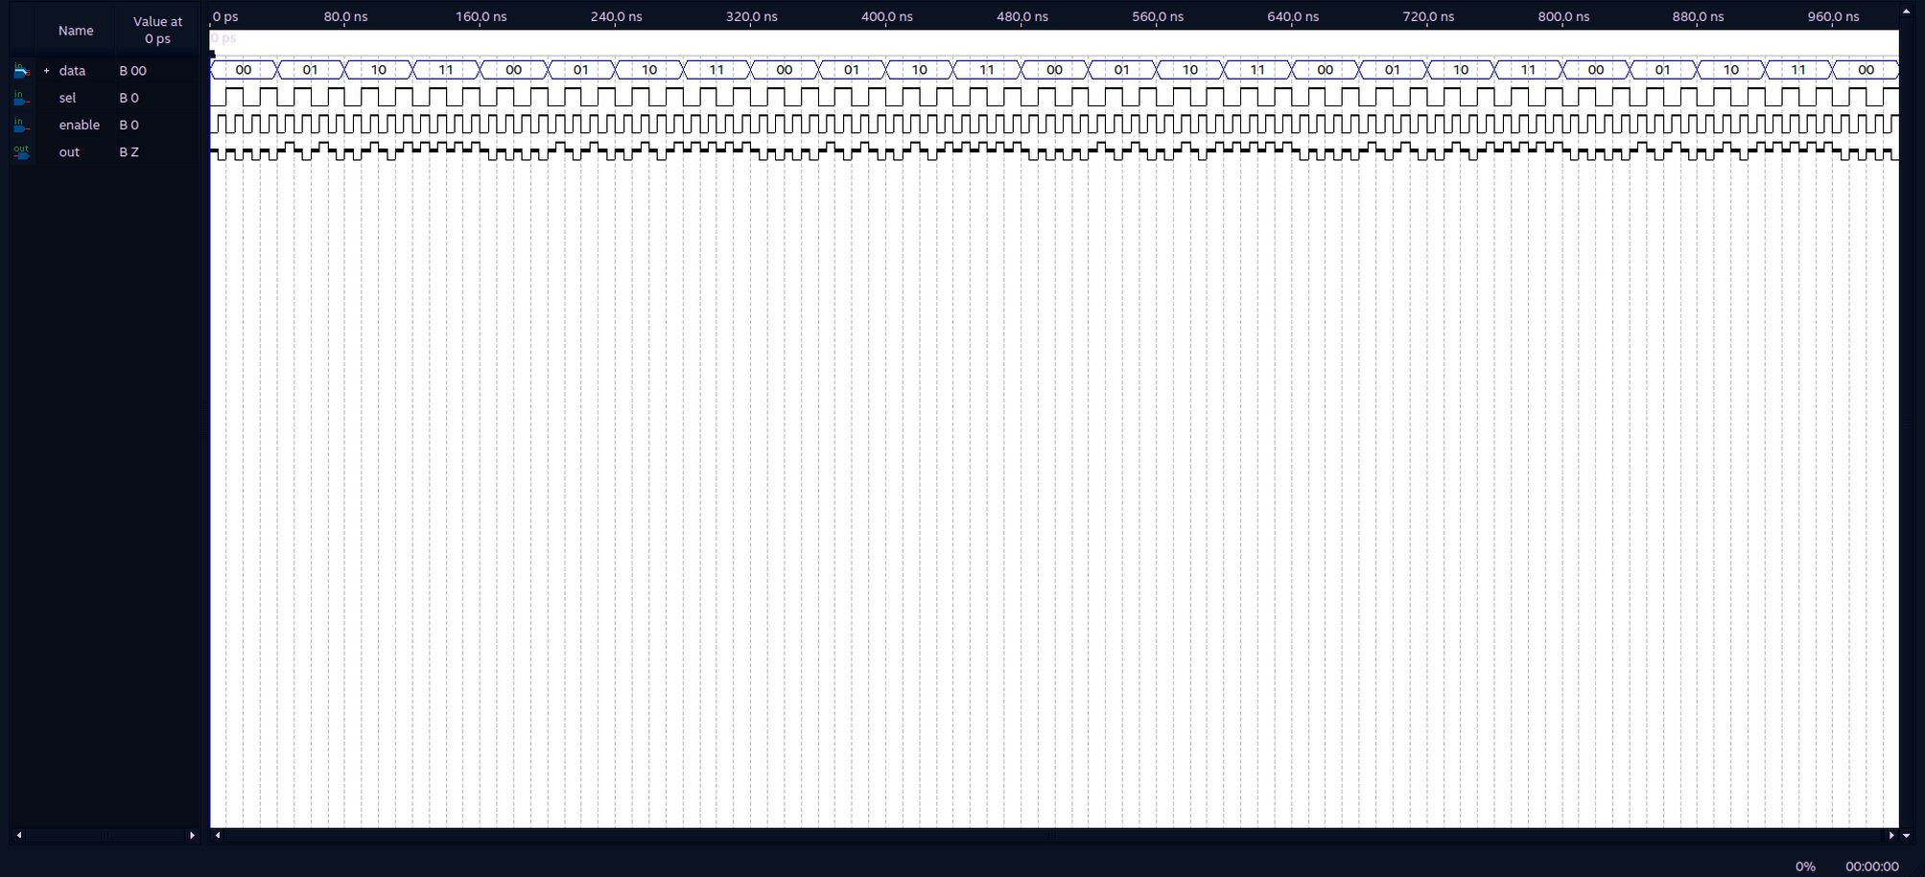

MUX2x4:

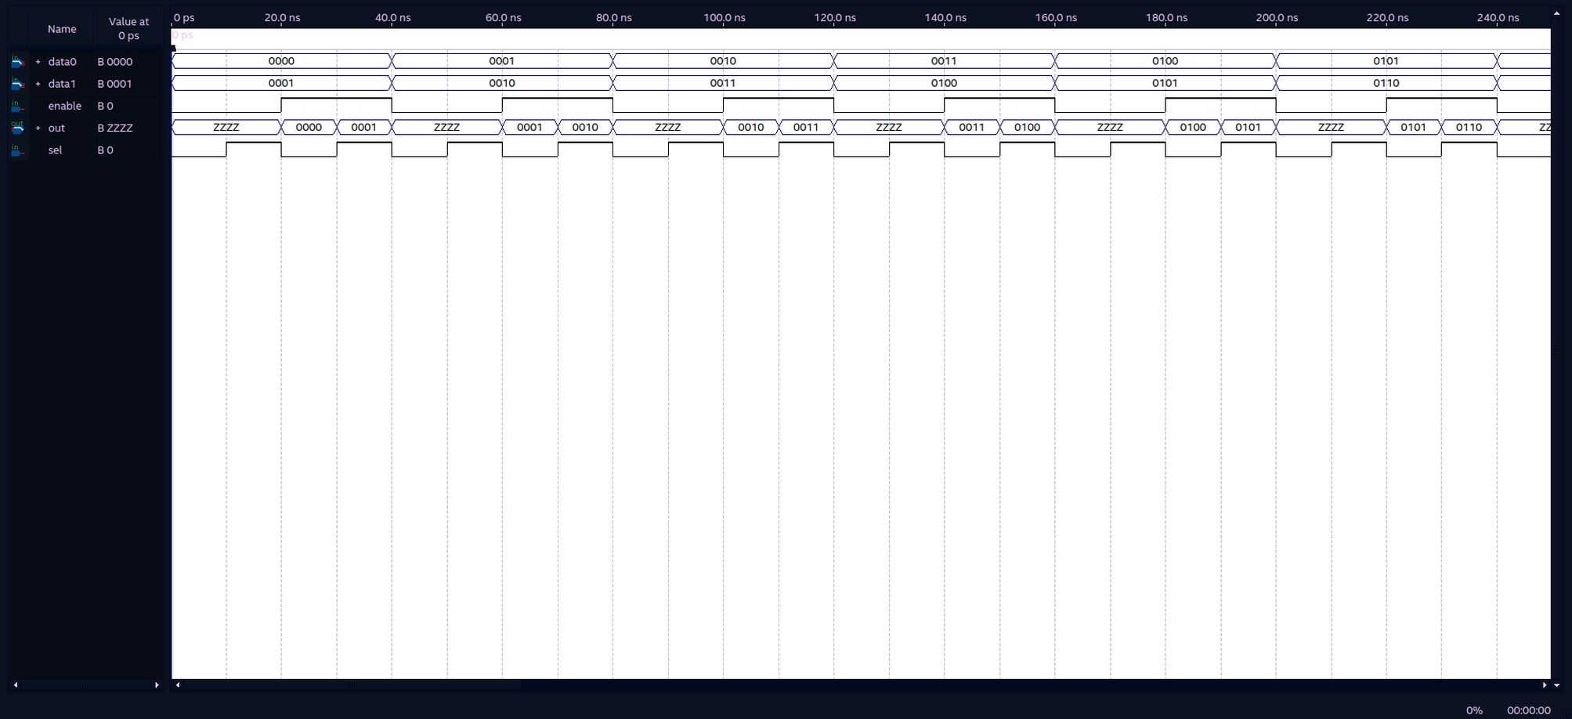

MUX2x12:

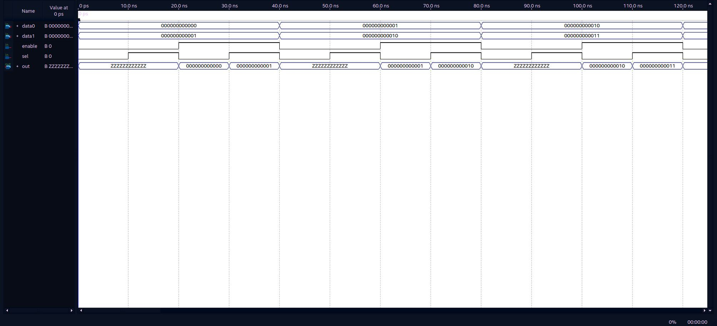

MUX4x1:

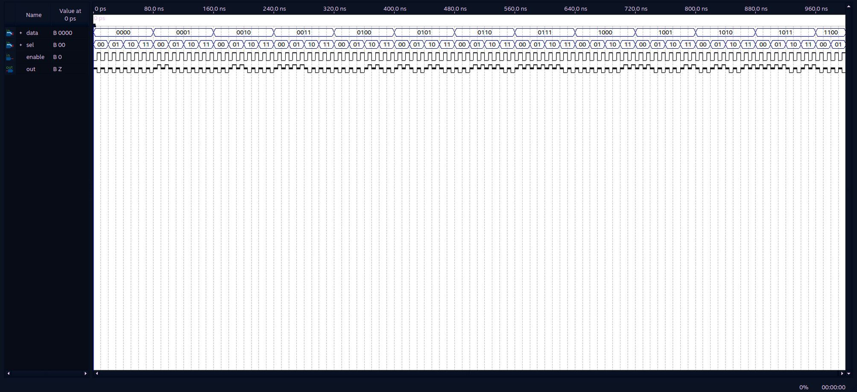

MUX16x16:

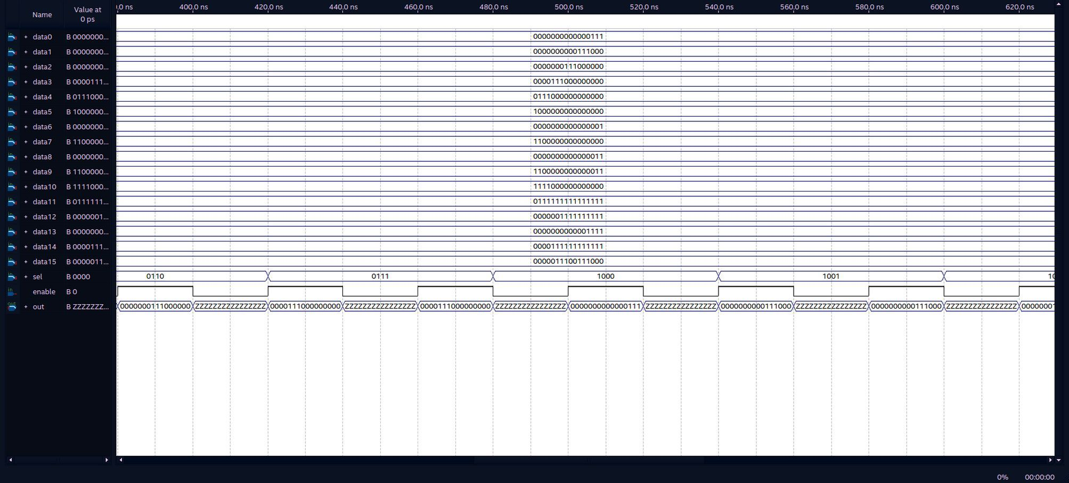

DEMUX1x2:

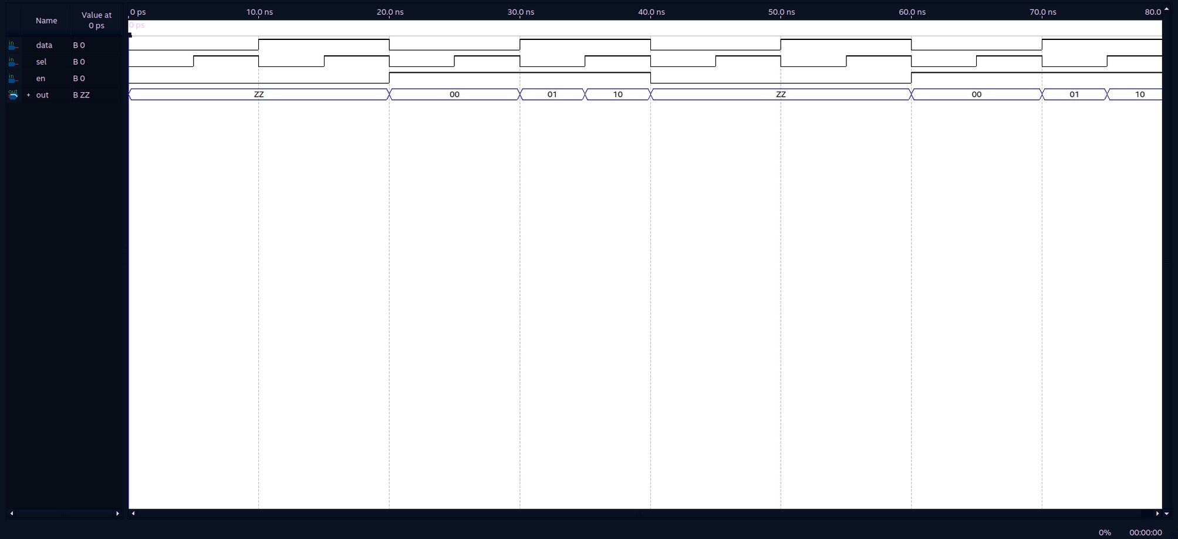

DEMUX1x4:

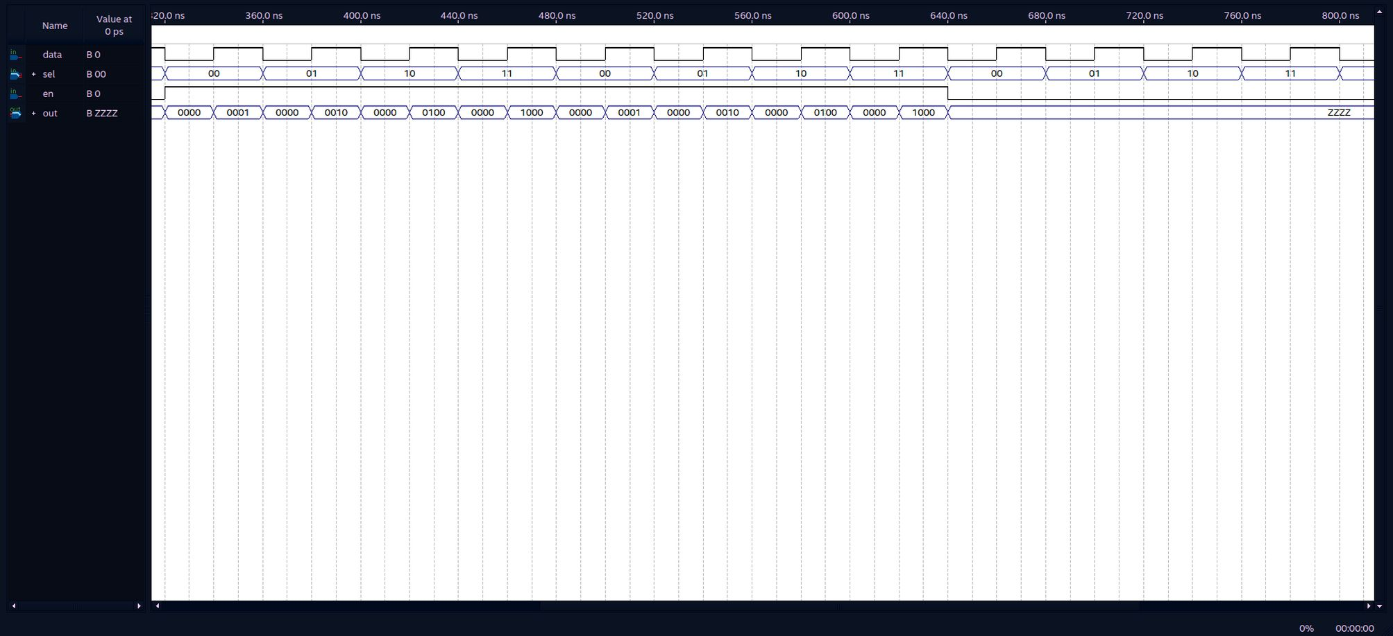

DEMUX1x8:

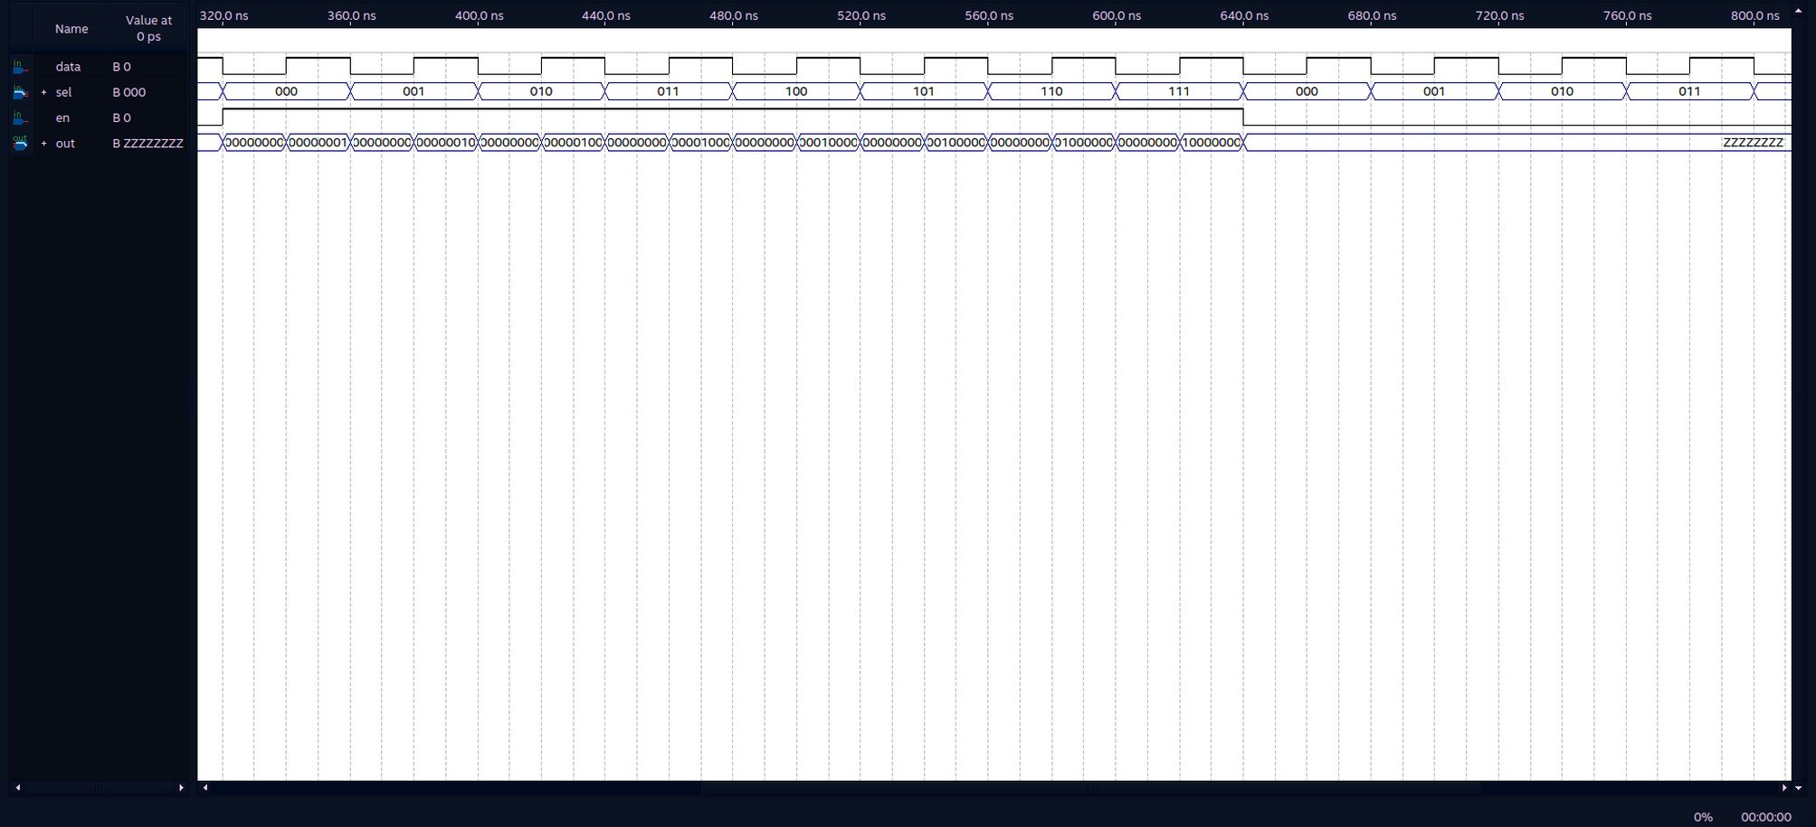

FullAdder:

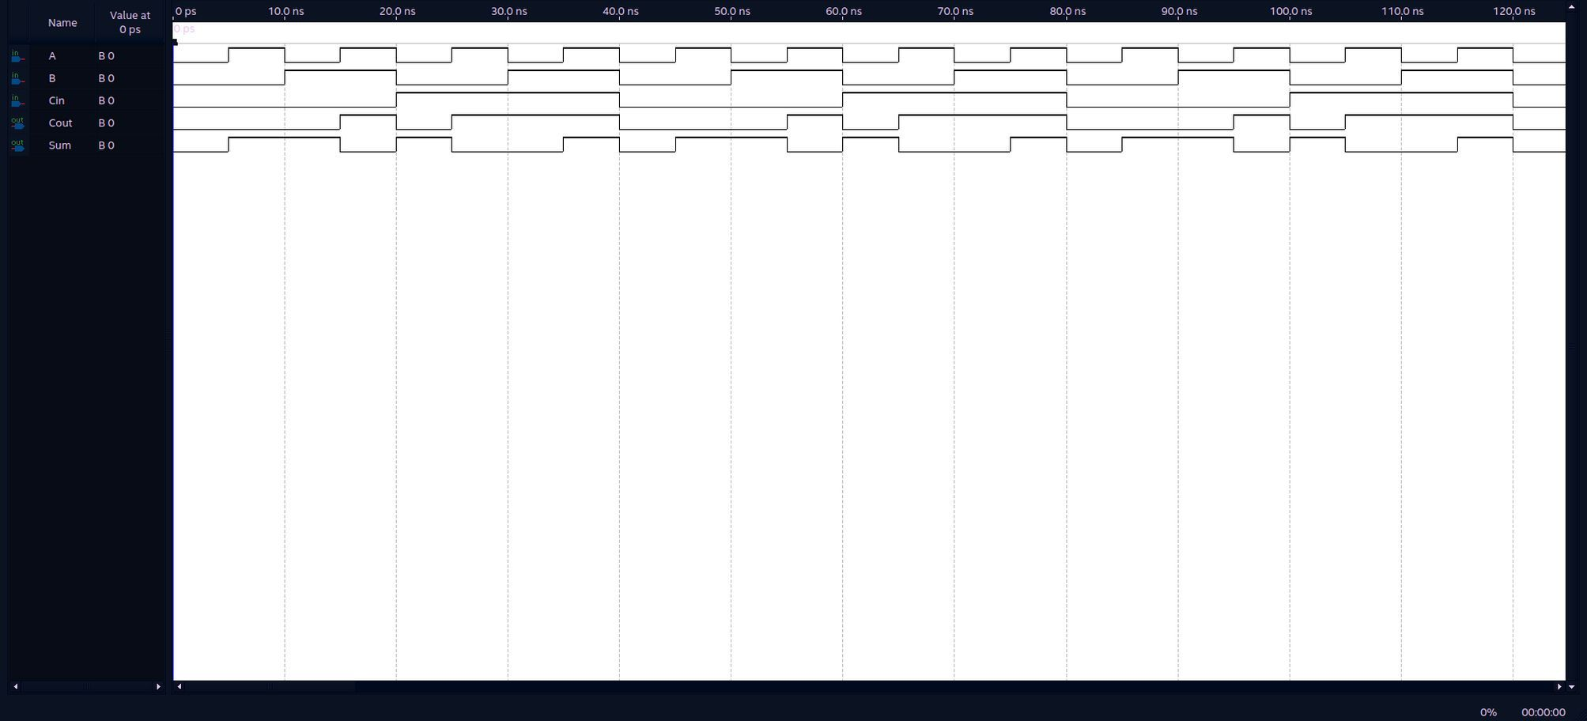

Register16Bit:

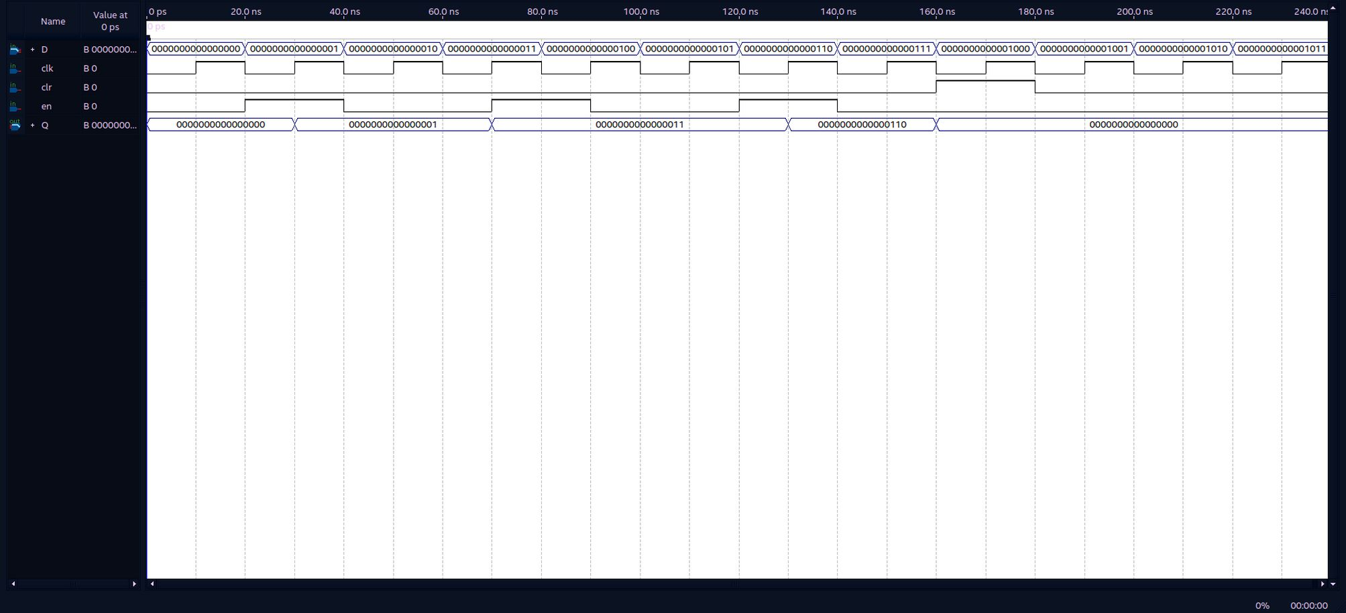

Adder16Bit:

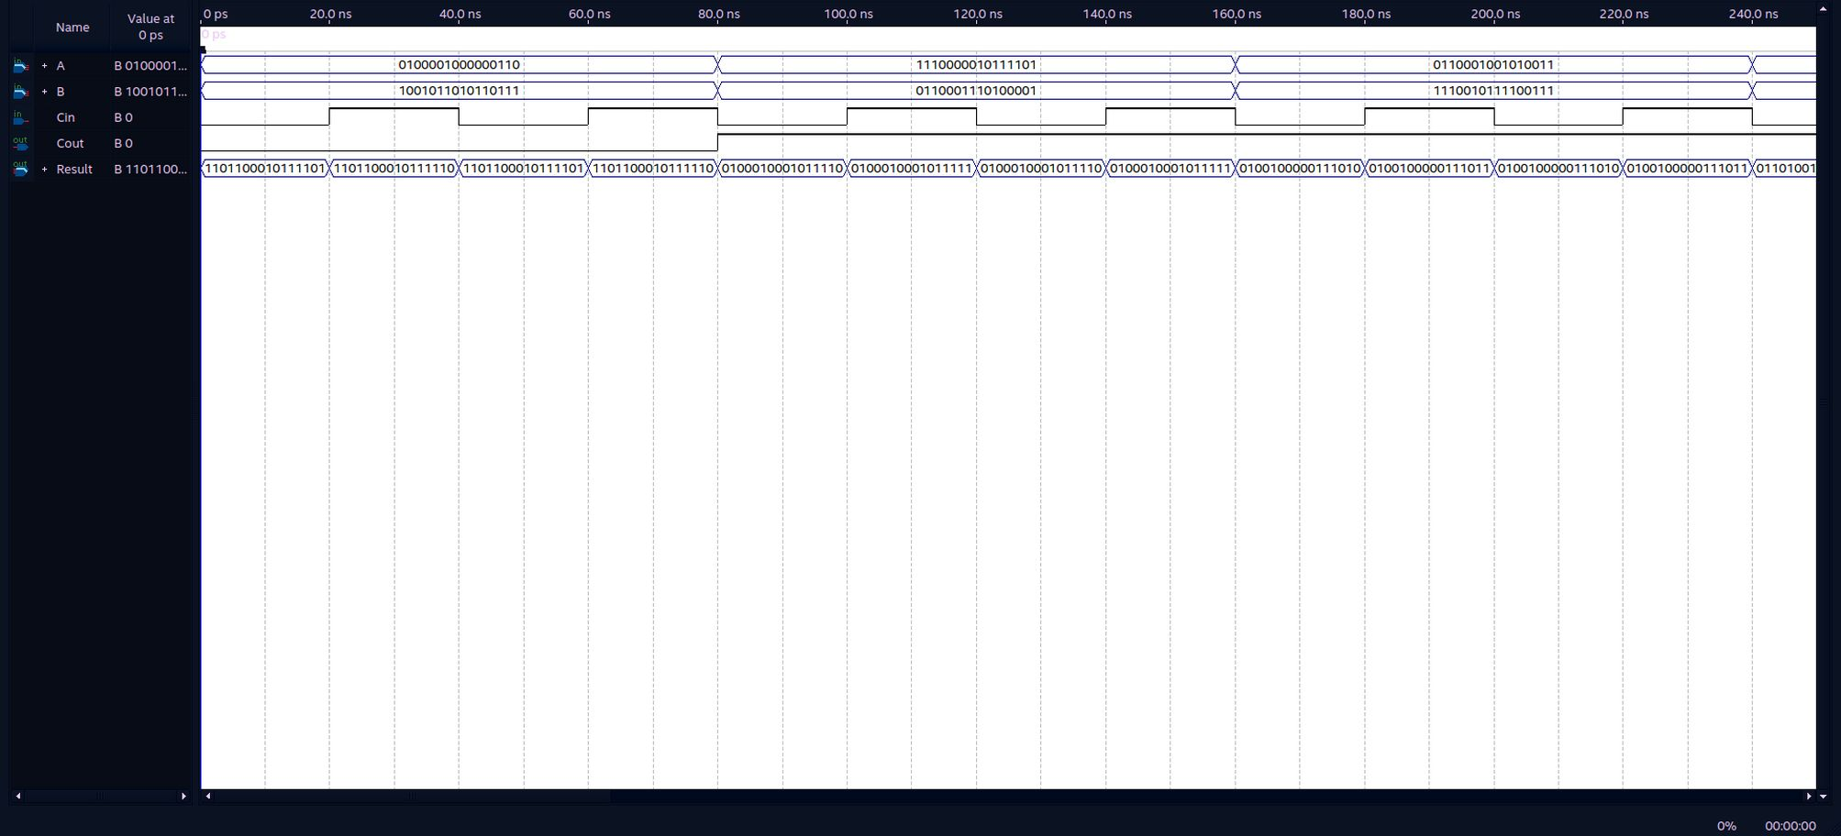

Subtractor16Bit:

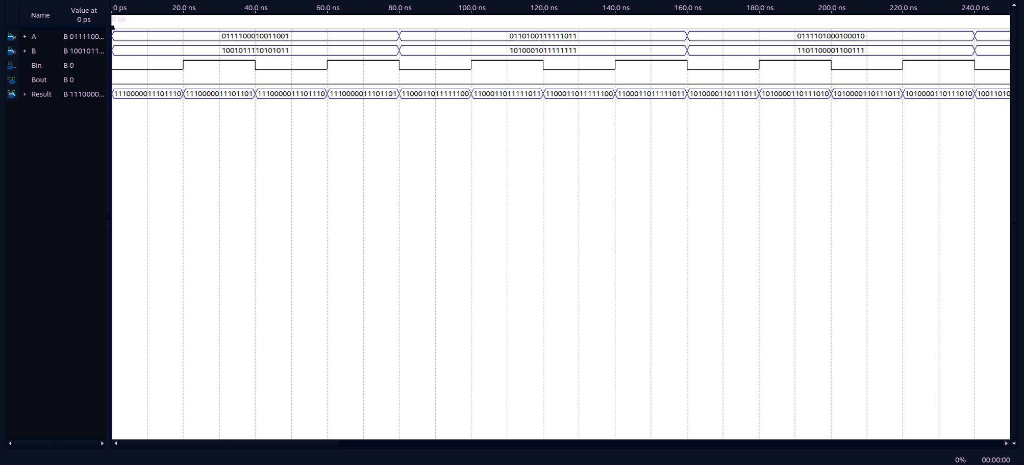

Negator16Bit:

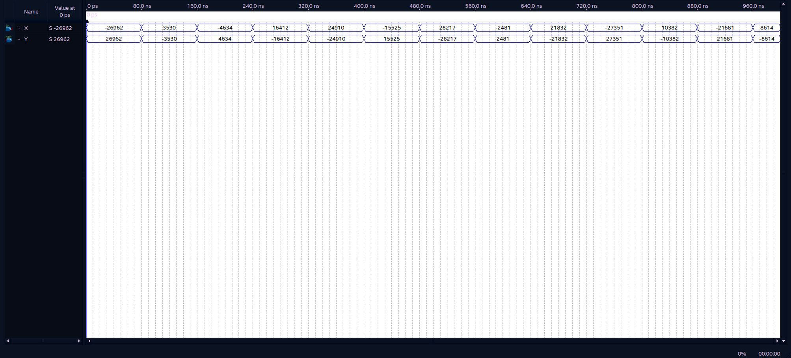

ArithmeticShiftRight16Bit:

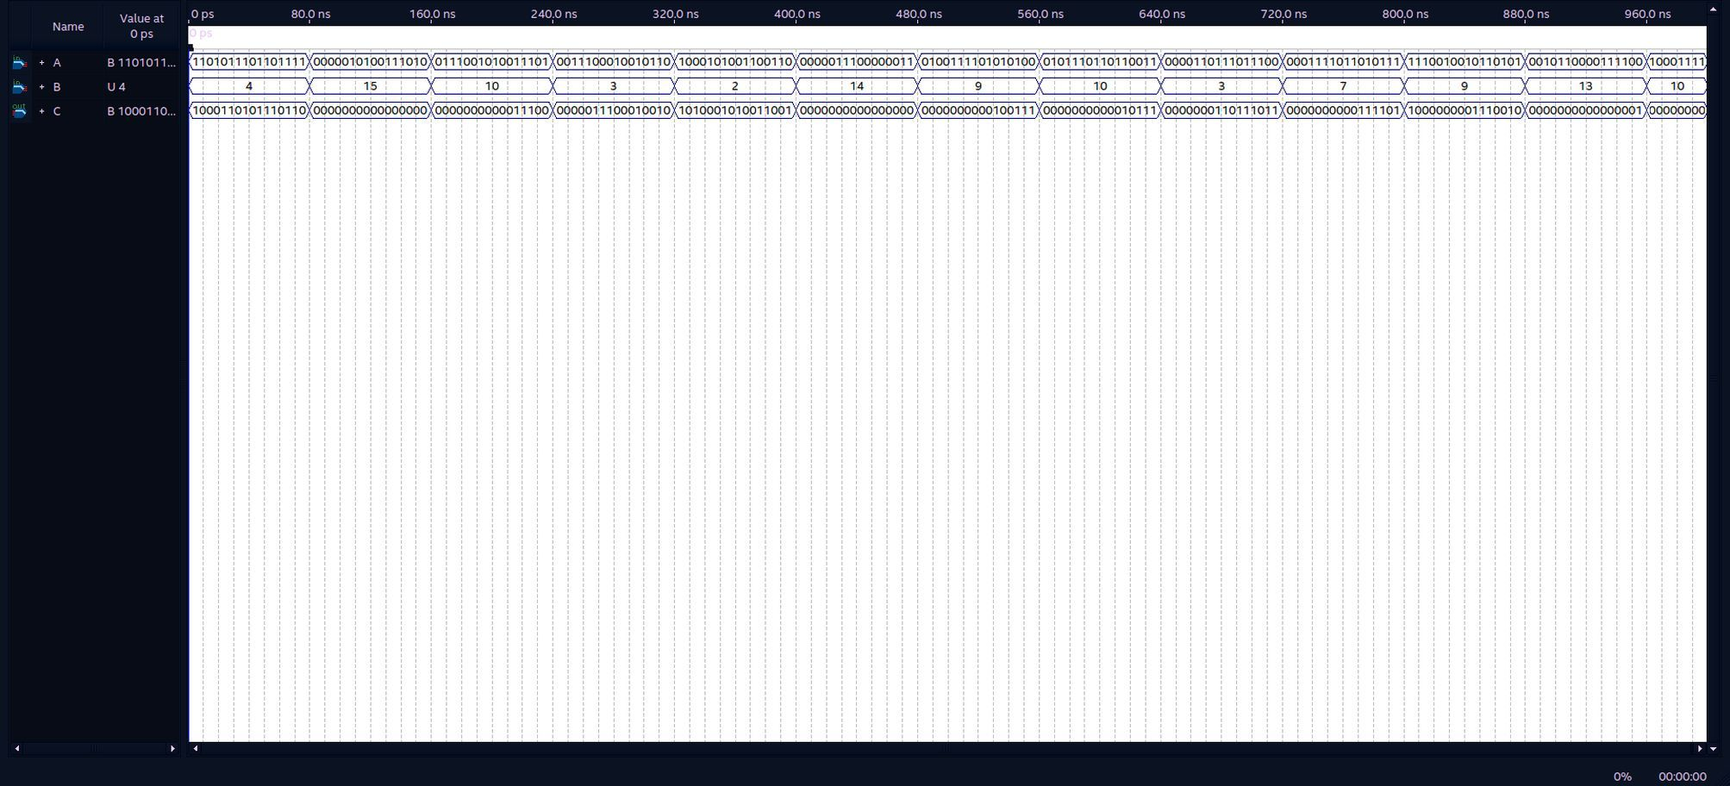

ShiftLeft16Bit:

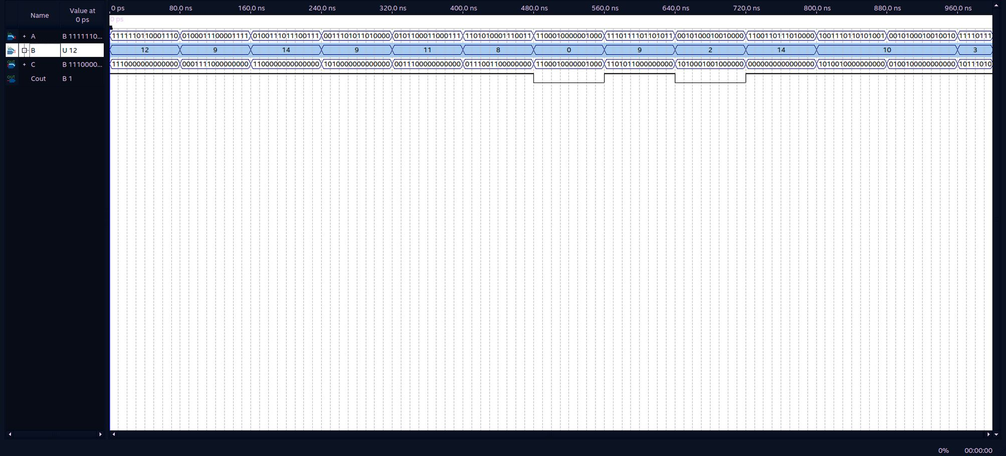

CircularShiftRight16Bit:

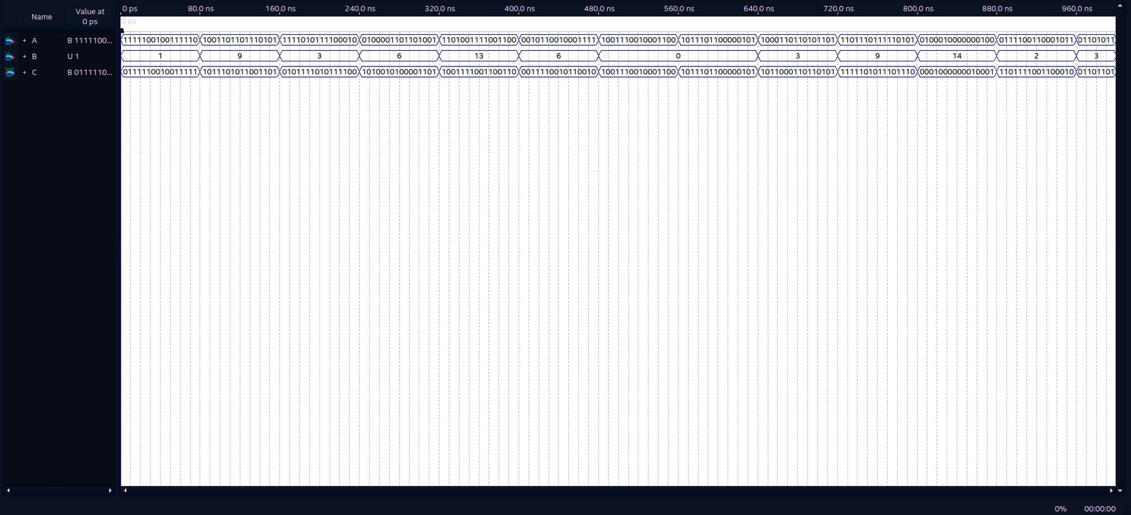

CircularShiftLeft16Bit:

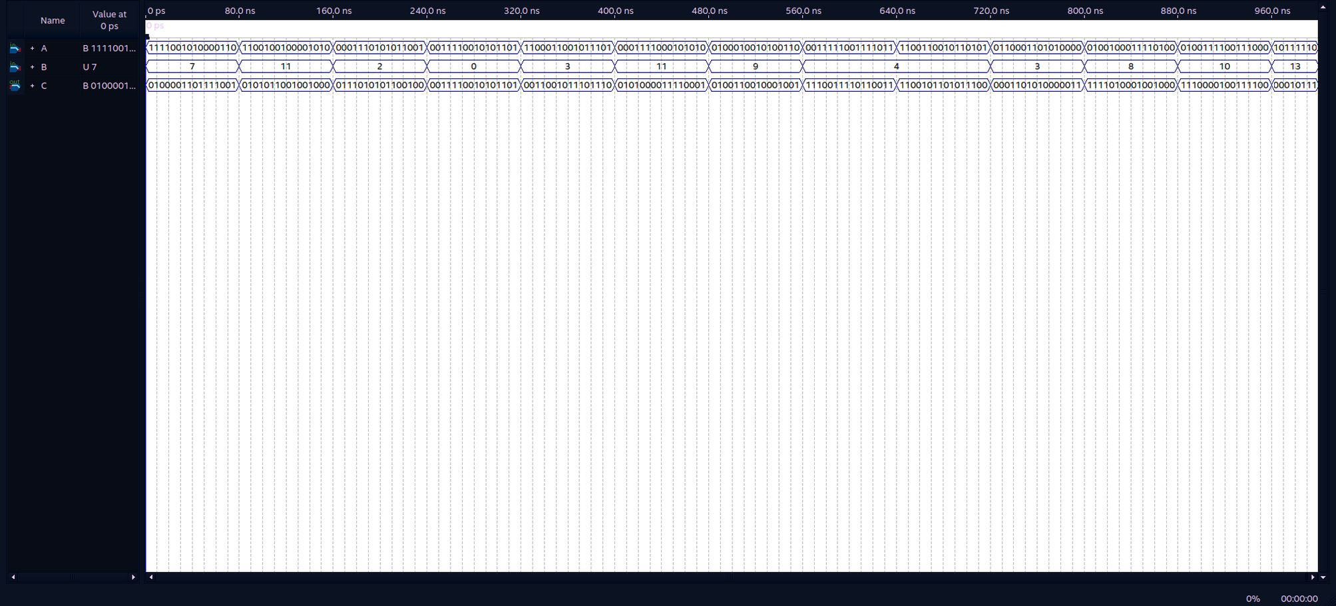

OddParity16Bit:

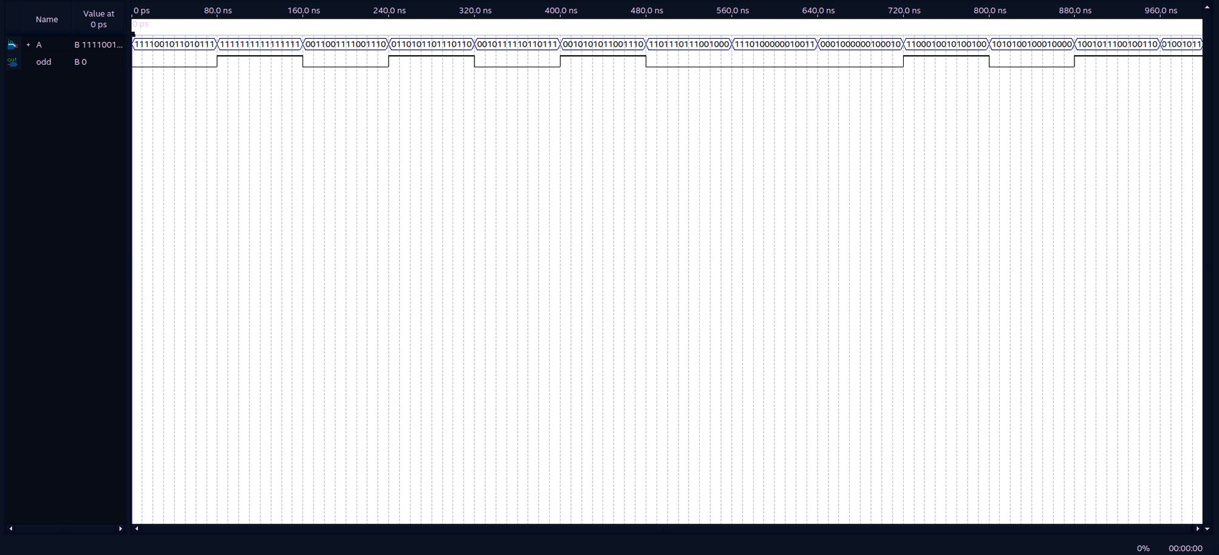

ALU16Bit:

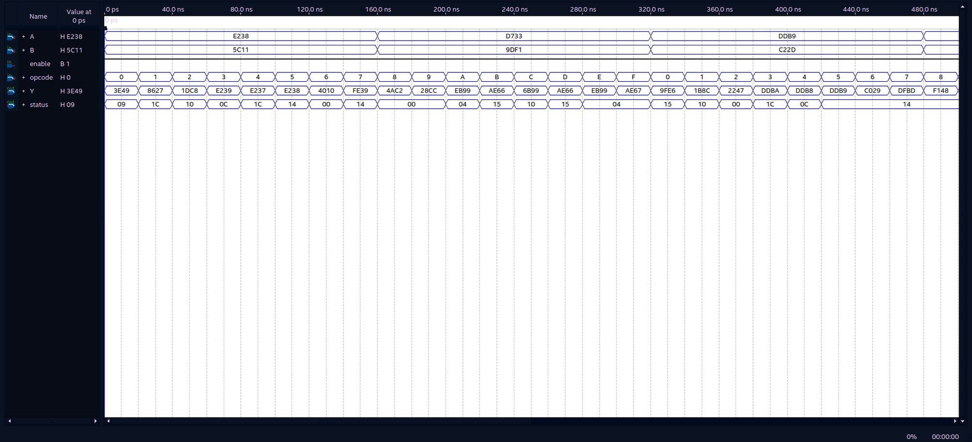

RegisterFile:

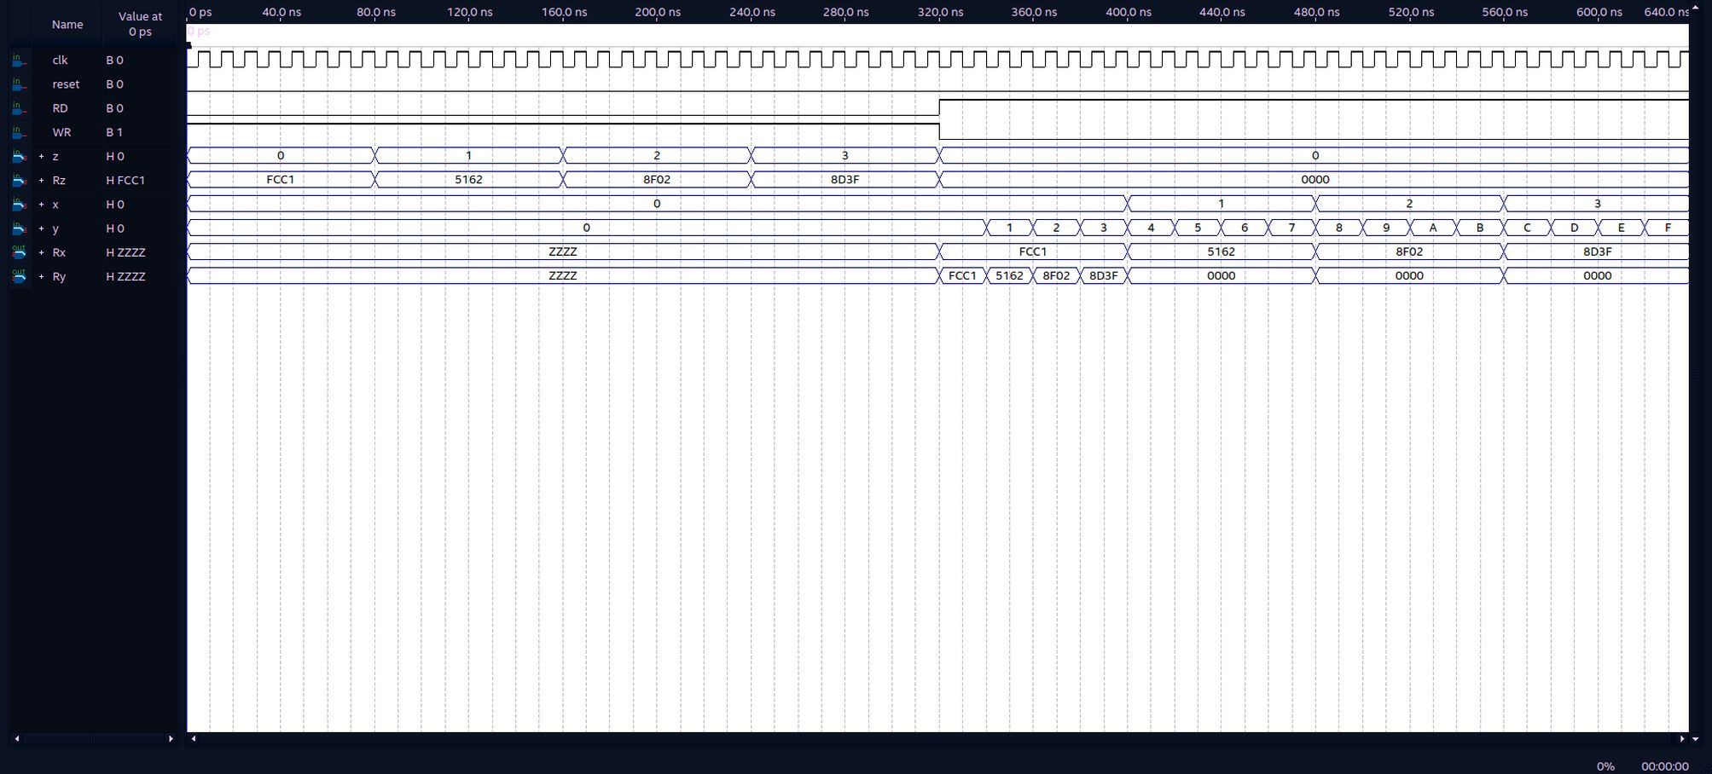

Comparator2Bit:

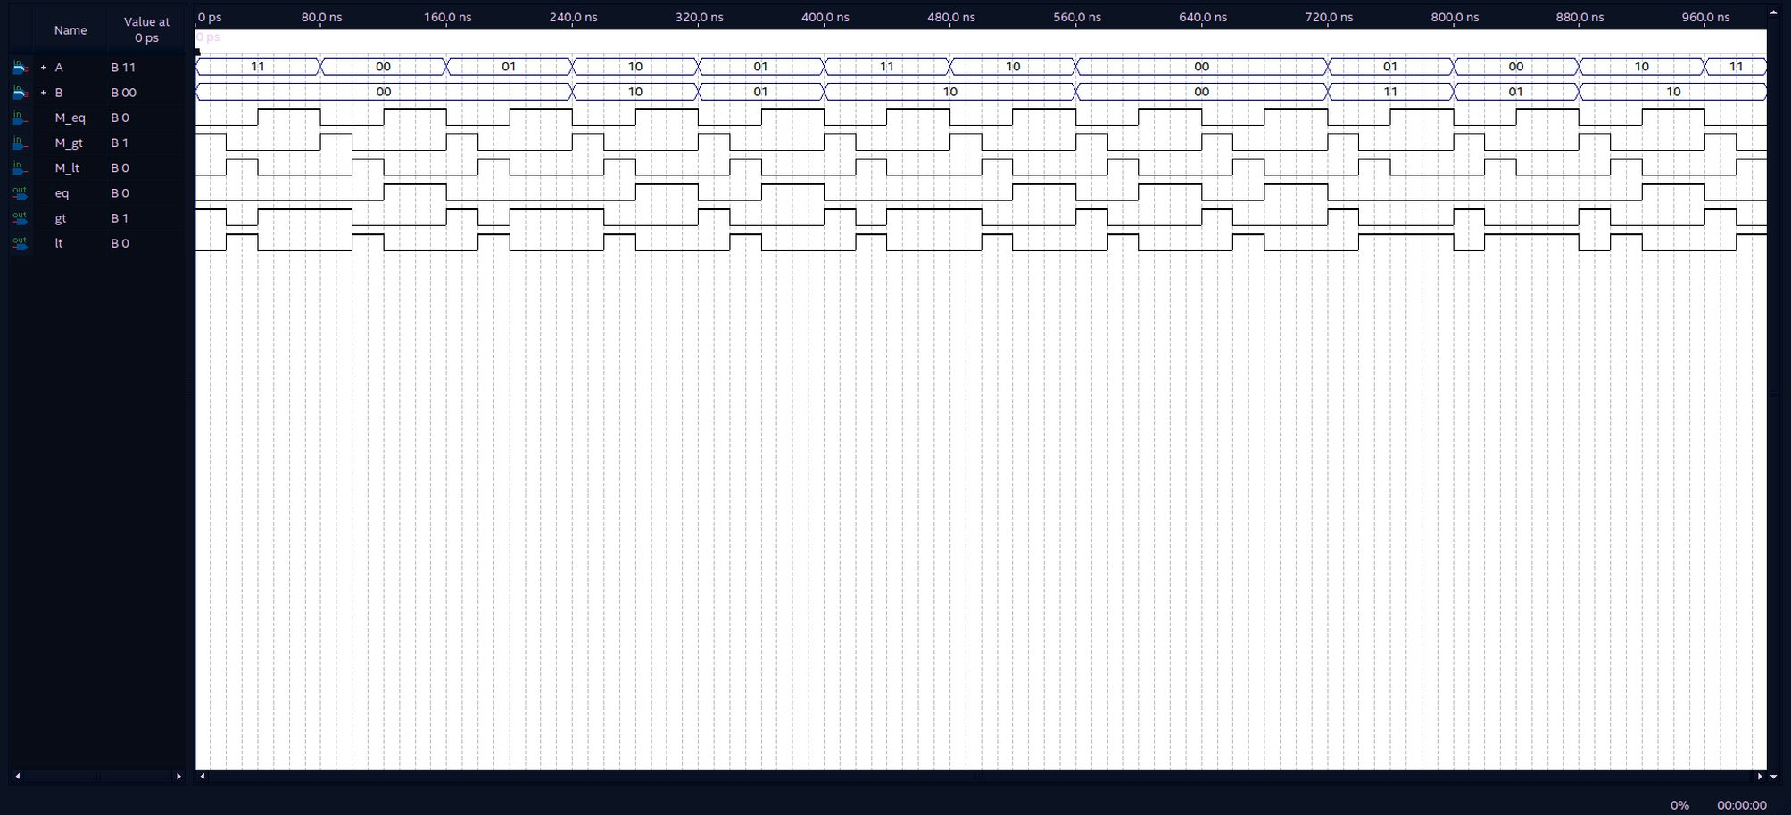

Comparator16Bit:

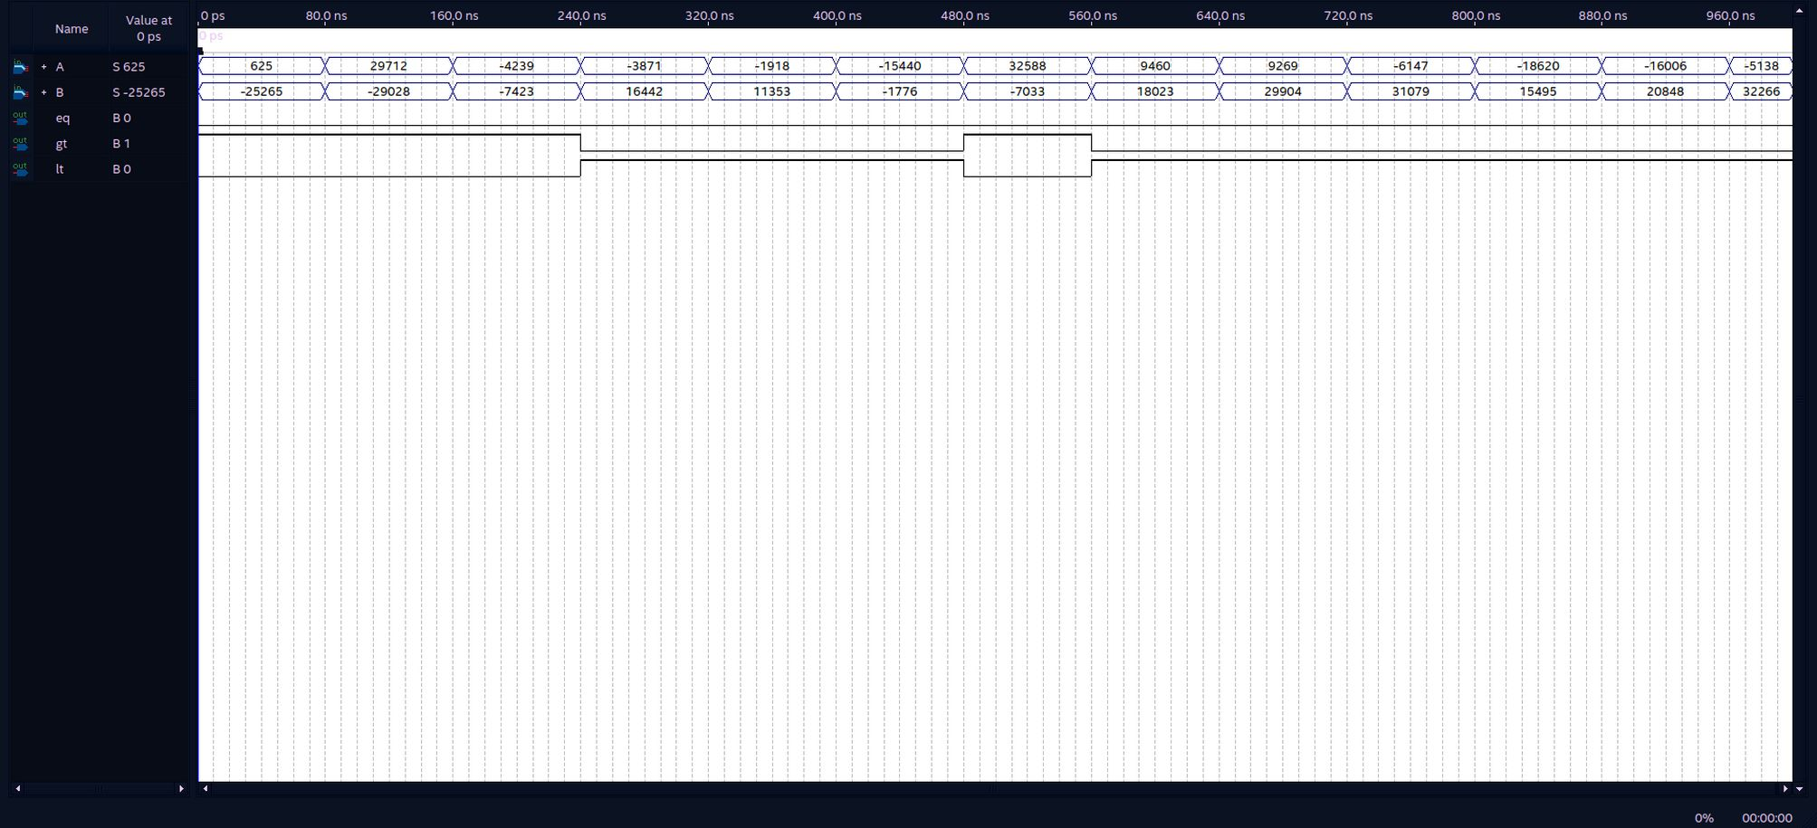

Note that the tristate modules have been changed to zeros instead in order to solve bugs in our design.

- Practical Testing

Testing all of the operations in ALU using a new CPUTester Module code given below:

module CPUTester(
input clk,
input clkBtn,
input res,
input enable,
input [1:0] btn,
output reg [3:0] dig,
output [7:0] seg
);

reg [25:0] bigCounter;
reg clockSlow;

initial begin
bigCounter <= 26'd0;
clockSlow <= 1'b0;
end
// Slow clock
always @(negedge clk)
begin
if(~res)
begin
clockSlow <= 1'b0;
bigCounter <= 26'd0;
end
// 50000000 clock cycles are needed to count for 1KHz clock (50000000 division):
if(bigCounter == 26'd50000000)
begin
bigCounter <= 26'd0;
clockSlow <= 1'b0;
end
else
begin
if(bigCounter == 16'd25000000)
begin
clockSlow <= 1'b1;
end
bigCounter <= bigCounter + 16'd1;
end
end

// Block ROM:
wire [11:0] ROMaddr;
reg [31:0] ROMdata;
wire ROMsel; // cs
// Block RAM:
wire [11:0] RAMaddr;
wire [15:0] RAMdataIn;
reg [15:0] RAMdataOut;
wire RAMsel; // cs
wire RAMld; // ~we
wire RAMclr;
// Define CPU connections:
CPUv2(
clockSlow,
~res,
enable,
// Instruction fetch pins (ROM)
ROMaddr,
ROMdata,
ROMsel,
// Data load/str pins (RAM)
RAMaddr,
RAMdataOut,
RAMdataIn,
RAMsel,
RAMld,
RAMclr
);
// Define ROM functionality:
reg [31:0] ROM [63:0];
initial begin
$readmemh("ROM.hex", ROM);
end
always @(negedge clk)
begin
ROMdata <= ROMsel ? ROM[ROMaddr[7:0]] : 32'h00000000;
end
// Digital Tube value register:
reg [15:0] hex4;
// Define RAM functionality:
reg [15:0] RAM [63:0];
integer i;
always @(negedge clk or posedge RAMclr)
begin
if(RAMclr == 1'b1)
begin
for(i = 0; i < 64; i = i + 1)
begin
RAM[i] <= 16'h0000;
end
hex4 <= 16'h0000;
end
else
begin
if(RAMsel)
begin
if(RAMld)
begin
if(RAMaddr == 12'd111)
begin
// Bind buttons to RAM:
RAMdataOut <= {14'b00000000000000, ~btn};
end
else
begin
RAMdataOut <= RAM[RAMaddr];
end
end
else
begin
if(RAMaddr == 12'd110)
begin
// Bind RAM[110] as digital tube:
hex4 <= RAMdataIn;
end
else
begin
RAM[RAMaddr] <= RAMdataIn;
end
end
end
else
begin
RAMdataOut <= 16'h0000;
end
end
end
reg clock1KHz;
reg [15:0] pulseCount;
reg [2:0] counter;
reg [15:0] hexSel;
reg [6:0] hexEncoding;
initial begin
clock1KHz <= 1'b0;
pulseCount <= 16'd0;
dig <= 4'b0111;
counter <= 3'b000;
hexSel <= 16'h0000;
end
always @(negedge clk)
begin
if(~res)
begin
clock1KHz <= 1'b0;
pulseCount <= 16'd0;
end
// 50000 clock cycles are needed to count for 1KHz clock (50000 division):
if(pulseCount == 16'd50000)
begin
pulseCount <= 16'd0;
clock1KHz <= 1'b0;
end
else
begin
if(pulseCount == 16'd25000)
begin
clock1KHz <= 1'b1;
end
pulseCount <= pulseCount + 16'd1;
end
end
always @(posedge clock1KHz)
begin
if(~res)
begin
dig <= 4'b0111;
counter <= 3'b000;
hexSel <= 16'h0000;
end
if(counter == 3'b100)
begin
dig <= 4'b0111;
hexSel <= hex4;
counter <= 3'b000;
end
else
begin
dig <= {dig[2:0], dig[3]};
// Set digital tube to show recieved code:
case (hexSel[3:0])
4'b0000 : hexEncoding <= 7'h3f;
4'b0001 : hexEncoding <= 7'h06;
4'b0010 : hexEncoding <= 7'h5b;
4'b0011 : hexEncoding <= 7'h4f;
4'b0100 : hexEncoding <= 7'h66;
4'b0101 : hexEncoding <= 7'h6d;
4'b0110 : hexEncoding <= 7'h7d;
4'b0111 : hexEncoding <= 7'h07;
4'b1000 : hexEncoding <= 7'h7f;
4'b1001 : hexEncoding <= 7'h6f;
4'b1010 : hexEncoding <= 7'h77;
4'b1011 : hexEncoding <= 7'h7c;
4'b1100 : hexEncoding <= 7'h39;
4'b1101 : hexEncoding <= 7'h5e;
4'b1110 : hexEncoding <= 7'h79;
4'b1111 : hexEncoding <= 7'h71;
endcase
hexSel <= {4'b0000, hexSel[15:4]};
counter <= counter + 3'b001;
end
end
assign seg[7] = 1'b1;
assign seg[6] = ~hexEncoding[6];
assign seg[5] = ~hexEncoding[5];
assign seg[4] = ~hexEncoding[4];
assign seg[3] = ~hexEncoding[3];
assign seg[2] = ~hexEncoding[2];
assign seg[1] = ~hexEncoding[1];
assign seg[0] = ~hexEncoding[0];
endmodule

Assembly code tested:

; R0 = 12
MOV R0, 0b1100
; R1 = 10
MOV R1, 0b1010
; R3 = -16
MOV R3, 0xFFF0
; R4 = 2
MOV R4, 2

; 12 + 10 = 22 = 0x0016
ADD R2, R0, R1
STR R2, 110

; 12 - 10 = 2 = 0x0002
SUB R2, R0, R1
STR R2, 110

; -(12) = -12 = -0b0000000000001100 = 0b1111 1111 1111 0100 = 0xFFF4
NEG R2, R0
STR R2, 110

; 12 + 1 = 13 = 0x000D
INC R2, R0
STR R2, 110

; 12 - 1 = 11 = 0x000B
DEC R2, R0
STR R2, 110

; 0b1100 & 0b1010 = 0b1000 = 0x0008
AND R2, R0, R1
STR R2, 110

; 0b1100 | 0b1010 = 0b1110 = 0x000E
OR R2, R0, R1
STR R2, 110

; 0b1100 ^ 0b1010 = 0b0110 = 0x0006
XOR R2, R0, R1
STR R2, 110

; ~(0b1100) = 0xFFF3
NOT R2, R0
STR R2, 110

; 0xFFF0 >> 2 (Arithmetic) = 0b1011 1111 1111 1100 = 0xBFFC
ASR R2, R3, R4
STR R2, 110

; 0xFFF0 << 2 = 0b1111 1111 1100 0000 = 0xFFC0
ASL R2, R3, R4
STR R2, 110

; 0xFFF0 >> 2 (Logical) = 0b0011 1111 1111 1100 = 0x3FFC
LSR R2, R3, R4
STR R2, 110

; 0xFFF0 << 2 = 0b1111 1111 1100 0000 = 0xFFC0
LSL R2, R3, R4
STR R2, 110

; 0xFFF0 csr 2 = 0b0011 1111 1111 1100 = 0x3FFC
CSR R2, R3, R4
STR R2, 110

; 0xFFF0 csl 2 = 0b1111 1111 1100 0011 = 0xFFC3
CSL R2, R3, R4
STR R2, 110

So the machine code for this:

C123A014
80000042
C197A014
80000442
C1B3A014
80000842
C1B3A014
80000C42
C1BFA014
80001042
C083A014
80001442
C1DFA014
80001842
C1BFA014
80001C42
C1CBA014
80002042
C1B3A014
80002442
C193A014
80002842
00000007
8800000B

Finally link to the demo video for this:

https://drive.google.com/file/d/1qN3D-pp6XvTK-qX1VQdLMbxbmrgEU0fi/view?usp=sharing

And a combined demo of CPU writing to RAM so VGAController can read from:

The code:
; H
MOV R0, 0b0100100011101000
STR R1, 0x0

; e
MOV R0, 0b0110010111101000
STR R1, 0x1

; l
MOV R0, 0b0110110011101000
STR R1, 0x2

; l
MOV R0, 0b0110110011101000
STR R1, 0x3

; o
MOV R0, 0b0110111111101000
STR R1, 0x4

; " "
MOV R0, 0b0010000011101000
STR R1, 0x5

; w
MOV R0, 0b0111011111101000
STR R1, 0x6

; o
MOV R0, 0b0110111111101000
STR R1, 0x7

; r
MOV R0, 0b0111001011101000
STR R1, 0x8

; l
MOV R0, 0b0110110011101000
STR R1, 0x9

; d
MOV R0, 0b0110010011101000
STR R1, 0xA

; Return to start without clearing RAM
CMP R0, R0
JE 0

The link to demo video:

https://drive.google.com/file/d/1Rim_TL8SQ2SJTGS2j00ESfhPuEdO5mO8/view?usp=sharing

