MARMARA UNIVERSITY
FACULTY OF ENGINEERING
ELECTRICAL&ELECTRONICS ENGINEERING

CSE2062

OBJECT-ORIENTED PROGRAMMING

Project 2


NAME STUDENT NUMBER
Efe Emir PEKMEZ 150718040
Batuhan Berkay ÖZTÜRK 150717031
Mehmet Mücahit DÖNMEZ 150717059
Hüseyin MENTEŞE 150717028
Mehmet Ali ÖZÇELİK 150717010
Alper ARSLAN 150717013

Submitted to: Şakir BİNGÖL

Due Date
2.07.2020
Problem Definition:
Managing every project is hard so our application helps with managing all the parts and materials needed to build for each project. Each of the unit price of materials, unit cost of parts are hold to further calculate and estimate a total cost in each project. We thought of a project as a whole unit consisting of multiple different parts and quantities for each parts. More so, we thought of each part as a unit consisting of smaller units called as materials.

To calculate total cost of project we must first calculate each of the parts project contains. This is done by summing all of unit prices and quantities of materials the part is consisting. Also there is an another criteria; if a material is not available in market then the parts consisting this material couldn’t be built so the projects consisting this parts couldn’t be built.

In conclusion the application we built has a unique usage case in industry and project budget planning.

Project Requirements & Criterias:
We implemented that so each window of our application’s GUI is represented with a class which implements interface we wrote, this child classes with their purposes are:

- MenuView:
  - This class is used to show the user the first screen he/she will see. This view shows user the projects saved in filesystem and make user pick a choice. There is 5 buttons for each choices user can pick in this screen. This options are: open the selected project on the list to further get details on project, create a new project with new name and a icon image, delete the selected project on the list, manage parts already defined in system (saved in filesystem) and manage materials already defined in system (saved in filesystem)

- MaterialLibraryView:
  - This class is used to show user the screen where he/she can lookup details of each material (with MaterialView class), add new materials to material library (with AddMaterialView class) and remove materials from library. Materials in library will be further used to choose from combobox when adding a material to a part.

- PartLibraryView:
  - This class is used to show user the screen where he/she can lookup details of each part (with PartView class), add new parts to part library (with AddPartView class) and remove parts from library. Parts in library will be further used to choose from combobox when adding a part to a project.

- AddMaterialView:
  - This view is used to create a new material to save in material library by getting name, icon image, unit price and availability from user.

- AddPartView:
  - This view is used to create a new part to save in part library by getting name and an icon image from user. The ingredient materials can be added by entering details about the newly created part. Unit cost is calculated later with added ingredients.

- MaterialView:
  - This class is used to show user details about a material. This details include: icon for the material, name of material, stock availability of material and unit price of material.

- PartView:
  - This class is used to show user details about a part. This details include: icon for the part, name of part, unit cost of part and a list of ingredient materials (if all ingredients are in stock otherwise show part cannot be built). Finally there is two buttons to manage materials of this part. A button to add a material defined in material library and a button to delete selected material on list.

- ProjectView:
  - This class is used to show user details of a project. This details include: icon for the project, name of project, total cost of the project and a list of ingredient parts (if all ingredients are in stock otherwise show project cannot be built). Finally there is two buttons to manage parts of this project. A button to add a part defined in part library and a button to delete selected part on list.

All of the views are set up the same way:
- Constructor sets up all of the layout; initializing members, setting up labels/buttons/etc., setting up correct layout for window, adding all elements to content pane and dealing with all the button action listeners and events.

- “run” method is used to set up the further state-dependent (changing according user input to application) data like loading the currently saved projects from filesystem, loading materials/parts and populating JLists with correct data.

The classes “Project”, “Part” and “Material” are used as building blocks for our application and later on saved and loaded with object streams. They have the necessary private members as:

- Project:
  - name: Represents project name.
  - image: Represents the corresponding image icon path.
  - parts: Represents key and value sets of ingredient parts and their quantities.

- Part:
  - name: Represents part name.
  - image: Represents the corresponding image icon path.
  - materials: Represents key and value sets of ingredient materials and their quantities.

- Material:
  - name: Represents material name.
  - price: Represents unit price of material.
  - image: Represents the corresponding image icon path.
  - inStock: Represents whether material is in stock or not.

And this classes have getter&setters for each of this private properities. Also “Part” and “Project” classes both have a “getCost” method. It is used to get the total cost with the way we explained in problem definition.

File operations are handled with the class called “FileManager”. This class has methods to load multiple, load one, create & add new, save and delete methods for each of the building block classes: “Project”, “Part”, “Material”. Object streams , buffered writers and readers are used.

For example for “Project” building block class:

- “loadProjects” method loads multiple projects from filesystem. This projects names are loaded from file called “project.dat” inside “data” folder. Then all the projects one by one from files with same names as projects with a “.bin” extension from inside of “data/projects” path. (loadProject method is used for each of the projects read from list of projects saved)

- “loadProject” method loads a project from filesystem with given name. Project is loaded from file with same name as project with a “.bin” extension from inside of “data/projects” path.

- “addNewProject” method saves a new project to filesystem with given “Project” instance. This instance is saved to a file with the same name as project with “.bin” extension from inside of “data/projects” path. The difference between this and “saveProject” is that this method also appends the project to list of saved projects ( “project.dat” ).

- “saveProject” method saves a project to filesystem with given “Project” instance. This instance is saved to a file with the same name as project with “.bin” extension from inside of “data/projects” path.

- “deleteProject” method deletes a project from filesystem with given project name. File with the same name as project with “.bin” extension from inside of “data/projects” path and corresponding icon image in “data/images/projects” path is removed and the project is deleted from list of saved projects ( “project.dat” ).

This same logic is used for “Part” and “Material” building block classes too.

There is also a method called “getImageResource” in “FileManager” class. This method is used to load selected images from their absolute path to intended “data/images” path onto folder associated with its “resourceClass” and saved under image name “name”. We used “ImageIO” library to scale the image to size 50x50 and save to new file. For ex: If we get a image resource for a project it is scaled to 50x50 and saved under “data/images/projects” path.

Finally, we have a class called “App” to start our application and instantiate “MenuView” to show to user menu screen.

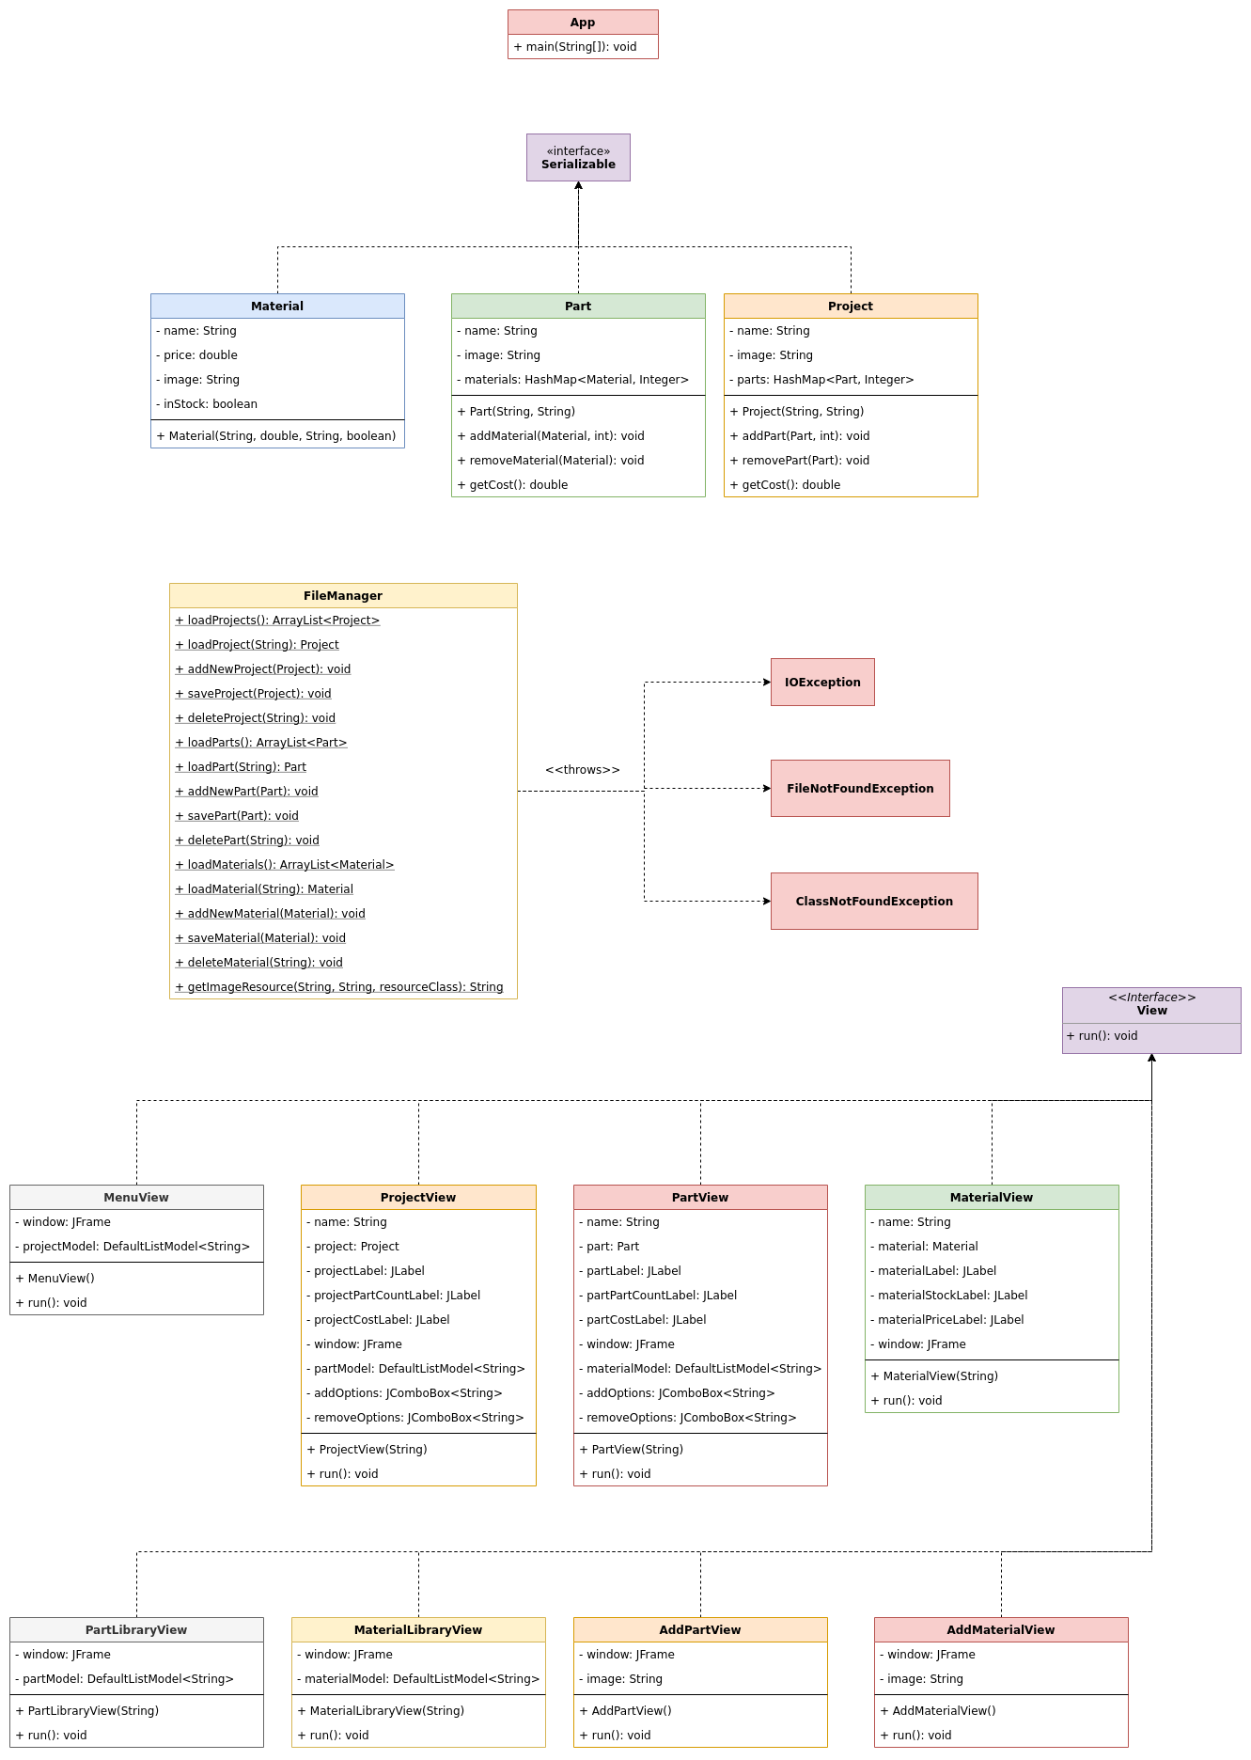
UML Diagram:
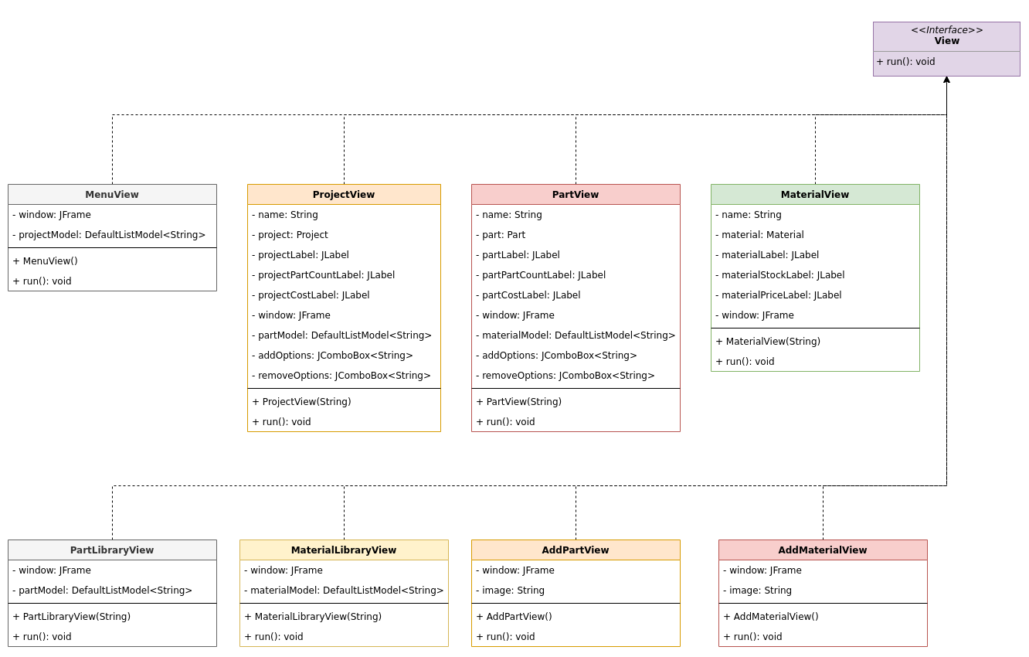

Output Screens:

MenuView:

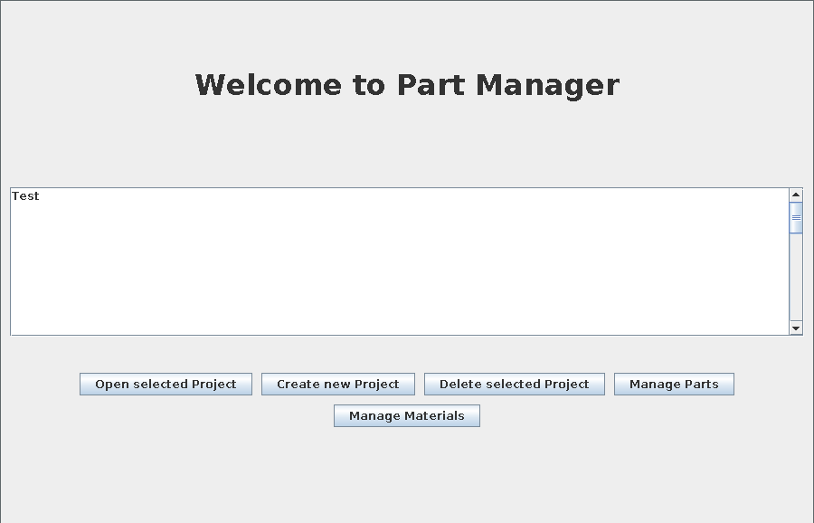

MaterialPartLibrary:

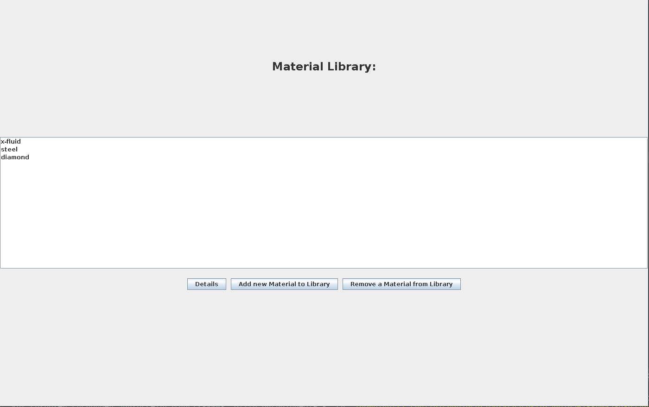

PartLibraryView:

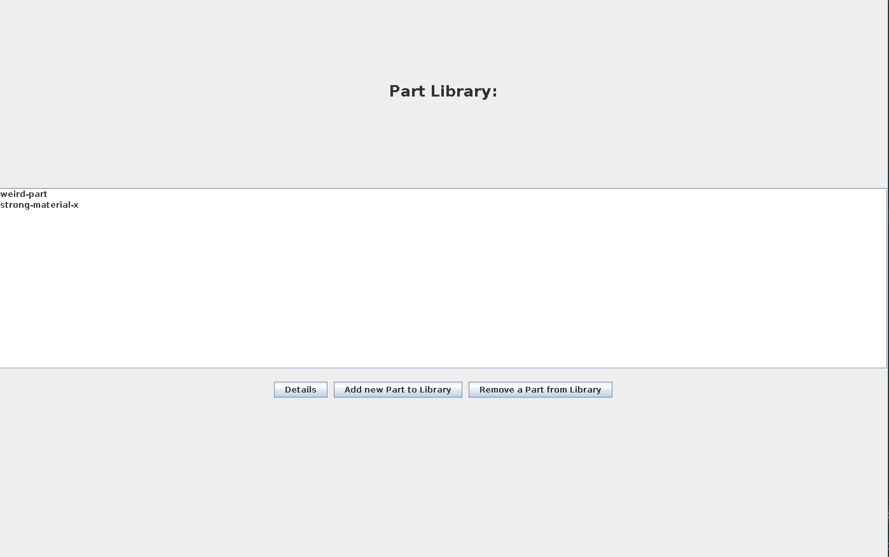

AddMaterialView:

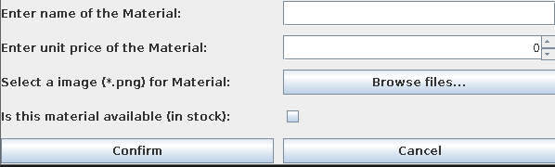

AddPartView:

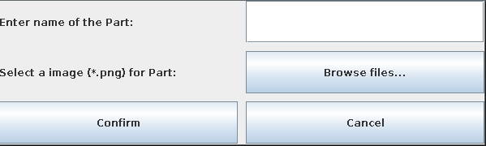

MaterialView:

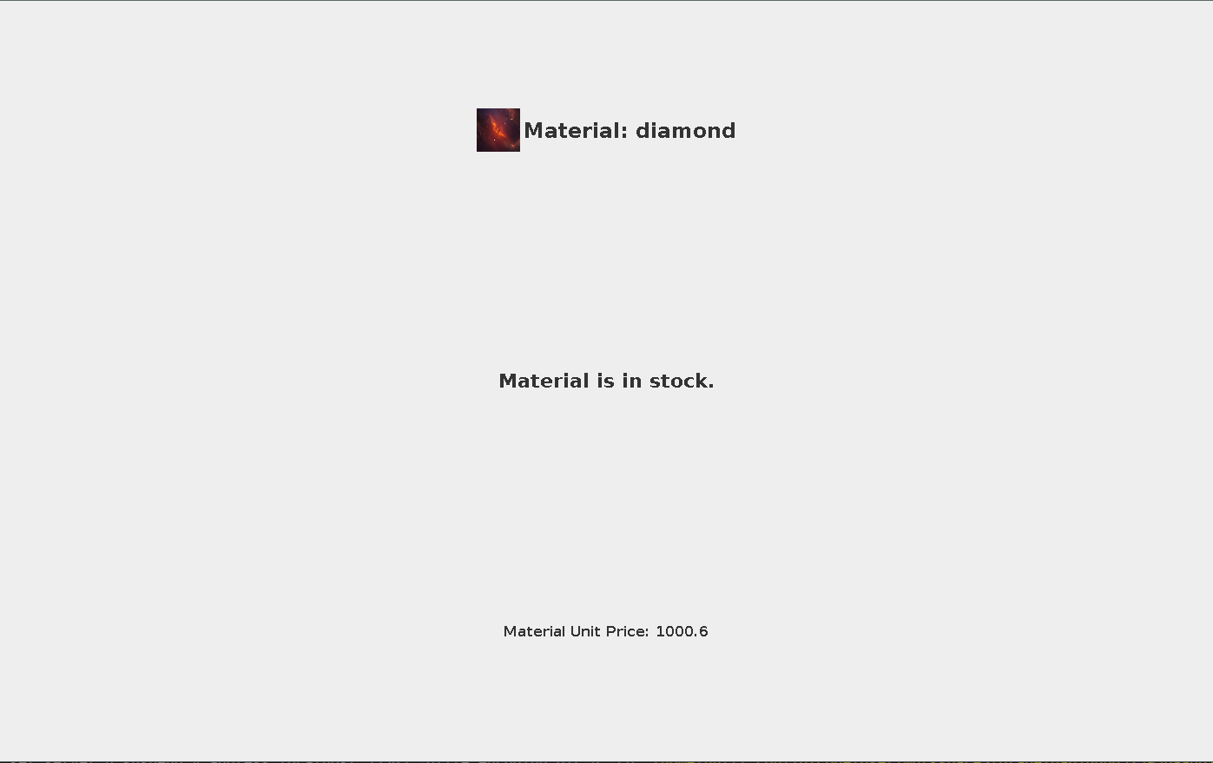

PartView:

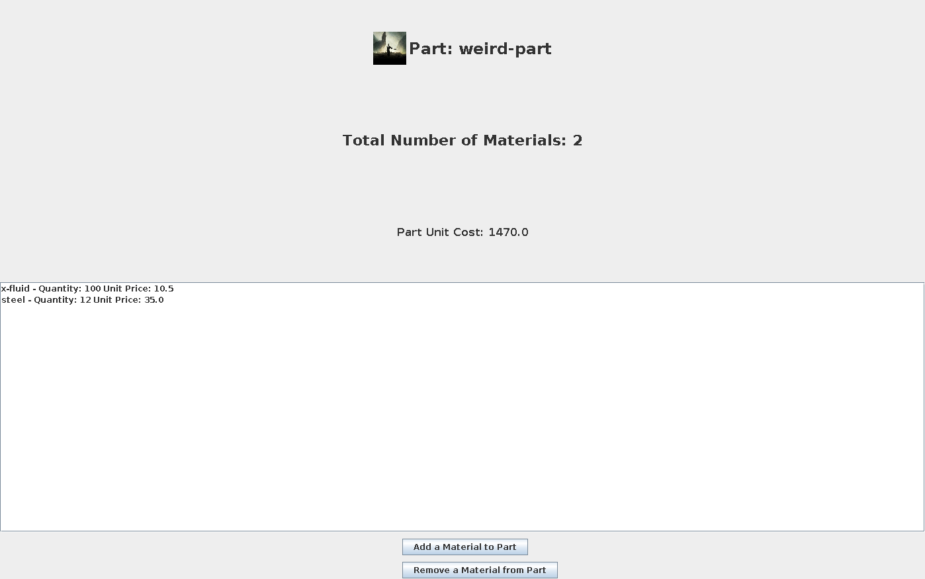

ProjectView:

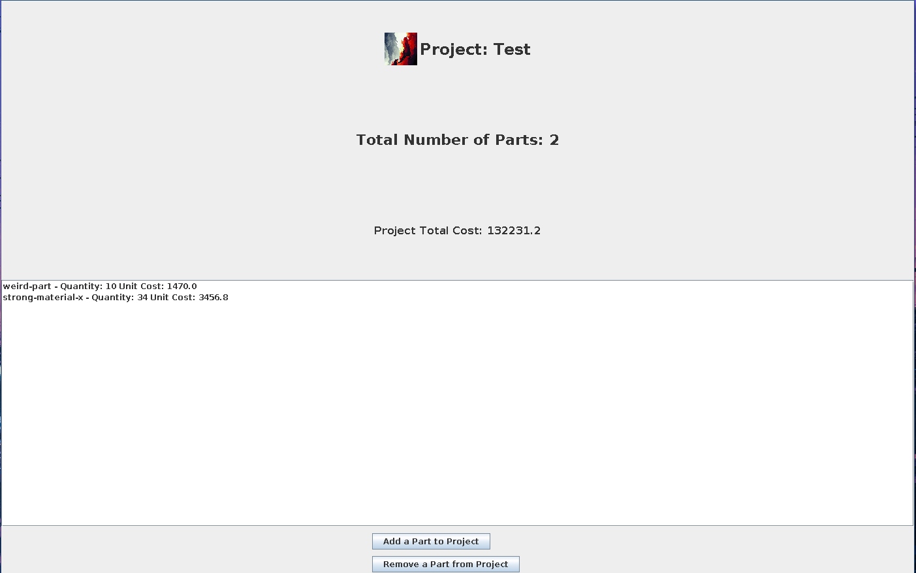

Adding a material to a part:
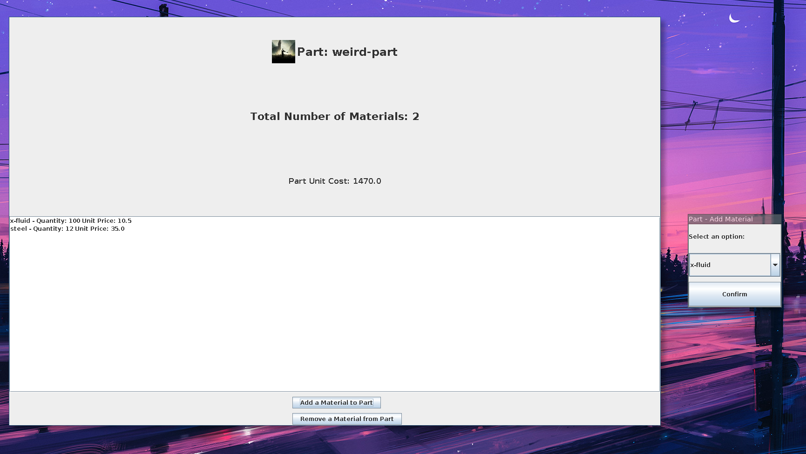

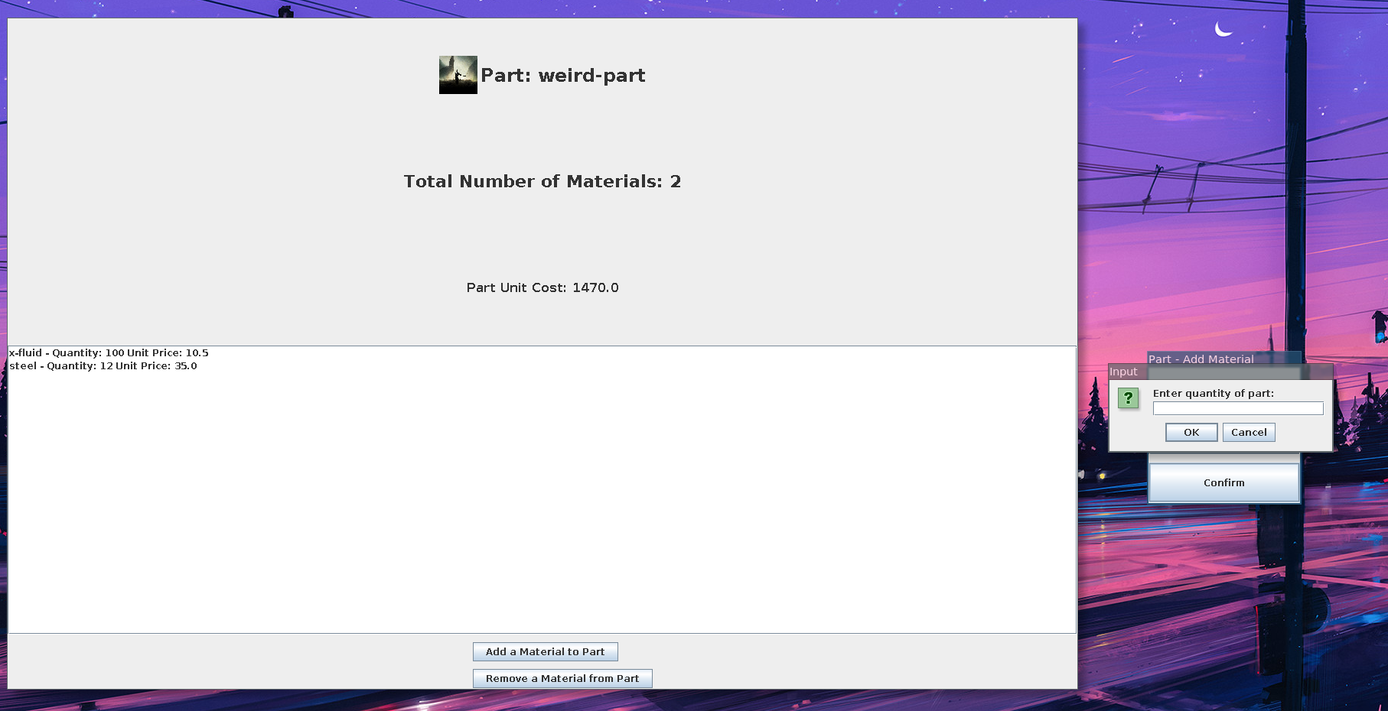

Adding a part to a project:

