**Assignment 1 plots:**

Code can be found in the appendix section of this document:

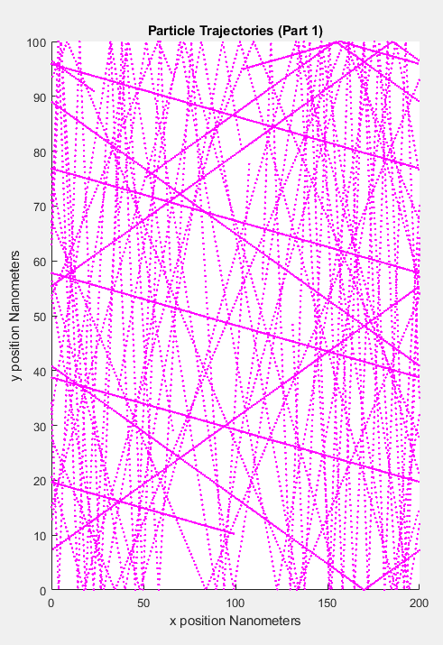

Figure 1: Particle trajectory without bottlenecks implemented

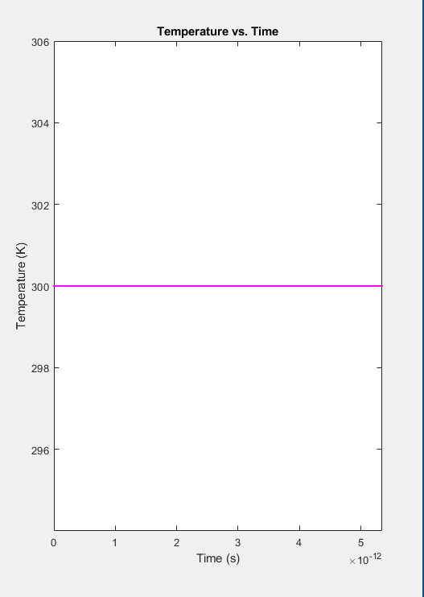

Figure 2: Temperature vs time

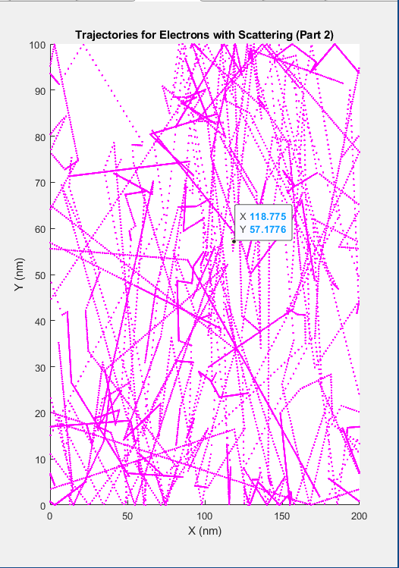

Figure 3: Particle trajectory with scattering

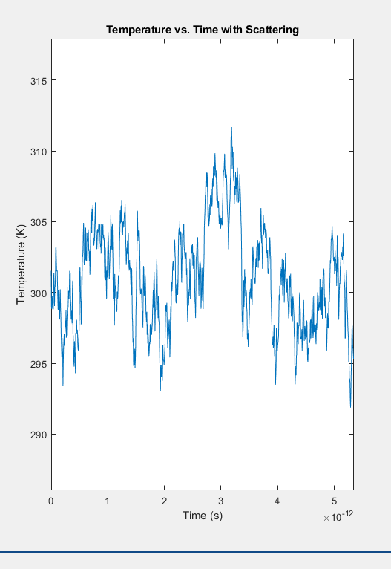

Figure 4: Average temperature vs time with scattering

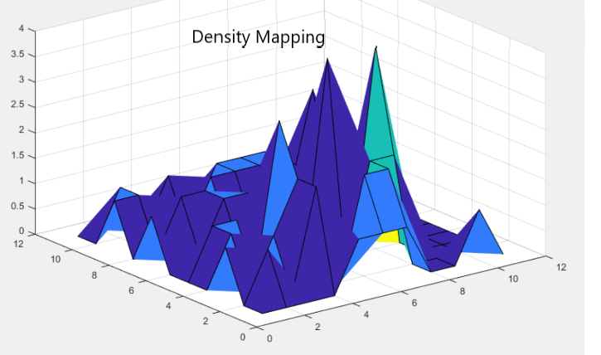

Figure 5: Density mapping

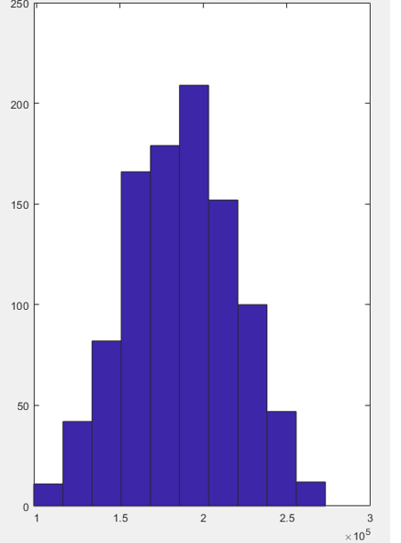

Figure 6: Histogram plot of particle velocity with a 1000 particles

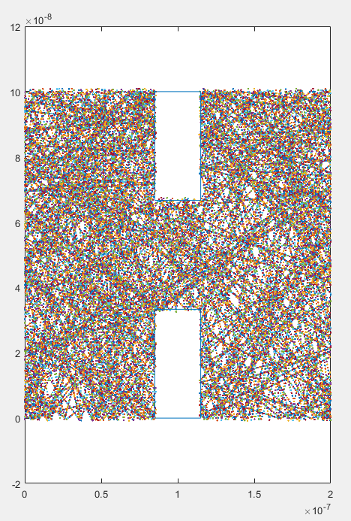

Figure 7: Particle trajectory with bottlenecks added

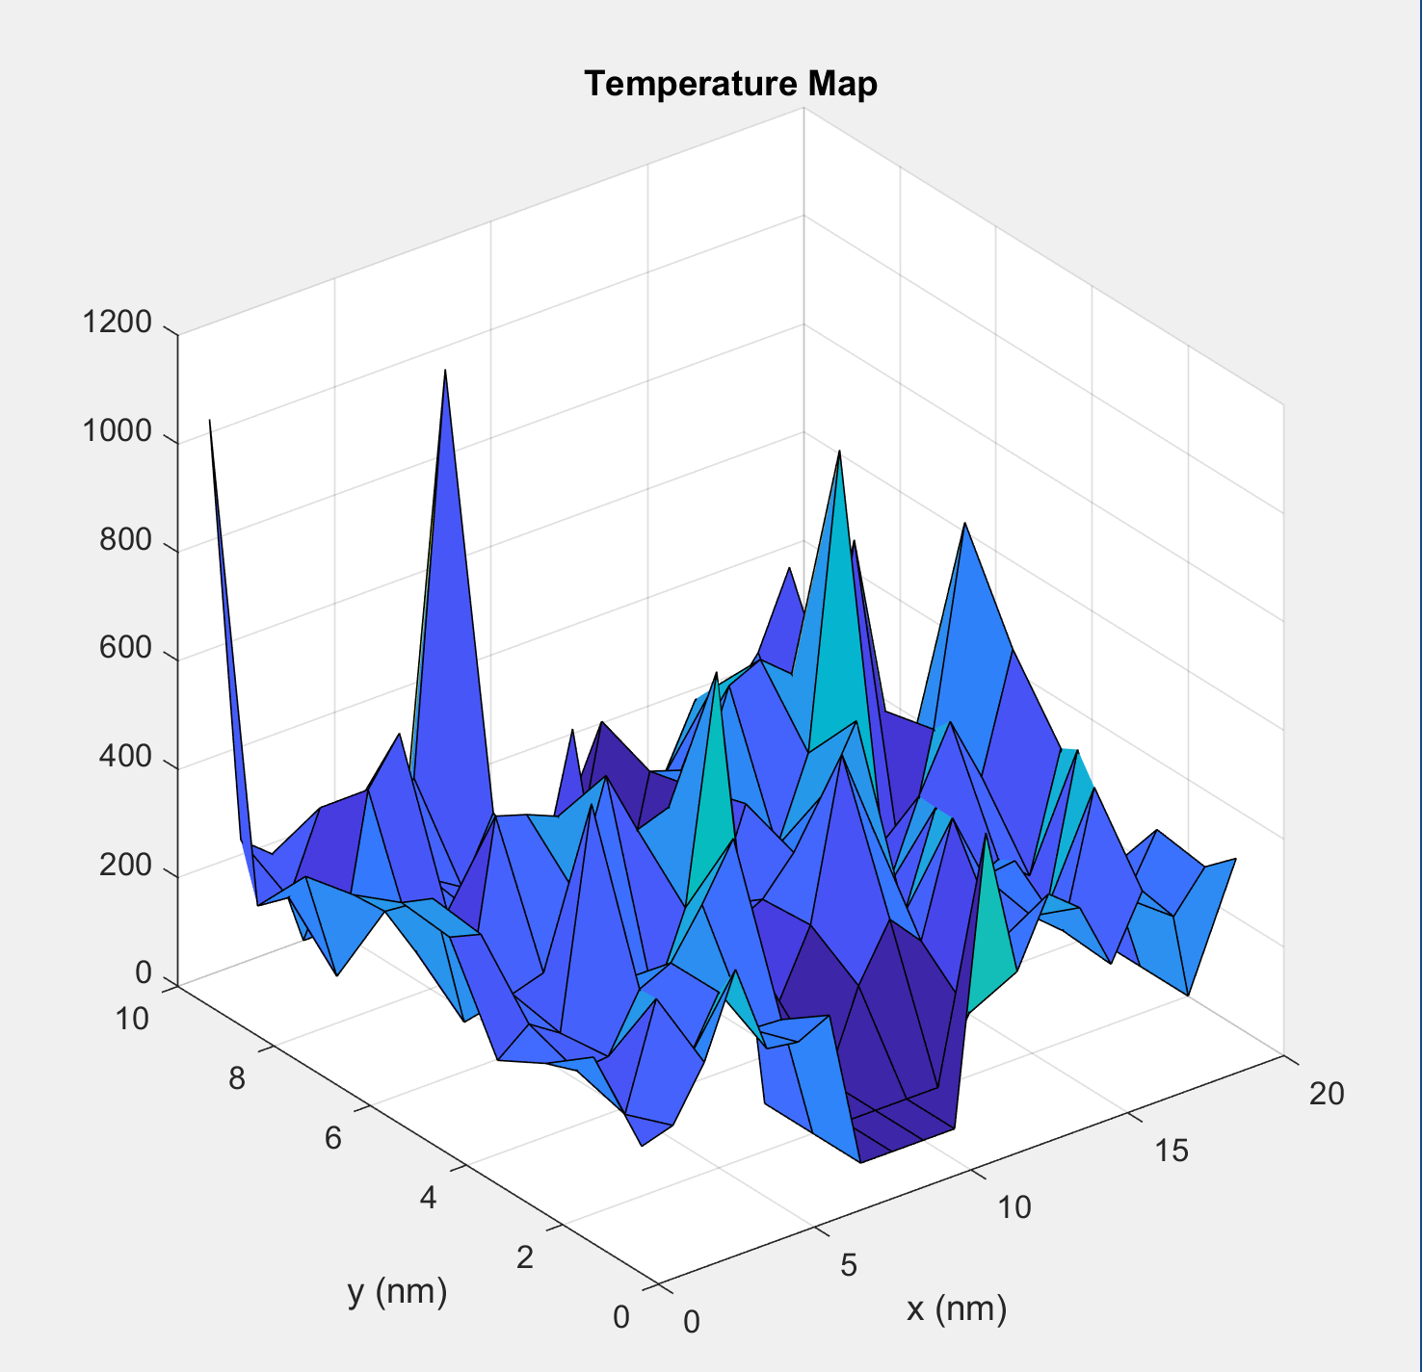

Figure 8: Temperature Mapping

**Appendix:**

clc

clear

clearvars

set(0,'DefaultFigureWindowStyle','docked')

% Name:Jarikre Efe Jeffery

% Student Number: 101008461

m0 = 9.10938215e-31;

effective_m = 0.26 * m0;

Temperature = 300;

q = 1.60217653e-19;

h = 1.054571596e-34;

h = h * 2 * pi;

boltz_c = 1.3806504e-23;

permittivity = 8.854187817e-12;

u_permittivity = 1.2566370614e-6;

c = 299792458;

gravity = 9.80665;

am = 1.66053892e-27;

Thermal_v = sqrt((boltz_c * 300) / effective_m);

Standard_deviation = Thermal_v/(sqrt(2));

delta_t = 7.5 * 10 ^ -15;

array_1 = zeros(1, 1000);

tmp_arary_1 = (1:1:1000);

show_m = 300;

wid_x = 200 * 10 ^ -9;

len_x = 100 * 10 ^ -9;

size_particles = 50;

tmn = 0.2 * 10 ^ -12;

x_pos = rand(1, size_particles) .* wid_x;

y_pos = rand(1, size_particles) .* len_x;

Theta = rand(1,size_particles)*2*pi;

x_vel = randn(1,size_particles) .*Standard_deviation;

y_vel = randn(1,size_particles) .*Standard_deviation;

inbox1 = true;

while inbox1 == true

inbox = ((x_pos <= (1.30 * wid_x/2) & (x_pos >= (0.90 * wid_x/2))) & ((y_pos < (len_x/3)) | y_pos >= (2*len_x/3)));

if (sum(inbox) > 0)

x_pos(inbox) = rand(1, sum(inbox)) .* wid_x;

y_pos(inbox) = rand(1, sum(inbox)) .* len_x;

else

inbox1 = false;

end

end

for i = 1:1000

x_old = x_pos;

x_pos = x_old + delta_t*x_vel;

y_old = y_pos;

y_pos = y_old + delta_t*y_vel;

j1 = (y_pos >= len_x);

j2 = (y_pos < 0);

y_vel(j1) = -y_vel(j1);

y_vel(j2) = -y_vel(j2);

j3 = ((x_pos) >= wid_x);

j4 = ((x_pos) < 0); %

x_old(j3) = x_old(j3) - wid_x;

x_pos(j3) = x_pos(j3) - wid_x;

x_old(j4) = x_old(j4) + wid_x;

x_pos(j4) = x_pos(j4) + wid_x;

inbox = ((x_pos <= (1.30 * wid_x/2) & (x_pos >= (0.90 * wid_x/2))) & ((y_pos < (len_x/3)) | y_pos >= (2*len_x/3)));

middle = ((x_old<= (1.30 * wid_x/2) & (x_old>= (0.90 * wid_x/2))) & ((y_old > (len_x/3)) & y_old <= (2*len_x/3)));

plot (x_pos,y_pos,'r.');

pause(0.05)

hold on

line([0.90*wid_x/2 0.90*wid_x/2], [len_x 2*len_x/3]);

line([1.30*wid_x/2 1.30*wid_x/2], [len_x 2*len_x/3]);

line([0.90*wid_x/2 1.30*wid_x/2], [len_x len_x]);

line([0.90*wid_x/2 1.30*wid_x/2], [2*len_x/3 2*len_x/3]);

line([0.90*wid_x/2 0.90*wid_x/2], [0 len_x/3]);

line([1.30*wid_x/2 1.30*wid_x/2], [0 len_x/3]);

line([0.90*wid_x/2 1.30*wid_x/2], [0 0]);

line([0.90*wid_x/2 1.30*wid_x/2], [len_x/3 len_x/3]);

vrms = sqrt ((x_vel.^2)+(y_vel.^2));

x_vel(inbox&(~middle)) = -x_vel(inbox&(~middle));

y_vel(inbox&middle) = -y_vel(inbox&middle);

meanfreetime = (Thermal_v * q)/200;

meanfreepath = mean(vrms) * meanfreetime;

vrms = sqrt ((x_vel.^2)+(y_vel.^2));

show_m = (sqrt (2) * (mean(vrms)^2) * effective_m )/boltz_c;

array_1 (1,i)= show_m;

[x_mesh, y_mesh] = meshgrid(0:(wid_x/10):wid_x, 0:(len_x/10):len_x);

electron_mat = zeros(11, 11);

temperture_mat = zeros(11, 11);

numelec_t = 0;

t_vel = 0;

for j = 1:10

efx_min = x_mesh(1, j);

efx_max = x_mesh(1,j+1);

for k = 1:10

efy_min = y_mesh(k, 1);

efy_max = y_mesh(k+1, 1);

for m = 1:size_particles

if((x_pos(m) > efx_min) && (x_pos(m) < efx_max) && ((y_pos(m) > efy_min) && y_pos(m) < efy_max))

numelec_t = numelec_t + 1;

electron_mat(j, k) = electron_mat(j, j) + 1;

t_vel = t_vel + sqrt((x_vel(m) .^ 2) + (x_vel(m) .^ 2));

temperture_mat(j, k) = ((sqrt(2)*(t_vel/numelec_t) ^ 2) * effective_m) / boltz_c;

end

end

t_vel = 0;

numelec_t = 0;

end

end

end

fprintf("The Mean Free Time is = %f\n", meanfreetime);

fprintf("The Mean Free Path is = %f\n", meanfreepath);

figure (1)

title(["Average temperature value = " num2str(show_m)]);

xlabel("particle on x axis");

ylabel("particle on y axis");

figure (2)

plot(tmp_arary_1, array_1);

title('Temperature across Time');

ylabel('Temperature');

xlabel('Time');

hold on

figure(3); histogram(vrms, 15);

title('Histogram of Thermal Velocities');

xlabel("Xlable");

ylabel("Ylable");

figure(4); surf(electron_mat);

title('Density Mapping');

xlabel("Xlable");

ylabel("Ylable");

figure(5); surf(temperture_mat);

title('Temperature Mapping');

xlabel("Xlable");

ylabel("Ylable");

clc

clear

clearvars

set(0,'DefaultFigureWindowStyle','docked')

particles = 1000;

global C X Y

C.q_0 = 1.60217653e-19;

C.hb = 1.054571596e-34;

C.h = C.hb * 2 * pi;

C.m_0 = 9.10938215e-31;

C.kb = 1.3806504e-23;

C.eps_0 = 8.854187817e-12;

C.mu_0 = 1.2566370614e-6;

C.c = 299792458;

C.g = 9.80665;

C.m_n = 0.26*C.m_0;

region_x = 200e-9;

region_y = 100e-9;

step_size = 1e-9;

timestep = 1000;

T = 300;

v_th = sqrt(2*C.kb*T/C.m_n);

v_change = step_size/v_th;

MT_C = 0.2e-12;

X = rand(2,particles);

Y = rand(1,particles);

X_position(1,:) = X(1,:)*region_x;

Y_position(1,:) = Y(1,:)*region_y;

check_X_left = X_position > 0.8e-7;

check_X_right = X_position < 1.2e-7;

check_X = check_X_left & check_X_right;

check_top = Y_position > 0.6e-7;

check_bottom = Y_position < 0.4e-7;

box_top = check_top & check_X;

box_bottom = check_bottom & check_X;

IN_A_BOX = box_top | box_bottom;

while(sum(IN_A_BOX) > 0)

temp_x = rand(1,sum(IN_A_BOX));

temp_y = rand(1,sum(IN_A_BOX));

X_position(IN_A_BOX) = temp_x*region_x;

Y_position(IN_A_BOX) = temp_y*region_y;

check_X_left = X_position > 0.8e-7;

check_X_right = X_position < 1.2e-7;

check_X = check_X_left & check_X_right;

check_top = Y_position > 0.6e-7;

check_bottom = Y_position < 0.4e-7;

box_top = check_top & check_X;

box_bottom = check_bottom & check_X;

IN_A_BOX = box_top | box_bottom;

end

angle(1,:) = X(2,:)*2*pi;

sigma = sqrt(C.kb*T/C.m_n)/4;

max_boltz_dist = makedist('Normal',v_th,sigma);

velocity = random(max_boltz_dist,1,particles);

figure(6)

hist(velocity)

title('Particle Velocity Histogram')

X_velocity = v_change*velocity(1,:).*cos(angle(1,:));

Y_velocity = v_change*velocity(1,:).*sin(angle(1,:));

PSCAT = 1 - exp(-v_change/MT_C);

mfp_vec = zeros(1,particles);

clc

clear

clearvars

set(0,'DefaultFigureWindowStyle','docked')

K = 1.3806e-23;

m = 0.26*9.1093e-31;

x = 200e-9*rand(1000,1);

y = 100e-9*rand(1000,1);

yboundSpecular = true;

xboundSpecular = true;

boxSpecular = true;

inbox1 = x > 80e-9 & x < 120e-9 & y > 60e-9;

inbox2 = x > 80e-9 & x < 120e-9 & y < 40e-9;

x(inbox1) = x(inbox1) + ((rand() > 0.5)*2 - 1)*40e-9*rand(size(x(inbox1)));

x(inbox2) = x(inbox2) + ((rand() > 0.5)*2 - 1)*40e-9*rand(size(x(inbox2)));

y(inbox1) = y(inbox1) - 0.2*rand(size(y(inbox1)));

y(inbox2) = y(inbox2) + 0.2*rand(size(y(inbox2)));

T = 300;

vth = sqrt(2*K*T/m);

std = sqrt(K*T/m);

Vx = normrnd(0,std,[1000,1]);

Vy = normrnd(0,std,[1000,1]);

V = sqrt(Vx.^2 + Vy.^2);

Tplot = zeros(1000,1);

figure(1)

histogram(V);

dt = 0.5e-14;

xold = x;

yold = y;

for i =1:400

%Defines the boundaries of the simulation as well as the boxes

yboundTop = y > 100e-9;

yboundBottom = y < 0;

inbox1 = x >= 80e-9 & x <= 120e-9 & y >= 60e-9;

inbox2 = x >= 80e-9 & x <= 120e-9 & y <= 40e-9;

xboundRight = x > 200e-9;

xboundLeft = x < 0;

if xboundSpecular

Vx(xboundRight | xboundLeft) = - Vx(xboundRight | xboundLeft);

else

theta = pi*rand();

Vx(xboundRight | xboundLeft) = V(xboundRight | xboundLeft)*cos(theta);

Vy(xboundRight | xboundLeft) = V(xboundRight | xboundLeft)*sin(theta);

end

%Reflection off of y boundary

if yboundSpecular

Vy(yboundTop | yboundBottom) = -Vy(yboundTop | yboundBottom);

else

theta = pi*rand();

Vy(yboundTop | yboundBottom) = V(yboundTop | yboundBottom)*cos(theta);

Vx(yboundTop | yboundBottom) = V(yboundTop | yboundBottom)*sin(theta);

end

if boxSpecular

Vx(inbox1 & yold >= 60e-9) = -Vx(inbox1 & yold >= 60e-9);

Vx(inbox2 & yold <= 40e-9) = -Vx(inbox2 & yold <= 40e-9);

Vy(inbox1 & yold <= 60e-9) = -Vy(inbox1 & yold <= 60e-9);

Vy(inbox2 & yold >= 40e-9) = -Vy(inbox2 & yold >= 40e-9);

else

theta = pi*rand();

Vx(inbox1 & yold >= 60e-9) = V(inbox1 & yold >= 60e-9)*cos(theta);

Vx(inbox2 & yold <= 40e-9) = V(inbox2 & yold <= 40e-9)*cos(theta);

Vy(inbox1 & yold >= 60e-9) = V(inbox1 & yold >= 60e-9)*sin(theta);

Vy(inbox2 & yold <= 40e-9) = V(inbox2 & yold <= 40e-9)*sin(theta);

Vy(inbox1 & yold <= 60e-9) = V(inbox1 & yold <= 60e-9)*cos(theta);

Vy(inbox2 & yold >= 40e-9) = V(inbox2 & yold >= 40e-9)*cos(theta);

Vx(inbox1 & yold <= 60e-9) = V(inbox1 & yold <= 60e-9)*sin(theta);

Vx(inbox2 & yold >= 40e-9) = V(inbox2 & yold >= 40e-9)*sin(theta);

end

y(yboundTop) = 100e-9;

y(yboundBottom) = 0;

x(xboundRight) = 200e-9;

x(xboundLeft) = 0;

x(inbox1 & yold >= 60e-9 & x <= 100e-9) = 80e-9;

x(inbox1 & yold >= 60e-9 & x > 100e-9) = 120e-9;

x(inbox2 & yold <= 40e-9 & x <= 100e-9) =80e-9;

x(inbox2 & yold <= 40e-9 & x >= 100e-9) =120e-9;

y(inbox1 & yold <= 60e-9) = 60e-9;

y(inbox2 & yold >= 60e-9) = 40e-9;

xold = x;

yold = y;

x = x + Vx*dt;

y = y + Vy*dt;

scatter = rand(1000,1) < (1 - exp(-dt/0.2e-12));

Vx(scatter) = normrnd(0,std,size(Vx(scatter)));

Vy(scatter) = normrnd(0,std,size(Vy(scatter)));

xplot = transpose([xold(1:20) x(1:20)]);

yplot = transpose([yold(1:20) y(1:20)]);

Tplot(i) = (1/(2*K))*mean(Vx.^2 + Vy.^2)*m;

xlim([0 200e-9])

ylim([0 100e-9])

drawnow

end

;

temp_sum_x = zeros(20,10);

temp_sum_y = zeros(20,10);

temp_num = zeros(20,10);

for i=1:1000

x1 = floor(x(i)/1e-8);

y1 = floor(y(i)/1e-8);

if(x1<=0)

x1 = 1;

end

if(y1<=0)

y1= 1;

end

if(y1>100)

y1 = 100;

end

if(x1>200)

x1=200;

end

temp_sum_y(x1,y1) = temp_sum_y(x1,y1) + Vy(i).^2;

temp_sum_x(x1,y1) = temp_sum_x(x1,y1) + Vx(i).^2;

temp_num(x1,y1) = temp_num(x1,y1) + 1;

end

temp = (temp_sum_x + temp_sum_y).*m./K./2./temp_num;

temp(isnan(temp)) = 0;

temp = transpose(temp);

figure(7)

surf(temp)

title('Temperature Map');

xlabel('x (nm)');

ylabel('y (nm)');