_______ _______ _______ _ _______ _______ _______ _________
( ___ )( ____ )( ____ \( ( /|( ____ )( ____ \( ____ )\__ __/
| ( ) || ( )|| ( \/| \ ( || ( )|| ( \/| ( )| ) (
| | | || (____)|| (__ | \ | || (____)|| (__ | (____)| | |
| | | || _____)| __) | (\ \) || _____)| __) | __) | |
| | | || ( | ( | | \ || ( | ( | (\ ( | |
| (___) || ) | (____/\| ) \ || ) | (____/\| ) \ \__ | |
(_______)|/ (_______/|/ )_)|/ (_______/|/ \__/ )_(

** OPENPERT ADD-IN FOR MICROSOFT OFFICE EXCEL REFERENCE GUIDE **

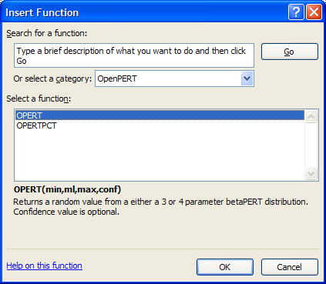

CREATED BY: Chris Hayes (nospam@hayesdf.com)
Jay Jacobs (jay@beechplane.com)

The OpenPERT add-in for Microsoft Office Excel was created to bring the betaPert distribution to practitioners of numerous professions and disciplines that leverage subject matter expert opinion, without the additional expense of commercial statistical function / simulation add-ins.

REFERENCE GUIDE VERSION: 1.0
UPDATED: 8/4/2011

TABLE OF CONTENTS
TABLE OF CONTENTS 2
ACKNOWLEDGEMENTS: 3
CONTRIBUTORS 3
INTERNET VBA REFERENCES 3
LICENSE: 4
OPENPERT MICROSOFT EXCEL ADD-IN 4
OPENPERT REFERENCE GUIDE 4
INSTALLATION: 5
FUNCTION OVERVIEW: 5
OPERT (min,ml,max,conf) 5
OPERTPCT (min,ml,max,pct,conf) 7
SIMULATION OVERVIEW: 8
betaPERT simulation 8
Modified betaPERT simulation 9
REFERENCES: 10
ACADEMIC TEXTS 10
MICROSOFT TRADEMARKS 10

ACKNOWLEDGEMENTS:
The OpenPERT Project would like to thank the following individuals / organizations for contributing to OpenPERT. Whether it was beta testing, offering valuable advice, offering feature / function suggestions or just providing encouragement to get version 1.0 released – THANK YOU!

*****************************

CONTRIBUTORS
*****************************

Kevin Brown
Patrick Florer, Risk Centric Security, Inc., Dallas, Texas
John Hofoss
Alex Hutton
Jack Jones
Kevin "black fist" Thompson, Minnesota State University, Mankato

*****************************

INTERNET VBA REFERENCES
*****************************

The resources below were invaluable for VBA code snippets and general understanding of VBA. I attempted to reference specific pages, but each web site in its entirety is useful.

Hawley, Dave and Raina. Excel Templates | Excel Add-ins and Excel Help with formulas and VBA Macros. Web. 7 Jul. 2011.
(http://www.ozgrid.com)
(http://www.ozgrid.com/VBA/excel-add-in-create.htm)

Jelen, Bill. How do you save a macro as an add-in?. Web. 7 Jul. 2011.
(http://www.mrexcel.com/)
(http://www.mrexcel.com/archive/VBA/13107.html)
(http://www.mrexcel.com/forum/showthread.php?t=404976)

Pearson, Chip. Creating An XLA Add-In For Excel. Web. 7 Jul. 2011
(http://www.cpearson.com)
(http://www.cpearson.com/excel/createaddin.aspx)

LICENSE:

OPENPERT MICROSOFT EXCEL ADD-IN

The OpenPERT add-in for Microsoft Office Excel is freely available and is licensed under the BSD 3-Clause ("BSD New" or "BSD Simplified") License.

***
Copyright (c) 2011, OpenPERT Project
All rights reserved.

Redistribution and use in source and binary forms, with or without modification, are permitted provided that the following conditions are met:
- Redistributions of source code must retain the above copyright notice, this list of conditions and the following disclaimer.
- Redistributions in binary form must reproduce the above copyright notice, this list of conditions and the following disclaimer in the documentation and/or other materials provided with the distribution.
- Neither the name of the OpenPERT Project nor the names of its contributors may be used to endorse or promote products derived from this software without specific prior written permission.

THIS SOFTWARE IS PROVIDED BY THE COPYRIGHT HOLDERS AND CONTRIBUTORS "AS IS" AND ANY EXPRESS OR IMPLIED WARRANTIES, INCLUDING, BUT NOT LIMITED TO, THE IMPLIED WARRANTIES OF MERCHANTABILITY AND FITNESS FOR A PARTICULAR PURPOSE ARE DISCLAIMED. IN NO EVENT SHALL "OPENPERT PROJECT" BE LIABLE FOR ANY DIRECT, INDIRECT, INCIDENTAL, SPECIAL, EXEMPLARY, OR CONSEQUENTIAL DAMAGES(INCLUDING, BUT NOT LIMITED TO, PROCUREMENT OF SUBSTITUTE GOODS OR SERVICES; LOSS OF USE, DATA, OR PROFITS; OR BUSINESS INTERRUPTION) HOWEVER CAUSED AND ON ANY THEORY OF LIABILITY, WHETHER IN CONTRACT, STRICT LIABILITY, OR TORT (INCLUDING NEGLIGENCE OR OTHERWISE) ARISING IN ANY WAY OUT OF THE USE OF THIS
SOFTWARE, EVEN IF ADVISED OF THE POSSIBILITY OF SUCH DAMAGE.
***

OPENPERT REFERENCE GUIDE

This work [OpenPERT Reference Guide] is licensed under the Creative Commons Attribution-NoDerivs 3.0 Unported License. To view a copy of this license, visit http://creativecommons.org/licenses/by-nd/3.0/ or send a letter to Creative Commons, 444 Castro Street, Suite 900, Mountain View, California, 94041, USA.

INSTALLATION:
OpenPERT can be installed like any other Microsoft Office Excel compatible add-in. Refer to http://office.microsoft.com/en-us/excel-help/load-or-unload-add-in-programs-HP010096834.aspx#BMexceladdin for additional guidance. Once installed there should be an OpenPERT menu in the Add-In ribbon bar section or tool bar section (image below).

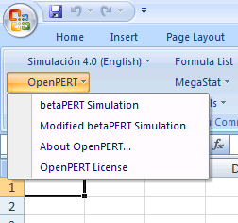

FUNCTION OVERVIEW:
There are two functions that can be used after the add-in has been installed; OPERT and OPERTPCT.

OPERT (min,ml,max,conf)

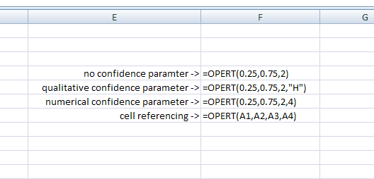

OPERT returns a random value from a betaPERT distribution given user-provided input parameters. Below are the input parameters for the OPERT function:

Min: The ‘minimum’ variable is a required parameter, must be a positive integer / decimal and must be less then or equal to the most likely value.

ML: The ‘most likely’ variable is a required parameter, must be a positive integer / decimal and must be less then or equal to the ‘maximum’ value.

Max: The ‘maximum’ variable is a required parameter, must be a positive integer / decimal and must be greater then or equal to the ‘most likely’ value.

Conf: The ‘confidence’ variable is an optional parameter. It reflects the confidence level of the assessor estimate for the ‘most likely’ parameter. By assigning a confidence level, we are also assigning a kurtosis value to the distribution. The higher the confidence (kurtosis) the more peaked the distribution, usually around the most likely value and thus a smaller standard deviation. The lower the confidence (kurtosis) the less peaked the distribution and thus a larger standard deviation value. The ‘confidence’ parameter must be one of five character combinations or a number:

“VH” <– reflects Very High confidence (a numerical value of 640)
“H” <- reflects High confidence (a numerical value of 160)
“M” <- reflects Moderate confidence (a numerical value of 20)
“L” <- reflects Low confidence (a numerical value of 4)
“VL” <- reflects Very Low confidence (a numerical value of 1)

Note: If you type the confidence parameter in the function versus referencing a cell containing a confidence value; you must enclose the confidence parameter in quotation marks (e.g. ”VH”).

Note: If you use a numerical value for confidence, the value must be greater then or equal to -1.

Note: If you do not declare a confidence parameter, a default confidence level of “LOW” is used.

Note: For additional information on kurtosis:
http://mathworld.wolfram.com/Kurtosis.html
http://www.tc3.edu/instruct/sbrown/stat/shape.htm

OPERTPCT (min,ml,max,pct,conf)

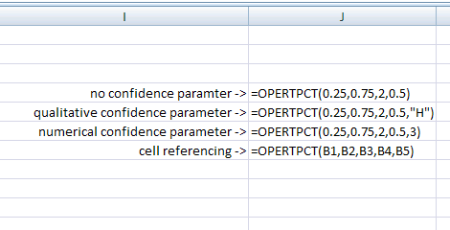

OPERTPCT returns an inverse cumulative value of a betaPERT distribution given minimum, most likely, maximum, probability and confidence (optional) parameters. This function is similar to OPERT function with one addition parameter called ‘PCT’.

Pct: this parameter allows the user to input a probability (value between 0 and 1) that when combined with the other input parameters, returns an inverse cumulative value. This value must be greater then zero and less then one.

SIMULATION OVERVIEW:
There are two simulation macros that can be invoked via the OpenPERT add-in menu; “betaPERT” and “Modified betaPERT”.

betaPERT simulation
This simulation will prompt you for minimum, most likely, and maximum values. The simulation will then generate an array of values based off the betaPERT distribution, create a new spreadsheet, and display: input parameters, descriptive statistics of the array that was created, percentile values from the array, and a histogram / cumulative percentage chart. Every time you run this simulation a new sheet will be created.

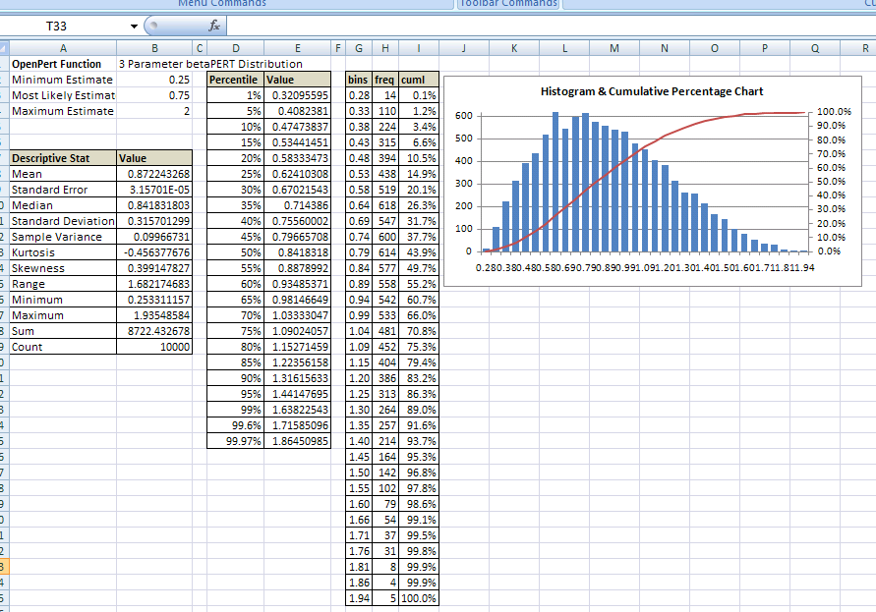

Modified betaPERT simulation
This simulation will prompt you for minimum, most likely, maximum and confidence values. The simulation will then generate an array of values based off the modified betaPERT distribution, create a new spreadsheet, and display: input parameters, descriptive statistics of the array that was created, percentile values from the array, and a histogram / cumulative percentage chart. Every time you run this simulation a new sheet will be created.

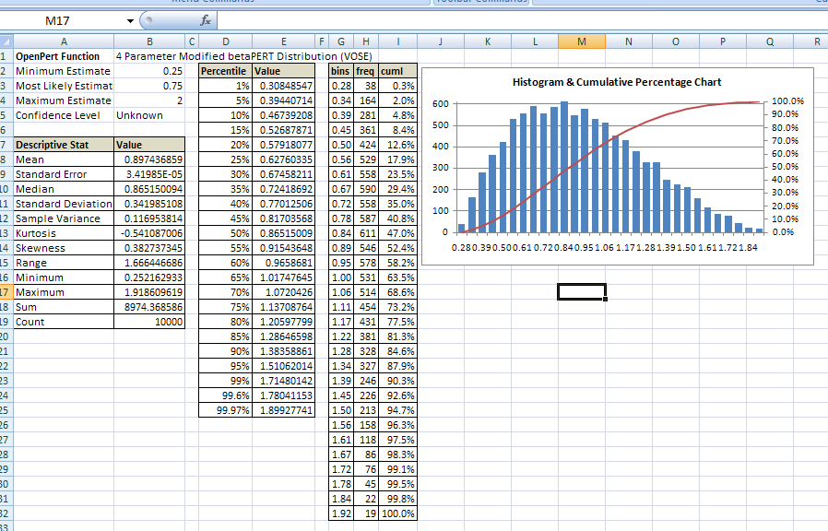

REFERENCES:
For those interested in referencing the betaPERT distribution, modified betaPERT distribution, and VBA code snippets used in the OpenPERT Microsoft Excel add-in:

*****************************

ACADEMIC TEXTS
*****************************

Vose, David. Risk Analysis: A Quantitative Guide. The Atrium, Southern Gate, Chichester, West Sussex, PO19 8SQ, England: John Wiley & Sons, Ltd., 2008. Print.

Also see:
http://www.vosesoftware.com/ModelRiskHelp/index.htm#Distributions/Continuous_distributions/Modified_PERT_distribution.htm

*****************************

MICROSOFT TRADEMARKS
*****************************
Microsoft, Windows, Microsoft Office, Microsoft Office System, Office, Excel, Microsoft Office Excel are either registered trademarks or trademarks of Microsoft Corporation in the United States and/or other countries.

