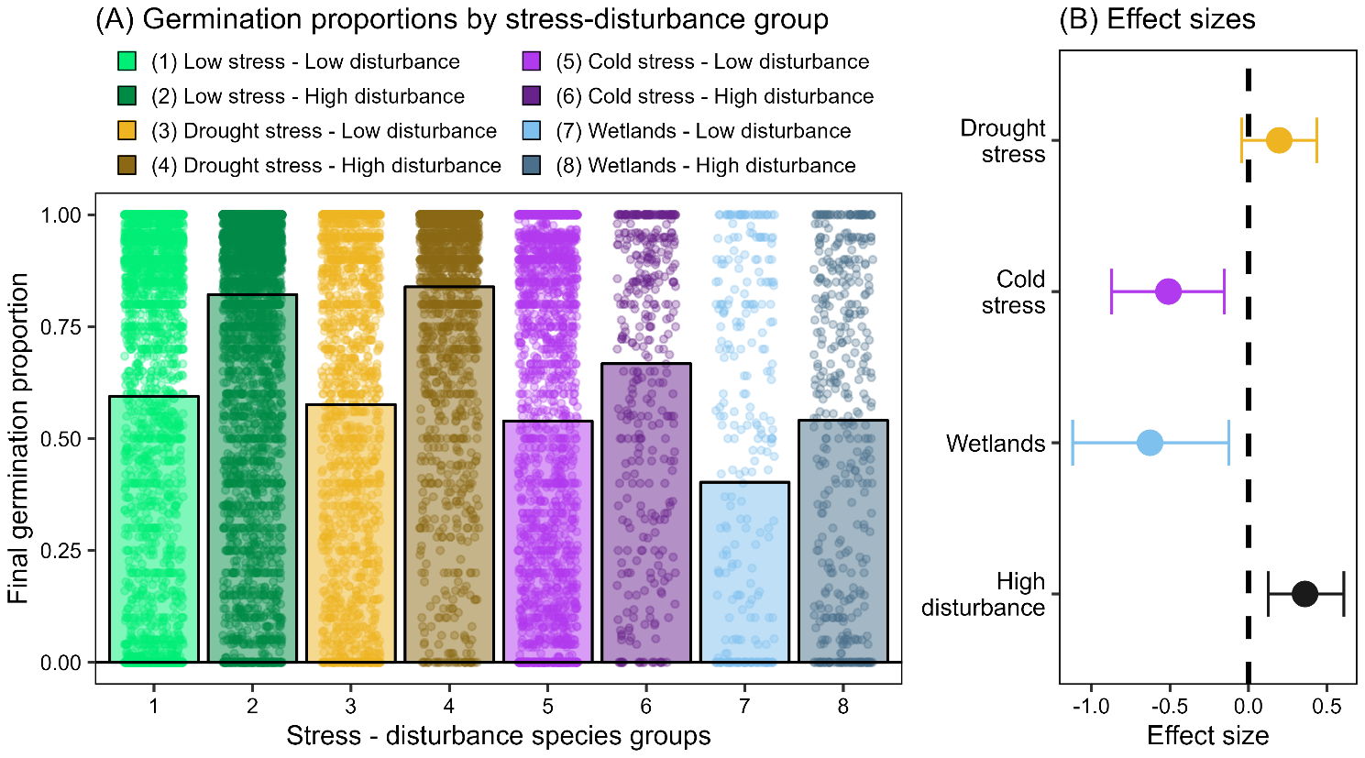

Delayed seed germination is a widespread strategy allowing plants to cope with environmental uncertainty. Using >14,000 germination records from nearly 1000 European species, we show that delayed germination is linked more strongly to environmental stress than to disturbance. Our results reveal a fundamental divide in the regeneration niche of angiosperms between species adapted to cold and those adapted to drought.

