Plant competition dominates at the leading edge of a migrating marsh-forest ecotone

Keryn B. Gedan, Whitney Hoot, Eduardo Fernández-Pascual

# Abstract

# Keywords

# Introduction

Global change is producing rapid shifts in species distributions (Chen et al. 2011). These shifts are being detected in the form of migrating ecosystems, such as alpine plant communities moving upwards as a consequence of warming (Walther et al. 2005), or coastal marshes being pushed landwards by sea level rise (Gedan & Fernández-Pascual 2019). At the leading edge of these migrating ecosystems, conditions are those of an ecotone, and thus species distributions and abundances are affected by edge effects (Ries et al. 2004). Of the mechanisms explaining edge effects, species interactions have received relatively little attention (Ries et al. 2004); and among species interactions the less attention has been paid to interactions between species within the same trophic level (Ries et al. 2017). Therefore, there are few generalizable rules about what type of ecological interactions to expect at a migrating ecotone. Nevertheless, a sound theoretical framework could be provided by the environmental stress gradient hypothesis, which suggests more intense competition where stress is low and more facilitative interactions where stress is high (Bertness & Callaway 1994; Bertness & Ewanchuk 2002).

The environmental stress gradient hypothesis is especially relevant for the migrating ecotone between tidal marshes and coastal forests, a system that is structured along strong and universal stress gradients, forming a stark zonation of plant communities (Adams 1963). At the marsh-forest ecotone, there are two abiotic gradients relevant to plants that exhibit major shifts: (1) salinity, which declines from the saline tidal marsh to the nonsaline upland forest, and (2) light availability, which declines from the low stature, graminoid community of the tidal marsh to the sub-canopy shrub-herbaceous community of the upland forest. Although salinity is a universal stress for terrestrial plant species, salinity stress will have a more negative effect on glycophytic upland plants relative to halophytic marsh plants. On the other hand, low light availability, also a universal challenge for photosynthetic plants, is likely to have a more negative effect on marsh plants, which generally occur in open sun environments and have high light demand.

A more refined interpretation of the environmental stress gradient hypothesis requires to take into account specific features of both the stress factors and the interacting species (Maestre et al. 2009). Regarding stress features, it is necessary to differentiate between stress that is resource-related (such as light availability) and non-resource-related (such as salinity). When stress is induced by a resource that is needed by both species, as is the case of light availability for co-occurring plants, the conceptual paradigm of the environmental stress gradient hypothesis may not hold (Maestre et al. 2009). If limited light availability is the main limiting stress factor, competition can only shift to facilitation when neighbors can increase the availability of the resource for the other species (Maestre & Cortina 2004), which is unlikely to happen when considering understory herbaceous species. On the other hand, salinity stress is not resource driven, and plant neighbors can ameliorate soil salinity leading to facilitative interactions. (Bertness & Ewanchuk 2002). In relation to the features of the interacting species, the response of their relationship to environmental stress is expected to depend on each species ability to compete and to tolerate stress (Grime 1977).

In this study, we sought to characterize plant interactions across the ecotone between tidal marsh and upland forest. In our study region of the Chesapeake Bay (USA), this ecotone is rapidly shifting due to sea level rise, as tidal marsh migrates inland (Schieder 2017). Therefore, understanding species interactions across this ecotone may help us to understand the biotic and abiotic controls on species distributions within these dynamic ecosystems, and could also elucidate management options with the goal of conserving tidal marsh ecosystems in the face of accelerated sea level rise (Kirwan & Megonigal 2013). For example, if species interactions on the upland edge of the ecotone are largely competitive for marsh plants, then clearing upland plants may reduce competition for migrating individuals and increase the rate or success of migration. Similarly, if interactions are largely facilitative along this boundary, then we would expect that clearing upland plants in the way of migrating marsh plants would negatively affect migration outcomes. This is particularly relevant as forest clearing is being considered as a management alternative to increase marsh migration. The rationale for this management tactic is altering the light environment at ground level, which is thought to favor marsh plant success.

We asked the question of whether the environmental stress gradient hypothesis can be applied across an ecotone where strong and universal stress gradients exist. We examined the interactions between three marsh grasses (*Spartina alterniflora* Loisel., *Spartina patens* (Aiton.), *Distichlis spicata* (L.) Greene) and one upland grass (*Panicum virgatum* L.) in a controlled greenhouse environment where we could manipulate abiotic factors to mimic opposing sides of the edge, and tease apart the effects of light availability and salinity stress, while controlling for other factors. We also surveyed field conditions where forest canopy cover had been experimentally disturbed to test the capacity of high marsh species to colonize the ecotone of intact and disturbed sites. With this experimental set up, we attempted to test the following predictions: (1) marsh species would be salinity-tolerant, the upland species would be shade-tolerant, and the upland species would be more competitive, (2) the interactions between marsh species and the upland species would shift from more negative to more positive with increasing values of salinity, but not of shade, and (3) marsh grasses would have a greater capacity to grow landwards when the forest canopy is removed.

# Materials and methods

## Field work

In 2 June 2015, a visit was made to a representative marsh-forest ecotone at Moneystump Marsh (Blackwater National Wildlife Refuge, Dorchester County, Maryland, USA). The area encompasses a brackish marsh and a neighboring forest of loblolly pine (*Pinus taeda* L.). Local land cover has experienced large changes in the last century that include a high degree of marsh loss (Stevenson et al. 1985) and marsh migration (Schepers et al. 2017). Changes have been attributed to high rates of relative sea level rise, which are 4 to 10 mm/yr (Ezer & Corlett 2012), well above the global average (Sallenger et al. 2012).

Within the Moneystump Marsh, three field sites were selected within 1 km of one another. Two sites (“Control East” and “Control West”) had intact marsh-upland ecotones. At the third site (“Forest Cut”), 3 ha of forest had been experimentally cut in August 2014, as part of a forest disturbance and marsh migration experiment. Site conditions at Forest Cut were similar to Control East and Control West in all regards, except light availability in the cleared forest, and other conditions indirectly affected by light availability, such as soil temperature and humidity. In each of the three sites, three points were chosen along the marsh-forest gradient: (1) high marsh edge, (2) mid-ecotone, and (3) forest edge. High marsh edge, mid-ecotone, and forest edge points were determined based on the plant communities, with the high marsh edge characterized by the indicator species *Spartina patens* (Aiton.) Muhl. and *Iva frutescens* L., the mid-ecotone characterized by *Panicum virgatum* L. and *Baccharis halimifolia* L., and the forest edge characterized by *Pinus taeda*.

To characterize the light gradient across the ecotone, light measurements were collected at all points at the Control East site at 100 cm height using an Apogee light meter. Light availability decreased from the high marsh (1,693 μmol m-2 s-1) to the mid-ecotone (1,492 μmol m-2 s-1) and forest edge (1,138 μmol m-2 s-1). To characterize variation in salinity across the ecotone, soil porewater (n = 6 ) was collected from the top 5 cm of the soil at six points within each location (high marsh, mid-ecotone, and forest edge) at each site (Control East, Control West, and Forest Cut) during a neap tide in July using a syringe, and porewater salinity was measured on a handheld refractometer. Average salinity decreased from the high marsh (4.6 psu) to the mid-ecotone (3.5 psu) and forest edge (2.7 psu).

Finally, aboveground biomass of naturally occurring high-marsh grasses (*S. patens* and *Distichlis spicata* (L.) Greene) was collected at five haphazardly selected 10 x 10 cm quadrats at each point within each site to investigate the field effects of salinity and light availability on natural biomass production. Aboveground biomass of the two grass species was mixed, dried in a drying oven at 60 ºC until constant mass, and weighed. The resulting field biomass dataset is available in the data folder of the GitHub repository (see Data Availability Statement).

## Greenhouse experiment

A greenhouse experiment was set up to investigate plant responses to stress and competition. Based on their occurrence at the field sites, we selected four grass species (Poaceae) that were common along the ecotone: (1) the upland plant *P. virgatum* was chosen as a focal competitor for the analysis, as indicator species of the marsh-forest ecotone: in the field, this species grows best in the low light and low salinity conditions of the leading edge of the ecotone (Jobe IV & Gedan 2021); (2) *S. patens* and (3) *D. spicata* were chosen as indicator species of the high-marsh; and (4) *Spartina alterniflora* Loisel. was chosen as indicator species of the low marsh. This last species was included because, at some of the marshes of the US East Coast, the high marsh zone is missing and the marsh grades directly from the *S. alterniflora* low marsh to the ecotone.

Plants of the four species were purchased as 5 cm x 5 cm plugs from a plant nursery (Environmental Concern, St. Michaels, MD). Roots of plugs were gently separated before being planted alone (i.e. no competition) or with a neighbor (i.e. competition). To focus on ecotone interactions between upland and tidal marsh species, the neighbor crosses consisted of *P. virgatum* and one of the three marsh species. Plants were planted within one week of purchase, in experimental pots (11.4 x 11.4 x 15.2 cm) filled with Px-1 Metro Mix Soil. Thus, each pot contained either one (no competition pots) or two (competition pots) individual plants. Pots were transferred to a greenhouse bay where they were watered with fresh water to recover from transplant stress for a period of 10 days. After the recovery period, plants were transferred to trays without drainage holes to mimic flooded conditions. Each tray contained all neighbor combinations. One week later, shade and salinity treatments were started.

To mimic the soil salinity of deep forest, forest edge, and tidal marsh, individual trays were watered with 0, 3, and 6 psu water. Salinities were achieved by adding Instant Ocean salt to tap water. To gently acclimate plants to salinity treatments, the salinity of the 3 and 6 psu treatments was raised gradually, from 0 to 1 to 3 to 6 psu over eight days. Trays were drained and re-watered with the assigned salinity every 3 days to maintain treatment levels and prevent the build-up of excessive porewater salinity through evapotranspiration.

To mimic the shade of deep forest, forest edge, and tidal marsh, shade tents were placed above the trays. Shade tents were 1.6 x 1.0 x 1.3 m (w x l x h), and were built from a PVC pole frame with a roof of 75% shade cloth (Heavy Green Sun Fabric, Easy Gardener) that overhung the sides of the frame by 0.5 m on all sides. Shade treatments had three levels: ambient light (tent frame without a shade), 75% reduction in ambient light (single layer of shade cloth), and 90% reduction in ambient light (double layer of shade cloth). There were four replicates of each level of shade. Each shade tent housed six trays, two of each salinity level. To confirm that the expected abiotic conditions were met, regular measurements were made of light in all shade treatments with a handheld light meter (Apogee Instruments) and of salinity in all water reservoirs using a refractometer.

The experimental treatments were continued for 16 weeks, during which treatments were regularly rotated around the room to avoid orientation or room biases, before plants were harvested. To separate roots and disentangle roots of neighboring plants for biomass measurements, plant roots were power washed to remove soil. Individual plants (including above and belowground biomass) were dried in a drying oven at 60 ºC until constant mass, and then weighed. The resulting greenhouse biomass dataset is available in the data folder of the GitHub repository (see Data Availability Statement).

## Statistical analysis

### Goal 1 - Species responses to salinity, shade and competition

To test the stress-tolerant or competitive character of the study species, the greenhouse biomass dataset was analyzed using linear mixed models as implemented in the ‘nlme’ package (2020) of R (R Core Team 2020). First, fully factorial models were fitted, including the main effects of species identity, competition (i.e. whether the species was planted alone or with a neighbor), salinity and shade; plus all possible interactions; plus shade tent and tray as random factors. Then a model selection was applied, sequentially removing non-significant interaction, until the minimal adequate model that best explained the data was found (Crawley & Crawley 2013). The R script for this and subsequent analyses are available in the src folder of the GitHub repository (see Data Availability Statement).

### Goal 2 - Effect of salinity and shade on the competitive interactions with *P. virgatum*

To measure the competitive interactions of the migrating marsh species with the upland grass *P. virgatum*, relative interaction indices (RIIs) (Armas et al. 2004) were calculated using the greenhouse biomass dataset. RIIs were calculated at the tray level for each marsh species, following

RII = (Ba - Bn) / (Ba + Bn)

where Ba is the biomass of the species when grown alone and Bn is the biomass of the species when grown with *P. virgatum*. RIIs take values from -1 (maximum competition) to +1 (maximum facilitation), with zero indicating no effect.

The interactive effects of salinity, shade and species identity on the RIIs of their interaction with *P. virgatum* were modeled using linear mixed models as implemented in the ‘nlme’ package (2020) of R (R Core Team 2020). First, fully factorial models were fitted, including the main effects of species identity, salinity and shade; plus all possible interactions; plus shade tent and tray as random factors. Then a model selection was applied, sequentially removing non-significant interaction, until the minimal adequate model that best explained the data was found (Crawley & Crawley 2013).

### Goal 3 - Effect of canopy cut on field growth of high marsh grasses

To test the effect of forest clearings in the ability of high marsh grasses to colonize landwards, the field biomass dataset was analyzed by fitting a linear model in R (R Core Team 2020). The linear model included field site, marsh-forest gradient position, and their interaction.

# Results

## Goal 1 - Effect of salinity, shade and competition on biomass growth

Results of the greenhouse experiment indicated that biomass growth was driven by two significant (p < 0.05) interactions, one between species identity and responses to salinity, and another between competition and responses to shade (**Table 1**).

Thus, the response to salinity was species-dependent and did not interact with shade or competition: the low marsh grass *S. alterniflora* produced higher biomass with increasing salinity; the high marsh indicators *S. patens* and *D. spicata* were indifferent to salinity; and the marsh-forest ecotone species *P. virgatum* had a negative response to increasing salinity (**Fig. 1**).

At the same time, the growth response to shade was not significantly different between the four species (p > 0.05): all species responded negatively to increasing levels of shade (**Fig. 2**). Response to shade did not interact with salinity, but was affected by whether the plants were grown alone or in competition: plants in competition produced less biomass than plants grown alone in all levels of shade (**Fig. 2**), but at the highest level the decrease was less pronounced in plants grown in competition, since they were already limited by the competitor.

## Goal 2 - Effect of salinity and shade on the competitive interactions with *P. virgatum*

The analysis of the net RIIs showed that the strength of competition was not affected by the levels of salinity or species identity; and only the shade levels had a significant effect (**Table 2**). The interaction of the marsh species with *P. virgatum* was most negative at the middle shade treatment, and become the least negative in the full shade treatment, without ever becoming positive, i.e. facilitative (**Fig. 3**).

## Goal 3 - Effect of canopy cut on field growth of high marsh grasses

The field biomass measurements supported a higher capacity of high marsh grasses (*S. patens* and *D. spicata*) to colonize landwards at the forest cut site (**Fig. 4**). There were significant differences in biomass along the marsh-forest gradient, but these were affected by the site where the measurements were made (**Table 3**): at the two intact forest control sites, biomass sharply declined at the deep forest points; while at the forest cut site the biomass of the marsh grasses was still high at the deep forest point (**Fig. 4**).

# Discussion

Key findings:

Goal 1

* Species salinity-tolerance follows what can be expected from the system’s zonation.
* Species shade-tolerance is similar; Panicum is not especially shade-tolerant (at least not statistically significant).
* Species competition-tolerance is similar; again Panicum is not especially tolerant of competition.

Goal 2

* Interactions are almost always competitive for marsh plants, no evidence of facilitation, therefore giving support to removal of upland plants. As the ESG deals with facilitation, it does not generally apply to this system.
* No effect of salinity in the interaction contradicts ESG hypothesis: after all, marsh species are salinity-tolerant. It is worth mentioning that I did not include the interactions of Panicum when grown with the marsh species because it does not fit with the narrative as it is now: we want to know if marsh plants are facilitated or not by upland plants, i.e. we do not care for upland plants. However, there is ALSO no evidence that facilitation is widespread for Panicum when interacting with marsh plants.
* Effect of shade in the interactions indicate that competition with Panicum is especially intense at mid-shade, which makes sense: at low shade, light not limitant, at high shade, also Panicum limited. Question: would the best policy be to NOT clear trees, but remove Panicum and other forest understory? In migrating marshes, what change occurs first: tree deaths, or substitution of the understory?

Goal 3

* Gives support to the idea of forest cuttings.

Caveats

* Flood might have affected Panicum disproportionally?
* Pairwise approach does not account for the possibility of competitive suppression of a competitor, known as indirect facilitation
* Lortie and Callaway (2006)’s critique of stress gradients of various lengths being lumped together. Do the shade gradient and salinity gradient represent “equivalent” lengths? They were based on the reality of the system, but of course, this is just one systems – salinity gradients can be more extreme in euhaline marsh-upland boundaries, and shade gradients would be more extreme in marsh-deciduous forest ecotones. He and Bertness (2014): environmental gradients versus stress gradients

Biomass does not equal fitness (Goldberg et al. 1999)…

# Data availability

The original datasets, R code for the analysis and creation of the manuscript can be accessed at the GitHub repository <https://github.com/efernandezpascual/ecotone>. Upon publication, a version of record of the repository will be deposited in Zenodo.

# References

Adams, D.A. 1963. Factors Influencing Vascular Plant Zonation in North Carolina Salt Marshes. *Ecology* 44: 445–456.

Armas, C., Ordiales, R., & Pugnaire, F.I. 2004. Measuring plant interactions: a new comparative index. *Ecology* 85: 2682–2686.

Bertness, M.D., & Callaway, R. 1994. Positive interactions in communities. *Trends in Ecology & Evolution* 9: 191–193.

Bertness, M.D., & Ewanchuk, P.J. 2002. Latitudinal and climate-driven variation in the strength and nature of biological interactions in New England salt marshes. *Oecologia* 132: 392–401.

Chen, I.C., Hill, J.K., Ohlemüller, R., Roy, D.B., & Thomas, C.D. 2011. Rapid range shifts of species associated with high levels of climate warming. *Science* 333: 1024–1026.

Crawley, M.J., & Crawley, M.J. 2013. Chapter 9: Statistical modelling. In Crawley, M.J. (ed.), pp. 388–488. John Wiley & Sons, New York - Chichester.

Ezer, T., & Corlett, W.B. 2012. Is sea level rise accelerating in the Chesapeake Bay? A demonstration of a novel new approach for analyzing sea level data. *Geophysical Research Letters* 39:

Gedan, K.B., & Fernández-Pascual, E. 2019. Salt marsh migration into salinized agricultural fields: A novel assembly of plant communities. *Journal of Vegetation Science* 30: 1007–1016.

Grime, J.P. 1977. Evidence for the existence of three primary strategies in plants and its relevance to ecological and evolutionary theory. *The American Naturalist* 111: 1169–1194.

Jobe IV, J.G.D., & Gedan, K. 2021. Species-specific responses of a marsh-forest ecotone plant community responding to climate change. *Ecology* 102: e03296.

Kirwan, M.L., & Megonigal, J.P. 2013. Tidal wetland stability in the face of human impacts and sea-level rise. *Nature* 504: 53–60.

Maestre, F.T., Callaway, R.M., Valladares, F., & Lortie, C.J. 2009. Refining the stress-gradient hypothesis for competition and facilitation in plant communities. *Journal of Ecology* 97: 199–205.

Maestre, F.T., & Cortina, J. 2004. Do positive interactions increase with abiotic stress? A test from a semi-arid steppe. *Proceedings of the Royal Society of London. Series B: Biological Sciences* 271: S331–S333.

R Core Team. 2020. R: a language and environment for statistical computing. Version 4.0.3.

Ries, L., Murphy, S.M., Wimp, G.M., & Fletcher, R.J. 2017. Closing persistent gaps in knowledge about edge ecology. *Current Landscape Ecology Reports* 2: 30–41.

Ries, L., Robert J. Fletcher, J., Battin, J., & Sisk, T.D. 2004. Ecological Responses to Habitat Edges: Mechanisms, Models, and Variability Explained. *Annual Review of Ecology, Evolution, and Systematics* 35: 491–522.

Sallenger, A.H., Doran, K.S., & Howd, P.A. 2012. Hotspot of accelerated sea-level rise on the Atlantic coast of North America. *Nature Climate Change* 2: 884–888.

Schepers, L., Kirwan, M., Guntenspergen, G., & Temmerman, S. 2017. Spatio-temporal development of vegetation die-off in a submerging coastal marsh. *Limnology and Oceanography* 62: 137–150.

Schieder, N. 2017. Reconstructing coastal forest retreat and marsh migration response to historical sea level rise.

Stevenson, J.C., Kearney, M.S., & Pendleton, E.C. 1985. Sedimentation and erosion in a Chesapeake Bay brackish marsh system. *Marine Geology* 67: 213–235.

Walther, G.-R., Sascha, B., & Burga, C.A. 2005. Trends in the upward shift of alpine plants. *Journal of Vegetation Science* 16: 541–548.

2020.

# Figures

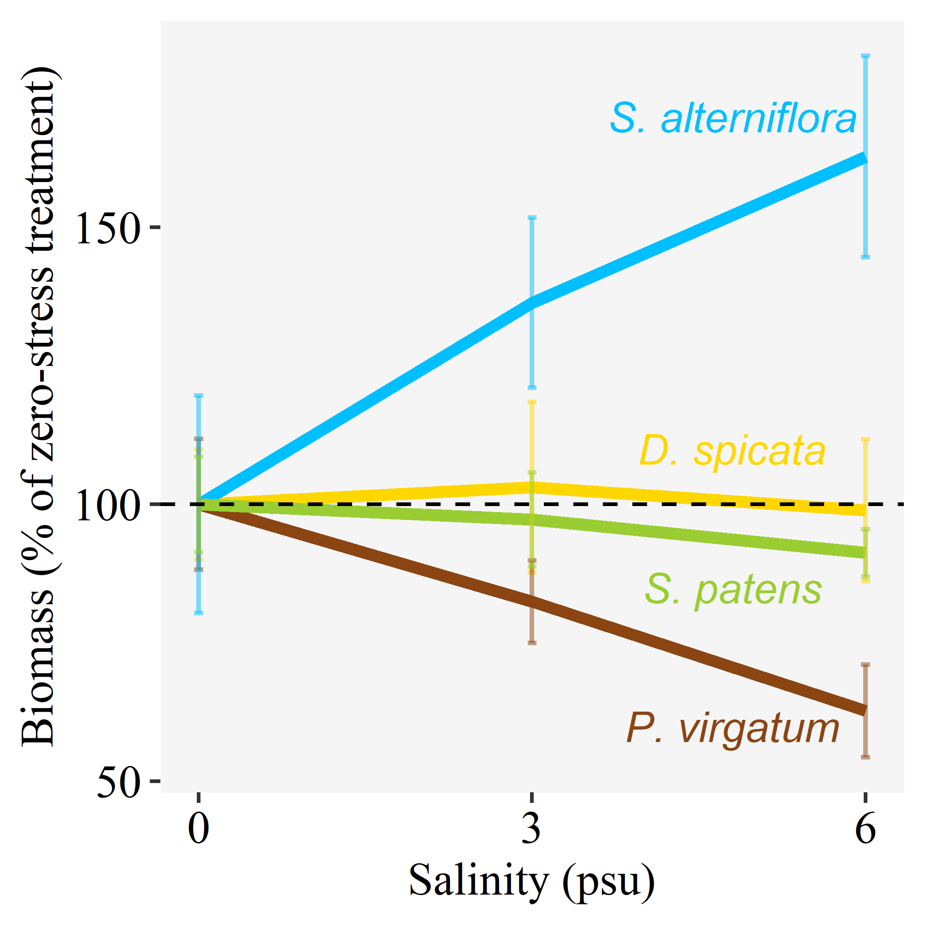

Figure 1: Species responses to salinity. Final biomass produced in the greenhouse for each of the four study species, in each of the salinity treatments. Results shown are for the no shade, no competition treatment. Lines indicate the average biomass at each level of salinity, and whiskers the standard error. For ease of comparison, all values were standardized by dividing them by the species biomass at the 0 salinity treatment.

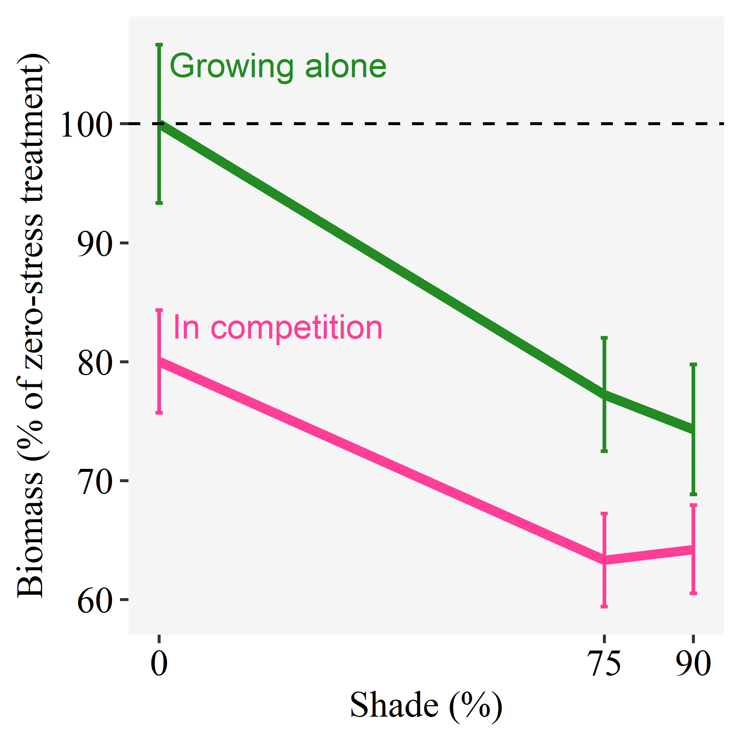

Figure 2: Responses to shade and competition. Final biomass produced in the greenhouse for plants grown alone and in competition, in each of the shade treatments. Results shown are for the no salinity treatment, and averaging across the four study species. Lines indicate the average biomass at each level of shade, and whiskers the standard error. For ease of comparison, all values were standardized by dividing them by the biomass at the 0 shade, no competition treatment.

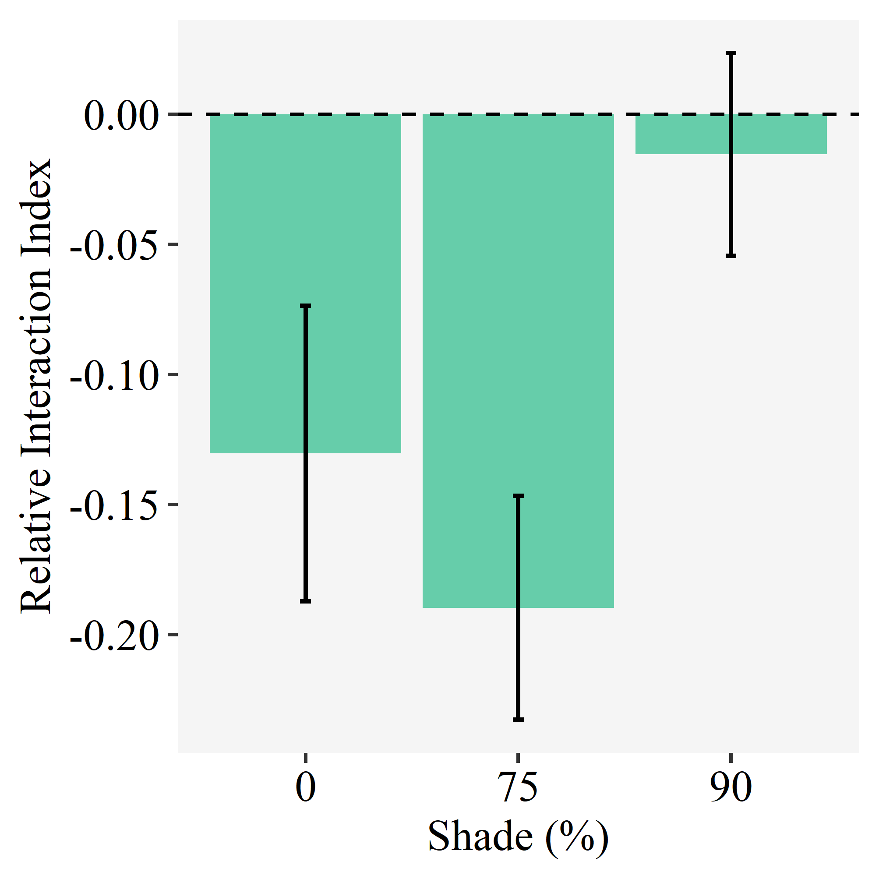

Figure 3: Competition between three marsh grasses and the upland forest grass *Panicum virgatum* grown in the greenhouse. The Relative Interaction Index (RII) was calculated for each marsh species by comparing its growth alone to its growth when grown with *P. virgatum* species comparison. The RIIs were calculated by averaging all treatments of salinity for all species. Bars indicate the average RII, and whiskers the standard error. Positive values of the RII would indicate a facilitative interaction, while negative values indicate a competitive interaction, and zero a neutral interaction.

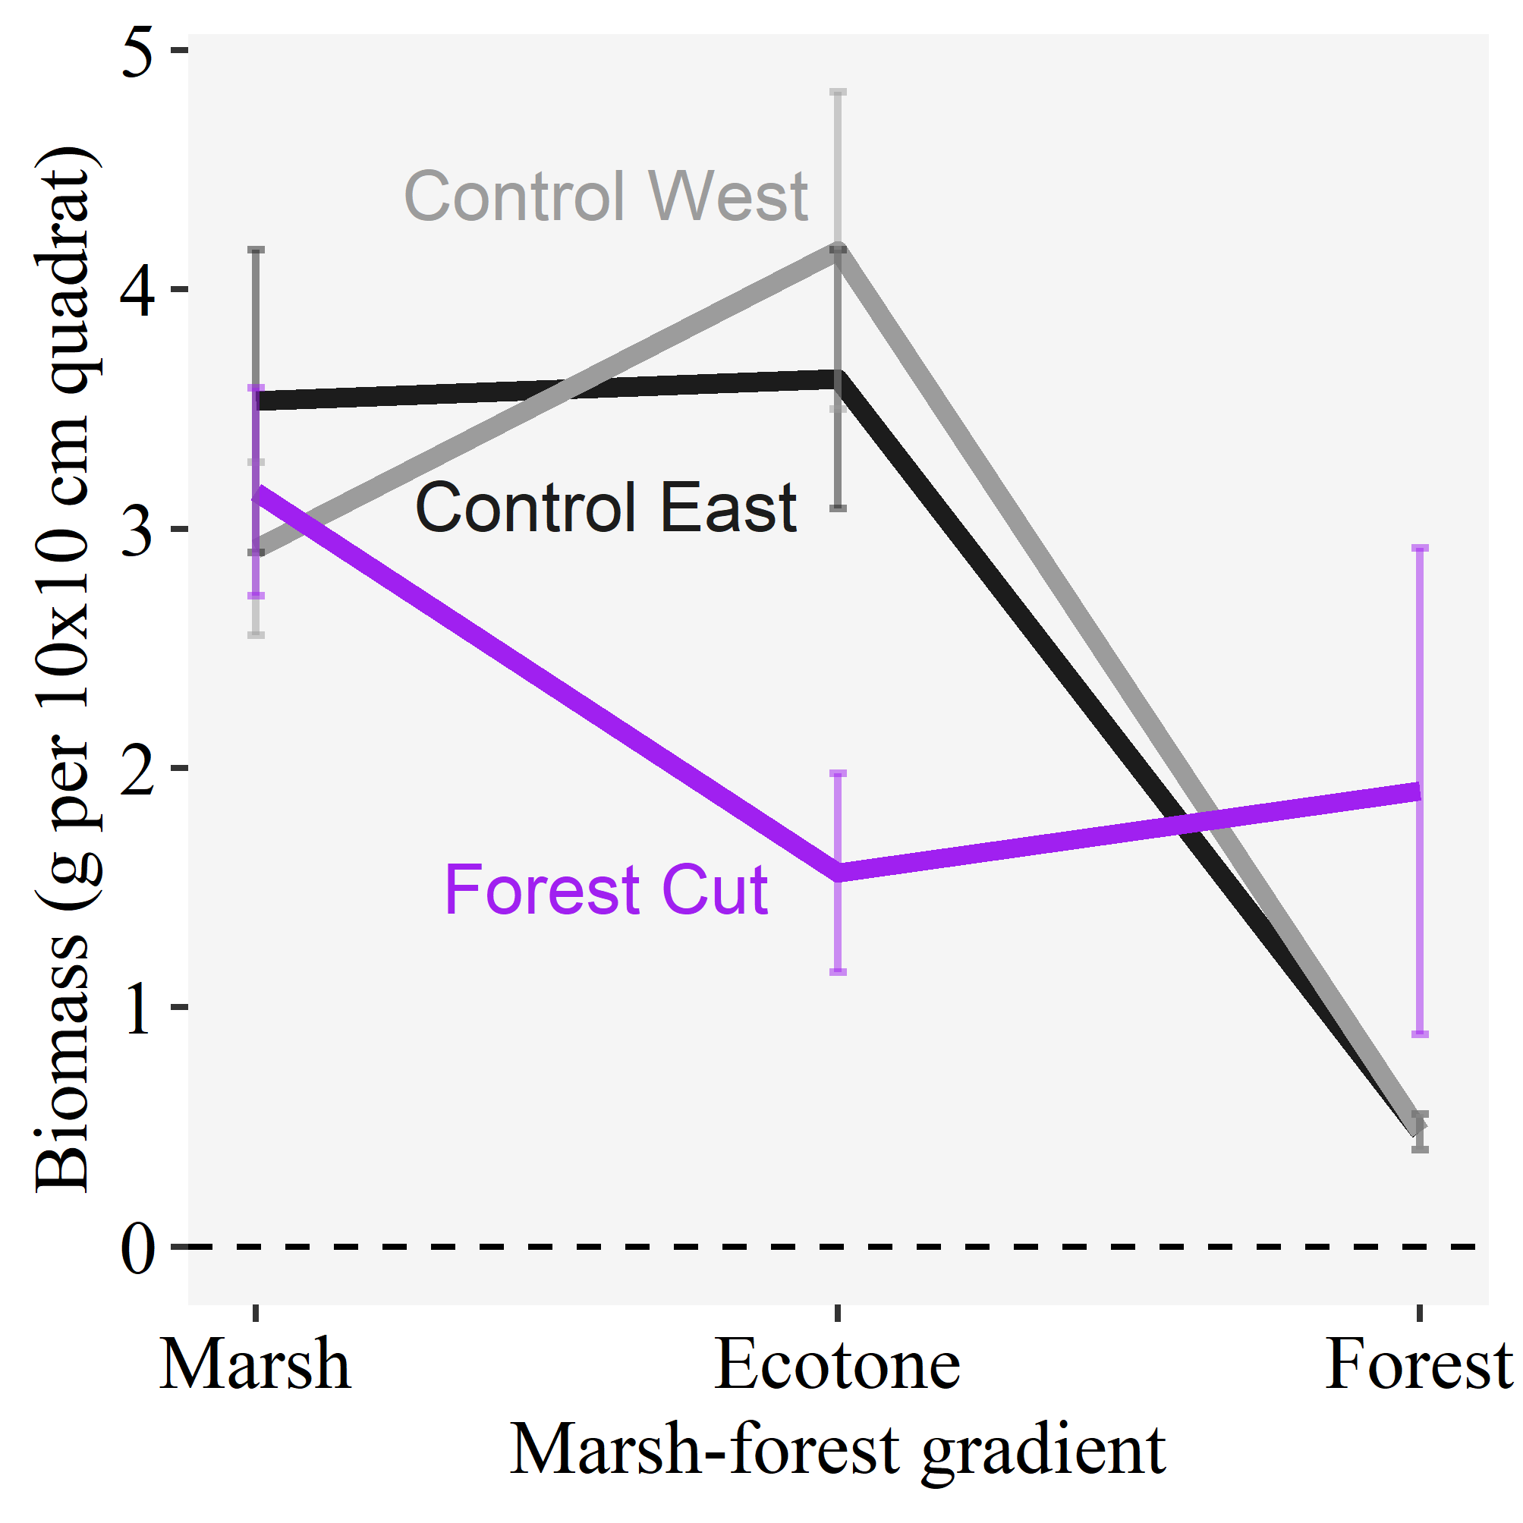

Figure 4: Field growth of high marsh grasses (*Spartina patens* and *Distichlis spicata*). Lines indicate the average aggregated biomass of the two species at three positions in the marsh-forest gradient, and whiskers the standard error. Biomass was collected from three sites: two control intact forest sites and a forest cut site where the canopy had been removed.

# Tables

Table 1 Anova table for the effect of species identity, salinity, shade and competition on final biomass in the greenhouse. The output shown is for a minimal adequate model selected by sequential removal of non-significant interactions. The model is a linear mixed model with shade tent and tray as random factors.

| Term | df | Chi-squared | p |
| --- | --- | --- | --- |
| Salinity | 1 | 0.006 | 0.937 |
| Shade | 1 | 18.767 | < 0.001 |
| Species | 3 | 43.965 | < 0.001 |
| Competition | 1 | 66.528 | < 0.001 |
| Salinity:Species | 3 | 16.885 | 0.001 |
| Shade:Competition | 1 | 7.356 | 0.007 |

Table 2 Anova table for the effect of species identity, salinity and shade on the net Relative Interaction Index (RII) of three marsh species competing with *Panicum virgatum* in the greenhouse. The output shown is for a minimal adequate model selected by sequential removal of non-significant interactions and main effects. The model is a linear mixed model with shade tent and tray as random factors.

| Term | df | Chi-squared | p |
| --- | --- | --- | --- |
| Shade | 2 | 9.062 | 0.011 |

Table 3 Anova table for the effect of site and elevation along the marsh-forest gradient on the aggregate biomass of high marsh grasses (*Spartina patens* and *Distichlis spicata*) collected in the field. The model is a linear model.

| Term | df | F | p |
| --- | --- | --- | --- |
| Site | 2 | 2.279 | 0.117 |
| Elevation | 2 | 10.806 | < 0.001 |
| Site:Elevation | 4 | 4.299 | 0.006 |