Seed ecology of European mesic meadows: the domestication of plant regeneration strategies

Eduardo Fernández-Pascual1 +, Madalena Vaz2, Beatriz Morais1, Ramón Reiné3, Joaquín Ascaso3, Elías Afif Khouri1, Angelino Carta4

1 Departamento de Biología de Organismos y Sistemas, Universidad de Oviedo, Oviedo/Uviéu, Spain; 2 Banco Português de Germoplasma Vegetal, Instituto Nacional de Investigação Agrária e Veterinária (INIAV), Braga, Portugal; 3 Departamento de Ciencias Agrarias y Medio Natural, Universidad de Zaragoza, Huesca, Spain; 4 Dipartimento di Biologia, Botany Unit, University of Pisa, Pisa, Italy

+ Correspondence: Departamento de Biología de Organismos y Sistemas, Universidad de Oviedo, C/ Catedrático Rodrigo Uría, 33006 Oviedo/Uviéu, Spain. Email: [efernandezpascual@gmail.com](mailto:efernandezpascual@gmail.com). Telephone: +34985104787.

# Abstract

# Keywords

*Arrhenatheretalia*, *Arrhenatherion*, plant regeneration, seed germination, seed morphology, species-rich meadows, hay meadows, mesic grasslands

# Introduction

European mesic meadows are semi-natural open habitats that occupy moderately fertile and well-drained soils (Mucina et al. 2016). These plant communities developed in clearings of a temperate woodland landscape as a consequence of anthropogenic intervention (Poschlod et al. 2009; Hejcman et al. 2013). At a time, they were novel plant communities with a composite flora made up of species from different origins: grasslands plants that existed in non-forested “islands” of the landscape, plus plants that evolved in parallel to human intervention by hybridization or polyploidization (Poschlod et al. 2009). During historical times the botanical composition of mesic meadows evolved following changes in human activities and management practices (Chytrý 2012; Hejcman et al. 2013). They are thus the result of a process of habitat domestication that is characteristic of Europe’s natural history (Flannery 2018). Nowadays, mesic meadows maintained by agricultural practices are an essential aspect of European landscapes, both real (Finck et al. 2002) and imagined (Judd & Judd 2017).

Traditional phytosociological classification of mesic grasslands puts emphasis on the separation between meadows used for hay making versus pastures maintained by grazing, but a recent revision at the European level showed that the main driver of variation in species composition is the intensity rather than the type of management (Rodríguez-Rojo et al. 2017). Indeed, changes in the intensity of management, including land abandonment and agricultural intensification, are threatening the maintenance of mesic meadows in large parts of Europe (Carboni et al. 2015). For this reason, the European Habitats Directive (92/43/EEC) has included in its lists of habitats of conservation interest those species-rich meadows that are traditionally managed by one or two annual cuts and light grazing.

One of the reasons for the high conservation interest of traditional mesic meadows is their high species richness, and for this same reason they have been highlighted as a valuable source of natural seed materials to be used in ecological restoration, rewilding and urban greening (Krautzer et al. 2013; Haslgrübler et al. 2014; Golińska et al. 2017). However, a lack of knowledge about species germination traits has already been identified as a bottleneck (Ladouceur et al. 2018) hampering the development of a competitive native seed industry (De Vitis et al. 2017) in Europe. Understanding seed germination is part of the practical scientific framework needed to tackle large-scale ecological restoration challenges (Merritt & Dixon 2011) and to maintain *ex situ* collections of plant genetic resources (Li & Pritchard 2009). When such a knowledge framework is available, ambitious regional schemes of seed-based landscape restoration can be designed (Jiménez-Alfaro et al. 2020).

Mesic meadows are dominated by mesophilous grasses of the Poaceae family, which make up most of the biomass and define the structure of the vegetation. The dispersal unit in the grasses is generally the floret (**Fig. 1a**), a composite structure made up of the caryopsis or grain (a dry, indehiscent and monospermic fruit) and its surrounding bracts (i.e. modified leaves): the lemma and the palea. Removal of the lemma and palea, as well as puncturing the pericarp, can aid in seed germination (Probert et al. 1985). The dispersal unit is often accompanied by awns or hairs (**Fig. 1b**) that are assumed to aid dispersal, although it is not always the case that they do (Schonfeld 1983). Meadow grass seeds have been reported as having physiological seed dormancy (Sprague 1940; Dixon 1995; Baskin & Baskin 2014) in various degrees, but germinability is usually high even without treating the seeds with cold stratification (Grime et al. 1981; Schonfeld 1983; Williams 1983c; Bean 1984; Froud-Williams et al. 1984; Froud-Williams et al. 1986; Froud-Williams 1987; Dixon 1995; Pérez-Fernández & Rodríguez-Echeverría 2003; Pérez-Fernández et al. 2006; Stanisavljevic et al. 2011; Oliveira et al. 2012; Wille et al. 2013; Stanisavljevic et al. 2015). Freshly harvested seeds are comparatively more dormant, but dormancy tends to disappear quickly in dry storage (Sprague 1940; Dixon 1995). Germination has been reported to occur at temperatures ranging from 5 to 30 ºC (Grime et al. 1981; Williams 1983b; Pannangpetch & Bean 1984; Froud-Williams et al. 1986; Probert et al. 1986; Dixon 1995). Most Poaceae species have also been reported to germinate better in light than in darkness (Williams 1983b; Williams 1983a; Froud-Williams et al. 1984; Probert et al. 1985; Probert et al. 1986; Probert 1986; Thompson 1989; Dixon 1995) and even to be inhibited to germinate by darkness (Froud-Williams et al. 1986). Nonetheless, species of *Bromus* have been reported as germinating better in darkness (Thompson 1989) and *Cynosurus cristatus* as being indifferent to light/darkness (Williams 1983b; Williams 1983a). In *Poa trivialis*, germination was promoted by light but not by alternating temperatures (Froud-Williams 1987), although alternating temperatures did encourage some germination in darkness (Froud-Williams et al. 1986). Wild grass ecotypes usually have a germination response to alternating temperatures (Schonfeld 1983; Williams 1983b; Williams 1983a; Pannangpetch & Bean 1984; Probert et al. 1985; Probert et al. 1986; Probert 1986; Thompson 1989), although this response is missing in some wild ecotypes and in the domesticated cultivars (Pannangpetch & Bean 1984), and some species such as *Lolium perenne* have been reported as insensitive to temperature alternation (Thompson 1977; Williams 1983a).

Next in abundance to the grasses are the legumes of the Fabaceae family. Legumes contribute to the nutritional value of meadow fodder, as thanks to their N-fixating capabilities they have high N contents (Reiné et al. 2020; Álvarez et al. 2021). The dispersal unit of most legumes is the seed itself (**Fig. 1c**) but in some species dispersal units are more complex, including indehiscent monospermic fruits (e.g. *Onobrychis*, **Fig. 1d**) or indehiscent monospermic fruit fragments, i.e. loments (e.g. *Ornithopus*, **Fig. 1e**). Legume seeds are generally hard-seeded, i.e. they have a water-impermeable seed coat which needs to become permeable before germination can happen (i.e. physical seed dormancy) (Grime et al. 1981; Jones 1986; Ehrman & Cocks 1996; Kupferschmid et al. 2000; Baskin & Baskin 2014). In *Medicago*, seeds that have not reached full maturity can germinate before they become impermeable, but the completion of maturation imposes coat impermeability, and thereafter the seed must be scarified to allow water imbibition and germination (Gresta et al. 2007). Buried legume seeds are able to track the seasons, and in some species germination seems to be promoted by cold stratification and alternating temperatures (Van Assche et al. 2003); some of these species have been described as having combinational dormancy (i.e. physical + physiological) (Van Assche & Vandelook 2010). However, seeds have also been reported to germinate without any previous treatment (Marchiol et al. 2000; Nikolic et al. 2007; Kabouw et al. 2010; Oliveira et al. 2012), and to lose dormancy during storage (Van Assche & Vandelook 2010). As in the grasses, legume seeds have been reported to germinate in high numbers across a range of temperatures from 5 to 25 ºC (Grime et al. 1981; Gresta et al. 2007). Legume seeds have been described as not responsive to light and capable of germinating in darkness (Silvertown 1980; Grime et al. 1981).

Grasses and legumes are accompanied by a diversity of other families which, even if present in lower abundances, contribute to the aesthetic value of the meadows (Southon et al. 2017; Chollet et al. 2018). They also add nutritional scope, being richer than grasses and legumes in specific elements (Reiné et al. 2020; Álvarez et al. 2021). In many of the most frequent minor families (e.g. in the Asteraceae, Ranunculaceae, Polygonaceae, Lamiaceae, Dipsacaceae, Cyperaceae) the dispersal unit is the achene: dry, indehiscent and monospermic fruits. The morphology of these achenes is varied: cypselae with a hairy pappus in *Centaurea* (Asteraceae, **Fig. 1f**); beaked in *Ranunculus* (Ranunculaceae, **Fig. 1g**); hardened nutlets in *Prunella* (Lamiaceae, **Fig. 1h**); hairy in *Knautia* (Dipsacaceae, **Fig. 1i**); surrounded by a perigynium which aids in dispersal by water in *Carex* (Cyperaceae, **Fig. 1j**). In the genus *Sanguisorba* (Rosaceae), the dispersal unit is the urn-shaped receptacle containing one to three achenes (**Fig. 1k**). In the Apiaceae, it is the mericarp (**Fig. 1l**), an indehiscent monospermic fragment of the fruit. In some other minor families the dispersal unit is the seed itself, such as in the Caryophyllaceae (**Fig. 1m**), the Plantaginaceae (**Fig. 1n**), the Juncaceae or the hemiparasitic species of *Rhinanthus* (Orobanchaceae) (**Fig. 1o**). In the Asteraceae, high germination without pretreatments has been reported in *Taraxacum officinale* (Mezynski 1974; Washitani 1984; Noronha 1997; Benvenuti & Pardossi 2016; Masin et al. 2017), *Hypochaeris radicata* (Oomes 1976; Benvenuti & Pardossi 2016) and *Achillea millefolium* (Oomes 1976). *Taraxacum officinale* germinates between 5 and 30 ºC (Masin et al. 2017; RN1428; Washitani 1984), and has higher germination in light (Thompson 1989; Letchamo 1996; Noronha 1997) and in alternating temperatures (Mezynski 1974). In *Stachys officinalis* (Lamiaceae), seeds need either cold stratification, light or alternating temperatures to germinate (Wagner 2011; Kolodziejek et al. 2017). Underdeveloped embryos that need to grow inside the seed before germination (i.e. morphological dormancy) are widespread in the Ranunculaceae and the Apiaceae (Jauzein & Mansour 1992; Baskin & Baskin 2014). *Ranunculus repens* (Ranunculaceae) germinates between 10 and 25 ºC, but the germination percentages were reported to be low (Harris 1998); the same species has been reported to respond to alternating temperatures, which can promote its germination even in darkness (Thompson & Grime 1983). In the Polygonaceae, *Rumex acetosa* can germinate immediately after dispersal and between 7 and 27 ºC, while the congeneric *Rumex acetosella* does not, this difference is due to the former being able to germinate at constant temperatures in the darkness (Grime et al. 1981; Van Assche et al. 2002), while the latter has an absolute requirement for light (Van Assche et al. 2002). In *Heracleum sphondylium* (Apiaceae), growth of the embryo only occurs below 10 ºC, in moist conditions (Jauzein & Mansour 1992). *Sanguisorba minor* (Rosaceae) increases its germination after abrasion of the seeds with bleach (Tavşanoğlu et al. 2015; Benvenuti & Pardossi 2016), although germination without pre-treatment has also been reported (Ludewig et al. 2014; Tavşanoğlu et al. 2015). Seeds of the hemiparasitic species *Rhinanthus angustifolius* and *Rhinanthus minor* (Orobanchaceae) require relatively long periods of cold stratification to germinate (Ter Borg 2005), and are able to germinate in the dark (Marin et al. 2019).

Although a wealth of studies has accumulated, a synthesis of the seed ecology of mesic meadows is missing, despite their conservation, restoration and cultural significance. In this article, we present for the first time a synthesis of regeneration by seed in European mesic meadows. To do so, we combine newly-generated data on seed morphology and germination with records from databases (Kleyer et al. 2008; Royal Botanic Gardens, Kew 2017; Carta et al. 2021; Fernández-Pascual 2021). To the resulting dataset containing 1,940 germination records from 32 European countries we apply Bayesian meta-analysis (Pappalardo et al. 2020) to test the seed germination response to environmental cues including scarification, stratification, temperature, alternating temperature and light. We analyze the relationship between seed traits and species environmental preferences, and compare the germination ecology of mesic meadows with that of other herbaceous plant communities.

# Materials and methods

## Selection of mesic meadow species

To create a list of representative mesic meadow species for inclusion in our analysis, we used a dataset comprising 118 vegetation relevés (i.e. records of plants species co-occurring in sampling plots) from three Western European regions with well-maintained mesic meadows: 43 relevés from Northern Portugal, 25 from the Cantabrian Mountains of Spain and 50 from the Pyrenees. These relevés contain a sample of mesic meadow diversity, as they were recorded along a major stress gradient related to summer drought (Rodríguez-Rojo et al. 2014): the Pyrenees and Cantabrian Mountains have a temperate macroclimate, whereas Northern Portugal is transitional between the temperate and Mediterranean macroclimates. Furthermore, meadows from the Pyrenees are closest to the European optimum of mesic meadow vegetation while the Portuguese ones are in suboptimal areas at the limit of the European distribution of temperate meadows (Rodríguez-Rojo et al. 2017). Finally, the traditional management of meadows is relatively well preserved in these three regions compared to their European context (Prince et al. 2012; Guadilla-Sáez et al. 2019).

Sampled meadows had been maintained by traditional agricultural practices: mowing for hay-making once or twice per year plus light grazing. Each sampling plot was placed in a square area (25-100 m2 area) situated in the central part of a meadow, avoiding the margins. Sampling took place in 2016-2017, at the peak of plant development, just before mowing. All vascular plant species in the plots were recorded and given a cover value using the transformation of the Braun-Blanquet scale to coverage (+ = 0.1%, 1 = 5%, 2 = 17.5%, 3 = 37.5%, 4 = 62.5% and 5 = 87.5%). All plant names were assigned following the nomenclature of Euro+Med (2006), which is used throughout this article. As expected, the vegetation of the sampled meadows was dominated by the Poaceae and the Fabaceae: these two families represented 47% and 17%, respectively, of the total plant cover recorded in all the plots. Other 20 families were recorded, the largest of which was the Asteraceae; each of these other families represented less than 10% of the total cover. These numbers refer only to the seed plants, pteridophytes being a marginal part of the records.

Using all the relevés, we calculated the cumulative cover of each species in the entire area. To perform the calculation, first we standardized the cover values of the plots by dividing the cover of each species in each plot by the total plant cover in that plot. Then, for each species, we calculated its total cover in the dataset, by summing its standardized cover values from all the plots. Finally, we rescaled the values of all species to a 1-100 scale to obtain the cumulative cover values. We removed 208 species with cumulative cover values below 2%, considering them to be transient species that might have been recorded by chance and may not represent the core mesic meadows flora. We used the remaining 116 species as the core list to retrieve seed germination data for this article. The majority of these species were hemicryptophytes (78%), with some therophytes (16%) and a few chamaephytes and geophytes (3% of each). The family with more species in the list was the Poaceae (22%), with another 17% belonging to the Fabaceae, 15% to the Asteraceae, 8% to the Apiaceae, and the rest of the families representing less than 5% each.

We also used the relevés as a basis to characterize the preferences of the selected species for three ecological drivers of mesic meadow diversity: cold, summer drought and soil reaction (Rodríguez-Rojo et al. 2014). For cold and drought, we used the coordinates of the plots to retrieve from CHELSA (Karger et al. 2017) the bioclimatic variables bio06 (minimum temperature of the coldest month) and bio14 (precipitation of the driest month). and represents the limiting water availability along the Iberian gradient of summer drought. For soil reaction, we took from each plot five soil samples from between 0 and 20 cm depth with a Dutch auger and combined them to make a bulk soil horizon, which we subsequently air-dried, crumbled, finely crushed and sieved with a 2 mm screen, to finally measure the pH in H2O with a glass electrode in a suspension of soil and water (1:2.5). For each of these three environmental variables (bio06, bio14, pH) measured at the plot level we calculated the species niche centroids (SNCs). The SNC for any given species and variable is the mean of the environmental variable in all the plots were the species occurs, weighted by species cover in each plot (Zelený 2018). The list of core species, with their cumulative covers and SNCs, is available at GitHub (see Data Availability Statement).

## Seed morphology and germination dataset

From the vegetation plots described above, we collected dispersal units (hereafter called seeds) during the dispersal seasons of 2016, 2017 and 2018. Seed collection followed the methodology of ENSCONET (2009). To describe seed morphology, we acquired images of 100-seed samples of each species using a flatbed scanner (Brother LC985) with a resolution of 200 dpi and a scanning area of 1024 x 1024 pixels (Bacchetta et al. 2008). We distributed the seeds on the transparent glass of the scanner, in a 10 x 10 grid. For each sample, and without moving the seeds, we repeated the scans with black and white backgrounds. In the case of the black background, we covered samples with a black box to avoid interference from environmental light. For the white background, we used the scanner cover. We digitized the obtained images and stored them in JPEG format (Joint Photographic Experts Group). We processed the scanned images using *ImageJ*, an open-source image processing program designed for scientific multidimensional images (Schneider et al. 2012). The program calculates several biometric parameters for each seed on the sample, and among these we choose seed length and width. Additionally, we retrieved species values of seed mass from the Seed Information Database (Royal Botanic Gardens, Kew 2017) and of seed number at the individual/ramet level from the LEDA database (Kleyer et al. 2008). The dataset with the length and width measures is available at GitHub (see Data Availability Statement).

We germinated the collected seeds using three germination treatments to determine the germination response to temperatures that are representative of the study area: 14/4 ºC representing the capacity of freshly-dispersed seeds to germinate at cool temperatures of spring and autumn, 22/12 ºC as the summer temperature, and 30/20 ºC as sun-heated soil, e.g. soil exposed to sun after hay cutting. Additionally, we compared, at each of these temperature regimes, the germination of fresh seeds versus seeds subjected to a dormancy-breaking treatment. In the case of the Fabaceae and other families that might present physical dormancy (Baskin & Baskin 2014), the treatment consisted in scarification by chipping the seed coat with a scalpel. For the rest of the families, we used gibberellic acid GA3 (0,0645 mM) in darkness during 24h, as a treatment to remove potential physiological seed dormancy (Blandino et al. 2019). For each species and treatment, we sowed four Petri dishes with 25 seeds each. The germination substrate was 1% distilled water - agar. We sealed dishes with Parafilm to prevent desiccation. Trials took place in a germination chamber (KBW 400, Binder GmbH, Tuttlingen, Germany) with a 12/12-hour photoperiod (the light period corresponding to the higher temperature). Experiments lasted for four weeks, with germination scoring once per week. The germination criterion was 2 mm radicle emergence. After four weeks, we cut the seeds that failed to germinate and examined them under a magnifying glass. We classified them as normal when the embryo was visible and firm, empty when they lacked an embryo, and contaminated when they were moldy. We only considered normal seeds to calculate germination proportions and conduct subsequent analyses.

In addition to this experimental data, we retrieved seed germination records from ENSCOBASE (Carta et al. 2021), the seed germination database of the European Native Seed Conservation Network (<http://enscobase.maich.gr/index.tml>); and the *SylvanSeeds* database of seed germination records for the nemoral biome (Fernández-Pascual 2021). The combined dataset, including our own experimental data and the records from ENSCOBASE and *SylvanSeeds*, contained 1,940 germination records (i.e. germination proportions for a given seed lot of a species, recorded in a set of laboratory experimental conditions) from 32 European countries. There were 104 species in the dataset (i.e. 90% of the core list of meadow species was covered). Overall, 131,747 seeds had been used in the experiments. The range of experimental germination temperatures (weighted average of the daily thermoperiod) which had been used in the experiments spanned from 2 to 31 ºC, with 1,146 records of constant temperatures (i.e. experiments that used the same temperature during all their duration) and 794 of alternating temperatures (i.e. experiments where different temperatures were applied during the day and the night, in diurnal cycles). Seeds had been exposed to light during some part of the diurnal cycle in 1,861 records or kept in total darkness in 79 records. Experiments had been performed with unstratified seeds (i.e. not subjected to a previous dormancy-breaking incubation) in 1,765 records and with stratified seeds (i.e. subjected to previous incubation in dormancy-breaking conditions, including treatments of wet incubation under cold, warm and combinations of cold and warm conditions) in 175 records. Finally, there were 212 records where GA3 had been applied, and 460 records where seeds had been scarified. The full germination dataset is available at GitHub (see Data Availability Statement).

## Statistical analysis

We conducted all analyses in R (R Core Team 2020), and the code for analysis and creation of the figures and manuscript is available at GitHub (see Data Availability Statement)

To test the effect of germination cues on seed germination proportions, we performed a meta-analysis (Pappalardo et al. 2020) of the germination dataset by fitting binomial generalized mixed models with Bayesian estimation (Markov Chain Monte Carlo generalized linear mixed models, MCMCglmms) (Carta et al. 2021; Fernández-Pascual et al. 2021) using the R package *MCMCglmm* (Hadfield 2010). We fitted models to the entire dataset, and also separately for each of the three botanical groups of mesic meadows: Poaceae, Fabaceae, and the other families. To account for the effect of a shared phylogeny in species traits, models included as a random effect a reconstructed phylogenetic tree for the study species. To create the phylogeny, we used the R package *V.PhyloMaker* (Jin & Qian 2019) which contains an updated mega-tree of the seed plants based on Smith & Brown (2018). We placed taxa absent from the mega-tree at the genus-level basal node. The phylogenetic tree is available at GitHub (see Data Availability Statement). Germination proportion was the response variable. Models had, as fixed effects, the experimental conditions (scarification, stratification, GA3, temperature, alternating temperature and light). Random effects included the phylogenetic tree, species identity, seed lot and source of the data. In all models, response variables were scaled so their contribution to the effect sizes could be compared. We used weakly informative priors in all models, with parameter-expanded priors for the random effects. Each model was run for 500,000 MCMC steps, with an initial burn-in phase of 50,000 and a thinning interval of 50 (De Villemereuil & Nakagawa 2014), resulting, on average, in 9,000 posterior distributions. From the resulting posterior distributions, we calculated mean parameter estimates and 95% Highest Posterior Density (HPD) and Credible Intervals (CI). We estimated the significance of model parameters by examining CIs, considering parameters with CIs overlapping with zero as non-significant. To estimate the phylogenetic signal of seed germination over all variables, we used Pagels’s lambda (λ) (Pagel 1999), estimated simultaneously with the models by calculating the mean of the posterior distribution and the 95% CI of λ as indicated by De Villemereuil et al. (2014). When λ = 0, related taxa are no more similar than expected by chance, while when λ = 1, the trait is evolving following a constant variance random walk or Brownian motion model; intermediate values of λ indicate a phylogenetic correlation in trait evolution that does not fully follow a Brownian motion model (Pagel 1999). Detailed results of the MCMCglmms are available at GitHub (see Data Availability Statement).

To check whether seed traits and plant ecological preferences were related, we did a Principal Component Analysis (PCA) of seed traits and species SNCs for cold, drought and pH. We performed the PCA ordination at the species level, i.e. calculating a series of continuous seed traits for each species. We transformed the final germination proportions to create a continuous variable for the germination cues (i.e. stratification, scarification, temperature, alternating temperatures and light). To do so, for each cue and species, we calculated a weighted average of the cue levels (in the case of temperature, cue levels were the temperature treatments; for the other cues the levels were 0 = absence and 1 = presence), weighting by the germination proportion at each level. This approach underrepresents the importance of the levels that were not tested for a given species, but can serve as a proxy of the response to the germination cues when visualized across the whole dataset. We also included seed mass and seed number in the ordination. We left GA3 out of the PCA because its ecological interpretation is subordinated to stratification (as both cues break physiological seed dormancy). We also left seed length and width out because these values were not available for enough species. We calculated the PCA with the package *FactoMineR* (Lê et al. 2008).

Finally, to compare the germination of mesic meadow species with other herbaceous communities, we retrieved data from previous works on the seed germination ecology of bogs and fens (Fernández-Pascual et al. 2013; Fernández-Pascual 2016), alpine and subalpine grasslands (Fernández-Pascual, Jiménez-Alfaro, et al. 2017), and coastal plant communities of rocky cliffs and sand dunes (Fernández-Pascual, Pérez-Arcoiza, et al. 2017). These additional germination records corresponded to the same experimental methodology as the one employed for some of the germination experiments of this study: recently-collected seeds, untreated for physiological dormancy (but scarified in the cases of families known of having physical dormancy), had been subjected to three germination thermoperiods (14/4 ºC, 22/12 ºC, 30/20 ºC) in the same conditions as described previously. All seeds had been collected in the Cantabrian Mountains of Spain and the neighboring coast. We added these records and the records with matching experimental conditions from the meadows germination dataset, and performed a PCA of the resulting dataset. The germination records for the other plant communities are available at GitHub (see Data Availability Statement).

# Results

## Seed morphology

The Poaceae had lower values of seed mass and higher values of seed number, while the Fabaceae had heavier but fewer seeds (**Fig. 2**). The other families covered the range of values showed by the Poaceae and the Fabaceae, but their median values were high for both traits: their median seed mass was close to that of the Fabaceae, while their median seed number was higher than that of the Poaceae (**Fig. 2**). Seed shape also showed a divergence between the Poaceae and Fabaceae, with seeds being elongated in the former and rounder in the latter (**Fig. 2**). The other families covered the full range of variation, with both elongated and round seeds (**Fig. 2**).

## Seed germination

When considering the full set of mesic meadow species, all of the six studied germination cues had a significant effect on final germination proportions (**Fig. 3**). The germination of meadow seeds was positively associated with scarification, stratification, GA3, alternating temperatures, and light. Average temperature had a negative effect, indicating a trend towards higher germination at lower temperatures. Averaging the whole dataset, the highest germination proportions were achieved at 20 ºC. Between 0 ºC and 20 ºC, germination proportions increased steadily with increasing temperatures. Above 20 ºC, germination declined more sharply, and meadow seeds rarely germinated at 30 ºC.

Some differences became apparent when dividing the dataset in the three floristic groups that compose mesic meadow vegetation. In the dominant group of the Poaceae (**Fig. 3**), no effect was found for stratification, GA3 or temperature. Stratification had a negative effect on germination. The major drivers of Poaceae germination appeared to be alternating temperatures and light, with both having a positive effect. In the group of the Fabaceae (**Fig. 3**), the largest positive effect on germination was produced by scarification, with no effect of stratification, GA3 or light. Temperature had a negative effect, and in fact Fabaceae species had higher germination proportion at temperatures under 20 ºC. Fabaceae seed germination also responded negatively to alternating temperatures. Finally, in the remaining families (**Fig. 3**), the main cues having a positive effect on germination were stratification, GA3, alternating temperatures and light. These species did not respond to scarification nor to average temperature.

To describe the effects of the random factors, we will refer only to the full model that included all species in the dataset. The strongest effect was that of the phylogeny (mean = 6.48, CI = 3.7 - 9.79), followed by the source of the data (mean = 2.9, CI = 1.21 - 4.98) and the seed lot (mean = 1.28, CI = 0.94 - 1.61). The phylogenetic signal in the germination responses was relatively high (lambda = 0.75, CI = 0.65 - 0.84).

## Seed traits and ecological preferences

PCA indicated a clear separation between environmental preferences and seed traits, with each set of variables contributing to different axes (**Fig. 4**). The first PCA axis explained 27% of the variation and was related to environmental preferences. The variables with the largest contribution to this first axis were soil reaction (pH), winter cold (bio06) and summer drought (bio14). This horizontal axis separated (i, left) species with preferences for sites with warm winter temperatures from (ii, right) species with preferences for sites with high summer rainfall and alkaline soils. Axis 2 explained 21% of the variability and related to seed traits. The main contributing variables were seed mass, seed number and the germination response to scarification. This axis separated (iii, bottom) species of the Poaceae that produced many seeds with a positive germination response to alternating temperatures from (iv, top) species of the Fabaceae that produced heavy seeds with a positive response to scarification.

## Comparison with other habitats

The second ordination resulted in a separation of mesic meadow species from species belonging to natural herbaceous communities of the same region (**Fig. 5**). Axis 1 explained 78% of the variance and was positively associated to germination at all three temperature treatments. This horizontal axis separated (i, left) species with low germination across treatments from (ii, right) species with high germinability across treatments. The second axis explained 17% of the variation and separated (iii, bottom) species that responded more to the cool temperature germination treatment from (iv, top) species that responded more positively to the warm germination treatment. Meadow species tended to be situated to the right in the horizontal axis, indicating high germinability; and at the center of the vertical axis, indicating a neutral response to temperature. On the other hand, species from the other communities were positioned at the left of the horizontal axis, indicating a lower germinability; and were more separated along the vertical axis, indicating a preference for either warmer (bogs and fens) or cooler (alpine grasslands, coastal communities) germination treatments.

# Discussion

Our meta-analysis of germination records showed that, overall, the regeneration of mesic meadows is characterized by (1) high germinability when compared to other herbaceous plant communities; (2) low variation in relation to natural environmental drivers of mesic meadow diversity; and (3) a strong phylogenetic separation between the two major families, the Poaceae and the Fabaceae.

Alternating temperatures and light are usually considered to be micro-environmental cues that indicate, at a fine scale, the existence of safe sites for regeneration (Jumpponen et al. 1999). The diurnal alternation of temperatures decreases with burial depth in the soil, and the alternation is also reduced by vegetation cover (Thompson 1977; Van Assche & Vanlerberghe 1989; Saatkamp et al. 2011). Thus, a positive germination response to alternating temperatures could detect the depth of seed burial, and prevent the germination of seeds that are buried too deep for seedlings to survive before emerging from the ground (Bond et al. 1999). Perhaps more importantly in this habitat, alternating temperatures could also indicate that the vegetation cover has been diminished by either sowing or grazing, and therefore mark an appropriate time for seedling regeneration, when the competition by the established plants is lessened. Similar functions can be ascribed to the germination response to light, as physiologically-active light in significant amounts only travels the uppermost milliliters of soil (Tester & Morris 1987) and the quality of light will be affected by vegetation cover (Jankowska-Blaszczuk & Daws 2007). Therefore, the germination response to alternating temperatures and light indicate conditions that are found immediately after mowing for haymaking, a predictable perturbation that occurs approximately at the same time every year, and which forces meadow plants to establish, grow and reproduce in the time frame determined by this perturbation (Grime 2006; Klimešová et al. 2010). In addition, these traits would also promote the formation of a persistent soil seed bank (Williams 1983b; Venn & Morgan 2010; Jaganathan et al. 2015). On the other hand, it is worth mentioning that the Poaceae, which show the germination response to alternating temperatures and light, also have the more elongated seed shape, a trait that is thought to reduce the capacity of seeds to enter the soil seed bank in temperate meadows (Thompson et al. 1993; Funes et al. 1999).

The strong effect of scarification was specifically related to the hard-seeded Fabaceae. In this family, physical dormancy as a result of an impermeable seed coat works as a mechanism to detect seasonal cycles of temperature and humidity (Van Assche et al. 2003). It has been also proposed that hardseedness can avoid seed predation, by preventing the emission of olfactory cues that are elicited by seed imbibition and that can be perceived by seed predators (Paulsen et al. 2013). In the case of this study, Fabaceae seeds are amongst the heaviest, and they clearly follow a separate regeneration strategy from that of the other families. While other groups rely on alternating temperatures and light as gap-detecting mechanisms, Fabaceae seeds do not respond to these factors, and instead they are mainly regulated by scarification, and they also respond to cooler temperatures than the rest of species. This would indicate that Fabaceae seeds tend to germinate when temperatures are cooler, and thus before or after the summer hay-making season. Their larger size, and the related larger reserves, could allow Fabaceae seedlings to emerge at times when the competition from the established vegetation would be higher.

The germination response to average temperatures and stratification is understood to detect cues related to seasonal cycling and macroclimatic variation (Finch-Savage & Leubner-Metzger 2006; Carta et al. 2021). Apart from the aforementioned response to cool temperatures in the Fabaceae, the rest of the families did not show a response to average temperatures, further highlighting their reliance on micro-habitat cueing. Moreover, the dominant family of the Poaceae showed a negative response to cold stratification. The minor families, however, showed a divergence from the Poaceae strategy in their positive response to stratification. These subordinate species appear to require a period of cold stratification, indicating that overwintering has occurred, before they can germinate (Baskin & Baskin 2014). These minor families are also the only group that shows a positive response to GA3, a phytohormone which can work as a substitute of cold stratification to overcome physiological dormancy (Bewley et al. 2013).

The positive phylogenetic signal found in the models highlights the phylogenetic clustering of regeneration strategies that we have described so far: (1) the dominant family of the Poaceae, showing a lack of responses to seasonal cues (average temperature and cold stratification), and relying instead on micro-niche cues (alternating temperatures, light) that can be associated to the yearly perturbation of mowing, (2) the second most-dominant family, the Fabaceae, which do not respond to the micro-niche cues, and regulate their germination timing through scarification and cooler germination temperatures, possibly because their larger size and reserves allow their seeds to decouple their emergence timing from the mowing disturbance, and finally (3) the minor families that respond to micro-cues in a similar way than the Poaceae, but which are differentiated from them by showing a positive response to cold stratification and G3, indicating that they rely on physiological seed dormancy. The phylogenetic clustering is also apparent regarding seed shape, mass and number, with the Poaceae seeds producing many elongated and light seeds, and the Fabaceae producing fewer, rounder and heavier seeds. The shape of the Poaceae seeds could make them particularly successful in being dispersed attached to hay, and grass seeds tend to be overrepresented in seed mixes obtained via hay-making (Scotton et al. 2009; Haslgrübler et al. 2014).

As we have seen, this regeneration strategy of high germinability appears to be unrelated to environmental patterns in hay meadows, and seems more adapted to successful regeneration in face of the predictable perturbation that is yearly mowing. In an abandoned meadow of the Prealps, resuming mowing promoted germination and emergence, although natural regeneration was limited due to a lack of seed dispersal to the site (Kupferschmid et al. 2000). Mowing also promoted autumn germination in a dry grassland of northern Germany (Kahmen & Poschlod 2008). These results agree with the lack of dormancy and the high germinability of meadows seeds that we have found, and which has also been highlighted by previous studies. For example, when comparing populations of *Poa trivialis*, grassland seeds were less dormant than seeds collected in an arable field (Froud-Williams et al. 1986). Ten Brink et al. (2013), when comparing congeneric herbaceous species from open and forest habitats found that species from open habitats needed less cold stratification. Similarly, seeds collected from a hay meadow germinated better when left untreated, rather than when being exposed to dormancy-breaking treatments (Haslgrübler et al. 2014). These high-germinability strategy has the consequence of greatly limiting the long-term seed bank of mesic meadows. Rather, the soil bank is transient in hay meadows and related grasslands (Milberg 1992; McDonald 1993; Hutchings & Booth 1996). In Poland, the soil bank of a hay meadow was dominated by forbs of arable and weedy species, with low representation of grasses and legumes (Janicka 2017). Overall, this indicated that mesic meadows are quite sensitive to land use change, and their inability to form seed banks leads to the known dispersal limitation to natural regeneration (Kupferschmid et al. 2000), highlighting the importance of active actions of meadow restoration via seed supply. Human activities have shaped the regeneration of hay meadows, leading to a loss of seed dormancy and seasonal tracking, as has been found in many domesticated species (Dürr et al. 2015). The same anthropic processes that have shaped semi-natural mesic meadows have left them dependent on continued human intervention for their regeneration.

# Acknowledgements

E.F.P. received financial support from the Government of Asturias and the FP7 – Marie Curie - COFUND programme of the European Commission (Grant ‘Clarín’ ACB17-19). This research was supported by project Interreg SUDOE “SOS PRADERAS” SOE1/P5/E037 (<https://www.sospraderas.eu/en/>).

# Author contributions

All authors contributed data. E.F.P. conceived the study and performed the analyses. E.F.P. wrote the manuscript with help from A.C. All authors revised the manuscript, and approved the final version.

# Data availability

The original data, R code for the analysis and creation of the manuscript can be accessed at the GitHub repository <https://github.com/efernandezpascual/meadows>. Upon publication, a version of record of the repository will be deposited in Zenodo.

# References

Álvarez, J., Afif, E., Díaz, T.E., García, L., & Oliveira, J.A. 2021. Effects of management practices on soil properties and plant nutrition in hay meadows in Picos de Europa. *Environments* 8: 38.

Bacchetta, G., Grillo, O., Mattana, E., & Venora, G. 2008. Morpho-colorimetric characterization by image analysis to identify diaspores of wild plant species. *Flora* 203: 669–682.

Baskin, C.C., & Baskin, J.M. 2014. *Seeds. Ecology, Biogeography and Evolution of Dormancy and Germination. Second Edition*. Academic Press, San Diego.

Bean, S.T., E. W.; Sengul. 1984. The germination of grass seeds after storage at different temperatures in aluminium foil and manilla paper packets. *Annals of Applied Biology* 105: 399–403.

Benvenuti, S., & Pardossi, A. 2016. Germination ecology of nutraceutical herbs for agronomic perspectives. *European Journal of Agronomy* 76: 118–129.

Bewley, J.D., Bradford, K., Hilhorst, H., & Nonogaki, H. 2013. *Seeds: Physiology of Development, Germination and Dormancy. 3rd Edition*. Springer, Berlin - Heidelberg - New York.

Blandino, C., Fernández-Pascual, E., Marin, M., Vernet, A., & Pritchard, H.W. 2019. Seed ecology of the geophyte *Conopodium majus* (Apiaceae), indicator species of ancient woodland understories and oligotrophic meadows. *Plant Biology* 21: 487–497.

Bond, W.J., Honig, M., & Maze, K.E. 1999. Seed size and seedling emergence: an allometric relationship and some ecological implications. *Oecologia* 120: 132–136.

Brink, D.-J. ten, Hendriksma, H.P., & Bruun, H.H. 2013. Habitat specialization through germination cueing: a comparative study of herbs from forests and open habitats. *Annals of Botany* 111: 283–292.

Carboni, M., Dengler, J., Mantilla-Contreras, J., Venn, S., & Török, P. 2015. Conservation value, management and restoration of Europe’s semi-natural open landscapes. *Hacquetia* 14:

Carta, A., Vandelook, F., Fernández-Pascual, E., Rosbakh, S., Saatkamp, A., Gioria, M., Rivière, S., Müller, J.V., & Mattana, E. 2021. The seed germination spectrum of European flowering plants.

Chollet, S., Brabant, C., Tessier, S., & Jung, V. 2018. From urban lawns to urban meadows: Reduction of mowing frequency increases plant taxonomic, functional and phylogenetic diversity. *Landscape and Urban Planning* 180: 121–124.

Chytrý, M. 2012. Vegetation of the Czech Republic: diversity, ecology, history and dynamics. *Preslia* 84: 427–504.

De Villemereuil, P., & Nakagawa, S. 2014. General quantitative genetic methods for comparative biology. In *Modern Phylogenetic Comparative Methods and their Application in Evolutionary Biology*, pp. 287–303. Springer.

De Vitis, M., Abbandonato, H., Dixon, K.W., Laverack, G., Bonomi, C., & Pedrini, S. 2017. The European native seed industry: characterization and perspectives in grassland restoration. *Sustainability* 9: 1682.

Dixon, J. 1995. *Trisetum flavescens* (L.) Beauv.(*T. pratense* Pers., *Avena flavescens* L.). *Journal of Ecology* 83: 895–909.

Dürr, C., Dickie, J.B., Yang, X.Y., & Pritchard, H.W. 2015. Ranges of critical temperature and water potential values for the germination of species worldwide: Contribution to a seed trait database. *Agricultural and Forest Meteorology* 200: 222–232.

Ehrman, T., & Cocks, P.S. 1996. Reproductive patterns in annual legume species on an aridity gradient. *Vegetatio* 122: 47–59.

ENSCONET. 2009. *Seed Collecting Manual for Wild Species*. Royal Botanic Gardens, Kew.

Euro+Med. 2006. Euro+Med PlantBase - the information resource for Euro-Mediterranean plant diversity. Published on the Internet http://ww2.bgbm.org/EuroPlusMed/ (January 2019).

Fernández-Pascual, E. 2016. Comparative seed germination traits in bog and fen mire wetlands. *Aquatic Botany* 130: 21–26.

Fernández-Pascual, E. 2021. *SylvanSeeds*, a seed germination database for temperate deciduous forests. *Journal of Vegetation Science* 21: e12960.

Fernández-Pascual, E., Carta, A., Mondoni, A., Cavieres, L.A., Rosbakh, S., Venn, S., Satyanti, A., Guja, L., Briceño, V.F., Vandelook, F., Mattana, E., Saatkamp, A., Bu, H., Sommerville, K., Poschlod, P., Liu, K., Nicotra, A., & Jiménez-Alfaro, B. 2021. The seed germination spectrum of alpine plants: a global meta-analysis. *New Phytologist* 229: 3573–3586.

Fernández-Pascual, E., Jiménez-Alfaro, B., & Bueno, Á. 2017. Comparative seed germination traits in alpine and subalpine grasslands: higher elevations are associated with warmer germination temperatures. *Plant Biology* 19: 32–40.

Fernández-Pascual, E., Jiménez-Alfaro, B., & Díaz, T.E. 2013. The temperature dimension of the seed germination niche in fen wetlands. *Plant Ecology* 214: 489–499.

Fernández-Pascual, E., Pérez-Arcoiza, A., Prieto, J.A., & Díaz, T.E. 2017. Environmental filtering drives the shape and breadth of the seed germination niche in coastal plant communities. *Annals of Botany* 119: 1169–1177.

Finch-Savage, W.E., & Leubner-Metzger, G. 2006. Seed dormancy and the control of germination. *New Phytologist* 171: 501–523.

Finck, P., Riecken, U., & Schröder, E. 2002. Pasture Landscapes and Nature Conservation — New strategies for the preservation of open landscapes in Europe. In Redecker, B., Härdtle, W., Finck, P., Riecken, U., & Schröder, E. (eds.), *Pasture Landscapes and Nature Conservation*, pp. 1–13. Springer, Berlin, Heidelberg.

Flannery, T. 2018. *Europe: The First 100 Million Years*. Penguin Books, London, UK.

Froud-Williams, R., R. J.; Ferris. 1987. Germination of proximal and distal seeds of *Poa trivialis* L. from contrasting habitats. *Weed Research* 27: 245–250.

Froud-Williams, R.J., Drennan, D.S.H., & Chancellor, R.J. 1984. The influence of burial and dry-storage upon cyclic changes in dormancy, germination and response to light in seeds of various arable weeds. *New Phytologist* 96: 473–481.

Froud-Williams, R.J., Hilton, J.R., & Dixon, J. 1986. Evidence for an endogenous cycle of dormancy in dry stored seeds of *Poa trivialis* L. *New Phytologist* 102: 123–131.

Funes, G., Basconcelo, S., Díaz, S., & Cabido, M. 1999. Seed size and shape are good predictors of seed persistence in soil in temperate mountain grasslands of Argentina. *Seed Science Research* 9: 341–345.

Golińska, B., Czerwiński, M., & Goliński, P. 2017. Harvesting seeds of an *Arrhenatherion* meadow as a source of propagation material for grassland restoration. *Grassland resources for extensive farming systems in marginal lands: major drivers and future scenarios. Proceedings of the 19th Symposium of the European Grassland Federation*

Gresta, F., Avola, G., Anastasi, U., & Miano, V. 2007. Effect of maturation stage, storage time and temperature on seed germination of *Medicago* species. *Seed Science and Technology* 35: 698–708.

Grime, J.P. 2006. Trait convergence and trait divergence in herbaceous plant communities: mechanisms and consequences. *Journal of Vegetation Science* 17: 255–260.

Grime, J.P., Mason, G., Curtis, A.V., Rodman, J., Band, S.R., Mowforth, M.A.G., Neal, A.M., & Shaw, S. 1981. A comparative study of germination characteristics in a local flora. *Journal of Ecology* 69: 1017–1059.

Guadilla-Sáez, S., Pardo-de-Santayana, M., & Reyes-García, V. 2019. The role of traditional management practices in shaping a diverse habitat mosaic in a mountain region of Northern Spain. *Land Use Policy* 89: 104235.

Hadfield, J.D. 2010. MCMC methods for multi-response generalized linear mixed models: the MCMCglmm R package. *Journal of Statistical Software* 33: 1–22.

Harris, D.J.G., S. M.; Doohan. 1998. The effect of thermal time and soil water on emergence of *Ranunculus* repens. *Weed Research* 38: 405–412.

Haslgrübler, P., Krautzer, B., Blaschka, A., Graiss, W., & Pötsch, E.M. 2014. Quality and germination capacity of seed material harvested from an *Arrhenatherion* meadow. *Grass and Forage Science* 69: 454–461.

Hejcman, M., Hejcmanová, P., Pavlů, V., & Beneš, J. 2013. Origin and history of grasslands in Central Europe – a review. *Grass and Forage Science* 68: 345–363.

Hutchings, M.J., & Booth, K.D. 1996. Studies on the feasibility of re-creating chalk grassland vegetation on ex-arable land. I. The potential roles of the seed bank and the seed rain. *Journal of Applied Ecology* 33: 1171–1181.

Jaganathan, G.K., Dalrymple, S.E., & Liu, B. 2015. Towards an understanding of factors controlling seed bank composition and longevity in the alpine environment. *The Botanical Review* 81: 70–103.

Janicka, M. 2017. The evaluation of soil seed bank in two *Arrhenatherion meadow* habitats in central Poland. *Acta Scientiarum Polonorum Agricultura* 15: 25–38.

Jankowska-Blaszczuk, M., & Daws, M.I. 2007. Impact of red : far red ratios on germination of temperate forest herbs in relation to shade tolerance, seed mass and persistence in the soil. *Functional Ecology* 21: 1055–1062.

Jauzein, P., & Mansour, A. 1992. Principaux facteurs de la germination de *Heracleum sphondylium* L.: importance de l’oxygène. *Agronomie* 12: 85–96.

Jiménez-Alfaro, B., Frischie, S., Stolz, J., & Gálvez-Ramírez, C. 2020. Native plants for greening Mediterranean agroecosystems. *Nature Plants* 6: 209–214.

Jin, Y., & Qian, H. 2019. V.PhyloMaker: an R package that can generate very large phylogenies for vascular plants. *Ecography* 42: 1353–1359.

Jones, R., David A.; Turkington. 1986. *Lotus corniculatus* L. *The Journal of Ecology* 74: 1185–1212.

Judd, W.S., & Judd, G.A. 2017. *Flora of Middle-Earth: plants of JRR Tolkien’s legendarium*. Oxford University Press, New York, USA.

Jumpponen, A., Väre, H., Mattson, K.G., Ohtonen, R., & Trappe, J.M. 1999. Characterization of “safe sites” for pioneers in primary succession on recently deglaciated terrain. *Journal of Ecology* 87: 98–105.

Kabouw, P., Nab, M., & Dam, N.M. van. 2010. Activated carbon addition affects substrate pH and germination of six plant species. *Soil Biology and Biochemistry* 42: 1165–1167.

Kahmen, S., & Poschlod, P. 2008. Does germination success differ with respect to seed mass and germination season? Experimental testing of plant functional trait responses to grassland management. *Annals of Botany* 101: 541–548.

Karger, D.N., Conrad, O., Böhner, J., Kawohl, T., Kreft, H., Soria-Auza, R.W., Zimmermann, N.E., Linder, H.P., & Kessler, M. 2017. Climatologies at high resolution for the earth’s land surface areas. *Scientific Data* 4: 170122.

Kleyer, M., Bekker, R.M., Knevel, I.C., Bakker, J.P., Thompson, K., Sonnenschein, M., Poschlod, P., Groenendael, J.M. van, Klimeš, L., Klimešová, J., Klotz, S., Rusch, G.M., Hermy, M., Adriaens, D., Boedeltje, G., Bossuyt, B., Dannemann, A., Endels, P., Götzenberger, L., Hodgson, J.G., Jackel, A.K., Kühn, I., Kunzmann, D., Ozinga, W.A., Römermann, C., Stadler, M., Schlegelmilch, J., Steendam, H.J., Tackenberg, O., Wilmann, B., Cornelissen, J.H.C., Eriksson, O., Garnier, E., & Peco, B. 2008. The LEDA Traitbase: a database of life-history traits of the Northwest European flora. *Journal of Ecology* 96: 1266–1274.

Klimešová, J., Janeček, Š., Bartušková, A., Lanta, V., & Doležal, J. 2010. How is regeneration of plants after mowing affected by shoot size in two species-rich meadows with different water supply? *Folia Geobotanica* 45: 225–238.

Kolodziejek, J., Patykowski, J., & Wala, M. 2017. Effect of light, gibberellic acid and nitrogen source on germination of eight taxa from dissapearing European temperate forest, *Potentillo albae-Quercetum*. *Scientific Reports* 7: 13924.

Krautzer, B., Graiss, W., Haslgrübler, P., Kirmer, A., Tischew, S., & Pötsch, E. 2013. Establishment of *Arrhenatherion* meadows through on-site threshing material and green hay transfer. *Grassland Science in Europe - The role of grasslands in a green future*

Kupferschmid, A.D., Stampfli, A., & Newbery, D.M. 2000. Dispersal and microsite limitation in an abandoned calcareous grassland of the southern Prealps. *Folia Geobotanica* 35: 125–141.

Ladouceur, E., Jiménez-Alfaro, B., Marin, M., De Vitis, M., Abbandonato, H., Iannetta, P.P.M., Bonomi, C., & Pritchard, H.W. 2018. Native seed supply and the restoration species pool. *Conservation Letters* 11: e12381–e12381.

Letchamo, A., W.; Gosselin. 1996. Light, temperature and duration of storage govern the germination and emergence of *Taraxacum officinale* seed. *Journal of Horticultural Science* 71: 373–377.

Lê, S., Josse, J., & Husson, F. 2008. FactoMineR: an R package for multivariate analysis. *Journal of Statistical Software* 25: 1–18.

Li, D.-Z., & Pritchard, H.W. 2009. The science and economics of *ex situ* plant conservation. *Trends in Plant Science* 14: 614–621.

Ludewig, K., Zelle, B., Eckstein, R.L., Mosner, E., Otte, A., & Donath, T.W. 2014. Differential effects of reduced water potential on the germination of floodplain grassland species indicative of wet and dry habitats. *Seed Science Research* 24: 49–61.

Marchiol, L., Cesco, S., Pinton, R., & Zerbi, G. 2000. Germination and initial root growth of four legumes as affected by landfill biogas atmosphere. *Restoration Ecology* 8: 93–98.

Marin, M., Laverack, G., Matthews, S., & Powell, A.A. 2019. Germination characteristics of *Rhinanthus minor* influence field emergence, competitiveness and potential use in restoration projects. *Plant Biology* 21: 470–479.

Masin, R., Onofri, A., Gasparini, V., Zanin, G., & Gonzalez-Andujar, J. 2017. Can alternating temperatures be used to estimate base temperature for seed germination? *Weed Research* 57: 390–398.

McDonald, A.W. 1993. The role of seedbank and sown seeds in the restoration of an English flood-meadow. *Journal of Vegetation Science* 4: 395–400.

Merritt, D.J., & Dixon, K.W. 2011. Restoration seed banks—a matter of scale. *Science* 332: 424–425.

Mezynski, D.F., P. R.; Cole. 1974. Germination of dandelion seed on a thermogradient plate. *Weed Science* 22: 506–507.

Milberg, P. 1992. Seed bank in a 35-year-old experiment with different treatments of a semi-natural grassland. *Acta oecologica* 13: 743–752.

Mucina, L., Bültmann, H., Dierßen, K., Theurillat, J.-P., Raus, T., Čarni, A., Šumberová, K., Willner, W., Dengler, J., García, R.G., Chytrý, M., Hájek, M., Di Pietro, R., Iakushenko, D., Pallas, J., Daniëls, F.J.A., Bergmeier, E., Santos Guerra, A., Ermakov, N., Valachovič, M., Schaminée, J.H.J., Lysenko, T., Didukh, Y.P., Pignatti, S., Rodwell, J.S., Capelo, J., Weber, H.E., Solomeshch, A., Dimopoulos, P., Aguiar, C., Hennekens, S.M., & Tichý, L. 2016. Vegetation of Europe: hierarchical floristic classification system of vascular plant, bryophyte, lichen, and algal communities. *Applied Vegetation Science* 19: 3–264.

Nikolic, R., Mitic, N., Zivkovic, S., Grubisic, D., & Neskovic, M. 2007. Cytokinins and urea derivatives stimulate seed germination in *Lotus corniculatus* L. *Archives of Biological Sciences* 59: 125–128.

Noronha, A. 1997. Rate of change in dormancy level and light requirement in weed seeds during stratification. *Annals of Botany* 80: 795–801.

Oliveira, G., Nunes, A., Clemente, A., & Correia, O. 2012. Testing germination of species for hydroseeding degraded mediterranean areas. *Restoration Ecology* 20: 623–630.

Oomes, W.T., M. J. M.; Elberse. 1976. Germination of six grassland herbs in microsites with different water contents. *The Journal of Ecology* 64: 745–755.

Pagel, M. 1999. Inferring the historical patterns of biological evolution. *Nature* 401: 877–884.

Pannangpetch, K., & Bean, E.W. 1984. Effects of temperature on germination in populations of *Dactylis glomerata* from NW Spain and Central Italy. *Annals of Botany* 53: 633–639.

Pappalardo, P., Ogle, K., Hamman, E.A., Bence, J.R., Hungate, B.A., & Osenberg, C.W. 2020. Comparing traditional and Bayesian approaches to ecological meta-analysis. *Methods in Ecology and Evolution* 11: 1286–1295.

Paulsen, T.R., Colville, L., Kranner, I., Daws, M.I., Hogstedt, G., Vandvik, V., & Thompson, K. 2013. Physical dormancy in seeds: a game of hide and seek? *New Phytologist* 198: 496–503.

Pérez-Fernández, M.A., Calvo-Magro, E., Montanero-Fernández, J., & Oyola-Velasco, J.A. 2006. Seed germination in response to chemicals: effect of nitrogen and pH in the media. *Journal of Environmental Biology* 27: 13–20.

Pérez-Fernández, M.A., & Rodríguez-Echeverría, S. 2003. Effect of smoke, charred wood, and nitrogenous compounds on seed germination of ten species from woodland in central-western Spain. *Journal of Chemical Ecology* 29: 237–51.

Poschlod, P., Baumann, A., & Karlik, P. 2009. Origin and development of grasslands in Central Europe. In Veen, P., Jefferson, R., Smidt, J. de, & J, van der S. (eds.), *Grasslands in Europe*, pp. 15–25. KNNV Publishing.

Prince, H.E., Bunce, R.G.H., & Jongman, R.H.G. 2012. Changes in the vegetation composition of hay meadows between 1993 and 2009 in the Picos de Europa and implications for nature conservation. *Journal for Nature Conservation* 20: 162–169.

Probert, R.O., R. J.; Smith. 1986. The joint action of phytochrome and alternating temperatures in the control of seed germination in *Dactylis glomerata*. *Physiologia Plantarum* 67: 299–304.

Probert, R.J., Smith, R.D., & Birch, P. 1985. Germination responses to light and alternating temperatures in european populations of *Dactylis glomerata* L. *New Phytologist* 100: 447–455.

Probert, R.J., Smith, R.D., & Birch, P. 1986. Germination responses to light and alternating temperatures in european populations of *Dactylis glomerata* L.. V. the principle components of the alternating temperature requirement. *New Phytologist* 102: 133–142.

R Core Team. 2020. R: a language and environment for statistical computing. Version 4.0.3.

Reiné, R., Ascaso, J., & Barrantes, O. 2020. Nutritional quality of plant species in pyrenean hay meadows of high diversity. *Agronomy* 10: 883.

Rodríguez-Rojo, M.P., Fernández-González, F., Tichý, L., & Chytrý, M. 2014. Vegetation diversity of mesic grasslands (*Arrhenatheretalia*) in the Iberian Peninsula. *Applied Vegetation Science* 17: 780–796.

Rodríguez-Rojo, M.P., Jiménez-Alfaro, B., Jandt, U., Bruelheide, H., Rodwell, J.S., Schaminée, J.H.J., Perrin, P.M., Kącki, Z., Willner, W., Fernández-González, F., & Chytrý, M. 2017. Diversity of lowland hay meadows and pastures in Western and Central Europe. *Applied Vegetation Science* 20: 702–719.

Royal Botanic Gardens, Kew. 2017. Seed Information Database (SID). Version 7.1. Available from: http://www.kew.org/data/sid (October 2017).

Saatkamp, A., Affre, L., Baumberger, T., Dumas, P.-J., Gasmi, A., Gachet, S., & Arène, F. 2011. Soil depth detection by seeds and diurnally fluctuating temperatures: different dynamics in 10 annual plants. *Plant and Soil* 349: 331–340.

Schneider, C.A., Rasband, W.S., & Eliceiri, K.W. 2012. NIH Image to ImageJ: 25 years of image analysis. *Nature Methods* 9: 671–675.

Schonfeld, R.J., M. A.; Chancellor. 1983. Factors influencing seed movement and dormancy in grass seeds. *Grass and Forage Science* 38: 243–250.

Scotton, M., Piccinin, L., Dainese, M., & Sancin, F. 2009. Seed harvesting for ecological restoration: efficiency of haymaking and seed-stripping on different grassland types in the eastern Italian Alps. *Ecological Restoration* 27: 66–75.

Silvertown, J. 1980. Leaf-canopy-induced seed dormancy in a grassland flora. *New Phytologist* 85: 109–118.

Smith, S.A., & Brown, J.W. 2018. Constructing a broadly inclusive seed plant phylogeny. *American Journal of Botany* 105: 302–314.

Southon, G.E., Jorgensen, A., Dunnett, N., Hoyle, H., & Evans, K.L. 2017. Biodiverse perennial meadows have aesthetic value and increase residents’ perceptions of site quality in urban green-space. *Landscape and Urban Planning* 158: 105–118.

Sprague, V. 1940. Germination of freshly harvested seeds of several *Poa* species and of *Dactylis glomerata*. *Journal of the American Society of Agronomy* 32: 715–21.

Stanisavljevic, R., Vuckovic, S., Strbanovic, R., Postic, D., Trkulja, N., Radic, V., & Dodig, D. 2015. Enhancement of seed germination in three grass species using chemical and temperature treatments. *Range Management and Agroforestry* 36: 115–121.

Stanisavljevic, R., Ðjokic, D., Milenkovic, J., Ðukanovic, L., Stevovic, V., Simic, A., & Dodig, D. 2011. Seed germination and seedling vigour of italian ryegrass, cocksfoot and timothy following harvest and storage. *Ciência e Agrotecnologia* 35: 1141–1148.

Tavşanoğlu, Ç., Çatav, Ş.S., & Özüdoğru, B. 2015. Fire-related germination and early seedling growth in 21 herbaceous species in Central Anatolian steppe. *Journal of Arid Environments* 122: 109–116.

Ter Borg, S.J. 2005. Dormancy and germination of six *Rhinanthus* species in relation to climate. *Folia Geobotanica* 40: 243–260.

Tester, M., & Morris, C. 1987. The penetration of light through soil. *Plant, Cell & Environment* 10: 281–286.

Thompson, K. 1989. A comparative study of germination responses to high irradiance light. *Annals of Botany* 63: 159–162.

Thompson, J.P.M., K.; Grime. 1977. Seed germination in response to diurnal fluctuations of temperature. *Nature* 267: 147–9.

Thompson, K., Band, S.R., & Hodgson, J.G. 1993. Seed Size and Shape Predict Persistence in Soil. *Functional Ecology* 7: 236–241.

Thompson, K., & Grime, J.P. 1983. A comparative study of germination responses to diurnally-fluctuating temperatures. *Journal of Applied Ecology* 20: 141–146.

Van Assche, J.A., Debucquoy, K.L.A., & Rommens, W.A.F. 2003. Seasonal cycles in the germination capacity of buried seeds of some Leguminosae (Fabaceae). *New Phytologist* 158: 315–323.

Van Assche, J.A., & Vandelook, F.E.A. 2010. Combinational dormancy in winter annual Fabaceae. *Seed Science Research* 20: 237–242.

Van Assche, J.A., & Vanlerberghe, K.A. 1989. The role of temperature on the dormancy cycle of seeds of *Rumex obtusifolius* L. *Functional Ecology* 3: 107–115.

Van Assche, J., Van Nerum, D., & Darius, P. 2002. The comparative germination ecology of nine *Rumex* species. *Plant Ecology* 159: 131–142.

Venn, S.E., & Morgan, J.W. 2010. Soil seedbank composition and dynamics across alpine summits in south-eastern Australia. *Australian Journal of Botany* 58: 349–362.

Wagner, R.F.K., Markus; Pywell. 2011. The germination niches of grassland species targeted for restoration: effects of seed pre-treatments. *Seed Science Research* 21: 117–131.

Washitani, I. 1984. Germination responses of a seed population of *Taraxacum officinale* Weber to constant temperatures including the supra-optimal range. *Plant Cell and Environment* 7: 655–659.

Wille, W., Thiele, J., Walker, E.A., & Kollmann, J. 2013. Limited evidence for allelopathic effects of giant hogweed on germination of native herbs. *Seed Science Research* 23: 157–162.

Williams, E.D. 1983a. Effects of temperature, light, nitrate and pre chilling on seed germination of grassland plants. *Annals of Applied Biology* 103: 161–172.

Williams, E.D. 1983b. Effects of temperature fluctuation, red and far-red light and nitrate on seed germination of five grasses. *The Journal of Applied Ecology* 20: 923–935.

Williams, E.D. 1983c. Germinability and enforced dormancy in seeds of species of indigenous grassland. *Annals of Applied Biology* 102: 557–566.

Zelený, D. 2018. Which results of the standard test for community‐weighted mean approach are too optimistic? *Journal of Vegetation Science* 29: 953–966.

# Figures

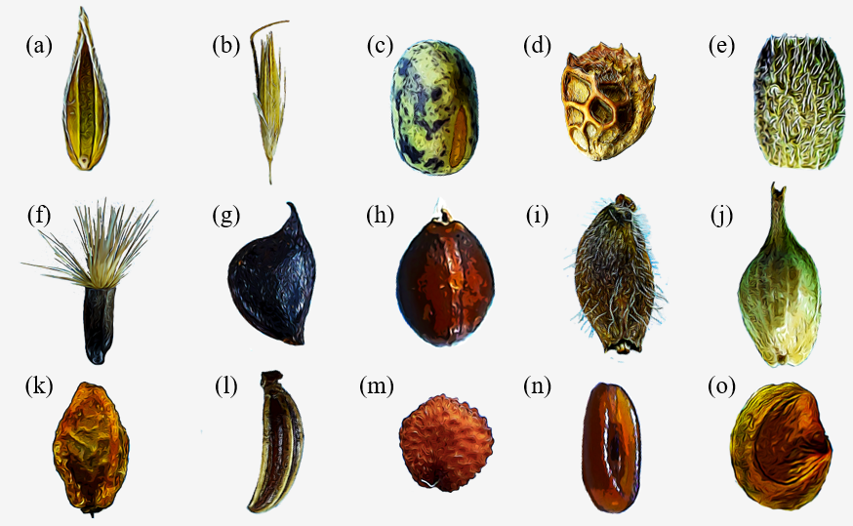

Figure 1: Diversity of dispersal units in mesic meadows: (a) Floret of *Cynosurus cristatus* (Poaceae); (b) floret of *Arrhenatherum elatius* (Poaceae); (c) seed of *Lathyrus pratensis* (Fabaceae); (d) legume of *Onobrychis viciifolia* (Fabaceae); (e) loment fragment of *Ornithopus perpusillus* (Fabaceae); (f) achene with pappus of *Centaurea scabiosa* (Asteraceae); (g) achene of *Ranunculus acris* (Ranunculaceae); (h) nutlet of *Prunella grandiflora* (Lamiaceae); (i) achene of *Knautia nevadensis* (Dipsacaceae); (j) perigynium of *Carex binervis* (Cyperaceae); (k) receptacle of *Sanguisorba minor* (Rosaceae); (l) mericarp of *Carum verticillatum* (Apiaceae); (m) seed of *Cerastium fontanum* (Caryophyllaceae); (n) seed of *Plantago lanceolata* (Plantaginaceae); (o) seed of *Rhinanthus angustifolius* (Orobanchaceae).

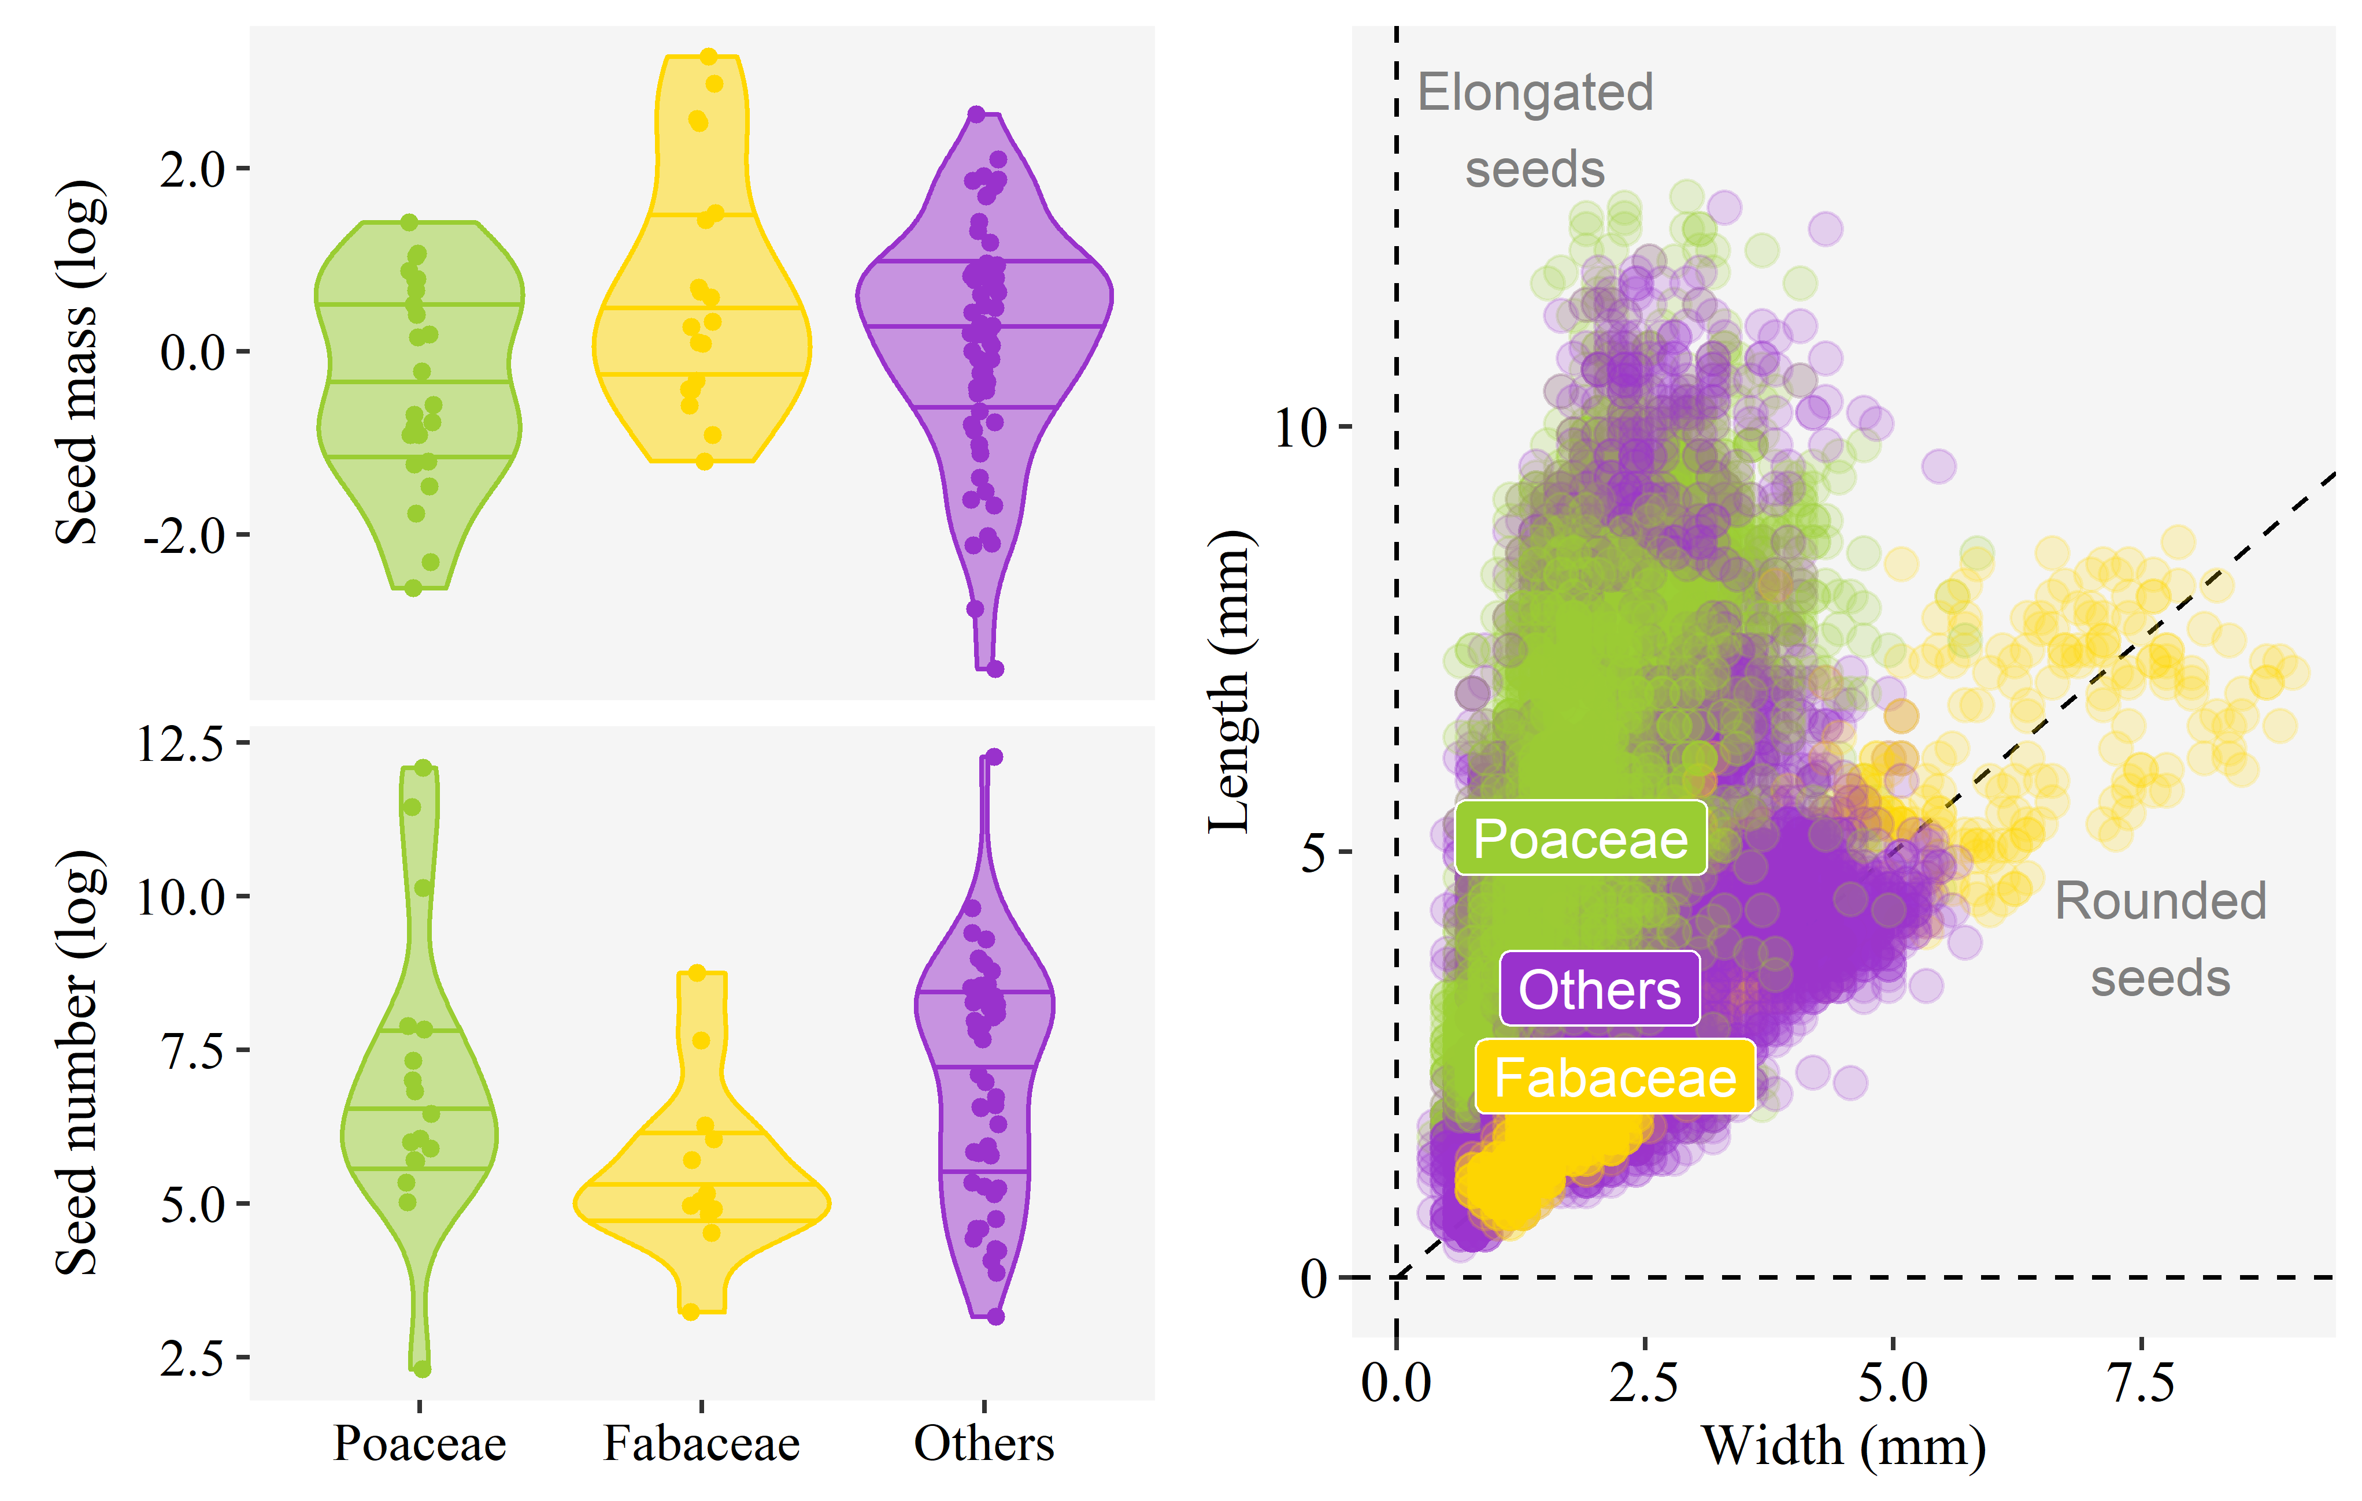

Figure 2: Morphology of mesic meadow seeds. The two panels on the left show the probability densities of species values for seed mass and seed number. The three horizontal lines within the probability densities represent the first quartile, the median and the third quartile of the values. The panel on the right shows values of seed length and width obtained by image analysis, with each point being a seed. In all cases, data is divided between the grasses (Poaceae), legumes (Fabaceae) and the other botanical families.

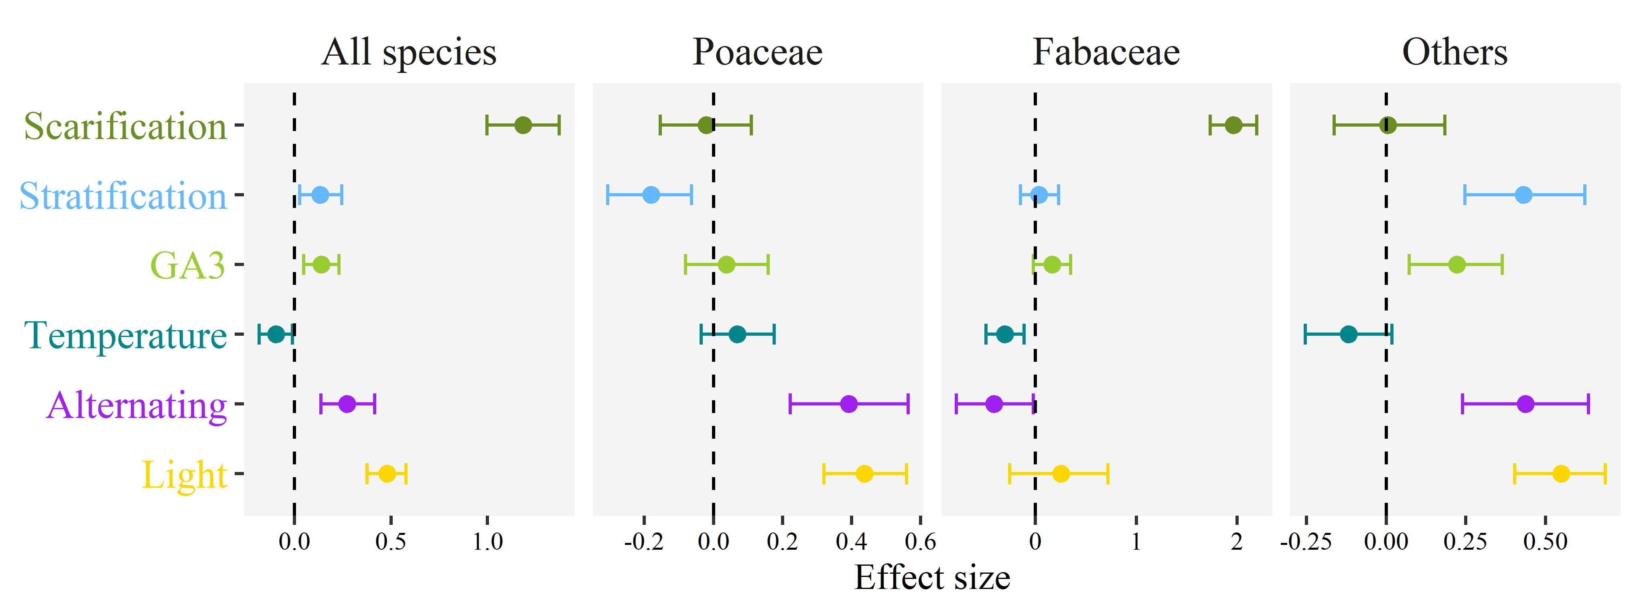

Figure 3: Germination cues in mesic meadows. Effect of germination cues simulated in the laboratory over the final germination proportions of mesic meadow seeds. Dots indicate the posterior mean of the effect size for each cue, and whiskers the 95% credible interval of the effect size. The line of zero-effect is shown: when a credible interval overlaps with the zero-effect line, the effect can be regarded as non-significant. In separate panels, the figure shows the results of a general model including data for all species, plus specific models for the three main botanical groups of mesic meadows: grasses (Poaceae), legumes (Fabaceae) and the other families.

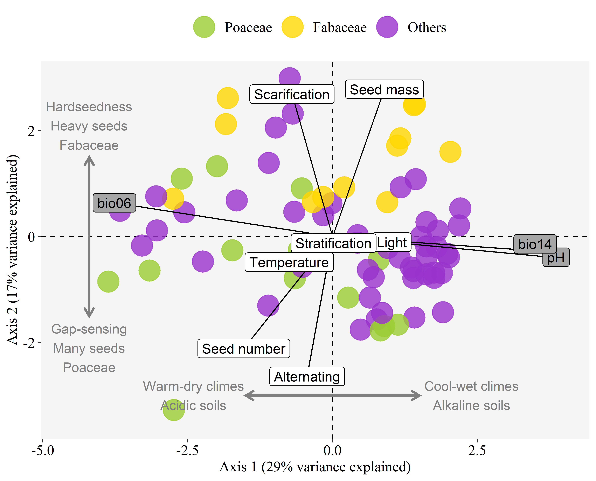

Figure 4: Environment and seed traits are separate axis of variation in mesic meadows. Principal Component Analysis ordination of mesic meadow species considering their environmental preferences and their seed traits. Each point is a species, colored by the three main botanical groups of mesic meadows: grasses (Poaceae), legumes (Fabaceae) and the other families. Labels indicate the contribution of the variables to the axes: grey-background labels for environmental preferences, and white-background labels for seed traits. Environmental preferences were calculated as species niche centroids (SNCs) for the minimal temperature of the coldest month (bio06), precipitation of the driest month (bio14), and soil pH. To calculate the SNCs, a vegetation dataset of mesic meadows of the Iberian Peninsula was used. The seed traits are seed mass and the germination relative indices for the response to scarification, stratification, average germination temperature (temperature), alternating temperature (alternating) and light. All environmental preferences were aligned to the first axis, while the seed traits were aligned to the second axis, showing that environment and seed traits are separate axis of variation in mesic meadows.

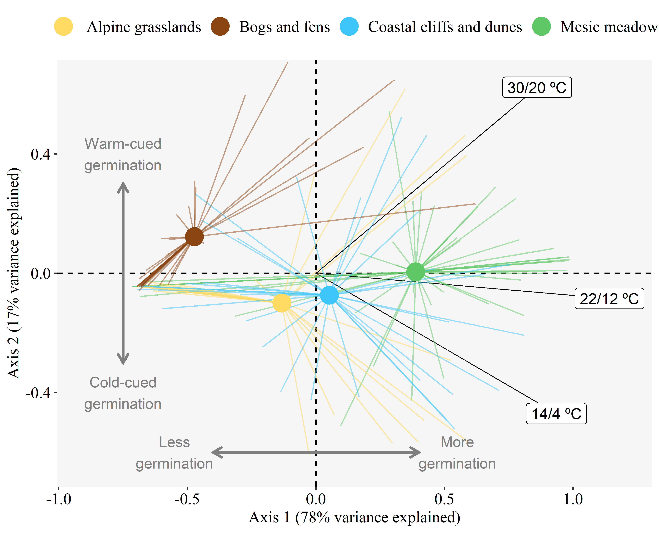

Figure 5: Higher germinability in mesic meadows compared to other herbaceous plant communities. Principal Component Analysis ordination of species responses to three seed germination treatments. Species are grouped by their habitat, with points showing the centroid for each habitat group, and rays linking the centroid with the position of each species in the group. Labels indicate the contribution of the germination treatments to the axes. All species had been collected in herbaceous vegetation types of the Cantabrian Mountains of Spain and the neighboring coast. All seeds were recently collected and untreated, except for scarification, which was applied routinely to all botanical families presenting it. Germination treatments consisted in 12/12 h periods with a warmer phase in light and a cooler phase in darkness. The position of mesic meadows compared to the other habitats indicates that their species tended to have higher germinability even if untreated (i.e. less seed dormancy) and were more neutral in their thermal requirements.