Microclimate of mire wetlands: testing the thermal buffer of groundwater in waterlogged and dry soils

Eduardo Fernández-Pascual, University of Oviedo ([fernandezpeduardo@uniovi.es](mailto:fernandezpeduardo@uniovi.es))

12/05/2020

# Introduction

Mires are however azonal habitats whose existence depends on local soil properties (Breckle 2002): by definition, they are areas with waterlogged soils. Grounwater can produce a buffer effect on soil temperature, keeping soils warmer than the air during cold periods, and vice versa (Ellenberg 1988; Geiger, Aron, and Todhunter 2009). Root-zone temperature is a major determinant of plant ecophysiology (Körner and Paulsen 2004), so the groundwater buffer effect is expected to allow mire plants to live along a wider range of air temperatures than they could otherwise. Indeed, mires have a relatively homogeneous flora despite being distributed from Mediterranean to Boreal biomes, and from low valleys to the alpine belt (Peterka et al. 2017). Recently, soil temperature measurements have become available for mires of North America (Raney, Fridley, and Leopold 2014), Western Europe (Fernandez-Pascual et al. 2015) and Central Europe (Horsák et al. 2018). Their comparison with air temperatures derived from models has shown that mire soils are indeed warmer in winter and cooler in summer, thus giving support to the existence of the groundwater thermal buffer (Fernandez-Pascual et al. 2015; Horsák et al. 2018). Furthermore, the effect has been linked to the composition of mire flora and fauna (Horsák et al. 2018; Schenková et al., n.d.), the growth rings of mire trees (Raney et al. 2016) and the role of mires as glacial refugia (Jiménez-Alfaro et al. 2016; Dítě et al. 2017).

# Figures

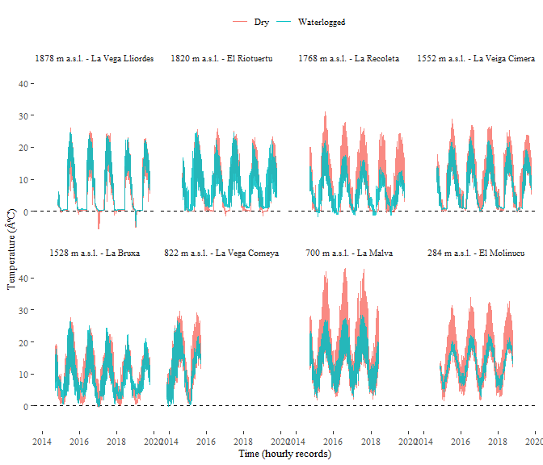

Hourly soil temperature records at the mire sites. The blue series was recorded within the mire, in a waterloged area. The red series was recorded in a neighbouring dry area. Dataloggers were buried at 5 cm depth.

# References

Bergamini, A., M. Peintinger, S. Fakheran, H. Moradi, B. Schmid, and J. Joshi. 2009. “Loss of Habitat Specialists Despite Conservation Management in Fen Remnants 1995-2006.” Journal Article. Perspectives in Plant Ecology, Evolution and Systematics 11 (1): 65–79. <https://doi.org/10.1016/j.ppees.2008.10.001>.

Breckle, Siegmar-Walter. 2002. Walter’s Vegetation of the Earth: The Ecological Systems of the Geo-Biosphere. Book. Berlin - Heidelberg - New York: Springer.

Cornelissen, Johannes H. C., Peter M. Van Bodegom, Rien Aerts, Terry V. Callaghan, Richard S. P. Van Logtestijn, Juha Alatalo, F. Stuart Chapin, et al. 2007. “Global Negative Vegetation Feedback to Climate Warming Responses of Leaf Litter Decomposition Rates in Cold Biomes.” Journal Article. Ecology Letters 10 (7): 619–27. <https://doi.org/10.1111/j.1461-0248.2007.01051.x>.

Dítě, Daniel, Tomáš Peterka, Zuzana Dítětová, Petra Hájková, and Michal Hájek. 2017. “Arcto-Alpine Species at Their Niche Margin: The Western Carpathian Refugia of <i>Juncus Castaneus</I> and <i>J. Triglumis</I> in Slovakia.” Journal Article. Annales Botanici Fennici 54 (1–3): 67–82, 16. <https://doi.org/10.5735/085.054.0311>.

Ellenberg, Heinz. 1988. “Spring Areas and Adjacent Swamps.” Book Section. In, 313–13. Cambridge: Cambridge University Press.