Mire microclimate: groundwater buffers temperature in waterlogged versus dry soils

Short title: Testing the thermal buffer of mire groundwater

Eduardo Fernández-Pascual1 +, Eva Correia-Álvarez2

1 Universidad de Oviedo, 2 Independent researcher

+ Correspondence: Departamento de Biología de Organismos y Sistemas, Universidad de Oviedo, C/ Catedrático Rodrigo Uría, 33006 Oviedo/Uviéu, Spain. Email: [efernandezpascual@gmail.com](mailto:efernandezpascual@gmail.com). Telephone: +34985104787.

# Graphical abstract

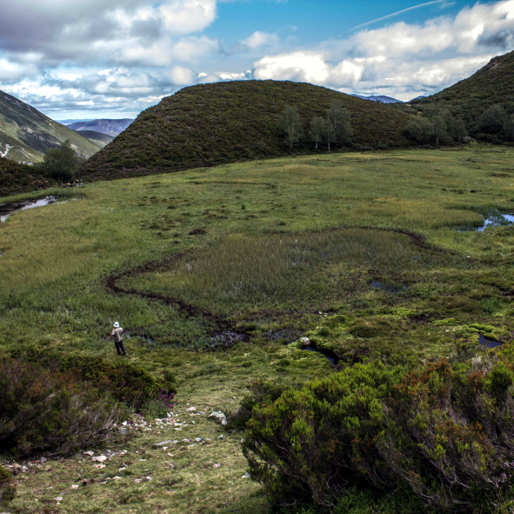

Mires are semi-terrestrial wetlands that remain waterlogged for most of the year. Waterlogged soils experience a thermal buffer effect that isolates them from surrounding temperature variations. This article tests the buffer effect in waterlogged mire soils and adjacent dry soils.

# Abstract

# Keywords

azonal vegetation, bog, datalogger, fen, microniche, peatland, soil temperature, wetland

# Introduction

Climate change (Ipcc 2014) affects global biodiversity, from drylands (Huang et al. 2016) to forests (Seidl et al. 2017) and oceans (Hoegh-Guldberg et al. 2017). Traditional models of species responses to global warming are based on macroclimatic data from weather stations. Recently, several authors have pointed out the need of complementing these models with *in situ* microclimatic measures (Lembrechts, Nijs, and Lenoir 2019; Lembrechts et al. 2019; Maclean, Mosedale, and Bennie 2019; Philippov and Yurchenko 2019). As has being shown for European forests (Zellweger et al. 2020), ecosystems usually respond to broad climate changes through local processes. An accurate prediction of species responses requires to focus on physiologically-relevant variables related to critical plant growth periods (Gardner, Maclean, and Gaston 2019).

Mires are permanent semi-terrestrial peatlands whose soils remain waterlogged but not inundated during most of the year (Wheeler and Proctor 2000). They are azonal habitats whose existence depends on local soil properties rather than macroclimatic zonation (Breckle 2002). Groundwater can produce a buffer effect on soil temperature, keeping soils warmer than the air during cold periods, and vice versa (Ellenberg 1988; Geiger, Aron, and Todhunter 2009). Root-zone temperature is a major determinant of plant ecophysiology (Körner and Paulsen 2004), so the groundwater buffer effect is expected to allow mire plants to live in a wider range of air temperatures than they could otherwise. Indeed, mires have a relatively homogeneous flora despite being distributed from Mediterranean to Boreal biomes, and from low valleys to the alpine belt (Peterka et al. 2017). Recently, soil temperature measurements have become available for mires of North America (Raney, Fridley, and Leopold 2014), Western Europe (Fernandez-Pascual et al. 2015) and Central Europe (Horsák et al. 2018). Their comparison with air temperatures derived from models has shown that mire soils are indeed warmer in winter and cooler in summer, thus giving support to the existence of the groundwater thermal buffer (Fernandez-Pascual et al. 2015; Horsák et al. 2018). Furthermore, the effect has been linked to the composition of mire flora and fauna (Horsák et al. 2018; Schenková et al. 2020), the growth rings of mire trees (Raney et al. 2016) and the role of mires as glacial refugia (Jiménez-Alfaro et al. 2016; Dítě et al. 2017).

Mires meet certain criteria that make them especially vulnerable to climate change (Horsák et al. 2018): (a) preponderance of species that evolved under a cold climate; (b) low productivity due to nutrient limitation, making them sensitive to increased nutrient cycling caused by warming (Cornelissen et al. 2007); and (c) scattered distribution pattern, which limits species dispersal and migration (Pearson and Dawson 2005). Therefore, mires are priority habitats for biodiversiuty conservation, harbouring high numbers of endangered species (Bergamini et al. 2009), and supporting highly-adapted floras in spatially-reduced areas (Grootjans et al. 2006). Worringly, mires retain high levels of methane which can be released due to global warming (Koffi et al. 2020). Habitat distribution models have predicted a loss of mire surface as a consequence of ongoing climate change (Essl et al. 2012).

It is evident that the groundwater buffer effect will play a determinant role in the response of mire habitats to climate change. As is the case for all azonal habitats, locally measured temperatures are essential to understand this response. Available references recorded temperatures only on the waterlogged soils, using model-derived air temperatures for comparison (Fernandez-Pascual et al. 2015; Horsák et al. 2018; Schenková et al. 2020); or recorded temperatures in both wet and dry spots but for less than a year, lacking representativeness throughout the growth cycle of mire vegetation (Raney, Fridley, and Leopold 2014; Raney et al. 2016). This article provides the first measurement of the thermal buffer against surrounding non-mire areas, based on soil temperatures recorded during a period of five years. These measures are used to test the hypotheses that, when compared to adjacent dry soils, waterlogged mire soil are (i) warmer in winter and (ii) colder in summer; and have less thermal amplitude in (iii) daily and (iv) annual scales. In addition, we compare *in situ* measurements with data derived from the CHELSA climatic models (Karger et al. 2017).

# Materials and methods

This study took place in the temperate oceanic region of north-western Spain (43º N, 5º W). Local geography and climate are dominated by the Cantabrian Mountains (> 1500 m above sea level), which run parallel to the coast and trap the prevailing NW Atlantic winds. The resulting humid climate harbours the south-western limit of mire communities in Europe (Jiménez-Alfaro, Díaz González, and Fernández-Pascual 2011; Fernández Prieto, Fernández Ordóñez, and Collado Prieto 1985). Rain-fed raised bogs and acid valley mires can be found from the coast to just below the treeline, in poorly drained valleys and former glacial lakes. Glacial lakes undergoing silting develop transition mires and quaking bogs communities in the water-to-land transition. Spring fens appear in the mountains above 1000 m; they range from soft-water poor fens on acid bedrocks, to alkaline calcareous fens on limestone.

We selected 8 mire sites representing the regional elevation gradient of mire vegetation and the different mire types (Table ??)). In each site, we buried two dataloggers (M-Log5W, GeoPrecision, Ettlingen, Germany) at a depth of 5 cm below the upper layer of the soil: one datalogger in a flat waterlogged spot within the mire; the other one in the close vicinity, but in a flat and dry area outside the mire. The vegetation was always either mire or pasture, with no shrubs, trees or any other landscape features shading the measuring points. Dataloggers recorded temperature on an hourly basis and stayed on site for approximately five years, after which we retrieved them and downloaded their records. At the moment of retrieval, the internal clock of all dataloggers had not deviated for more than four hours.

To clean the logs we took the following steps: (i) removing records from the first week after installation, to account for the installation process and the settling of the soils; and (ii) keeping only time series with records for both the dry and waterlogged points, because some of the dataloggers had failed at different points in time. Afterwards, we calculated four bioclimatic variables for each datalogger: (1) the mean diurnal range; i.e. the average for the whole period of the daily differences between the maximum and the minimum temperatures recorded in the day; (2) the maximum temperature of the warmest month; i.e. the average of the daily maximum records, for the warmst month; (3) the minimum temperature of the codlest month; i.e. the average of the daily minimum records, for the coldest month; and (4) the annual range; i.e. the difference between the maximum temperature of the warmest month and the minimum temperature of the coldest month. To compare our measurements with model-based predictions of air temperature, we downloaded from CHELSA the same bioclimatic variables for our measuring coordinates.

To test if the differences between the dry and the waterlogged points of each site was significant, we used paired t-tests. Tests were one-tailed, according to the following hypotheses: the dry point would have a higher diurnal range, a higher maximum temperature, a lower minimum temperature, and a higher annual range. To test whether the CHELSA values predicted our measurements, we fitted linear models.

# Results

Dataloggers recorded temperatures for five years in five of the sites, four years in two, and two years in one. Time series showed considerably less variation at waterlogged points, for all eight site comparisons (Fig. 1).

Bioclimatic variables (Table ?? and Fig. 2) supported this notion. The mean annual range was wider at dry points, as was the mean diurnal range. Maximum temperatures of the warmest months were usually higher at dry measuring points. The opposite was true for the minimums of the coldest months, in which case temperature was generally colder at dry points, although the difference was less pronounced than for the maximums (Fig. 2).

Patterns regarding the maximum temperatures and annual range were especially noticeable at both low (El Molinucu, La Malva) and high (La Recoleta) elevations. The pattern for the diurnal range, however, was more prominent just at the low sites (El Molinucu, La Malva), whereas the minimuns of the coldest months were especially colder at high elevations (La Bruxa, La Veiga Cimera) (Table ??).

T-tests supported the original hypotheses; namely waterlogged measuring points had (a) smaller diurnal fluctuactions (t = , p = , effect size = ºC); (b) lower maximums (t = , p = , effect size = ºC); (c) higher minimums (t = , p = , effect size = ºC), and (d) smaller annual fluctuations (t = , p = , effect size = ºC).

The CHELSA climatic model (Table ?? and Fig. 3) predicted well the minimuns of the coldest month, especially at dry points (R2 = 0.78) but also at waterlogged points (R2 = 0.66). CHELSA also predicted to some extent the maximums at the warmest month in dry points (R2 = 0.42), but failed to predict waterlogged points (R2 = 0.16). CHELSA did not predict the values for the annual and diurnal range, at both dry and waterlogged points.

# Discussion

The results presented here prove the existence of a thermal buffer effect in waterlogged mire soils, when compared with adjacent dry soils. The mire thermal buffer had been compared previously with air temperatures derived from models, with generally similar results (Fernandez-Pascual et al. 2015; Horsák et al. 2018). The mire buffer had also been compared to dry soils but only during the growing season (Raney, Fridley, and Leopold 2014; Raney et al. 2016); our results confirm those findings and extend them to the full year. Therefore, there exists a thermal buffer effect in mire soils that makes their temperatures less extreme than the surrounding landscape. This highlights the importance of using fine-scale microclimatic data to assess vegetation responses to climate change (Storlie et al. 2014; Lembrechts, Nijs, and Lenoir 2019; Zellweger et al. 2020).

One important difference with previous studies is the importance of the buffer during winter. The articles that had used model air temperatures as a control concluded that the buffer effect was stronger at the cold end of the thermal gradient, i.e. in winter and at night (Fernandez-Pascual et al. 2015; Horsák et al. 2018). In the case of this investigation, the situation was reverse: the effect was weaker when considering the minimum temperatures of the cold period. This indicates the importance of identifying root temperatures when working with plant communities. At high elevations of the study region, the soil can remain covered by snow for periods of winter, and this has its own insulating effect on soil temperatures (Körner 2003). Indeed, snow cover has being described as one of the vertical features that affects vegetation distribution in a local manner (Maclean, Mosedale, and Bennie 2019).

In concordance with our results, the air temperature measured at 0.5 m from the surface of boreal bogs is lower at the wetter zones, at least during the warmest months (Philippov and Yurchenko 2019). Thus, the water buffering effect seems to take place both at southern and northern latitudes and may affect not only the temperature in the soil but also the air temperature within certain highness from the soil. Nonetheless, Philippov *et al.* did not record winter months, so more monitoring is needed at more northern latitudes, where the winter effect may be more relevant (Horsák et al. 2018).

The buffering effect was much stronger during the summer. This was most noticeable in the two lowest elevations, El Molinucu and La Malva. La Malva showed specially high summer temperatures within the dry soils (> 40 ºC). This site is in a southeast-facing slope on limestone, a place experiencing sub-Mediterranean conditions at the micro-scale (Sánchez de Dios, Benito-Garzón, and Sainz-Ollero 2009). This suggests the importance of groundwater in the existence of mire vegetation in Mediterranean areas (Hoyos et al. 1996), not only from the water-availability aspect, but also providing cooling regulation during summer (Ellenberg 1988). The buffering was also prominent at one of the highest elevations, La Recoleta, which may be explained by the high saturation of water in this kind of habitat, a quaking bog.

Most of the current models to predict vegetation and species distribution use macroclimatic parameters, like the ones obtained from CHELSA (Karger et al. 2017). This study revealed that CHELSA can predict quite well the minimum temperatures at the coldest month in the mire habitats. However, it fails to predict temperatures at the warm extremes, especially at the waterlogged points. This brings out the importance of studying local factors as drivers of microclimatic changes (Zellweger et al. 2019). These factors contribute to landscape heterogeinity, producing safe sites that can act as micro-refugees and buffer species from regional climatic warming.

In summary, this article shows that waterlogged mire soils have a thermal buffer when compared to adjacent soils, contributing to their behaviour as mild island habitats in a landscape that can be more thermally variable (Horsák et al. 2018). The effect occurs during cold and warm periods, but it is stronger during the summer at least in the study area. Future recording schemes are needed to obtain local soil temperatures from other latitudes, and from more microtopographies within the same mire. Our study provides useful microclimate parameters to improve the current models that predict the impact of global warming on specific ecosystems.

# Data availability

Upon publication, the original temperature records along with R analysis scripts will be uploaded to a public repository in GitHub.

# Acknowledgements

E.F.P. received financial support from the Government of Asturias and the FP7 – Marie Curie - COFUND programme of the European Commission (Grant ‘Clarín’ ACB17-19).

# Tables

Mire sites included in this study, indicating the type of fen, the elevation, coordinates, and length of the temperature recording period.

| Site | Habitat | Elevation (m) | Latitude (ÂºC) | Longitude (ÂºC) | Records (days) |
| --- | --- | --- | --- | --- | --- |
| El Molinucu | Raised bog | 284 | 43.3924 | -5.5392 | 1421 |
| La Malva | Alkaline fen | 700 | 43.1176 | -6.2543 | 1347 |
| La Vega Comeya | Raised bog | 822 | 43.2856 | -4.9885 | 664 |
| La Bruxa | Alkaline fen | 1528 | 43.0232 | -6.2113 | 1850 |
| La Veiga Cimera | Acid fen | 1552 | 43.0252 | -6.2539 | 1850 |
| La Recoleta | Quaking bog | 1768 | 43.0167 | -6.1112 | 1854 |
| El Riotuertu | Alkaline fen | 1820 | 43.0096 | -5.9479 | 1852 |
| La Vega Lliordes | Alkaline fen | 1878 | 43.1504 | -4.8464 | 1809 |

Groundwater buffer effect per mire and bioclimatic variable. The buffer effect was calculated as the difference between the value in the waterlogged and the dry sites.

| Site | Annual range | Diurnal range | Summer max | Winter min |
| --- | --- | --- | --- | --- |
| El Molinucu | -7.80 | -4.90 | -6.59 | 1.21 |
| El Riotuertu | -3.62 | 1.12 | -2.28 | 1.34 |
| La Bruxa | -1.09 | -0.88 | 0.99 | 2.08 |
| La Malva | -10.81 | -5.14 | -10.25 | 0.56 |
| La Recoleta | -8.81 | -2.62 | -8.85 | -0.04 |
| La Vega Comeya | -3.63 | -2.99 | -3.51 | 0.12 |
| La Vega Lliordes | -1.26 | -0.71 | -0.28 | 0.98 |
| La Veiga Cimera | -3.41 | -2.21 | -3.47 | -0.06 |

Results of the linear models predicting the soil bioclimatic variables from the CHELSA air temperatures, per bioclimatic variable and groundwater situation.

| Variable | Groundwater | t | p | R2 |
| --- | --- | --- | --- | --- |
| Annual range | Dry | 0.012 | 0.991 | -0.17 |
| Annual range | Waterlogged | -0.334 | 0.750 | -0.15 |
| Diurnal range | Dry | 0.016 | 0.988 | -0.17 |
| Diurnal range | Waterlogged | 1.354 | 0.225 | 0.11 |
| Summer max | Dry | 2.450 | 0.050 | 0.42 |
| Summer max | Waterlogged | 1.527 | 0.178 | 0.16 |
| Winter min | Dry | 5.115 | 0.002 | 0.78 |
| Winter min | Waterlogged | 3.809 | 0.009 | 0.66 |

# Figures

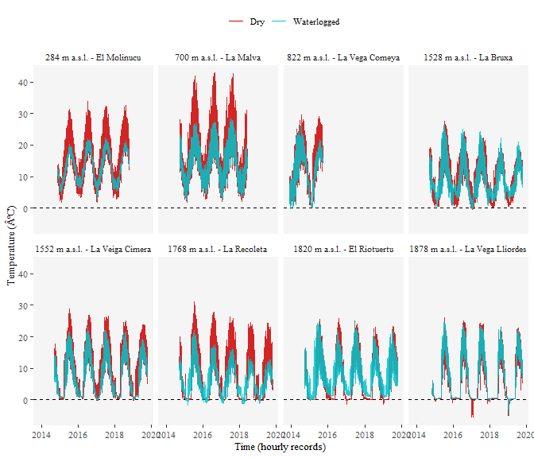

Figure 1: Hourly soil temperature records at the mire sites. The blue series was recorded within the mire, in a waterloged area. The red series was recorded in a neighbouring dry area. Dataloggers were buried at 5 cm depth.

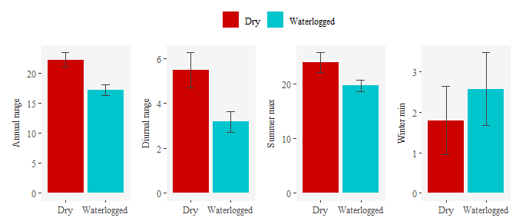

Figure 2: Average bioclimatic variables in the dry and waterlogged sites. The bars represent the mean value, and the bars the standard error of 8 records.

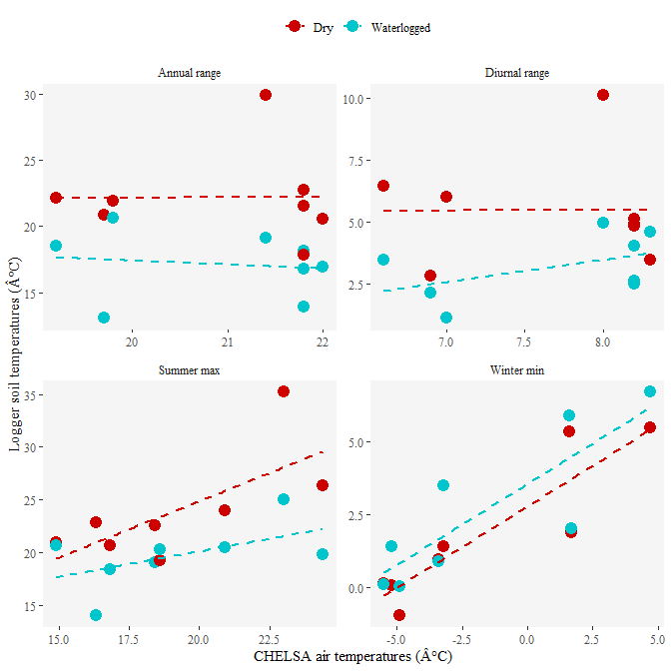

Figure 3: Scatter plots of the bioclimatic variables predicted by CHELSA air temperatures vs. soil temperatures measured in situ, in dry and waterlogged sites.

# References

Bergamini, A., M. Peintinger, S. Fakheran, H. Moradi, B. Schmid, and J. Joshi. 2009. “Loss of habitat specialists despite conservation management in fen remnants 1995-2006.” Journal Article. *Perspectives in Plant Ecology, Evolution and Systematics* 11 (1): 65–79. <https://doi.org/10.1016/j.ppees.2008.10.001>.

Breckle, Siegmar-Walter. 2002. *Walter’s Vegetation of the Earth: The Ecological Systems of the Geo-biosphere*. Book. Berlin - Heidelberg - New York: Springer.

Cornelissen, Johannes H. C., Peter M. Van Bodegom, Rien Aerts, Terry V. Callaghan, Richard S. P. Van Logtestijn, Juha Alatalo, F. Stuart Chapin, et al. 2007. “Global negative vegetation feedback to climate warming responses of leaf litter decomposition rates in cold biomes.” Journal Article. *Ecology Letters* 10 (7): 619–27. <https://doi.org/10.1111/j.1461-0248.2007.01051.x>.

Dítě, Daniel, Tomáš Peterka, Zuzana Dítětová, Petra Hájková, and Michal Hájek. 2017. “Arcto-Alpine species at their niche margin: the Western Carpathian refugia of *Juncus castaneus* and *J. triglumis* in Slovakia.” Journal Article. *Annales Botanici Fennici* 54 (1–3): 67–82, 16. <https://doi.org/10.5735/085.054.0311>.

Ellenberg, Heinz. 1988. “Spring areas and adjacent swamps.” Book Section. In *Vegetation Ecology of Central Europe*, 313–13. Cambridge: Cambridge University Press.

Essl, Franz, Stefan Dullinger, Dietmar Moser, Wolfgang Rabitsch, and Ingrid Kleinbauer. 2012. “Vulnerability of mires under climate change: implications for nature conservation and climate change adaptation.” Journal Article. *Biodiversity and Conservation* 21: 655–69.

Fernandez-Pascual, Eduardo, Borja Jimenez-Alfaro, Michal Hajek, Tomas E. Diaz, Hugh W. Pritchard, Eduardo Fernández-Pascual, Borja Jiménez-Alfaro, et al. 2015. “Soil thermal buffer and regeneration niche may favour calcareous fen resilience to climate change.” Journal Article. *Folia Geobotanica* 50 (4): 293–301. <https://doi.org/10.1007/s12224-015-9223-y>.

Fernández Prieto, José Antonio, María del Carmen Fernández Ordóñez, and Miguel Ángel Collado Prieto. 1985. “Datos sobre la vegetación de las turberas de esfagnos galaico-asturianas y orocantábricas.” Journal Article. *Lazaroa* 7: 443–71.

Gardner, Alexandra S., Ilya M. D. Maclean, and Kevin J. Gaston. 2019. “Climatic predictors of species distributions neglect biophysiologically meaningful variables.” Journal Article. *Diversity and Distributions* 25 (8): 1318–33. <https://doi.org/10.1111/ddi.12939>.

Geiger, Rudolf, Robert H. Aron, and Paul Todhunter. 2009. *The Climate Near the Ground*. Book. Lanham: Rowman & Littlefield.

Grootjans, A. P., E. B. Adema, W. Bleuten, H. Joosten, M. Madaras, and M. Janáková. 2006. “Hydrological landscape settings of base-rich fen mires and fen meadows: an overview.” Journal Article. *Applied Vegetation Science* 9: 175–84. <http://search.ebscohost.com/login.aspx?direct=true&db=aph&AN=25691039&lang=es&site=ehost-live>.

Hoegh-Guldberg, Ove, Elvira S. Poloczanska, William Skirving, and Sophie Dove. 2017. “Coral reef ecosystems under climate change and ocean acidification.” Journal Article. *Frontiers in Marine Science* 4 (158). <https://doi.org/10.3389/fmars.2017.00158>.

Horsák, Michal, Vendula Polášková, Marie Zhai, Jindřiška Bojková, Vít Syrovátka, Vanda Šorfová, Jana Schenková, Marek Polášek, Tomáš Peterka, and Michal Hájek. 2018. “Spring-fen habitat islands in a warming climate: partitioning the effects of mesoclimate air and water temperature on aquatic and terrestrial biota.” Journal Article. *Science of the Total Environment* 634: 355–65. <https://doi.org/https://doi.org/10.1016/j.scitotenv.2018.03.319>.

Hoyos, D de, Jesús Muñoz Fuente, A Negro, Juan José Aldasoro, JC Vega, and Gonzalo Moreno Moral. 1996. “A survey on Cantabrian mires (Spain).” Journal Article. *Anales Del Jardín Botánico de Madrid* 54 (1): 472–89.

Huang, Jianping, Haipeng Yu, Xiaodan Guan, Guoyin Wang, and Ruixia Guo. 2016. “Accelerated dryland expansion under climate change.” Journal Article. *Nature Climate Change* 6 (2): 166–71. <https://doi.org/10.1038/nclimate2837>.

Ipcc. 2014. *Climate Change 2014: Synthesis Report. Contribution of Working Groups I, II and III to the Fifth Assessment Report of the Intergovernmental Panel on Climate Change [Core Writing Team, R.K. Pachauri and L.A. Meyer (eds.)]*. Book. Geneva: IPCC.

Jiménez-Alfaro, Borja, Tomás Díaz González, and Eduardo Fernández-Pascual. 2011. “Grupos de vegetación y hábitats de tremedales neutro-basófilos en las montañas pirenaico-cantábricas.” Journal Article. *Acta Botanica Barcinonensia* 53: 47–60.

Jiménez-Alfaro, Borja, Laura García-Calvo, Pedro García, and José Luis Acebes. 2016. “Anticipating extinctions of glacial relict populations in mountain refugia.” Journal Article. *Biological Conservation* 201: 243–51.

Karger, Dirk Nikolaus, Olaf Conrad, Jürgen Böhner, Tobias Kawohl, Holger Kreft, Rodrigo Wilber Soria-Auza, Niklaus E. Zimmermann, H. Peter Linder, and Michael Kessler. 2017. “Climatologies at high resolution for the earth’s land surface areas.” Journal Article. *Scientific Data* 4 (1): 170122. <https://doi.org/10.1038/sdata.2017.122>.

Koffi, Ernest N., Peter Bergamaschi, Romain Alkama, and Alessandro Cescatti. 2020. “An observation-constrained assessment of the climate sensitivity and future trajectories of wetland methane emissions.” Journal Article. *Science Advances* 6 (15): eaay4444. <https://doi.org/10.1126/sciadv.aay4444>.

Körner, Christian. 2003. *Alpine Plant Life: Functional Plant Ecology of High Mountain Ecosystems*. Book. 2nd ed. Berlin - Heidelberg - New York: Springer.

Körner, Christian, and Jens Paulsen. 2004. “A world-wide study of high altitude treeline temperatures.” Journal Article. *Journal of Biogeography* 31: 713–32. [http://10.0.4.87/j.1365-2699.2003.01043.x http://search.ebscohost.com/login.aspx?direct=true&db=aph&AN=12823821&lang=es&site=ehost-live](http://10.0.4.87/j.1365-2699.2003.01043.x%0Ahttp://search.ebscohost.com/login.aspx?direct=true&db=aph&AN=12823821&lang=es&site=ehost-live).

Lembrechts, Jonas J., Jonathan Lenoir, Nina Roth, Tarek Hattab, Ann Milbau, Sylvia Haider, Loïc Pellissier, et al. 2019. “Comparing temperature data sources for use in species distribution models: from in-situ logging to remote sensing.” Journal Article. *Global Ecology and Biogeography* 28 (11): 1578–96. <https://doi.org/10.1111/geb.12974>.

Lembrechts, Jonas J., Ivan Nijs, and Jonathan Lenoir. 2019. “Incorporating microclimate into species distribution models.” Journal Article. *Ecography* 42 (7): 1267–79. <https://doi.org/10.1111/ecog.03947>.

Maclean, Ilya M. D., Jonathan R. Mosedale, and Jonathan J. Bennie. 2019. “Microclima: an R package for modelling meso- and microclimate.” Journal Article. *Methods in Ecology and Evolution* 10 (2): 280–90. <https://doi.org/10.1111/2041-210x.13093>.

Pearson, Richard G., and Terence P. Dawson. 2005. “Long-distance plant dispersal and habitat fragmentation: identifying conservation targets for spatial landscape planning under climate change.” Journal Article. *Biological Conservation* 123 (3): 389–401. <https://doi.org/https://doi.org/10.1016/j.biocon.2004.12.006>.

Peterka, Tomáš, Michal Hájek, Martin Jiroušek, Borja Jiménez-Alfaro, Liene Aunina, Ariel Bergamini, Daniel Dítě, et al. 2017. “Formalized classification of European fen vegetation at the alliance level.” Journal Article. *Applied Vegetation Science* 20 (1): 124–42. <https://doi.org/10.1111/avsc.12271>.

Philippov, Dmitriy A., and Victoria V. Yurchenko. 2019. “Data on air temperature, relative humidity and dew point in a boreal *Sphagnum* bog and an upland site (Shichengskoe mire system, North-Western Russia).” Journal Article. *Data in Brief* 25: 104156. <https://doi.org/https://doi.org/10.1016/j.dib.2019.104156>.

Raney, PatrickA, JasonD Fridley, and DonaldJ Leopold. 2014. “Characterizing microclimate and plant community variation in wetlands.” Journal Article. *Wetlands* 34 (1): 43–53. <https://doi.org/10.1007/s13157-013-0481-2>.

Raney, Patrick A., Donald J. Leopold, Martin Dovčiak, and Colin M. Beier. 2016. “Hydrologic position mediates sensitivity of tree growth to recent climate change: wetlands as refugia in a warmer world.” Journal Article. *Ecological Applications* in press.

Sánchez de Dios, Rut, Marta Benito-Garzón, and Helios Sainz-Ollero. 2009. “Present and future extension of the Iberian submediterranean territories as determined from the distribution of marcescent oaks.” Journal Article. *Plant Ecology* 204 (2): 189–205. <https://doi.org/10.1007/s11258-009-9584-5>.

Schenková, Jana, Vendula Polášková, Martina Bílková, Jindřiška Bojková, Vít Syrovátka, Marek Polášek, and Michal Horsák. 2020. “Climatically induced temperature instability of groundwater-dependent habitats will suppress cold-adapted Clitellata species.” Journal Article. *International Review of Hydrobiology* 105: 85–93. <https://doi.org/10.1002/iroh.201902006>.

Seidl, Rupert, Dominik Thom, Markus Kautz, Dario Martin-Benito, Mikko Peltoniemi, Giorgio Vacchiano, Jan Wild, et al. 2017. “Forest disturbances under climate change.” Journal Article. *Nature Climate Change* 7 (6): 395–402. <https://doi.org/10.1038/nclimate3303>.

Storlie, Collin, Andres Merino-Viteri, Ben Phillips, Jeremy VanDerWal, Justin Welbergen, and Stephen Williams. 2014. “Stepping inside the niche: microclimate data are critical for accurate assessment of species’ vulnerability to climate change.” Journal Article. *Biology Letters* 10 (9): 20140576. <https://doi.org/doi:10.1098/rsbl.2014.0576>.

Wheeler, B. D., and M. C. F. Proctor. 2000. “Ecological gradients, subdivisions and terminology of north-west European mires.” Journal Article. *Journal of Ecology* 88 (2): 187–203. <https://doi.org/10.1046/j.1365-2745.2000.00455.x>.

Zellweger, Florian, Pieter De Frenne, Jonathan Lenoir, Duccio Rocchini, and David Coomes. 2019. “Advances in microclimate ecology arising from remote sensing.” Journal Article. *Trends in Ecology & Evolution* 34 (4): 327–41. <https://doi.org/https://doi.org/10.1016/j.tree.2018.12.012>.

Zellweger, Florian, Pieter De Frenne, Jonathan Lenoir, Pieter Vangansbeke, Kris Verheyen, Markus Bernhardt-Römermann, Lander Baeten, et al. 2020. “Forest microclimate dynamics drive plant responses to warming.” Journal Article. *Science* 368 (6492): 772–75. <https://doi.org/10.1126/science.aba6880>.