Spatiotemporal buffering of microclimatic variation in alpine plant communities of Picos de Europa National Park (Cantabrian Mountains, Spain)

Borja Jiménez-Alfaro, Eduardo Fernández-Pascual, Corrado Marcenó

# Abstract

**Questions**: In alpine landscapes, topography creates a mosaic of microclimatic niches which might prevent local extinctions through climate buffering. However, the magnitude of this buffering is poorly studied, limiting our understanding of climate change effects on alpine vegetation. Here we ask (1) how microclimatic factors influence the composition of local alpine communities across time and space, and (2) which microclimatic scenarios are more likely to drive local species extinctions.

**Location**: Relict alpine communities in Picos de Europa National Park, Cantabrian Mountains, Spain.

**Methods**: We used data from a long-term monitoring project on four alpine sites with a 10-year record of species composition and microclimate. We sampled further spatial variation in composition and microclimate in 80 plots within the four sites. Climatic variation was evaluated through growing degree days (GDD) and freezing degree days (FDD) and four microclimatic scenarios: hot-snowy, hot-freezing, cold-snowy and cold-freezing. We used the most extreme conditions recorded during the 10 years of monitoring as plausible scenarios to predict species extinctions.

**Results**: We found a temporal trend of temperature warming coupled with slight changes in the cover of winner and loser species. Microclimatic conditions were similarly varied in time and space, but GDD showed higher variation in space than time. A total of 16 species (out of 86) responded significantly to spatial microclimatic variation. The scenario with the highest number of extinctions was hot-freezing (9), followed by hot-snowy (6), cold-freezing (6) and cold-snowy (1).

**Conclusions**: Spatial microclimatic refugia may compensate for temporal changes in temperature, but this will depend on species microclimatic preferences. A shift towards more Mediterranean conditions, with snow-free and freezing winters, will have the highest impact on local plant communities. With sufficient snow precipitation, the response of the study system to climate warming seems more likely to produce a re-accommodation of species relative abundances along topographical variation, as it might have occurred during the Holocene.

# 1. Introduction

Withinlandscapes, topography creates a mosaic of microclimatic niches which might prevent local extinctions

Bullet points:

* Climate impact on alpine communities is unclear
* Topographic buffering along meso-climatic gradients is well known
* We know little about the real impact of topography at the microscale, and whether termophilization or decrease in snowcover or freezing frequencies influence alpine communities.
* We ask (1) whether microclimate variation measured in long-term vegetation monitoring is scalable with the spatial variation found in the microclimatic surroundings, and (2) what might be the impact of this variation on the abundance and composition of communities

Peter le Roux comments at IAVS22 [Miska Luoto; -> Pekka Niitynen (snow); -> Mia Momberg (wind); soil moisture (GCB); biotic interac / facilitation (ecology); geomorpho (JVS); Check TDR300 Field scout (soil mousture)]

# 2. Methods

## 2.1 Study system

This study was conducted in the Cantabrian Mountains of Spain, a biodiversity hotspot for cold-adapted plants in the Iberian Peninsula and a biogeographical hub for Alpine and Mediterranean lineages in Western Europe (Jiménez-Alfaro et al. 2021). Study sites were placed in the central calcareous massif of the Picos de Europa National Park (**Fig. 1A**), which includes the highest elevations of the Cantabrian Mountains. Local alpine vegetation occurs between 1900 and 2400 m a.s.l., supporting a species pool of 230 plant species (Jiménez-Alfaro et al. 2014, JVS). In 2008, we established a long-term ecological research program for monitoring soil climate and vegetation, including four study sites distributed in the calcareous massif along a North-South gradient (**Fig. 1B**). These sites reflect variation in local climatic gradients and represent the two major vegetation types described in the study area: stripped habitats subjected to cryoturbation and alpine-like communities with higher biomass (Jiménez-Alfaro et al. 2014, Lazaroa).

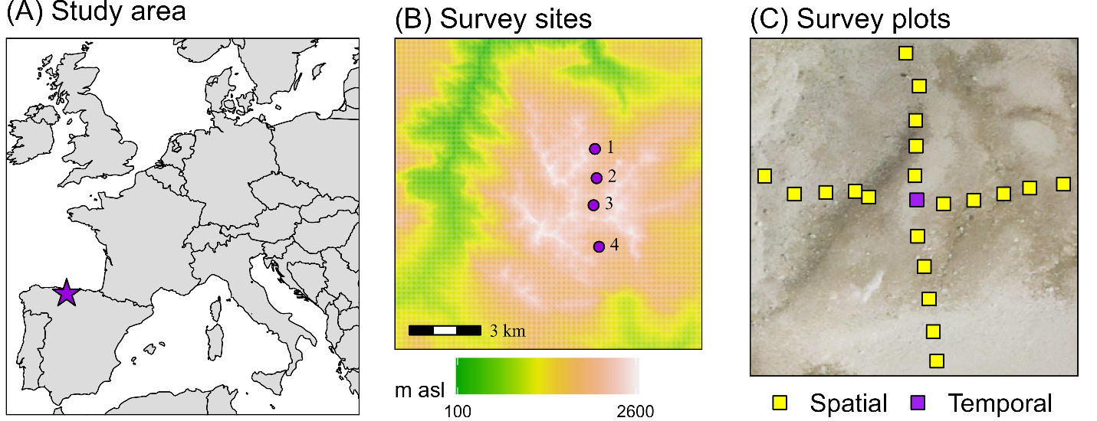

**Figure 1** Study system. (A) Situation of the study area (purple star) in Western Europe. (B) Four study sites (purple circles) placed in a North-South gradient in the central massif of Picos de Europa National Park. Site names are Los Cazadores (1); Ḥou Sin Tierri (2); Los Boches (3); Hoyo Sin Tierra (4). (C) Sampling design in one of the sites, showing the central plot (purple square) for the temporal survey and the additional plots (yellow squares) for the spatial survey.

## 2.2 Temporal survey

In each of the four sites, we buried a temperature logger (M-Log5W, GeoPrecision, Ettlingen, Germany; accuracy: +/- 0.1 ºC at 0 ºC, resolution: 0.01 ºC, records each hour) at 5 cm depth in a relatively flat and homogeneous vegetation patch. We surveyed the plant community in two replicated plots of 1 m2 separated 1 m from the logger, identifying species composition of vascular plants and estimating relative cover in %. Within each 1 m2 plot, we sampled species frequency using a grid template of 100 microplots (10 cm x 10 cm) following the methodology of the Global Observation Research Initiative in Alpine Environments (GLORIA, Pauli et al. 2015). Loggers were replaced by new ones when needed, to obtain a continuous temperature record from 1 Jan 2008 to 31 Dec 2018. In 2019, we re-surveyed the plots in the same way to detect changes in species presence and frequency. The vegetation data from these surveys, together with the soil temperature collected in the four study sites for 10 years, represent the ‘temporal survey’.

## 2.3 Spatial survey

In 2018, we visited the study sites to measure the spatial variation of microclimate and vegetation around the four plots sampled in the temporal survey. In each of the four sites, using the long-term temperature logger as the central reference, we additionally placed 20 iButtons (Thermochron, iButton, Newbury, UK; accuracy: +/- 0.5 ºC from -10 ºC to +65 ºC, resolution: 0.5 ºC, records each 4 hours) in 20 plots of 1 m2 separated 10 m from each other along the four cardinal directions (**Fig. 1C**). The recording period for the iButtons went from 1 Oct 2018 to 31 Aug 2019 (330 days). For each one of the 20 plots per site, we identified all vascular plants and estimated their relative cover in %. The iButton data, together with the associated vegetation data of the plots, represent the ‘spatial survey’.

## 2.4. Microclimatic data

We used the microclimatic data of the temporal and spatial surveys to calculate several bioclimatic indices. For comparison, we homogenized the data of the temporal survey at 4-hour intervals, keeping the same 330 calendar days covered by the spatial survey (i.e. removing the months of September). In total, we obtained 40 data points for the temporal survey (4 sites x 10 years) and 80 for the spatial survey (4 sites x 20 plots).

We used bioclimatic indices based on standard variables used by WorldClim (Fick and Hijmans 2017), together with additional variables assumed to have a relevant effect along alpine topographic gradients: snow cover, growing degree days (Bürli et al. 2021) and freezing degree days (Choler 2018). The final selected variables were: (1) bio1 = annual mean temperature; (2) bio2 = mean diurnal range, i.e. the mean of the monthly differences between maximum and minimum temperatures; (3) bio7 = temperature annual range; i.e. the difference between the maximum temperature of the warmest month and the minimum temperature of the coldest month; (4) snow = the number of days of snow cover, considered to be those days in which the maximum temperature was below 0.5 ºC and the minimum temperature was above -0.5 ºC; (5) GDD = growing degree days, i.e. the sum of daily mean temperatures for days in which the mean temperature was above 1 ºC; and (6) FDD = freezing degree days, i.e. the sum of daily mean temperatures for days in which the mean temperature was below 0 ºC. For FDD, we transformed the values from negative to positive, so higher values equal more freezing, making interpretation more straightforward.

After 10 years of soil temperature monitoring (**Fig. 2A**), two of the sites (Los Cazadores and Los Boches) showed a consistent pattern of continuous snow cover during winter (i.e. snowbed conditions reflected by winter temperature records around 0 ºC). In contrast, the two other sites (Ḥou Sin Tierri and Hoyo Sin Tierra) showed repeated freezing (below 0ºC) temperatures during winter (i.e. fellfield conditions). Such differences were associated with contrasting conditions of annual temperature, GDD and FDD along the four sites (**Table 1**). Soil temperatures from the spatial survey also showed variation between snowbed and fellfield conditions, but within each of the four sites (**Fig. 2B**). Within each site, the length of snow cover across plots ranged from 0 days under snow (with freezing temperatures during most of the winter) to 8 months (with a maximum of 234 days, from November to July). Across the whole system, the annual temperature range (bio7) varied from 17.8 ºC to 30.3 ºC, and the diurnal range (bio2) from 1.6 ºC to 5.5 ºC. The absolute maximum was 33 ºC, the absolute minimum -12 ºC. GDD ranged from 517 ºC to 1,612 ºC and FDD from 0 ºC to 206 ºC.

**Table 1.** Bioclimatic description of the study sites. Soil temperatures at -5 cm, recorded every hour in the central temporal survey plots of 4 alpine sites of Picos de Europa National Park, Spain for the period 1 Jan 2009 – 31 Dec 2018. This table includes all records of the temporal survey, not only the records homogenized for comparison with the spatial survey (see methods).

|  |  |  |  |  |
| --- | --- | --- | --- | --- |
|  | Los Cazadores | Ḥou Sin Tierri | Los Boches | Hoyo Sin Tierra |
| Habitat | Snowbed | Fellfield | Snowbed | Fellfield |
| Elevation (m asl) | 2130 | 1990 | 2140 | 1950 |
| Mean annual temperature (bio1, ºC) | 5.5 | 5.0 | 3.8 | 6.2 |
| Diurnal thermal range (bio2, ºC) | 2.8 | 3.0 | 2.0 | 2.8 |
| Annual thermal range (bio7, ºC) | 20.1 | 22.3 | 19.4 | 23.8 |
| Absolute min temperature (ºC) | -2.8 | -12.0 | -4.1 | -9.9 |
| Absolute max temperature (ºC) | 27.1 | 27.0 | 24.9 | 27.4 |
| Annual growing degree days (ºC) | 1388.8 | 1368.0 | 930.0 | 1711.2 |
| Annual freezing degree days (ºC) | 3.0 | 89.2 | 25.6 | 99.7 |
| Annual snow cover (days) | 130 | 102 | 193 | 71 |

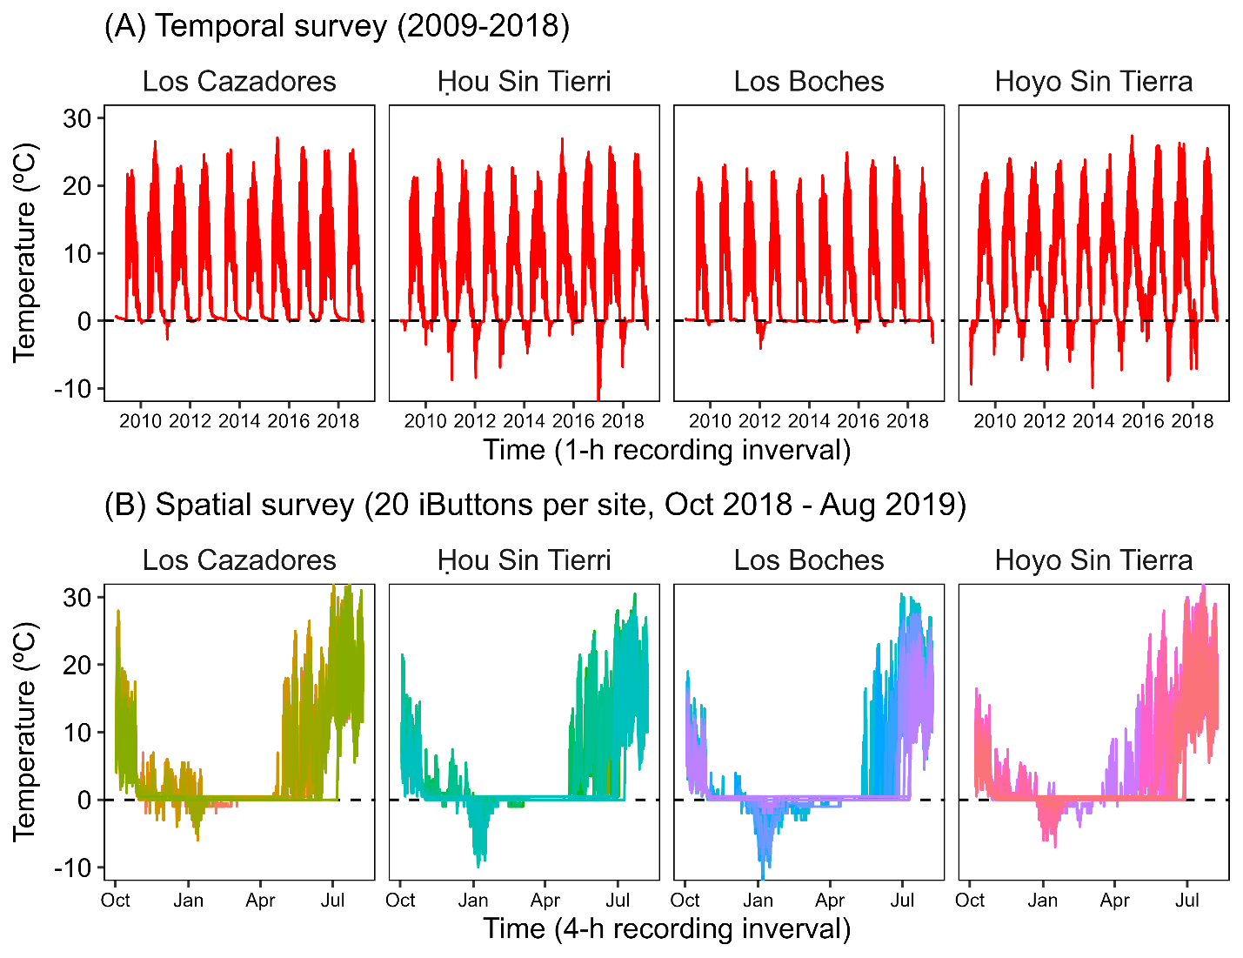

**Figure 2** Soil temperature logs. (A) Soil temperatures at -5 cm, recorded every hour in the central temporal survey plots of the 4 sites for the period 1 Jan 2009 – 31 Dec 2018. (B) Soil temperatures at -5 cm, recorded every 4 hours in the 20 spatial survey plots (each color being a plot) of the 4 sites for the period 1 Oct 2018 to 31 Aug 2019.

We conducted a principal component analysis (PCA) (Lê *et al.* 2008) of the bioclimatic indices to identify the main gradients of microclimatic variability at both temporal and spatial scales (**Fig. 3**). The first PCA axis explained 48% of the variance and represented a gradient of thermicity mixed with seasonality: from left to right, it ordered records from low to high values of growing degree days (GDD), annual mean temperature (bio1), diurnal thermal range (bio2) and annual thermal range (bio7). The second PCA axis explained 24% of the variance and represented a gradient of freezing intensity: from top to bottom, it ordered records from low to high values of freezing degree days (FDD). The third PCA axis (not shown) explained 16% of the variance and represented a gradient of snow cover.

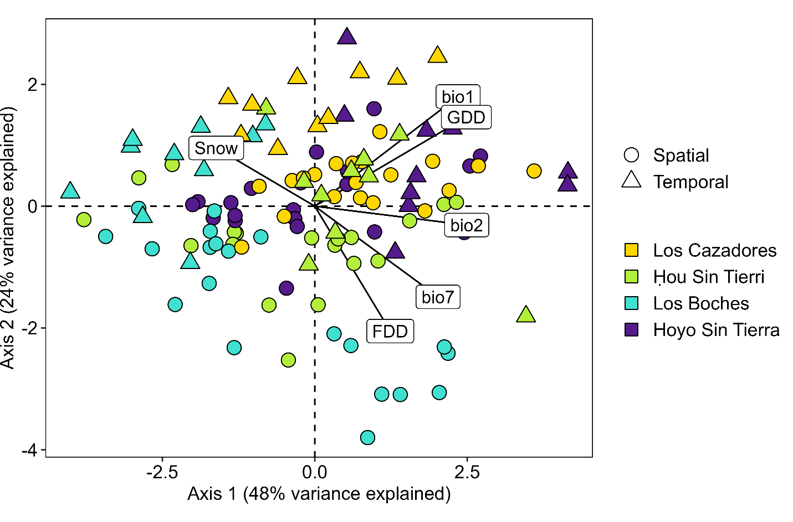

**Figure 3** Principal Component Analysis of the variation in soil bioclimatic indices. Data includes the temporal survey (triangles, 4 sites x 10 years) and the spatial survey (squares, 4 sites x 20 plots) of alpine soils in the Picos de Europa National Park (Spain). Bioclimatic variables include the annual mean temperature (bio1), the diurnal thermal range (bio2), the annual thermal range (bio7), the length of snow cover (Snow), the growing degree days (GDD) and the freezing degree days (FDD).

## 2.5. Vegetation data

Across the whole study system (temporal and spatial surveys) we recorded 86 taxa of vascular plants, representing 38% of the local species pool of the study area. Of these, 81 species were found in the spatial survey plots and 48 in the temporal survey plots. In the temporal survey (2 visits x 2 plots x 4 sites, n = 16) we recorded 42 species in 2009 and 47 in 2019. In the spatial survey, the average species richness per 1 m2 plot was 13, with the richest plot having 25 species and the poorest two species. The five most frequent species were *Thymus praecox* subsp. *ligusticus* (83 occurrences), *Anthyllis vulneraria* (73), *Koeleria vallesiana* (59), *Minuartia verna* (55) and *Helianthemum canum* (52).

We used non-metric multidimensional scaling (NMDS) with environmental fitting (Oksanen *et al.* 2019) to assess the whole variation in species composition based on the spatial survey (80 plots), and the relation of species variation with GDD, FDD and snow cover. We removed from the ordination two plots that had fallen on rocks and had highly differential compositions. Along the NMDS computed for the remaining 78 plots (**Figure 4**), we identified four major climatic conditions: Hot & Snowy, Cold & Snowy, Hot & Freezing and Cold & Freezing. The study sites were poorly differentiated, although one site (Los Boches) was more represented in the Cold & Freezing space.

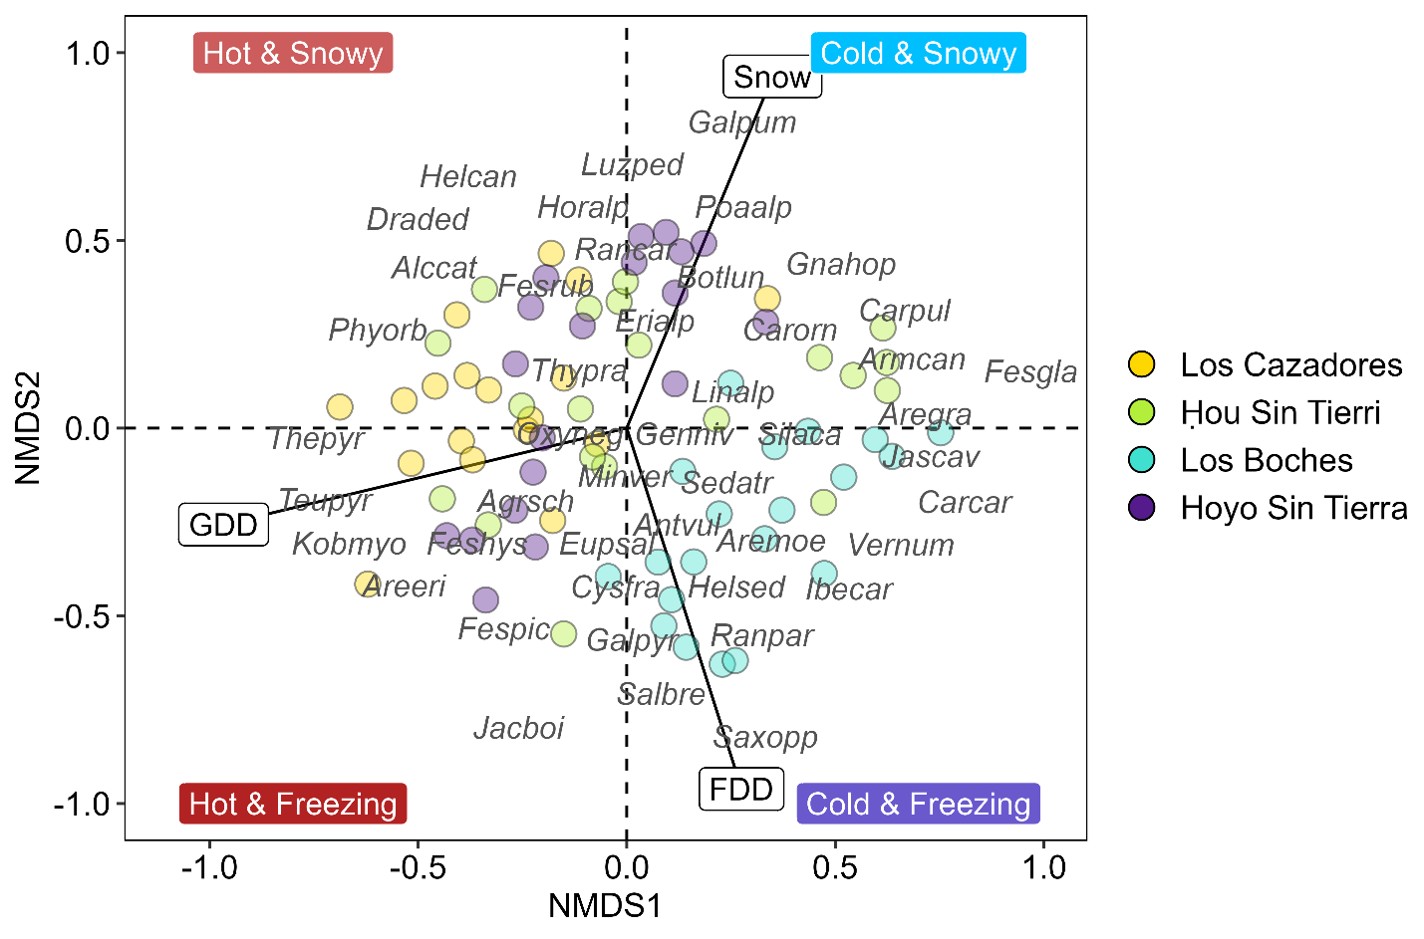

**Figure 4.** Non-Metric Dimensional Scaling (NMDS) of the variation in vegetation composition. Data includes 78 1 m2 plots sampled in the spatial survey of alpine communities in four sites of the Picos de Europa National Park (Spain) in summer 2018. Vectors represent the environmental fitting of growing degree days (GDD, p < 0.001, R2 = 0.328), freezing degree days (FDD, p < 0.001, R2 = 0.217) and snow length (Snow, p = 0.204, R2 = 0.043) to the first (NMDS1) and second (NMDS2) axes.

## 2.6. Data analyses

To identify the temporal trends in soil temperature, we decomposed the hourly temperature logs into seasonal, trend and irregular components using the function *stl* in R. To identify the temporal trends in vegetation, we calculated the percentage change in species frequency in 10 x 10 cm cells between the 2009 initial sampling and the 2019 resurvey, ignoring annual species. To compare the spatial and temporal variation in soil temperatures, and the spatial potential for climatic recue, we (1) calculated the density plots of values in each survey and (b) calculated and compared, for each survey and site, the difference between the maximum and minimum values recorded for the variables with the highest contribution to the climatic PCA and vegetation NMDS (growing degree days and freezing degree days). To assess the probability of species extinctions in specific microclimatic scenarios, we used the temporal survey data to construct scenarios of climate change using the extreme values of the 10-year temporal survey (2009-2018). Scenarios were based on the main axes of variation as interpreted by PCA and NMDS ordination of the climatic and vegetation data (see above). According to this, we created four plausible scenarios corresponding to the maximum and minimum values recorded during the 10 years of monitoring: hot and snowy (max GDD = 2069 ºC, min FDD = 0 ºC), hot and freezing (max GDD = 2069 ºC, max FDD = 247 ºC), cold and snowy (min GDD = 570 ºC, min FDD = 0 ºC) and cold and freezing (min GDD = 570 ºC, max FDD = 247 ºC). We then used Generalized Linear Models (GLMs, binomial family) to predict the probability of occurrence for each species and scenario, considering that a probability of 0 in a scenario would mean the extinction of the species. The predictions were computed for each plot (n = 78, we removed two plots placed in rocks) as a response to the plot’s values of GDD and FDD. We only modeled species with at least 10 occurrences in the plots, keeping the models in which at least one of the bioclimatic indices had a significant effect size (p < 0.05) and for which the value of McFadden’s pseudo R2 (McFadden 1974) was higher than 0.15 – since McFadden’s pseudo R2 tends to have lower values than R2 in ordinary least squares regression, values between 0.2 and 0.4 represent very good fit (McFadden 1979). All analyses in this article were conducted with R (R Core Team 2021) and the code and data are available at GitHub (see Data Availability Statement).

# 3. Results

## 3.1. Temporal trends

The soil temperature data obtained by the dataloggers for the period 1 Jan 2009 – 31 Dec 2018 showed a steady increase during the ten-year period (**Fig. 5**). The increase was most noticeable in the two cryoturbated sites (Ḥou Sin Tierri, Hoyo Sin Tierra), and less pronounced in the snowbed and coldest site (Los Boches).

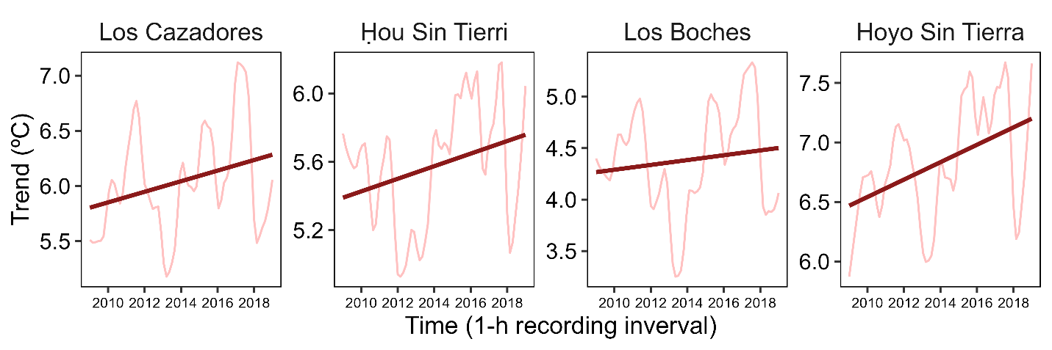

**Figure 5** Temporal trends in soil temperature. Shaded red lines indicate the trend component in the soil temperature time series for the period 1 Jan 2009 – 31 Dec 2018. The dark red line is the slope of a linear regression fitted to the temperature trends.

During the vegetation resurvey of 2019 (**Fig. 6**), two species were not found again (*Agrostis schleicheri*, *Galium pyrenaicum*) and other eight species were recorded for the first time in the plots (*Arenaria purpurascens*, *Lotus corniculatus*, *Potentilla crantzii*, *Sedum album*, *Sedum brevifolium*, *Seseli montanum*, *Silene ciliata*, *Solidago virgaurea*). The five species with the highest decrease in frequency from 2009 to 2019 (ignoring annual species and species that occurred in less than ten 10 x 10 cm cells in 2009) were *Armeria cantabrica*, *Poa alpina*, *Salix breviserrata*, *Jurinea humilis* and *Ranunculus parnassiifolius* subsp. *favargeri*. The five species with the highest increases (again, ignoring annual species and species that occurred in less than ten 10 x 10 cm cells in 2009) were *Minuartia verna*, *Helianthemum apenninum* subsp. *urrielense*, *Arenaria moehringioides*, *Saxifraga conifera* and *Silene acaulis*.

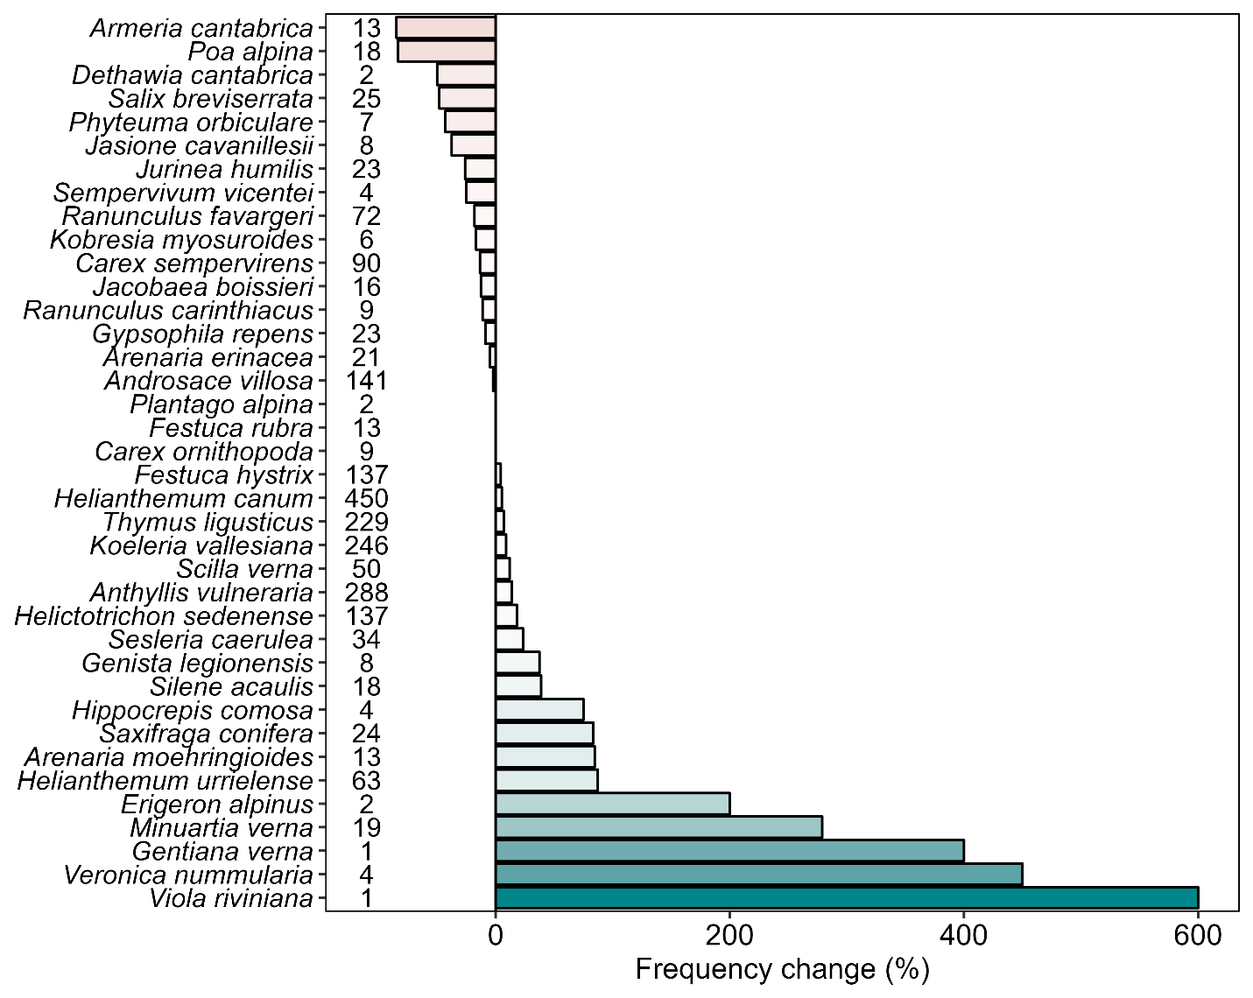

**Figure 6** Winners and losers in the temporal survey of vegetation. Each bar shows the percentage change of species frequency in 10 x 10 cm cells across 2 plots x 4 study sites, between the initial sampling of 2009 and the resurvey of 2019. The numbers next to the species indicate the number of 10 x 10 cm cells in which each species was present in 2009.

## 3.2 Space vs. time

The comparison of the soil temperature values obtained during the temporal and spatial surveys indicated that the immediate surroundings of the focus communities (i.e. 40 plots situated < 50 m from the focus plot) offered a potential for climatic rescue. The range and density of values obtained during one year of spatial surveys was generally larger than the values obtained during ten years of temporal survey (**Fig. 7**). A pattern emerged when comparing the snowbed focus plots (Los Cazadores, Los Boches) with the fellfield focus plots (Ḥou Sin Tierri, Hoyo Sin Tierra): in the snowbeds, the range of values of the spatial survey was larger than that of the temporal survey; whereas in the fellfields the spatial surroundings did never reach as cold values as those recorded during the ten years in the focus plots.

**Figure 7** Spatial vs. temporal variation in soil temperature. Actual values and density plots of the values recorded during the temporal survey (triangles, 4 sites x 10 year) and the spatial survey (squares, 4 sites x 20 plots) of alpine soils in the Picos de Europa National Park (Spain).

We also calculated the differences between the two surveys in the maximum and minimum values recorded in each site for the two key bioclimatic parameters: growing degree days (GDD and freezing degree days (FDD). The spatial differences for GDD (824 ± 62 SE across sites) were larger than the temporal ones (638 ± 44 SE), but the difference was only marginally significant (paired t-test, one-sided, t = 1.945, df = 3, p = 0.073). For FDD, the two differences (121 ± 31 SE in space vs. 134 ± 43 SE in time) were not significantly different (paired t-test, one-sided, t = -0.29029, df = 3, p = 0.6047).

## 3.3. Species extinction probability

From the 81 species recorded in the spatial surveys, 36 had more than 10 occurrences, and we included them in the GLM modeling. For 16 of these species, we produced models that met the criteria to be considered relevant (i.e. at least one of the two bioclimatic indices had a significant effect size and the value of McFadden’s pseudo R2 was higher than 0.15). The predictions (**Table 2**) show that some species survived only in either the hot scenarios (e.g. *Androsace villosa*), the cold scenarios (e.g. *Festuca glacialis*) or the snowy scenario (e.g. *Alchemilla catalaunica*). The cold & snowy scenario produced the lowest number of species extinctions and the hot & freezing scenario the higher number of extinctions, with the cold & freezing and the hot & snowy scenarios producing intermediate numbers (**Figure 5**).

**Table 2.** Output of the extinction models in four microclimatic scenarios. Scenarios were based on the maximum and minimum values of growing degree days (GDD) and freezing degree days (FDD) recorded in the alpine soils during the 10 years of the temporal survey. Species extinctions were estimated as the probability of occurrence equal to zero according to the predictions of GLMs fitted with the GDD and FDD values recorded in the spatial survey. Columns 'Cold & Freezing' to 'Hot & Snowy' show the probability of occurrence of each species in each scenario. The columns of frequency show the species frequency in 10 x 10 cm cells as recorded in the initial sampling of 2009 and the resurvey of 2019.

| Taxon | GDD estimate | GDD p | FDD estimate | FDD p | rho2 | Cold & Freezing | Cold & Snowy | Hot & Freezing |  | Hot & Snowy | Frequency 2009 | Frequency 2019 |
| --- | --- | --- | --- | --- | --- | --- | --- | --- | --- | --- | --- | --- |
| Alchemilla catalaunica | 0.00 | 0.174 | -0.06 | 0.035 | 0.20 | 0 | 17 | 0 |  | 74 |  |  |
| Androsace villosa | 0.01 | <0.001 | -0.01 | 0.376 | 0.49 | 0 | 0 | 100 |  | 100 | 17.6 | 17.2 |
| Arabis alpina | -0.01 | 0.004 | -0.01 | 0.396 | 0.22 | 25 | 60 | 0 |  | 0 |  |  |
| Arenaria grandiflora | 0.00 | 0.004 | -0.01 | 0.272 | 0.18 | 22 | 62 | 0 |  | 0 |  |  |
| Arenaria moehringioides | -0.01 | 0.001 | 0.01 | 0.03 | 0.34 | 97 | 60 | 0 |  | 0 | 1.6 | 3 |
| Armeria cantabrica | -0.01 | <0.001 | -0.01 | 0.029 | 0.39 | 65 | 98 | 0 |  | 0 | 1.6 | 0.2 |
| Carex sempervirens | 0.00 | 0.007 | -0.02 | 0.007 | 0.18 | 1 | 38 | 36 |  | 97 | 11.2 | 9.8 |
| Erigeron alpinus | 0.00 | 0.972 | -0.06 | 0.035 | 0.19 | 0 | 34 | 0 |  | 33 | 0.2 | 0.8 |
| Euphrasia salisburgensis | 0.00 | 0.11 | 0.03 | <0.001 | 0.32 | 91 | 1 | 100 |  | 33 | 4.4 | 3.2 |
| Festuca glacialis | -0.02 | 0.001 | 0.01 | 0.278 | 0.67 | 100 | 100 | 0 |  | 0 |  |  |
| Festuca hystrix | 0.01 | <0.001 | 0.00 | 0.644 | 0.30 | 0 | 1 | 98 |  | 99 | 17.1 | 17.9 |
| Galium pyrenaicum | 0.00 | 0.9 | 0.03 | <0.001 | 0.37 | 95 | 2 | 96 |  | 3 | 0.9 | 0 |
| Helianthemum canum | 0.01 | <0.001 | -0.01 | 0.333 | 0.40 | 1 | 3 | 100 |  | 100 | 56.2 | 59.2 |
| Iberis carnosa | 0.00 | 0.023 | 0.02 | <0.001 | 0.27 | 98 | 26 | 21 |  | 0 | 0.2 | 0 |
| Lotus corniculatus | 0.00 | 0.045 | -0.04 | 0.05 | 0.18 | 0 | 10 | 0 |  | 85 | 0 | 0.1 |
| Scilla verna | 0.00 | 0.006 | -0.05 | 0.035 | 0.25 | 0 | 6 | 0 |  | 96 | 6.2 | 7 |

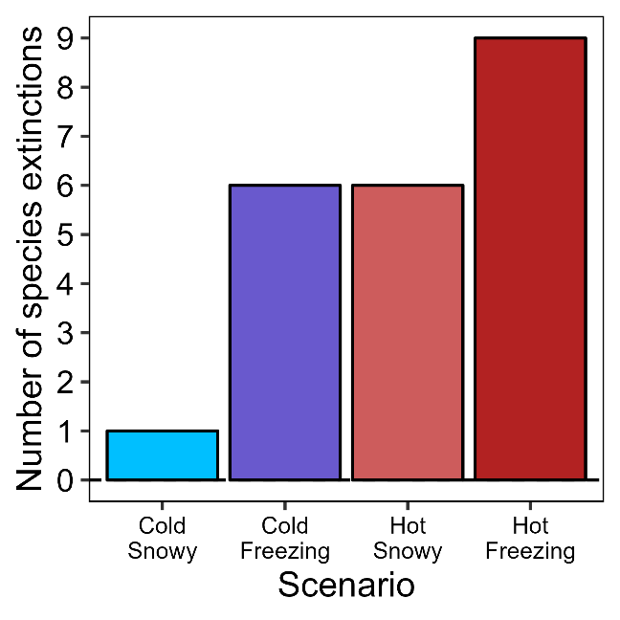

**Figure 8** Number of species extinctions per microclimatic scenario. Scenarios were based on the maximum and minimum values of growing degree days (GDD) and freezing degree days (FDD) recorded in the alpine soils during the 10 years of the temporal survey. Species extinctions were estimated as the probability of occurrence equal to zero according to the predictions of GLMs fitted with the GDD and FDD values recorded in the spatial survey.

# 4. Discussion

Differences between life forms, chorology

Why FDD and GDD are orthogonal? Further, why is snow in a third axis?

Problem of comparing when spatial was done in a year which was not average + the period does not coincide with the temporal one.

Easier to find hotter rescue sites than colder rescue sites.

# DATA AVAILABILITY

The original data, R code for the analysis and creation of the manuscript can be accessed at the GitHub repository <https://github.com/efernandezpascual/picos>. A version of record of the repository is deposited in Zenodo.

# LITERATURE CITED

**Bürli S, Theurillat J-P, Winkler M, *et al.*** **2021**. A common soil temperature threshold for the upper limit of alpine grasslands in European mountains. *Alpine Botany* **131**: 41–52.

**Fick SE, Hijmans RJ**. **2017**. WorldClim 2: new 1-km spatial resolution climate surfaces for global land areas. *International Journal of Climatology* **37**: 4302–4315.

**Lê S, Josse J, Husson F**. **2008**. FactoMineR: an R package for multivariate analysis. *Journal of Statistical Software* **25**: 1–18.

**McFadden D**. **1974**. Conditional logit analysis of qualitative choice behavior In: Zarembka P, ed. *Frontiers in Econometrics*. Cambridge, MA: Academic Press, 105–142.

**McFadden D**. **1979**. Quantitative methods for analyzing travel behaviour on individuals: Some recent developments In: Hensher D, Stopher P, eds. *Behavioural Travel Modelling*. London, UK: Routledge, 48.

**Oksanen J, Blanchet FG, Friendly M, *et al.*** **2019**. vegan: Community Ecology Package. R package version 2.5-6.

**R Core Team**. **2021**. R: a language and environment for statistical computing. Version 4.1.1.