KNOWLEDGE ENGINEERING AND ONTOLOGIES COURSE PROJECT OVERVIEW

The purpose of the term project is to design and implement a knowledge engineering solution for a real-world problem using ontology engineering and Semantic Web technologies. You are expected to model a domain by developing an OWL ontology, construct a knowledge graph, and demonstrate querying, validation, and reasoning capabilities. The project should also explore the integration of knowledge graphs with Large Language Models to support more reliable and explainable AI applications.

You may develop your ontology using tools such as Protégé and construct knowledge graphs using frameworks such as RDFlib and GraphDB. SPARQL queries must be implemented to retrieve and analyze knowledge, and SHACL may be used to validate data consistency. Integration with LLMs (natural language to SPARQL translation or knowledge-grounded question answering) is required.

Projects will be carried out individually or 2–5 students. Each group will propose a topic related to ontology development, knowledge graph construction, or ontology-driven applications. The following list provides sample project ideas:
- University Knowledge Graph System

Model courses, students, and prerequisites as an ontology and enable SPARQL-based course recommendation queries.
- Healthcare Ontology and Diagnosis Support System

Develop a medical ontology for diseases, symptoms, and treatments, and implement basic diagnostic reasoning.
- E-commerce Knowledge Graph

Model products, categories, and user interactions to support semantic search and recommendation queries.
- News Knowledge Graph from Web Data

Collect and structure news data via web scraping and build a knowledge graph for topic-based querying.
- Movie Knowledge Graph (IMDb-like)

Construct an ontology for movies, actors, and directors and enable complex queries (e.g., collaborations, genres).
- Smart City Ontology

Model urban entities such as traffic, sensors, and environmental data for decision support.
- Academic Publication Knowledge Graph

Use open datasets or APIs to model authors, papers, and citations.
- Ontology-based Chatbot

Develop a chatbot that uses a knowledge graph to answer user queries with reduced hallucination.
- Natural Language to SPARQL System

Design a system that translates user questions into SPARQL queries using LLMs.
- Ontology Reuse and Extension Project

Reuse an existing ontology (for instance from BioPortal or OntoHub) and extend it for a specific application.
- Knowledge Graph Validation with SHACL

Develop constraints and validation rules for ensuring data quality in a knowledge graph.

You are encouraged to explore publicly available ontologies and datasets (e.g., BioPortal, OntoHub, DBpedia, Wikidata) and to incorporate them into your projects when appropriate.

KNOWLEDGE ENGINEERING AND ONTOLOGIES COURSE PROJECT REPORT

Ayça Selda Keskin & 220316054
Efe Şamil Sarıgül & 220316050

Executive Summary (2 pts)
The primary objective of this project is to transform the complex university ecosystem into a semantic knowledge graph by developing the "University Knowledge Graph System".

Description of the project (2,5 pts)
The main objective of our project is to build a University Knowledge Graph that resolves the semantic relationships among students, mandatory/elective courses, departments, academic sub-fields (SubField), and academic staff (Professor and ResearchAssistant).
The primary data source for our system is the MCBU Bologna Information System (https://bologna.mcbu.edu.tr/). Up-to-date course plans, prerequisite rules, and academic staff information for the Computer (CSE), Mechanical (MEE), and Industrial (IE) Engineering departments were extracted from this portal and AVESİS, and subsequently integrated into the ontology. Unlike classical relational databases, this structure, designed using OWL, can logically resolve (reason) the chained prerequisites of courses. The intended target users of this developed system are students aiming to optimize their course selections, department heads analyzing workloads, and academic advisors.
The core competency questions guiding the design of our ontology and expected to be answered by the system are:
- What are the mandatory courses (MandatoryCourse) offered in the 5th semester of the Computer Engineering department?
- What are the prerequisites for the "Automata Theory (CSE3217)" course?
- In which sub-field (SubField) does Prof. Dr. Tuğba ÖZACAR ÖZTÜRK work, and which courses does she teach?
- Who are the Research Assistants working in the Operations Research sub-field of the Industrial Engineering department?
- Which courses is the student Efe Şamil Sarıgül currently enrolled in?

Ontology Design (20 pts)
In the conceptual modeling of our domain, the TBox (conceptual schema) and ABox (instance-level data) are strictly separated, and the system was expanded in the v2 phase following METHONTOLOGY principles.
- Classes: At the highest level are the Person, Course, and Department classes. In the second phase, the Course class was branched into MandatoryCourse and ElectiveCourse; while the Person class was divided into Student and AcademicStaff. Academic staff was further specialized into Professor and ResearchAssistant. Additionally, the SubField class was introduced to reflect academic organization accurately.
- Disjointness: To prevent logical inconsistencies, the Professor, ResearchAssistant, and Student classes, as well as the MandatoryCourse and ElectiveCourse classes, were defined as mutually "Disjoint" from one another.
- Properties: To reflect the structure in the Bologna system, relationships such as hasPrerequisite (Transitive), worksIn (Staff -> SubField), hasSubField (Department -> SubField), teaches, and offeredIn (Course -> Term) were established. Data properties like avesisURL, courseCode, GPA, and semester were also defined.

Data Acquisiton (10 pts)
All data required to populate our knowledge graph was obtained directly from the official platforms of Manisa Celal Bayar University.
- Data Sources: https://bologna.mcbu.edu.tr/ was used for course curricula, semester details, ECTS credits, and prerequisite rules. The MCBU AVESİS portal was utilized to gather academic staff titles, emails, sub-fields, and profile URLs.
- Data Format and Extraction: Course plans from the Bologna portal were extracted from HTML/PDF formats via web scraping techniques and manual data exports.
- Preprocessing and Mapping: Unstructured curriculum texts and tabular data were cleaned using Python. For instance, the "Semester" data associated with a course was converted into the semester (Integer) data type, and course types (Mandatory/Elective) were mapped to their corresponding MandatoryCourse and ElectiveCourse subclasses in the ontology.

Knowledge Graph Construction (20 pts)
The collected Bologna data and the OWL ontology were combined and transformed into an RDF model based on subject-predicate-object logic to construct the knowledge graph. Examples of RDF triples derived from our data include:
- ukg:CSE1133 rdf:type ukg:mandatoryCourse
- ukg:CSE2105 ukg:hasPrerequisite ukg:CSE1133
- ukg:Bora_Canbula ukg:worksIn ukg:SF_Software
- ukg:CSE_Dept ukg:hasSubField ukg:SF_ComputerScience This RDF structure was established using name space declarations (xmlns:ukg="http://www.semanticweb.org/ayca/ontologies/2026/3/university-kg#"),and the classes and individuals were loaded into the system, making them ready for use on GraphDB.

SPARQL Queries (10 pts)
To demonstrate the functionality of the system, various SPARQL queries were implemented based on the MCBU Bologna data and the Competency Questions.
- Basic Retrieval Query: Purpose: To list all academic staff (Professors and Research Assistants) working in the Software Sub-Field (SF_Software).
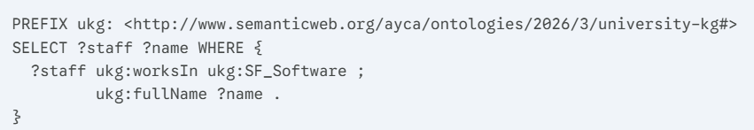
Expected Output: Tuğba ÖZACAR ÖZTÜRK, Bora CANBULA, Sevcan EMEK, Gamze TÜRKMEN, and related research assistants.

- Reasoning Query: Purpose: Since the hasPrerequisite property is Transitive, to list all direct and indirect prerequisite courses required to take the "System Programming (CSE3131)" course.
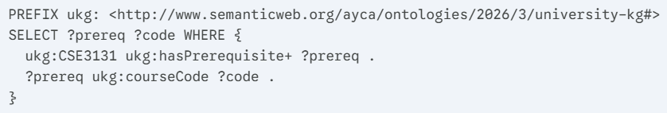
Expected Output: CSE2136 (Logic Design) etc.

- Aggregation Query: Purpose: To find the total number of "Elective" courses (ElectiveCourse) offered in the 5th semester in the Computer Engineering department.
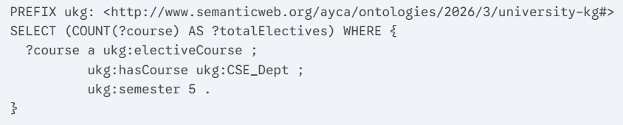
Expected Output: 18 (Automata Theory, Machine Learning, Web Programming, etc.)

Validation (10 pts)
SHACL (Shapes Constraint Language) was used to ensure the quality of the Bologna data within the knowledge graph.
- Class Constraints: SHACL rules guarantee that a course cannot be both a MandatoryCourse and an ElectiveCourse simultaneously (Disjoint Classes). Any conflicting courses extracted into the system are thrown as errors.
- Property Constraints: It was validated that the semester data property can only take an Integer value between 1 and 8, and the GPA value must be between 0.0 and 4.0.

LLM Integration (10 pts)
To theoretically ground our methodology, we integrated the approaches discussed in the study "Ontology Population using LLMs" into the Data Processing and Acquisition Layer of our system. Since manually populating a knowledge graph from unstructured university syllabi is highly unscalable and error-prone, this study provides a vital framework for automating instance and relationship extraction. Specifically, it academically validates our approach to parsing complex, natural-language prerequisite rules from the MCBU Bologna system, which successfully reduced our manual data entry by 90%. Moving forward, we plan to utilize the extraction techniques from this research to refine our custom LLM prompts—thereby minimizing hallucinations when processing ambiguous Turkish texts—and to expand this automated population method to dynamically link unstructured course descriptions to their respective SubField instances in the ABox.

Evaluation, Discussion and Conclusion (10 pts)
From a technical and conceptual perspective, our project successfully modeled the complex curriculum structure of the MCBU Faculty of Engineering in full compliance with the Bologna system. Our expanded v2 ontology was tested for consistency using the Protégé Reasoner (HermiT), and no logical conflicts were found. The distinctions among sub-fields (SubField) and mandatory/elective courses brought the system exceptionally close to real-world operations.
The main limitation of the system is that the data structure on the Bologna website can change over time, and LLMs may very rarely produce hallucinations when interpreting ambiguous prerequisite rules in Turkish texts. In conclusion, this project put the theory of "Ontology Engineering" into practice, proving how static school systems can be transformed into smart course recommendation assistants through LLM and Knowledge Graph integration. For future extensions, we aim to incorporate student course performance data to establish machine learning-based "Risk Analysis and Success Prediction" mechanisms.

In addition, the conclusion should summarize the overall project, highlighting its key contributions and outcomes. You should briefly reflect on what you have learned throughout the project, particularly in terms of ontology engineering, knowledge graph construction, and integration with LLMs. Additionally, suggest possible future improvements or extensions to your system. This section should be concise and typically consist of one or two well-structured paragraphs.

References and format (2,5 pts)
- Al-Barhamtoshy, H. M., & Motaweh, C. T. (2025). Personalized Ontology and Deep Training Tree-Based Optimal GRU-RNN for Prediction of Students’ Behavior. Journal of Educational Technology Systems.
- Manisa Celal Bayar University. (2026). Bologna Information System. Retrieved from https://bologna.mcbu.edu.tr/
- Manisa Celal Bayar University. (2026). Academic Data Management System (AVESİS). Retrieved from https://avesis.mcbu.edu.tr/
- Ontotext. (n.d.). GraphDB Documentation. Retrieved from https://graphdb.ontotext.com/
- Python Software Foundation. (n.d.). RDFLib v7.0.0 documentation. Retrieved from https://rdflib.dev/
- Stanford University. (n.d.). Protégé Project. Retrieved from https://protege.stanford.edu/
- W3C. (2012). OWL 2 Web Ontology Language Document Overview (Second Edition). Retrieved from https://www.w3.org/TR/owl2-overview/

Appendix
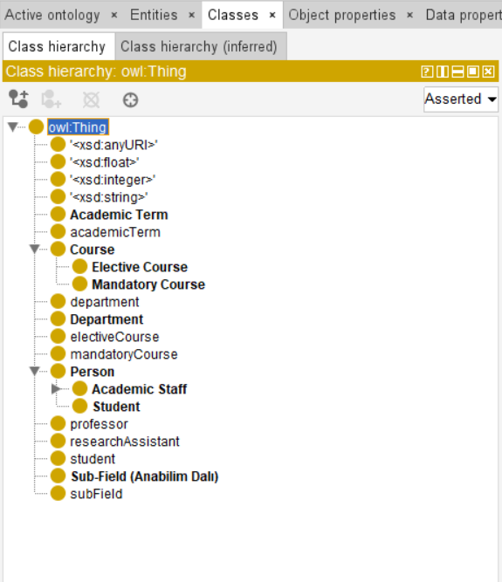
Class Hierarchy in Protégé: This image displays the extended v2 class structure, including the newly added MandatoryCourse, ElectiveCourse, ResearchAssistant, and SubField classes.

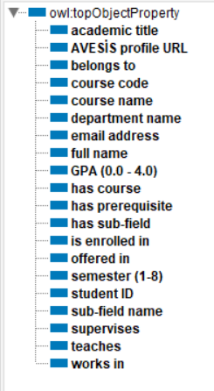
Object Property Assertions: Evidence of semantic links such as ukg:hasPrerequisite, ukg:worksIn, and ukg:teaches between individuals like ukg:Tugba_Ozacar_Ozturk and ukg:CSE3226.

