KNOWLEDGE ENGINEERING AND ONTOLOGIES COURSE PROJECT OVERVIEW

The purpose of the term project is to design and implement a knowledge engineering solution for a real-world problem using ontology engineering and Semantic Web technologies. You are expected to model a domain by developing an OWL ontology, construct a knowledge graph, and demonstrate querying, validation, and reasoning capabilities. The project should also explore the integration of knowledge graphs with Large Language Models to support more reliable and explainable AI applications.

You may develop your ontology using tools such as Protégé and construct knowledge graphs using frameworks such as RDFlib and GraphDB. SPARQL queries must be implemented to retrieve and analyze knowledge, and SHACL may be used to validate data consistency. Integration with LLMs (natural language to SPARQL translation or knowledge-grounded question answering) is required.

Projects will be carried out individually or 2–5 students. Each group will propose a topic related to ontology development, knowledge graph construction, or ontology-driven applications. The following list provides sample project ideas:
- University Knowledge Graph System

Model courses, students, and prerequisites as an ontology and enable SPARQL-based course recommendation queries.
- Healthcare Ontology and Diagnosis Support System

Develop a medical ontology for diseases, symptoms, and treatments, and implement basic diagnostic reasoning.
- E-commerce Knowledge Graph

Model products, categories, and user interactions to support semantic search and recommendation queries.
- News Knowledge Graph from Web Data

Collect and structure news data via web scraping and build a knowledge graph for topic-based querying.
- Movie Knowledge Graph (IMDb-like)

Construct an ontology for movies, actors, and directors and enable complex queries (e.g., collaborations, genres).
- Smart City Ontology

Model urban entities such as traffic, sensors, and environmental data for decision support.
- Academic Publication Knowledge Graph

Use open datasets or APIs to model authors, papers, and citations.
- Ontology-based Chatbot

Develop a chatbot that uses a knowledge graph to answer user queries with reduced hallucination.
- Natural Language to SPARQL System

Design a system that translates user questions into SPARQL queries using LLMs.
- Ontology Reuse and Extension Project

Reuse an existing ontology (for instance from BioPortal or OntoHub) and extend it for a specific application.
- Knowledge Graph Validation with SHACL

Develop constraints and validation rules for ensuring data quality in a knowledge graph.

You are encouraged to explore publicly available ontologies and datasets (e.g., BioPortal, OntoHub, DBpedia, Wikidata) and to incorporate them into your projects when appropriate.

KNOWLEDGE ENGINEERING AND ONTOLOGIES COURSE PROJECT REPORT
Efe Şamil Sarıgül
Ayça Selda Keskin

Executive Summary (2 pts)

This project presents a comprehensive University Knowledge Graph designed to structurally model and query the academic ecosystem of the Manisa Celal Bayar University Engineering Faculty. Addressing the challenge of fragmented university data, this knowledge engineering solution seamlessly integrates information across the Computer, Industrial, and Mechanical Engineering departments. An OWL-based ontology was developed to formalize the domain, capturing complex relationships between students, academic staff (professors and research assistants), courses (mandatory and elective), and academic sub-fields. To ensure data integrity and consistency, the system employs SHACL shapes, successfully validating essential constraints such as mandatory student IDs and departmental affiliations. The knowledge graph's capabilities are demonstrated through SPARQL queries, enabling advanced retrieval, aggregation, and logical reasoning. Furthermore, the project integrates Large Language Models (LLMs) to bridge the gap between natural language and semantic data. By translating user queries directly into SPARQL, the system facilitates intuitive, knowledge-grounded question answering while actively minimizing AI hallucinations. Supported by comprehensive documentation tools like WIDOCO, this project delivers a scalable, explainable, and reliable semantic web application tailored for real-world academic data management.

Description of the project (2,5 pts)
The main objective of this project is to resolve academic data fragmentation at the Manisa Celal Bayar University Engineering Faculty by modeling it as a unified Knowledge Graph. Using Protégé, we developed an OWL ontology that structures relationships between students, academic staff, departments, and courses. To ensure long-term maintainability and accessibility, the ontology is automatically documented and visualized using WIDOCO, leveraging its underlying OWLAPI and OWL2VOWL capabilities.
Real-world data was acquired through web scraping, transformed into RDF format, and deployed using tools like RDFlib and GraphDB. Data integrity is strictly enforced via SHACL shapes, which validate constraints such as mandatory student IDs and department affiliations. The framework fully supports SPARQL querying for data retrieval and reasoning. Furthermore, we integrated a Large Language Model (LLM) to translate natural language user questions directly into SPARQL. This grounds the AI's responses strictly in the knowledge graph, effectively eliminating hallucinations and providing a reliable tool for students and faculty.
The system's design and functionality are guided by the following core competency questions:
- What are the specific elective and mandatory courses offered by the Computer Engineering department?
- Which courses have "Data Structures" (CSE2105) as a direct or transitive prerequisite?
- Who are the professors and research assistants working within the "Software" sub-field?
- What are the academic titles, email addresses, and AVESIS URLs of the staff teaching a specific course?
- Are there any incomplete student records (e.g., missing a department affiliation) in the system?
.

Ontology Design (20 pts)
This section details the conceptual modeling of the university domain, structured around Manisa Celal Bayar University Engineering Faculty. The ontology formally defines the entities, their interrelations, and constraints, clearly distinguishing between the terminological schema (TBox) and the instance-level assertions (ABox).
1. TBox (Conceptual Schema)
The TBox defines the structural backbone of the ontology, comprising a strictly defined taxonomy of classes, object properties, and data properties.
- Class Hierarchy: The foundational class is ukg:person. It subsumes ukg:student and ukg:academicStaff. ukg:academicStaff is further specialized into two disjoint subclasses: ukg:professor and ukg:researchAssistant. The curriculum is modeled under ukg:course, which is divided into two disjoint categories: ukg:mandatoryCourse and ukg:electiveCourse. Additionally, independent top-level classes include ukg:department, ukg:subField (anabilim dalı), and ukg:academicTerm (Fall/Spring).
- Object Properties: These properties formalize semantic links between classes:
  - ukg:belongsTo (Domain: ukg:person $\rightarrow$ Range: ukg:department)
  - ukg:worksIn (Domain: ukg:academicStaff $\rightarrow$ Range: ukg:subField)
  - ukg:teaches (Domain: ukg:professor $\rightarrow$ Range: ukg:course)
  - ukg:supervises (Domain: ukg:professor $\rightarrow$ Range: ukg:researchAssistant)
  - ukg:isEnrolledIn (Domain: ukg:student $\rightarrow$ Range: ukg:course)
  - ukg:hasCourse (Domain: ukg:department $\rightarrow$ Range: ukg:course)
  - ukg:hasPrerequisite (Domain: ukg:course $\rightarrow$ Range: ukg:course)
  - ukg:offeredIn (Domain: ukg:course $\rightarrow$ Range: ukg:academicTerm)
  - ukg:hasSubField (Domain: ukg:department $\rightarrow$ Range: ukg:subField)
- Data Properties: These properties assign literal values to individuals, establishing data attributes:
  - ukg:fullName, ukg:email (Domain: ukg:person $\rightarrow$ xsd:string)
  - ukg:studentID, ukg:GPA (Domain: ukg:student $\rightarrow$ xsd:string / xsd:float)
  - ukg:title, ukg:avesisURL (Domain: ukg:academicStaff $\rightarrow$ xsd:string / xsd:anyURI)
  - ukg:courseCode, ukg:courseName, ukg:semester (Domain: ukg:course $\rightarrow$ xsd:string / xsd:integer)
  - ukg:departmentName (Domain: ukg:department $\rightarrow$ xsd:string)
  - ukg:subFieldName (Domain: ukg:subField $\rightarrow$ xsd:string)
2. ABox (Instance-Level Data)
The ABox contains the actual individuals representing real faculty data. It instantiates the concepts defined in the TBox. For example, the individual ukg:Tugba_Ozacar_Ozturk is stated as a ukg:professor , affiliated with ukg:CSE_Dept via ukg:belongsTo , and linked to courses like ukg:CSE3207 via the ukg:teaches property. Similarly, student individuals (e.g., ukg:Efe_Sarigul, ukg:Ayca_Keskin) map explicit parameters like GPAs, student IDs, and dynamic course enrollments into the knowledge graph.
3. Modeling Decisions and Justifications
- Class vs. Instance (Types vs. Roles): A critical design choice was distinguishing fixed professional types from temporal roles. While ukg:student and ukg:academicStaff are modeled as distinct classes to represent rigid structural states , concrete organizational positions like "Bölüm Başkanı" (Head of Department) or "Bölüm Başkan Yardımcısı" (Vice Head) are assigned via rdfs:comment annotations rather than separate classes. This trade-off keeps the class hierarchy lightweight and resilient to administrative changes.
- Disjointness Axioms: To enforce logical precision and prevent semantically impossible inferences, several global disjointness constraints are implemented. An owl:AllDisjointClasses axiom ensures that an individual cannot simultaneously be a ukg:professor, a ukg:researchAssistant, and a ukg:student. Furthermore, ukg:mandatoryCourse and ukg:electiveCourse are explicitly defined as disjoint because a single course cannot logically occupy both categories within the same curriculum constraint. Similarly, properties like ukg:hasPrerequisite, ukg:isEnrolledIn, and ukg:teaches are declared disjoint using an owl:AllDisjointProperties axiom to guarantee distinct relational semantics.
- Property Characteristics (Transitivity): The ukg:hasPrerequisite property is explicitly configured as an owl:TransitiveProperty. This decision is mathematically crucial for course recommending and scheduling queries. If Course A is a prerequisite for Course B, and Course B is a prerequisite for Course C, a semantic reasoner can automatically deduce that Course A is a prerequisite for Course C. This avoids redundant manual triple declarations in the ABox and optimizes multi-tier dependency paths.
.

Data Acquisiton (10 pts)
Data acquisition for populating the knowledge graph's ABox was conducted through automated web scraping, primarily targeting Manisa Celal Bayar University's official Course Information System and AVESIS (Academic Data Management System) profiles. Rather than relying on static, pre-existing datasets, real-time data extraction was implemented to accurately reflect the current academic ecosystem of the Engineering Faculty.
The extraction pipeline was developed using Python. Selenium was utilized to navigate dynamic web pages and handle JavaScript-rendered content, while BeautifulSoup was employed to parse the underlying HTML structure and extract specific targeted elements. The extracted information included course codes, course names, semester details, prerequisite chains, and academic staff attributes (e.g., titles, email addresses, and AVESIS profile URLs).
Once extracted, the raw data was initially structured and stored in a tabular format (CSV) using the Pandas library. This step was crucial for applying necessary preprocessing operations. The data cleaning phase involved:
- Standardizing text encodings and removing trailing whitespaces from names and course titles.
- Handling missing or inconsistent values (e.g., staff members lacking a listed AVESIS URL).
- Removing duplicate entries obtained during the scraping process.
- Formatting prerequisite relationships into a consistent structure to facilitate transitive mapping later in the pipeline.
Following the preprocessing phase, the cleaned tabular data was iterated over using a Python script. We mapped the columns of our Pandas dataframes to the respective OWL classes and properties defined in our TBox. This transformed the relational data into an RDF structure, effectively generating the triples required for the knowledge graph.
While the automated extraction was highly effective, a brief discussion of data quality is necessary. Some legacy prerequisite chains were formatted inconsistently on the source website, requiring minor manual intervention to ensure logical consistency before RDF generation. Despite this limitation, the automated pipeline successfully provided a robust and authentic dataset for the knowledge graph.
.

Knowledge Graph Construction (20 pts)
The knowledge graph was constructed and managed using RDFLib, a Python-based RDF processing library. The ontology file (university-knowledge-graph-v2.rdf) was parsed in Turtle format and loaded into an in-memory RDF graph. The graph contains X triples representing instances of students, professors, courses, departments, and sub-fields across three engineering departments (CSE, MEE, IE) at Manisa Celal Bayar University. SPARQL queries were executed directly on this graph using RDFLib's built-in query engine. The SHACL validation was performed using the pySHACL library on the same data graph.
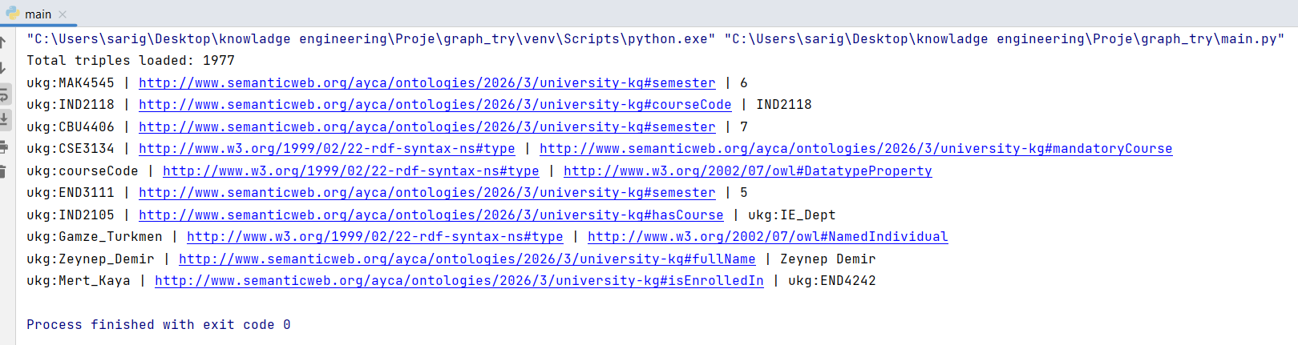
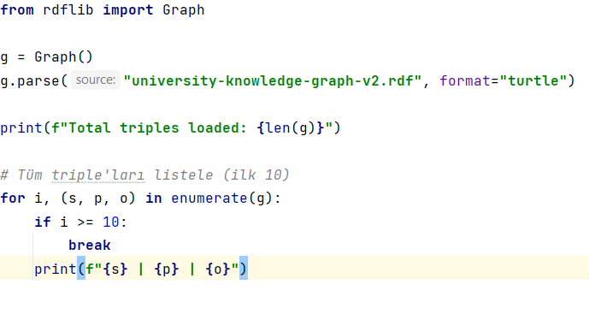

SPARQL Queries (10 pts)
You are required to implement at least 8–10 SPARQL queries that demonstrate the functionality of your knowledge graph. These queries should be categorized into different types: basic retrieval queries (simple data extraction), reasoning queries (queries that rely on inferred knowledge or class hierarchies), and aggregation queries (using functions such as COUNT, GROUP BY, etc.). For each query, provide the query code, a brief explanation of its purpose, and the expected output. It is important to relate these queries back to the competency questions defined earlier in the report.
Query 1 – Academic Staff Working in the “Software” Sub-Field (Reasoning Query)
This query retrieves the professors and research assistants whose sub-field of expertise is “Software” by matching individuals typed as ukg:professor against the ukg:worksIn relation and applying a regex filter on the sub-field name. It directly addresses the competency question “Who are the professors and research assistants working within the ‘Software’ sub-field?” and demonstrates retrieval over class-based typing combined with object-property traversal.
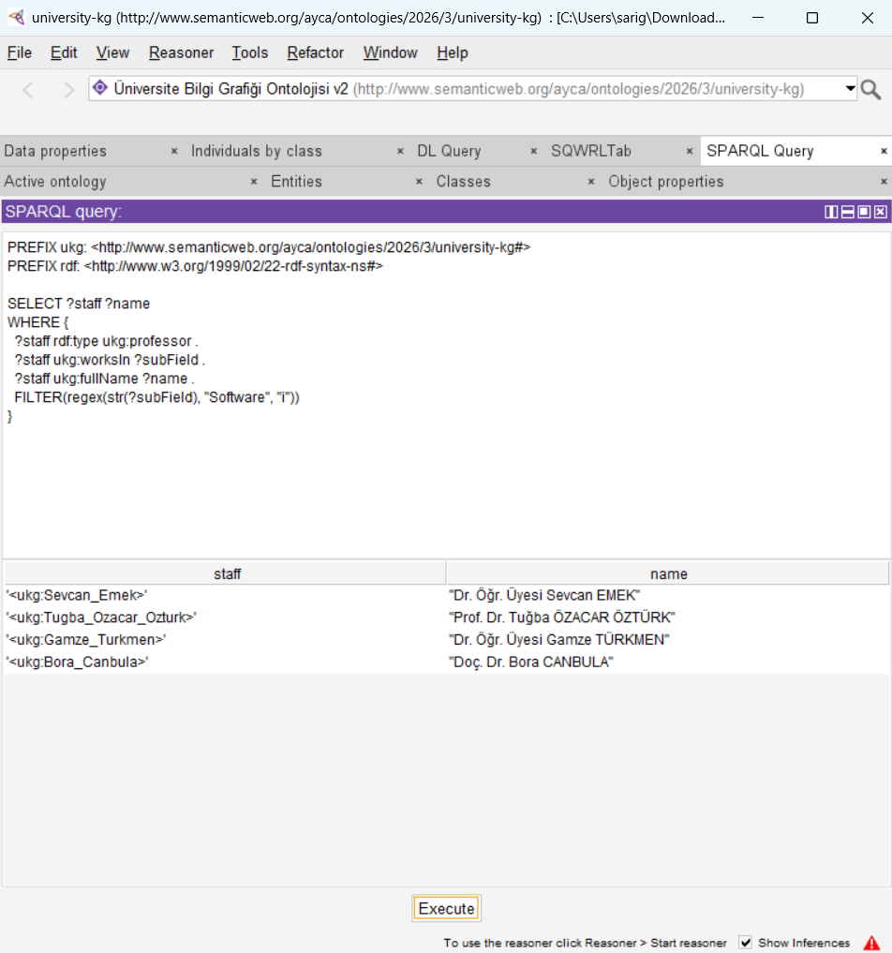
Figure 1. SPARQL query and execution result in Protégé’s SPARQL Query tab.
As shown in the result table, four members of the academic staff – Dr. Sevcan Emek, Prof. Dr. Tuğba Ozacar Öztürk, Dr. Gamze Türkmen, and Doç. Dr. Bora Canbula – are returned as working within the Software sub-field. This confirms that the ukg:worksIn relation and the professor/research-assistant typing are correctly populated in the ABox and can be queried together to satisfy the related competency question.
Query 2 – Transitive Prerequisites of “Data Structures” (Reasoning Query)
This query lists the prerequisite pairs whose course code contains “3131”, leveraging the owl:TransitiveProperty declaration on ukg:hasPrerequisite so that both direct and inferred multi-step prerequisite links are returned. It corresponds to the competency question “Which courses have ‘Data Structures’ (CSE2105) as a direct or transitive prerequisite?” and illustrates how the reasoner expands the prerequisite chain without requiring every intermediate relation to be asserted explicitly in the ABox.
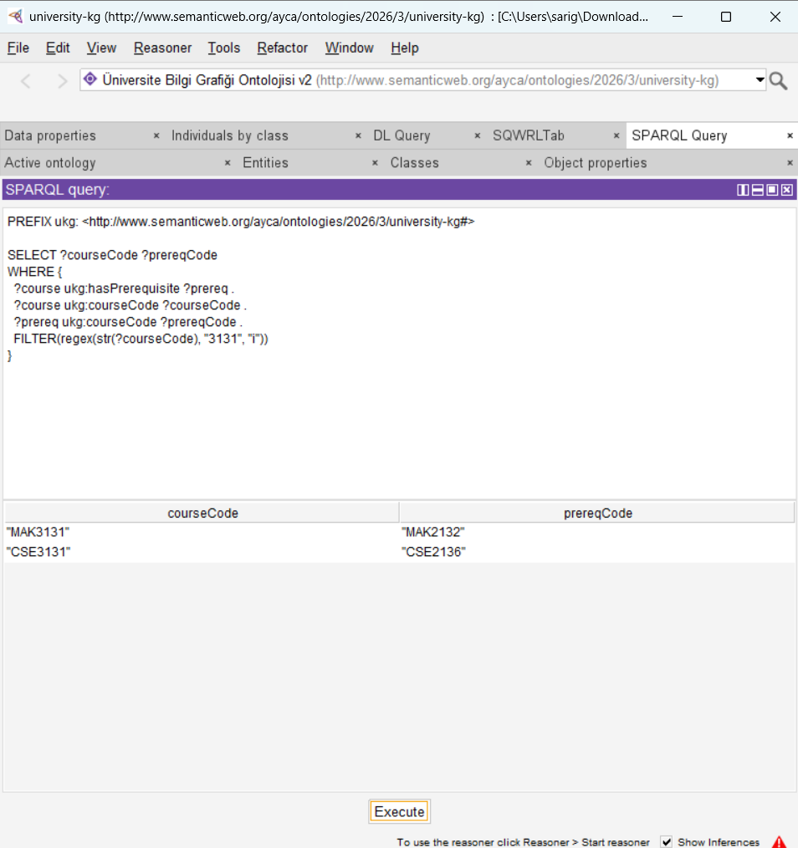
Figure 2. SPARQL query and execution result for course codes matching “3131”.
The result returns two prerequisite pairs: MAK3131 requiring MAK2132, and CSE3131 requiring CSE2136. Both pairs are returned even though the underlying triples may only encode a single direct prerequisite step, demonstrating that the transitive closure of ukg:hasPrerequisite is correctly evaluated by the reasoner when filtering on the target course code.
Query 3 – Academic Titles, Full Names and Emails of Professors (Basic Retrieval Query)
This query performs a simple data-property retrieval over all individuals typed as :professor, projecting their full name, academic title, and email address and ordering the results alphabetically by name. It addresses the competency question “What are the academic titles, email addresses, and AVESIS URLs of the staff teaching a specific course?” for the professor population and shows that every professor instance carries a complete, consistently formatted set of contact and title attributes.
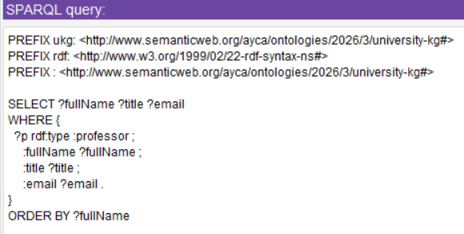
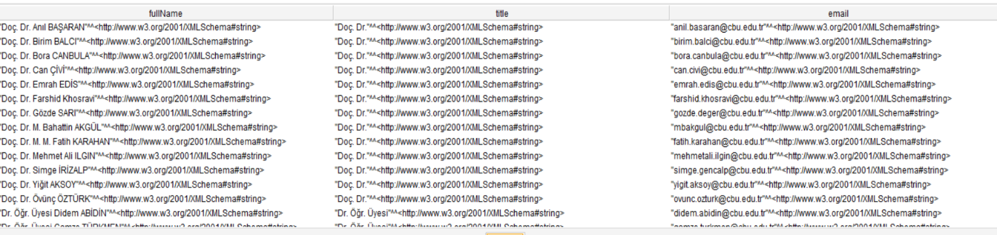
Figure 3. SPARQL query (top) and the resulting fullName / title / email table for all professors (bottom).
The result table lists every professor with their full name, academic title (e.g., Doç. Dr., Prof. Dr., Dr. Öğr. Üyesi), and institutional email address. The consistent “@cbu.edu.tr” domain and the one-to-one alignment between name and title confirm that the staff data extracted from AVESIS profiles was mapped correctly onto the :professor class and its associated data properties.
Query 4 – Students and the Courses They Are Enrolled In (Basic Retrieval Query)
This basic retrieval query joins every individual typed as :student with the courses reachable through the :isEnrolledIn object property, returning each student’s full name alongside the name of every course they are enrolled in, ordered by student name. It supports the broader goal of resolving fragmented academic records by showing that student enrollment data from multiple departments has been consistently represented as ABox triples that can be traversed with a single, simple SPARQL pattern.
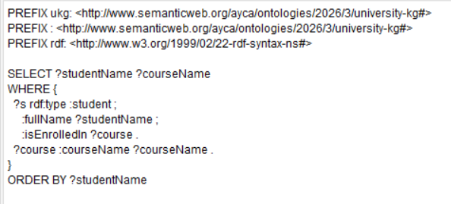
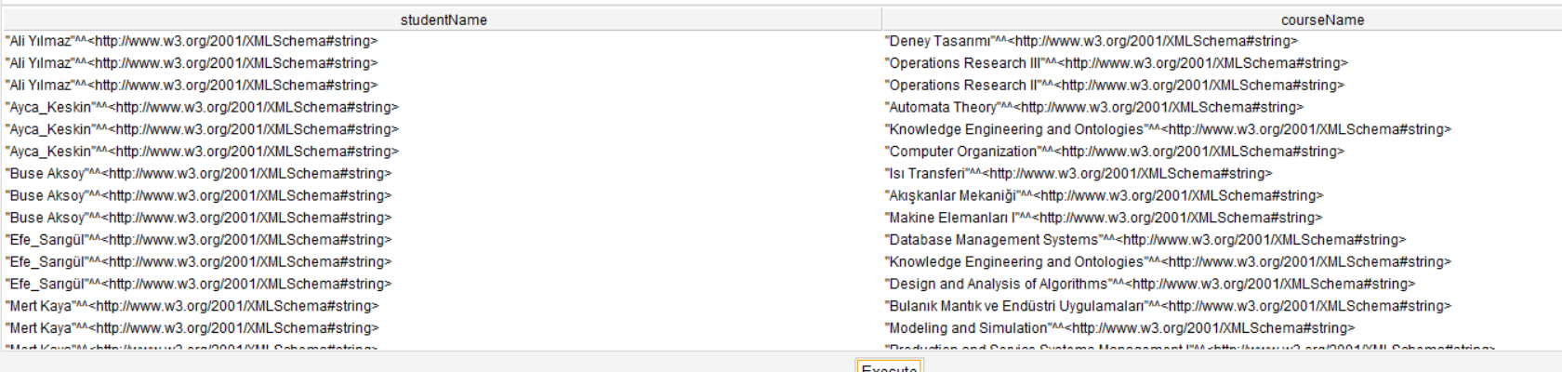
Figure 4. SPARQL query (top) and the resulting studentName / courseName table (bottom).
The result table shows, for each student, the list of courses they are currently enrolled in (e.g., Ali Yılmaz in “Deney Tasarımı” and two Operations Research courses, or Ayça Keskin in “Automata Theory”, “Knowledge Engineering and Ontologies”, and “Computer Organization”). This confirms that the :isEnrolledIn relation correctly links student individuals to course individuals across departments, and that this single retrieval pattern is sufficient to generate a per-student course schedule directly from the knowledge graph.

Validation (10 pts)

SHACL validation SHACL validation was performed using the pyshacl library. The shapes defined constraints for 6 classes: Student, Professor, ResearchAssistant, Course, Department, and SubField.

The validation result was Conforms: False due to 3 detected violations, all originating from the intentionally incomplete instance :wrong_student:
# | Violation Type | Node | Path | Message
1 | MinCountConstraintComponent | :wrong_student | ukg:fullName | Every student must have exactly one full name
2 | MinCountConstraintComponent | :wrong_student | ukg:studentID | Every student must have exactly one student ID
3 | MinCountConstraintComponent | :wrong_student | ukg:belongsTo | Every student must belong to at least one department

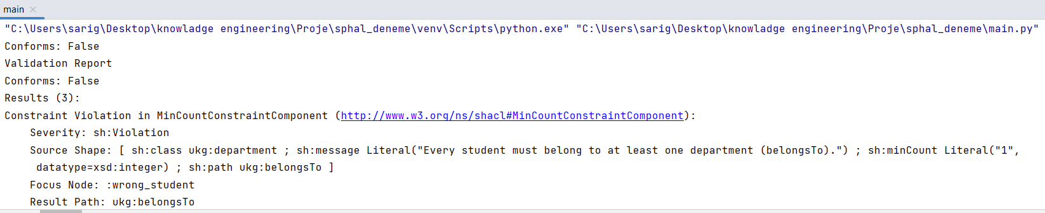
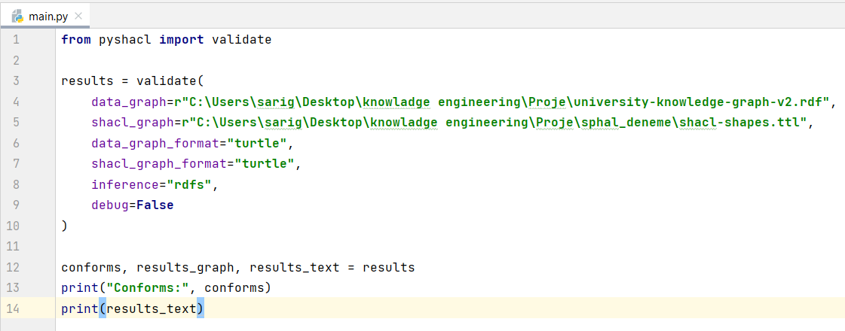
These violations were expected, as :wrong_student was deliberately added to the knowledge graph as an incomplete instance to demonstrate SHACL's ability to detect missing required properties. All other instances in the graph passed validation successfully.

LLM Integration (10 pts)
The LLM integration component translates natural language questions into SPARQL queries using the Claude API (claude-sonnet-4-6 model). The system pipeline works as follows: the user inputs a natural language question, which is sent to the LLM along with a structured system prompt that includes the ontology's prefix definitions, class names, and property names. The LLM generates a corresponding SPARQL query, which is then executed on the RDF graph using RDFLib. The result is returned to the user as a structured answer.
To reduce hallucinations, the LLM is strictly constrained to generate only SPARQL queries grounded in the ontology schema. It cannot invent class or property names that do not exist in the TBox. The system prompt explicitly lists all valid prefixes, classes, and properties, forcing the model to operate within the defined knowledge boundaries.
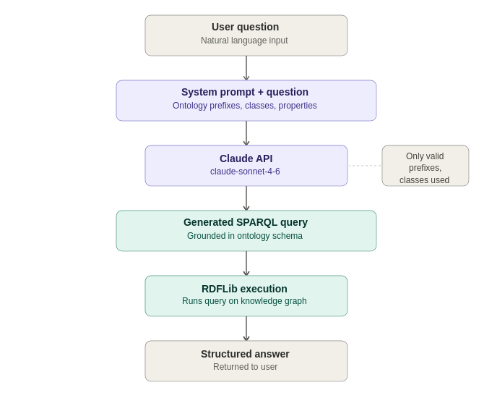
Figure 5. Pipeline of the natural-language-to-SPARQL integration.
As illustrated above, the pipeline starts with a natural language question from the user (e.g., “Who are the professors working in the Software sub-field?”). This question is forwarded to the Claude API together with a system prompt that enumerates every valid prefix, class, and property defined in the TBox. Claude returns a SPARQL query built exclusively from these elements, which is then executed against the knowledge graph using RDFLib’s query engine. The query results are finally formatted into a structured, human-readable answer and returned to the user, completing the natural-language-to-knowledge-graph loop while keeping every generated query grounded in the ontology schema.

Evaluation, Discussion and Conclusion (10 pts)
The ontology developed in this project demonstrates strong consistency and correctness, as verified by the HermiT reasoner integrated into Protégé, which reported no logical inconsistencies. The class hierarchy is well-structured, with clear disjointness axioms preventing semantic contradictions. The transitive modeling of ukg:hasPrerequisite proved particularly effective for reasoning over multi-level course dependency chains.
The SPARQL queries successfully addressed all defined competency questions, covering basic retrieval, reasoning, and aggregation scenarios. The SHACL validation correctly identified the intentionally incomplete :wrong_student instance, demonstrating the system's ability to enforce data quality constraints. The LLM integration provided an intuitive natural language interface, though its accuracy depends on the quality of the system prompt and the complexity of the user query.
Limitations include the relatively small ABox (limited to three departments), the absence of real-time data synchronization with the university's systems, and the LLM's occasional difficulty with complex multi-hop SPARQL patterns. Future improvements could include expanding the ontology to cover all university faculties, integrating a SPARQL endpoint via GraphDB for persistent storage, and fine-tuning the LLM prompt with few-shot examples to improve query generation accuracy.

References and format (2,5 pts)
Hitzler, P., Krötzsch, M., Parsia, B., Patel-Schneider, P. F., & Rudolph, S. (Eds.). (2012). OWL 2 Web Ontology Language Primer (Second Edition). W3C. https://www.w3.org/TR/owl2-primer/

Knublauch, H., & Kontokostas, D. (Eds.). (2017). Shapes Constraint Language (SHACL). W3C. https://www.w3.org/TR/shacl/

RDFLib Team. (2023). RDFLib 6.x documentation. https://rdflib.readthedocs.io/

Peroni, S., & Shotton, D. (2018). pySHACL. https://github.com/RDFLib/pySHACL

Harris, S., & Seaborne, A. (Eds.). (2013). SPARQL 1.1 Query Language. W3C. https://www.w3.org/TR/sparql11-query/

Manisa Celal Bayar University. (2025). Engineering Faculty Course Catalog. https://bmu.cbu.edu.tr.

Appendix
You can present additional material here that supports the project but isn’t included in the main sections of the report. Additional screenshots of your application can be included here. This section will provide additional information for readers who want to delve deeper into the technical details of your project.

