Predictive Analytics for Game-Theoretic Market Strategy Optimization in a Closed Economy
Kapalı Bir Ekonomide Oyun-Teorik Piyasa Strateji Optimizasyonu için Öngörücü Analitik
Hikmet Topak¹, Efe Yalım¹, Emirhan Ünsal¹
¹ Marmara University, Faculty of Engineering, Department of Computer Engineering, İstanbul, Türkiye
hikmettopak@marun.edu.tr, efeyalim@marun.edu.tr, emirhanunsal@marun.edu.tr
Abstract
This study presents an agent-based simulation framework for optimizing market strategies in a decentralized peer-to-peer (P2P) electricity trading environment. In conventional grid systems, prosumers sell surplus renewable energy at low Feed-in Tariff (FiT) rates, while consumers purchase electricity at higher Time-of-Use (ToU) prices, creating an economic inefficiency that static, rule-based pricing mechanisms cannot resolve in a market where supply and demand change dynamically over time. To reduce this gap, a decentralized market is modeled in which autonomous producer and consumer agents trade energy directly through a discrete-time double auction mechanism. The proposed system uses 48 daily time steps, heterogeneous agents, incomplete market information and non-storable electrical energy. A baseline rule-based model is first implemented to represent traditional pricing behavior; two learning-based approaches, Multi-Agent Tabular Q-Learning and a Neural Network-based (REINFORCE) policy model, are then developed and compared. Experimental results show that learning-based agents significantly improve P2P market performance. Compared with the baseline, P2P trading volume increases from 76.61 kWh to 245.49 kWh and grid dependency decreases substantially. The Neural Network model achieves the highest P2P ratio of 18.8% and the lowest buyer cost of $270.20, while seller revenue rises, indicating that adaptive pricing can create mutually beneficial outcomes for both buyers and sellers.
Keywords: peer-to-peer electricity trading, multi-agent reinforcement learning, double auction, Q-learning, REINFORCE, adaptive pricing
Öz
Bu çalışma, merkezi olmayan eşler arası (P2P) elektrik ticareti ortamında piyasa stratejilerini optimize etmek için ajan tabanlı bir simülasyon çerçevesi sunmaktadır. Geleneksel şebeke sistemlerinde üreticiler (prosumer) fazla yenilenebilir enerjiyi düşük Besleme Tarifesi (FiT) fiyatlarıyla satarken, tüketiciler elektriği daha yüksek Kullanım Zamanı (ToU) fiyatlarıyla satın alır; bu durum, arz ve talebin zamanla dinamik olarak değiştiği bir piyasada statik, kural tabanlı fiyatlandırmanın çözemediği ekonomik bir verimsizlik yaratır. Bu farkı azaltmak için, otonom üretici ve tüketici ajanlarının ayrık zamanlı bir çift taraflı açık artırma mekanizması aracılığıyla doğrudan enerji alıp sattığı merkezi olmayan bir piyasa modellenmiştir. Önerilen sistem 48 günlük zaman adımı, heterojen ajanlar, eksik piyasa bilgisi ve depolanamayan elektrik enerjisi kullanır. Önce geleneksel davranışı temsil eden kural tabanlı bir taban model uygulanmış; ardından Çok-Ajanlı Tablosal Q-Öğrenme ve Sinir Ağı tabanlı (REINFORCE) politika modeli geliştirilerek karşılaştırılmıştır. Deneysel sonuçlar, öğrenme tabanlı ajanların P2P piyasa performansını önemli ölçüde artırdığını göstermektedir: P2P ticaret hacmi 76,61 kWh'den 245,49 kWh'ye yükselmiş ve şebeke bağımlılığı azalmıştır.
Anahtar Kelimeler: eşler arası elektrik ticareti, çok-ajanlı pekiştirmeli öğrenme, çift taraflı açık artırma, Q-öğrenme, REINFORCE, uyarlanabilir fiyatlandırma

I. INTRODUCTION
The increasing use of distributed renewable energy resources is changing the structure of traditional electricity markets. In conventional grid systems, consumers only purchase electricity from centralized utilities, while small-scale renewable energy producers sell their surplus energy back to the grid. However, this structure often creates an economic inefficiency: prosumers are usually compensated at relatively low Feed-in Tariff (FiT) rates for their surplus energy, whereas consumers purchase electricity from the grid at higher Time-of-Use (ToU) prices. As a result, locally generated renewable energy is undervalued when exported to the grid, while nearby consumers continue to pay higher retail prices.
Peer-to-peer (P2P) electricity trading provides a decentralized alternative to this traditional market structure. Instead of routing all transactions through a central utility, local buyers and sellers can trade energy directly with each other. In such a market, sellers may receive a better price than the FiT rate, while buyers may purchase energy at a lower price than the ToU rate. Therefore, P2P trading has the potential to increase the local utilization of renewable energy, reduce dependency on the central grid, and create mutually beneficial outcomes for both producers and consumers.
Despite these advantages, designing an efficient P2P electricity market is challenging. Electrical energy is time dependent, highly variable and non-storable in the proposed model. Supply changes according to photovoltaic (PV) generation patterns, while demand varies throughout the day according to consumer load profiles. Furthermore, market participants operate under incomplete information and cannot directly know the private cost, valuation or strategy of other agents. In such a dynamic environment, static and rule-based pricing mechanisms are insufficient because they cannot adapt to real-time changes in supply, demand and market competition.
The motivation of this project is to investigate whether autonomous learning agents can improve pricing decisions in a decentralized P2P electricity trading environment. Agents act as buyers or sellers according to their net energy position: sellers with surplus PV energy submit ask prices, while buyers with energy deficits submit bid prices. These orders are cleared through a double auction mechanism, which allows market prices to emerge from the interaction of multiple buyers and sellers. To address the limitations of static pricing, this study develops and compares learning-based pricing strategies. A baseline rule-based model is first implemented to represent traditional behavior; then Multi-Agent Tabular Q-Learning and a Neural Network-based policy model are used to allow agents to learn adaptive bidding and asking strategies.
The main contribution of this work is the development of an agent-based P2P electricity trading simulation that compares three pricing approaches under the same market assumptions. The simulation includes heterogeneous agents, incomplete information, non-storable electrical energy, external grid options through FiT and ToU prices, and a discrete-time double auction mechanism. By comparing these approaches, the project evaluates whether learning-based agents can increase P2P trading volume, reduce grid dependency, improve seller revenue and decrease buyer cost under the modeled market conditions.
To achieve this goal, the project pursues a set of concrete objectives: to design a decentralized P2P trading environment in which autonomous agents participate as buyers or sellers according to their net energy position; to model the market using 48 daily time steps of 30 minutes so that time-dependent changes in demand and PV generation are captured; to define agent states from relevant market and energy variables such as time slot, surplus or demand level, best bid, best ask and average market price; to implement a baseline rule-based model, a Multi-Agent Tabular Q-Learning model and a Neural Network-based policy model; to integrate a double auction mechanism that aggregates bids and asks; and to evaluate the three approaches using measurable indicators including P2P trading ratio, traded energy volume, grid dependency, average P2P price, seller revenue and buyer cost.
II. RELATED WORK
Agent-Based Modeling (ABM) is a bottom-up modeling approach in which a system is represented as a collection of autonomous decision-making agents, allowing researchers to observe how macro-level market outcomes emerge from micro-level interactions between heterogeneous agents. One of the foundational studies in this area is the Santa Fe Artificial Stock Market, introduced by Palmer et al. [1] and further discussed by LeBaron [2], in which adaptive agents evolved their trading rules and generated complex market behaviors such as bubbles, crashes and volatility clustering without a central controller. Raberto et al. [3] showed that heterogeneous agents with budget constraints and rule-based trading behavior can reproduce statistical properties of real financial markets. Yao et al. [4] applied reinforcement learning to agent-based market simulation and showed that learning agents can discover trading strategies in a competitive environment, while Deissenberg et al. [5] presented EURACE, a large-scale agent-based model of the European economy. These works focus mainly on financial assets and stylized facts, whereas the present study applies adaptive learning to a P2P electricity market where the goal also includes increasing local renewable-energy utilization and reducing grid dependency.
Double auction mechanisms [9] are widely used in decentralized markets where multiple buyers and sellers interact simultaneously by submitting bids and asks, so that prices emerge from the interaction of local participants rather than from a single central price setter. A continuous double auction, common in financial markets, clears trades immediately whenever a compatible bid and ask are found; in the final version of this project, a discrete-time double auction was selected because orders are collected within each 30-minute simulation step and then cleared periodically, which better matches the structure of the electricity trading simulation.
Reinforcement Learning (RL) is a framework in which agents improve their behavior by interacting with an environment and receiving rewards, and Multi-Agent Reinforcement Learning (MARL) extends this idea to settings where the outcome of one agent's action depends on the decisions of others. Huh and Mohapatra [7] provide a broad survey of MARL concepts and challenges, while Karpathy [8] demonstrated how a neural policy trained with policy-gradient methods can learn complex decision-making behavior directly from observations and reward feedback. The neural policy model in this study follows a similar principle, learning a continuous pricing policy from observed market conditions rather than selecting from a fixed table.
Peer-to-peer electricity trading has become an important research area with the growing adoption of distributed renewable resources. Taylor and Mathieu [10] studied strategic bidding in electricity markets with renewable sources, highlighting how variable generation affects bidding behavior. Qiu et al. [9] proposed a multi-agent reinforcement learning approach for automated peer-to-peer energy trading in a double-sided auction market, and Jiang et al. [11] studied deep reinforcement learning-based bidding strategies for prosumers in a double auction-based transactive energy market. Realistic demand and PV profiles are also essential: Ratnam et al. [12] presented an Australian distribution network dataset containing residential load and rooftop PV generation. The main difference between the current project and these related studies is its compact comparative structure: rather than focusing on a single learning method, this work evaluates three pricing strategies — a baseline rule-based model, a tabular Q-Learning model and a neural network-based policy model — under identical market assumptions.
III. MATERIALS AND METHODS
3.1. Market Environment and System Model
The proposed P2P electricity market is modeled as a Partially Observable Markov Game (POMG), in which multiple autonomous agents interact under incomplete information. The market consists of prosumers with PV generation capabilities and consumers with electricity demand. The environment is represented by the tuple in Eq. (1), where N denotes the set of market participants, S the global environment state, Oₙ the observation space of agent n, Aₙ its action space, T the state transition function and Rₙ its reward function.
(1)
The simulation contains four producer (prosumer) agents and four consumer agents. Producer agents own photovoltaic generation systems and may generate surplus energy during daylight hours, whereas consumer agents purchase energy to satisfy their demand. The market operates using 48 discrete time steps per day, corresponding to 30-minute intervals. Because agents cannot observe the private information of other participants, the environment is partially observable. At each time step t, agent n observes the vector in Eq. (2), where Pᵢₙᶠ is the net inflexible load, λᵇ the best bid price, λˢ the best ask price, λᵃᵛᵍ the previous average clearing price and t the current time slot.
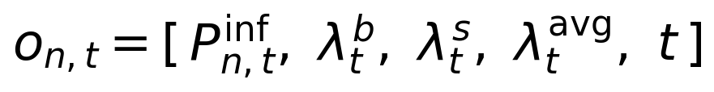 (2)
3.2. Action Spaces
Agents determine trading prices for their energy surplus or deficit. For Tabular Q-Learning, the action space is discretized into 15 price levels (K = 15) between the FiT and ToU tariffs, as given in Eq. (3). For the REINFORCE neural policy, the network instead outputs a continuous coefficient a ∈ [0,1], which is transformed into a market price through Eq. (4). This enables continuous pricing decisions rather than selecting from a fixed set of actions, allowing agents to generalize beyond fixed discrete price levels.
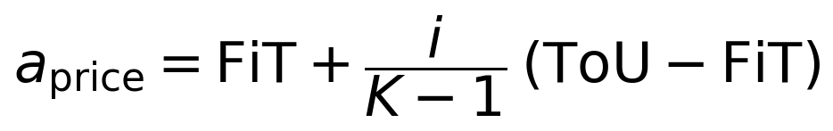 (3)
(4)
3.3. Market Settlement Mechanism
The market uses a discrete-time Partial Match Double Auction mechanism. At each trading interval, buyers submit bids and sellers submit asks; bids are sorted in descending order and asks in ascending order to maximize trading priority. The highest-bidding consumers are sequentially matched with the lowest-asking prosumers whenever a bid is greater than or equal to an ask, and each successful trade is cleared at the exact midpoint between the matched bid and ask, as defined in Eq. (5). Any residual unmatched demand or surplus at the end of the time step is automatically settled through the centralized utility grid: buyers purchase remaining energy at the ToU price, while sellers export remaining energy at the FiT price. Figure 1 illustrates the resulting ordering of buy and sell orders and the point at which the market clears.
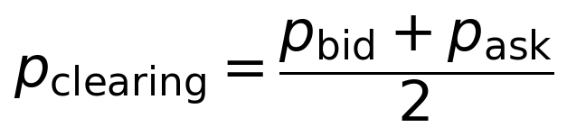 (5)
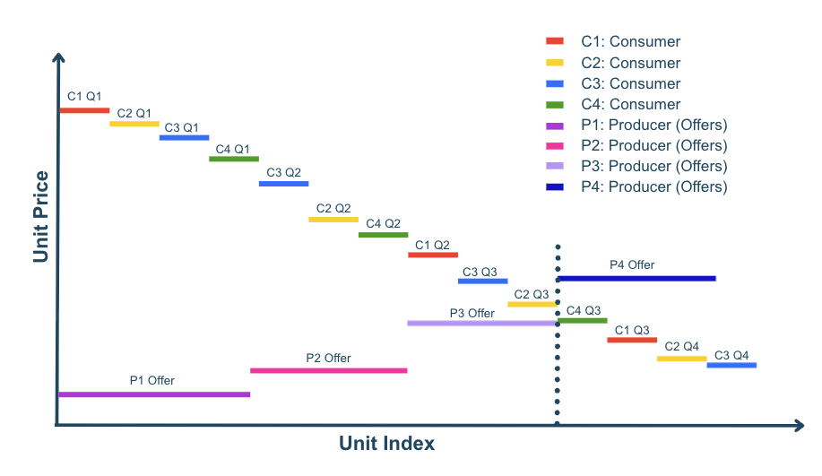
Figure 1. Partial Match Double Auction: descending buyer bids matched against ascending seller offers.
3.4. Reward Functions
The reward structure reflects the economic objectives of the market participants. For sellers, the reward in Eq. (6) combines revenue from matched P2P trading (qₘ pₘₐᵣₖₑₜ) and revenue from exporting unmatched energy to the grid at the FiT rate (qᵤ FiT), together with a price-premium term scaled by β = 1.5 that signals the agent to sell above the FiT rate and encourages profitable P2P transactions. For buyers, the reward in Eq. (7) is the negative of total procurement cost, so that minimizing cost is equivalent to maximizing reward; unmet demand is penalized at the ToU price.
(6)
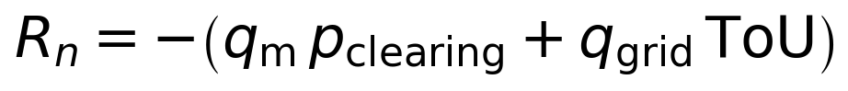 (7)
3.5. Baseline Rule-Based Model
The baseline model is a rule-based reference system used to benchmark the learning-based agents. At each time step, the role of an agent is determined by its net energy position in Eq. (8): if Pₙₑₜ(t) > 0 the agent acts as a buyer, and if Pₙₑₜ(t) < 0 it acts as a seller. Buyer agents determine their willingness to pay using an exponential Marginal Benefit function, Eq. (9), which represents decreasing willingness-to-pay as the demanded quantity increases. Seller agents follow a Use-It-or-Lose-It (UILI) pricing strategy, Eq. (10): because surplus electricity cannot be stored and has near-zero marginal production cost, higher surplus quantities drive lower ask prices, incentivizing local trade over grid export at the minimum FiT rate. The baseline does not include learning and therefore acts as the control group of the study.
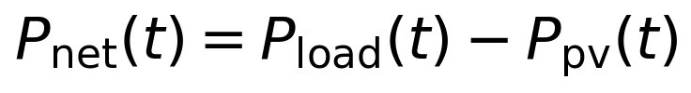 (8)
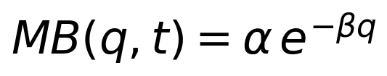 (9)
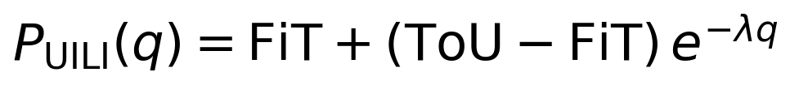 (10)
3.6. Multi-Agent Tabular Q-Learning
Tabular Q-Learning is used as the first adaptive pricing approach. Each agent maintains a compact Q-table that stores the expected reward of selecting a particular pricing action in a given market state, and updates it using the rule in Eq. (11). To keep the Q-table tractable and interpretable, the state representation is discretized. Each agent can act as either a seller or a buyer according to its net load, and each role is represented by a compact state built from the time slot and the surplus/demand level. Time is grouped into three buckets based on ToU periods (night/off-peak 00:00–08:00 and 20:00–24:00; daytime/solar 08:00–17:00; and evening peak 17:00–20:00), while surplus and demand are grouped into four kWh buckets (low, medium-low, medium-high and high). This yields 3 × 4 = 12 states per role. The learning hyperparameters are summarized in Table 1.
(11)
Table 1. Q-Learning hyperparameters.
Hyperparameter | Value | Description
Learning rate (α) | 0.1 | Q-value update step size
Discount factor (γ) | 0.95 | Present value of future rewards
Initial epsilon | 1.0 | Fully random exploration at episode 0
Minimum epsilon | 0.05 | Constant 5% exploration margin
Epsilon decay | 0.985 | Per-episode multiplicative decay

Tabular Q-Learning is transparent and interpretable because its explicit Q-values make the learned policy fully auditable; it is computationally lightweight and its two compact Q-tables converge reliably without specialized hardware. Its limitations are a discrete action space restricted to 15 fixed price levels, coarse state aggregation that maps distinct market conditions to the same bucket, and poor scalability as the number of agents, time periods or variables grows.
3.7. REINFORCE Neural Policy Model
To overcome the limitations of discrete pricing, a policy-gradient REINFORCE agent is implemented. Unlike Q-Learning, the policy directly outputs a continuous pricing coefficient within the feasible tariff range, and parameters are updated by minimizing the policy loss in Eq. (12), where Gₜ is the discounted return. During training, Gaussian exploration noise is added to the action, and the resulting price remains bounded between the FiT and ToU limits. The model uses two separate networks for buyers and sellers that share the same architecture but keep independent weights.
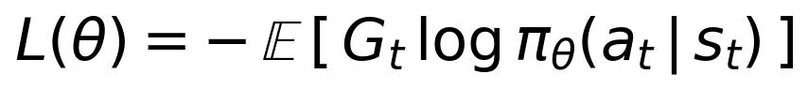 (12)
Each policy network concatenates a 5-dimensional state observation with a 16-dimensional embedding produced by a Time-Series Encoder, forming a 21-dimensional input that passes through two hidden layers of 64 units with ReLU activations and a final sigmoid output. The encoder summarizes the last 12 clearing prices using a price projection and a positional embedding, and averages the encoded vectors to give the policy temporal awareness of recent market patterns. The advantages of this approach are continuous price selection between FiT and ToU, temporal awareness of historical prices, and scalability to unseen states without large Q-tables. Its limitations are slower convergence, more limited interpretability and higher training variance compared with the tabular method.
Table 2. State-space representation of the neural policy.
Dimension | Seller | Buyer
s1 | hour / 47 | hour / 47
s2 | surplus / 10 | deficit / 10
s3 | best_bid / 0.5 | best_bid / 0.5
s4 | best_ask / 0.5 | best_ask / 0.5
s5 | avg_price / 0.5 | avg_price / 0.5

Table 2 lists the five normalized state dimensions observed by the seller and buyer policies, and Table 3 summarizes the shared network architecture. Each policy network has approximately 5,857 parameters including the time-series encoder, and two separate networks (one for buyers and one for sellers) are used, giving roughly 11,700 parameters per agent.
Table 3. Policy network architecture.
Layer | Dimensions | Parameters
Input | 5 + 16 = 21 | —
Linear + ReLU | 21 → 64 | 1,408
Linear + ReLU | 64 → 64 | 4,160
Linear + Sigmoid | 64 → 1 | 65
Total (+ encoder) | — | ≈ 5,857

3.8. Evaluation Metrics and Dataset
All pricing models are evaluated under identical market conditions using the same set of quantitative metrics: the P2P trading ratio in Eq. (13), the average P2P price in Eq. (14), total P2P traded energy, grid-purchased and grid-sold energy, seller revenue, buyer cost and the cumulative system reward. Seller revenue is the sum of P2P clearing income and grid FiT income, whereas buyer cost is the sum of P2P clearing cost and grid ToU cost. Together, these metrics jointly evaluate market efficiency, local energy utilization, economic performance and learning effectiveness.
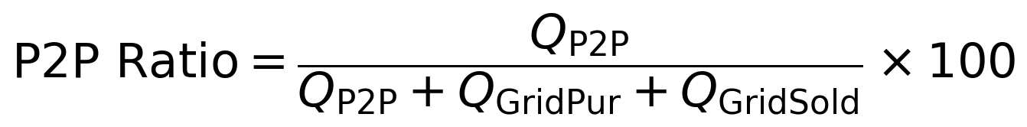 (13)
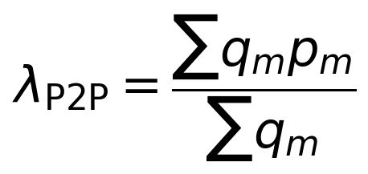 (14)
The simulation environment uses electricity consumption and PV generation profiles based on the Australian Ausgrid smart-grid dataset, which contains residential load and rooftop PV measurements reported at 30-minute intervals. The synthetic load profile exhibits demand peaks around the morning and evening periods, while PV generation is modeled as a daytime curve between approximately 06:00 and 19:00. This structure creates a realistic mismatch between generation and consumption, so that agents naturally become sellers during high-solar periods and buyers during high-demand periods. For benchmarking, the same load and PV profiles, agent population, 48-step daily structure, tariff boundaries and clearing mechanism are used for every experiment, so the only component that changes between experiments is the pricing strategy.
3.9. System Architecture and Implementation
The simulation is implemented in Python with a modular, object-oriented architecture that separates the market environment, agent decision models, auction mechanism, profile data and evaluation logic into independent components. This separation makes it possible to test the baseline, Q-Learning and neural network-based agents under identical market rules and physical energy profiles. The system consists of five main components: an environment component that manages the simulation clock, daily time steps, agent observations and reward calculation; an agent component that represents the decision-making layer for each strategy; an auction component that performs order matching and price clearing; a profile component that supplies the Ausgrid-based load and PV data; and an evaluation component that computes the comparison metrics. Version control (Git) was used to manage source-code changes and support collaboration among team members, while all market conditions except the pricing strategy are held fixed to ensure a fair comparison.
IV. RESULTS AND DISCUSSION
4.1. Overall Market Performance
Three pricing models were evaluated under identical market conditions with four producer agents (Pr1–Pr4) and four consumer agents (C1–C4). Table 4 summarizes the overall market performance. Both learning-based approaches substantially outperform the baseline: P2P trading volume increased from 76.61 kWh to 242.60 kWh with Q-Learning and 245.49 kWh with the Neural Network model, and the P2P trading ratio increased from 5.2% to approximately 18.8%. At the same time, grid-purchased energy decreased by roughly 14% and surplus energy exported to the grid decreased by nearly 78%, showing that learning-based agents match local supply and demand far more effectively.
Table 4. Overall market performance of the three pricing models.
Metric | Baseline | Q-Learning | REINFORCE-NN
P2P Ratio (%) | 5.2 | 18.6 | 18.8
P2P Trading (kWh) | 76.61 | 242.60 | 245.49
Grid Purchased (kWh) | 1180.30 | 1014.40 | 1011.50
Grid Sold (kWh) | 215.00 | 49.01 | 46.12
Avg. P2P Price ($/kWh) | 0.205 | 0.134 | 0.118

Another notable outcome is the reduction in the average P2P clearing price. Compared with the baseline, the Neural Network model achieved the lowest average clearing price, reducing it by 42.6%. This contributed to lower buyer costs while still maintaining attractive revenues for sellers through increased transaction volume.
4.2. Seller Revenue Analysis
The impact of adaptive pricing on seller profitability was evaluated by comparing total seller revenues, reported in Table 5. Compared with the baseline, Q-Learning increased total seller revenue by approximately 23.5%, while the Neural Network model achieved an increase of 10.6%. Although FiT income decreased significantly, this reduction was compensated by substantially higher P2P trading activity: the learning agents successfully shifted energy sales from the grid market toward direct peer-to-peer transactions, resulting in higher overall revenues for producers.
Table 5. Seller revenue comparison ($).
Metric | Baseline | Q-Learning | REINFORCE-NN
P2P Income | 15.70 | 32.39 | 28.86
Grid FiT Income | 12.90 | 2.94 | 2.77
Total Seller Revenue | 28.60 | 35.33 | 31.62

4.3. Buyer Cost Analysis
Buyer-side performance was evaluated by measuring total energy expenditure, shown in Table 6. The learning-based models reduced total buyer cost despite increasing direct P2P purchases. The Neural Network approach achieved the lowest overall buyer cost at $270.20, corresponding to an 11.2% reduction relative to the baseline, while Q-Learning produced a reduction of approximately 9.8%. These findings suggest that adaptive pricing creates mutually beneficial outcomes in which sellers earn higher revenues while buyers pay lower overall costs. Agent-level analysis confirmed this: all consumer agents (C1–C4) experienced lower net costs, and producer agents generally obtained higher revenues through increased P2P participation.
Table 6. Buyer cost comparison ($).
Metric | Baseline | Q-Learning | REINFORCE-NN
P2P Purchase Cost | 15.70 | 32.17 | 28.73
Grid ToU Cost | 288.54 | 242.30 | 241.46
Total Buyer Cost | 304.24 | 274.47 | 270.20

Figure 2 shows the net cost of each individual producer (Pr1-Pr4) and consumer (C1-C4) agent under the three strategies. The consumer agents, which dominate the total cost, consistently move to lower net costs under both learning-based strategies, confirming at the agent level the aggregate savings reported in Table 6.
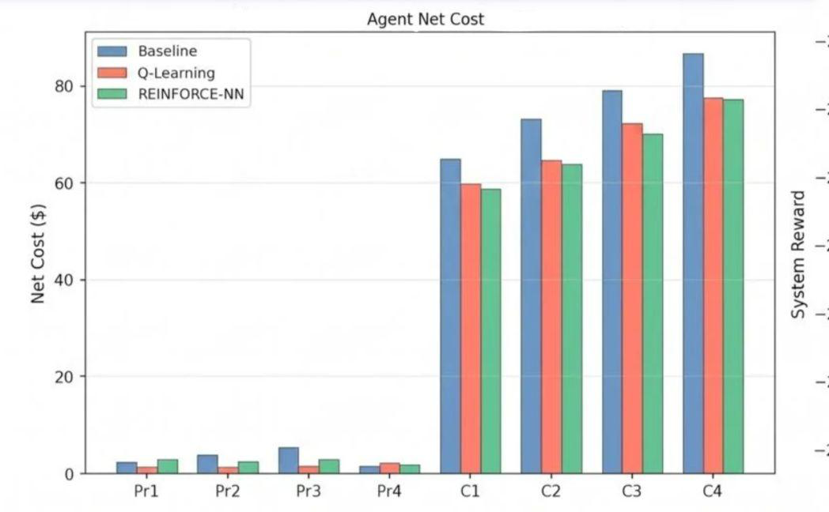
Figure 2. Net cost of individual producer and consumer agents.
4.4. Price Dynamics and Market Behavior
The average hourly clearing price, shown in Figure 3, provides insight into how each pricing strategy influences market behavior. The baseline model produced the highest clearing prices throughout most of the trading period, whereas both learning-based models converged toward lower and more stable market prices, with the Neural Network approach generating the lowest average prices during most trading hours. Lower clearing prices reduced buyer costs while still maintaining attractive revenues for sellers through increased transaction volume.
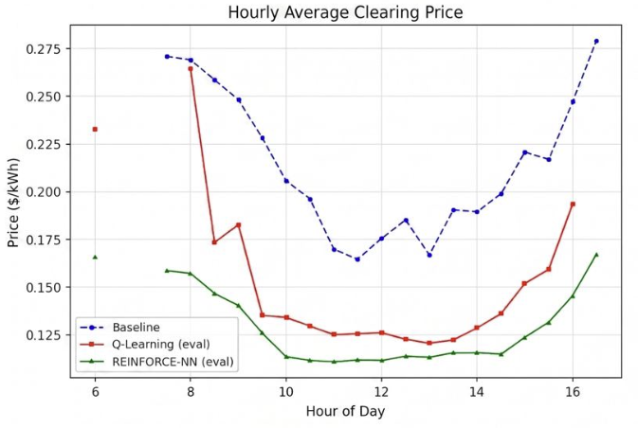
Figure 3. Hourly average clearing price for the three pricing strategies.
The transaction-volume analysis in Figure 4 shows that learning agents consistently generated more trades during peak solar-production hours, indicating that adaptive pricing improved the matching efficiency between local energy supply and demand. The concentration of P2P trades around midday reflects the overlap between high PV generation and local consumption that the learning agents were able to exploit.
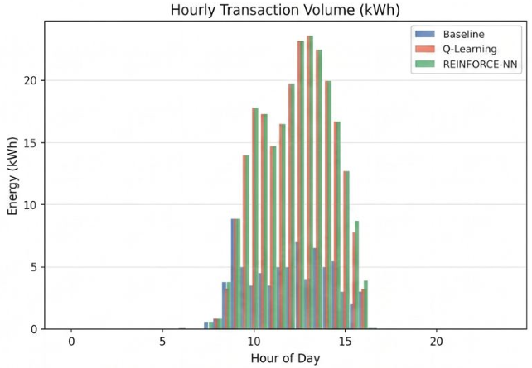
Figure 4. Hourly transaction volume (kWh) for the three pricing strategies.
4.5. Learning Performance
The learning progress of both reinforcement learning approaches was evaluated using the cumulative system reward during training, shown in Figure 5. Both models improved over time and converged toward stable policies. Q-Learning exhibited faster initial convergence due to its discrete action space, while the Neural Network model required more training episodes but ultimately achieved slightly better market performance. The smoother long-term behavior of the Neural Network policy suggests that continuous pricing decisions provide additional flexibility in dynamic market environments.
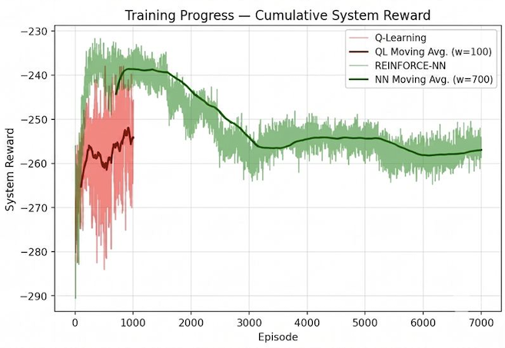
Figure 5. Training progress – cumulative system reward.
4.6. Discussion
The experimental results demonstrate a significant improvement in local market efficiency and community welfare when shifting from static structures to reinforcement learning frameworks. In the baseline scenario, producer agents are heavily constrained by rigid grid structures, capturing a low total revenue of $28.60 due to exporting their surplus PV generation at the unfavorable FiT rate. With Multi-Agent Tabular Q-Learning, sellers dynamically discover localized demand and increase their revenue to $35.33. Under the REINFORCE-NN policy, total revenue settles at $31.62; this slight reduction compared with Q-Learning is an expected outcome of continuous price discovery, where the policy network prioritizes long-term trading-volume maximization over high-margin price extraction.
On the consumer side, the economic advantages of learning models are equally prominent. Baseline consumers incur an expensive total procurement cost of $304.24 due to their reliance on high ToU grid prices during peak hours. Multi-agent learning minimizes this dependency, reducing total buyer cost to $274.47 under Q-Learning and to $270.20 under REINFORCE-NN, an 11.2% reduction. The empirical data confirm that, while discrete Q-Learning introduces structural price volatility due to its 15 fixed action intervals, the continuous REINFORCE-NN model achieves a more resilient game-theoretic equilibrium: it optimally balances the profit-seeking behavior of prosumers with the cost-minimization goals of consumers. By reducing financial leakage to the centralized utility grid, adaptive pricing creates a highly autonomous, mutually beneficial localized energy market. It is important to note that these results are outcomes of the modeled assumptions and should not be treated as direct predictions for a real electricity market.
Table 7. Three-way performance comparison with relative change over the baseline.
Metric | Base | QL | NN | ΔQL | ΔNN
P2P Ratio (%) | 5.2 | 18.6 | 18.8 | +257% | +262%
P2P Trading (kWh) | 76.61 | 242.60 | 245.49 | +217% | +220%
Grid Purchased (kWh) | 1180.3 | 1014.4 | 1011.5 | -14.1% | -14.3%
Grid Sold (kWh) | 215.0 | 49.01 | 46.12 | -77.2% | -78.5%
Avg. P2P Price ($/kWh) | 0.21 | 0.13 | 0.12 | -34.8% | -42.6%

4.7. Benefits, Impact and Considerations
Beyond the quantitative metrics, the framework has broader implications. Economically, the simulation shows that adaptive pricing can reduce buyer costs while increasing seller revenues, giving prosumers an alternative to monetizing unused renewable generation at low FiT rates and letting consumers buy locally available surplus energy below the ToU tariff. Environmentally, by increasing local energy matching, the proposed system supports better utilization of distributed renewable energy and reduces unnecessary export to the grid, although the project itself is a software simulation and does not directly reduce emissions. From a sustainability perspective, the framework is modular and extensible, so future versions can include battery storage, electric vehicles, demand response and larger agent populations.
Socially, peer-to-peer energy trading supports a more participatory ecosystem in which users are not only passive consumers but can become active market participants. The model also supports privacy-aware decentralization, because market decisions are made by local agents using limited state information rather than requiring full centralized control over user data. The project further has an indirect relationship with energy security: a decentralized P2P model can encourage local balancing of supply and demand and reduce dependency on centralized grid purchases, supporting more resilient community-level energy systems. These benefits should be interpreted at the conceptual and simulation level; a real deployment would require regulatory approval, reliable metering infrastructure, strong cybersecurity mechanisms and coordination with grid operators.
V. CONCLUSION
This project presented an agent-based simulation framework for adaptive peer-to-peer energy trading in a decentralized market environment. The main objective was to investigate whether autonomous agents can learn effective pricing strategies under a double auction mechanism and improve market outcomes compared with static rule-based pricing. The developed model represents a local electricity market in which producer and consumer agents interact under incomplete information, while the traditional grid acts as an outside option through FiT and ToU pricing.
The experimental results show that learning-based pricing strategies improve the overall performance of the simulated P2P market. Compared with the baseline, both tabular Q-Learning and neural network-based agents increased local energy trading and reduced dependency on grid-based transactions. The most successful configuration increased P2P trading volume by approximately 220%, while also reducing buyer costs and improving seller revenues under the modeled conditions. The comparison between the two learning approaches also provides a clear methodological insight: tabular Q-Learning is transparent, lightweight and easy to interpret, but limited by its discrete action space and coarse state representation, whereas the neural network approach enables continuous pricing and temporal awareness at the cost of slower convergence, higher variance and lower interpretability. The project therefore highlights a trade-off between explainability and performance in learning-based market agents.
The current simulation has several limitations: it uses a limited number of agents and simplified market assumptions, models electrical energy as non-storable, and excludes transaction costs and physical network constraints. Because there is no energy storage, the temporal coupling between time steps is limited. Future work can increase the number and diversity of agents; integrate battery storage so that agents can learn when to store, consume, sell or buy energy; add an explicit producer cost function; and include transaction costs, grid-capacity limits and regulatory constraints. More advanced multi-agent reinforcement learning methods, such as actor-critic models and centralized training with decentralized execution, may further improve scalability. Finally, because the underlying agent-based auction framework is market-agnostic, it can be adapted to other decentralized markets in which autonomous buyers and sellers interact under incomplete information.
ACKNOWLEDGMENT
The authors would like to express their sincere gratitude to their project supervisors, Dr. Kamil Erdayandı and Dr. Mehmet Kadir Baran, for their valuable guidance, feedback and continuous support throughout the development of this project, and to the faculty members of the Marmara University Computer Engineering Department.
REFERENCES
[1] R. G. Palmer, W. B. Arthur, J. H. Holland, B. LeBaron, and P. Tayler, “Artificial economic life: A simple model of a stockmarket,” Physica D: Nonlinear Phenomena, vol. 75, no. 1–3, pp. 264–274, 1994.
[2] B. LeBaron, “Building the Santa Fe artificial stock market,” Physica A: Statistical Mechanics and its Applications, vol. 314, no. 1–4, pp. 1–20, 2002.
[3] M. Raberto, S. Cincotti, S. M. Focardi, and M. Marchesi, “Agent-based simulation of a financial market,” Physica A: Statistical Mechanics and its Applications, vol. 299, no. 1–2, pp. 319–327, 2001.
[4] Z. Yao, Z. Li, M. Thomas, and I. Florescu, “Reinforcement learning in agent-based market simulation: Unveiling realistic stylized facts and behavior,” arXiv preprint arXiv:2010.05135, 2020.
[5] C. Deissenberg, S. van der Hoog, and H. Dawid, “EURACE: A massive agent-based simulation of the European economy,” CompUME Working Paper, 2008.
[6] Ausgrid, “Solar home electricity data,” Open Data Repository, 2013. [Online]. Available: https://www.ausgrid.com.au/
[7] D. Huh and P. Mohapatra, “Multi-agent reinforcement learning: A comprehensive survey,” University of California, Davis, Tech. Rep., 2020.
[8] A. Karpathy, “Deep reinforcement learning: Pong from pixels,” Andrej Karpathy Blog, 2016. [Online]. Available: http://karpathy.github.io/2016/05/31/rl/
[9] J. Qiu, Q. Wang, J. Wang, and G. Strbac, “A multi-agent reinforcement learning approach for automated peer-to-peer energy trading in a double-sided auction market,” IEEE Transactions on Power Systems, vol. 37, no. 5, pp. 3450–3463, 2022.
[10] J. A. Taylor and M. B. Mathieu, “Strategic bidding in electricity markets with renewable energy sources,” IEEE Transactions on Power Systems, vol. 29, no. 5, pp. 2547–2554, 2014.
[11] C. Jiang, Y. Q. Qiu, M. S. Nazir, and H. J. Wang, “Deep reinforcement learning-based bidding strategies for prosumers in a double auction-based transactive energy market,” International Journal of Electrical Power & Energy Systems, vol. 135, p. 107521, 2022.
[12] E. C. Ratnam, S. R. Weller, C. M. Kellett, and E. A. Murray, “Residential load and rooftop PV generation data from an Australian distribution network,” Scientific Data, vol. 4, no. 1, pp. 1–7, 2017.

