RESEARCH ARTICLE / ARAŞTIRMA MAKALESİ
Reinforcement Learning Based Pricing Strategies in Local Energy Markets
Hikmet TOPAK ¹, Efe YALIM ¹, Emirhan ÜNSAL ¹, Mehmet Kadir BARAN ¹, Kamil ERDAYANDI ¹
¹Marmara University, Faculty of Engineering, Department of Computer Engineering, İstanbul, Türkiye
Abstract
This study presents an agent-based simulation framework for optimizing market strategies in a decentralized peer-to-peer (P2P) electricity trading environment. In conventional grid systems, prosumers sell surplus renewable energy at low Feed-in Tariff (FiT) rates, while consumers purchase electricity at higher Time-of-Use (ToU) prices, creating an economic inefficiency that static, rule-based pricing mechanisms cannot resolve in a market where supply and demand change dynamically over time. To reduce this gap, a decentralized market is modelled in which autonomous producer and consumer agents trade energy directly through a discrete-time double auction mechanism. The proposed system uses 48 daily time steps, heterogeneous agents, incomplete market information and non-storable electrical energy. A baseline rule-based model is first implemented to represent traditional pricing behaviour; two reinforcement learning based approaches, Multi-Agent Tabular Q-Learning and a Neural Network-based (REINFORCE) policy model, are then developed and compared. Experimental results show that reinforcement learning based agents significantly improve P2P market performance. Compared with the baseline, P2P trading volume increases from 84.47 kWh to 245.49 kWh and grid dependency decreases substantially. The Neural Network model achieves the highest P2P ratio of 18.7% and the lowest buyer cost of $272.42, while seller revenue rises, indicating that adaptive pricing can create mutually beneficial outcomes for both buyers and sellers. This work is a preliminary study: the results are obtained for a single community of eight agents on one simulated day, and a follow-up study will extend the analysis to larger populations, repeated training runs and controlled ablations.
Keywords: Peer-to-peer electricity trading, Multi-agent reinforcement learning, Double auction, Q-learning, REINFORCE, Adaptive pricing
I. INTRODUCTION
The increasing use of distributed renewable energy resources is changing the structure of traditional electricity markets [1]. In conventional grid systems, consumers only purchase electricity from centralized utilities, while small-scale renewable energy producers sell their surplus energy back to the grid. However, this structure often creates an economic inefficiency: prosumers are usually compensated at relatively low Feed-in Tariff (FiT) rates for their surplus energy, whereas consumers purchase electricity from the grid at higher Time-of-Use (ToU) prices [6]. As a result, locally generated renewable energy is undervalued when exported to the grid, while nearby consumers continue to pay higher retail prices.
Peer-to-peer (P2P) electricity trading provides a decentralized alternative to this traditional market structure [3]. Instead of routing all transactions through a central utility, local buyers and sellers can trade energy directly with each other. In such a market, sellers may receive a better price than the FiT rate, while buyers may purchase energy at a lower price than the retail price [2]. Therefore, P2P trading has the potential to increase the local utilization of renewable energy, reduce dependency on the central grid, and create mutually beneficial outcomes for both producers and consumers [1].
Despite these advantages, designing an efficient P2P electricity market is challenging. Electrical energy is time dependent, highly variable and non-storable in the proposed model. Supply changes according to photovoltaic (PV) generation patterns, which fluctuate with weather conditions [4], while demand varies throughout the day according to consumer load profiles. Furthermore, market participants operate under incomplete information and cannot directly know the private cost, valuation or strategy of other agents; in practice this limitation is reinforced by the privacy requirements of local energy markets, where bids, offers and consumption data are treated as sensitive user information [5]. In such a dynamic environment, static and rule-based pricing mechanisms are insufficient because they cannot adapt to real-time changes in supply, demand and market competition.
This study investigates whether autonomous learning agents can improve pricing decisions in a decentralized P2P electricity trading environment. Agents act as buyers or sellers according to their net energy position: sellers with surplus PV energy submit ask prices, while buyers with energy deficits submit bid prices. These orders are cleared through a double auction mechanism, which allows market prices to emerge from the interaction of multiple buyers and sellers; clearance mechanisms of this kind are commonly built on either auction theory or game theory [2]. To address the limitations of static pricing, this study develops and compares learning-based pricing strategies. A baseline rule-based model is first implemented to represent traditional behaviour; then Multi-Agent Tabular Q-Learning and a Neural Network-based policy model are used to allow agents to learn adaptive bidding and asking strategies.
A complete local energy market comprises bid generation, market clearance, and billing and settlement; the present work addresses the clearance stage, while privacy-preserving billing and settlement are treated separately in the literature [8]. The main contribution of this work is the development of an agent-based P2P electricity trading simulation that compares three pricing approaches under the same market assumptions. The simulation includes heterogeneous agents, incomplete information, non-storable electrical energy, external grid options through FiT and ToU prices, and a discrete-time double auction mechanism. By comparing these approaches, the study evaluates whether learning-based agents can increase P2P trading volume, reduce grid dependency, improve seller revenue and decrease buyer cost under the modelled market conditions. The study is positioned as a preliminary, proof-of-concept investigation. It deliberately uses a compact population of four producers and four consumers, the configuration that Qiu et al. [6] also built from the same dataset, so that every bid, ask and clearing price can be traced and audited. The conclusions are therefore restricted to this configuration; larger populations, repeated training runs and ablations that equalize the inputs and the order format of the strategies are left to a follow-up study, whose scope is outlined in Sections 4.8 and V.
To achieve this goal, the study pursues a set of concrete objectives: to design a decentralized P2P trading environment in which autonomous agents participate as buyers or sellers according to their net energy position; to model the market using 48 daily time steps of 30 minutes so that time-dependent changes in demand and PV generation are captured; to define agent states from relevant market and energy variables; to implement a baseline rule-based model, a Multi-Agent Tabular Q-Learning model and a Neural Network-based policy model; to integrate a double auction mechanism that aggregates bids and asks; and to evaluate the three approaches using measurable indicators including P2P trading ratio, traded energy volume, grid dependency, average P2P price, seller revenue and buyer cost.
II. RELATED WORK
Agent-Based Modelling (ABM) is a bottom-up modelling approach in which a system is represented as a collection of autonomous decision-making agents, allowing researchers to observe how macro-level market outcomes emerge from micro-level interactions between heterogeneous agents. One of the foundational studies in this area is the Santa Fe Artificial Stock Market, introduced by Palmer et al. [9] and further discussed by LeBaron [10], in which adaptive agents evolved their trading rules and generated complex market behaviours such as bubbles, crashes and volatility clustering without a central controller. Raberto et al. [11] showed that heterogeneous agents with budget constraints and rule-based trading behaviour can reproduce statistical properties of real financial markets. Yao et al. [12] applied reinforcement learning to agent-based market simulation and showed that learning agents can discover trading strategies in a competitive environment, while Deissenberg et al. [13] presented EURACE, a large-scale agent-based model of the European economy. These works focus mainly on financial assets and stylized facts, whereas the present study applies adaptive learning to a P2P electricity market where the goal also includes increasing local renewable-energy utilization and reducing grid dependency.
Double auction mechanisms [6] are widely used in decentralized markets where multiple buyers and sellers interact simultaneously by submitting bids and asks, so that prices emerge from the interaction of local participants rather than from a single central price setter. Continuous double auctions, widely used in financial markets, clear trades instantaneously as soon as a bid and an ask become compatible. In this study, however, a discrete-time double auction was adopted in the final design: orders are accumulated over each 30-minute simulation step and cleared periodically at the end of the interval, which aligns more naturally with the temporal structure of the electricity trading simulation.
Reinforcement Learning (RL) is a framework in which agents improve their behaviour by interacting with an environment and receiving rewards, and Multi-Agent Reinforcement Learning (MARL) extends this idea to settings where the outcome of one agent's action depends on the decisions of others. Huh and Mohapatra [14] provide a broad survey of MARL concepts and challenges, while Karpathy [15] demonstrated how a neural policy trained with policy-gradient methods can learn complex decision-making behaviour directly from observations and reward feedback. The neural policy model in this study follows a similar principle, learning a continuous pricing policy from observed market conditions rather than selecting from a fixed table.
Peer-to-peer electricity trading has become an important research area with the growing adoption of distributed renewable resources. Taylor and Mathieu [16] studied strategic bidding in electricity markets with renewable sources, highlighting how variable generation affects bidding behaviour. Qiu et al. [6] proposed a multi-agent reinforcement learning approach for automated peer-to-peer energy trading in a double-sided auction market, and Jiang et al. [7] studied deep reinforcement learning-based bidding strategies for prosumers in a double auction-based transactive energy market. Realistic demand and PV profiles are also essential: Ratnam et al. [17] presented an Australian distribution network dataset containing residential load and rooftop PV generation.
The Ausgrid data have since been used across a wide range of research areas. Kell et al. [24] trained a deep reinforcement learning controller for a domestic battery and PV system using the Ausgrid solar home data, and the dataset has also served as a benchmark for residential short-term load forecasting [25]. Several studies use it specifically for energy pricing and P2P trading. Qiu et al. [6] selected eight Ausgrid households, arranged as four prosumers and four consumers, and trained DA-MADDPG agents that bid in a double-side auction bounded by the Ausgrid ToU and FiT tariffs. Sanayha and Vateekul [19] and Uthayansuthi and Vateekul [20] applied model-based multi-agent deep reinforcement learning to P2P trading among Ausgrid households, the former with clustered prosumers and the latter without information sharing between agents. Liyanage and Islam [21] compared average, trade-reduction and Vickrey–Clarke–Groves clearing rules in a double auction using six Ausgrid households, while Kochupurackal et al. [22] proposed rolling-horizon optimisation for P2P trading under real-time variations in demand and generation. Moniruzzaman et al. [23] combined cooperative game theory with blockchain and validated their trading scheme on the Ausgrid data.
The main difference between this work and these related studies is its compact comparative structure. Rather than focusing on a single learning method, it evaluates three pricing strategies under identical market assumptions: a baseline rule-based model, a tabular Q-Learning model, and a neural network-based policy model.
III. MATERIALS AND METHODS
This section describes the simulated market and the three pricing strategies compared in the study. Section 3.1 defines the market environment, and Section 3.2 the settlement mechanism through which all strategies trade. Section 3.3 presents the rule-based baseline that serves as the control group. Sections 3.4 to 3.6 introduce the reinforcement learning formulation shared by the two learning-based strategies, which are then described individually in Sections 3.7 and 3.8. Finally, Sections 3.9 and 3.10 present the evaluation metrics, the dataset and the software architecture.
3.1. Market Environment and System Model
The proposed market is a local peer-to-peer electricity market in which autonomous agents trade energy directly with one another and use the central grid as an outside option. The simulation contains four producer (prosumer) agents and four consumer agents. Producer agents own photovoltaic generation systems and may generate surplus energy during daylight hours, whereas consumer agents purchase energy to satisfy their demand. The market operates using 48 discrete time steps per day, corresponding to 30-minute intervals, and the external grid tariffs are fixed at FiT = $0.06/kWh and ToU = $0.28/kWh. Agents cannot observe the private cost, valuation or strategy of other participants, so each of them acts under incomplete information. At every time step the role of an agent is determined by its net energy position, defined in Eq. (1) as the difference between its load and its PV generation: a positive value means the agent must buy energy, whereas a negative value means it has surplus available for sale.
Four modelling assumptions are stated explicitly because they bound the interpretation of the results. First, the quantities in Eq. (1) are energies per 30-minute slot, expressed in kWh. Second, the retail price is denoted ToU, following [6], but it is kept constant at $0.28/kWh over the whole day; the time buckets used later by the Q-Learning state describe the load and generation pattern, not tariff periods. Third, the grid authority is modelled as an unconstrained external party: in every slot it supplies any unmatched demand at the ToU price and absorbs any unmatched surplus at the FiT price, without capacity limits. No storage is modelled on either side, so neither the agents nor the grid authority can carry surplus energy from one slot to the next, and how the grid authority balances the energy it absorbs lies outside the model. Fourth, demand is perfectly inelastic: P_{n}^{load}(t) is exogenous, cannot be shifted in time and must be fully served in its own slot, so an agent chooses only the price of its order and never its quantity. The implications of this assumption for the pricing strategies are discussed in Section 4.8.
3.2. Market Settlement Mechanism
The market uses a discrete-time Partial Match Double Auction mechanism. At each trading interval, buyers submit bids and sellers submit asks. Bids are sorted in descending price order and asks in ascending price order, and the algorithm repeatedly matches the current highest bid with the current lowest ask whenever the bid is greater than or equal to the ask. A single ask may be distributed across several bids and a single bid may be filled from several asks. Every successful trade is cleared at the exact midpoint between the matched bid and ask, as defined in Eq. (2). Matching stops as soon as the current best bid falls below the current best ask, since no further match is possible in sorted books. Any residual unmatched demand or surplus is discarded from the order book and settled through the centralized utility grid: buyers purchase remaining energy at the ToU price, while sellers export remaining energy at the FiT price.
Order construction differs between the baseline and the learning-based strategies. In the baseline, each consumer’s demand is divided into unit blocks, and each block is priced at the value of the exponential marginal benefit function, Eq. (3), evaluated at the corresponding cumulative quantity; this produces the stepped demand curve labelled Q1–Q4 in Figure 1. The Q-Learning and REINFORCE consumers instead submit a single aggregate bid at their learned price, so their demand appears as one block per agent. Sellers submit a single aggregate ask in all three strategies. This difference in order format is formalized in Eq. (18) of Section 3.11, where its consequences for the comparison are also discussed.
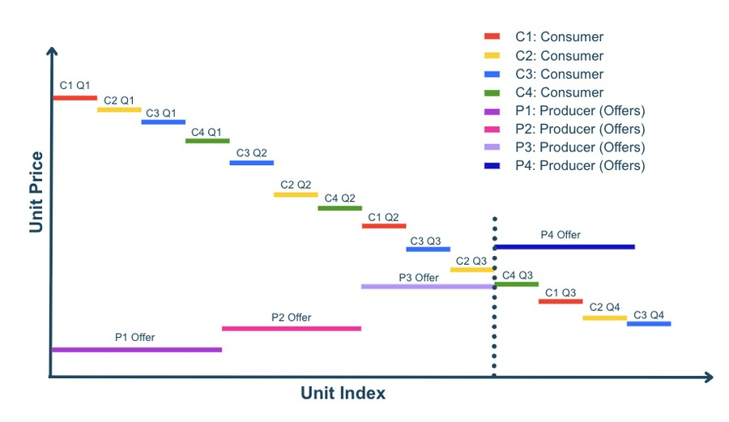
Figure 1. Illustrative example of the Partial Match Double Auction under the baseline strategy: descending buyer bids matched against ascending seller offers. The dotted line marks the point at which the market clears.
3.3. Baseline Rule-Based Model
The baseline model is a rule-based reference system used to benchmark the learning-based agents. At each time step, the role of an agent is determined by its net energy position in Eq. (1): if P_{n}^{net}(t) > 0 the agent acts as a buyer, and if P_{n}^{net}(t) < 0 it acts as a seller. Buyer agents determine their willingness to pay using an exponential Marginal Benefit function, Eq. (3), in which q_{d} is the quantity the buyer demands at the current step, so that willingness-to-pay decreases as the demanded quantity grows; the coefficients α_{MB} and β_{MB} are calibrated per half-hourly slot from the Ausgrid dataset, as described in Section 3.9. Seller agents follow a Use-It-or-Lose-It (UILI) pricing strategy, Eq. (4), in which q_{s} is the surplus quantity the seller has available: because surplus electricity cannot be stored and has near-zero marginal production cost, larger surpluses drive lower ask prices through the decay rate κ, incentivizing local trade over grid export at the minimum FiT rate. The baseline does not include learning and therefore acts as the control group of the study.
3.4. Reinforcement Learning Formulation
The decision problem faced by the learning-based agents is modelled as a Partially Observable Markov Game (POMG), in which multiple autonomous agents interact under incomplete information. The environment is represented by the tuple in Eq. (5), where N denotes the set of market participants, S the global environment state, Ω_{n} the observation space of agent n, A_{n} its action space, O the observation function that maps the global state to the local observation of each agent, T the state transition function, R_{n} its reward function and γ the discount factor applied to future rewards. The global state at step t comprises the time index, the net energy position of every agent and the average clearing price of the previous period.
Because agents cannot observe the private information of other participants, the environment is partially observable. At each time step t, the environment provides agent n with the observation vector in Eq. (6), where P_{n,t}^{net} is the net energy position defined in Eq. (1), λ_{avg} the previous average clearing price and t the current time slot.
Each strategy maps this observation to its own internal state representation. The baseline uses only the net energy position. The Q-Learning agent discretizes the time index and its own net position into buckets and discards the price component entirely. The REINFORCE agent uses all three components directly and additionally maintains a rolling window of the twelve most recent values of λ_{avg}, which it summarizes through the encoder described in Section 3.8; this window is agent-side memory built from past observations rather than an additional observation channel.
The two learning strategies therefore operate on different observation sets. This follows from the methods themselves: the Q-table must stay small enough to be visited repeatedly, so adding a price dimension would multiply the number of states, whereas the neural policy accepts additional continuous inputs at no structural cost. The comparison in Section IV is thus between complete pricing strategies, each with the state representation that suits it, rather than between learning algorithms given identical inputs.
The number of inputs therefore differs across the strategies: the baseline uses one input (the net position), the Q-Learning agent two (time and net position, discretized into 3 × 4 = 12 states), and the REINFORCE agent three continuous inputs together with a window of the twelve most recent clearing prices, i.e. a 19-dimensional network input. The effect of this difference on the performance metrics can be stated as follows. For the tabular learner the number of values to be estimated grows multiplicatively with every additional input: each role has |S| × |A| = 12 × 15 = 180 Q-values, and a price input discretized into B buckets would raise this number to 180·B, each entry being visited proportionally less often within a fixed training budget. In return for its small table, all slots that fall into the same state necessarily receive the same price, so the tabular policy cannot follow slot-level changes in supply and demand; this is consistent with its lower local matching efficiency (Section 4.1) and its more volatile price path (Section 4.6). The neural policy does not pay this cost and conditions its price on continuous time, quantity and recent prices. Consequently, the differences between Q-Learning and REINFORCE reported in Section IV cannot be attributed to the learning rule alone: they are the joint effect of the learning rule, the state representation and the action space. Separating these factors requires an ablation in which both learners receive identical inputs, which is part of the planned follow-up study.
3.5. Action Spaces
Agents determine trading prices for their energy surplus or deficit. For Tabular Q-Learning, the action space is discretized into 15 price levels (K = 15) between the FiT and ToU tariffs, as given in Eq. (7). For the REINFORCE neural policy, the network instead outputs a continuous coefficient a ∈ [0,1], which is transformed into a market price through Eq. (8). This enables continuous pricing decisions rather than selecting from a fixed set of actions, allowing agents to generalize beyond fixed discrete price levels.
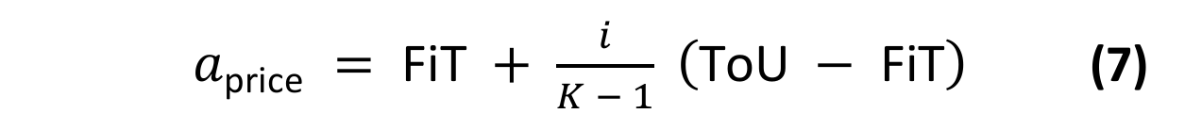
where i ∈ {0, 1, …, K−1}
3.6. Reward Functions
The reward structure reflects the economic objectives of the market participants. For sellers, the reward in Eq. (9) combines revenue from energy matched in the P2P market, obtained by multiplying the matched quantity q_{m} by the clearing price p_{clearing}, and revenue from exporting the unmatched quantity q_{u} to the grid at the FiT rate. A third, price-premium term rewards the seller in proportion to the margin earned above the FiT rate on the matched energy, scaled by β = 0.3, which signals the agent to sell above the FiT rate and encourages profitable P2P transactions. For buyers, the reward in Eq. (10) is the negative of the total procurement cost, so that minimizing cost is equivalent to maximizing reward; the quantity that remains unmatched in the P2P market is bought from the grid at the ToU price, which is higher than any attainable P2P price.
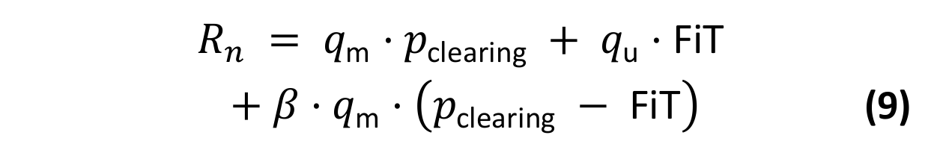
3.7. Multi-Agent Tabular Q-Learning
Tabular Q-Learning is used as the first adaptive pricing approach. The agent learns an action-value function Q(s, a), which estimates the discounted return obtained by choosing pricing action a in market state s and following the learned policy thereafter. After each trading step the agent observes the realized reward and the next state, and moves its current estimate towards the observed value by the temporal-difference rule in Eq. (11), where the step size α controls how strongly a single observation revises the estimate and the discount factor γ weights future rewards. Because every agent stores these values explicitly in a table, the learned policy can be inspected directly.
Action selection follows an ε-greedy policy: with probability ε the agent draws one of the 15 price levels uniformly at random, and otherwise it selects the level with the highest current Q-value. This balances exploration of untried prices against exploitation of what has already been learned. Exploration starts at ε = 1.0, so the first episode is fully random, and ε is multiplied by 0.985 after every episode until it reaches a floor of 0.05, which keeps a small amount of exploration active throughout training. The remaining learning hyperparameters are summarized in Table 1.
To keep the Q-table tractable and interpretable, the state representation is discretized. Each agent can act as either a seller or a buyer according to its net load, and each role is represented by a compact state built from the time slot and the surplus/demand level. Time is grouped into three buckets based on ToU periods (night/off-peak 00:00–08:00 and 20:00–24:00; daytime/solar 08:00–17:00; and evening peak 17:00–20:00), while surplus and demand are grouped into four kWh buckets (low, medium-low, medium-high and high). This yields 3 × 4 = 12 states per role.
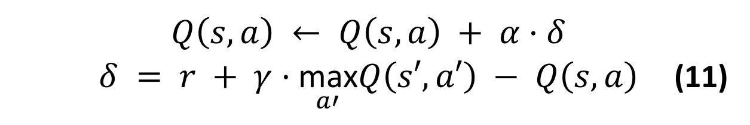
Table 1. Q-Learning hyperparameters.
Hyperparameter | Value | Description
Learning rate (α) | 0.1 | Q-value update step size
Discount factor (γ) | 0.95 | Present value of future rewards
Initial epsilon | 1.0 | Fully random exploration at episode 0
Minimum epsilon | 0.05 | Constant 5% exploration margin
Epsilon decay | 0.985 | Per-episode multiplicative decay

Tabular Q-Learning is transparent and interpretable because its explicit Q-values make the learned policy fully auditable; it is computationally lightweight and its two compact Q-tables converge reliably without specialized hardware. Its limitations are a discrete action space restricted to 15 fixed price levels, coarse state aggregation that maps distinct market conditions to the same bucket, and poor scalability as the number of agents, time periods or variables grow.
3.8. REINFORCE Neural Policy Model
To overcome the limitations of discrete pricing, a policy-gradient REINFORCE agent is implemented. Unlike Q-Learning, the policy directly outputs a continuous pricing coefficient within the feasible tariff range, and parameters are updated by minimizing the policy loss in Eq. (12), where G_{t} is the discounted return. During training the action is sampled from a Gaussian policy whose mean is the network output, so that the log-probability term in Eq. (12) is well defined; the sampled value is then clipped so that the resulting price remains bounded between the FiT and ToU limits. The model uses two separate networks for buyers and sellers that share the same architecture but keep independent weights.
Each policy network concatenates a 3-dimensional state observation with a 16-dimensional embedding produced by a price-history encoder, forming a 19-dimensional input that passes through two hidden layers of 64 units with ReLU activations and a final sigmoid output. The encoder maps each of the last 12 clearing prices through a shared linear projection, adds a learned positional embedding, applies a hyperbolic tangent activation and mean-pools the resulting vectors into a single summary. The activation is applied after the positional embedding is added, which is what makes the summary sensitive to the order of the price sequence rather than to its mean alone; the encoder therefore provides the policy with a compact representation of recent price dynamics at no additional parameter cost. The advantages of this approach are continuous price selection between FiT and ToU, awareness of recent price dynamics, and scalability to unseen states without large Q-tables. Its limitations are slower convergence, more limited interpretability and higher training variance compared with the tabular method.
Table 2. State-space representation of the neural policy.
Dimension | Seller | Buyer
s1 | hour / 47 | hour / 47
s2 | surplus / 10 | deficit / 10
s3 | avg_price / 0.5 | avg_price / 0.5

Table 2 lists the three normalized state dimensions observed by the seller and buyer policies, and Table 3 summarizes the shared network architecture. Each policy network has approximately 5,729 parameters including the time-series encoder, and two separate networks (one for buyers and one for sellers) are used, giving roughly 11,460 parameters per agent.
Table 3. Policy network architecture.
Layer | Dimensions | Parameters
Input | 3 + 16 = 19 | —
Linear + ReLU | 19 → 64 | 1,280
Linear + ReLU | 64 → 64 | 4,160
Linear + Sigmoid | 64 → 1 | 65
Total (+ encoder) | — | ≈ 5,729

3.9. Evaluation Metrics and Dataset
All pricing models are evaluated under identical market conditions using the same set of quantitative metrics. The P2P trading ratio ρ_{P2P} in Eq. (13) expresses the share of demand and surplus that is settled locally rather than through the grid, where EP2P is the total energy traded peer-to-peer over the day, EGridPur the total energy bought from the grid at the ToU price, and EGridSold the total surplus exported to the grid at the FiT rate, all measured in kWh. The average P2P price in Eq. (14) is the quantity-weighted mean of the clearing prices, where the index k runs over all trades executed during the simulation and q_{k} and p_{k} denote the quantity and the clearing price of trade k, the latter given by Eq. (2). The remaining metrics are seller revenue, buyer cost and the cumulative system reward. Seller revenue is the sum of P2P clearing income and grid FiT income, whereas buyer cost is the sum of P2P clearing cost and grid ToU cost. Together, these metrics jointly evaluate market efficiency, local energy utilization, economic performance and learning effectiveness.
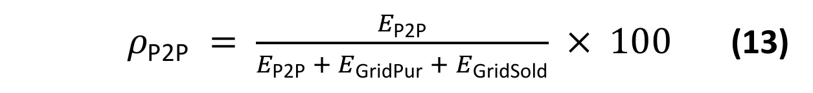
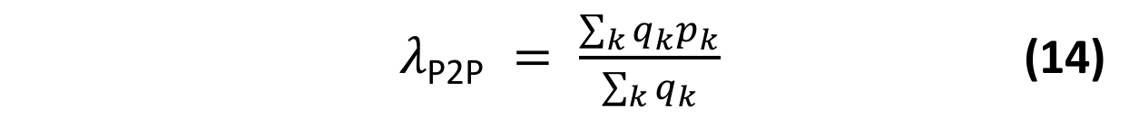
The simulation environment uses parametric daily profiles, sampled at the same 30-minute resolution as the market, whose shape is inspired by the daily load and generation patterns of the Australian Ausgrid smart-grid dataset [18], which contains residential load and rooftop PV measurements reported at 30-minute intervals. The same dataset underlies several P2P pricing studies [6], [19]–[23]; in particular, the population of four producers and four consumers adopted here mirrors the eight-household configuration of Qiu et al. [6], which facilitates a qualitative comparison with that line of work. PV generation is represented by a Gaussian curve peaking around solar noon and set to zero outside the interval 06:00–19:00. Demand is represented by a three-component profile with a morning peak around 08:00, a smaller midday component around 13:00 and a dominant evening peak around 18:30, superposed on a constant base load. Both profiles are scaled per agent and perturbed by Gaussian noise, so that no two agents receive identical profiles. The Ausgrid dataset is additionally used to calibrate the marginal-benefit function of Eq. (3): for each half-hourly slot the coefficients α_{MB} and β_{MB} are fitted from the maximum consumption recorded for the corresponding Ausgrid customer, so that willingness-to-pay falls from $0.28/kWh to $0.06/kWh across the observed demand range. This structure creates a mismatch between generation and consumption, so that agents naturally become sellers during high-solar periods and buyers during high-demand periods. It should be noted that the midday demand component coincides with the PV peak, so a certain degree of local supply–demand overlap is built into the profiles themselves.
Because the profiles are synthetic, their construction is given here in full. Let h ∈ {0, 0.5, …, 23.5} denote the hour of day at the start of a slot and n ∈ {0, …, 7} the agent index, where n = 0–3 are the producers Pr1–Pr4 and n = 4–7 the consumers C1–C4. The PV energy of producer n in a slot follows Eq. (15) and the load of every agent follows Eq. (16), in which G(h; μ, σ) = exp(−(h − μ)²/(2σ²)) and the three Gaussian terms are the morning, midday and evening components:
P_{n}^{pv}(h) = A_{n} · G(h; μ_{n}, 2.5) + ε (15)
P_{n}^{load}(h) = f_{n} · [ b + L · ( 0.6 · G(h; 8, 1.2)
+ 0.3 · G(h; 13, 1.0) + G(h; 18.5, 1.5) ) ] + ε (16)
In Eq. (15), A_{n} = 9.0 · (0.8 + 0.1n) kWh, μ_{n} = 12 + 0.3 · (n − 1.5) h and ε ∼ N(0, 0.25²); negative values are clipped to zero and the profile is set to zero for h < 6 and h > 19. In Eq. (16), f_{n} = 0.8 + 0.15n is an agent-specific scale factor; (b, L) = (0.8, 2.5) kWh with ε ∼ N(0, 0.2²) for the producers and (b, L) = (2.0, 5.8) kWh with ε ∼ N(0, 0.35²) for the consumers, and values below 0.5 kWh are raised to 0.5 kWh. A new noise realization is drawn for every simulated day from a seeded random generator. On the day used for evaluation (seed 1), the daily PV energy of the four producers is 88.8–121.7 kWh and their load 55.9–88.2 kWh, while the load of the four consumers is 236.9–314.5 kWh; the community-wide deficit and surplus over the day are D = 1263.64 kWh and S = 291.61 kWh. These magnitudes are well above those of a single household, so each agent should be read as an aggregated or representative participant rather than as an individual Ausgrid home; only the daily shape of the profiles is taken from the dataset.
The Ausgrid measurements enter the simulation in one place only, the calibration of Eq. (3). The file used is the 2011–2012 release of the solar home electricity data [18] (1 July 2011 to 30 June 2012, 300 customers), from which the general-consumption (GC) records of customers 1–4 are assigned to the consumers C1–C4; the producers, in the slots in which they act as buyers, use the calibration of customer 1. For each half-hourly slot τ, Q_{max}(τ) is the largest consumption recorded for that customer in that slot over the year, and the coefficients are set by Eq. (17), so that the willingness-to-pay equals ToU at zero quantity and falls to FiT at Q_{max}(τ):
α_{MB} = ToU,
β_{MB}(τ) = ln(ToU / FiT) / max{ Q_{max}(τ), 0.1 } (17)
With ToU = $0.28/kWh and FiT = $0.06/kWh, ln(ToU/FiT) = 1.54. The resulting Q_{max} values lie between 0.35 and 3.79 kWh per slot, whereas the simulated consumer demand reaches 14.5 kWh per slot; the marginal-benefit curve of the baseline is therefore evaluated mostly beyond its calibration range, a point taken up in Section 3.11 and listed among the limitations.
The remaining parameters are fixed as follows: block size u = 0.5 kWh, UILI decay rate κ = 0.15 kWh⁻¹ and reward coefficient β = 0.3. Each training episode is one simulated day with its own noise realization. Q-Learning is trained for 3000 episodes with the hyperparameters of Table 1, and REINFORCE for 7000 episodes with the Adam optimizer, a learning rate of 5 × 10⁻⁴, a discount factor of 0.95 and an exploration standard deviation that decays from 0.25 to 0.05 by a factor of 0.993 per episode. After training, the greedy Q-Learning policy (ε = 0) and the deterministic REINFORCE policy (no exploration noise) are evaluated on the day generated with seed 1, the same day on which the baseline is run. All values reported in Section IV refer to this single day and to one training run per method.
For benchmarking, the same load and PV profiles, agent population, 48-step daily structure, tariff boundaries and clearing mechanism are used for every experiment, so the only components that change between experiments are the pricing strategy and the state representation it uses.
3.10. System Architecture and Implementation
The simulation is implemented in Python with a modular, object-oriented architecture that separates the market environment, agent decision models, auction mechanism, profile data and evaluation logic into independent components. This separation makes it possible to test the baseline, Q-Learning and neural network-based agents under identical market rules and physical energy profiles. The system consists of five main components: an environment component that manages the simulation clock, daily time steps, agent observations and reward calculation; an agent component that represents the decision-making layer for each strategy; an auction component that performs order matching and price clearing; a profile component that supplies the Ausgrid-based load and PV data; and an evaluation component that computes the comparison metrics. All market conditions except the pricing strategy are held fixed to ensure a fair comparison.
3.11. Order Format, Feasibility Bound and Accounting Identities
This subsection formalizes three elements that are needed to interpret the results: the order format of each strategy, the physical upper bound on local trade, and the identities that link the energy and monetary quantities reported in Section IV.
Order format. Let q_{n}(t) = P_{n}^{net}(t) > 0 be the deficit of buyer n. A baseline buyer splits q_{n}(t) into J_{n} = ⌈q_{n}(t)/u⌉ blocks of size u (the last block holds the remainder) and prices block j = 0, …, J_{n} − 1 as in Eq. (18):
b_{n,j} = min{ ToU, m_{n} · α_{MB} · exp(−β_{MB} · j · u) } (18)
where m_{n} = 1 in the regular case. When the marginal benefit at the full quantity, MB(q_{n}, t), falls below a numerical price floor of $0.001/kWh, the curve is rescaled by m_{n} = 0.001/MB(q_{n}, t), so that it reaches the floor at the full quantity; on the evaluation day this applied to 74 of the 315 baseline buy orders. A Q-Learning or REINFORCE buyer instead submits one order (q_{n}(t), b_{n}) for its whole deficit, with b_{n} given by Eq. (7) or Eq. (8). A seller submits one order (q_{s}, a_{s}) for its whole surplus under all three strategies, with a_{s} given by Eq. (4) in the baseline and by Eq. (7) or Eq. (8) for the learners.
Because b_{n,j} decreases in j, a baseline buyer can trade only its leading blocks: a block is matched with an ask a_{s} only if b_{n,j} ≥ a_{s}. On the evaluation day, the buyers demanded 465.97 kWh in the slots in which at least one seller was present, but only 121.54 kWh of this quantity (26.1%) was bid at or above the lowest ask of the slot. A learning buyer, in contrast, makes its whole deficit tradable whenever b_{n} ≥ a_{s}. The gap between the baseline and the learning strategies therefore has two sources that the present experiments do not separate: the adaptation of prices through learning, and the order format itself (stepped marginal-benefit bids, evaluated largely beyond the calibration range of Eq. (17), against single-price bids). The baseline should accordingly be read as a rule-based reference with marginal-benefit bidding, not as a non-learning counterpart with an identical order format; an ablation with a common order format is part of the follow-up study.
Feasibility bound. Let S_{t} and D_{t} be the community-wide surplus and deficit in slot t, Eq. (19). Since energy cannot be stored, the energy traded locally in a slot cannot exceed either of them, which gives the upper bound E_{max} of Eq. (20) and the local matching efficiency η of Eq. (21):
S_{t} = Σ_{n} max{ −P_{n}^{net}(t), 0 },
D_{t} = Σ_{n} max{ P_{n}^{net}(t), 0 } (19)
E_{P2P} ≤ E_{max} = Σ_{t=1…48} min{ S_{t}, D_{t} } (20)
η = ( E_{P2P} / E_{max} ) × 100 (21)
All unmatched energy is settled with the grid, so the energy balances of Eq. (22) hold for every strategy, where D = Σ_{t} D_{t} and S = Σ_{t} S_{t}. Substituting them into Eq. (13) bounds the P2P trading ratio as in Eq. (23):
E_{GridPur} = D − E_{P2P}, E_{GridSold} = S − E_{P2P} (22)
ρ_{P2P} = E_{P2P} / (D + S − E_{P2P}) × 100
≤ ρ_{max} = E_{max} / (D + S − E_{max}) × 100 (23)
E_{max}, η and ρ_{max} depend only on the profiles and not on any pricing strategy. The bound is attained whenever every bid in a slot is at least as high as every ask; η therefore measures how much of the feasible local trade a strategy realizes, but not, by itself, how sophisticated the strategy is.
Monetary identities. The net revenue of the grid authority is its income from energy sold at ToU minus its payments for energy bought at FiT. Every P2P payment is a transfer between two members of the community, so the sum of the net costs C_{n} of all agents (Figure 2) equals this revenue, Eq. (24); using Eq. (22), it can be written as Eq. (25):
R_{grid} = ToU · E_{GridPur} − FiT · E_{GridSold}
= Σ_{n} C_{n} (24)
R_{grid} = ToU · D − FiT · S − (ToU − FiT) · E_{P2P} (25)
Each kWh traded locally therefore lowers the net payment of the community to the grid authority by exactly ToU − FiT = $0.22, independently of the clearing price. The clearing price only determines how this amount is shared: per kWh, the buyer saves ToU − p_{clearing} and the seller gains p_{clearing} − FiT. Finally, Tables 5 and 6 report group-level quantities. Let R_{sell} be the gross revenue of the producer agents Pr1–Pr4 (P2P income plus FiT income), C_{buy} the cost of the consumer agents C1–C4 (P2P purchases plus grid purchases at ToU) and C_{prod} the purchases of the producer agents in the slots in which they are net buyers. The identity of Eq. (26) then links the group-level values to the system-level revenue:
R_{grid} = C_{buy} + C_{prod} − R_{sell} (26)
IV. RESULTS AND DISCUSSION
4.1. Overall Market Performance
Three pricing models were evaluated under identical market conditions with four producer agents (Pr1–Pr4) and four consumer agents (C1–C4). Table 4 summarizes the overall market performance. Both learning-based approaches substantially outperform the baseline: P2P trading volume increased from 84.47 kWh to 219.15 kWh with Q-Learning and 245.49 kWh with the Neural Network (NN) model, and the P2P trading ratio increased from 5.7% to 16.4% with Q-Learning and 18.7% with the Neural Network model. At the same time, grid-purchased energy decreased by 11.4% and 13.7% respectively, while surplus energy exported to the grid decreased by 65.0% and 77.7%, showing that learning-based agents match local supply and demand far more effectively.
Table 4. Overall market performance of the three pricing models.
Metric | Base | QL | NN | ΔQL | ΔNN
P2P Ratio (%) | 5.7 | 16.4 | 18.7 | +186% | +226%
P2P Trading (kWh) | 84.47 | 219.15 | 245.49 | +159% | +191%
Grid Purchased (kWh) | 1179.2 | 1044.5 | 1018.2 | -11.4% | -13.7%
Grid Sold (kWh) | 207.15 | 72.46 | 46.12 | -65.0% | -77.7%
Avg. P2P Price ($/kWh) | 0.21 | 0.16 | 0.13 | -23.4% | -38.3%

Another notable outcome is the reduction in the average P2P clearing price. Compared with the baseline, the Neural Network model achieved the lowest average clearing price, reducing it by 38.3%. This contributed to lower buyer costs while still maintaining attractive revenues for sellers through increased transaction volume.
These volumes can be related to the feasibility bound of Section 3.11. For the simulated day, D = 1263.64 kWh and S = 291.61 kWh; surplus is available in 20 of the 48 slots and exceeds the community demand in 7 of them, so that E_{max} = 245.49 kWh and ρ_{max} = 18.7%. The local matching efficiency of Eq. (21) is 34.4% for the baseline, 89.3% for Q-Learning and 100% for the REINFORCE policy. The P2P ratio of 18.7% reached by the neural policy is thus the largest value attainable with these profiles: the remaining 46.12 kWh of exported energy is surplus for which no local demand exists in the same slot, and the modest absolute level of the ratio reflects the supply-to-demand ratio of the community (S/D = 0.23), not unexploited trade.
4.2. Seller Revenue Analysis
The impact of adaptive pricing on seller profitability was evaluated by comparing total seller revenues, reported in Table 5. Compared with the baseline, Q-Learning increased total seller revenue by approximately 30.5%, while the Neural Network model achieved an increase of 13.8%. Although FiT income decreased significantly, this reduction was compensated by substantially higher P2P trading activity: the learning agents successfully shifted energy sales from the grid market toward direct peer-to-peer transactions, resulting in higher overall revenues for producers. Table 5 covers the four producer agents (Pr1–Pr4) and reports their gross sales revenue; the energy that these agents buy outside PV hours is accounted for separately in Table 7.
Table 5. Seller revenue comparison ($).
Metric | Baseline | Q-Learning | REINFORCE-NN
P2P Income | 17.38 | 34.55 | 31.16
Grid FiT Income | 12.43 | 4.35 | 2.77
Total Seller Revenue | 29.81 | 38.90 | 33.93

4.3. Buyer Cost Analysis
Buyer-side performance was evaluated by measuring total energy expenditure, shown in Table 6. The learning-based models reduced total buyer cost. The Neural Network approach achieved the lowest overall buyer cost at $272.42, corresponding to a 10.3% reduction relative to the baseline, while Q-Learning produced a reduction of approximately 6.8%. These findings suggest that adaptive pricing creates mutually beneficial outcomes in which sellers earn higher revenues while buyers pay lower overall costs. Agent-level analysis confirmed this: all consumer agents (C1–C4) experienced lower net costs, and producer agents generally obtained higher revenues through increased P2P participation. Table 6 covers the four consumer agents (C1–C4) only, whereas the grid-purchased energy in Table 4 is the total over all eight agents; the two are reconciled in Table 7.
Table 6. Buyer cost comparison ($).
Metric | Baseline | Q-Learning | REINFORCE-NN
P2P Purchase Cost | 17.06 | 34.53 | 31.16
Grid ToU Cost | 286.67 | 248.66 | 241.26
Total Buyer Cost | 303.73 | 283.18 | 272.42

Figure 2 shows the net cost of each individual producer (Pr1-Pr4) and consumer (C1-C4) agent under the three strategies. The consumer agents, which dominate the total cost, consistently move to lower net costs under both learning-based strategies, confirming at the agent level the aggregate savings reported in Table 6.
System-wide reconciliation and grid authority revenue. Tables 4–6 are defined over different groups of agents, and Table 7 reconciles them through the identities of Section 3.11. The grid-purchased energy of Table 4 (1179.17 kWh in the baseline) is the sum of the purchases of the consumers (1023.83 kWh) and of the producers (155.34 kWh), the latter occurring when PV generation does not cover the producers’ own load. Multiplying the consumer part by the constant ToU price gives the Grid ToU Cost of Table 6 (1023.83 kWh × $0.28/kWh = $286.67), and the same holds for the learning strategies (888.05 kWh and 861.63 kWh, giving $248.66 and $241.26). The producer part ($43.50, $43.80 and $43.82) appears in neither Table 5 nor Table 6. Likewise, the P2P income of Table 5 exceeds the P2P purchase cost of Table 6 by $0.32 in the baseline and by $0.02 under Q-Learning because producers bought 1.17 kWh and 0.08 kWh, respectively, from other producers; these purchases are a cost of the producer group, not of the consumers. With these items included, Eq. (26) closes for all three strategies.
The last rows of Table 7 give the revenue of the grid authority. Its net revenue, which by Eq. (24) equals the net payment of the whole community, falls from $317.74 in the baseline to $288.11 under Q-Learning (−9.3%) and to $282.31 under REINFORCE (−11.1%). In agreement with Eq. (25), these reductions equal, up to rounding, (ToU − FiT) times the additional energy traded locally: 0.22 × (219.15 − 84.47) = $29.63 and 0.22 × (245.49 − 84.47) = $35.42. The gain of the community is therefore exactly the margin that the grid authority no longer earns on energy that is produced and consumed locally; whether such a reduction is acceptable to the grid authority, for instance in exchange for lower network loading, is a regulatory question outside the scope of this study. The split of the gain between the two sides of the market follows from the average clearing price: of the $0.22 available per traded kWh, the buying side retains 34% in the baseline, 56% under Q-Learning and 70% under REINFORCE. At the level of individual agents the gains are not uniform: under the REINFORCE policy the net cost of Pr1 and Pr4 is higher than in the baseline (Figure 2), although the producer group as a whole is better off (Table 7).
Table 7. Reconciliation of Tables 4–6 and grid authority revenue.
Quantity | Baseline | Q-Learning | REINFORCE-NN
Grid purchases, consumers (kWh) | 1023.83 | 888.05 | 861.63
Grid purchases, producers (kWh) | 155.34 | 156.43 | 156.52
Consumer cost C_{buy} ($) | 303.73 | 283.18 | 272.42
Producer grid cost at ToU ($) | 43.50 | 43.80 | 43.82
Producer P2P purchases ($) | 0.32 | 0.02 | 0.00
Producer revenue R_{sell} ($) | 29.81 | 38.90 | 33.93
Producer group net cost ($) | 14.01 | 4.92 | 9.89
Grid sales at ToU ($) | 330.17 | 292.46 | 285.08
Grid FiT payments ($) | 12.43 | 4.35 | 2.77
Grid net revenue R_{grid} ($) | 317.74 | 288.11 | 282.31
Change in R_{grid} | — | −9.3% | −11.1%
Matching efficiency η (%) | 34.4 | 89.3 | 100.0
Values are rounded to two decimals, so sums may differ by ±0.01.
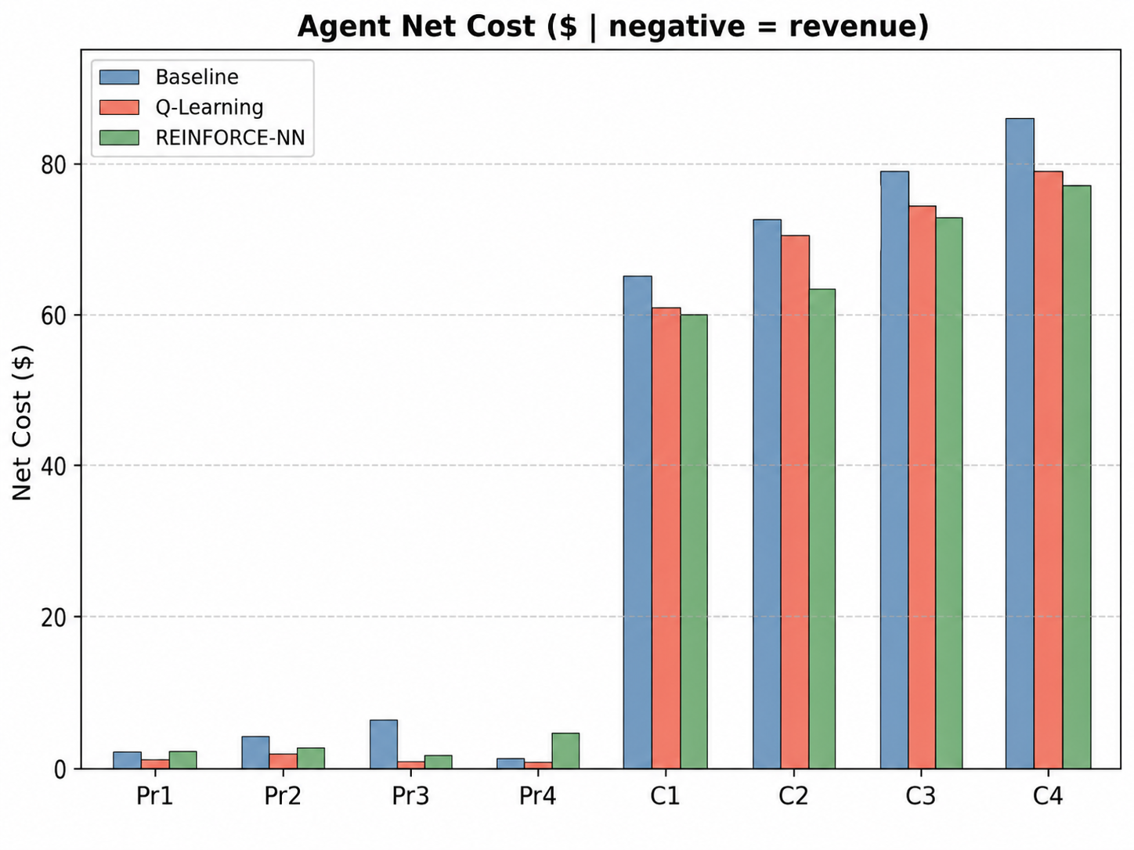
Figure 2. Net cost of individual producer and consumer agents.
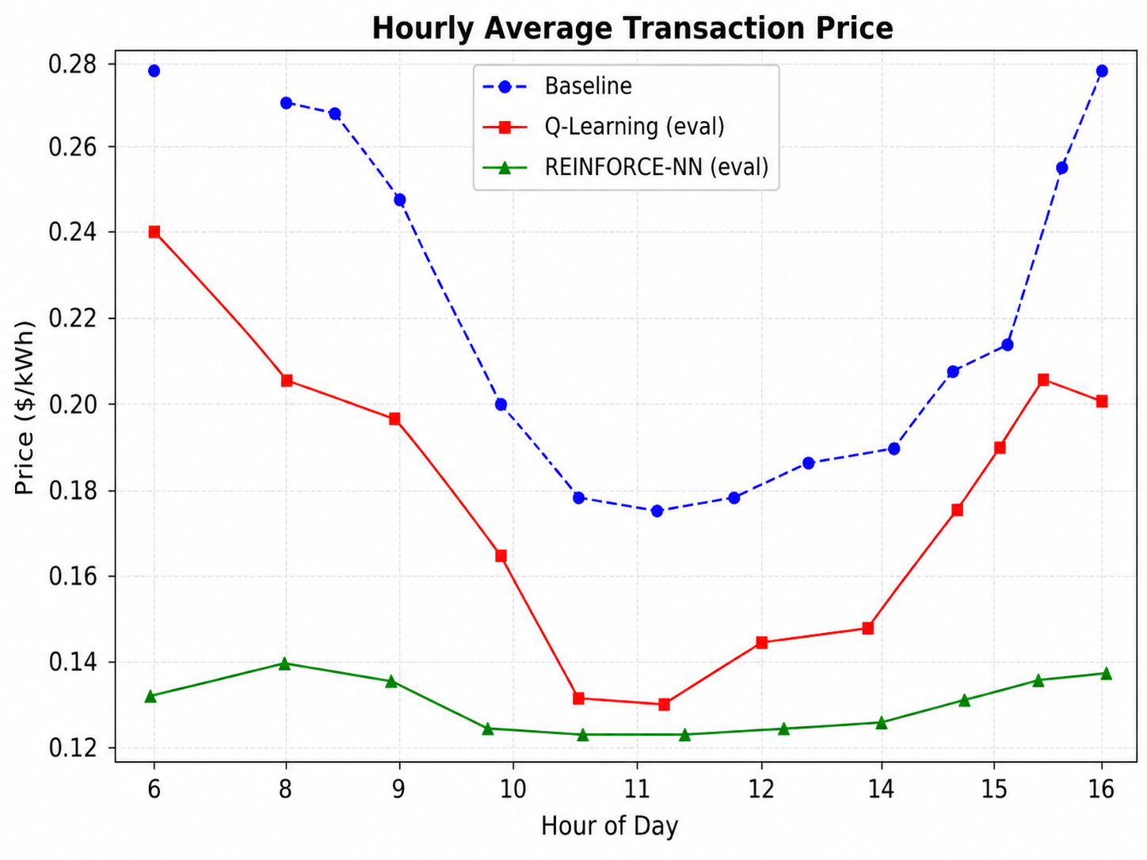
Figure 3. Hourly average clearing price for the three pricing strategies.
4.4. Price Dynamics and Market Behaviour
The average hourly clearing price, shown in Figure 3, provides insight into how each pricing strategy influences market behaviour. The baseline model produced the highest clearing prices throughout most of the trading period, whereas both learning-based models converged toward lower and more stable market prices, with the Neural Network approach generating the lowest average prices during most trading hours. Lower clearing prices reduced buyer costs while still maintaining attractive revenues for sellers through increased transaction volume. The transaction-volume analysis in Figure 4 shows that learning agents consistently generated more P2P trades during peak solar-production hours, indicating that adaptive pricing improved the matching efficiency between local energy supply and demand.
The concentration of P2P trades around midday reflects the overlap between high PV generation and local consumption that the learning agents were able to exploit; as noted in Section 3.9, part of this overlap is built into the demand profile itself, so the effect should be attributed to the pricing strategies only to the extent that it exceeds the baseline.
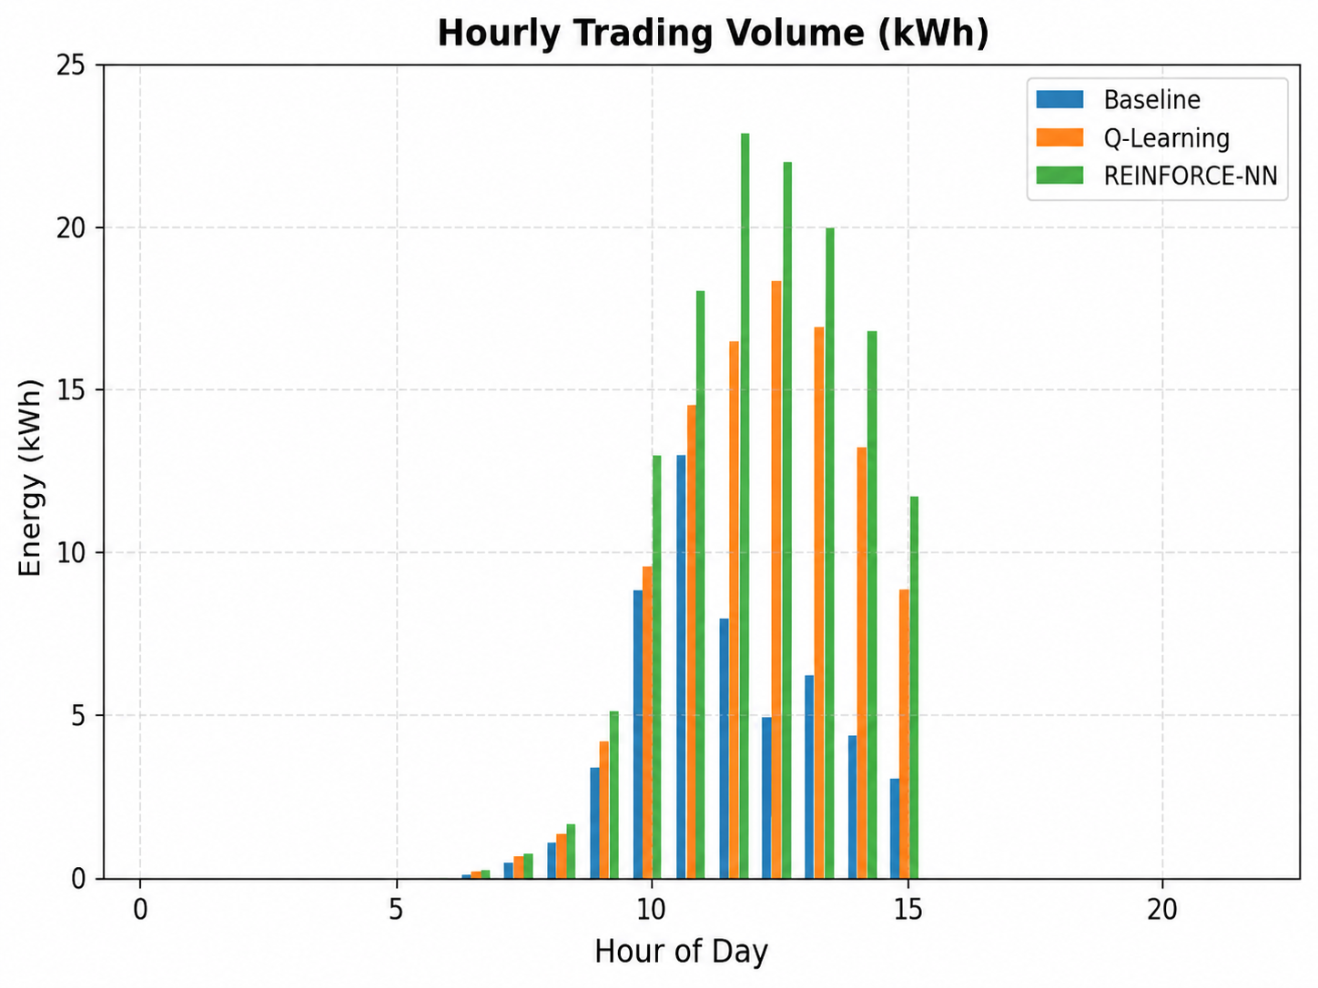
Figure 4. Hourly transaction volume (kWh) for the three pricing strategies.
4.5. Learning Performance
The learning progress of both reinforcement learning approaches was evaluated using the cumulative system reward during training, shown in Figure 5. Both models improved over time and converged toward stable policies. Q-Learning exhibited faster initial convergence due to its discrete action space, while the Neural Network model required more training episodes but ultimately achieved slightly better market-level outcomes in terms of P2P ratio, grid dependency and buyer cost, whereas Q-Learning yielded higher seller revenue.
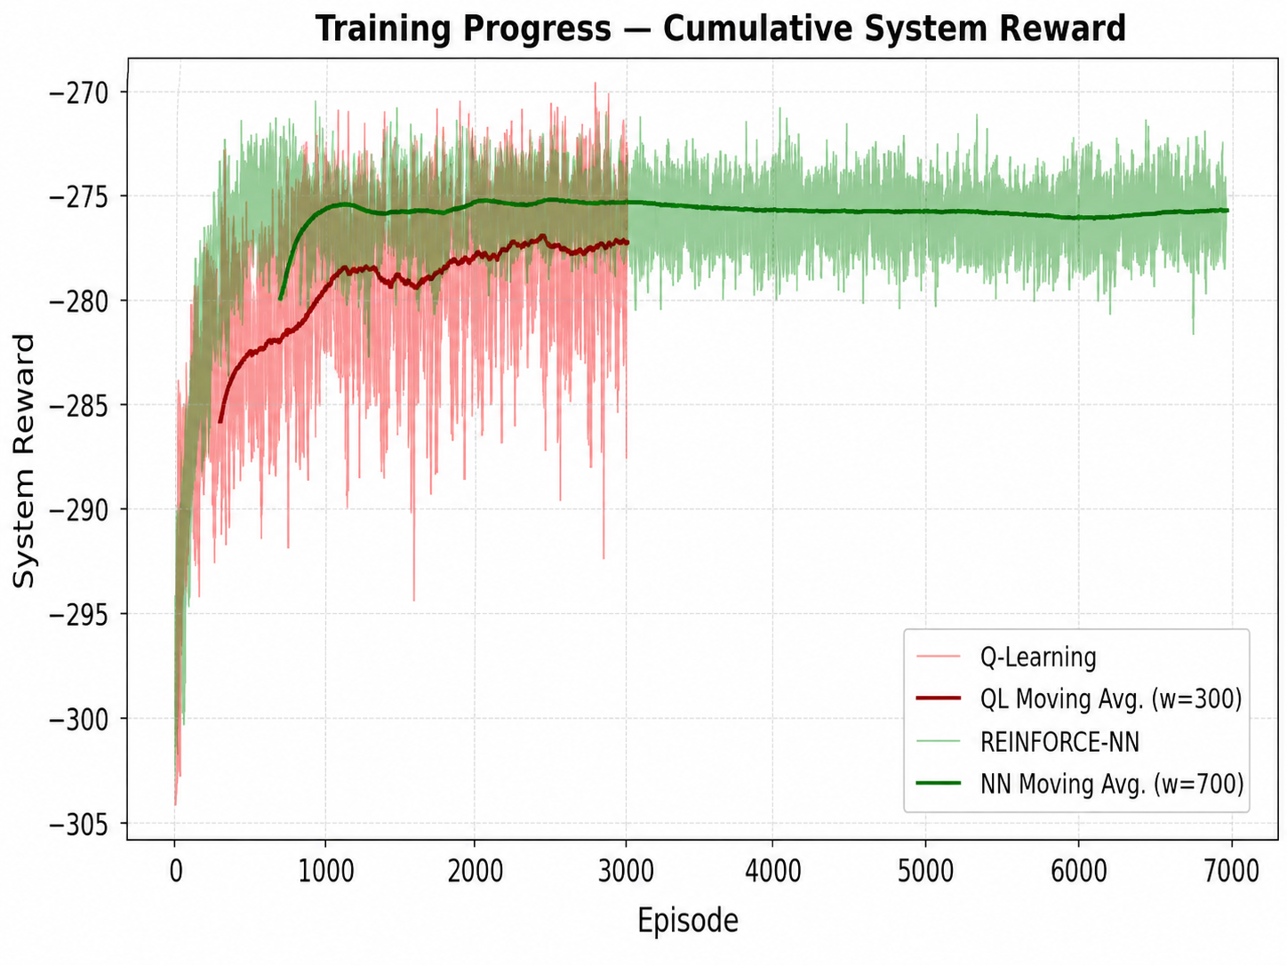
Figure 5. Training progress – cumulative system reward.
4.6. Discussion
The experimental results demonstrate a significant improvement in local market efficiency and community welfare when shifting from static pricing rules to reinforcement learning frameworks. In the baseline scenario, producer agents follow a static Use-It-or-Lose-It rule that does not adapt to observed market conditions. Because the resulting ask prices remain well above the level at which most buyer blocks clear, only 84.47 kWh of the 291.61 kWh of available surplus is traded locally and the remaining 71% is exported to the grid at the unfavourable FiT rate, yielding a low total revenue of $29.81. Note that the grid tariffs and the clearing mechanism are identical across all three strategies, so this outcome is attributable to the pricing rule rather than to the market structure. With Multi-Agent Tabular Q-Learning, sellers dynamically discover localized demand and increase their revenue to $38.90. Under the REINFORCE-NN policy, total revenue settles at $33.93: compared with Q-Learning, the continuous policy cleared a larger volume (245.49 kWh against 219.15 kWh) at a substantially lower average price ($0.13 against $0.16 per kWh), so the higher turnover did not compensate for the reduced margin.
On the consumer side, the economic advantages of both learning models are prominent. Baseline consumers incur an expensive total procurement cost of $303.73 due to their reliance on grid purchases at the constant ToU price. Multi-agent learning reduces this dependency, lowering total buyer cost to $283.18 under Q-Learning and to $272.42 under REINFORCE-NN. The two learning strategies therefore distribute the gains differently: the discrete Q-Learning policy sustains higher clearing prices and yields the larger seller revenue, whereas the continuous REINFORCE-NN policy clears more energy at lower prices and delivers the larger saving to buyers. The restricted action set of Q-Learning is also visible as a more volatile hourly price path in Figure 3. By reducing financial leakage to the centralized utility grid, adaptive pricing supports a more autonomous and mutually beneficial localized energy market.
Table 8 positions the present study among existing works that use the Ausgrid dataset for P2P pricing. A direct numerical comparison is not meaningful, because the studies differ in the number of households, the tariff levels, the presence of storage and the way the data are used: prior works replay the measured household traces, whereas this study uses the dataset to shape the daily profiles and to calibrate the marginal-benefit function. The closest configuration is that of Qiu et al. [6], who report for eight Ausgrid households with energy storage that learned bidding raised internally traded energy from 31.74 kWh under a zero-intelligence strategy to 65.42 kWh and lowered the total energy bill from $38.32 under grid-only trading to $30.78. The trend observed here is consistent with that result: learned pricing increases local trading (84.47 kWh to 245.49 kWh) and reduces buyer cost ($303.73 to $272.42) relative to a non-learning baseline. Unlike the studies in Table 8, which each evaluate a single learning or clearing method, this work compares a rule-based, a tabular and a neural policy under one identical market.
Table 8. Studies using the Ausgrid dataset for P2P energy pricing.
Study | Use of Ausgrid data | Market / pricing | Method
Qiu et al. [6] | 8 households (4 prosumers, 4 consumers) | Double-side auction, ToU/FiT bounds | DA-MADDPG
Sanayha and Vateekul [19] | Households grouped into clusters | P2P trading across clusters | Model-based multi-agent DRL
Uthayansuthi and Vateekul [20] | 300 households | P2P trading without information sharing | Model-based DRL
Liyanage and Islam [21] | 6 households, Jul 2012–Jun 2013 | Double auction: average, TR and VCG clearing | Auction clearing rules (no learning)
Kochupurackal et al. [22] | 6 houses, summer and winter days | P2P trading between fixed utility and feed-in rates | Rolling-horizon optimisation
Moniruzzaman et al. [23] | Ausgrid data with IEEE 14-bus network | Cooperative game, blockchain settlement | Game theory (no learning)
This work | Profile shape and marginal-benefit calibration; 4 producers, 4 consumers | Partial-match double auction, ToU/FiT bounds | Rule-based, Q-Learning, REINFORCE

4.7. Benefits, Impact and Considerations
Beyond the quantitative metrics, the framework has broader implications. Economically, the simulation shows that adaptive pricing can reduce buyer costs while increasing seller revenues, giving prosumers an alternative to monetizing unused renewable generation at low FiT rates and letting consumers buy locally available surplus energy below the ToU tariff. Environmentally, by increasing local energy matching, the proposed system supports better utilization of distributed renewable energy and reduces unnecessary export to the grid. In doing so, it may strengthen the incentive for prosumers to invest in and deploy renewable energy sources. It is highly possible that the net effect will be lower carbon emissions, driven by the wider deployment and higher local consumption of green energy; however, the simulation contains no emission or generation-mix model, so this effect is an expectation that was not measured in the present study.
Socially, peer-to-peer energy trading supports a more participatory ecosystem in which users are not only passive consumers but can become active market participants. The model also supports a fully decentralized learning architecture: each agent maintains its own policy parameters and updates them from its own reward signal, without sharing gradients, model weights or private cost parameters with a central learner. The only information exchanged between participants is the aggregate clearing price. The project further has an indirect relationship with energy security: a decentralized P2P model can encourage local balancing of supply and demand and reduce dependency on centralized grid purchases, supporting more resilient community-level energy systems. This relationship is a qualitative inference from the reduction in grid purchases (Table 4); no reliability or security-of-supply indicator was computed.
From a sustainability perspective, the framework is modular and extensible, so future versions can include battery storage, electric vehicles, demand response and larger agent populations. All these benefits should be interpreted at the conceptual and simulation level; a real deployment would require regulatory approval, reliable metering infrastructure, strong cybersecurity mechanisms and coordination with grid operators.
4.8. Scope of the Results, Market Size and Demand Elasticity
Scope. The learning results of this section were obtained for one population (four producers and four consumers), one evaluation day and one training run per method, and the noise realization of the evaluation day was also part of the training sequence. They are therefore a proof of concept for the modelled configuration, not a statistical statement about local energy markets in general, and no confidence intervals can be given for the learning strategies. The population of eight agents was chosen for two reasons: it reproduces the eight-household configuration that Qiu et al. [6] built from the same dataset, and it keeps the market small enough for every order and trade to be inspected.
Market size and supply–demand mix. Retraining the learning agents for other populations is left to the follow-up study. What can be established without retraining is how the environment itself changes with the population, because the bounds of Eqs. (20) and (23) and the rule-based baseline involve no learning. Table 9 reports these quantities for five populations produced by the same profile generator, as the mean and standard deviation over 30 independently generated days; agents without an individual calibration reuse the marginal-benefit calibration of the first Ausgrid customer. For balanced populations of 8, 10 and 20 agents the attainable P2P ratio is 19.0%, 18.4% and 17.6%, and the baseline realizes 34.0%, 35.5% and 32.2% of the feasible local trade, so the size of the market alone changes neither the bound nor the headroom left to a pricing strategy by more than a few percentage points. The supply–demand mix matters far more: with six producers and two consumers only 40% of the surplus can be absorbed locally (ρ_{max} = 14.4%), whereas with two producers and six consumers all surplus is absorbable and the baseline already realizes 67.4% of it. For the population studied here, the baseline traded 84.0 ± 1.8 kWh over the 30 days, so the value of 84.47 kWh obtained on the evaluation day is representative. Table 9 does not show how the learned policies behave in larger markets, where more competing orders per slot and a more non-stationary learning problem are expected; this, together with repeated training runs, is the first item of the follow-up study.
Table 9. Feasibility bound and rule-based baseline for different populations (mean ± standard deviation over 30 days; no learning involved).
Population (Pr + C) | S/D | E_{max} (kWh) | ρ_{max} (%) | Baseline E_{P2P} (kWh) | Baseline η (%)
4 + 4 | 0.23 | 247.0 ± 3.0 | 19.0 ± 0.2 | 84.0 ± 1.8 | 34.0 ± 0.6
5 + 5 | 0.25 | 266.7 ± 3.1 | 18.4 ± 0.2 | 94.7 ± 1.7 | 35.5 ± 0.6
10 + 10 | 0.25 | 502.8 ± 4.5 | 17.6 ± 0.2 | 161.7 ± 2.6 | 32.2 ± 0.5
6 + 2 | 0.45 | 160.6 ± 2.3 | 14.4 ± 0.2 | 52.4 ± 2.7 | 32.6 ± 1.4
2 + 6 | 0.08 | 132.7 ± 2.0 | 8.5 ± 0.1 | 89.4 ± 2.3 | 67.4 ± 1.4

Volume versus price. Because E_{max} is reached whenever all bids in a slot are at least as high as all asks, a non-adaptive rule in which buyers bid ToU and sellers ask FiT would also clear E_{max}, at the midpoint price of $0.17/kWh. The contribution of learning in this market should therefore be judged less by the traded volume than by the prices that the agents discover without knowing the valuations of the others, and by how these prices divide the gain of $0.22/kWh between the two sides (Section 4.3).
Inelastic demand. Since demand is inelastic (Section 3.1), the outside option of a buyer is always a purchase at ToU and that of a seller a sale at FiT. Every clearing price strictly between FiT and ToU is consequently beneficial for both parties; a bid only influences whether, and at what price, the fixed quantity is matched, and the learned bids and asks settle inside the tariff band, at an average price of $0.158/kWh for Q-Learning and $0.127/kWh for REINFORCE. Inelasticity also fixes E_{max}: the 46.12 kWh of surplus that finds no local demand cannot be used by any pricing strategy. If demand were elastic or shiftable, prices would additionally change the traded quantities: load moved into the seven surplus slots could raise E_{max} up to the total surplus of 291.61 kWh, and low midday prices would then act as the signal for such shifts. Modelling this response, together with storage, requires a utility model for consumption and is left to future work.
V. CONCLUSION
This work presented an agent-based simulation framework for adaptive peer-to-peer energy trading in a decentralized market environment. The main objective was to investigate whether autonomous agents can learn effective pricing strategies under a double auction mechanism and improve market outcomes compared with static rule-based pricing. The developed model represents a local electricity market in which producer and consumer agents interact under incomplete information, while the traditional grid acts as an outside option through FiT and ToU pricing.
The experimental results show that learning-based pricing strategies improve the overall performance of the simulated P2P market. Compared with the baseline, both tabular Q-Learning and neural network-based agents increased local energy trading and reduced dependency on grid-based transactions. The most successful configuration increased P2P trading volume by approximately 190%, while also reducing buyer costs and improving seller revenues under the modelled conditions. The comparison between the two learning approaches also provides a clear methodological insight: tabular Q-Learning is transparent, lightweight and easy to interpret, but limited by its discrete action space and coarse state representation, whereas the neural network approach enables continuous pricing and temporal awareness at the cost of slower convergence, higher variance and lower interpretability. This work therefore highlights a trade-off between explainability and performance in learning-based market agents.
The current simulation has several limitations: it uses a limited number of agents and simplified market assumptions, models electrical energy as non-storable, and excludes transaction costs and physical network constraints. Because there is no energy storage, the temporal coupling between time steps is limited. Future work can increase the number and diversity of agents; integrate battery storage so that agents can learn when to store, consume, sell or buy energy; add an explicit producer cost function; and include transaction costs, grid-capacity limits and regulatory constraints. More advanced multi-agent reinforcement learning methods, such as actor-critic models may further improve the performance. Finally, because the underlying agent-based auction framework is market-agnostic, it can be adapted to other decentralized markets in which autonomous buyers and sellers interact under incomplete information.
This study should be read as a preliminary investigation. Its results are limited to one eight-agent community, one evaluation day and one training run per method; the three strategies differ in their inputs and, between the baseline and the learners, in their order format; the synthetic profiles are larger than household-scale data, so the Ausgrid-calibrated marginal-benefit curve of the baseline is used mostly outside its calibration range; demand is inelastic; and the environmental and energy-security benefits discussed in Section 4.7 were not quantified. A follow-up study is planned to address these points by (i) retraining and evaluating the learning agents for populations of 10 and 20 agents and for different producer–consumer mixes, (ii) repeating the training over multiple random seeds and reporting confidence intervals, (iii) running ablations in which all strategies share the same inputs and the same order format, and (iv) introducing household-scale profiles, elastic demand and storage.
ACKNOWLEDGMENT
The authors would like to express their sincere gratitude to the faculty members of the Marmara University Computer Engineering Department.
REFERENCES
[1] W. Tushar, T. K. Saha, C. Yuen, D. Smith, and H. V. Poor, “Peer-to-peer trading in electricity networks: An overview,” IEEE Transactions on Smart Grid, vol. 11, no. 4, pp. 3185–3200, (2020). DOI: 10.1109/TSG.2020.2969657.
[2] K. Erdayandi and M. A. Mustafa, “PP-LEM: Efficient and privacy-preserving clearance mechanism for local energy markets,” Sustainable Energy, Grids and Networks, vol. 39, p. 101477, (2024). DOI: 10.1016/j.segan.2024.101477.
[3] T. Capper, A. Gorbatcheva, M. A. Mustafa, M. Bahloul, J. M. Schwidtal, R. Chitchyan, M. Andoni, V. Robu, M. Montakhabi, I. J. Scott, et al., “Peer-to-peer, community self-consumption, and transactive energy: A systematic literature review of local energy market models,” Renewable and Sustainable Energy Reviews, vol. 162, p. 112403, (2022). DOI: 10.1016/j.rser.2022.112403.
[4] X. Liang, “Emerging power quality challenges due to integration of renewable energy sources,” IEEE Transactions on Industry Applications, vol. 53, no. 2, pp. 855–866, (2016). DOI: 10.1109/TIA.2016.2626253.
[5] K. Erdayandi, L. C. Cordeiro, and M. A. Mustafa, “Towards privacy preserving local energy markets,” in Competitive Advantage in the Digital Economy (CADE 2022): Resilience, Sustainability, Responsibility, and Identity, IET, (2022), pp. 127–134. DOI: 10.1049/icp.2022.2053.
[6] D. Qiu, J. Wang, J. Wang, and G. Strbac, “Multi-agent reinforcement learning for automated peer-to-peer energy trading in double-side auction market,” in Proc. 30th Int. Joint Conf. Artificial Intelligence (IJCAI-21), pp. 2913–2920, (2021). DOI: 10.24963/ijcai.2021/401.
[7] J. Jiang, Y. Li, L. Hou, M. Ghafouri, P. Zhang, J. Yan, and Y. Liu, “Deep reinforcement learning-based bidding strategies for prosumers trading in double auction-based transactive energy market,” arXiv preprint arXiv:2502.15774, (2025). DOI: 10.48550/arXiv.2502.15774.
[8] K. Erdayandi, L. C. Cordeiro, and M. A. Mustafa, “Privacy-preserving and accountable billing in peer-to-peer energy trading markets with homomorphic encryption and blockchain,” Sustainable Energy, Grids and Networks, vol. 41, p. 101568, (2025). DOI: 10.1016/j.segan.2024.101568.
[9] R. G. Palmer, W. B. Arthur, J. H. Holland, B. LeBaron, and P. Tayler, “Artificial economic life: A simple model of a stockmarket,” Physica D: Nonlinear Phenomena, vol. 75, no. 1–3, pp. 264–274, (1994). DOI: 10.1016/0167-2789(94)90287-9.
[10] B. LeBaron, “Building the Santa Fe artificial stock market,” Physica A: Statistical Mechanics and its Applications, vol. 314, no. 1–4, pp. 1–20, (2002).
[11] M. Raberto, S. Cincotti, S. M. Focardi, and M. Marchesi, “Agent-based simulation of a financial market,” Physica A: Statistical Mechanics and its Applications, vol. 299, no. 1–2, pp. 319–327, (2001). DOI: 10.1016/S0378-4371(01)00312-0.
[12] Z. Yao, Z. Li, M. Thomas, and I. Florescu, “Reinforcement learning in agent-based market simulation: Unveiling realistic stylized facts and behavior,” arXiv preprint arXiv:2403.19781, (2024). DOI: 10.48550/arXiv.2403.19781.
[13] C. Deissenberg, S. van der Hoog, and H. Dawid, “EURACE: A massively parallel agent-based model of the European economy,” Applied Mathematics and Computation, vol. 204, no. 2, pp. 541–552, (2008). DOI: 10.1016/j.amc.2008.05.116.
[14] D. Huh and P. Mohapatra, “Multi-agent reinforcement learning: A comprehensive survey,” arXiv preprint arXiv:2312.10256, (2023). DOI: 10.48550/arXiv.2312.10256.
[15] A. Karpathy, “Deep reinforcement learning: Pong from pixels,” Andrej Karpathy Blog, (2016). [Online]. Available: http://karpathy.github.io/2016/05/31/rl/
[16] J. A. Taylor and J. L. Mathieu, “Strategic bidding in electricity markets with only renewables,” in Proc. American Control Conference (ACC), pp. 5885–5890, (2016). DOI: 10.1109/ACC.2016.7526592.
[17] E. L. Ratnam, S. R. Weller, C. M. Kellett, and A. T. Murray, “Residential load and rooftop PV generation: An Australian distribution network dataset,” International Journal of Sustainable Energy, vol. 36, no. 8, pp. 787–806, (2017). DOI: 10.1080/14786451.2015.1100196.
[18] Ausgrid, “Solar home electricity data,” Open Data Repository, 2013. [Online]. Available: https://www.ausgrid.com.au/
[19] M. Sanayha and P. Vateekul, “Model-based approach on multi-agent deep reinforcement learning with multiple clusters for peer-to-peer energy trading,” IEEE Access, vol. 10, pp. 127882–127893, (2022). DOI: 10.1109/ACCESS.2022.3224460.
[20] N. Uthayansuthi and P. Vateekul, “Optimization of peer-to-peer energy trading with a model-based deep reinforcement learning in a non-sharing information scenario,” IEEE Access, vol. 12, pp. 111021–111034, (2024). DOI: 10.1109/ACCESS.2024.3442445.
[21] K. K. G. H. Liyanage and S. N. Islam, “Comparative analysis of market clearing mechanisms for peer-to-peer energy market based on double auction,” Energies, vol. 17, no. 22, p. 5708, (2024). DOI: 10.3390/en17225708.
[22] A. Kochupurackal, K. P. Pancholi, S. N. Islam, A. Anwar, and A. M. T. Oo, “Rolling horizon optimisation based peer-to-peer energy trading under real-time variations in demand and generation,” Energy Systems, vol. 14, no. 2, pp. 541–565, (2023). DOI: 10.1007/s12667-022-00511-w.
[23] M. Moniruzzaman, A. Yassine, and R. Benlamri, “Blockchain and cooperative game theory for peer-to-peer energy trading in smart grids,” International Journal of Electrical Power & Energy Systems, vol. 151, p. 109111, (2023). DOI: 10.1016/j.ijepes.2023.109111.
[24] A. J. M. Kell, A. S. McGough, and M. Forshaw, “Optimizing a domestic battery and solar photovoltaic system with deep reinforcement learning,” arXiv preprint arXiv:2109.05024, (2021). DOI: 10.48550/arXiv.2109.05024.
[25] M. A. Husnoo, A. Anwar, N. Hosseinzadeh, S. N. Islam, A. N. Mahmood, and R. Doss, “A secure federated learning framework for residential short term load forecasting,” arXiv preprint arXiv:2209.14547, (2022). DOI: 10.48550/arXiv.2209.14547.

