RESEARCH ARTICLE / ARAŞTIRMA MAKALESİ
Reinforcement Learning Based Pricing Strategies in Local Energy Markets
Hikmet TOPAK ¹, Efe YALIM ¹, Emirhan ÜNSAL ¹, Mehmet Kadir BARAN ¹, Kamil ERDAYANDI ¹
¹Marmara University, Faculty of Engineering, Department of Computer Engineering, İstanbul, Türkiye
Abstract
This study presents an agent-based simulation framework for optimizing market strategies in a decentralized peer-to-peer (P2P) electricity trading environment. In conventional grid systems, prosumers sell surplus renewable energy at low Feed-in Tariff (FiT) rates, while consumers purchase electricity at higher Time-of-Use (ToU) prices, creating an economic inefficiency that static, rule-based pricing mechanisms cannot resolve in a market where supply and demand change dynamically over time. To reduce this gap, a decentralized market is modelled in which autonomous producer and consumer agents trade energy directly through a discrete-time double auction mechanism. The proposed system uses 48 daily time steps, heterogeneous agents, incomplete market information and non-storable electrical energy. A zero-intelligence baseline that prices its orders uniformly at random, with the same order format as the learning agents, is first implemented as an uninformed reference; two reinforcement learning based approaches, Multi-Agent Tabular Q-Learning and a Neural Network-based (REINFORCE) policy model, are then developed and compared. The strategies are evaluated for four communities (4+4, 10+10 and 20+20 producers and consumers, and a consumer-heavy 10+20 mix) over five random seeds. The learning agents realize 95–100% of the physically feasible local trade in every community, against 57–65% for the random baseline, and lower the net revenue of the grid authority by 3–8%. Q-Learning sustains higher clearing prices and yields the larger seller revenue, whereas the REINFORCE policy clears the largest volume and gives the lowest buyer cost; when supply is scarce, the gain shifts towards the sellers. Adding one or two hidden layers to the policy network does not improve these outcomes but lengthens training by 13–40%, and training time grows approximately linearly with the number of agents. This work is a preliminary study: it relies on synthetic single-day profiles, inelastic demand and no storage, and a follow-up study will address controlled ablations, unseen evaluation days, elastic demand and storage.
Keywords: Peer-to-peer electricity trading, Multi-agent reinforcement learning, Double auction, Q-learning, REINFORCE, Adaptive pricing
I. INTRODUCTION
The increasing use of distributed renewable energy resources is changing the structure of traditional electricity markets [1]. In conventional grid systems, consumers only purchase electricity from centralized utilities, while small-scale renewable energy producers sell their surplus energy back to the grid. However, this structure often creates an economic inefficiency: prosumers are usually compensated at relatively low Feed-in Tariff (FiT) rates for their surplus energy, whereas consumers purchase electricity from the grid at higher Time-of-Use (ToU) prices [6]. As a result, locally generated renewable energy is undervalued when exported to the grid, while nearby consumers continue to pay higher retail prices.
Peer-to-peer (P2P) electricity trading provides a decentralized alternative to this traditional market structure [3]. Instead of routing all transactions through a central utility, local buyers and sellers can trade energy directly with each other. In such a market, sellers may receive a better price than the FiT rate, while buyers may purchase energy at a lower price than the retail price [2]. Therefore, P2P trading has the potential to increase the local utilization of renewable energy, reduce dependency on the central grid, and create mutually beneficial outcomes for both producers and consumers [1]. Tanis et al. [28] review P2P energy trading in terms of market structure, operational layers, energy cooperatives and multi-energy systems, and note that such trading can reduce peak demand, reserve requirements and network losses while making transactions more complex across the virtual and physical layers.
Despite these advantages, designing an efficient P2P electricity market is challenging. Electrical energy is time dependent, highly variable and non-storable in the proposed model. Supply changes according to photovoltaic (PV) generation patterns, which fluctuate with weather conditions [4], while demand varies throughout the day according to consumer load profiles. Furthermore, market participants operate under incomplete information and cannot directly know the private cost, valuation or strategy of other agents; in practice this limitation is reinforced by the privacy requirements of local energy markets, where bids, offers and consumption data are treated as sensitive user information [5]. In such a dynamic environment, static and rule-based pricing mechanisms are insufficient because they cannot adapt to real-time changes in supply, demand and market competition. Dynamic pricing has also been proposed as a control signal for this balancing task: Alagoz et al. [26] regulate the energy price in closed loop to balance supply and demand in real time in a smart-grid energy market, and Akcin et al. [27] build a data-driven demand-side energy market management model on optimal closed-loop dynamic price control. In these approaches the price is set by a controller; in the present study it emerges from the bids and asks of decentralized learning agents.
This study investigates whether autonomous learning agents can improve pricing decisions in a decentralized P2P electricity trading environment. Agents act as buyers or sellers according to their net energy position: sellers with surplus PV energy submit ask prices, while buyers with energy deficits submit bid prices. These orders are cleared through a double auction mechanism, which allows market prices to emerge from the interaction of multiple buyers and sellers; clearance mechanisms of this kind are commonly built on either auction theory or game theory [2]. To address the limitations of static pricing, this study develops and compares learning-based pricing strategies. A zero-intelligence baseline with random prices is first implemented as an uninformed reference; then Multi-Agent Tabular Q-Learning and a Neural Network-based policy model are used to allow agents to learn adaptive bidding and asking strategies.
A complete local energy market comprises bid generation, market clearance, and billing and settlement; the present work addresses the clearance stage, while privacy-preserving billing and settlement are treated separately in the literature [8]. The main contribution of this work is the development of an agent-based P2P electricity trading simulation that compares three pricing approaches under the same market assumptions. The simulation includes heterogeneous agents, incomplete information, non-storable electrical energy, external grid options through FiT and ToU prices, and a discrete-time double auction mechanism. By comparing these approaches, the study evaluates whether learning-based agents can increase P2P trading volume, reduce grid dependency, improve seller revenue and decrease buyer cost under the modelled market conditions. The study is positioned as a preliminary investigation. Its detailed case study uses a compact population of four producers and four consumers, the configuration that Qiu et al. [6] also built from the same dataset, so that every bid, ask and clearing price can be traced and audited. To test whether the conclusions depend on this configuration, the experiments are then repeated for communities of 20, 40 and 30 agents (10+10, 20+20 and a consumer-heavy 10+20 mix), for five random seeds, for deeper policy networks and for a doubled training budget (Section 4.7). Ablations that equalize the inputs of the two learning strategies, elastic demand and storage are left to a follow-up study, whose scope is outlined in Sections 4.8 and V.
To achieve this goal, the study pursues a set of concrete objectives: to design a decentralized P2P trading environment in which autonomous agents participate as buyers or sellers according to their net energy position; to model the market using 48 daily time steps of 30 minutes so that time-dependent changes in demand and PV generation are captured; to define agent states from relevant market and energy variables; to implement a zero-intelligence random baseline, a Multi-Agent Tabular Q-Learning model and a Neural Network-based policy model; to integrate a double auction mechanism that aggregates bids and asks; and to evaluate the three approaches using measurable indicators including P2P trading ratio, traded energy volume, grid dependency, average P2P price, seller revenue and buyer cost.
II. RELATED WORK
Agent-Based Modelling (ABM) is a bottom-up modelling approach in which a system is represented as a collection of autonomous decision-making agents, allowing researchers to observe how macro-level market outcomes emerge from micro-level interactions between heterogeneous agents. One of the foundational studies in this area is the Santa Fe Artificial Stock Market, introduced by Palmer et al. [9] and further discussed by LeBaron [10], in which adaptive agents evolved their trading rules and generated complex market behaviours such as bubbles, crashes and volatility clustering without a central controller. Raberto et al. [11] showed that heterogeneous agents with budget constraints and rule-based trading behaviour can reproduce statistical properties of real financial markets. Yao et al. [12] applied reinforcement learning to agent-based market simulation and showed that learning agents can discover trading strategies in a competitive environment, while Deissenberg et al. [13] presented EURACE, a large-scale agent-based model of the European economy. These works focus mainly on financial assets and stylized facts, whereas the present study applies adaptive learning to a P2P electricity market where the goal also includes increasing local renewable-energy utilization and reducing grid dependency.
Double auction mechanisms [6] are widely used in decentralized markets where multiple buyers and sellers interact simultaneously by submitting bids and asks, so that prices emerge from the interaction of local participants rather than from a single central price setter. Continuous double auctions, widely used in financial markets, clear trades instantaneously as soon as a bid and an ask become compatible. In this study, however, a discrete-time double auction was adopted in the final design: orders are accumulated over each 30-minute simulation step and cleared periodically at the end of the interval, which aligns more naturally with the temporal structure of the electricity trading simulation. Gode and Sunder [29] showed that a double auction populated by zero-intelligence traders, who price their orders at random subject only to a budget constraint, already attains a large share of the available gains from trade. Such traders therefore provide a natural baseline against which the contribution of learning can be measured, and Qiu et al. [6] benchmark their agents against a strategy of this kind.
Reinforcement Learning (RL) is a framework in which agents improve their behaviour by interacting with an environment and receiving rewards, and Multi-Agent Reinforcement Learning (MARL) extends this idea to settings where the outcome of one agent's action depends on the decisions of others. Huh and Mohapatra [14] provide a broad survey of MARL concepts and challenges, while Karpathy [15] demonstrated how a neural policy trained with policy-gradient methods can learn complex decision-making behaviour directly from observations and reward feedback. The neural policy model in this study follows a similar principle, learning a continuous pricing policy from observed market conditions rather than selecting from a fixed table.
Peer-to-peer electricity trading has become an important research area with the growing adoption of distributed renewable resources. Taylor and Mathieu [16] studied strategic bidding in electricity markets with renewable sources, highlighting how variable generation affects bidding behaviour. Qiu et al. [6] proposed a multi-agent reinforcement learning approach for automated peer-to-peer energy trading in a double-sided auction market, and Jiang et al. [7] studied deep reinforcement learning-based bidding strategies for prosumers in a double auction-based transactive energy market. Realistic demand and PV profiles are also essential: Ratnam et al. [17] presented an Australian distribution network dataset containing residential load and rooftop PV generation.
The Ausgrid data have since been used across a wide range of research areas. Kell et al. [24] trained a deep reinforcement learning controller for a domestic battery and PV system using the Ausgrid solar home data, and the dataset has also served as a benchmark for residential short-term load forecasting [25]. Several studies use it specifically for energy pricing and P2P trading. Qiu et al. [6] selected eight Ausgrid households, arranged as four prosumers and four consumers, and trained DA-MADDPG agents that bid in a double-side auction bounded by the Ausgrid ToU and FiT tariffs. Sanayha and Vateekul [19] and Uthayansuthi and Vateekul [20] applied model-based multi-agent deep reinforcement learning to P2P trading among Ausgrid households, the former with clustered prosumers and the latter without information sharing between agents. Liyanage and Islam [21] compared average, trade-reduction and Vickrey–Clarke–Groves clearing rules in a double auction using six Ausgrid households, while Kochupurackal et al. [22] proposed rolling-horizon optimisation for P2P trading under real-time variations in demand and generation. Moniruzzaman et al. [23] combined cooperative game theory with blockchain and validated their trading scheme on the Ausgrid data.
The main difference between this work and these related studies is its compact comparative structure. Rather than focusing on a single learning method, it evaluates three pricing strategies under identical market assumptions: a zero-intelligence baseline with random prices [29], a tabular Q-Learning model, and a neural network-based policy model. The comparison is repeated across community sizes, random seeds and network depths.
III. MATERIALS AND METHODS
This section describes the simulated market and the three pricing strategies compared in the study. Section 3.1 defines the market environment, and Section 3.2 the settlement mechanism through which all strategies trade. Section 3.3 presents the zero-intelligence baseline with random prices that serves as the control group. Sections 3.4 to 3.6 introduce the reinforcement learning formulation shared by the two learning-based strategies, which are then described individually in Sections 3.7 and 3.8. Finally, Sections 3.9 and 3.10 present the evaluation metrics, the dataset and the software architecture.
3.1. Market Environment and System Model
The proposed market is a local peer-to-peer electricity market in which autonomous agents trade energy directly with one another and use the central grid as an outside option. The simulation contains four producer (prosumer) agents and four consumer agents. This is the reference configuration; the larger communities used in Section 4.7 are defined in Section 3.9. Producer agents own photovoltaic generation systems and may generate surplus energy during daylight hours, whereas consumer agents purchase energy to satisfy their demand. The market operates using 48 discrete time steps per day, corresponding to 30-minute intervals, and the external grid tariffs are fixed at FiT = $0.06/kWh and ToU = $0.28/kWh. Agents cannot observe the private cost, valuation or strategy of other participants, so each of them acts under incomplete information. At every time step the role of an agent is determined by its net energy position, defined in Eq. (1) as the difference between its load and its PV generation: a positive value means the agent must buy energy, whereas a negative value means it has surplus available for sale.
Four modelling assumptions are stated explicitly because they bound the interpretation of the results. First, the quantities in Eq. (1) are energies per 30-minute slot, expressed in kWh. Second, the retail price is denoted ToU, following [6], but it is kept constant at $0.28/kWh over the whole day; the time buckets used later by the Q-Learning state describe the load and generation pattern, not tariff periods. Third, the grid authority is modelled as an unconstrained external party: in every slot it supplies any unmatched demand at the ToU price and absorbs any unmatched surplus at the FiT price, without capacity limits. No storage is modelled on either side, so neither the agents nor the grid authority can carry surplus energy from one slot to the next, and how the grid authority balances the energy it absorbs lies outside the model. Fourth, demand is perfectly inelastic: P_{n}^{load}(t) is exogenous, cannot be shifted in time and must be fully served in its own slot, so an agent chooses only the price of its order and never its quantity. The implications of this assumption for the pricing strategies are discussed in Section 4.8.
3.2. Market Settlement Mechanism
The market uses a discrete-time Partial Match Double Auction mechanism. At each trading interval, buyers submit bids and sellers submit asks. Bids are sorted in descending price order and asks in ascending price order, and the algorithm repeatedly matches the current highest bid with the current lowest ask whenever the bid is greater than or equal to the ask. A single ask may be distributed across several bids and a single bid may be filled from several asks. Every successful trade is cleared at the exact midpoint between the matched bid and ask, as defined in Eq. (2). Matching stops as soon as the current best bid falls below the current best ask, since no further match is possible in sorted books. Any residual unmatched demand or surplus is discarded from the order book and settled through the centralized utility grid: buyers purchase remaining energy at the ToU price, while sellers export remaining energy at the FiT price.
Order construction is identical for all strategies. In every slot, each agent with a non-zero net position submits a single aggregate order for its whole deficit (a bid) or its whole surplus (an ask). An agent therefore chooses only the price of its order, and the strategies differ solely in how this price is determined.
3.3. Zero-Intelligence Baseline
The baseline is a zero-intelligence strategy in the sense of Gode and Sunder [29] and serves as the control group of the study. At each time step, the role of an agent is determined by its net energy position in Eq. (1): if P_{n}^{net}(t) > 0 the agent acts as a buyer, and if P_{n}^{net}(t) < 0 it acts as a seller. The agent submits a single aggregate order for its whole deficit or surplus, exactly as the learning agents do, and prices it by an independent draw from the uniform distribution over the tariff band, Eq. (3).
p_{n}(t) ∼ U(FiT, ToU) (3)
The orders are cleared by the partial-match double auction of Section 3.2. The strategy uses no information and learns nothing: neither the net position, nor the time of day, nor past prices influence the price. Because its outcome is random, every metric M is reported as the mean over K = 200 independent price draws on the same day, Eq. (4), together with the standard deviation over the draws.
⟨M⟩ = (1/K) · Σ_{k=1…K} M_{k} (4)
A bid and an ask drawn in this way are compatible with probability one half, so random pricing clears a substantial part, but not all, of the feasible local trade. Since the baseline shares the market, the order format and the tariff band with the learning agents, whatever a learning strategy achieves beyond it can be attributed to the prices it has learned.
3.4. Reinforcement Learning Formulation
The decision problem faced by the learning-based agents is modelled as a Partially Observable Markov Game (POMG), in which multiple autonomous agents interact under incomplete information. The environment is represented by the tuple in Eq. (5), where N denotes the set of market participants, S the global environment state, Ω_{n} the observation space of agent n, A_{n} its action space, O the observation function that maps the global state to the local observation of each agent, T the state transition function, R_{n} its reward function and γ the discount factor applied to future rewards. The global state at step t comprises the time index, the net energy position of every agent and the average clearing price of the previous period.
Because agents cannot observe the private information of other participants, the environment is partially observable. At each time step t, the environment provides agent n with the observation vector in Eq. (6), where P_{n,t}^{net} is the net energy position defined in Eq. (1), λ_{avg} the previous average clearing price and t the current time slot.
Each strategy maps this observation to its own internal state representation. The random baseline uses none of its components. The Q-Learning agent discretizes the time index and its own net position into buckets and discards the price component entirely. The REINFORCE agent uses all three components directly and additionally maintains a rolling window of the twelve most recent values of λ_{avg}, which it summarizes through the encoder described in Section 3.8; this window is agent-side memory built from past observations rather than an additional observation channel.
The two learning strategies therefore operate on different observation sets. This follows from the methods themselves: the Q-table must stay small enough to be visited repeatedly, so adding a price dimension would multiply the number of states, whereas the neural policy accepts additional continuous inputs at no structural cost. The comparison in Section IV is thus between complete pricing strategies, each with the state representation that suits it, rather than between learning algorithms given identical inputs.
The number of inputs therefore differs across the strategies: the random baseline uses none, the Q-Learning agent two (time and net position, discretized into 3 × 4 = 12 states), and the REINFORCE agent three continuous inputs together with a window of the twelve most recent clearing prices, i.e. a 19-dimensional network input. The effect of this difference on the performance metrics can be stated as follows. For the tabular learner the number of values to be estimated grows multiplicatively with every additional input: each role has |S| × |A| = 12 × 15 = 180 Q-values, and a price input discretized into B buckets would raise this number to 180·B, each entry being visited proportionally less often within a fixed training budget. In return for its small table, all slots that fall into the same state necessarily receive the same price, so the tabular policy cannot follow slot-level changes in supply and demand; this is consistent with its lower local matching efficiency (Sections 4.1 and 4.7). The neural policy does not pay this cost and conditions its price on continuous time, quantity and recent prices. Consequently, the differences between Q-Learning and REINFORCE reported in Section IV cannot be attributed to the learning rule alone: they are the joint effect of the learning rule, the state representation and the action space. Separating these factors requires an ablation in which both learners receive identical inputs, which is part of the planned follow-up study. The gap between the random baseline and the two learners, in contrast, measures what the information in the observation, together with learning, contributes under an identical order format.
3.5. Action Spaces
Agents determine trading prices for their energy surplus or deficit. For Tabular Q-Learning, the action space is discretized into 15 price levels (K = 15) between the FiT and ToU tariffs, as given in Eq. (7). For the REINFORCE neural policy, the network instead outputs a continuous coefficient a ∈ [0,1], which is transformed into a market price through Eq. (8). This enables continuous pricing decisions rather than selecting from a fixed set of actions, allowing agents to generalize beyond fixed discrete price levels.
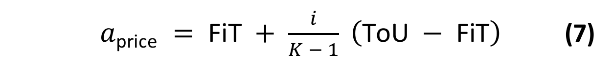
where i ∈ {0, 1, …, K−1}
3.6. Reward Functions
The reward structure reflects the economic objectives of the market participants. For sellers, the reward in Eq. (9) combines revenue from energy matched in the P2P market, obtained by multiplying the matched quantity q_{m} by the clearing price p_{clearing}, and revenue from exporting the unmatched quantity q_{u} to the grid at the FiT rate. A third, price-premium term rewards the seller in proportion to the margin earned above the FiT rate on the matched energy, scaled by β = 0.3, which signals the agent to sell above the FiT rate and encourages profitable P2P transactions. For buyers, the reward in Eq. (10) is the negative of the total procurement cost, so that minimizing cost is equivalent to maximizing reward; the quantity that remains unmatched in the P2P market is bought from the grid at the ToU price, which is higher than any attainable P2P price.
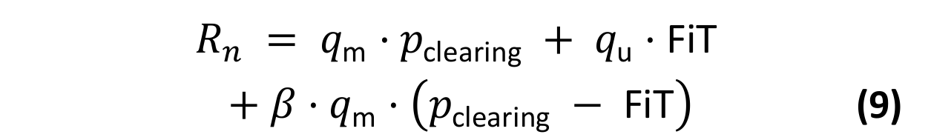
3.7. Multi-Agent Tabular Q-Learning
Tabular Q-Learning is used as the first adaptive pricing approach. The agent learns an action-value function Q(s, a), which estimates the discounted return obtained by choosing pricing action a in market state s and following the learned policy thereafter. After each trading step the agent observes the realized reward and the next state, and moves its current estimate towards the observed value by the temporal-difference rule in Eq. (11), where the step size α controls how strongly a single observation revises the estimate and the discount factor γ weights future rewards. Because every agent stores these values explicitly in a table, the learned policy can be inspected directly.
Action selection follows an ε-greedy policy: with probability ε the agent draws one of the 15 price levels uniformly at random, and otherwise it selects the level with the highest current Q-value. This balances exploration of untried prices against exploitation of what has already been learned. Exploration starts at ε = 1.0, so the first episode is fully random, and ε is multiplied by 0.985 after every episode until it reaches a floor of 0.05, which keeps a small amount of exploration active throughout training. The remaining learning hyperparameters are summarized in Table 1.
To keep the Q-table tractable and interpretable, the state representation is discretized. Each agent can act as either a seller or a buyer according to its net load, and each role is represented by a compact state built from the time slot and the surplus/demand level. Time is grouped into three buckets based on ToU periods (night/off-peak 00:00–08:00 and 20:00–24:00; daytime/solar 08:00–17:00; and evening peak 17:00–20:00), while surplus and demand are grouped into four kWh buckets (low, medium-low, medium-high and high). This yields 3 × 4 = 12 states per role.
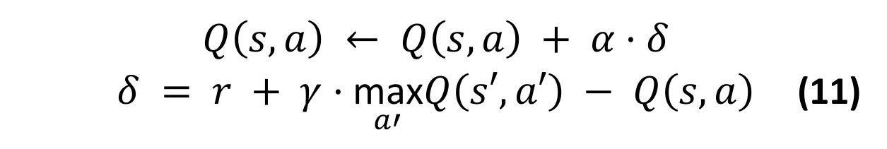
Table 1. Q-Learning hyperparameters.
Hyperparameter | Value | Description
Learning rate (α) | 0.1 | Q-value update step size
Discount factor (γ) | 0.95 | Present value of future rewards
Initial epsilon | 1.0 | Fully random exploration at episode 0
Minimum epsilon | 0.05 | Constant 5% exploration margin
Epsilon decay | 0.985 | Per-episode multiplicative decay

Tabular Q-Learning is transparent and interpretable because its explicit Q-values make the learned policy fully auditable; it is computationally lightweight and its two compact Q-tables converge reliably without specialized hardware. Its limitations are a discrete action space restricted to 15 fixed price levels, coarse state aggregation that maps distinct market conditions to the same bucket, and poor scalability as the number of agents, time periods or variables grow.
3.8. REINFORCE Neural Policy Model
To overcome the limitations of discrete pricing, a policy-gradient REINFORCE agent is implemented. Unlike Q-Learning, the policy directly outputs a continuous pricing coefficient within the feasible tariff range, and parameters are updated by minimizing the policy loss in Eq. (12), where G_{t} is the discounted return. During training the action is sampled from a Gaussian policy whose mean is the network output, so that the log-probability term in Eq. (12) is well defined; the sampled value is then clipped so that the resulting price remains bounded between the FiT and ToU limits. The model uses two separate networks for buyers and sellers that share the same architecture but keep independent weights.
Each policy network concatenates a 3-dimensional state observation with a 16-dimensional embedding produced by a price-history encoder, forming a 19-dimensional input that passes through two hidden layers of 64 units with ReLU activations and a final sigmoid output. The encoder maps each of the last 12 clearing prices through a shared linear projection, adds a learned positional embedding, applies a hyperbolic tangent activation and mean-pools the resulting vectors into a single summary. The activation is applied after the positional embedding is added, which is what makes the summary sensitive to the order of the price sequence rather than to its mean alone; the encoder therefore provides the policy with a compact representation of recent price dynamics at no additional parameter cost. The advantages of this approach are continuous price selection between FiT and ToU, awareness of recent price dynamics, and scalability to unseen states without large Q-tables. Its limitations are slower convergence, more limited interpretability and higher training variance compared with the tabular method.
Table 2. State-space representation of the neural policy.
Dimension | Seller | Buyer
s1 | hour / 47 | hour / 47
s2 | surplus / 10 | deficit / 10
s3 | avg_price / 0.5 | avg_price / 0.5

Table 2 lists the three normalized state dimensions observed by the seller and buyer policies, and Table 3 summarizes the shared network architecture. Each policy network has approximately 5,729 parameters including the time-series encoder, and two separate networks (one for buyers and one for sellers) are used, giving roughly 11,460 parameters per agent. To examine the effect of network size, two deeper variants with three and four hidden layers of 64 units (9,889 and 14,049 parameters per network, respectively) are also trained in Section 4.7; all other settings are unchanged.
Table 3. Policy network architecture.
Layer | Dimensions | Parameters
Input | 3 + 16 = 19 | —
Linear + ReLU | 19 → 64 | 1,280
Linear + ReLU | 64 → 64 | 4,160
Linear + Sigmoid | 64 → 1 | 65
Total (+ encoder) | — | ≈ 5,729

3.9. Evaluation Metrics and Dataset
All pricing models are evaluated under identical market conditions using the same set of quantitative metrics. The P2P trading ratio ρ_{P2P} in Eq. (13) expresses the share of demand and surplus that is settled locally rather than through the grid, where EP2P is the total energy traded peer-to-peer over the day, EGridPur the total energy bought from the grid at the ToU price, and EGridSold the total surplus exported to the grid at the FiT rate, all measured in kWh. The average P2P price in Eq. (14) is the quantity-weighted mean of the clearing prices, where the index k runs over all trades executed during the simulation and q_{k} and p_{k} denote the quantity and the clearing price of trade k, the latter given by Eq. (2). The remaining metrics are seller revenue, buyer cost and the cumulative system reward. Seller revenue is the sum of P2P clearing income and grid FiT income, whereas buyer cost is the sum of P2P clearing cost and grid ToU cost. Together, these metrics jointly evaluate market efficiency, local energy utilization, economic performance and learning effectiveness.
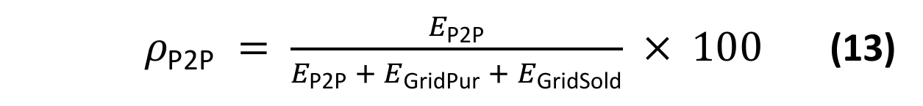
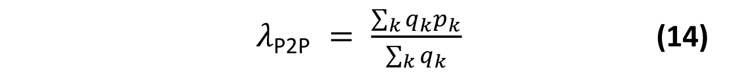
The simulation environment uses parametric daily profiles, sampled at the same 30-minute resolution as the market, whose shape is inspired by the daily load and generation patterns of the Australian Ausgrid smart-grid dataset [18], which contains residential load and rooftop PV measurements reported at 30-minute intervals. The same dataset underlies several P2P pricing studies [6], [19]–[23]; in particular, the population of four producers and four consumers adopted here mirrors the eight-household configuration of Qiu et al. [6], which facilitates a qualitative comparison with that line of work. PV generation is represented by a Gaussian curve peaking around solar noon and set to zero outside the interval 06:00–19:00. Demand is represented by a three-component profile with a morning peak around 08:00, a smaller midday component around 13:00 and a dominant evening peak around 18:30, superposed on a constant base load. Both profiles are scaled per agent and perturbed by Gaussian noise, so that no two agents receive identical profiles. This structure creates a mismatch between generation and consumption, so that agents naturally become sellers during high-solar periods and buyers during high-demand periods. It should be noted that the midday demand component coincides with the PV peak, so a certain degree of local supply–demand overlap is built into the profiles themselves.
Because the profiles are synthetic, their construction is given here in full. Let h ∈ {0, 0.5, …, 23.5} denote the hour of day at the start of a slot and n ∈ {0, …, 7} the agent index, where n = 0–3 are the producers Pr1–Pr4 and n = 4–7 the consumers C1–C4. The PV energy of producer n in a slot follows Eq. (15) and the load of every agent follows Eq. (16), in which G(h; μ, σ) = exp(−(h − μ)²/(2σ²)) and the three Gaussian terms are the morning, midday and evening components:
P_{n}^{pv}(h) = A_{n} · G(h; μ_{n}, 2.5) + ε (15)
P_{n}^{load}(h) = f_{n} · [ b + L · ( 0.6 · G(h; 8, 1.2)
+ 0.3 · G(h; 13, 1.0) + G(h; 18.5, 1.5) ) ] + ε (16)
In Eq. (15), A_{n} = 9.0 · (0.8 + 0.1n) kWh, μ_{n} = 12 + 0.3 · (n − 1.5) h and ε ∼ N(0, 0.25²); negative values are clipped to zero and the profile is set to zero for h < 6 and h > 19. In Eq. (16), f_{n} = 0.8 + 0.15n is an agent-specific scale factor; (b, L) = (0.8, 2.5) kWh with ε ∼ N(0, 0.2²) for the producers and (b, L) = (2.0, 5.8) kWh with ε ∼ N(0, 0.35²) for the consumers, and values below 0.5 kWh are raised to 0.5 kWh. A new noise realization is drawn for every simulated day from a seeded random generator. On the day used for evaluation (seed 1), the daily PV energy of the four producers is 88.8–121.7 kWh and their load 55.9–88.2 kWh, while the load of the four consumers is 236.9–314.5 kWh; the community-wide deficit and surplus over the day are D = 1263.64 kWh and S = 291.61 kWh. These magnitudes are well above those of a single household, so each agent should be read as an aggregated or representative participant rather than as an individual Ausgrid home; only the daily shape of the profiles is taken from the dataset.
No Ausgrid measurement enters the simulation directly. The dataset [18] serves as the template for the 30-minute resolution, for the daily shape of load and PV generation that Eqs. (15)–(16) reproduce, and, through [6], for the configuration of four producers and four consumers. The profiles themselves are fully synthetic and are generated from the equations and coefficients given above, so the experiments can be reproduced without access to the dataset.
The reward coefficient is fixed at β = 0.3. Each training episode is one simulated day with its own noise realization. Q-Learning is trained for 3000 episodes with the hyperparameters of Table 1, and REINFORCE for 7000 episodes with the Adam optimizer, a learning rate of 5 × 10⁻⁴, a discount factor of 0.95 and an exploration standard deviation that decays from 0.25 to 0.05 by a factor of 0.993 per episode. After training, the greedy Q-Learning policy (ε = 0) and the deterministic REINFORCE policy (no exploration noise) are evaluated on the day generated with the seed of the run, and the random baseline is evaluated on the same day as the mean over 200 price draws. Sections 4.1–4.3 report this evaluation in detail for the reference community and seed 1; Section 4.7 repeats it for several seeds and communities, following the protocol below.
Experimental protocol. Three groups of experiments are summarized in Table 9. In Experiment A the random baseline, Q-Learning and REINFORCE are compared for four communities: 4+4, 10+10 and 20+20 producers and consumers, which share the same supply-to-demand ratio, and a consumer-heavy community of 10 producers and 20 consumers, in which supply is scarce. Each configuration is repeated for five seeds. In Experiment B the REINFORCE policy is retrained with three and four hidden layers for the same four communities and three seeds; the two-layer runs of Experiment A with the same seeds serve as the reference. In Experiment C the training budget of both learners is doubled for the largest community, to check whether the standard budget remains sufficient when the number of agents grows. In total 47 independent jobs were run.
Table 9. Design of the experiments.
Exp. | Communities (Pr + C) | Strategies | Seeds | Episodes (QL / NN)
A (20 jobs) | 4+4, 10+10, 20+20, 10+20 | Random, QL, NN (2 layers) | 1–5 | 3000 / 7000
B (24 jobs) | 4+4, 10+10, 20+20, 10+20 | NN with 3 and 4 layers | 1–3 | — / 7000
C (3 jobs) | 20+20 | QL, NN (2 layers) | 1–3 | 6000 / 14000

For communities with more than four agents per side, producer j receives the profile parameters of producer j mod 4 in Eqs. (15)–(16) and consumer j those of consumer 4 + (j mod 4), each with its own independent noise realization. A larger community is thus a replication of the same four producer and four consumer types, which keeps the per-agent scale and, for balanced communities, the supply-to-demand ratio unchanged (S/D = 0.23) and isolates the effect of the number of competing agents. The seed determines the noise realizations of the training and evaluation days as well as the initialization and exploration of the learners, and the random generators are re-seeded before each method, so that a result does not depend on which methods were run before it. Results are reported as the mean and the sample standard deviation over seeds. All runs were executed on the CPU of one workstation with 32 hardware threads (Python 3.14, PyTorch 2.15, NumPy 2.5), one thread per job, and the wall-clock training time of every method was recorded.
For benchmarking, the same load and PV profiles, agent population, 48-step daily structure, tariff boundaries and clearing mechanism are used for every experiment, so the only components that change between experiments are the pricing strategy and the state representation it uses.
3.10. System Architecture and Implementation
The simulation is implemented in Python with a modular, object-oriented architecture that separates the market environment, agent decision models, auction mechanism, profile data and evaluation logic into independent components. This separation makes it possible to test the baseline, Q-Learning and neural network-based agents under identical market rules and physical energy profiles. The system consists of five main components: an environment component that manages the simulation clock, daily time steps, agent observations and reward calculation; an agent component that represents the decision-making layer for each strategy; an auction component that performs order matching and price clearing; a profile component that supplies the synthetic load and PV profiles; and an evaluation component that computes the comparison metrics. All market conditions except the pricing strategy are held fixed to ensure a fair comparison.
3.11. Feasibility Bound and Accounting Identities
This subsection formalizes two elements that are needed to interpret the results: the physical upper bound on local trade, and the identities that link the energy and monetary quantities reported in Section IV.
Feasibility bound. Let S_{t} and D_{t} be the community-wide surplus and deficit in slot t, Eq. (17). Since energy cannot be stored, the energy traded locally in a slot cannot exceed either of them, which gives the upper bound E_{max} of Eq. (18) and the local matching efficiency η of Eq. (19):
S_{t} = Σ_{n} max{ −P_{n}^{net}(t), 0 },
D_{t} = Σ_{n} max{ P_{n}^{net}(t), 0 } (17)
E_{P2P} ≤ E_{max} = Σ_{t=1…48} min{ S_{t}, D_{t} } (18)
η = ( E_{P2P} / E_{max} ) × 100 (19)
All unmatched energy is settled with the grid, so the energy balances of Eq. (20) hold for every strategy, where D = Σ_{t} D_{t} and S = Σ_{t} S_{t}. Substituting them into Eq. (13) bounds the P2P trading ratio as in Eq. (21):
E_{GridPur} = D − E_{P2P}, E_{GridSold} = S − E_{P2P} (20)
ρ_{P2P} = E_{P2P} / (D + S − E_{P2P}) × 100
≤ ρ_{max} = E_{max} / (D + S − E_{max}) × 100 (21)
E_{max}, η and ρ_{max} depend only on the profiles and not on any pricing strategy. The bound is attained whenever every bid in a slot is at least as high as every ask; η therefore measures how much of the feasible local trade a strategy realizes, but not, by itself, how sophisticated the strategy is.
Monetary identities. The net revenue of the grid authority is its income from energy sold at ToU minus its payments for energy bought at FiT. Every P2P payment is a transfer between two members of the community, so the sum of the net costs C_{n} of all agents equals this revenue, Eq. (22); using Eq. (20), it can be written as Eq. (23):
R_{grid} = ToU · E_{GridPur} − FiT · E_{GridSold}
= Σ_{n} C_{n} (22)
R_{grid} = ToU · D − FiT · S − (ToU − FiT) · E_{P2P} (23)
Each kWh traded locally therefore lowers the net payment of the community to the grid authority by exactly ToU − FiT = $0.22, independently of the clearing price. The clearing price only determines how this amount is shared: per kWh, the buyer saves ToU − p_{clearing} and the seller gains p_{clearing} − FiT. Finally, Tables 5 and 6 report group-level quantities. Let R_{sell} be the gross revenue of the producer agents Pr1–Pr4 (P2P income plus FiT income), C_{buy} the cost of the consumer agents C1–C4 (P2P purchases plus grid purchases at ToU) and C_{prod} the purchases of the producer agents in the slots in which they are net buyers. The identity of Eq. (24) then links the group-level values to the system-level revenue:
R_{grid} = C_{buy} + C_{prod} − R_{sell} (24)
IV. RESULTS AND DISCUSSION
4.1. Overall Market Performance
The three strategies were first evaluated for the reference community of four producer agents (Pr1–Pr4) and four consumer agents (C1–C4) on the day generated with seed 1. Table 4 summarizes the market-level outcome; the random baseline is reported as the mean over 200 price draws. Both learning strategies clearly outperform the baseline: P2P trading volume increases from 140.62 ± 14.39 kWh to 219.15 kWh with Q-Learning (+55.8%) and to 245.49 kWh with the REINFORCE neural network (NN) policy (+74.6%), and the P2P trading ratio rises from 10.0% to 16.4% and 18.7%. Grid-purchased energy decreases by 7.0% and 9.3%, and the surplus exported to the grid by 52.0% and 69.5%. None of the 200 random draws reaches the volume of either learner (the largest is 174.33 kWh).
Table 4. Overall market performance for the reference community (4+4, seed 1). Random: mean over 200 price draws; Δ: change relative to the random baseline.
Metric | Random | QL | NN | ΔQL | ΔNN
P2P Ratio (%) | 10.0 | 16.4 | 18.7 | +64.8% | +88.3%
P2P Trading (kWh) | 140.62 | 219.15 | 245.49 | +55.8% | +74.6%
Grid Purchased (kWh) | 1123.0 | 1044.5 | 1018.1 | −7.0% | −9.3%
Grid Sold (kWh) | 150.99 | 72.46 | 46.12 | −52.0% | −69.5%
Avg. P2P Price ($/kWh) | 0.170 | 0.158 | 0.128 | −7.5% | −25.1%
Matching efficiency η (%) | 57.3 | 89.3 | 100.0 | +55.8% | +74.6%

The average clearing price of the random baseline, $0.170/kWh, lies at the midpoint of the tariff band, as expected for uniformly drawn prices. Q-Learning clears at $0.158/kWh and the REINFORCE policy at $0.128/kWh, so the neural policy trades the largest volume at the lowest price.
These volumes can be related to the feasibility bound of Section 3.11. For this day, D = 1263.64 kWh and S = 291.61 kWh; surplus is available in 20 of the 48 slots and exceeds the community demand in 7 of them, so that E_{max} = 245.49 kWh and ρ_{max} = 18.7%. The local matching efficiency of Eq. (19) is 57.3% for the random baseline, 89.3% for Q-Learning and 100% for the REINFORCE policy. The P2P ratio of 18.7% reached by the neural policy is thus the largest value attainable with these profiles: the remaining 46.12 kWh of exported energy is surplus for which no local demand exists in the same slot, and the modest absolute level of the ratio reflects the supply-to-demand ratio of the community (S/D = 0.23), not unexploited trade.
4.2. Seller Revenue Analysis
Table 5 reports the gross sales revenue of the four producer agents (Pr1–Pr4). Under random pricing the sellers earn $33.03 ± 1.92. Q-Learning raises this revenue to $38.90 (+17.7%), a level that none of the 200 random draws reaches. The REINFORCE sellers earn $34.11 (+3.3%), which lies within the spread of the random draws (56 of the 200 draws yield a higher seller revenue). The neural policy shifts sales from the grid to the P2P market, so that FiT income falls from $9.06 to $2.77, but it trades the additional volume at a low price; on this day it therefore does not raise seller revenue beyond what random pricing achieves. The energy that the producer agents buy outside PV hours is accounted for separately in Table 7.
Table 5. Seller revenue comparison ($) for the reference community (4+4, seed 1).
Metric | Random | Q-Learning | REINFORCE
P2P Income | 23.97 | 34.55 | 31.34
Grid FiT Income | 9.06 | 4.35 | 2.77
Total Seller Revenue | 33.03 | 38.90 | 34.11

4.3. Buyer Cost Analysis
Table 6 reports the total energy expenditure of the four consumer agents (C1–C4). Under random pricing the consumers pay $294.62 ± 1.92. Q-Learning lowers this cost to $283.18 (−3.9%) and the REINFORCE policy to $272.60 (−7.5%), and no random draw attains the buyer cost of either learner. The buyers thus benefit under both learning strategies, whereas the sellers benefit clearly only under Q-Learning. Table 6 covers the consumer agents only, whereas the grid-purchased energy in Table 4 is the total over all eight agents; the two are reconciled in Table 7.
Table 6. Buyer cost comparison ($) for the reference community (4+4, seed 1).
Metric | Random | Q-Learning | REINFORCE
P2P Purchase Cost | 23.89 | 34.53 | 31.34
Grid ToU Cost | 270.73 | 248.66 | 241.26
Total Buyer Cost | 294.62 | 283.18 | 272.60

System-wide reconciliation and grid authority revenue. Tables 4–6 are defined over different groups of agents, and Table 7 reconciles them through the identities of Section 3.11. The grid-purchased energy of Table 4 (1123.02 kWh under random pricing) is the sum of the purchases of the consumers (966.91 kWh) and of the producers (156.11 kWh), the latter occurring when PV generation does not cover the producers’ own load. Multiplying the consumer part by the constant ToU price gives the Grid ToU Cost of Table 6 (966.91 kWh × $0.28/kWh = $270.73), and the same holds for the learning strategies (888.05 kWh and 861.63 kWh, giving $248.66 and $241.26). The producer part ($43.71, $43.80 and $43.82) appears in neither Table 5 nor Table 6. Likewise, the P2P income of Table 5 exceeds the P2P purchase cost of Table 6 by $0.08 under random pricing and by $0.02 under Q-Learning, because producers also buy small quantities from other producers; these purchases are a cost of the producer group, not of the consumers. With these items included, Eq. (24) closes for all three strategies.
The last rows of Table 7 give the revenue of the grid authority. Its net revenue, which by Eq. (22) equals the net payment of the whole community, falls from $305.39 under random pricing to $288.11 under Q-Learning (−5.7%) and to $282.31 under REINFORCE (−7.6%). In agreement with Eq. (23), these reductions equal, up to rounding, (ToU − FiT) times the additional energy traded locally: 0.22 × (219.15 − 140.62) = $17.28 and 0.22 × (245.49 − 140.62) = $23.07. The gain of the community is therefore exactly the margin that the grid authority no longer earns on energy that is produced and consumed locally; whether such a reduction is acceptable to the grid authority, for instance in exchange for lower network loading, is a regulatory question outside the scope of this study. The split of the gain between the two sides of the market follows from the average clearing price: of the $0.22 available per traded kWh, the buying side retains 50% under random pricing, 56% under Q-Learning and 69% under REINFORCE.
Table 7. Reconciliation of Tables 4–6 and grid authority revenue (4+4, seed 1).
Quantity | Random | Q-Learning | REINFORCE
Grid purchases, consumers (kWh) | 966.91 | 888.05 | 861.63
Grid purchases, producers (kWh) | 156.11 | 156.43 | 156.52
Consumer cost C_{buy} ($) | 294.62 | 283.18 | 272.60
Producer grid cost at ToU ($) | 43.71 | 43.80 | 43.82
Producer P2P purchases ($) | 0.08 | 0.02 | 0.00
Producer revenue R_{sell} ($) | 33.03 | 38.90 | 34.11
Producer group net cost ($) | 10.76 | 4.92 | 9.72
Grid sales at ToU ($) | 314.44 | 292.46 | 285.08
Grid FiT payments ($) | 9.06 | 4.35 | 2.77
Grid net revenue R_{grid} ($) | 305.39 | 288.11 | 282.31
Change in R_{grid} vs. random | — | −5.7% | −7.6%
Buyers’ share of the gain (%) | 50 | 56 | 69
Matching efficiency η (%) | 57.3 | 89.3 | 100.0
Values are rounded to two decimals, so sums may differ by ±0.01.
4.4. Learning Performance
The learning progress of both reinforcement learning approaches was evaluated using the system reward per training episode. Figure 1 shows the training curves for all four communities of Section 3.9, averaged over five seeds. Both learners improve steadily and converge to stable policies. In terms of episodes, the system reward of the REINFORCE policy levels off within roughly the first 1000 episodes and that of Q-Learning within about 2000, in every community; in terms of wall-clock time, Q-Learning is by far the cheaper method (Section 4.7). The neural policy ultimately achieves the better market-level outcome in terms of P2P ratio, grid dependency and buyer cost, whereas Q-Learning yields the higher seller revenue.
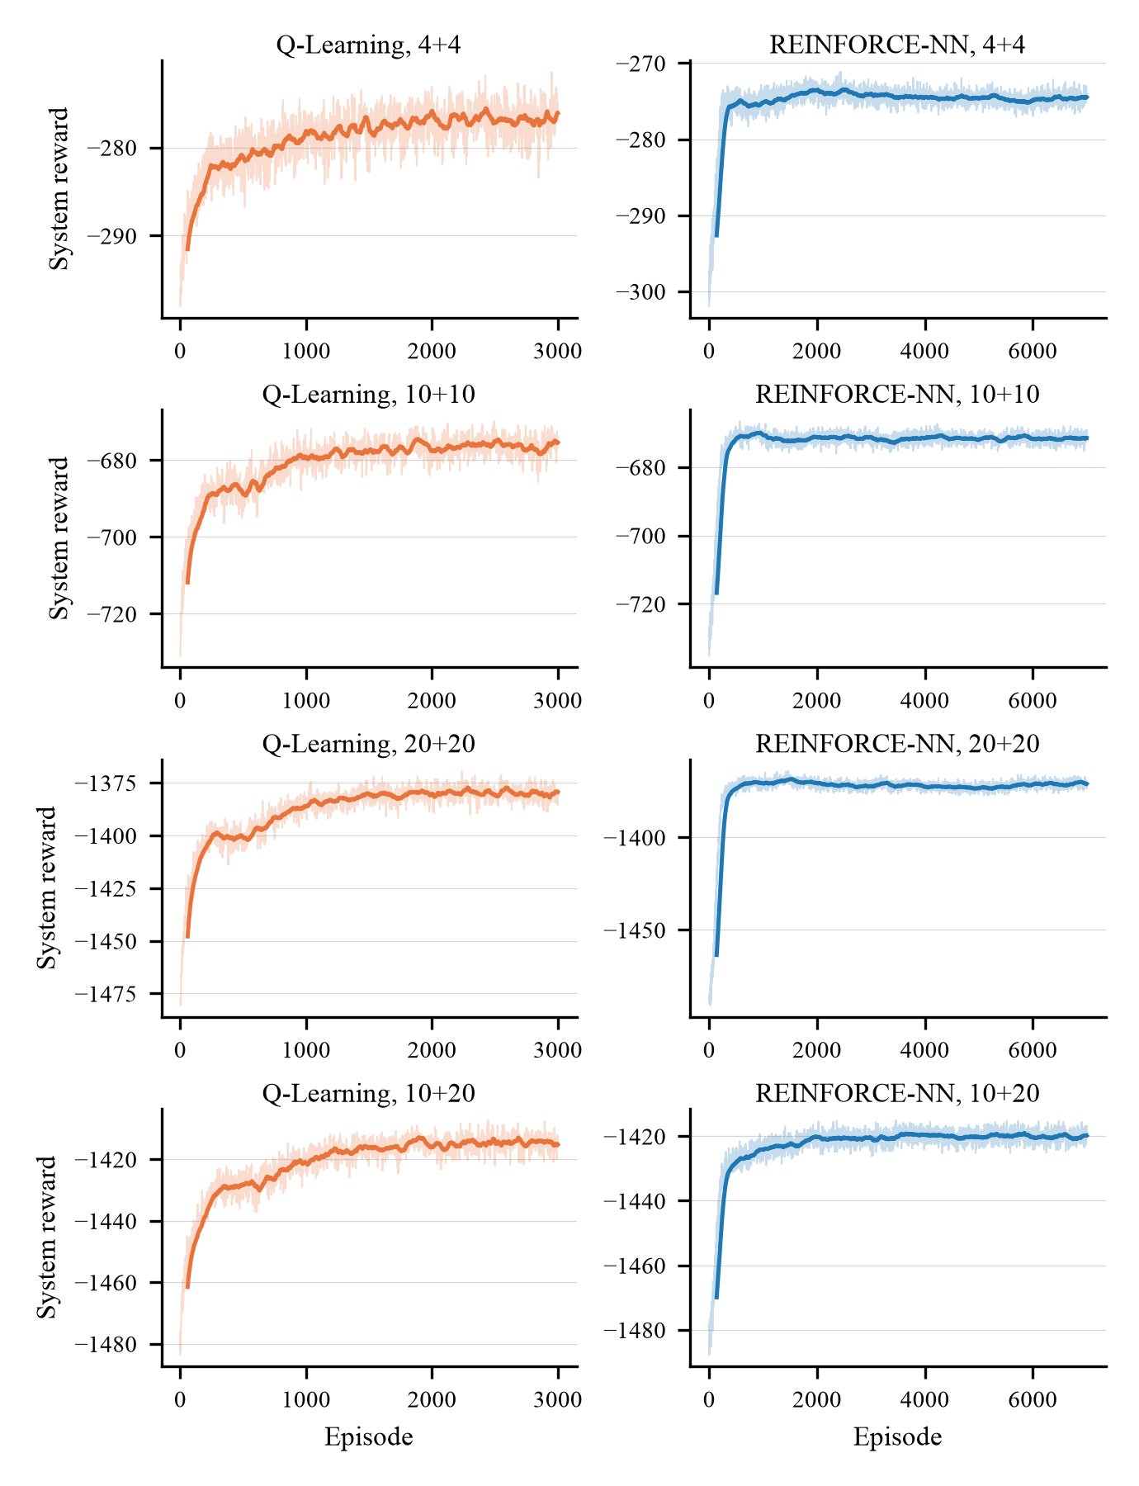
Figure 1. Training curves: system reward per episode for the four communities, averaged over five seeds (bold line: moving average).
4.5. Discussion
The experimental results show that learned pricing improves local market efficiency relative to uninformed pricing. Under the random baseline a bid and an ask are compatible only by chance, so on the reference day only 140.62 kWh of the 291.61 kWh of available surplus is traded locally and 52% of it is exported to the grid at the unfavourable FiT rate, which gives the sellers a revenue of $33.03. The grid tariffs, the clearing mechanism and the order format are identical across all three strategies, so the differences are attributable to the prices alone. With Multi-Agent Tabular Q-Learning, sellers discover the local demand and increase their revenue to $38.90. Under the REINFORCE policy, total revenue settles at $34.11: compared with Q-Learning, the continuous policy clears a larger volume (245.49 kWh against 219.15 kWh) at a substantially lower average price ($0.13 against $0.16 per kWh), so the higher turnover does not compensate for the reduced margin and seller revenue stays close to that of the random baseline.
On the consumer side, the advantage of both learning models is clear. With random pricing the consumers incur a total procurement cost of $294.62, most of it for grid purchases at the constant ToU price. Learning reduces this dependency and lowers the total buyer cost to $283.18 under Q-Learning and to $272.60 under REINFORCE. The two learning strategies therefore distribute the gains differently: the discrete Q-Learning policy sustains higher clearing prices and yields the larger seller revenue, whereas the continuous REINFORCE policy clears more energy at lower prices and delivers the larger saving to buyers. Section 4.7 shows that this pattern holds across seeds and community sizes, and that it shifts in favour of the sellers when supply is scarce. By reducing financial leakage to the centralized utility grid, adaptive pricing supports a more autonomous local energy market.
Table 8 positions the present study among existing works that use the Ausgrid dataset for P2P pricing. A direct numerical comparison is not meaningful, because the studies differ in the number of households, the tariff levels, the presence of storage and the way the data are used: prior works replay the measured household traces, whereas this study uses the dataset only as the template for the shape of its synthetic daily profiles. The closest configuration is that of Qiu et al. [6], who report for eight Ausgrid households with energy storage that learned bidding raised internally traded energy from 31.74 kWh under a zero-intelligence strategy to 65.42 kWh, a 2.1-fold increase, and lowered the total energy bill from $38.32 under grid-only trading to $30.78. The present study uses the same kind of baseline and obtains a 1.5- to 1.75-fold increase in locally traded energy, depending on the community and the learner (Section 4.7), together with a lower buyer cost. Unlike the studies in Table 8, which each evaluate a single learning or clearing method, this work compares a tabular and a neural policy with a zero-intelligence baseline under one identical market and across community sizes.
Table 8. Studies using the Ausgrid dataset for P2P energy pricing.
Study | Use of Ausgrid data | Market / pricing | Method
Qiu et al. [6] | 8 households (4 prosumers, 4 consumers) | Double-side auction, ToU/FiT bounds | DA-MADDPG
Sanayha and Vateekul [19] | Households grouped into clusters | P2P trading across clusters | Model-based multi-agent DRL
Uthayansuthi and Vateekul [20] | 300 households | P2P trading without information sharing | Model-based DRL
Liyanage and Islam [21] | 6 households, Jul 2012–Jun 2013 | Double auction: average, TR and VCG clearing | Auction clearing rules (no learning)
Kochupurackal et al. [22] | 6 houses, summer and winter days | P2P trading between fixed utility and feed-in rates | Rolling-horizon optimisation
Moniruzzaman et al. [23] | Ausgrid data with IEEE 14-bus network | Cooperative game, blockchain settlement | Game theory (no learning)
This work | Template for the daily profile shape only (synthetic profiles); 8 to 40 agents | Partial-match double auction, ToU/FiT bounds | Random baseline, Q-Learning, REINFORCE

4.6. Benefits, Impact and Considerations
Beyond the quantitative metrics, the framework has broader implications. Economically, the simulation shows that adaptive pricing can reduce buyer costs while increasing seller revenues, giving prosumers an alternative to monetizing unused renewable generation at low FiT rates and letting consumers buy locally available surplus energy below the ToU tariff. Environmentally, by increasing local energy matching, the proposed system supports better utilization of distributed renewable energy and reduces unnecessary export to the grid. In doing so, it may strengthen the incentive for prosumers to invest in and deploy renewable energy sources. It is highly possible that the net effect will be lower carbon emissions, driven by the wider deployment and higher local consumption of green energy; however, the simulation contains no emission or generation-mix model, so this effect is an expectation that was not measured in the present study.
Socially, peer-to-peer energy trading supports a more participatory ecosystem in which users are not only passive consumers but can become active market participants. The model also supports a fully decentralized learning architecture: each agent maintains its own policy parameters and updates them from its own reward signal, without sharing gradients, model weights or private cost parameters with a central learner. The only information exchanged between participants is the aggregate clearing price. The project further has an indirect relationship with energy security: a decentralized P2P model can encourage local balancing of supply and demand and reduce dependency on centralized grid purchases, supporting more resilient community-level energy systems. This relationship is a qualitative inference from the reduction in grid purchases (Table 4); no reliability or security-of-supply indicator was computed.
From a sustainability perspective, the framework is modular and extensible, so future versions can include battery storage, electric vehicles, demand response and larger agent populations. All these benefits should be interpreted at the conceptual and simulation level; a real deployment would require regulatory approval, reliable metering infrastructure, strong cybersecurity mechanisms and coordination with grid operators.
4.7. Robustness: Seeds, Community Size, Network Depth and Training Budget
The results of Sections 4.1–4.3 describe one community, one day and one training run. This section reports the additional experiments defined in Section 3.9 (Table 9), in which the random baseline, Q-Learning and REINFORCE are retrained and evaluated for the four communities of Table 10 and for several seeds. All values are means ± sample standard deviations over seeds.
Table 10. Communities used in the robustness experiments (mean ± standard deviation over five seeds).
Community (Pr + C) | Agents | S/D | E_{max} (kWh) | ρ_{max} (%)
4+4 | 8 | 0.23 | 247.2 ± 2.7 | 18.9 ± 0.2
10+10 | 20 | 0.23 | 603.2 ± 2.5 | 18.9 ± 0.1
20+20 | 40 | 0.23 | 1236.0 ± 6.0 | 19.0 ± 0.1
10+20 | 30 | 0.12 | 719.7 ± 2.7 | 12.2 ± 0.1

The three balanced communities have the same supply-to-demand ratio (S/D = 0.23) and the same attainable P2P ratio (ρ_{max} ≈ 18.9%), so they differ only in the number of competing agents. The 10+20 community has twice as many consumers as producers (S/D = 0.12); its surplus never exceeds the demand of the same slot, so the whole surplus can be absorbed locally (E_{max} = S) and the attainable P2P ratio drops to 12.2%.
Repeated runs for the reference community. For the 4+4 community, the five seeds give E_{max} = 247.23 ± 2.66 kWh. The random baseline realizes η = 57.2 ± 0.2% of it, Q-Learning 95.1 ± 5.0% and REINFORCE 100.0 ± 0.0% (Table 11). The REINFORCE policy reaches the feasibility bound for every seed, whereas the Q-Learning result varies from seed to seed (89.3, 99.1, 97.6, 90.1 and 99.2%). The value of 89.3% reported in Section 4.1 for seed 1 is the lowest of the five, so the single run understated the tabular learner: the difference between the two learners in traded volume is about five percentage points on average, not eleven. The economic pattern of Sections 4.2 and 4.3 is confirmed. Q-Learning yields the higher seller revenue ($41.53 ± 1.91 against $34.99 ± 3.65) and REINFORCE the lower buyer cost ($271.48 ± 3.48 against $280.64 ± 2.30), because the neural policy settles at a lower and more seed-dependent price ($0.130 ± 0.015 against $0.162 ± 0.007 per kWh; individual seeds range from $0.110 to $0.150). As a consequence, the seller revenue under REINFORCE exceeds that of the random baseline ($33.26 ± 0.19) by only 5.2%, which is within the spread of the seeds: for this community the neural policy benefits the buyers rather than the sellers. The seed-1 results of Sections 4.1–4.3 are the first of these five runs.
Community size. Table 11 and Figure 2 give the results for all communities, and Table 12 the changes relative to the random baseline. Increasing the community from 8 to 40 agents does not degrade either learner: η stays at 95.1–96.6% for Q-Learning and at 99.4–100% for REINFORCE, against 57.2–58.5% for random pricing. The spread across seeds shrinks as the community grows (for Q-Learning from 5.0 to 1.4 percentage points), since the outcome of a small market depends more strongly on the policy of each single agent. The average clearing price of Q-Learning falls slightly, from $0.162 to $0.151 per kWh, while that of REINFORCE stays between $0.130 and $0.141. Relative to the random baseline, Q-Learning raises seller revenue by 16.0–24.9% and lowers buyer cost by 4.2–5.1%; REINFORCE raises seller revenue by 5.2–11.0% and lowers buyer cost by 6.3–7.3%. In every balanced community Q-Learning is thus the more favourable strategy for the sellers and REINFORCE for the buyers, and the net revenue of the grid authority falls by 6.7–7.7%, in agreement with Eq. (23).
Table 11. Results of Experiment A for the four communities (mean ± standard deviation over five seeds).
Community | Random | Q-Learning | REINFORCE
Matching efficiency η (%)
4+4 | 57.2 ± 0.2 | 95.1 ± 5.0 | 100.0 ± 0.0
10+10 | 58.5 ± 0.1 | 96.5 ± 1.6 | 99.5 ± 1.1
20+20 | 58.1 ± 0.1 | 95.4 ± 1.4 | 99.4 ± 0.8
10+20 | 65.3 ± 0.1 | 97.2 ± 1.6 | 98.5 ± 1.7
P2P trading ratio ρ_{P2P} (%)
4+4 | 10.03 ± 0.06 | 17.85 ± 1.16 | 18.94 ± 0.18
10+10 | 10.24 ± 0.03 | 18.10 ± 0.34 | 18.77 ± 0.30
20+20 | 10.21 ± 0.04 | 17.94 ± 0.28 | 18.83 ± 0.17
10+20 | 7.66 ± 0.04 | 11.85 ± 0.20 | 12.03 ± 0.24
Average P2P price ($/kWh)
4+4 | 0.170 ± 0.000 | 0.162 ± 0.007 | 0.130 ± 0.015
10+10 | 0.172 ± 0.000 | 0.153 ± 0.003 | 0.141 ± 0.007
20+20 | 0.172 ± 0.000 | 0.151 ± 0.002 | 0.140 ± 0.006
10+20 | 0.188 ± 0.000 | 0.229 ± 0.004 | 0.189 ± 0.009
Seller revenue ($)
4+4 | 33.26 ± 0.19 | 41.53 ± 1.91 | 34.99 ± 3.65
10+10 | 82.61 ± 0.25 | 97.28 ± 1.55 | 91.73 ± 4.23
20+20 | 168.35 ± 0.56 | 195.25 ± 3.02 | 185.75 ± 7.41
10+20 | 103.08 ± 0.41 | 161.49 ± 3.72 | 134.91 ± 7.45
Buyer cost ($)
4+4 | 293.00 ± 1.80 | 280.64 ± 2.30 | 271.48 ± 3.48
10+10 | 718.01 ± 3.46 | 682.14 ± 5.53 | 672.64 ± 5.81
20+20 | 1462.86 ± 1.25 | 1388.31 ± 2.66 | 1367.95 ± 8.07
10+20 | 1497.70 ± 4.87 | 1505.53 ± 3.82 | 1476.85 ± 9.80
Grid authority net revenue R_{grid} ($)
4+4 | 303.62 ± 2.17 | 283.02 ± 3.56 | 280.34 ± 1.96
10+10 | 741.52 ± 3.47 | 691.05 ± 4.41 | 687.08 ± 4.39
20+20 | 1513.16 ± 2.67 | 1411.79 ± 4.91 | 1400.92 ± 1.76
10+20 | 1500.77 ± 5.06 | 1450.22 ± 5.72 | 1448.13 ± 6.61

Table 12. Change of the mean relative to the random baseline (%).
Community | Q-Learning | REINFORCE
P2P energy (%)
4+4 | +66.2 | +74.8
10+10 | +65.0 | +70.1
20+20 | +64.2 | +71.1
10+20 | +48.9 | +50.9
Seller revenue (%)
4+4 | +24.9 | +5.2
10+10 | +17.8 | +11.0
20+20 | +16.0 | +10.3
10+20 | +56.7 | +30.9
Buyer cost (%)
4+4 | −4.2 | −7.3
10+10 | −5.0 | −6.3
20+20 | −5.1 | −6.5
10+20 | +0.5 | −1.4
Grid authority net revenue (%)
4+4 | −6.8 | −7.7
10+10 | −6.8 | −7.3
20+20 | −6.7 | −7.4
10+20 | −3.4 | −3.5

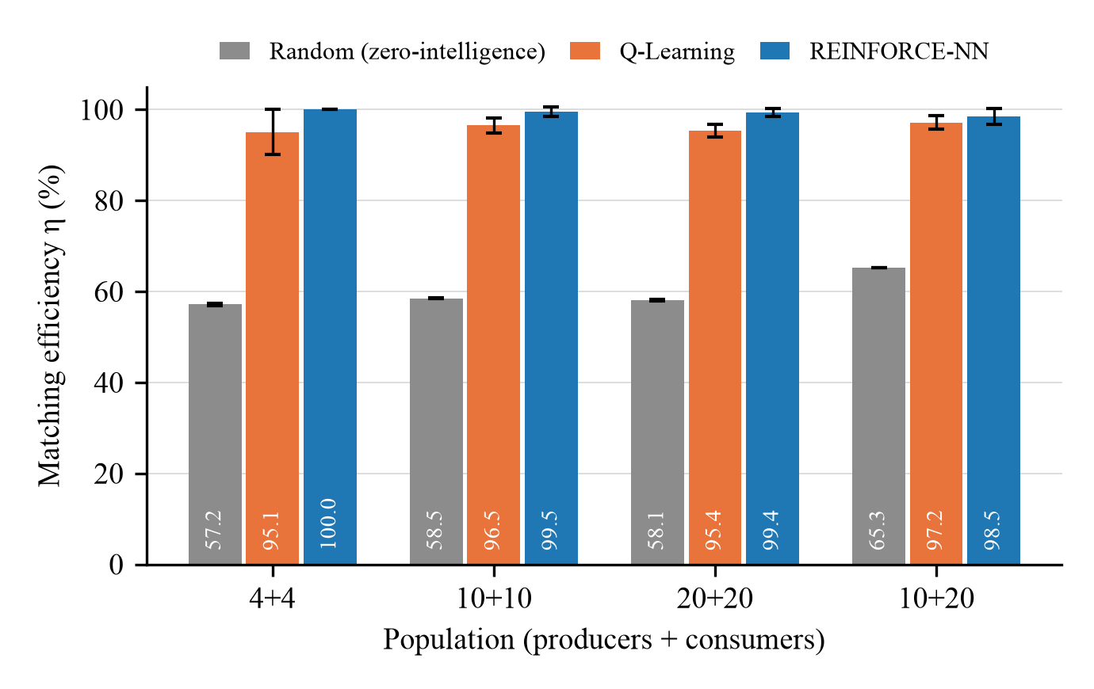
Figure 2. Matching efficiency η for the four communities (mean ± standard deviation over five seeds).
Supply-scarce community. In the 10+20 community both learners still realize almost all feasible trade (97.2 ± 1.6% and 98.5 ± 1.7%), and the random baseline performs better than in the balanced communities (65.3%), which is consistent with several buyers competing for each ask, so that a random ask is more likely to meet a compatible bid. What changes is the division of the gain. With supply scarce, the sellers hold the stronger position: Q-Learning sellers raise the average price to $0.229 per kWh, close to the ToU price, and their revenue increases by 56.7% relative to random pricing, while the buyer cost is no lower than under random pricing (+0.5%). The REINFORCE policy settles at $0.189 per kWh, raises seller revenue by 30.9% and lowers buyer cost by 1.4%. Of the $0.22 available per traded kWh, the buying side retains 23% under Q-Learning and 41% under REINFORCE, compared with 54–59% and 63–68% in the balanced communities. In a consumer-heavy market the benefit of P2P trading therefore accrues largely to the producers, and the supply–demand mix, not the number of agents, is the market condition that changes the outcome.
Network depth. Table 13 and Figure 3 compare REINFORCE policies with two, three and four hidden layers. The additional layers do not change the outcome: the differences in η are at most 1.7 percentage points and lie within the spread of the seeds in every community, and seller revenue and buyer cost show no consistent trend with depth in the three larger communities. The largest difference in η, from 98.0 ± 2.0% to 99.6 ± 0.6% for four layers in the 10+20 community, rests on three seeds and is not conclusive. For the 4+4 community the deeper networks settled at a higher price ($0.149 and $0.151 against $0.121 per kWh) at an unchanged volume, which moves revenue from the buyers to the sellers; this effect does not appear in the other communities and, with three seeds, cannot be separated from the seed dependence of the price noted above. The cost of depth, in contrast, is systematic: training takes 13–22% longer with three layers and 31–40% longer with four. The two-layer network of Table 3 is therefore sufficient for this problem, which is plausible given its low-dimensional state.
Table 13. Effect of the depth of the REINFORCE policy network (mean ± standard deviation over three seeds; parameters per network in parentheses).
Community | 2 layers (5,729) | 3 layers (9,889) | 4 layers (14,049)
Matching efficiency η (%)
4+4 | 100.0 ± 0.0 | 100.0 ± 0.0 | 100.0 ± 0.0
10+10 | 100.0 ± 0.0 | 99.2 ± 1.3 | 100.0 ± 0.0
20+20 | 99.1 ± 1.0 | 99.2 ± 0.7 | 99.6 ± 0.8
10+20 | 98.0 ± 2.0 | 98.0 ± 1.8 | 99.6 ± 0.6
Average P2P price ($/kWh)
4+4 | 0.121 ± 0.009 | 0.149 ± 0.016 | 0.151 ± 0.017
10+10 | 0.144 ± 0.006 | 0.143 ± 0.006 | 0.144 ± 0.007
20+20 | 0.141 ± 0.008 | 0.142 ± 0.006 | 0.141 ± 0.007
10+20 | 0.184 ± 0.003 | 0.195 ± 0.010 | 0.179 ± 0.006
Seller revenue ($)
4+4 | 32.7 ± 2.1 | 39.6 ± 4.4 | 40.1 ± 4.1
10+10 | 94.1 ± 3.8 | 92.7 ± 4.0 | 93.8 ± 4.4
20+20 | 187.8 ± 9.7 | 188.7 ± 7.8 | 188.6 ± 9.4
10+20 | 130.9 ± 1.5 | 138.2 ± 5.4 | 128.4 ± 4.2
Buyer cost ($)
4+4 | 269.7 ± 2.5 | 276.6 ± 4.3 | 277.1 ± 5.8
10+10 | 673.1 ± 7.2 | 672.7 ± 2.9 | 672.7 ± 6.9
20+20 | 1370.1 ± 10.6 | 1370.6 ± 8.2 | 1369.7 ± 7.5
10+20 | 1471.7 ± 8.2 | 1479.0 ± 3.9 | 1466.5 ± 2.3
Training time (s)
4+4 | 375 ± 11 | 447 ± 26 | 527 ± 23
10+10 | 939 ± 15 | 1150 ± 50 | 1307 ± 59
20+20 | 2058 ± 125 | 2318 ± 163 | 2697 ± 217
10+20 | 1446 ± 67 | 1709 ± 101 | 1978 ± 131

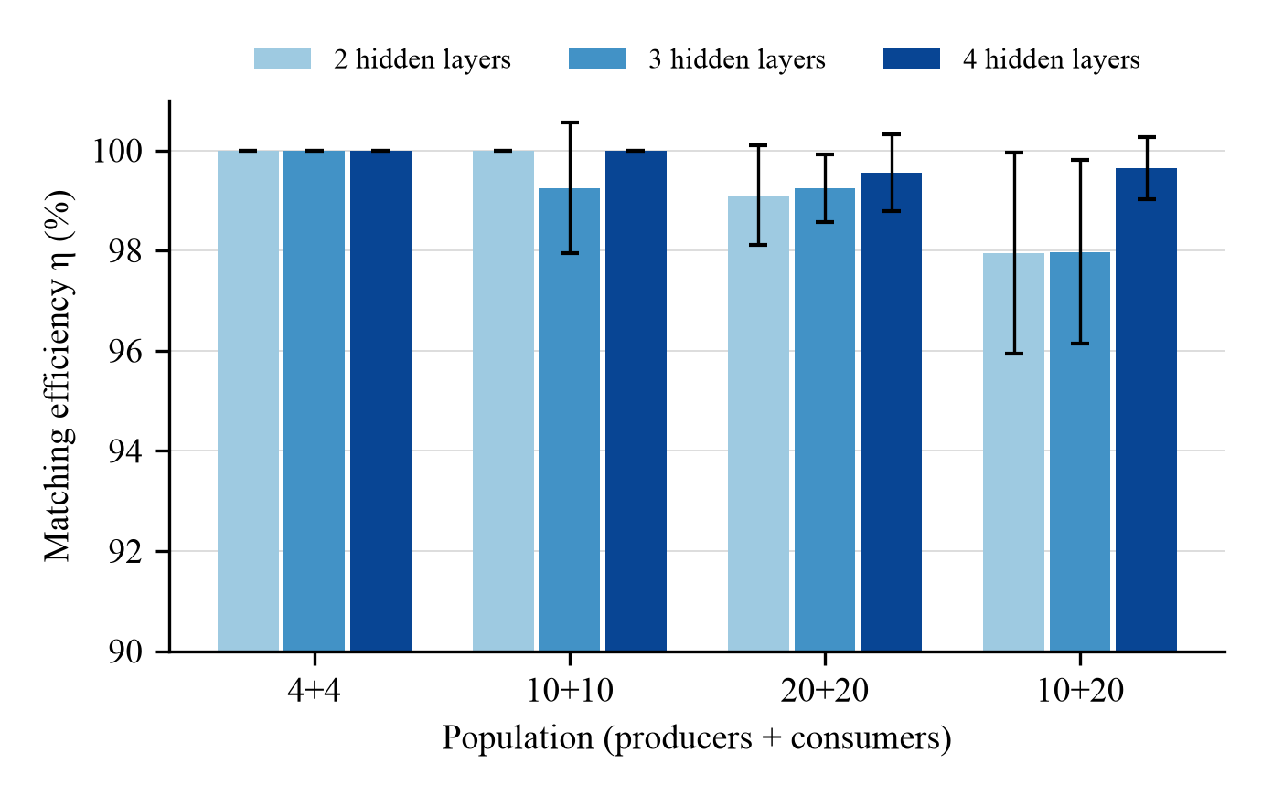
Figure 3. Matching efficiency η of REINFORCE policies with two, three and four hidden layers (mean ± standard deviation over three seeds; the vertical axis starts at 90%).
Training budget. Table 14 compares the standard budget with a doubled one for the 20+20 community. Doubling the number of episodes does not improve Q-Learning (η = 95.2 ± 1.0% with 3000 episodes and 94.3 ± 1.1% with 6000): the tabular learner has reached the plateau set by its state aggregation and its price grid. For REINFORCE, η rises from 99.1 ± 1.0% to 100.0 ± 0.0%, i.e. the doubled budget removes the residual 1% of unmatched energy, but the buyer cost is unchanged ($1370.13 against $1370.04). The training curves in Figure 1 give the same picture: in every community the system reward of REINFORCE levels off within roughly the first 1000 episodes and that of Q-Learning within about 2000. The standard budgets of 3000 and 7000 episodes are thus adequate for communities of up to 40 agents.
Table 14. Standard and doubled training budget for the 20+20 community (mean ± standard deviation over three seeds).
Metric | QL, 3000 ep. | QL, 6000 ep. | NN, 7000 ep. | NN, 14000 ep.
η (%) | 95.2 ± 1.0 | 94.3 ± 1.1 | 99.1 ± 1.0 | 100.0 ± 0.0
P2P (kWh) | 1179 ± 8 | 1168 ± 9 | 1228 ± 14 | 1239 ± 6
Price ($/kWh) | 0.150 ± 0.001 | 0.152 ± 0.001 | 0.141 ± 0.008 | 0.142 ± 0.005
Seller rev. ($) | 194.7 ± 0.4 | 196.2 ± 1.5 | 187.8 ± 9.7 | 190.1 ± 5.5
Buyer cost ($) | 1388 ± 3 | 1392 ± 2 | 1370 ± 11 | 1370 ± 7
Train. (s) | 121 ± 3 | 245 ± 5 | 2058 ± 125 | 4112 ± 231

Computational cost. Table 15 reports the training times. They grow approximately linearly with the number of agents: from 8 to 40 agents the training time rises by a factor of 4.6 for Q-Learning (26 s to 121 s) and of 5.4 for REINFORCE (6.3 min to 34.0 min), and the 30-agent community falls in between. Q-Learning trains 14–17 times faster than the two-layer REINFORCE policy and gives up 1.3–4.9 percentage points of η in return. The random baseline needs no training; its 200 evaluation draws take 0.7–3.7 s. The 47 jobs required 20.9 CPU-hours in total.
Table 15. Run times in seconds (mean ± standard deviation over five seeds; one CPU thread per job).
Community (agents) | Random, 200 draws | Q-Learning training | REINFORCE training
4+4 (8) | 0.7 ± 0.0 | 26 ± 1 | 377 ± 10
10+10 (20) | 1.8 ± 0.1 | 62 ± 2 | 962 ± 33
20+20 (40) | 3.7 ± 0.3 | 121 ± 3 | 2039 ± 105
10+20 (30) | 2.9 ± 0.2 | 91 ± 3 | 1479 ± 66

4.8. Scope of the Results and Demand Elasticity
Scope. The detailed results of Sections 4.1–4.3 were obtained for one population, one evaluation day and one training run per method; Section 4.7 extends them to four communities of up to 40 agents and to three to five seeds per configuration. Several restrictions remain. The noise realization of each evaluation day was also part of the training sequence of the same seed, so the results describe how well the agents price a day they have encountered, not their generalization to unseen days. All communities are built from the same four producer and four consumer profile types (Section 3.9), so heterogeneity does not grow with the size of the community. The number of seeds is small, particularly for the depth and budget experiments, so differences of one or two percentage points should not be over-interpreted. Finally, the two learners still differ in their inputs and action spaces, and no ablation with identical inputs was run; only their comparison with the random baseline is made under fully identical conditions. The results are therefore a proof of concept for the modelled market, not a statistical statement about local energy markets in general.
Volume versus price. Because E_{max} is reached whenever all bids in a slot are at least as high as all asks, a non-adaptive rule in which buyers bid ToU and sellers ask FiT would also clear E_{max}, at the midpoint price of $0.17/kWh. The random baseline shows the other side of this observation: with uninformed prices, 35–43% of the feasible trade is lost, and the learners recover almost all of it without knowing the valuations of the others. The contribution of learning in this market should nevertheless be judged less by the traded volume than by the prices that the agents discover and by how these prices divide the gain of $0.22/kWh between the two sides: the buyers receive 54–59% of it under Q-Learning and 63–68% under REINFORCE in the balanced communities, and 23% and 41% when supply is scarce (Section 4.7).
Inelastic demand. Since demand is inelastic (Section 3.1), the outside option of a buyer is always a purchase at ToU and that of a seller a sale at FiT. Every clearing price strictly between FiT and ToU is consequently beneficial for both parties; a bid only influences whether, and at what price, the fixed quantity is matched, and the learned bids and asks settle inside the tariff band (on the day of Section 4.1, at an average price of $0.158/kWh for Q-Learning and $0.128/kWh for REINFORCE). Inelasticity also fixes E_{max}: on that day, the 46.12 kWh of surplus that finds no local demand cannot be used by any pricing strategy. If demand were elastic or shiftable, prices would additionally change the traded quantities: load moved into the seven surplus slots could raise E_{max} up to the total surplus of 291.61 kWh, and low midday prices would then act as the signal for such shifts, which is the mechanism on which closed-loop dynamic price control for demand-side management relies [26], [27]. Modelling this response, together with storage, requires a utility model for consumption and is left to future work.
V. CONCLUSION
This work presented an agent-based simulation framework for adaptive peer-to-peer energy trading in a decentralized market environment. The main objective was to investigate whether autonomous agents can learn effective pricing strategies under a double auction mechanism and improve market outcomes compared with uninformed, random pricing. The developed model represents a local electricity market in which producer and consumer agents interact under incomplete information, while the traditional grid acts as an outside option through FiT and ToU pricing.
The experimental results show that learning-based pricing strategies improve the overall performance of the simulated P2P market. Compared with the baseline, both tabular Q-Learning and neural network-based agents increased local energy trading and reduced dependency on grid-based transactions. On the reference day, the most successful configuration increased P2P trading volume by approximately 75% relative to the random baseline and reduced buyer cost by 7.5%. The comparison between the two learning approaches also provides a clear methodological insight: tabular Q-Learning is transparent, lightweight and easy to interpret, but limited by its discrete action space and coarse state representation, whereas the neural network approach enables continuous pricing and temporal awareness at the cost of slower convergence, higher variance and lower interpretability. This work therefore highlights a trade-off between explainability and performance in learning-based market agents. These conclusions hold beyond the reference configuration. Across communities of 8 to 40 agents and five random seeds, Q-Learning and REINFORCE realized 95–97% and 98.5–100% of the feasible local trade, against 57–65% for the random baseline, and raised the locally traded energy by 49–75% relative to it. The two learners divide the gain differently: Q-Learning is more favourable to the sellers and trains 14–17 times faster, whereas REINFORCE clears more energy and gives the lowest buyer cost. In a consumer-heavy community the gain moves largely to the producers. Deeper policy networks and a doubled training budget did not change the outcomes, and training time grew approximately linearly with the number of agents.
The current simulation has several limitations: it uses a limited number of agents and simplified market assumptions, models electrical energy as non-storable, and excludes transaction costs and physical network constraints. Because there is no energy storage, the temporal coupling between time steps is limited. Future work can increase the number and diversity of agents; integrate battery storage so that agents can learn when to store, consume, sell or buy energy; add an explicit producer cost function; and include transaction costs, grid-capacity limits and regulatory constraints. More advanced multi-agent reinforcement learning methods, such as actor-critic models may further improve the performance. Finally, because the underlying agent-based auction framework is market-agnostic, it can be adapted to other decentralized markets in which autonomous buyers and sellers interact under incomplete information.
This study should be read as a preliminary investigation. Although the experiments cover four communities and repeated training runs, they rest on synthetic single-day profiles built from four producer and four consumer types; the evaluation day is part of the training sequence; the two learning strategies differ in their inputs and action spaces; demand is inelastic and no storage is modelled; and the environmental and energy-security benefits discussed in Section 4.6 were not quantified. A follow-up study is planned to address these points by (i) running ablations in which both learners share the same inputs, (ii) evaluating the trained policies on unseen days and on measured household-scale profiles, (iii) increasing the number of seeds and reporting confidence intervals, and (iv) introducing elastic demand and storage.
ACKNOWLEDGMENT
The authors would like to express their sincere gratitude to the faculty members of the Marmara University Computer Engineering Department.
REFERENCES
[1] W. Tushar, T. K. Saha, C. Yuen, D. Smith, and H. V. Poor, “Peer-to-peer trading in electricity networks: An overview,” IEEE Transactions on Smart Grid, vol. 11, no. 4, pp. 3185–3200, (2020). DOI: 10.1109/TSG.2020.2969657.
[2] K. Erdayandi and M. A. Mustafa, “PP-LEM: Efficient and privacy-preserving clearance mechanism for local energy markets,” Sustainable Energy, Grids and Networks, vol. 39, p. 101477, (2024). DOI: 10.1016/j.segan.2024.101477.
[3] T. Capper, A. Gorbatcheva, M. A. Mustafa, M. Bahloul, J. M. Schwidtal, R. Chitchyan, M. Andoni, V. Robu, M. Montakhabi, I. J. Scott, et al., “Peer-to-peer, community self-consumption, and transactive energy: A systematic literature review of local energy market models,” Renewable and Sustainable Energy Reviews, vol. 162, p. 112403, (2022). DOI: 10.1016/j.rser.2022.112403.
[4] X. Liang, “Emerging power quality challenges due to integration of renewable energy sources,” IEEE Transactions on Industry Applications, vol. 53, no. 2, pp. 855–866, (2016). DOI: 10.1109/TIA.2016.2626253.
[5] K. Erdayandi, L. C. Cordeiro, and M. A. Mustafa, “Towards privacy preserving local energy markets,” in Competitive Advantage in the Digital Economy (CADE 2022): Resilience, Sustainability, Responsibility, and Identity, IET, (2022), pp. 127–134. DOI: 10.1049/icp.2022.2053.
[6] D. Qiu, J. Wang, J. Wang, and G. Strbac, “Multi-agent reinforcement learning for automated peer-to-peer energy trading in double-side auction market,” in Proc. 30th Int. Joint Conf. Artificial Intelligence (IJCAI-21), pp. 2913–2920, (2021). DOI: 10.24963/ijcai.2021/401.
[7] J. Jiang, Y. Li, L. Hou, M. Ghafouri, P. Zhang, J. Yan, and Y. Liu, “Deep reinforcement learning-based bidding strategies for prosumers trading in double auction-based transactive energy market,” arXiv preprint arXiv:2502.15774, (2025). DOI: 10.48550/arXiv.2502.15774.
[8] K. Erdayandi, L. C. Cordeiro, and M. A. Mustafa, “Privacy-preserving and accountable billing in peer-to-peer energy trading markets with homomorphic encryption and blockchain,” Sustainable Energy, Grids and Networks, vol. 41, p. 101568, (2025). DOI: 10.1016/j.segan.2024.101568.
[9] R. G. Palmer, W. B. Arthur, J. H. Holland, B. LeBaron, and P. Tayler, “Artificial economic life: A simple model of a stockmarket,” Physica D: Nonlinear Phenomena, vol. 75, no. 1–3, pp. 264–274, (1994). DOI: 10.1016/0167-2789(94)90287-9.
[10] B. LeBaron, “Building the Santa Fe artificial stock market,” Physica A: Statistical Mechanics and its Applications, vol. 314, no. 1–4, pp. 1–20, (2002).
[11] M. Raberto, S. Cincotti, S. M. Focardi, and M. Marchesi, “Agent-based simulation of a financial market,” Physica A: Statistical Mechanics and its Applications, vol. 299, no. 1–2, pp. 319–327, (2001). DOI: 10.1016/S0378-4371(01)00312-0.
[12] Z. Yao, Z. Li, M. Thomas, and I. Florescu, “Reinforcement learning in agent-based market simulation: Unveiling realistic stylized facts and behavior,” arXiv preprint arXiv:2403.19781, (2024). DOI: 10.48550/arXiv.2403.19781.
[13] C. Deissenberg, S. van der Hoog, and H. Dawid, “EURACE: A massively parallel agent-based model of the European economy,” Applied Mathematics and Computation, vol. 204, no. 2, pp. 541–552, (2008). DOI: 10.1016/j.amc.2008.05.116.
[14] D. Huh and P. Mohapatra, “Multi-agent reinforcement learning: A comprehensive survey,” arXiv preprint arXiv:2312.10256, (2023). DOI: 10.48550/arXiv.2312.10256.
[15] A. Karpathy, “Deep reinforcement learning: Pong from pixels,” Andrej Karpathy Blog, (2016). [Online]. Available: http://karpathy.github.io/2016/05/31/rl/
[16] J. A. Taylor and J. L. Mathieu, “Strategic bidding in electricity markets with only renewables,” in Proc. American Control Conference (ACC), pp. 5885–5890, (2016). DOI: 10.1109/ACC.2016.7526592.
[17] E. L. Ratnam, S. R. Weller, C. M. Kellett, and A. T. Murray, “Residential load and rooftop PV generation: An Australian distribution network dataset,” International Journal of Sustainable Energy, vol. 36, no. 8, pp. 787–806, (2017). DOI: 10.1080/14786451.2015.1100196.
[18] Ausgrid, “Solar home electricity data,” Open Data Repository, 2013. [Online]. Available: https://www.ausgrid.com.au/
[19] M. Sanayha and P. Vateekul, “Model-based approach on multi-agent deep reinforcement learning with multiple clusters for peer-to-peer energy trading,” IEEE Access, vol. 10, pp. 127882–127893, (2022). DOI: 10.1109/ACCESS.2022.3224460.
[20] N. Uthayansuthi and P. Vateekul, “Optimization of peer-to-peer energy trading with a model-based deep reinforcement learning in a non-sharing information scenario,” IEEE Access, vol. 12, pp. 111021–111034, (2024). DOI: 10.1109/ACCESS.2024.3442445.
[21] K. K. G. H. Liyanage and S. N. Islam, “Comparative analysis of market clearing mechanisms for peer-to-peer energy market based on double auction,” Energies, vol. 17, no. 22, p. 5708, (2024). DOI: 10.3390/en17225708.
[22] A. Kochupurackal, K. P. Pancholi, S. N. Islam, A. Anwar, and A. M. T. Oo, “Rolling horizon optimisation based peer-to-peer energy trading under real-time variations in demand and generation,” Energy Systems, vol. 14, no. 2, pp. 541–565, (2023). DOI: 10.1007/s12667-022-00511-w.
[23] M. Moniruzzaman, A. Yassine, and R. Benlamri, “Blockchain and cooperative game theory for peer-to-peer energy trading in smart grids,” International Journal of Electrical Power & Energy Systems, vol. 151, p. 109111, (2023). DOI: 10.1016/j.ijepes.2023.109111.
[24] A. J. M. Kell, A. S. McGough, and M. Forshaw, “Optimizing a domestic battery and solar photovoltaic system with deep reinforcement learning,” arXiv preprint arXiv:2109.05024, (2021). DOI: 10.48550/arXiv.2109.05024.
[25] M. A. Husnoo, A. Anwar, N. Hosseinzadeh, S. N. Islam, A. N. Mahmood, and R. Doss, “A secure federated learning framework for residential short term load forecasting,” arXiv preprint arXiv:2209.14547, (2022). DOI: 10.48550/arXiv.2209.14547.
[26] B. B. Alagoz, A. Kaygusuz, M. Akcin, and S. Alagoz, “A closed-loop energy price controlling method for real-time energy balancing in a smart grid energy market,” Energy, vol. 59, pp. 95–104, (2013). DOI: 10.1016/j.energy.2013.06.074.
[27] M. Akcin, A. Ates, B. B. Alagoz, T. Karadag, and A. Kaygusuz, “Data-driven demand-side energy market management model based on the optimal closed loop dynamic energy price control,” Engineering Science and Technology, an International Journal, vol. 80, p. 102454, (2026). DOI: 10.1016/j.jestch.2026.102454.
[28] Z. Tanis, A. Durusu, and N. Altintaş, “A comprehensive review on peer-to-peer energy trading: Market structure, operational layers, energy cooperatives and multi-energy systems,” IET Renewable Power Generation, vol. 19, no. 1, p. e70075, (2025). DOI: 10.1049/rpg2.70075.
[29] D. K. Gode and S. Sunder, “Allocative efficiency of markets with zero-intelligence traders: Market as a partial substitute for individual rationality,” Journal of Political Economy, vol. 101, no. 1, pp. 119–137, (1993). DOI: 10.1086/261868.

