Project Description: Prototype application for Flyaway application users to book flights.

Developer details : Ratna Kumar Boddu

Sprints planning:

3 Sprints with each sprint of 5 days.

Sprint 1 –

* Task 1- Develop high level design project using project requirements.
* Task 2- Develop low level design using project specifications.
* Task 3- Develop the flow chart that depicts the flow and features

Sprint 2 -

* Task 1 – Create database tables as per database design
* Task 2 – Develop presentation layer, controllers.
* Task 3- Develop the code to implement the classes( Part 1)

Sprint 3-

* Task 3- Develop the code to implement the classes( Part 2)
* Task 4- Complete UAT testing.

Algorithms: ArrayList

Flowcharts of the application:

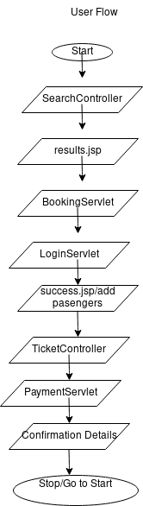

Core concepts used in the project :

Collections, DTO, Exceptions Handling, JDBC,inheritance, composition, JSP, Servlets, Tomcat, MySql., DAO

Links to the GitHub repository to verify the project completion

https://github.com/eff-sunyl/FlyawayRepo.git

Enhancing the application:

1. We can improve the ticket allocation based on the seat numbers. Ticketing can be improved by having some pattern in the ticket , this patter can detect the airlines that we are booking.