Project Description: Prototype application for handling file operations.

Developer details : Ratna Kumar Boddu

Sprints planning:

3 Sprints with each sprint of 5 days.

Sprint 1 –

* Task 1- Develop high level design project using project requirements.
* Task 2- Develop low level design using project specifications.
* Task 3- Develop the flow chart that depicts the flow and features

Sprint 2 -

* Task 1 – Create a class diagrams based on the flow charts. These include identifying interfaces.
* Task 2 – Define exceptions and unit testing on the developed classes.
* Task 3- Develop the code to implement the classes( Part 1)

Sprint 3-

* Task 3- Develop the code to implement the classes( Part 2)
* Task 4- Complete Junit testing.
* Task 5- Perform UAT.

Algorithms: Binary Search , ArrayList data structure

Flowcharts of the application:

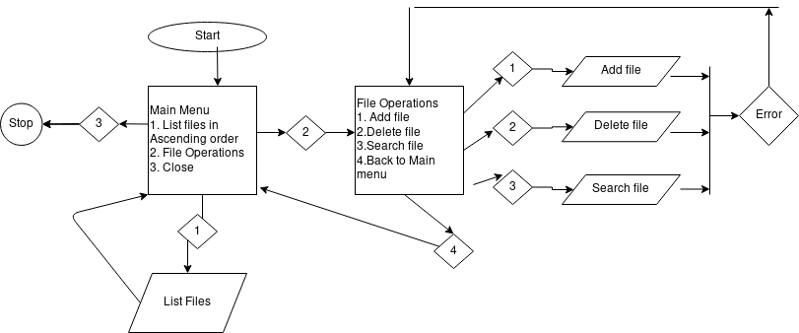

Core concepts used in the project :

Collections, DTO, Exceptions Handling, File handling,inheritance, composition, comparator

Links to the GitHub repository to verify the project completion

https://github.com/eff-sunyl/Lockedmerepo.git

Enhancing the application:

1. We can have a data structure that can maintain the state of a particular directory. This data structure will be created dynamically and all its operations will be mapped to Persistent layer which is File system.