## Where the texture is loaded

buttonLoadImage.cs, line 65

## Where the texture is saved

DelaunayApp.cs, line 308

## How to create the triangulation for a given model (to do once only)

Go the DelaunayApp script in the scene, select ‘learning mode’ (I created it).

Map all the points, something like this:

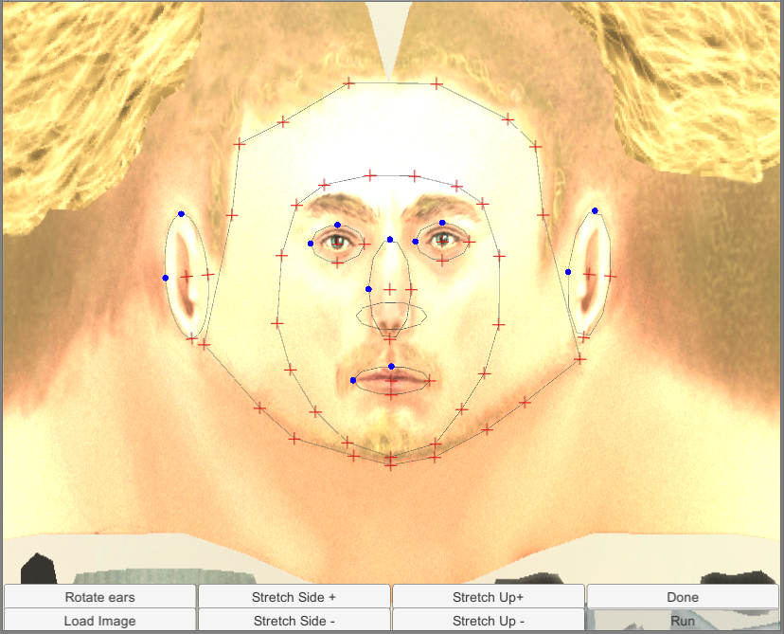

Click on ‘Done’. In the output console, you will see a list of ‘new Point(…)’. You just have to copy and paste those in DelaunayApp.cs in the list modelFacePoints. If you want to use several model, then you should save those points as an xml file or something for each model and load it at runtime

## How to map

Uncheck ‘learning mode’ and load the user image. Map all the points, making sure that it corresponds to the same body parts

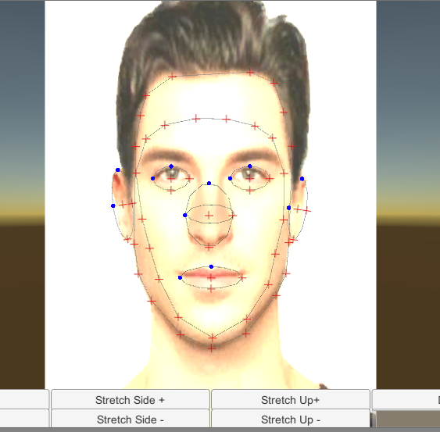

Then click on ‘Done’ and then ‘Run’. I optimized the process a bit with boundary boxes, so even if there are more points the processing time is similar to the previous one.

## Adding/Removing shapes

DelauneyApp.cs in the scene: add or remove FaceElements in the inspector

Example: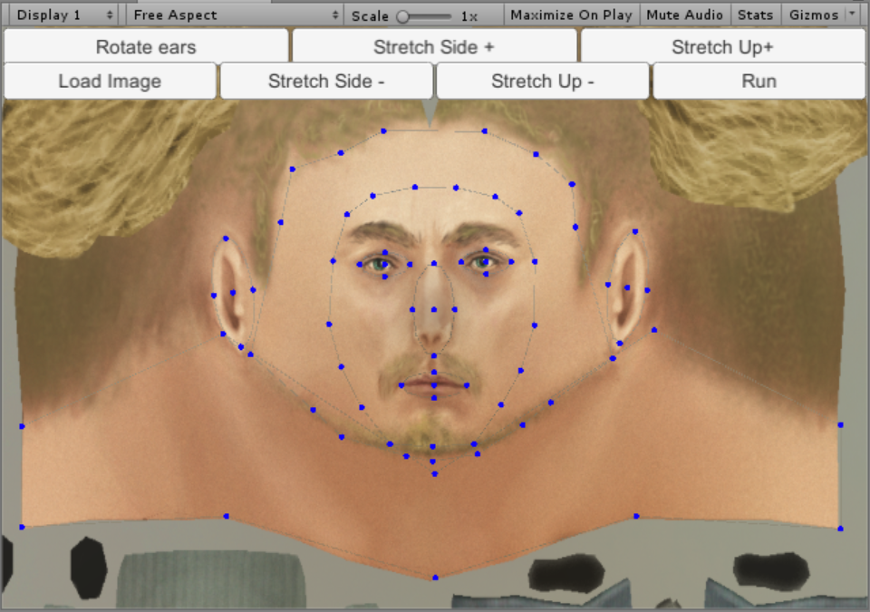

Neck element was added (it’s very wide for the model texture, once done you should make it a narrower shape to guide the user).

## Other things

You will see that all control shapes (ellipses for ears, face contour, etc.) inherits from the same base class. You can create as many shapes as you want (maybe a triangle for the nose, etc.), it’s very easy as everything is generic. The only important thing is to make sure that all points in scene have a unique ID.

You can simplify the interface for the user by using ellipses for the face contours (and generating points on its contour)

The inner and outer face contour is what suppress the edge that was shown before in the app. By adding the outer contour, the face is mapped up to the hairs.

Also, you can map the neck with the outer contour if you want, it works (I tried). You might have to try various positions / configurations for different models, the important thing is to show to the user where he is supposed to put the points with a sample picture.