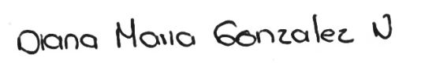

_________________________  
Diana María González Narváez  
1061782295  
Representante legal de Effective Software