Assignment 3.2

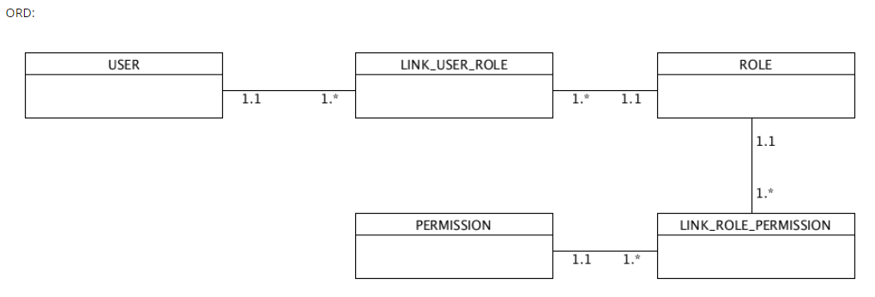

Business Rules:

* A USER can have many LINK USER ROLEs.
* Each LINK USER ROLEs can have one ROLE.
* A ROLE can have many LINK ROLE PERMISSIONs.
* Each LINK ROLE PERMISSION can have one PERMISSION.

NoSQL data structure:

