Assignment 3.3

Normalized ORD and NoSQL Document diagram:

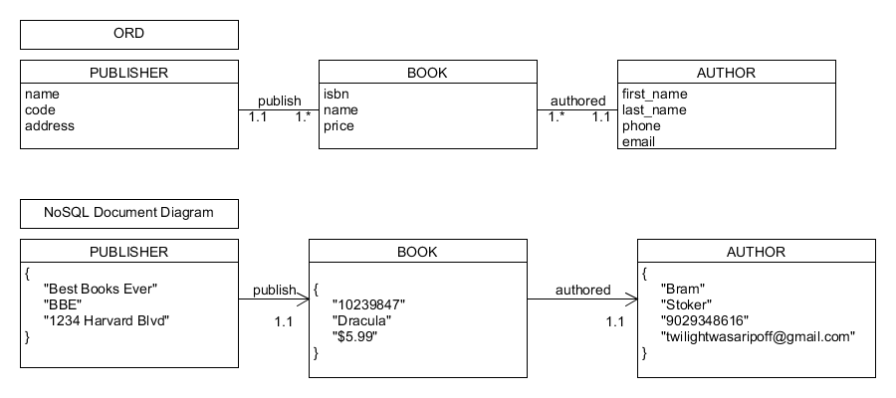

Business Rules:

* A PUBLISHER has one NAME.
* A PUBLISHER has one CODE.
* A PUBLISHER has one ADDRESS.
* A PUBLISHER can publish many BOOKs.
* Each BOOK has one ISBN.
* Each BOOK has one NAME.
* Each BOOK has one PRICE.
* Each BOOK is authored by an AUTHOR.
* An AUTHOR has one FIRST_NAME.
* An AUTHOR has one LAST_NAME.
* An AUTHOR has one PHONE.
* An AUTHOR has one EMAIL.

NoSQL data structure:

