Objective and Context
CEO, Ben, aims to invest at least £1M in online advertising to generate a minimum of 200,000 new website visitors. I gathered historical data on five keywords for UK fashion online retail ads e.g. “retail UK”, “cardigan etc. Then, I built a model to estimate advertising efficiency (cost-per-click, CPC) and to determine how the budget should be optimally allocated.
Key Findings
Exploratory analysis shows substantial variation in CPC across keywords. Generic terms such (e.g. “retail UK”) consistently deliver the lowest CPCs while niche or trend-driven keywords (e.g. “dua lipa gloves”) exhibit very high and volatile CPCs. This variability is partly explained by differences in relevance, seasonality, and advertiser competition.
Keyword-specific linear regression models confirm the exploratory insights: “retail UK” is the most cost-effective keyword, while “dua lipa gloves” is the least.
Optimal Allocation Results
A simple optimisation model, that maximizes clicks subject only to a £1M budget constraint, allocates the entire budget to “retail UK,” yielding approximately 254,000 clicks. While mathematically optimal, this “corner solution” is unrealistic in practice due to concentration risk and diminishing returns.
I added a diversification constraint (max. £300k per keyword): the budget is then spread across four keywords, generating about 155,000 clicks. This reduces total traffic but lowers risk and improves exposure across customer segments.
Financial Implications
Assuming an average revenue of £4 per click, even the most cost-efficient allocation barely breaks even. Diversified strategies generate negative net revenue under this assumption. An extended model that allows the total budget to be optimised confirms that, given current CPC levels and monetisation assumptions, the profit-maximizing decision is to spend little or nothing. A break-even formulation suggests that spending close to £1M is only viable if the budget is heavily concentrated on the lowest-CPC keywords.
Business Recommendations
Firstly: do not scale spend aggressively unless revenue per click increases (e.g. through better conversion rates or higher basket sizes). Subsequently, short-term spend on high-efficiency keywords (“retail UK”, “free shipping UK”) but impose moderate diversification to manage risk.
Suggested Extensions
To improve decision quality, future analysis should: (i) incorporate conversion rates and revenue per keyword, not just clicks (ii) explicitly model cross-keyword and cross-platform cannibalisation effects.
Appendices
Appendix A: Exploratory Analysis on Keyword CPCs
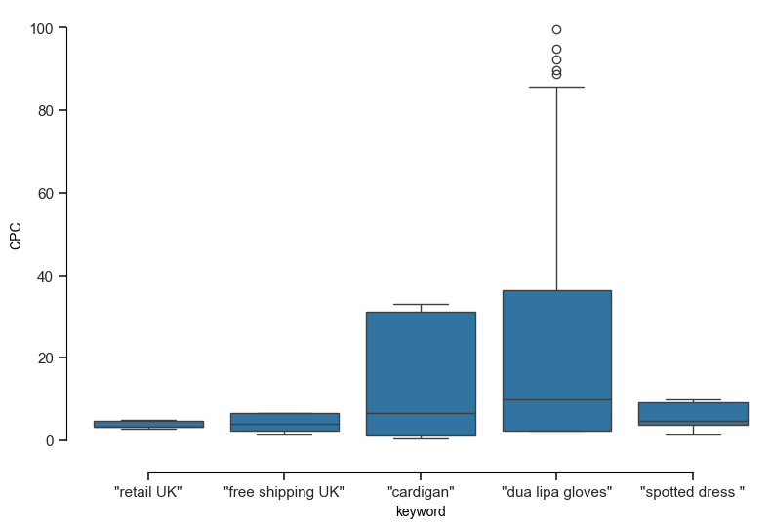
Appendix B: Net Revenue with Diversified Constraints
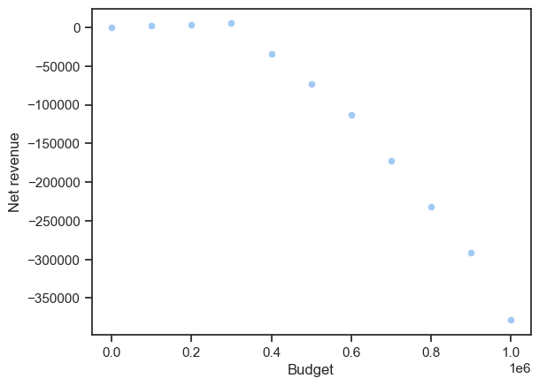

See Appendix A
See Appendix B

