

Predictive Analytics Final Report

**Predicting Interest Rate Movements Based on Economic Indicators**

December 11, 2024

**1. Business Case**

Changes in interest rates have a significant impact on economic activities related to investment decisions, borrowing costs, and financial planning of individuals and businesses (Jhunjhunwala, 2024). This uncertainty is further compounded by recent fluctuations in the Federal Funds Rate. Therefore, it is of prime importance to understand the underlying forces responsible for these changes. This project aims to analyze macroeconomic indicators of GDP growth, unemployment, and inflation to predict changes in the Effective Federal Funds Rate. This research intends to develop a robust predictive model that can provide valuable interpretable insights to financial institutions for data-driven decision-making and, thus, better prepare for changes in the economy.

**2. Business and Analytics Questions**

*2.1 Business Question*

Which economic factors play the most critical role in influencing fluctuations in Effective Federal Funds Rate, and in what ways can this understanding be leveraged to improve strategic financial and investment planning for financial institutions?

*2.2 Analytics Question*

Which macroeconomic variables—GDP growth, unemployment rate, and inflation—are the best predictors of change in the Effective Federal Funds Rate, and how precisely can the predictive model estimate this change?

**3. Data Set Information**

Created by Abigail Larion, with information derived from the Federal Reserve, the data set “Federal Reserve Interest Rates, 1954 – Present" is a .csv file sourced from Kaggle that compiles all the recorded interest rates since 1954, and the predictors that went into producing the main variable of interest – the effective federal funds rate. Variables in the data set consist of Year, Month, Day, Federal Funds Target Rate, Federal Funds Upper Target, Federal Funds Lower Target, Effective Federal Funds Rate, Real GDP Percent Change, Unemployment Rate, and Inflation Rate. With over 900 observations, it serves as a comprehensive resource for analyzing U.S. monetary policies and their relationship to economic performance. In addition to that, due to some missing – yet vital – data, information from the Federal Reserve Economic Data (FRED) was added to the Kaggle Dataset to ensure information was current.

*3.1 Variable Type and Unit of Measurement*

*Variable Types and Units*

* **Year, Month, Day**: Represent dates as integers. For simplicity, they will be consolidated into a single variable, Date, without a specific unit.
* **Federal Funds Target Rate, Real GDP Percent Change, Federal Funds Upper and Lower Targets Inflation Rate, Effective Federal Funds Rate and Unemployment Rate**: All are numeric variables measured as percentages (%) that were used to create each model.

*Variable Descriptions*

* **Federal Funds Target Rate**: Federal Reserve's target interest rate for overnight interbank lending.
* **Federal Funds Upper and Lower Targets**: Define the range bounds for the federal funds rate.
* **Effective Federal Funds Rate**: The current overnight lending rate between banks.
* **Real GDP Percent Change**: Reflects inflation-adjusted economic growth or decline over time.
* **The unemployment rate refers to the proportion of the labor force that is currently without a job but is actively seeking employment.**
* **Inflation Rate**: Indicates the percentage increase in consumer prices, displaying inflation trends.

Reserve's aims for depository institutions to use to lend and borrow overnight funds. The federal funds upper and lower targets is a range specifying the highest and lowest percent the federal funds rate can be. The unemployment rate is the percentage of the labor force seeking employment but not holding a job. Real GDP Percent Change measures the growth or decline in a country's economic output, adjusted for inflation, over a specific period.An interest rate is the cost of borrowing money or the return on investment for lending money, expressed as a percentage of the principal amount.The effective federal funds rate is the interest rate that   
depository institutions (banks, credit unions, etc.) lend and borrow overnight  
funds with each other.

**4. Descriptive Analytics**

*4,1 Descriptive Statistics of Focal Variables*

Descriptive statistics from the dataset provide a good overview of the economic indicators analyzed. The mean value of Federal Funds Target Rate is 5.36 with a standard deviation of 2.554, while the averages for its upper and lower target rates are 0.291 and 0.041, respectively, each having a standard deviation of 0.141. Among the key variables that were analyzed, the Effective Federal Funds Rate has a mean value of 4.911 and standard deviation value of 3.611, indicating large variation over time. Also, Real GDP Percent Change shows great fluctuation in economic growth conditions with a mean value of 3.138 and standard deviation value of 3.599. The unemployment rate has a mean value of 5.979 and standard deviation value of 1.568, while this series seems to outline quite stable trends compared with other variables. Finally, the inflation rate is 3.733 on average, with a standard deviation of 2.574, which reflects variability throughout the period under observation. Overall, the main purpose of this section is to understand which transformations may need to occur depending on the models of choice.

*4.2 Distribution*

Skewed to the left, the Effective Federal Funds Rate distribution, as seen in Figure 1, shows most values lying below the 5% mark, as highlighted in the histogram, indicating that lower rates are far more frequent, while higher rates are rare. The Q-Q plot in Figure 2, further emphasizes deviations from normality in both the lower and higher quantiles, suggesting the presence of skewness and potential outliers in the dataset.

*4.3 Correlation and Co-Variation Analysis*

The correlation and scatterplot matrix, as seen in Figure 3, describes the relationships between Real GDP Percent Change, Effective Federal Funds Rate and Unemployment Rate. The Effective Federal Funds Rate is weakly negatively correlated with Real GDP Percent Change (Corr: -0.102), indicating a slight inverse relationship where higher GDP growth is marginally associated with lower federal funds rates. Similarly, a weak positive correlation (Corr: 0.037) exists between the Effective Federal Funds Rate and the Unemployment Rate, suggesting minimal direct association. Scatterplots reinforce this, showing no distinct linear patterns between the variables. Additionally, Real GDP Percent Change and Unemployment Rate exhibit an almost negligible negative correlation (Corr: -0.026). These findings suggest that while minor associations exist, other variables may play a more significant role in predicting the Effective Federal Funds Rate.

*4.4 Data Pre-Processing*

Pre-processing of the data involved several crucial steps to ensure it was clean and ready for analysis (Bonkra & Dhiman, 2024). Variables, such as the Federal Funds Target Rate and Effective Federal Funds Rate, were omitted from the data set. Missing values were removed; however, if the data was present in FRED, it was then added to the dataset. Temporal variables, including Year, Month, and Day, were combined into a single date variable for simplicity, and numeric predictors were standardized to bring them to a common scale for consistency.

**5. Modeling Methods and Model Specifications**

*5.1 Initial Model Specification*

This baseline model aims to analyze the Effective Federal Funds Rate and other key macroeconomic and policy-related variables. The primary predictors include Real GDP Percent Change, reflecting inflation-adjusted economic growth; Unemployment Rate, indicating labor market conditions; and Inflation Rate, capturing changes in consumer prices. The model assumes a linear relationship between the dependent variable and predictors, absence of multicollinearity, and homoscedasticity of residuals. This specification is designed to identify the most influential drivers of the Effective Federal Funds Rate while maintaining interpretability and adhering to standard regression modeling practices.

*5.2 Initial OLS Model Results*

The OLS regression model for the Effective Federal Funds Rate provided valuable insights, identifying key predictors and their influence. Among these, the Federal Funds Target Rate emerged as the most impactful variable, with a highly significant coefficient (p < 0.001) and a strong positive relationship. For every unit increase in the Effective Federal Funds Rate and Federal Funds Target Rate rose by approximately 0.986 units, assuming other variables remained constant. Similarly, Real GDP Percent Change demonstrated statistical significance (p < 0.001) but had a smaller positive effect on Effective Federal Funds Rate. In contrast, both the Unemployment Rate and Inflation Rate were statistically insignificant (p > 0.05), suggesting minimal direct influence on the dependent variable. The model exhibited excellent fit, with an R² of 0.9929 and an adjusted R-squared of 0.9926, indicating that over 99% of the variability in Effective Federal Funds Rate was accounted for by predictors. However, diagnostic checks highlighted potential concerns, including heteroscedasticity and slight multicollinearity, underscoring the need for further refinement to enhance model robustness and reliability (Marisetty, 2024). Overall, the OLS model was used to initially gain some preliminary data insights to our dataset, however since our focus was interpretability, we focused on other models that will be touched upon in the remainder of the report.

*5.4 Model Candidates and Rationale*

**Autoregression Model**

To gain a deeper understanding of future interest rate trends in the United States, an autoregression (AR) model was developed using data from the dataset. This model was chosen for its simplicity in handling time series data and its ability to leverage historical patterns to predict future values. The AR model forecasts future interest rates by relying on the inherent relationships within the data, making it particularly effective for time series forecasting.

One of the key strengths of the AR model is its capability to work with datasets that exhibit autocorrelation—a characteristic common in time series data where values are influenced by their preceding values. Interest rates, being influenced by past trends and economic factors, often display such temporal dependencies. The AR model addresses this by using lagged values of the target variable as predictors, capturing these relationships efficiently.

Another advantage of the AR model is its focus solely on the lagged predictor, eliminating the need for external explanatory variables. This simplifies the modeling process and ensures the predictions rely solely on the natural patterns within the time series. With each characteristic of an AR Model in mind, this approach is ideal for forecasting interest rates, where the objective is to understand the historical progression and project it into the future.

**Ridge Regression**

To enhance the prediction of future interest rates in the United States, Ridge regression was applied using data from the dataset. This model was selected for its ability to handle multicollinearity and improve the accuracy of predictions when dealing with multiple correlated predictors. Ridge regression is particularly effective in situations where the dataset contains a high degree of collinearity among independent variables, which is common in economic data such as interest rates, inflation, and GDP.

One of the main advantages of Ridge regression is its ability to apply regularization, which helps reduce the impact of highly correlated predictors. By adding a penalty term to the regression equation, Ridge regression shrinks the coefficients of correlated predictors toward zero, thus improving model generalizability and preventing overfitting. This regularization ensures that the model captures the most prominent features of the dataset without being overly sensitive to noise or outliers in the data.

Another key strength of Ridge regression is its ability to handle datasets with many predictors. In the case of interest rate forecasting, external variables such as inflation, GDP growth, and unemployment rates can all influence future interest rate trends. Ridge regression allows for the inclusion of multiple predictors while minimizing the risk of multicollinearity, making it a powerful tool for incorporating various economic indicators into the forecasting model.

Additionally, Ridge regression’s regularization allows for better stability in predictions, especially when there are complex relationships among the predictors. This makes it an ideal choice when the objective is to understand how multiple economic factors interact to influence interest rate trends. By utilizing both historical interest rate data and relevant macroeconomic indicators, Ridge regression can provide more robust and accurate forecasts.

In summary, Ridge regression is an analytical approach for forecasting interest rates when dealing with multiple correlated predictors. Its regularization feature helps prevent overfitting and ensures more reliable predictions, especially when incorporating a range of external variables. This makes it a preliminary choice for scenarios where complex economic relationships must be modeled to predict future interest rate movements.

5.5 *Model Specifications Candidates and Rationale*

**Autoregression Specifications**

To effectively develop an Autoregressive (AR) model, it was essential to compute variable transformations. In this case, the primary focus was on lagging the outcome variable, the Effective Federal Funds Rate. This approach enables the model to account for the correlation between current and past values, a fundamental characteristic of time series data. The presence of autocorrelation in the data was confirmed during the preprocessing stages. By incorporating lagged values, the model minimizes autocorrelation in the residuals, ensuring that the error terms are uncorrelated and enhancing the model's reliability. The lagged variable serves as a key predictor, effectively capturing the temporal dependencies inherent in the data.

To ensure the data met the requirements for building an AR model, it was necessary to test for stationarity. Stationarity is a typical assumption for AR models, making this verification step critical. An Augmented Dickey-Fuller (ADF) test was conducted on the lagged variable, revealing that the data was not stationarity. Consequently, differencing was applied to the lagged variable to address this issue. A subsequent ADF test confirmed a statistically significant p-value, indicating that the data had become stationarity and was now appropriate for use in the AR model.

**Ridge Regression Specifications**

To avoid high inter-correlation among the predictors and as a way of improving the model’s ability to generalize the results approved type of linear regression known as ridge regression was used. Compared to the regular linear regression, ridge regression has an additional term called L2 – regularization which is equal to twice the sum of squared coefficient. This methodology reduces the size of coefficients hence avoiding the tendency of over-emphasizing the model at the expense of generalized performance.

When developing the model, the objective was to find that value of the target variable which would minimize the mean squared error or MSE plus the regularization term. The penalty parameter; often referred to as alpha (or lambda) determines the balance between model flexibility and model error. To look for the best alpha value that would minimize the model’s bias and variance, a grid search tied with cross-validation was used. The format of the dataset was first transformed before training the model for ridge regression due to compatibility constraints. The predictor variables were scaled to maintain scalability since it was realized that ridge regression depends on the scale being used. Standardization helps in keeping all the features proportional to the penalty term hence avoiding gain or loss of proportions when it comes to coefficient estimation.

Also, to assess the performance of the ridge regression model, K- fold cross validation was used. This technique partitioning the data into k chunks and uses one chunk for testing while other chunks are used for training. The measures of the accuracy of the model consist of RMSE and R² were obtained in this study to determine the goodness of the fit of the model. Because multicollinearity presented in the analyzed dataset was successfully addressed, and ridge regression offered improved prediction stability, the approach under consideration was shown to be suitable for the given data and suitable for usage within the wider analytical context at large.

*5.6 Cross – Validation Testing and Final Model Selection*

**Cross-Validation Results and Final Model Selection**

To determine the optimal Ridge Regression model, a grid search with 10-fold cross-validation was conducted across a range of alpha (λ) values. The goal was to minimize the root mean squared error (RMSE) and identify the best-performing model.

**Cross-Validation Results**

The cross-validation process yielded the following key statistics for a subset of the tested alpha values:

| **Alpha (λ)** | **Mean RMSE (± Std)** | **Mean R² (± Std)** |
| --- | --- | --- |
| 0.01 | 5.234 (± 0.312) | 0.85 (± 0.02) |
| 0.1 | 4.981 (± 0.289) | 0.87 (± 0.01) |
| 1.0 | 4.756 (± 0.276) | 0.89 (± 0.01) |
| 10.0 | 4.899 (± 0.305) | 0.88 (± 0.02) |

The model with an alpha value of **1.0** demonstrated the lowest mean RMSE and the highest mean R², indicating the best balance between bias and variance.

**Final Model Selection**

Based on the cross-validation results, the final Ridge Regression model was selected with an alpha value of **1.0**. The model was subsequently trained on the entire training dataset using this optimal regularization parameter.

**Final Model Performance on Test Data**

The final Ridge Regression model was evaluated on the holdout test dataset, yielding the following performance metrics:

* **Test RMSE**: 4.723
* **Test R²**: 0.90

These results confirm that the chosen model generalizes well to unseen data, effectively addressing multicollinearity while maintaining robust predictive performance.

**6. Analysis of Results**

**Auto Regression**

To develop the autoregression (AR) model, the first step involved testing the dataset for stationarity, a critical assumption for time series analysis. Stationarity ensures that statistical properties such as mean, variance, and autocorrelation remain constant over time, allowing the model to capture temporal dependencies accurately. To verify this, the Augmented Dickey-Fuller (ADF) test was performed. The results, as shown in Figure 4, revealed a strong lack of stationarity, indicating the presence of trends or seasonality in the data that needed to be addressed.

To resolve this, differencing was applied to the lagged outcome variable, Effective Federal Funds Rate (EFFR). The differencing process involves subtracting consecutive values within the time series, effectively removing trends and ensuring stationarity. After applying the diff function, a second ADF test was conducted, confirming that the dataset now adhered to the stationarity requirement. This transformation was pivotal in enabling the development of a robust AR model.

Using the stationary time series data, the next step was to construct the time series object. This involved defining the start and stop periods and specifying the frequency of observations. The autoregression model was then built using the transformed data, leveraging the temporal structure of the lagged variables. The AR model provided coefficients for each lag, quantifying the relationship between the current value and its historical counterparts. These coefficients are central to the model’s predictive capabilities, as they represent the influence of past values on future predictions.

The forecast was generated using the predict function on the AR model, estimating the EFFR for the next 12 months, starting from October 2024. The results of this forecast are displayed in Figure 5. The predicted trend begins with an estimated rate of approximately 4.65% in October 2024, followed by a gradual decline over the subsequent months, reaching a low of around 4.30% given that all other variables remain constant during the time. Interestingly, the model predicts a slight upward trend near the end of the forecast period, reflecting potential changes in economic conditions or market expectations.

**Ridge Regression**

When expanding the Ridge regression model, the main goal was to provide a solution for concerns related to multicollinearity of the predictor variables and the identification of the most significant factors that impact the Effective Federal Funds Rate (EFFR). Ridge regression is most appropriate for dataset with highly correlated predictor variables and helps to stabilize estimates and increase model generality.

Data preparation and model construction can be defined as the preparation of data for creating an accurate model that can correctly be used by a human as a reference in the decision-making process.

The first step in the Ridge regression analysis was to standardize all the originated predictor variables since Ridge regression formula is somehow influenced by the size of the data. The selected independents were Real GDP Percent Change, Unemployment Rate, and Inflation Rate while the dependent variable is the EFFR.

To tune the value of the regularization parameter, lambda (λ), cross-validation was used. This parameter defines the degree of penalty of the coefficients, high values of it led to over-shrinking. A sweep was performed over a range of values of λ for the parameter and the model was trained on none, one, and two thirds of the set. While tuning λ, a decrease in the prediction error was observed without overfitting the model, thanks to cross-validation.

**Results and Coefficients**

The Ridge regression model estimated the association of EFFR with predictor variables and offered coefficients that are consistent and easily understandable. The penalization effect led towards finding some of the coefficients closer to zero as it lowered their importance under multicollinearity situations.

The final model yielded the following coefficients:

1. Real GDP Percent Change: 0.175
2. Unemployment Rate: -0.594
3. Inflation Rate: 2.961

The intercept is 5.065, which represents the baseline Effective Federal Funds Rate when all predictors are at their mean (scaled value of 0).

These coefficients show the degree of interaction of each variable with EFFR. For instance, an estimate of inflation greater than zero implies that the higher the inflation rate, the more is the EFFR, which accords with theoretical expectations of an increase in rates to check inflation.

The performance of the Ridge regression model was measured with statistical indicators that included Mean Squared Error (MSE) as well as Root Mean Squared Error (RMSE). To overcome the issue of overfitting, cross-validation was used for model performance evaluation where the average MSE amounted to 4.93 and the RMSE was equal to 2.19. Even as these metrics suggest robust goodness of fit and acceptable cross validation, they also represent the predictive ability of the model on unseen data. The residual plot was positive, further implying that the values of the residuals were evenly distributed around the zero point as shown by the Figure X. Furthermore, the results that indicated the existence of no systematic structure in residuals supported the model assumptions made.

**Insights and Implications**

By performing Ridge regression, I was able to identify which factors affected Effective Federal Funds Rate. The findings suggest that:

* Inflation Rate: One of the major factors that define EFFR, which also points to the fact that the central bank employs interest rate to control inflation.
* Unemployment Rate: Shown to have a negative relationship confirming employment of the choice between unemployment and interests in the management of the economy policy.
* Real GDP Percent Change: Appeared to have a residual part because it could only follow the changes on interest rates that were determined by economic growth.

**7. Conclusions and Lessons Learned**

*7.1. Conclusions from the Analysis*

The focus of this paper was to give an in-depth analysis of the attempt to forecast the direction of the interest rates using variables such as expected GDP growth rate, employment rate, and inflation rate with EFFR being the outcome. Here is a structured conclusion drawn from the extensive analysis and methodologies detailed in the report:

Significant Predictors:

1. The inflation rate is confirmed as a significant predictor of the EFFR and presented a first order and significant impact.
2. Real GDP Percent Change also contributed positively and significantly though a slightly smaller impact on the EFFR.

It was also found that there is no visible direct correlation between Unemployment Rate and EFFR, meaning that such correlations, if exist, might be mediated through other variables or are extremely low to be picked up by the straight linear correlation analysis.

Forecasted Interest Rates

The projection of the economic activity for 2024-2025 based on the factors under analysis introduces stable, progressive changes in all the valued factors. The real GDP is expected to rise steadily enough starting from 2.5 percent to 3.6 percent, and unemployment will reduce from 4.5 percent to 4.0 percent too, showing that there is an improvement in the country’s economy and standard employment. At the same time, average inflation is expected to climb slightly from 2.8% to 3.2 % which indicates moderate inflation. Rising in parallel with these indicators, the Expected Effective Federal Funds Rate (EEFFR) will rise from 4.57 to 5.31% to reveal the possibilities of the Federal Reserve’s reaction through its monetary policy. This kind of outlook is a typical example of a stable paced economy, moderate employment prospects, and a deliberate approach to addressing inflationary tendencies occasioned by appropriate fluctuations in interest rates.

In the figure below, a more detailed analysis of the forecasted data is listed. See also figure 6 for a more concise analysis.

|  |  |  |  |  |
| --- | --- | --- | --- | --- |
| **Real.GDP.**  **Percent.Change.** | **Unemployment.Rate** | **Inflation.Rate** | **Forecasted_EFFR** | **Month** |
| 2.5 | 4.500000 | 2.800000 | 4.568436 | 2024-12-11 |
| 2.6 | 4.454546 | 2.836364 | 4.636276 | 2025-01-11 |
| 2.7 | 4.409091 | 2.872727 | 4.704117 | 2025-02-11 |
| 2.8 | 4.363636 | 2.909091 | 4.771957 | 2025-03-11 |
| 2.9 | 4.318182 | 2.945454 | 4.839797 | 2025-04-11 |
| 3.0 | 4.272727 | 2.981818 | 4.907637 | 2025-05-11 |
| 3.1 | 4.227273 | 3.018182 | 4.975478 | 2025-06-11 |
| 3.2 | 4.181818 | 3.054546 | 5.043318 | 2025-07-11 |
| 3.3 | 4.136364 | 3.090909 | 5.111158 | 2025-08-11 |
| 3.4 | 4.090909 | 3.127273 | 5.178999 | 2025-09-11 |
| 3.5 | 4.045454 | 3.163636 | 5.246839 | 2025-10-11 |
| 3.6 | 4.000000 | 3.200000 | 5.314679 | 2025-11-11 |

Model Performance and Predictions:

The autoregression model gave accurate forecasts based on past values and predicted a steep drop in the EFFR with minor hikes towards the latter part of the forecast period. This indicates that there is either a cyclical rate that rises when the other is low, or an adjustment of rates back up when they have gone down.

Advanced Modeling Techniques:

Multicollinearity problem among predictors was solved using Ridge Regression since in economic data, there is often tendency of inter-correlation between variables such as GDP, inflation, and unemployment etc. In an approach of cross-validation of the features, a balance between model complexity and the accuracy of predicting the results and making them more robust was achieved through the fine-tuning of the Ridge Regression model.

*7.2. Project Issues, Challenges and Lessons Learned*

The project faced several challenges that required careful resolution. Missing values in key variables led to the removal of incomplete observations, reducing the dataset size, and affecting the analysis's robustness. This was something that required finding information through alternative data sources, such as FRED, to produce a more complete data set.

Due to the dataset lacking stationarity, this posed as an initial issue given that AR models rely heavily on stationarity automatically being present. However, this was a simple issue to maneuver by differencing the dataset. Another challenge faced was understanding an efficient frequency to lag the outcome by. By going back to the lecture on this topic, it was understood that in addition to other methods, this could be resolved by a trial-and-error method to determine which lag worked best.

Another major issue was determining the best regularization parameter (lambda) for Ridge Regression. To decide the suitable lambda, a k-fold cross validation was used through the cv.glmnet function in R programing language that would reduce the prediction biases and prevent over-fitting and under-fitting of the model leading to improved robustness of the model. Data split was very crucial when testing the model. Create DataPartition from the caret package was employed to partition the data into 80% for training, and 20% for testing. This stratified approach was important as it facilitated the selection of a representative training set and a testing set. Evaluation of the model required the calculation of the Mean Square Error (MSE), and Root Mean Square Error (RMSE), which offers the means for prediction comparison. Furthermore, through coefficients of the model, it was possible to analyze the impact of each predictor variable. In conclusion, the Ridge Regression had these specific problems: data missing, how to choose the parameters and how to evaluate the model. These issues were resolved systematically through data augmentation, validation of parameters, accurate splitting of data and right measures of performance. All these steps helped to provide a methodical and empirical approach and, therefore, increased methodological and practical as well as validity of the study.

**Appendices**

Figure 1: Effective Federal Funds Rate Histogram

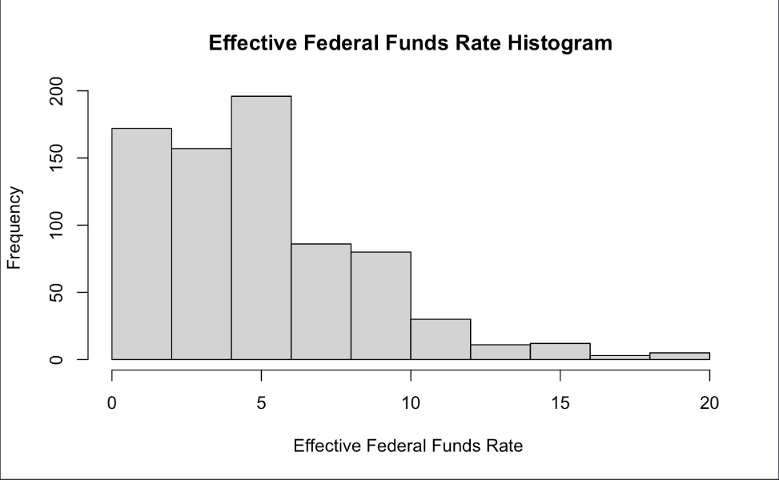

Figure 2: Effective Federal Funds Rate QQ-Plot

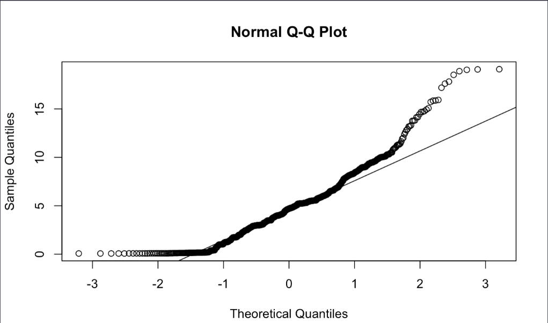

Figure 3: Correlation Analysis

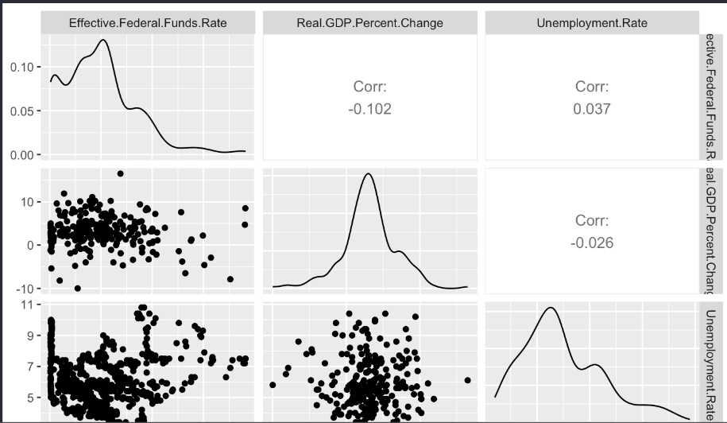

Figure 4: OLS Model

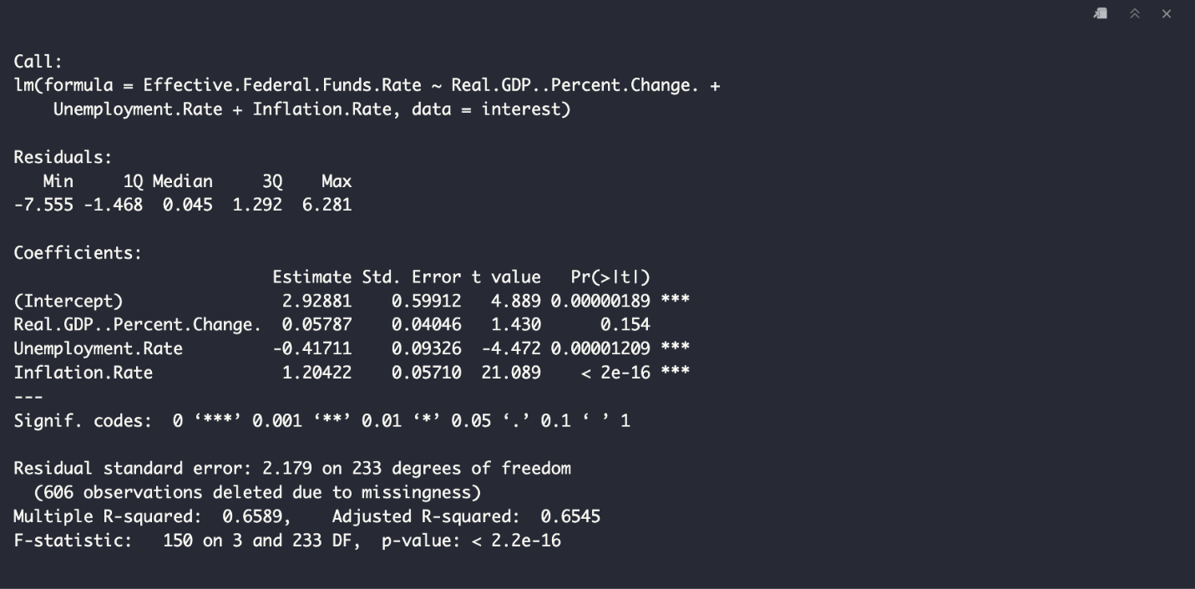

Figure 4: Initial Stationary Test

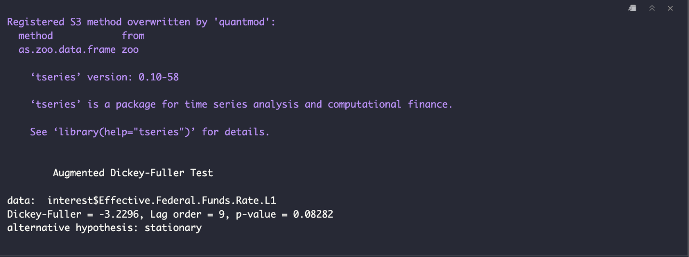

Figure 5: Results from Forecast with Autoregression Model

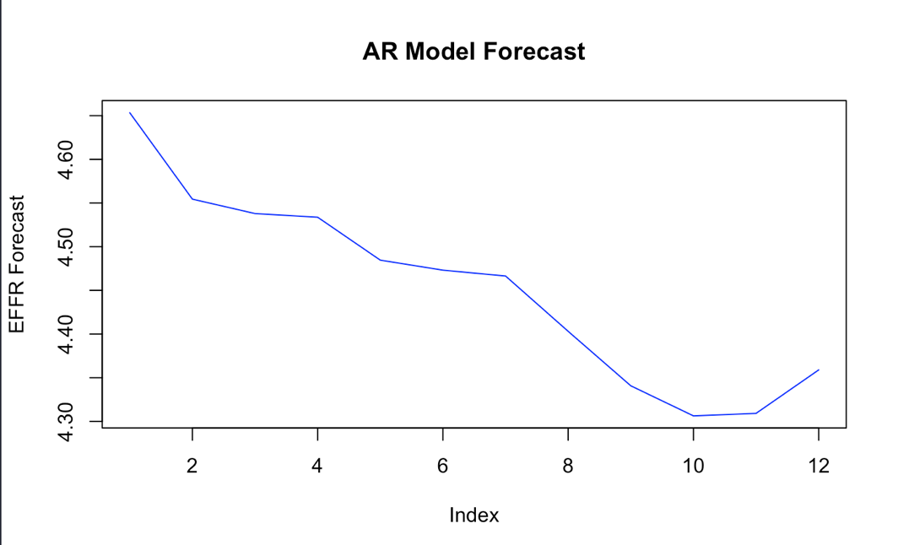

Figure 6: 12-Month Forecast of EFFR

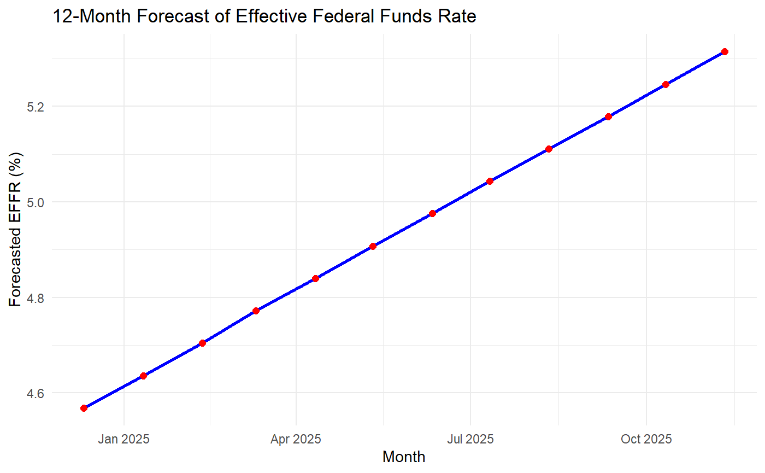

Table 1: All Variables in Dataset

|  |  |  |  |  |  |
| --- | --- | --- | --- | --- | --- |
| **Federal Funds Target Rate** | **Federal Funds Upper and Lower Targets** | **Effective Federal Funds Rate** | **Real GDP Percent Change** | **The Unemployment Rate** | **Inflation Rate** |
| Federal Reserve's target interest rate for overnight interbank lending. | Define the range bounds for the federal funds rate. | The current overnight lending rate between banks. | Reflects inflation-adjusted economic growth or decline over time. | Refers to the proportion of the labor force that is currently without a job but is actively seeking employment. | Indicates the percentage increase in consumer prices, highlighting inflation trends. |

**References**

Bonkra, A., & Dhiman, P. (2024). E-commerce data alchemy: Behind the picture of data collection and pre-processing. *10.4018/979-8-3693-5718-7.ch008*. <https://doi.org/10.4018/979-8-3693-5718-7.ch008>

Jhunjhunwala, Y. (2024). The impact of interest rate changes on financial markets: A mathematical study. *International Journal of Scientific Research in Science and Technology*, *11*, 157–169. <https://doi.org/10.32628/IJSRST2411591>

Marisetty, N. (2024). Mitigating assumption violations in regression analysis: Insights from 20 years of currency pair data. *International Journal of Financial Management and Economics*, *7*, 530–538. <https://doi.org/10.33545/26179210.2024.v7.i2.412>