Appendix 1 to the Flight Operation Document Unknown Ro   
27.03.2025  
ISSUE 00  
Flight Route 1

# 1. Route Overview

Figure A1.1 gives a general overview of the mission.  
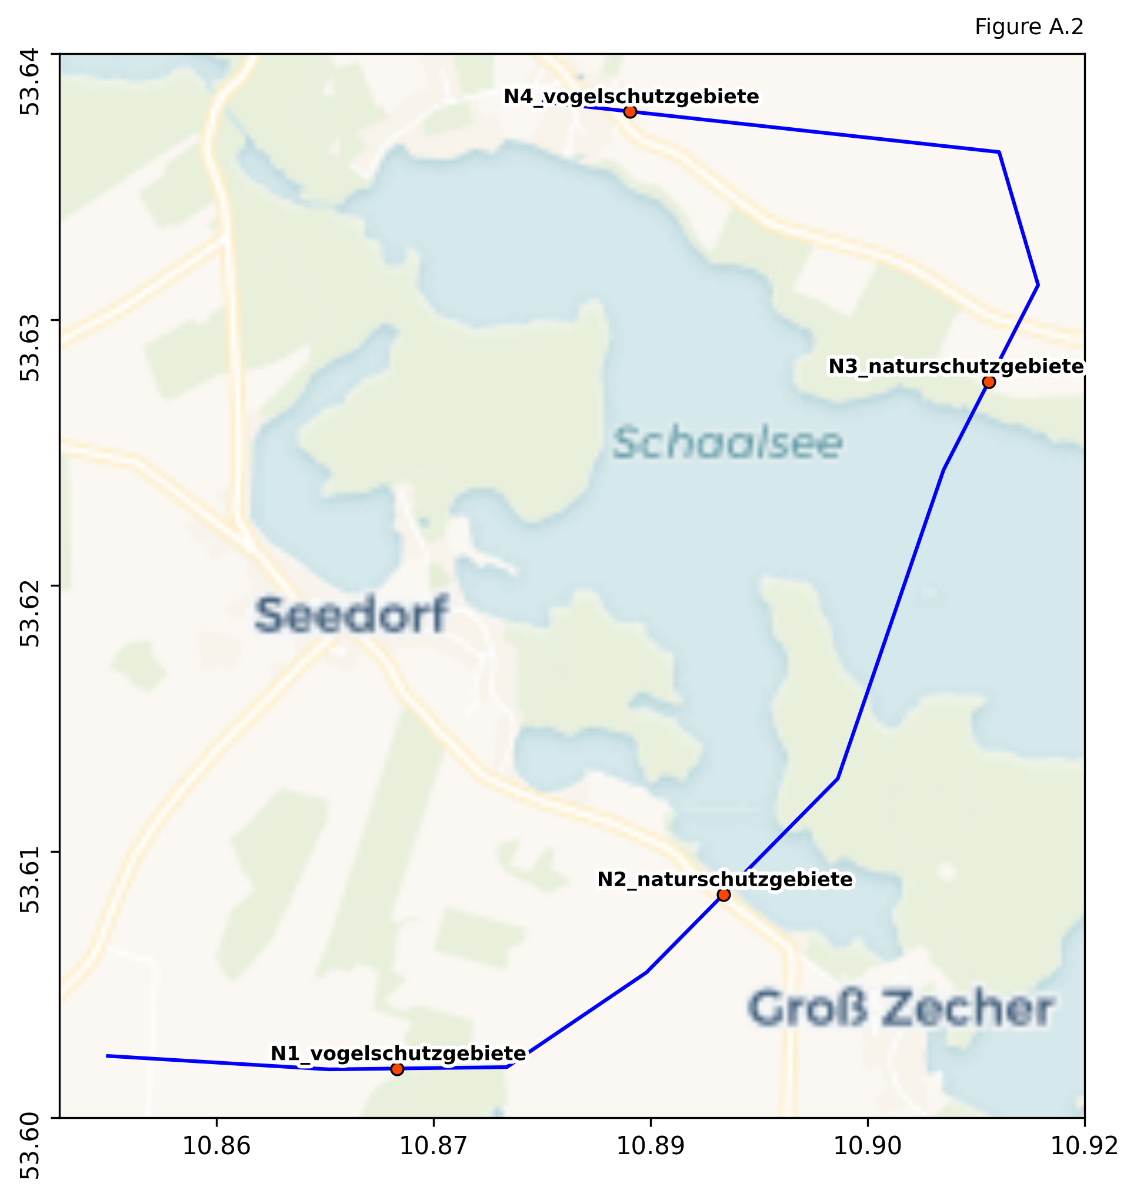

# 2. Flight Distances and Times