*Beagle Systems FO-Document: Unnamed*



**Appendix to the Flight Operation Document Unnamed 26.02.2025**   
**ISSUE 00**   
**Flight Route**

**1. Route Overview**

Figure A.1 gives a general overview of the mission.

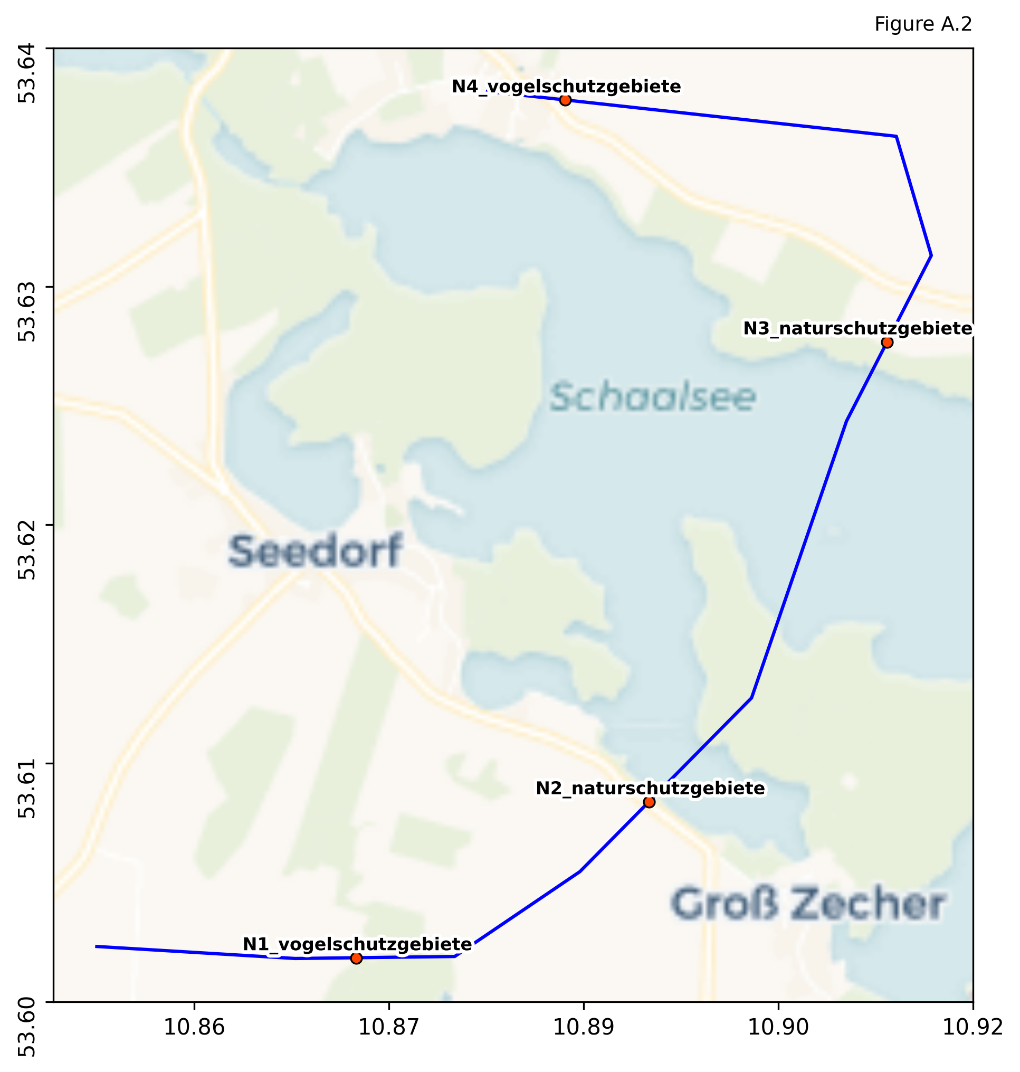

*Page 1*

*Beagle Systems FO-Document: Unnamed*



**2. Flight Distances and Times**

**3. Takeoff / Landing Site**

Takeoff and Landing occur at coordinates (None None), see Figure A.2 for details.

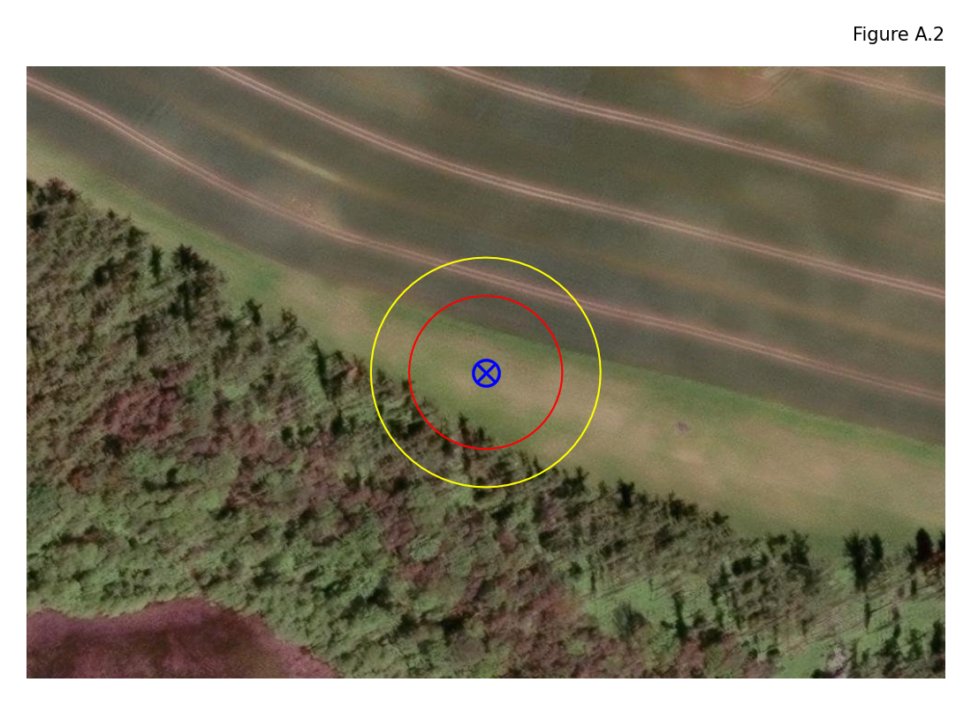

*Page 2*

*Beagle Systems FO-Document: Unnamed*



**4. Detailed Information**

Detailed population density assessment   
None required.

Individual Approvals   
None required.

Highway   
None required   
Railway Lines   
None required.

Federal Waterways   
None required.

Power Lines   
None required.

Closest public interest site (PIS)   
WMK Klinikum Helene von Bülow Hagenow, PIS MV313: 27.13 km

Natural Preserves   
See Figure A.1 and under 'Coordinates'   
bird sanctuary - (Schaalsee-Gebiet):  
 - From point N1 to point N4.

conservation area - (Schaalsee mit Niendorfer Binnensee, Priestersee und Großzecher Küchensee, Phulsee, Seedorfer Küchensee und Umgebung):  
 - From point N2 to point N3.

*Page 3*

*Beagle Systems FO-Document: Unnamed*



**5. Coordinates**

|  |  |  |
| --- | --- | --- |
| **Point** | **Lat** | **Lon** |
| Northernmost | 53.64049 | 10.88042 |
| Easternmost | 53.63300 | 10.91468 |
| Southernmost | 53.60093 | 10.86574 |
| Westernmost | 53.60148 | 10.85037 |
| N1_vogelschutzgebiete | 53.60097 | 10.87042 |
| N2_naturschutzgebiete | 53.60808 | 10.89296 |
| N3_naturschutzgebiete | 53.62906 | 10.91128 |
| N4_vogelschutzgebiete | 53.64009 | 10.88650 |

*Page 4*

*Beagle Systems FO-Document: Unnamed*



*Information stared in this paper is proprietary and belongs exclusivley to Beagle Systems and may not be reproduced without any prior notice the knowledge or a written consent approved by Beagle Systems.*

*www.beaglesystems.com*

*Page 5*