IT FND 110A

Yizhou Yang

Prof. Randal Root

TA: Aayush V. Shah

August 17, 2020

Assignment 06

<https://github.com/effyyangdesign/IntroToProg-Python-Mod06->

Assignment 06 Step Documentation

**Introduction**

This essay documents the steps I took to finish Assignment 06: finishing assignment 05 using functions.

**Steps**

In the beginning of the process, I got confused in the first function “add_data_to_list” on two parts. First, I was fixated on the idea that calling a function with the “task” and “priority” as argument, since it is similar to what we cover in class. Upon using debugging tool, I realized that somehow no value is being passed into this function. 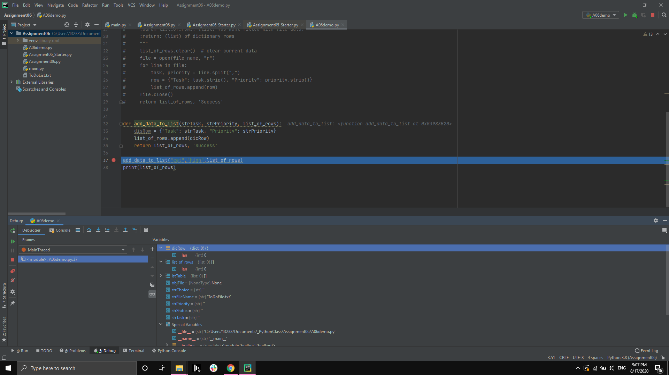

Then I went back to tested a basic function, making sure that I am getting the idea of calling function with arguments.

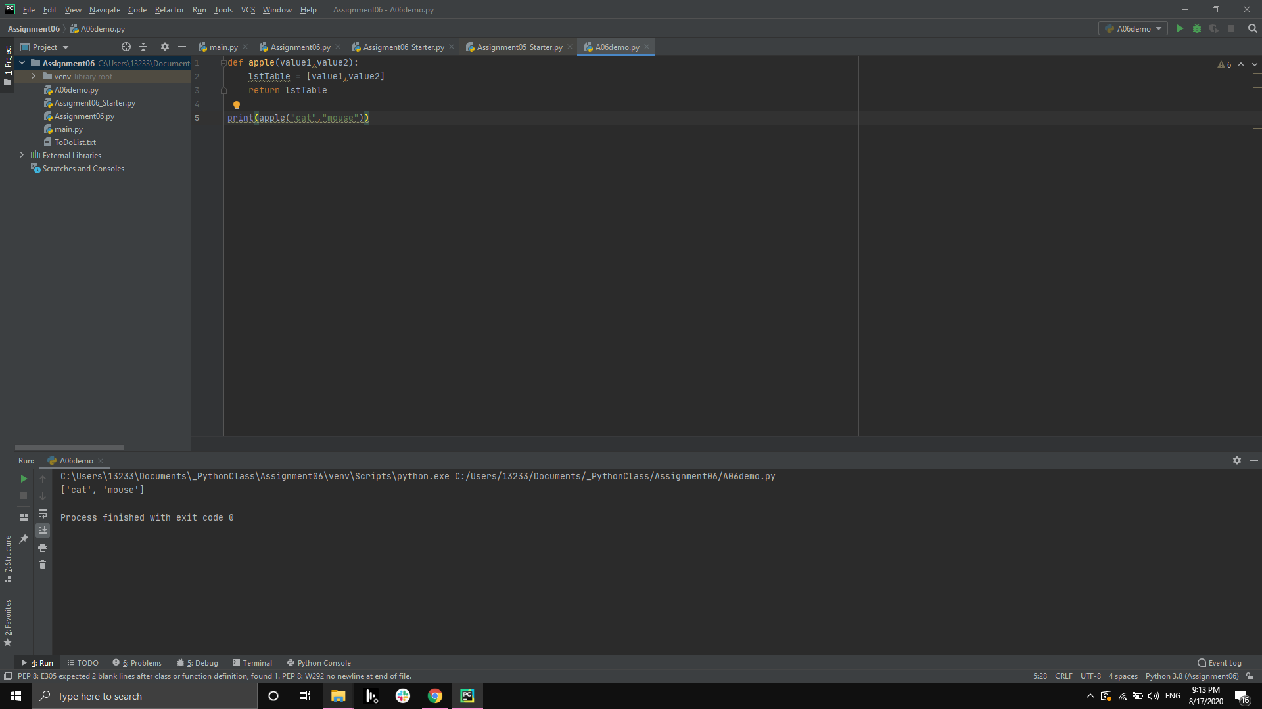

Then I realized that I can call function with the same variable name, while grabbing user input with the function.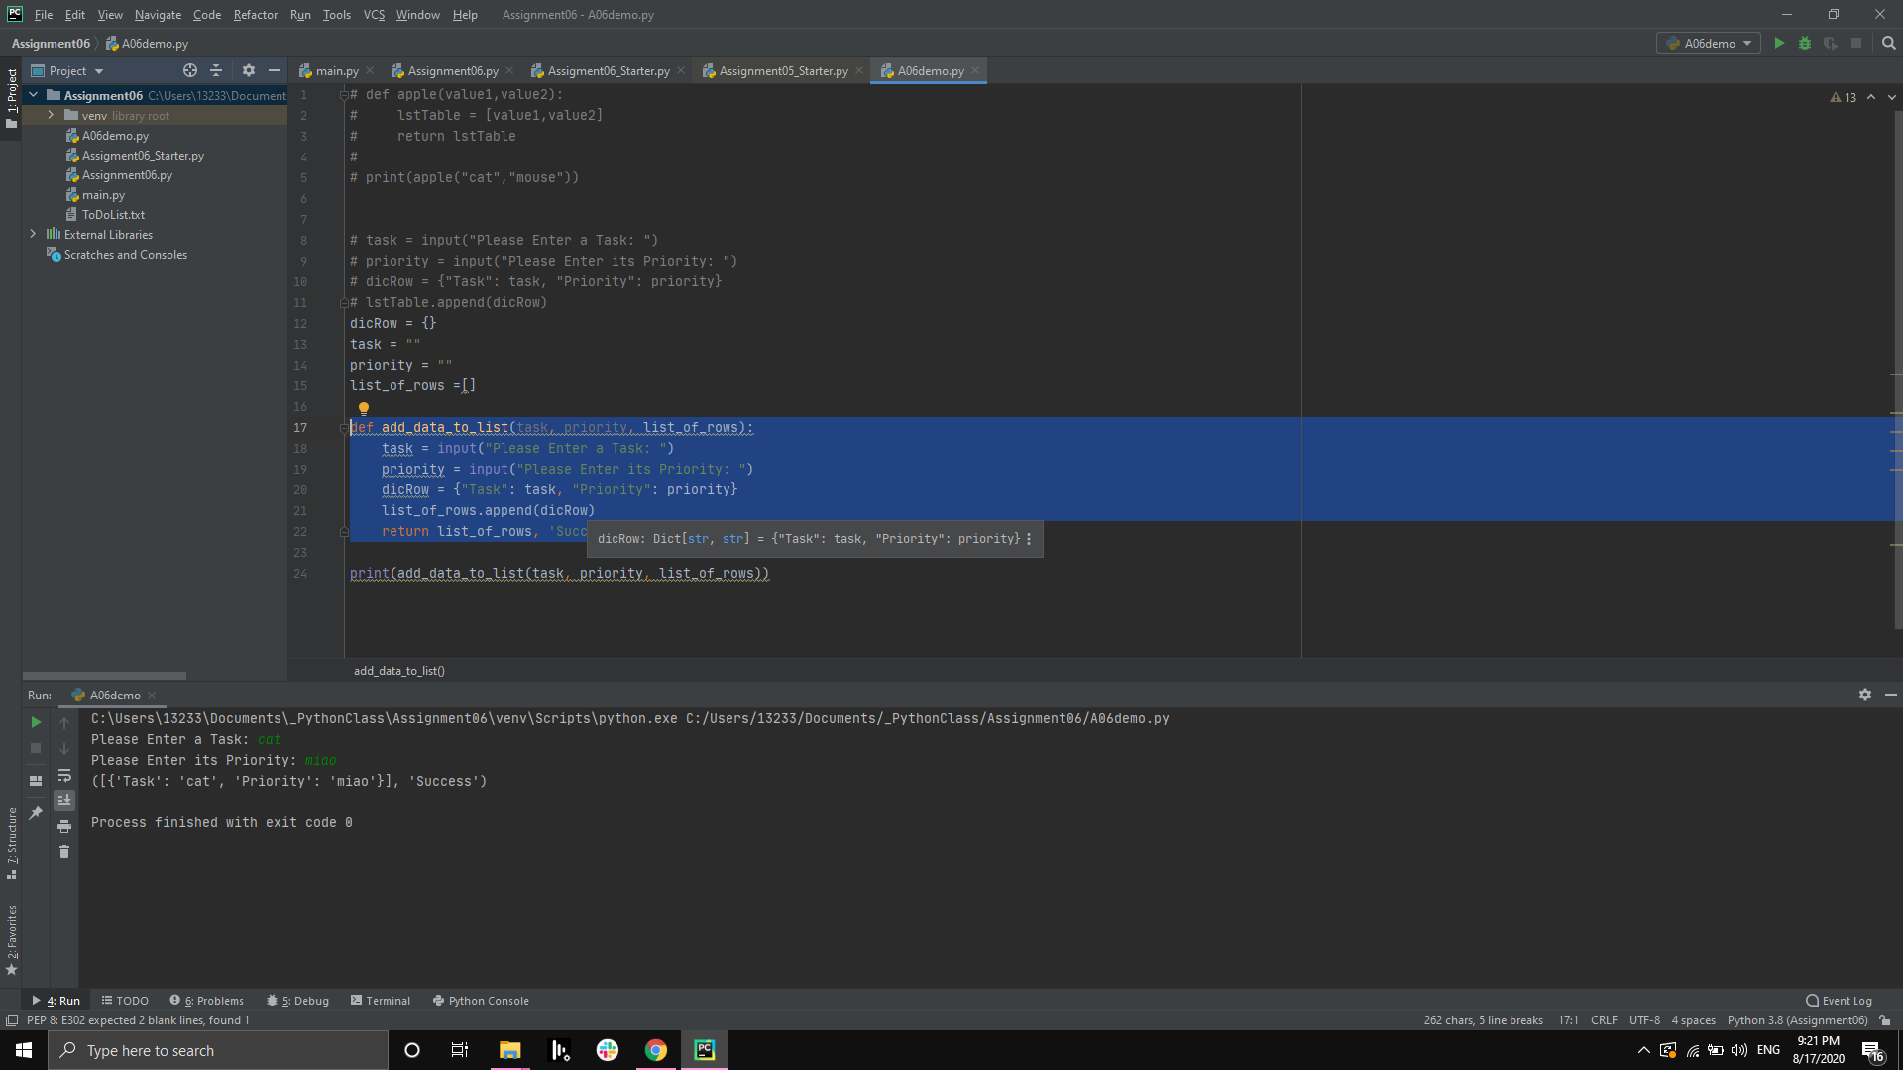

Only after finishing part 1, I realized that function under class Processor and function under class IO are responsible for two part of the process, which was done in a combined fashion in Assignment 05. In Processor part, we are not concerned with writing data to file, hence all data is held in memory. Therefore, even though when the program presents the addition of “dog” task, when you load the data from file again, you only see “Cat”, just like the txt presents. However by dividing the precess in this way, we can accomplish the goal of separating codes into “processing”, “presentation” and “Main”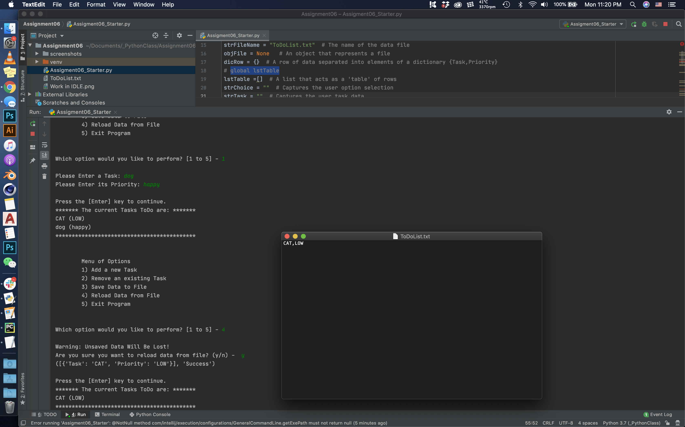

After figuring out the core difference between Assignment 06 and 05, I was able to migrate most of the code over and make them a function, so that the main body is just executing those function.

**Summary**

One concept that I still have question about is whether lstTable as a variable needs to be a global variable. I defined it global because even though it is called and constructed during step 1 of main body “read_data_from_file”. From observing other existing code provided by the starter project, variable should be shared across function. Yet to be safe, I decided to declare lettable as global. I would like to spend more time on this and verify which is the correct way to address this variable.