Full-Stack Web Developer

1. Fundamentals of HTML
2. Fundamentals of CSS
3. Developing Websites Locally
4. Deploying Websites
5. Improved Styling with CSS

Learn CSS: Typography

<https://www.cssfontstack.com/>

Wireframes

<https://careerfoundry.com/en/blog/ux-design/how-to-create-your-first-wireframe/>

<https://wireframe.cc/>

<https://www.figma.com/>

<https://www.invisionapp.com/>

1. Making a Website Responsive

Sizing Elements

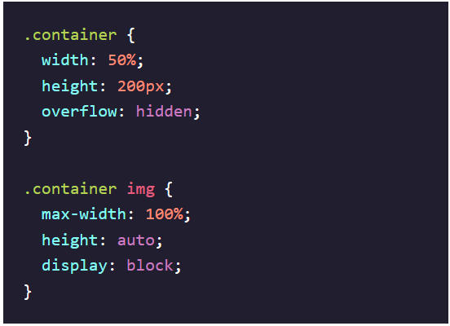

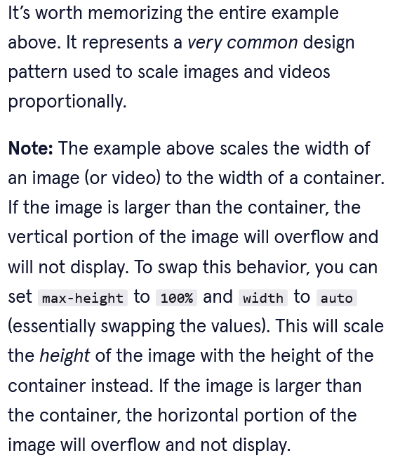

Frameworks

<https://www.taniarascia.com/you-dont-need-a-framework/>

<https://www.taniarascia.com/easiest-flex-grid-ever/>

<https://codepen.io/taniarascia/pen/rOLEGe/>

<https://www.taniarascia.com/understanding-classes-in-javascript/>

<https://developer.mozilla.org/en-US/docs/Web/JavaScript/Reference/Classes>

1. JavaScript Syntax, Part I
2. JavaScript Syntax, Part II
3. Git and GitHub, Part I

https://thoughtbot.com/upcase/mastering-git

1. JavaScript Syntax Portfolio Project

Mixed-Messages.js

1. Building Interactive Websites with JavaScript

DOM Events with JavaScript

Event Target = DOM Element (i.e. document)

Assign Event Target to Variable



Call Methods on the Event Target Object:

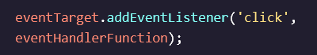



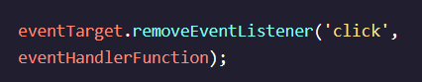

Modify Properties of the Event Target Object:









returns the property to its default value.

Event Object Properties

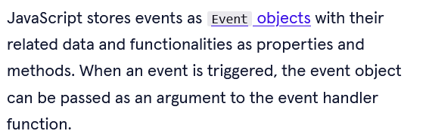

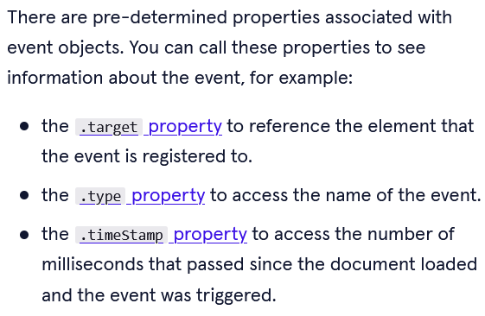

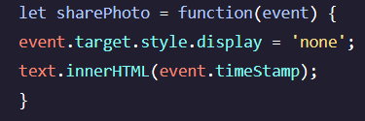

Event Handler = Event Function

Event Type = ‘click’, ‘hover’,…

1. Making a Website Accessible
2. Portfolio Project
3. JavaScript Syntax – Part 3

Modules:

<https://www.codecademy.com/paths/full-stack-engineer-career-path/tracks/fscp-javascript-syntax-part-iii/modules/fscp-learn-javascript-syntax-modules/articles/implementing-modules-in-node>

<https://www.codecademy.com/paths/full-stack-engineer-career-path/tracks/fscp-javascript-syntax-part-iii/modules/fscp-learn-javascript-syntax-modules/articles/implementing-modules-using-es-6-syntax>

<https://developer.mozilla.org/en-US/docs/Web/JavaScript/Guide/Modules>

<https://dev.to/iggredible/what-the-heck-are-cjs-amd-umd-and-esm-ikm>

Node.js / Express.js

Package.json

[The Basics of Package.json in Node.js and npm - NodeSource](https://nodesource.com/blog/the-basics-of-package-json-in-node-js-and-npm/)

Event Loop –

[The Node.js Event Loop (nodejs.dev)](https://nodejs.dev/learn/the-nodejs-event-loop)

Further Reading:

<https://developer.mozilla.org/en-US/docs/Web/JavaScript/Inheritance_and_the_prototype_chain>

<https://engineering.helpscout.com/reducing-complexity-with-guard-clauses-in-php-and-javascript-74600fd865c7>

<https://www.patterns.dev/posts/classic-design-patterns/#whatisapattern>

