Coastal Erosion on Yorkshire, England Coastline

Elizabeth Gronski
University of Missouri Institute of Data Science and Informatics
DSA8530: Geo AI & Satellite
Image Analysis
Columbia, MO, United States
efgronski@gmail.com

Abstract— Coastal erosion poses a significant threat to low-lying coastal regions, impacting infrastructure, ecosystems, and coastal cities. This study examines long-term coastal change along the Yorkshire coastline in northern England from 2000 to 2025 using multisensor satellite imagery and geospatial analysis techniques. Landsat imagery was used to generate land cover classifications at five-year intervals, while Sentinel-2 imagery supported recent high-resolution water detection and shoreline change analysis from 2020 to 2025. Digital elevation data from the Shuttle Radar Topography Mission and United Kingdom LiDAR composites were added to identify low-lying areas and terrain characteristics. A Random Forest classifier trained with ESA WorldCover data was applied to assess land cover distribution and change, achieving overall classification accuracies up to 76 percent. Elevation, distance to coast, and land cover were combined to produce a coastal erosion vulnerability risk map. Results indicate that the southern portion of the Yorkshire coastline, particularly near Kingston upon Hull, exhibits elevated vulnerability due to low elevation and urban development. The integrated vulnerability framework demonstrates the value of combining satellite-derived water, land cover, and elevation data for identifying coastal erosion risk and supporting regional coastal management efforts.

Keywords—Coastal Erosion, Multisensor Satellite Imagery, NDWI, Elevation, Land Cover, Geo AI

Introduction
Coastal Erosion has been well documented in England, with reports of impacts on communities, infrastructure, and the ecosystem. England has been documenting coastal erosion since Roman times, but in recent decades it has accelerated. With increased development, loss of vegetation, and the impacts of climate change, coastal erosion is becoming a global environmental crisis. All of these impacts have collectively heightened the risk to low-lying coastal regions across the country. This heightened risk brings about the need for effective monitoring and risk assessment strategies.
One region experiencing some of the most severe impacts of coastal erosion is the Yorkshire coastline. Yorkshire is a large county in Northern England, with a coastline approximately 160km long. This region has seen land loss, property damage, and repeated threats to coastal communities. It has become a focal point in England's news and has caught the attention of non-profits and other restoration organizations. As coastal erosion continues to affect communities at an increased rate due to climate change, understanding how the Yorkshire coastline has changed over time is essential for future intervention and mitigation efforts. The study will focus on the following question:
How have coastal erosion and land cover patterns changed along England’s Yorkshire coastline over the past 25 years, and how can these changes inform vulnerability mapping?
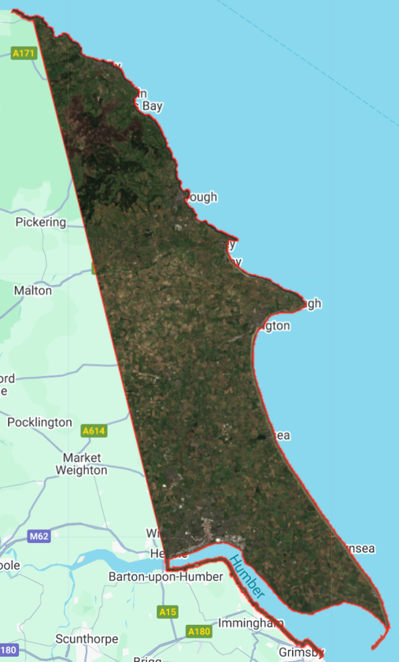
- True Color Composite of Yorkshore Coastline study area from Sentinel-2 imagery
Advances in remote sensing and satellite imagery have enabled consistent monitoring of coastal change across large spatial and temporal scales. Using long-term satellite imagery, such as Landsat, we can analyze historic shoreline positions and land cover change. In addition, we can incorporate higher-resolution satellite imagery, such as Sentinel imagery, to improve the detection of water, vegetation, and built-up areas. When we combine this data with DEM data, we can create a detailed analysis of the Yorkshire coastline and how its vulnerability has changed over recent history.
This study will utilize Landsat and Sentinel imagery, as well as geospatial analysis techniques, to examine how the Yorkshire coastline's position and land cover have changed from 2000 to 2025. By analyzing these trends, I aim to identify potential relationships among coastline change, land cover, and other environmental drivers. The outcome will help improve coastal monitoring and provide more individualized insight for this region and other regions like Yorkshire.

Data Sources
Shapefiles for Yorkshire were gathered from the UK government website [10]. The shapefile for the entire county was imported into QGIS, where I clipped it to a smaller region representing the coastline and a portion of land inland. That region is shown in Fig. 1.

Satellite imagery used in this study includes Landsat surface reflectance products and Sentinel-2 imagery obtained through Google Earth Engine. Landsat imagery was used to assess long-term shoreline and land cover trends, while Sentinel-2 imagery provided higher spatial resolution for vegetation and water index calculations.

Landsat 7 Enhanced Thematic Mapper Plus (ETM+) is a satellite product that launched April 15, 1999 [1]. It introduced a new panchromatic band to previous Landsat products, which had 15m spatial resolution. In 2003, the sensor experienced a Scan Line Corrector (SLC) failure, which caused all data after that to have gaps. It ran until January 19, 2024. In the time it ran it contained eight spectral bands. Its spatial capacity was 30m reflective and 60m thermal. Before the 2003 SLC failure, it provided global coverage, with repeat imaging every 16 days.

Landsat 8 and 9 Operational Land Imager (OLI) is two satellite products orbiting together. Landsat 8 was launched in February 2013 [2]. Onboard are the Operational Land Imager and the Thermal Infrared Sensor (TIRS) instruments. The OLI can measure visible, near and shortwave infrared portions of the light spectrum. Landsat 8 has 15m panchromatic spatial resolution, and 30m multi-spectral spatial resolutions. Landsat has a 16 day repeat cycle, like Landsat 7. It provides global coverage, gathering about 740 scenes a day in imaging. The OLI captures data with “improved radiometric precision over a 12-bit dynamic range, which improved overall signal to noise ratio” according to the USGS [3]. This means that levels of visibility are improved by 16 times, more than Landsat 7 and other previous models.

With Landsat 8, is Landsat 9 which was launched on September 27, 2021 [3]. Landsat 9 also carries the OLI and TIRS. The instruments are improvements on the Landsat 8, with higher radiometric resolution for OLI which allows the sensors to detect more subtle differences in dark areas (water or dense forests) [4]. The levels of visibility improvement on Landsat 8 are 4 times greater on Landsat 9. It also has 15m panchromatic spatial resolution and 30m multi-spectral spatial resolution. This product gathers about 750 scenes per day, with a repeat cycle of 16 days. Together with Landsat 8 they have a combined 8 day repeat cycle and almost 1500 scenes per day.

The Copernicus Sentinel-2 mission has two satellites within the same orbit, each with a wide swath and high resolution [4]. They are 180 degrees apart which allows them to cover all of Earth’s surfaces. These products provide a 10m resolution with 13 spectral bands, making it optimal for land and vegetation detection. These products have a revisit time of 5 days.

Digital elevation data were used to identify low-lying and high-risk coastal regions. This study started with Shuttle Radar Topography Mission (SRTM) data, which represents over nearly 80% of the Earth’s land surfaces [5]. It was launched in February of 2000 and represents a historic elevation with which to begin the analysis of change. SRTM took approximately 11 days to get global coverage and has a spatial resolution of 30m.

To gain a better understanding of elevation, LiDAR composite imagery was imported from the United Kingdom’s Environment Agency. These composite images included Digital Terrain and Surface models. The LiDAR Composite Digital Terrain Model (DTM) is a collection of raster images combined from 2000 to 2022. The DTM is produced to show ground level data (eliminating buildings or other higher objects) [7]. Their data is collected from their Time Stamped archive and National LiDAR Programme surveys. In addition to the DTM, the study also downloaded their LiDAR Composite Digital Surface Model (DSM) [8]. Produced by the same agency in the same time frame, the DSM measures elevation with other objects. This model comes in first return and last return imagery. DSM first return represents the highest surface intercepted by the LiDAR pulse (e.g., vegetation or buildings), while DSM last return represents the lowest non-ground return, with the DTM representing classified bare-earth elevation. Both products are in 1m resolution. It covers most of our Yorkshire coastline area, with a small gap in a higher elevation area to the north of our study region. This area was captured in SRTM.

Methods
This study produced long-term land cover classifications and their changes along the Yorkshire coastline using multisensor Landsat data and Random Forest classifications in Google Earth Engine [6]. Landsat 7 was used for 2000, 2005, and 2010, and Landsat 8 and 9 were used for 2015, 2020, and 2025. Both were collected from the Collection 2, Level 2 archive. For my target years, I collected annual composites for my Landsat 8/9 imagery and 3-year composites for Landsat 7 imagery. The 3-year composites were necessary due to gaps in the older imagery. These dates, cloud cover, and the extent of my study area were used to filter these images. They were run through a QA Pixel bitmask to remove clouds, shadows, snow, or other visual contamination.

In addition to spectral band classification, the Normalized Difference Vegetation Index (NDVI) and the Normalized Difference Water Index (NDWI) were added to improve classification accuracy. Bands were adjusted between Landsat 8/9 and Landsat 7, as each product has different bands available. Random Forest was chosen as the classification model. ESA WorldCover 2021 data was used for training and validation. A single-year land cover dataset was used to train the classifier consistently across all years, enabling better comparisons. The ESA WorldCover data includes 11 land cover classifications that I used in this study. Data were split into training (70%) and test (30%) sets, which were used to compute confusion matrices, accuracy, and kappa coefficients. For each target year, land cover statistics and area statistics were produced for comparison.

To assess coastal erosion, this study used Sentinel-2 satellite imagery from 2020 to 2025 to develop a coastal water detection analysis. This shorter, more recent period allows us to take advantage of the high spatial resolution and visit frequency. Cloud and shadow effects were again masked using quality bands. Annual composites were generated, and the Normalized Difference Water Index (NDWI) was calculated to identify the water bodies. Pixels with NDWI values above 0.3 were classified as water, and those values were clipped to the Yorkshire coast study area. Water extent in km² was quantified for each year.

To measure shoreline change, this study analyzed and mapped changes in water along the Yorkshire coastline from 2020 to 2025. Using annual water masks from Sentinel-2 imagery and NDWI, per-pixel changes were counted and categorized to display the amount of water area gained and lost between each set of years. This was accomplished by subtracting the previous year's water mask from the current years. This allowed the study to identify lost water as -1, no change as 0, and gained water as 1. These new values were visualized to show how the coastline could be changing from the satellite images. To quantify, the areas of water gained and lost each year were measured. This raster assessment was a less computationally heavy method that could be conducted on Google Earth Engine.

The land cover analysis, spanning 2000-2025 at five-year intervals, uses Landsat imagery to provide an older historical record. This extended time frame allows the study to examine significant changes in land cover, such as urban expansion or vegetation loss. The water detection in Sentinel-2 does not have the capability to go that far back in time, so it was decided to focus on more recent history with higher-resolution data. Together, these analyses can compare precise water changes with historical land cover changes and how they may affect coastal erosion.

For an elevation analysis, this study utilized SRTM data from 2000 to view the Yorkshire coastline region. Elevation images were captured for the region, along with maximum and minimum elevation measurements. To enhance understanding and bring the elevation analysis to a more recent timeframe and relevant data projects, a UK LiDAR Composite Digital Terrain Model was incorporated. This composite image was brought in and clipped for the Yorkshire coastline region. Visuals for the Digital Terrain Model (DTM), and Digital Surface Model (DSM) were captured. For DSM, first and last return images were captured to view high and low surfaces in the region. This process helped the study understand if areas were populated or bare in conjunction with our land cover analysis. Maximum and minimum measurements were also taken for all 3 of these images.

Using the elevation data, erosion risk was measured. A slope-based erosion methodology was modified to adapt to measuring coastal erosion. Slope-based erosion susceptibility is effective in upland landscapes but underestimates risk in flat, coastal environments where erosion is driven primarily by marine processes rather than gravitational instability. To modify, risk was calculated by measuring the elevation and weighting it against closeness to the coastline. Elevation was categorized as 10m = low, 5-10m = moderate, 2-5m = high, and <2m as extreme risk. This was weighted at 60%, with distance weighted at 40%. Distance was categorized as >=2000m from the coast = low, <2000m = moderate, <1000m = high, and <500m as extreme risk.

To expand vulnerability risk, land cover was added to the vulnerability weights, with classifications based on types of landcover. In this step of the process, LiDAR was chosen as the most accurate elevation data. The missing information in the north part of the region was deemed not critical, as it did not contain any coastline, and was in a high elevation, little populated area of the region. This area is shown in Fig. 2. Previous studies have shown that human-modified land covers such as built-up areas and cultivated land are associated with increased coastal vulnerability and habitat degradation, while natural vegetation and wetlands provide a protective buffering function against coastal disturbance [9]. From this research, land-cover classifications were converted into erosion-risk weights using a categorical remapping approach. Built-up areas were assigned the most extreme risk, then cropland, grassland, shrubland, and at the lowest risk all other land covers. The reference study, Factors influencing coastal land cover change and corresponding impact on habitat quality in the North-western Coastline of Guinea-Bissau, did not mention every cropland features in the ESA WorldCover dataset, so listed risks were weighted to negatively affect while other covers were treated as non-influential.

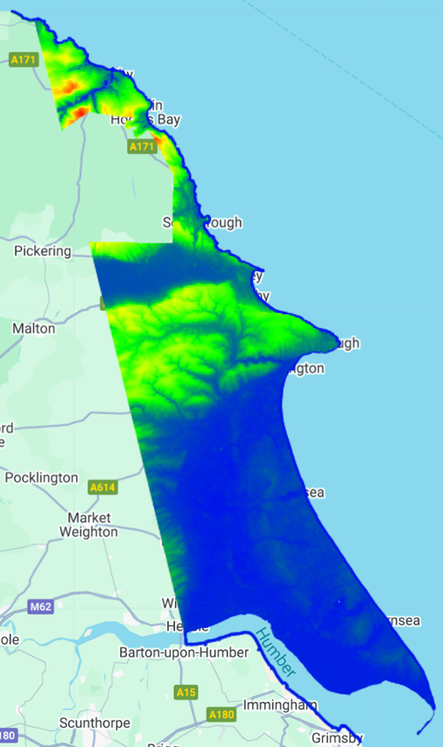
- LiDAR DSM for Yorkshire Coastline, shown to highlight the gap in coverage

Results
The results of the study’s methods include water detection to showcase changes in the coastline, land cover classification, elevation and identification of low-lying coastal zones, and ultimately a vulnerability risk map of the Yorkshire Coastline area. Each of these processes were first developed independently and then compared to one another. Land cover and elevation were ultimately combined to support the vulnerability map.

Water Detection Analysis
The purpose of this analysis was to show the shoreline by extracting water masks for 2020-2025. This temporal window was chosen to use Sentinel-2 data. In the output, we could see changes from year to year in water area being detected by the satellite, suggesting alterations to the coastline. However, these changes were not consistently increasing, which would have suggested the coast eroding and more water entering the study area window.

In Table I, it shows that most annual changes saw loss of water area rather than gain of water area. Ultimately, there is more area in 2025 than 2020, but the fluctuation in water areas do not support an accurate analysis in shoreline trends in the Yorkshire region. In Fig. 3, water area change is colored across the study area of Yorkshire. The white signifies no change, which is how land was categorized as well as water pixels that remained categorized as water in year-to-year analyses. Blue dots represent pixels that were not water in the previous year, but are being categorized as water this year. This image represents a change from 2020 to 2021, so in 2020 those blue pixels were not water but land.
- Annual Changes in Water Area on Yorkshire Coastline
Year | Water Area
 | Yearly Water Areas (km²) | Overall Change (km²) | Gained Water Area (km²) | Lost Water Area (km²)
2020 | 26.31 | - | - | -
2021 | 30.68 | 4.36 | 5.75 | 1.39
2022 | 29.16 | -1.52 | 2.86 | 4.38
2023 | 26.36 | -2.80 | 1.16 | 3.95
2024 | 29.10 | 2.74 | 4.22 | 1.48
2025 | 27.34 | -1.76 | 1.98 | 3.74

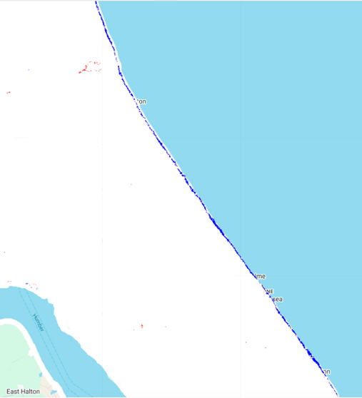
- Change in water pixel-area for Hull area of Yorkshire County for 2020-2021.
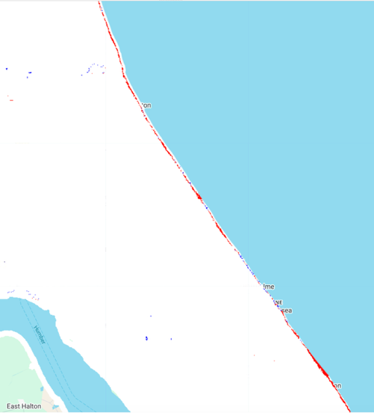
- Change in water pixel-area for Hull area of Yorkshire County for 2021-2022.
In 2021 they now represent water. The red pixels represent the loss of water area. In the 2020-2021 analysis, there were few red pixels, with lost water for the whole coastline only coming in at about 1.39 km2. However, in the 2021-2022 analysis, there were many more red pixels and less blue pixels. Lost water reached its peak in this analysis, with 4.38 km2. These fluctuations were seen in each year to year in Table I, with no noticeable pattern.

Land Cover Classification Results
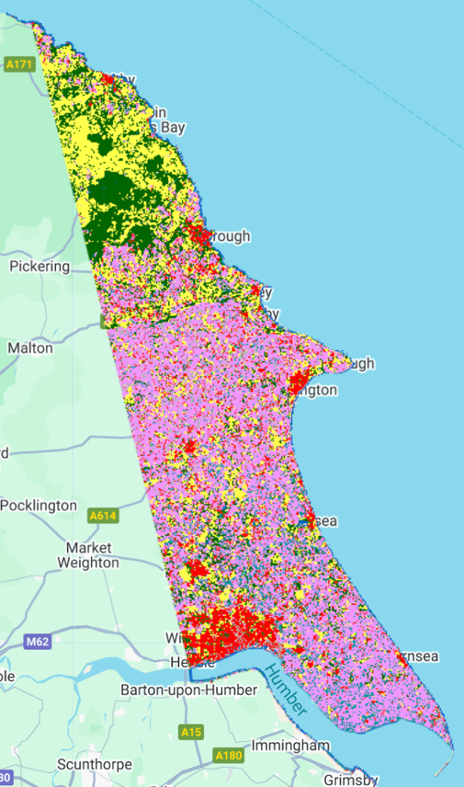
- Land Cover classification in 2000 for the Yorkshire Coastline area
The purpose of this analysis was to establish what kinds of surfaces exist in the Yorkshire coastline and how they changed over an extended period. The timeframe for our results shows landcover from 2000 to 2025, in 5-year intervals. The 2000-2010 images were created with Landsat 7 imagery and are 3-year composites to account for the SLC failure mentioned in Data Sources.
In Fig. 5., the distribution of land cover across the Yorkshire Coastline area in 2000 is shown. In the north, there are patches of grassland and forested areas. This is North York Moors National Park. There are spots of red within that park around the coast, signaling small seaside cities. These cities are Scarborough and above it, Whitby. Further down the region, under the National Park is an area known as the Vale of Pickering, which is a valley. This valley is distinguished in the visualizations by cropland mixed in with the grassland and forests. The valley meets the sea near a city called Filey, which is marked by another red dot. Below that everything turns into an expanse of cropland. Everything colored in pink is categorized as cropland. Within it are several cities. A large red path near the coast is Bridlington, and the largest red area at the bottom of the region is Kingston upon Hull. From this regional analysis there is a better understanding of the region.

In the land cover classification process, later years (mapped with Landsat 8/9) were more accurate than earlier years (mapped with Landsat 7), as shown in Table II. There was also an improved Kappa coefficient as the imagery became more recent. 2025 was the most accurate classification period, with an overall accuracy of 76% and a Kappa coefficient of 73%, as seen in Table II.
- Land Cover Classification Accuracy
Year | Table Column Head
 | Overall Accuracy | Kappa Coefficient | Dominant Land Cover | % of Dom. Land Cover Area
2000 | 65.08% | 59.25% | Cropland | 37%
2005 | 66.03% | 60.36% | Cropland | 39%
2010 | 69.34% | 64.24% | Cropland | 39%
2015 | 69.69% | 64.63% | Cropland | 44%
2020 | 74.87% | 70.67% | Cropland | 44%
2025 | 76.46% | 72.54% | Cropland | 46%

In each timeframe analysis, cropland dominated the area. The cropland area increased by almost 10% points. In 2025, it reached 46% of the region which is close to half of the entire area. Built-up area remains about 10% in each timeframe analysis, showing little to no urban development. The second dominant class is grassland, which also remains around 24% in each period.

Noticeably, water land cover followed a similar pattern in the Landsat landcover analysis as it did in the Sentinel 2 water detection analysis. Water area fluctuated throughout the years with little to no noticeable pattern.
- 2025 Land Cover Classification Confusion Matrix Values
Land Cover | Precision | Recall | Most False Negatives | Most False Positives
Tree Cover | 77.70% | 70.13% | Grassland | Grassland
Shrubland | 0% | 0% | Grassland | -
Grassland | 69.22% | 68.53% | Cropland | Tree Cover
Cropland | 69.82% | 76.87% | Built-up | Grassland
Built-up | 71.13% | 77.35% | Cropland | Bare/Sparse
Bare/Sparse | 81.53% | 77.29% | Built-up | Water
Ice/Snow | 0% | 0% | - | -
Water | 84.22% | 83.53% | Wetland | Bare/Sparse
Wetland | 83.36% | 82.09% | Water | Water

Within the confusion matrix for the 2025 classifications, the most accurate classifications based on the ESA data, some classes performed better than others. Water had the highest precision and recall. It was often misidentified for Wetland, and Bare/Sparse land was often categorized as water. Wetland also had a high precision and accuracy, followed by Bare/Sparse land, Tree Cover, Built-up, and Cropland.

Elevation and Terrain Characteristics
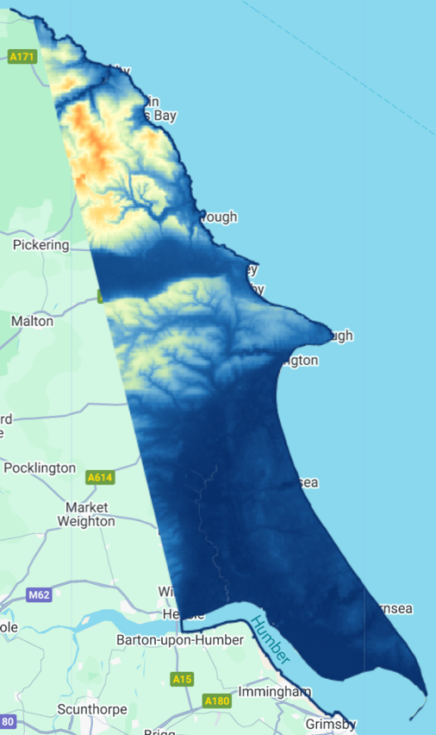
- SRTM DEM for Yorkshire Coastline, measured in 2000
The elevation analysis indicated that much of the Yorkshire coastline area lies within a narrow elevation range near sea level. According to SRTM, the highest elevation in the area was 298 meters near the national park area in the northern part of the region. The lowest elevation was -9 meters below sea-level near Kingston upon Hull. When looking at the LiDAR data, there are differing elevations. The lowest elevation was -5.12 meters below sea level. The highest elevation was approximately 288.99 meters measured by the DTM. These measurements are like SRTM, which was collected in 2000 while LiDAR is a composite from 2000-2022.

Looking at Fig. 6., there are brightly shaded orange and yellow spots in the northern area of the region showing the national park. In this visualization it is easy to see Vale of Pickering, the valley, which was discussed above in the land cover analysis. Towards the southern part of the area, it is much darker, showing the area below sea level in darkest blue.

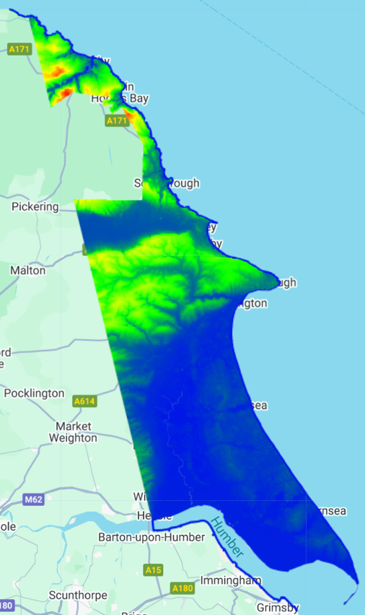
- LiDAR DTM for Yorkshire Coastline, 2000-2022 composite
We can see similar results within the LiDAR data. However, this data is missing a large portion of the national park. For this region, we have only the SRTM data. In both images, we can see in the low elevation area to the south, some inlets from the ocean going into the below sea level area.

Coastal Erosion Vulnerability Risk Mapping
To complete this study’s analysis, the data has been combined to create a vulnerability map of the area. The following images were created to build this map. In Fig. 8., low elevation areas shining in the southern part of the region, near the city of Kingston upon Hull. Some of the inlets spotted in the elevation data are highlighted in dark red. The dark red signifies any elevation below 2 m. We can see our coastline highlighted in red also, but in the northern part of the region, that coast is met by much higher elevation colored in green. Anything in green is higher than 10 meters.

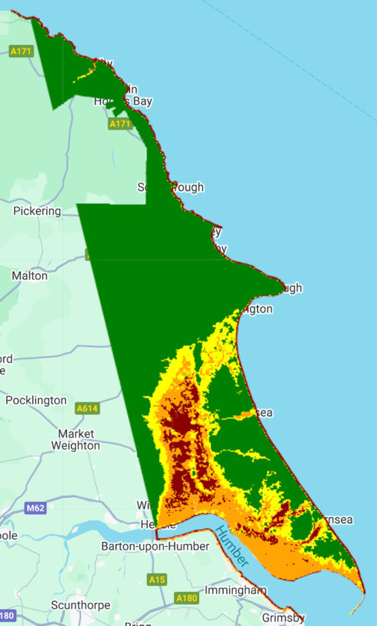
- Categorized Elevation Risk based on LiDAR data of Yorkshire Coastline
To compare distance to the coast, a distance risk map was created. In Fig. 9., distance is measured from the coastline shape developed from UK government shapefiles.

Lastly, land cover classification is created and shown in Fig. 9. From this visual, cities stand out tremendously, while most of the area if highlighted in orange, showing high risk based on land cover. With these images combined we have vulnerability measured for the region.

In Fig. 11., vulnerability is mapped for 2000. Much of Kingston upon Hull is highlighted in red, as well as other city areas and inlets that we spotted earlier in the analysis. The majority of this map is highlighted in high or extreme risk areas for coastal erosion. Keeping in mind that some of these areas are far from the coast, so they will most likely not experience coastal erosion.
In Fig. 12., the risk map has significantly changed for 2025. The only data changing between the two images is the land cover. As we can see the increase in cropland has change the map significantly, where there were patterns of green and yellow there is now large swaths of orange. Cropland adds more negative effects to the map, along with urban areas. Red areas have also increased and become more defined, clearly pointing to areas of extreme risk.
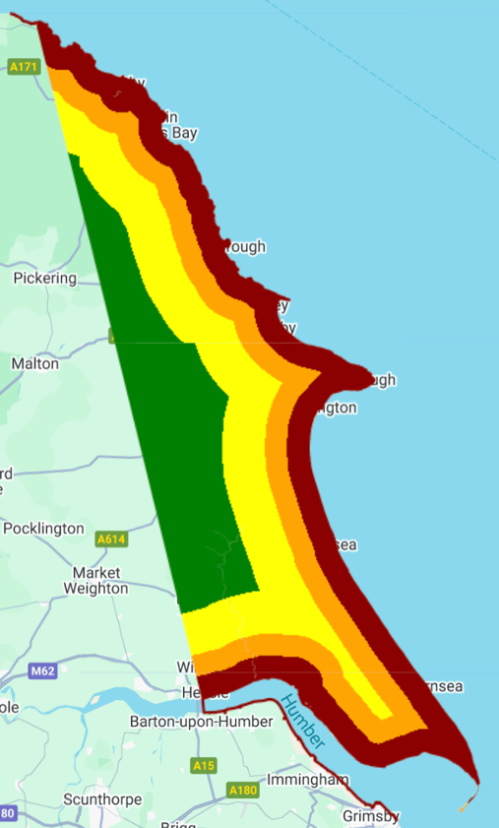
- Categorized Distance Risk based on a Coastline shapefile
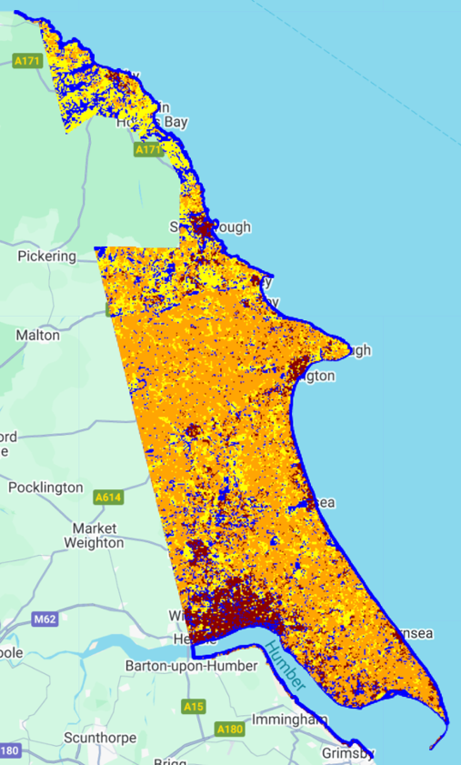
- Categorized Land Cover Risk based on classifications made from 2025 Landsat 8/9 data.
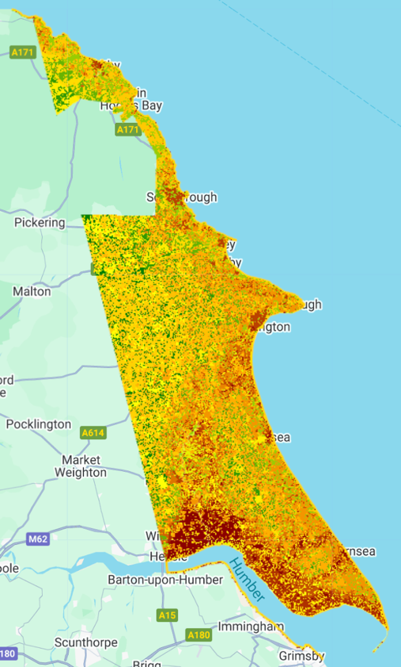
- Coastal Erosion vulnerability risk based on elevation, distance to coast, and land cover for 2000 in Yorkshire coastline region

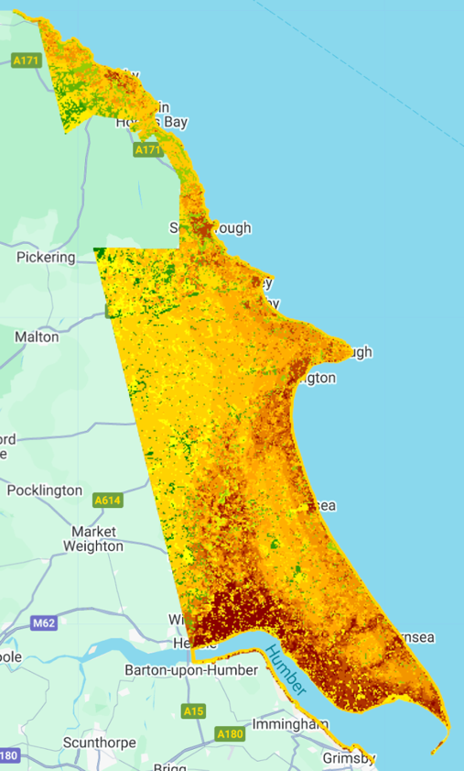
- Coastal Erosion vulnerability risk based on elevation, distance to coast, and land cover for 2025 in Yorkshire coastline region

Discussion
The results found in this study suggest that the coast of Yorkshire is changing, and land cover and elevation are important factors in that change. With very low elevation in the southern part of the region, near Kingston upon Hull, the area is subject to significant coastal erosion risk factors. Additionally, the concentration of a large metropolitan area in that low-lying region exacerbates those effects. Built-up areas in the region are the most at risk to coastal erosion. Additionally, the amount of cropland in the area is also a large risk factor especially fields near the coast.

In the land cover analysis, there were accuracy differences between different Landsat models. This could be issues with older imagery, or more relevant to the fact that ESA WorldCover data is from 2021. Area statistics of land cover show that cropland increased by 10 percentage points from 2000 to 2025. This shows the increase in agriculture in the area, and how much of the region it dominates. The 2025 confusion matrix showed that water, wetlands, and bare/sparse land were often predicted as one another. These results suggest that water misclassification could be a result of transitional landscape, or mixed pixels. Looking at cropland and water helps the study as they are essential land cover categories to the analysis.

In the elevation analysis, the lowest elevations recorded for both products were below sea level. Below sea level measurements already suggest problems with flooding and other water issues in the area, which could suggest issues with coastal erosion as well. Both elevation maps revealed many low-lying areas, including the Vale of Pickering and inlets from the ocean near the southern part of the region. These low-lying areas, if there is infrastructure there, could be at risk for more severe consequences of coastal erosion.

When examining the vulnerability maps, northern areas with higher elevation provide less cause for concern as they do not present with risk factors for coastal erosion. Areas in the southern part of the region do cause concern. However, it is important to distinguish between those near the coast, and those more inland. As we are looking at coastal erosion, more inland areas are not as pertinent. However, this suggests a regional pattern of risk that may take serious systematic action to improve. We see some of the red areas of our map grow. This could support the idea of some urban development in the area, especially near Kingston upon Hull.

This project begins a simple methodology for analyzing coastal erosion and possible effects. With limited knowledge, time and resources, coastline detection and measuring of change could not be performed. These advanced analyses could definitively prove how the coastline has changed, and at what rate it is changing. These findings could improve how vulnerable areas are in a timeliness aspect.

Conclusion
In conclusion, the Yorkshire coastline shows varying risk for coastal erosion. By identifying areas that are most at risk, assistance and intervention can be targeted to where it is needed most. However, this analysis is not complete, as more robust coastline analysis is needed and can greatly improve categorizations of risk.

Acknowledgment
The author thanks Dr. Dastour for guidance provided during the DSA8530 Geo AI and Satellite Image Analysis course.

Appendix
Due to limited prior experience with coastal erosion analysis in my coursework, I utilized ChatGPT assistance to help design a feasible methodology [12]. Specifically, AI guidance was employed to identify and implement raster-based approaches for quantifying annual water area change and estimating shoreline dynamics, allowing the study to efficiently measure coastal change over multiple years without relying on computationally intensive vector methods. Additionally, I utilized code from SpatialThoughts to learn how to extract coastlines [11].

References
- United States Geological Survey. (n.d.). Landsat 7. U.S. Department of the Interior. https://www.usgs.gov/landsat-missions/landsat-7
- United States Geological Survey. (n.d.). Landsat 8. U.S. Department of the Interior. https://www.usgs.gov/landsat-missions/landsat-8
- United States Geological Survey. (n.d.). Landsat 9. U.S. Department of the Interior. https://www.usgs.gov/landsat-missions/landsat-9
- European Space Agency. (n.d.). Introducing Sentinel-2. ESA. https://www.esa.int/Applications/Observing_the_Earth/Copernicus/Sentinel-2/Introducing_Sentinel-2
- NASA Earthdata. (n.d.). Shuttle Radar Topography Mission (SRTM). NASA. https://www.earthdata.nasa.gov/data/instruments/srtm
- Gorelick, N., et al. Google Earth Engine: Planetary-scale geospatial analysis for everyone.
- Environment Agency. (n.d.). LiDAR Composite Digital Terrain Model (DTM) 1 m – England. UK Government Environment Data Service. https://environment.data.gov.uk/dataset/13787b9a-26a4-4775-8523-806d13af58fc
- Environment Agency. (n.d.). LiDAR Composite Digital Surface Model (DSM) 2 m – England. UK Government Environment Data Service. https://environment.data.gov.uk/dataset/9ba4d5ac-d596-445a-9056-dae3ddec0178
- Namir Domingos Raimundo Lopes, Tianxin Li, Dayi Qian, Nametso Matomela, Rui Moutinho Sá, Factors influencing coastal land cover change and corresponding impact on habitat quality in the North-western Coastline of Guinea-Bissau (NC-GB), Ocean & Coastal Management, Volume 224, 2022, 106181, ISSN 0964-5691, https://doi.org/10.1016/j.ocecoaman.2022.106181.
- data.gov.uk. (n.d.). Counties and Unitary Authorities (May 2023) boundaries UK BGC. UK Government. https://www.data.gov.uk/dataset/85228aec-fe0e-49bf-9455-df000d61e731/counties-and-unitary-authorities-may-2023-boundaries-uk-bgc
- Jorden, C. (2023, January 18). Automated coastline extraction in Google Earth Engine. SpatialThoughts. https://spatialthoughts.com/2023/01/18/automated-coastline-extraction-gee/
- OpenAI. (2025). ChatGPT (GPT-5.2) [Large language model]. https://chat.openai.com/

