Joint Virtual MIMO and Data Gathering for Wireless Sensor Networks

Design Review

Oren Zaharia 204034482
Efi Dvir 201557113

Contents
Preface 1
Contents 2
1. Introduction 1-1
1.1 Definitions and abbreviations 1-1
1.2 Overview 1-1
1.3 Goals of the simulation 1-1
1.4 Assumptions 1-1
2. Design and Flow 2-2
2.1 Overview 2-2
2.2 Modules overview 2-2
2.3 Application Interfaces 2-2
2.4 Results and Test measurements 2-2

Introduction

Definitions and abbreviations
Abbreviations:
MIMO - multi-input multi-output
vMIMO - Virtual multi-input multi-output
MIMO-LEACH - multi-input multi-output - Low-energy adaptive clustering hierarchy
vMDG - Virtual MIMO data gathering
vMER - vMIMO-based Energy-efficient routing algorithm
vMTC - vMIMO-aware topology construction algorithm
MDT - Minimum Dijkstra Tree

Definitions:
Virtual MIMO - is an advanced technology that can effectively exploit the spatial domain of mobile fading channels to bring significant performance improvements to wireless communication systems. Virtual MIMO uses distributed antennas on different radio devices to achieve close to the theoretical gains of MIMO. The basic idea of Virtual MIMO is to group multiple devices into a virtual antenna array to achieve MIMO communications. A Cooperative MIMO transmission involves multiple point-to-point radio links, including links within a virtual array and possibly links between different virtual arrays.

Overview
Virtual multi-input multi-output (MIMO) or vMIMO is becoming an attractive technology to achieve spatial diversity in wireless networks without using additional antennas, and to reduce power consumption by cooperation among multiple nodes. As data gathering is one of the most important operations in many sensor network applications, this simulation studies energy-efficient data gathering in wireless sensor networks using vMIMO. We define the joint vMIMO and data gathering (vMDG) problem, which is NP-hard. We also propose a distributed method called D-vMDG as an approximation algorithm. This algorithm first constructs a tree-like topology by taking the unique features of vMIMO into account. Then, an energy-efficient routing protocol based on dynamic programming is proposed for each node on the constructed topology.

Goals of the simulation
The goals of our simulation is to show that D-vMDG decreases the energy consumption compared to the well-known MDT and MIMO-LEACH algorithms.

Assumptions
In our joint virtual MIMO and data gathering (vMDG) problem, there are n wireless nodes randomly distributed in a planar field. We assume that each node u knows its position denoted by (Xu; Yu). Each node is equipped with an antenna, and can adjust its transmission power arbitrarily.
We make four important assumptions for problem definition.
First, it is assumed that the network is synchronized. Despite some concerns over the infeasibility of the MIMO mode due to lack of simultaneous synchronization, some works have shown that a small synchronization error didn’t greatly decrease the performance of vMIMO transmission.
Second, it is assumed that transmission collision is avoided. Since our focus is not on MAC protocols we neither discuss channel access, nor explicitly consider collisions in the problem definition.
Third, this work ignores the cost of sharing the control information for vMIMO transmission in the data gathering. This assumption is based on the following reasons. First, the control packet is relatively short compared with the data packet. Second, the proposed algorithm will construct a tree. Most of the links in this tree are not long (in terms of geometric distance). Accordingly, the energy consumption of additional data exchange procedure will not greatly impact the energy consumption of vMIMO communication.
Fourth, we will consider vMIMO involving two (2) nodes at most. First, the SIMO, MISO and MIMO modes are more energy-efficient compared with the SISO mode. Second, in many cases, the 2 2 mode is much more energy-efficient than 1 1 (SISO), 3 3 (MIMO) and 4 4 (MIMO) modes. In addition, if more nodes cooperate with others in vMIMO transmission, the management of the cooperative nodes will also become more complex. Therefore, this paper studies the cooperation among (at most) two nodes for vMIMO.

For simplicity, we assume that base station is located on one vertex of the rectangle.

We will ignore the energy consumption due to channel access and packet collisions in the simulation using the built-in MAC of OMNet++ (which uses CSMA) by setting packet loss ratio to zero.

We execute each algorithm 100 times and then average the results.

Design and Flow

Overview
The optimization objective of this problem is to minimize the total energy consumption of data gathering for wireless sensor networks. More formally, the vMDG problem is stated as follows:
In the simulations, the nodes in a wireless sensor network are distributed on a planar rectangle area randomly - 100 sensor nodes in an area of 800 m 800 m.

Modules overview
Simple module – node
Description:
n wireless nodes randomly distributed in a planar field, each node u knows its position denoted by (Xu; Yu), which is randomly drawn.
In the simulations, the nodes in a wireless sensor network are distributed on a planar rectangle area randomly. The maximum communication range of each node is 200 m.
For simplicity, we assume that base station is located on one vertex of the rectangle. By default, there are 100 sensor nodes in an area of 800 m 800 m, and the parameter γ is set to 0.1 in the D-vMDG algorithm.
We assume that each node periodically sends a packet with 30 bytes (i.e., 240 bits) to base station.
For performance comparison, we use the total energy consumption, which is the sum of energy consumption needed by each node in the network to transmit a data packet to the base station in one period, as the main performance metric. In the simulations, we mainly observe the impacts of different network parameters on the energy consumption of data gathering
Parameters:
Xu – Random Horizontal position [m]
Yu – Random Vertical position [m]
maximum communication range – Fixed: 200[m]
packet size – Fixed: 30 bytes (i.e., 240 bits) [B]
γ – Fixed: 0.1
Transmission Power – Random [dBm]
Gates:
Inout[] – Input Output – connected according to distance and algorithm using signals

Connections:
Wireless channel

Application Interfaces
The parameters defined by omnetpp.ini for each Run:
- Range X dimentions – size of the testing area
- Range Y dimentions – size of the testing area

The parameters defined by user:
- The user can choose between 3 test schemes of the network:
  - Energy-efficient data gathering problem simulation scheme using vMDG optimization with D-vMDG algorithm
  - Energy-efficient data gathering problem simulation scheme using the Dijkstra algorithm to construct a spanning tree, called Minimum Dijkstra Tree or MDT, which is rooted at the base station and contains the “shortest” path for all other nodes in a given network.
  - Energy-efficient data gathering problem simulation scheme using MIMO-LEACH algorithm

Results and Test measurements
We perform a performance comparison of energy-efficient data gathering schemes. The first is MDT, which constructs the minimum-energy topology for data gathering under the SISO communication mode using the Dijkstra algorithm. The second is the MIMO-LEACH algorithm (hereafter referred to as LMIMO for short) , which implements the data gathering using vMIMO on a cluster structure. The reason for choosing these algorithms is two-fold. One is to show the energy efficiency of vMIMO communication by comparing with the optimal algorithm using the traditional (i. e., non-vMIMO) approach. Second, we compare with the LMIMO algorithm to show the performance improvement due to the constructed vMIMO topology used by our algorithm.
The D-vMDG algorithm decreases the energy consumption by about 81.6 and 36.6 percent compared with the MDT and LMIMO algorithms under case a). D-vMDG will decrease the energy consumption further by about 89.0 and 62.4 percent compared with the MDT and LMIMO algorithms in the area size of 1;000 m 1;000 m
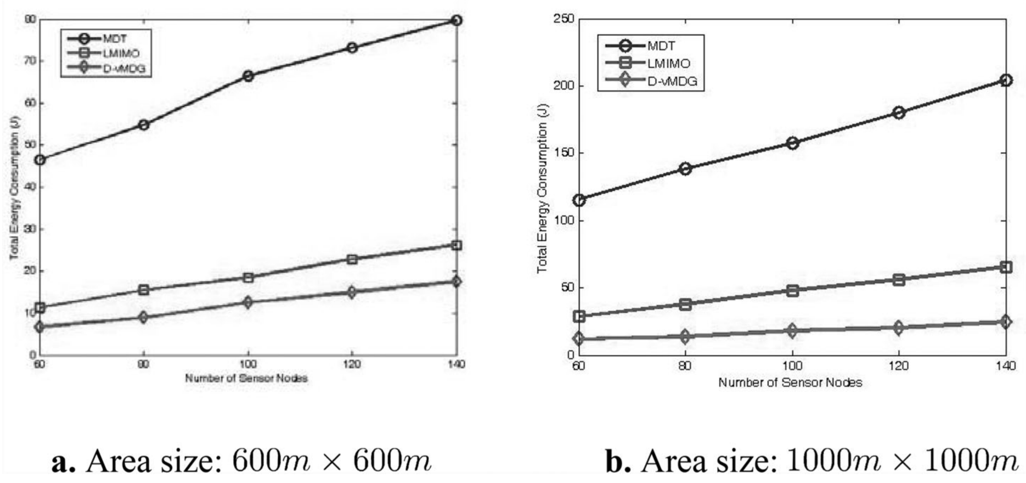
Total energy consumption versus number of sensor Nodes.
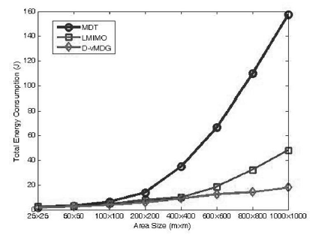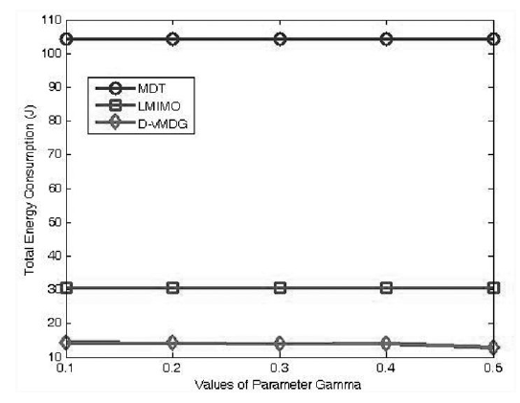
Total energy consumption versus area size Total energy consumption versus Parameter γ.
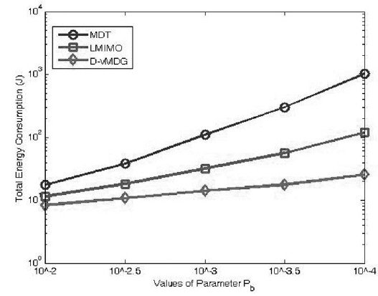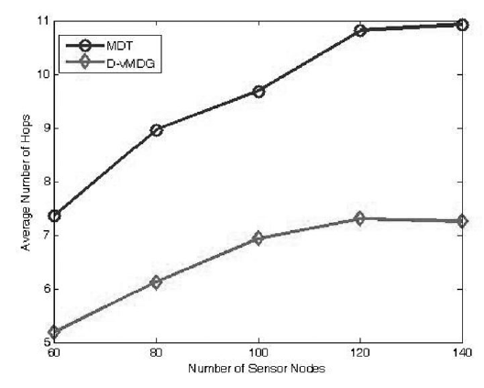
Total energy consumption versus parameter Pb. Maximum number of hops versus number of sensor Nodes.
Average number of hops versus number of sensor Nodes.
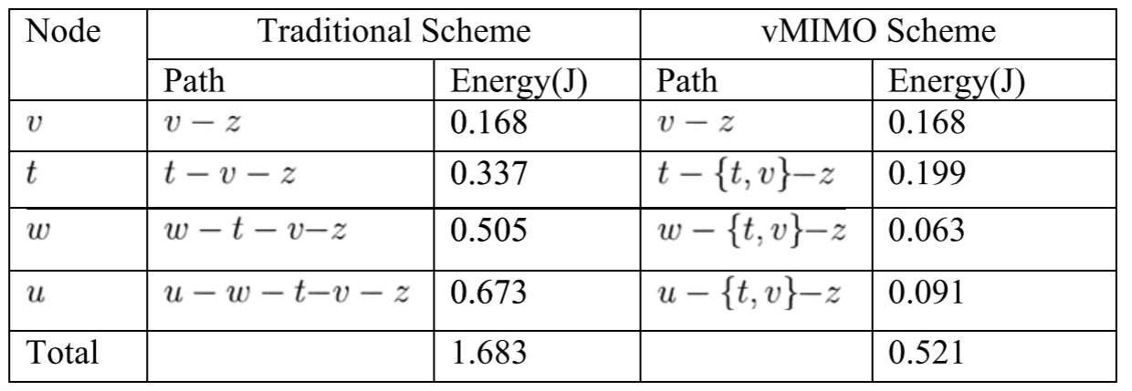
Numerical Illustration of the vMDG Problem
Statistics Gathering:
In Node:
Messages sent
Messages received
Active time
Power consumption
Total transmission time
In every message:
Current hop count
Time stamp
In network:
Total hop count
Average hop count
Total power consumption

