
T. C.
RECEP TAYYIP ERDOGAN UNIVERSITY
FACULTY OF ENGINEERING AND ARCHITECTURE
DEPARTMENT OF COMPUTER ENGINEERING

NATURAL DISASTERS AND ECONOMIC IMPACT: A DATA VISUALIZATION ANALYSIS OF THE EM-DAT GLOBAL DISASTER DATABASE

EMRE KIRAN
EFİL SAYLAM

COURSE INSTRUCTOR
ASST. PROF. YASIN YALÇIN
TABLE OF CONTENTS

1. Research Questions and Rationale 3
2. Dataset and Context 3
3. Data Preparation 4
4. Visualizations 5
5. Shiny Dashboard 8
6. Limitations and Possible Extensions 8
7. References 9

Research Questions and Rationale

Natural disasters are among the most economically destructive forces shaping societies worldwide. This project analyzes the EM-DAT International Disaster Database to uncover patterns in disaster-related economic damage across income groups, disaster types, and continents over the period 1900 to 2021. Three research questions structure the entire analysis:

- RQ1: How does economic damage from natural disasters relate to a country's income level? We hypothesize that higher-income countries incur greater absolute losses due to larger asset bases, while lower-income countries suffer disproportionately higher damage relative to GDP.
- RQ2: Which disaster types cause the most economic damage, and how has this changed over time? Storms and floods are expected to dominate, with upward real-term trends reflecting rising exposure and climate-related intensification.
- RQ3: How does disaster frequency and total economic loss vary across continents?
Asia and the Americas are expected to lead given their exposure to tropical cyclones, earthquakes, and dense urban development in hazard-prone zones.
Every visualization and every dashboard tab is explicitly tied to at least one of these questions.

Dataset and Context

The primary data source is EM-DAT [1], maintained by the Centre for Research on the Epidemiology of Disasters (CRED) at UCLouvain, Belgium. The dataset covers disasters from 1900 onward; the version used spans 1900–2021.
Each row represents one disaster event and includes year, country, ISO code, continent, disaster type, total deaths, total affected, and economic damages in thousands of US dollars. Three supplementary World Bank datasets were joined via the wbstats package [5]: country income classifications [2], US Consumer Price Index (FP.CPI.TOTL, 1960–2021) [3], and national GDP in current USD (NY.GDP.MKTP.CD, 1960–2021) [4]. After cleaning, the working dataset contains 4,936 rows across six disaster types and four income groups.

Data Preparation

The raw CSV was loaded with readr. Column selection retained only variables relevant to the three RQs. Rows missing the total damages value were dropped, as economic damage is the primary outcome variable. Income level was joined from the World Bank classification table by ISO code; countries classified as 'Not classified' were excluded. The dataset was filtered to six disaster types — Storm, Flood, Earthquake, Drought, Wildfire, and Landslide — the most economically significant and consistently reported natural hazard categories.

Two derived variables were constructed. First, a CPI inflation adjustment converted nominal damages to constant 2021 USD by multiplying each record by the ratio CPI₂₀₂₁ / CPIᵧₑₐᵣ. This variable (real_damages) is used in the time-series chart to remove the spurious upward trend that nominal figures produce; pre-1960 records retain nominal values. Second, a GDP-normalization metric (damage_pct_gdp) was computed by dividing each event's nominal damage by the country's GDP in that year, expressed as a percentage. This removes the infrastructure-cost bias that inflates absolute damage for wealthier countries and provides a fairer answer to RQ1.

Visualizations

RQ1: How does economic damage from natural disasters relate to a country's income level?
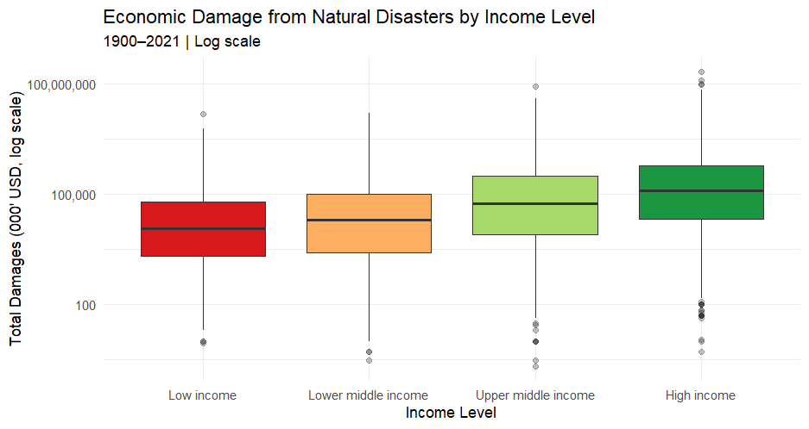
Plot 1 is a boxplot comparing the distribution of total economic damages (log scale) across the four World Bank income groups using the RdYlGn diverging palette. It confirms that high-income countries record substantially higher median absolute losses, consistent with their larger built environments and insured asset bases. Plot 1b addresses the bias in Plot 1 by expressing damage as a percentage of GDP. The ordering reverses: low-income and lower-middle-income countries exhibit substantially higher damage-to-GDP ratios, revealing that they bear a disproportionately heavier economic burden relative to their capacity — the more meaningful answer to RQ1.
Plot 1
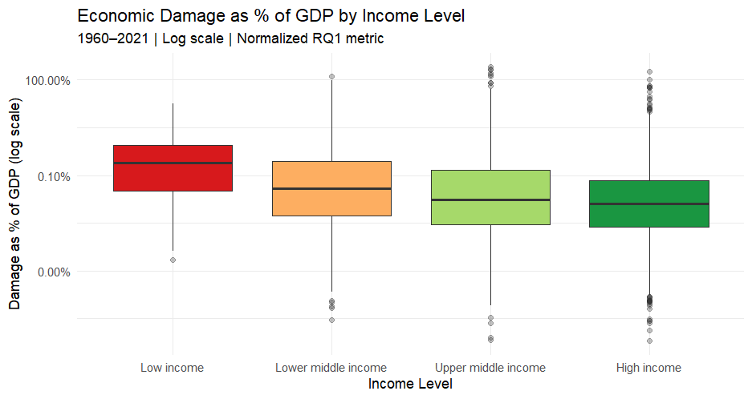
Plot 1b
RQ2: Which disaster types cause the most economic damage, and how has this changed over time?
Plot 2 is a horizontal bar chart aggregating total nominal damages by disaster type over 1900–2021. Storms and floods account for the vast majority of cumulative losses; earthquakes rank third despite lower frequency, due to catastrophic single events such as the 2011 Japan earthquake. Plot 3 is a multi-line time-series chart showing CPI-adjusted total damage per year by disaster type (1970–2021). Using constant 2021 USD removes inflation bias and reveals a genuine upward trend in storm and flood damage from the 1990s onward.
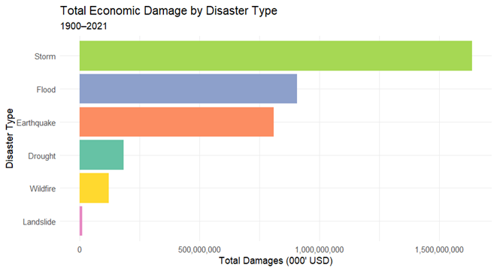
Plot 2

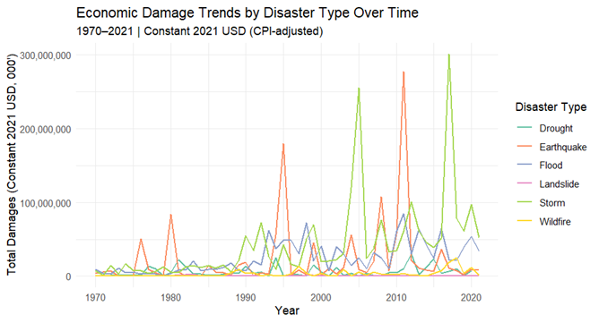
Plot 3

RQ3: How does disaster frequency and total economic loss vary across continents?

Plot 4 is a grouped bar chart displaying disaster frequency by continent and type; Asia leads by a wide margin, driven primarily by floods and storms. Plot 5 is a bubble scatter plot (event count vs. total damage, size scaled to damage) confirming Asia as an extreme outlier in both dimensions. Plot 6 is a faceted line chart showing economic damage trends by continent across each disaster type (with free y-axes per panel). This visualization reveals a stark contrast in regional vulnerabilities: while Asia heavily dominates in financial losses from earthquakes and floods, the Americas experience unprecedented economic damage driven primarily by catastrophic storms and wildfires.
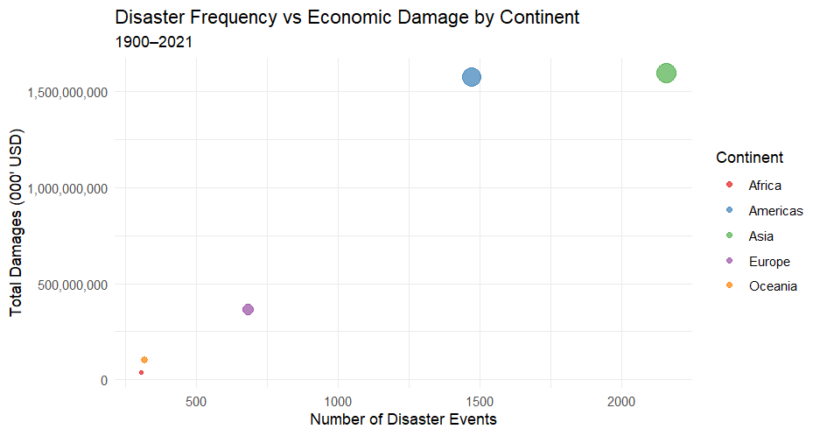
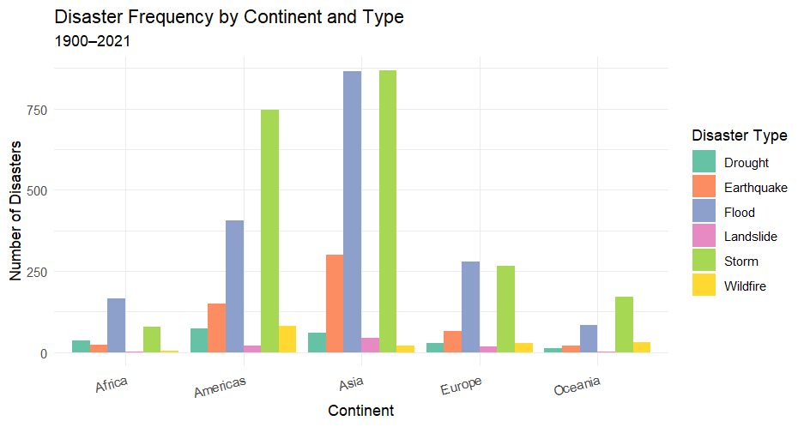
Plot 5
Plot 4
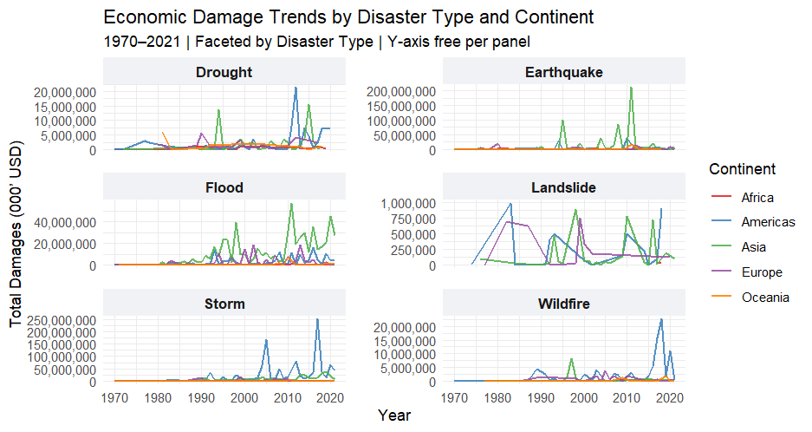
Plot 6

Shiny Dashboard

All visualizations are integrated into a Shiny dashboard built with the shiny [6] and plotly packages, with six tabs and a shared sidebar. The sidebar provides four cross-cutting filters — year range slider (1900–2021), disaster type checkboxes, continent dropdown, and income level dropdown — that reactively update all outputs simultaneously. Four summary cards at the top display the filtered count of countries, disaster events, total damage, and total deaths.

The World Map tab (RQ1–RQ3) renders an interactive Leaflet map with proportional circle markers colored by each country's dominant disaster type; click popups show full country-level statistics, and a tectonic fault-line overlay can be toggled for earthquake context. The Income & Damage tab (RQ1) contains both the absolute and GDP-normalized boxplots side by side. The Damage Trends tab (RQ2) presents the bar chart and CPI-adjusted time-series. The By Continent tab (RQ3) shows the frequency bar chart and scatter plot. The Heatmap tab (RQ3) displays average damage per event across continent × disaster-type combinations. The Data Table tab provides a searchable, sortable row-level table.

Limitations and Possible Extensions

Several limitations affect interpretation. EM-DAT relies on voluntary reporting; low-income countries are systematically under-represented, understating their true disaster burden. The CPI adjustment uses the US Consumer Price Index as a proxy for all countries, whereas country-specific deflators would be more precise. World Bank income classifications are fixed at 2022 groupings and applied retrospectively, misclassifying rapidly developing economies for earlier decades. The analysis is restricted to six disaster types, so damage totals are lower bounds of actual losses. Possible extensions include replacing the US CPI with country-specific GDP deflators, incorporating population exposure data to enable per-capita metrics, adding a choropleth map layer for spatial income analysis, and applying panel regression to identify which country characteristics most strongly predict high damage-to-GDP ratios.

References

[1] Centre for Research on the Epidemiology of Disasters (CRED). (2022). EM-DAT: The International Disaster Database. Universite catholique de Louvain. https://www.emdat.be

[2] World Bank. (2022). World Bank Country and Lending Groups. https://datahelpdesk.worldbank.org/knowledgebase/articles/906519

[3] World Bank. (2022). Consumer Price Index — FP.CPI.TOTL. World Development Indicators. https://data.worldbank.org/indicator/FP.CPI.TOTL

[4] World Bank. (2022). GDP (current US$) — NY.GDP.MKTP.CD. World Development Indicators. https://data.worldbank.org/indicator/NY.GDP.MKTP.CD

[5] Meschiari, S., et al. (2023). wbstats: Programmatic Access to the World Bank API. R package. https://CRAN.R-project.org/package=wbstats

[6] Chang, W., et al. (2023). shiny: Web Application Framework for R. R package version 1.7.4. https://CRAN.R-project.org/package=shiny

[7] Wickham, H. (2016). ggplot2: Elegant Graphics for Data Analysis. Springer-Verlag.

