Edward Fitzpatrick

Ai

Bilitiski

10/22/20

Easy NN

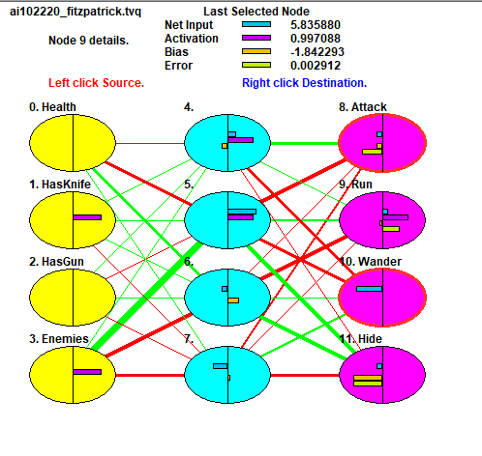

1. How many hidden layers did you use?

I used 4 hidden layers

1. Did you need to increase the number of hidden layers to get the network to train properly?

Yes, as the network shows most of the intended results but requires more layers to be accurate.

1. Did the network train slowly?

It trained at the expected speed.

1. Once trained, did your network produce the correct outputs 100%?

Nearly but not exact, it most likely requires more hidden layers.