Edward Fitzpatrick

Ai

Bilitski

11/2/20

Tensor Flow

# Files used:





# Output:

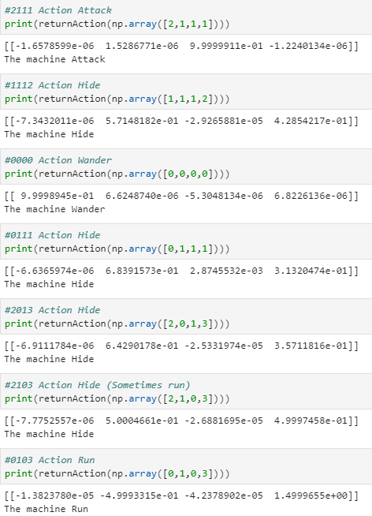

# Training Data:

# 