Goblin Brawl GDD
Andrew Perrault – August 14, 2015
Table of Contents
1 Overview 1
1.1 Setting/Theme 1
1.2 Player End-Goals 1
1.3 Platforms 2
2 Mechanics 2
3 Controls 2
4 Screens 2
4.1 Game Screen 2
4.2 UI 2
4.3 Camera System 2
5 Environment 2
5.1 The Arena 2
6 Art 3
7 Technical Design 3
7.1 Motor-doll System 3
8 Appendix A Options for the Future 3
8.1 Particle Effects 4
8.2 Fur Shading 4
8.3 Sub-Surface and/or Translucent Shading 4
8.4 Weapons 4
8.5 AI 4
8.6 Online Multiplayer 4

Overview
Goblin Brawl is a 3D action battle arena. The goblins in the game are in in a tournament to see who is the best. This project will have minimal menus and game structure and instead will focus on 3D physics and graphics programmings. The game will be very easy to pick up and play. It is intended as a local multiplayer party game.

Setting/Theme
The game takes place in a lava filled cave. The centre of the arena has a large stone platform rising out of the lava. Player will start across the arena from each other.

Player End-Goals
The goal is simple. Knock your opponent off the platform to win the challenge.

Platforms
The game is built using DirectX 11 and will target Windows desktop.

Mechanics
The players will use movement and attacks to knock their opponent off of the central platform. Hits will be physics based so that if both weapons collide the will have little effect. Low hits can be used to knock you opponent down. Clean hits to the head will knock your opponent unconscious for a short time.

Controls
The game will be using a game controller. One stick will change the character facing. The other stick will make the character strafe side to side and run forward and back. There will be a jump button and a attack button. The attack will be context sensitive so that forward-attack, sideways-attack, back-attack and jump-attack will have different results.

Screens

Game Screen
The game will be split screen local multiplayer.

UI
Little UI to speak of. There will be no points or health. There will be a simple overlay to let the player know the controls.

Camera System
The camera will be third person over the shoulder view. The camera will be locked to follow the player.

Environment

The Arena
The arena will consist of a rocky platform surrounded by lava. The lava pool will be big enough that the player cannot cross it. The lava will also be big enough that the over the shoulder camera will never hit the wall even if the player is at the edge of the pool facing inward.
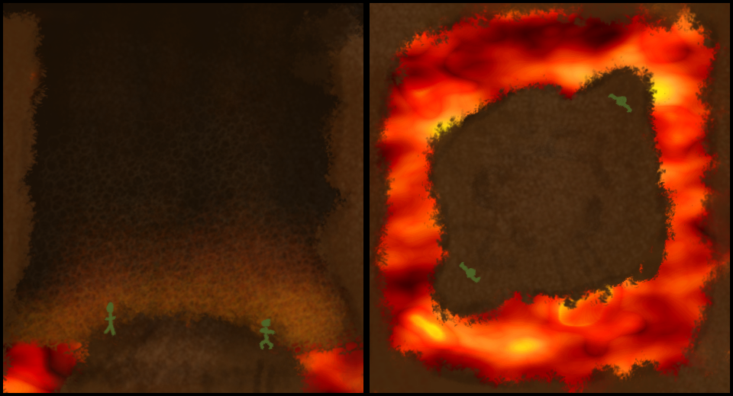Illustration 1: The Arena

Art

Visual
The art design will be gritty but painterly rather than realistic. I want the game to look like a Frank Frazetta painting or 1950s or 1960s comic book cover or paperback cover illustration. World of Warcraft style saturated bright coloured cartoons and Shadow of Mordor realistic style have both been done and I am aiming for something different.

Animation
The animation will be physically based. Traditional animation usually suffers from either animation taking control from the player and hurting the feel of the game or player control interrupting the animation and hurting the look. In this game they animation will be driven by physics so that it will interact dynamically with the opponent and environment.

Technical Design

Motor-doll System
The characters in this game will be represented by skinned meshes but they will not be controlled using traditional skeletal animation. I will still create animations using a regular 3D package but I will use a motor-doll system to interpolate between key-frames. Each bone exported from the traditional animation package will be bound to physics bodies and joint constraints. This skeleton of physics bodies is what I am calling a motor-doll. The motor-doll system will move by selecting target rotations for each joint using the next animation key frame and using a proportional-integral-derivative controller to drive the torque applied to each joint.

Appendix A Options for the Future
This section is for features that fit in the design but are likely to not fit in the scope of the prototype. If will add as many of these features as possible after the core of the prototype is complete. The list is roughly in order of estimated difficulty (and how likely they are to make it into the project).

Particle Effects
Smoke and fire when the player touches the lava as well as sparks and bubbles from the edges of the lava pit would all add atmosphere to the environment.

Fur Shading
Fur shading for the goblins cloths would be a nice addition without to much extra work.

Sub-Surface and/or Translucent Shading
SSS would be a nice addition to the shader model in the game. Specifically things like goblin ears with the glowing lava behind them would benefit from this addition.

Weapons
The game may be more interesting if the players have no weapons to start and clubs, bones, etc are scattered around the arena.

AI
Having a one player mode so a single player could practice would make the game better. This would require the addition of a menu screen as well as AI pathing and AI goal seeking to try and push the player off the platform.

Online Multiplayer
Obviously this would require a server and a system to connect the client to the server. This would be a huge gain and allow more than two simultaneous players.

